**THYROID SURGERIES IN A PRIVATE SETTING: OUR EXPERIENCE**

**ABSTRACT**

**Background:** Thyroid being an endocrine gland is involved in a diverse problems ranging from benign to a more concerned malignancy1. A benign looking thyroid swelling in a regular surgical clinic has to be evaluated and managed accordingly1. Thyroid diseases are commoner in females than in males2.

**Aim:** To identify the frequency of thyroid malignancy among patients with goiters in a private setting.

**Method:** This is a 2-year analytical descriptive retrospective study. All patients who underwent thyroidectomy in the center within the last two years who were16years and above were recruited. Data were collected from hospital record and patients’ details; age, sex, presenting complaints,investigations,diagnosis and treatment method were gotten.Results of their diagnosis and treatment were analyzed using Chi square for categorical values and T test for continuous variables.

**Results**: During the period of 2 years January 2022 to January 2024, 22 thyroidectomies were performed in the private hospital. Eighteen(18)(81.8%) were females, four(4)(18.2%) were males. Of all the thyroidectomies, three(3)(13.6%) were malignant (follicular thyroid cancer) while nineteen(19)(86.4%)were benign. Fifteen (68.2%) patients had total thyroidectomy, 5(22.7%) patients had hemithyroidectomy and 2(9.1%) patients had completion thyroidectomy.

**Conclusion:** The frequency of thyroid malignancy in our practice is low. Follicular thyroid cancer is the commonest differentiated thyroid cancer in the region. Thyroidectomy is safe and feasible in a low resource private center with expertise.

**Limitations:** small sample size

**Keywords:** Experience, private setting,thyroidectomy

**Introduction**

Thyroid being an endocrine gland is involved in a diverse problems ranging from benign to a more concerned malignancy.(1) A benign looking thyroid swelling in a regular surgical clinic has to be evaluated and managed accordingly.(1) Thyroid diseases are commoner in females than males.(2) Thyroid cancer is the most common endocrine cancers. Its incidence has continuously increased in the last three decades all over the world including Africa though with little data.(3,4,5) The increasing incidence is evidenced by the annual percentage change from 25% in 1990/1997 to 6.6% from 1997/2009 in USA for both genders.(3) The mortality from thyroid cancer is relatively low and had remained almost the same showing only slight increase.(5) Currently, it is unclear whether the noted increase in thyroid cancer is real or from overdiagnosis.(5) Thyroid cancer has different distribution on gender, age, race and environmental conditions.(5) In spite of increased progress in a better understanding of the thyroid cancer molecular biology, defining risk profile is difficult.The only clearly known is that differentiated cancers arise from the follicular cells of the thyroid gland and follicular cancer represents an increased portion of thyroid cancers in regions where dietary intake of iodine is low.(5,6) Familial occurrence of thyroid cancer is estimated at 5% for papillary thyroid cancer (PTC) and follicular thyroid cancer (FTC) and 15-30% for medullary thyroid cancer (MTC). (7) Mutations and Translocations in the genes coding the mitogen-activated protein kinase (MAPK) cellular signaling pathway have been implicated in the genetic basis of most thyroid cancers.(8)In a review of trends of differentiated thyroid cancers from some West Africa tertiary centers, the results indicated that in the 1980s, there was a predominance of follicular cancer over papillary cancer (35.8% vs 27.3%). (9) However, in the same report from the 1990 to 2004, there was a documented increase in papillary thyroid cancer over the follicular thyroid cancer (35.7% vs 24.8%). This may be a reflective of the changing iodine status of the continent as a result of widespread iodinization programs and a progressive increase in radiation exposure in the continent.(4,9) Thyroid cancers are fairly well studied in the African continent and results of review of biopsy specimens indicate that follicular cancers are sometimes the commonly encountered thyroid neoplasms in some geographical locations.(4) This distribution of follicular cancer may be largely dependent on the iodine status of the area of study.Over the last decades, there has been worldwide increase in the incidence of Papillary thyroid cancer and this was attributed to early detection and advanced imaging technology with risk of overdetection.(10) Anaplastic thyroid cancers (ATC) are a histologically heterogeneous group of extremely aggressive undifferentiated tumors arising from the follicular epithelium which accounts for 2–5% of all thyroid cancers.(11) ATC cells do not retain any of the biological features of the original follicular cells such as uptake of iodine and synthesis of thyroglobulin.(11) The prevalence of anaplastic thyroid neoplasms ranges from 4% to 21.4%. It is important to note that high prevalence rates of anaplastic cancers occurred in same regions with high prevalence rates of follicular cancers. Medullary carcinoma of the thyroid (MTC), a distinct thyroid carcinoma originating in the para follicular C cells of the thyroid gland was the least documented malignancy.(4) In Africa and worldwide, there are recent documented changing trend of increased prevalence rates of papillary thyroid cancer more than other types of thyroid cancers. The reason for the increase is controversial; attributed to the increased diagnostic intensity, lifestyle and environmental changes.(4,10) Based on data, thyroid cancer is the fifth most common cancer in women.(12)

During evaluation a thyroid function panel, high-resolution diagnostic thyroid ultrasound and fine-needle aspiration cytology[FNAC] are the most appropriate initial patient assessment. The FNAC result is usually reported by the Bethesda Criteria for reporting Thyroid Cytology, which stratifies the biopsy results and recommends the next line of treatment.(13) Treatment for differentiated thyroid cancer remains mainly surgical resection, followed by radioiodine ablation when indicated and suppression with thyroid hormone.(14,15) Systemic radiation and chemotherapy in advanced cases refractory to conventional treatment and in recurrence. To minimize the risk of complications, specifically recurrent laryngeal nerve injury and hypoparathyroidism, surgery is recommended, performed by experienced, ‘high-volume’ thyroid surgeons.(16) In the developing countries, the little data and the very limited technical platform, especially in Africa concerning thyroid cancer has necessitated this study. We aim to assess the frequency of thyroid cancer among patients with goiters in private setting and to analyze the epidemiological, clinical, and ultrasound risk factors.

**Method:**

This is a 2-year analytical descriptive retrospective study. All patients who underwent thyroidectomy in the center within the last two years who were16years and above were recruited. Data were collected from hospital record and patients’ details; age, sex, presenting complaints, investigations, diagnosis and treatment method were gotten.Results of their diagnosis and treatment were analyzed using Chi square for categorical values and T test for continuous variables.

**Results**:

During the period of 2 years January 2022 to January 2024, 22 thyroidectomies were performed in the private hospital. Eighteen(18)(81.8%) were females, four(4)(18.2%) were males. Of all the thyroidectomies, three(3)(13.6%) were malignant (follicular thyroid cancer) while nineteen(19)(86.4%)were benign. Among the thyroid cancers seen, 2(66.7%) were females while 1(33.3%) was a male and all were above 55years of age. Fifteen (68.2%) patients had total thyroidectomy, 5(22.7%) patients had completion thyroidectomy,hemithyroidectomy and 2(9.1%).

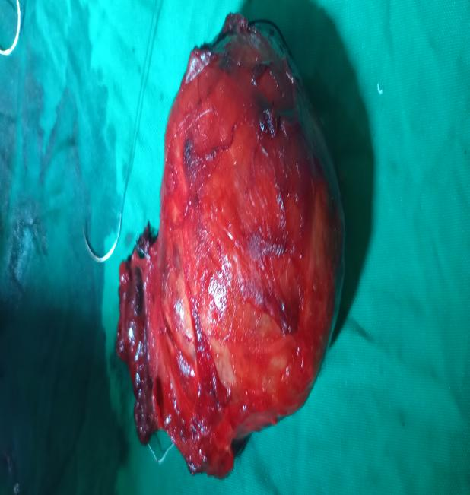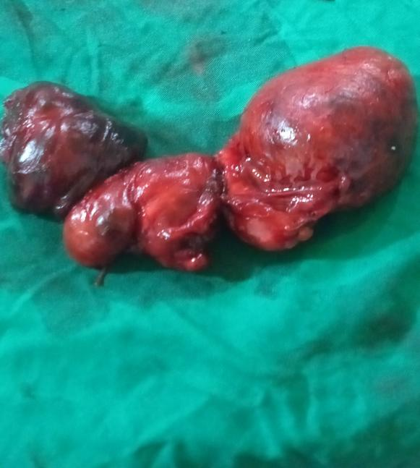

Fig 1-Resected thyroid gland

**Figure 2: Sex Distribution**

**Table 1: Age Distribution**

|  |
| --- |
| Male Female Total |
| **Age** |
| 16-25 1 1 2  26-35 1 3 4  36-45 1 8 9  46-55 1 3 4  56-65 2 2  66-75 1 1  76-85  86-95 |
| Total 4 18 22 |

**Table 2: Pathological Distribution**

|  |  |  |
| --- | --- | --- |
| Diagnosis  FTC  PTC  Multi-nodular goitre (MNG) | Frequency  3  0  19 | Percentage(%)  13.6  0.0  86.4 |

**Discussion**

In this study,women were predominant (81.8%) and the average age was 40.5 years, which corroborates data from the African and the world literature.(17,18,19)

This study shows an increased incidence of thyroid cancer when compared to similar studies done in the same area and other regions. (17,20,21) It also noted increased incidence of follicular thyroid cancer (13.6%) in the region when compared to previous study done in the same region that reported (7.1%) follicular thyroid cancer in four years. (17)

We revealed that there was no regional change in the type of thyroid cancer seen in the locality when compared to previous study in the region. (17)

We found out that thyroid cancer was commoner in females and that the age of onset tended to be younger, this corresponds to what is seen in other studies.(12,20) Patients with follicular carcinoma are typically older than those with papillary carcinoma, with average age of sixth decades and female-to-male ratio of 3 to1 which corresponds with the finding in the study.(22) The potential reason suggested for the global increase in incidence of follicular thyroid cancer which has been iodine intake,our study showed a thyroid cancer frequency of 20%. (23)

CONCLSION

In developing countries, it appears necessary to introduce the use of more precise diagnostic tools for thyroid cancer and also, to reinforce the improvement of known, controllable risk factors such as iodine intake as this could have contributed to persistent of same type of thyroid cancer and an increased incident in the same region.

**Reference:**

Karthik KS, Suresh SS, Balakrishna MA and Ramesh DB. Study of incidence of malignancy in clinically benign thyroid swelling. South Asian J Cancer.2015 Jul-Sept;4(3):151-153.

2.Tigabu E, Bekele KB & Dachew BA. Prevalence of goiter and associated factors among schoolchildren in northeast Ethiopia. [Epidemiol Health.](https://www.ncbi.nlm.nih.gov/pmc/articles/PMC5790981/) 2017; 39: e2017055.Published online 2017 Nov 25. doi: [10.4178/epih.e2017055](https://dx.doi.org/10.4178%2Fepih.e2017055).

3.Pellegriti G, Frasca F, Regalbuto C, Squatrito S,Vigneri R, Worldwide Increasing Incidence of Thyroid cancer: Update on Epidemiology and Risk Factors.Journal of cancer Epidemiology 2013; Article ID 965212,10pages. <http://dx.doi.org/10.1155/2013/965212>

4. Ogbera AO, Kuku SF, Epidemiology of the thyroid diseases Africa. Indian J Endocrinol Metab 2011 Jul; 15(Supp(2): P S82-S88/DOI:10.4103/2230-8210.83331

5.Evanthia G, Ioannis I, Vasiliki C. Risk factors and the progression of thyroid malignancies. Hell J Nucl Med. 2015 Sep-Dec;18(3):275-284. doi: 10. 1967/s002449910307. Epub 2015 No 18

6.Kalk WJ, Sita F, Patterson AC. Thyroid cancer in South Africa-an indicator of regional iodine deficiency. S Afr Med J 1997;87: 735-738

7.Nikiforov YE, Nikiforova MN. Molecular genetics and diagnosis of thyroid cancer. Nat Rev Endocrinol. 2011 Aug 30;7(10):569-80. [PubMed]

8.Fagin JA. How thyroid tumors start and why it matters: kinase mutatants as targets for solid cancer pharmacotherapy. J Endocrinol. 2004 Nov; 183(2):249-56. [PubMed]

9.Woodruff SL, Arowolo OA, Akute OO, Afolabi AO, Nwariaku F. Global variation in the pattern of differentiated thyroid cancer. Am J Surg 2010; 200: 462-466

10. Miranda-Filho A, Lortet-Tieulent J, Bray F, Cao B, Franceschi S, Vaccarella S, Dal Maso L. Thyroid cancer incidence trends by histology in 25 countries: a population-based study. Lancet Diabetes Endocrinol. 2021 Apr;9(4):225-234.[PubMed]

11.Voster MS.Detection of Extensive Metastases from Ogbera and Kuku: Thyroid in Africa S88 Indian Journal of Endocrinology and Metabolism / 2011 / Vol 15 / Supplement 2 Anaplastic Thyroid Cancer by F- 18 FDG-PET/CT. Open Nucl J 2011;3:1-6.

12. Jemal A, Siegel R, Xu J, Ward E, “Cancer statistics, 2010,” CA: A Cancer Journal for Clinicians, vol. 60, no. 5, pp. 277-300, 2010.

13.Cibas ES,Ali SZ. The 2017 Bethesda system for Reporting Thyroid. 2017 Nov; 27(11):1341-1346.[PubMed]

14.Haugen BR,Alexander EK, Bible KC, Doherty GM, Mandel SJ, Nikiforov YE, Pacini F, Randolph GW, Sawka AM, Schlumberger M,Schuff KG, Sherman SI, Sosa JA, Steward DL, Tuttle RM, Wartofsky L. 2015 American Thyroid Association Management Guidelines for Adult Patients with Thyroid Nodules and Differentiated Thyroid Cancer: The American Thyroid Association Guideline Tax Force on Thyroid Nodules and Differentiated Thyroid Cancer. Thyroid. 2016 Jan;26(1):1-133[PMC free article] [PubMed]

15.Pacini F, Schlumberger M, Dralle H, Eliser R, Smit JW, Wiersinga W. European Thyroid Cancer Taskforce. European consensus for the management of patients with differentiated thyroid carcinoma of the follicular epithelium. Eur J Endocrinol. 2006 Jun;154(6):787-803.[PubMed]

16.Adam MA, Thomas S, Youngwirth L, Hyslop T, Reed SD, Scheri RP, Roman SA,Sosa JA. Is There a Minimum Number of Thyroidectomies a Surgeon Should Perform to Optimize Patient Outcomes? Ann Surg. 2017 Feb;265(2):402-407.[PubMed]

17.Sunday-Nweke NA, Enemuo VC, Nwigwe CG, Oguonu AC Clinicopathological Features of Goiter In Abakaliki Nigeria. International Journal of Scientific & Engineering Research.2019;10(11):290 ISSN 2229-5518

18.Kakamba JB, Sabbah N, Bayauli P, Massicard M, Nkadila A, Mbunga B, Ditu S,Beckers A,Potora J, Thyroid cancer in the Democratic Republic of Congo; Frequency and risk factors .Annales d’Endocrinologie Vol.82 issue 6 Dec 2021 pg 606-612.

19.Hyeong SA, Hyun JK, Kyoung HK, Young SL, Seung JH, Yuri K, Min JK, Juan PB.Thyroid Cancer Screening in South Korea Increases Detection of Papillary Cancers with No Impact on Other subtypes or Thyroid Cancer Mortality. Thyroid. 2016 Nov;(11):1535-1540. doi: 10.1089/thy.2016.0075.Epub 2016 Oct 18

20.[Bao](https://pubmed.ncbi.nlm.nih.gov/?term=Bao%20W%5bAuthor%5d) WQ,  [Zi](https://pubmed.ncbi.nlm.nih.gov/?term=Zi%20H%5bAuthor%5d) H, [Yuan](https://pubmed.ncbi.nlm.nih.gov/?term=Yuan%20Q%5bAuthor%5d) QQ,  [Li](https://pubmed.ncbi.nlm.nih.gov/?term=Li%20L%5bAuthor%5d) LY,Deng T Global burden of thyroid cancer and its attributable risk factors in 204 countries and territories from 1990 to 2019.[Thorac Cancer.](https://www.ncbi.nlm.nih.gov/pmc/articles/PMC8447914/) 2021 Sep; 12(18): 2494–2503

21.Vigneri R, Malandrino P, Vigneri P.The changing epidemiology of thyroid cancer, why is incidence incresing? Current Opinion in Oncology 27(1):p 1-7, January 2015. 1 Dio: 10.1079/CCO.0000000000000148

22.McHenry CR, Phitayakorn R. Follicular adenoma and carcinoma of the thyroid gland. Oncologist. 2011;16(5):585-93. [PMC free article]

23.Knobel M, Medeiros-Neto G. Relevance of iodine intake as a reputed predisposing factor for thyroid cancer. Arq Bras Endocrinol Metabol.2007 Jul;51(5):701-12 [PubMed]