Original Research Article

Endotyping Cellular and Humoral Immunoreactivity to Cocoa and Nickel in patients with Atopic and Allergic Contact Dermatitis.

ABSTRACT

Background: Self-reported allergy to chocolate is a common complaint in the clinical practice of Allergology; however, IgE-mediated cocoa allergy is not a commonly demonstrable endotype responsible for the phenotypes associated with cocoa hypersensitivity. However, cocoa is one of the foods more consistently associated with high nickel content, a metal that functions as a hapten responsible for various non–IgE-mediated symptomatic hypersensitivities.
Aim: The present study is a proof-of-concept that hypothesizes that LAIT and the TTP may differentiate diverse degrees of cellular and humoral immunoreactivity against cocoa extract and a nickel solution, as well to verify some sort of cross-reactivity between them in patients suffering from non–IgE-mediated Atopic and Allergic Contact Dermatitis.
Study Design: We examined the medical charts of two cohorts of patients clinically diagnosed with Intrinsic Atopic Dermatitis and Allergic Contact Dermatitis, who were simultaneously investigated with cocoa extract and nickel solution with the help of TTP or LAIT.
Methodology: The registered results of the semi-quantitative serum TTP against cocoa extract and nickel solution, as well as the registered results of the Leukocyte Adherence Inhibition (LAI) percentage promoted by the ex vivo challenges against a cocoa extract and a nickel solution, were distributed in ranges through a cascade distribution chart to outline the variability of the results inside the cohorts.
Results: The TTP for the cocoa extract showed a distribution concentrated on the higher dilutions. The mean was estimated at 1:385; the median at 1:512; and the standard deviation at 1:180. The TTP for the nickel showed a distribution concentrated on the higher dilutions. The mean was estimated at 1:309; the median was 1:256; the standard deviation was estimated at 1:199; the mode was 1:512 (appeared 46 times). The cascade distribution demonstrated a wide range of LAI results for the cocoa extract. The LAI ranged from 0% to 98%. The mean was 51.9%; the median was 56%; the SD was 26.3%; the mode was 0% (appeared seven times). The cascade distribution demonstrated a wide range of LAI results for the nickel solution. The LAI ranged from 0% to 89%. The mean was 33%; the median was 33%; the SD was 26,6%; the mode was 0% (appeared eighteen times). The Pearson correlation indicated that there is a significant medium positive relationship between TTP results between Cocoa (x-axis) and Nickel (y-axis), r(98) = .335; p < .001. The Pearson correlation indicated that there is a significant medium positive relationship between LAIT results between Cocoa (x-axis) and Nickel (y-axis), r(98) = .425; p < .001.
Conclusion: The results demonstrated a more significant immunoreactivity from the tests performed with cocoa extract than obtained with the nickel solution. These findings state that cocoa possesses other allergens responsible for cellular immunoreactivity besides nickel. This means that if a patient presents cellular immunoreactivity against cocoa, he/she will not necessarily present immunoreactivity against nickel; however, reciprocation is less probable.

Keywords: Cocoa, Dermatitis, Endotype; Hypersensitivity; Leukocyte Adherence Inhibition Test; Nickel; Non–IgE-mediated Immunoreactivity; Precipitins.

Abbreviations:
LAI: Leukocyte Adherence Inhibition
LAIT: Leukocyte Adherence Inhibition Test
TTP: Tube Titration of Precipitins

1. INTRODUCTION

Self-reported allergy to chocolate is a common complaint in the clinical practice of Allergology; however, IgE-mediated cocoa hypersensitivity is not a commonly demonstrable endotype responsible for the phenotypes described as cocoa allergies (Nin-Valencia et al. 2024, Sloan and Powers 1986). When thoroughly investigated, IgE-mediated reactions to chocolate are usually due to cow's milk, hen's egg, peanut, soybean, hazelnut, almond, and other ingredients and contaminants added to cocoa to make sweet chocolate (Lopes et al. 2019, Pilolli et al. 2024). The Allergen Nomenclature Sub-Committee of the World Health Organization and International Union of Immunological Societies (WHO/IUIS) do not recognize any protein derived from Theobroma cacao that could officially be stated as a major (or a minor) IgE-mediated allergen. A candidate to be recognized as a significant IgE-mediated cocoa allergen is the Pathogenesis-Related protein PR10 (TcPR-10), a protein with homology to pollen and food allergens derived from the Birch (Betula verrucosa), the pear (Prunus persica), the apple (Malus domestica), the cherry (Prunus avium) and the carrot (Daucus carota) (Menezes et al. 2012).
However, cocoa is one of the foods more consistently associated with high nickel content, a metal that functions as a hapten responsible for various non–IgE-mediated symptomatic hypersensitivities associated with several toxic and allergic diseases (Cubadda et al. 2020). Nickel is the fifth most abundant metal in the earth's crust. It is found in soil, absorbed by cocoa roots, and transported upright to accumulate in cocoa beans (Mostafa, Mohamed and Fouad 2024).
Besides nickel, cocoa beans may present several toxic metals absorbed from the soil, posing human health risks (Frimpong et al. 2024). Besides cocoa, nickel may be present in licorice, lettuce, soybeans, oatmeal, nuts, almonds, legumes, peanuts, oats, grains, whole wheat (and whole meal flours), and mainly in canned food with high nickel contents, liberated from a nickel-plated tin alloy (Sharma 2013, Abeck et al. 1993, Veien and Menné 1990, Veien et al. 1985).
Nickel is one of the leading causes of allergic contact dermatitis, which is diagnosed by patch tests (Isufi et al. 2025). Nickel is a hapten collected by dendritic cells through the Toll-like receptor 4 and presented to naïve T cells in regional lymph nodes (Schmidt et al. 2010, Roediger and Weninger 2011). Nickel Hypersensitivity may be responsible for Allergic Contact Dermatitis, Allergic Contact Mucositis, and Systemic Nickel Allergy Syndrome, a term commonly used to describe clinical manifestations of the systemic provocation by haptens associated with atopic dermatitis, psoriasis, urticaria, angioedema, rhinitis, asthma, headache, chronic fatigue, post-prandial dyspnea, cystitis, vulvovaginitis, acne, and iron deficiency anemia (Schäfer et al. 2001, Ahlström et al. 2019, Greco et al. 2023, Ricciardi et al. 2014, Nijhawan et al. 2009, Veien 2011, Akiba et al. 2025).
Sometimes, the exposition through a systemic route of immunoreactive haptens may produce localized cutaneous hypersensitivity phenotypes such as dyshidrotic eczema (pompholyx), toxicoderma-like rash, chronic pruritus, maculopapular rash, vasculitis-like lesions, flexural dermatitis, papuloerythroderma-like eruptions, and baboon syndrome (Antico and Soana 2015).
Nickel hypersensitivity may be successfully treated with sublingual desensitization and a low-nickel diet. (Filatova and Cherpak 2020, Ricciardi et al. 2013, Morris 1998). Nickel allergy can be diagnosed with cutaneous and oral challenge tests (Veien et al. 1987). Non–IgE-mediated symptomatic Nickel hypersensitivity may be differentiated with the help of the Leukocyte Adherence Inhibition Test (Olivier et al. 2023c). Non–IgE-mediated cellular immunoreactivity against several food allergens had already been reported by our group with the help of the Leukocyte Adherence Inhibition Test (LAIT), as well as humoral immunoreactivity against several food allergens with the help of the Tube Titration of Precipitins (TTP) (Olivier et al. 2021d, Olivier et al. 2022a, Olivier et al. 2022c, Olivier et al. 2024a, Olivier et al. 2024b, Olivier et al. 2024c, Olivier et al. 2025). We routinely employ the LAIT and the TTP in our facilities as a triage to evaluate non–IgE-mediated immunoreactivity against suspected allergens before performing more exhaustive in vivo provocation tests (Kuratsuji 1981, Olivier et al. 2023f, Olivier et al. 2023h, Olivier et al. 2023d, Olivier et al. 2023b, Olivier et al. 2023e, Olivier et al. 2024f). To evaluate the potential of the LAIT and TTP to endotyping Non–IgE-mediated cellular and humoral immunoreactivity against cocoa extract and nickel solution, we retrospectively compiled the electronic medical charts of patients diagnosed with non–IgE-mediated hypersensitivity who were investigated simultaneously for immunoreactivity against these two allergens by one of these assays.
The present study is a proof-of-concept that hypothesizes that LAIT and the TTP may differentiate diverse degrees of cellular and humoral immunoreactivity against cocoa extract and nickel solution, as well to verify some cross-reactivity between them through the calculation of a paired t-test to distinguish some order of cross-reactivity in patients suffering from non–IgE-mediated clinically diagnosed allergies.
As the tests were performed simultaneously with the same venous sample for the two allergens, it is possible to calculate a paired t-test between LAIT results (since they refer to the same quantitative variable), as well as to present a dispersion graph between them to distinguish some order of correlation suggesting (or not) cross-reactivity (Gosset-Student 1908).

2. MATERIALS AND METHODS

2.1 Subjects

After receiving Institutional Review Board approval from the Instituto Alergoimuno de Americana (Brazil; 02/2025), we reviewed the electronic chart of 10.170 outpatients who attended our facility from January 2018 to March 2025.
A cohort of 100 consecutive outside patients (TTP cohort) had been simultaneously submitted to TTP with cocoa extract and nickel solution for presenting non–IgE-mediated intrinsic atopic dermatitis and contact dermatitis. This cohort counted 27 males; mean age 38.6 years; SD 21.4 years; range 1 to 84 years; median 37.5 years; modes = 4, 7, 27, 30, 32, 33, 41, 45, 46, 50 years (each appeared 3 times); geometric mean = 29.9 years.
A cohort of 100 consecutive outside patients (LAIT cohort) had been simultaneously submitted to TIAL with cocoa extract and nickel solution for presenting non–IgE-mediated intrinsic atopic dermatitis and contact dermatitis. This cohort counted 27 males; mean age 43.3 years; SD 19.4 years; range 10 to 91 years; median 40 years; mode = 35 years (appeared seven times); geometric mean = 38.7 years.
This study did not include patients under biological and/or systemic anti-inflammatory therapy. These procedures were offered to patients with clinical suspicion of cocoa and/or nickel hypersensitivity who demonstrated an undetectable specific IgE against cocoa and non-reactive or inconclusive skin tests against cocoa extract and nickel solution (Olivier et al. 2013).

2.2 Extracts

2.2.1 Cocoa extract

The whole cocoa (pulp, peel, and seeds) was crushed, homogenized, and then left for 48 hours in a Coca-based extractor solution (propylparaben 0.5g, methylparaben 1g, sorbitol 30g, NaCl 5g, NaHCO₃ 2.5g, 1,000mL H₂O) at 4 °C for protein extraction before centrifugation and separation of the water-soluble fraction from solid particles and oily fraction (Coca 1922). The protein quantification of the allergen extracts was done according to Bradford's protein-dye binding methodology (Bradford 1976). The solution was diluted in antigen dilution solution (NaCl 10g; KH₂PO₄ 0.72g; Na₃PO₄ 2.86g; methylparaben 1g; propylparaben 0.5g; glycerin 400mL; H₂O 600mL) to an estimated protein concentration of 1 mg/mL and stored at 4 °C into amber opaque glass vials. The cocoa extract was used to perform allergic skin tests, TTP, and LAIT. All relevant and mandatory laboratory health and safety measures have been complied with during the experiments.

2.2.2 Nickel solution

The [NiSO₄ (H₂O)₆] was acquired from Labcenter Campinas. The powder was weighed and diluted in a buffer solution [NaCl 10g; KH₂PO₄ 0,72g; Na₃PO₄ 2,86g; H₂O 600mL] to achieve the final concentration of 1 mg/mL to be employed in the LAIT, TTP, and cutaneous tests.

2.3. LAIT: Ex vivo Investigation: Leukocyte Adherence Inhibition Test

2.3.1 LAIT: Procedure for allergen ex vivo challenging

We performed the LAIT as previously described (Olivier et al. 2012, Olivier et al. 2014, Olivier et al. 2021b, Olivier et al. 2021c, Olivier et al. 2021e, Olivier et al. 2022b, Olivier et al. 2022a, Olivier et al. 2022c, Olivier et al. 2023f, Olivier et al. 2023h, Olivier et al. 2023a, Olivier et al. 2024e). Shortly, each donor's fresh plasma was divided into two parts and used in parallel ex vivo challenging tests with the cocoa extract, the nickel solution, and the unchallenged plasma (added with antigen dilution solution as a control). We collected plasma with high leukocyte content (buffy coat) from the heparinized tube after one hour of sedimentation at 37 °C. Then, we distributed aliquots of 100 μL into Eppendorf tubes with (or without) the challenging extract and kept them under agitation for 30 minutes (200 rpm at 37 °C).

2.3.2 LAIT: Procedure for adherence assay

After incubation, the plasma was allocated into a standard Neubauer hemocytometer counting chamber with a plain, non-metallic glass surface and left to stand for 2 hours at 37 °C in the humidified atmosphere of the covered water bath to allow leukocytes to adhere to the glass. Next, we counted the leukocytes, removed the coverslip, and washed the chamber by immersion in a beaker with phosphate buffer saline (PBS) at 37 °C. Then, we added a drop of PBS to the hemocytometer's chamber and allocated a clean coverslip over it. The remaining cells were counted in the same squares as previously examined.

2.3.3 LAIT: Procedure for calculation

The percentage of Leukocyte Adherence (LA) of each assay was estimated as: (the number of leukocytes observed on the hemocytometry chamber after washing divided by the number of leukocytes observed on the hemocytometry chamber before washing) and multiplied by 100 (%). The Leukocyte Adherence Ratio (LAR) was estimated based on the ratio between the LA from the antigen-specific challenged plasma and the LA from the unchallenged control plasma: LAR = LA of the challenged sample divided by LA of unchallenged control plasma multiplied by 100 (%). To further calculate the Leukocyte Adherence Inhibition (LAI), we subtracted the LAR from 100 (%). We employed the LAI results for the cascade distribution chart and the statistics calculations, both performed with the help of the Microsoft Excel® statistical package.

2.4 TTP: In vitro Investigation: Tube Titration of Precipitins

As previously reported, the semi-quantitative TTP against the cocoa extract and the nickel solution was performed in a transparent vitreous tube array (Olivier et al. 2021f, Olivier et al. 2024g, Olivier et al. 2024d, Olivier et al. 2024b, Olivier et al. 2024a). Shortly, the patient's blood was collected in a clot-activator collecting tube. After separation, the serum was centrifugated at 2,000 rpm for 10 minutes. Each allergen extract was allocated in sets of eleven glass tubes at progressive duplicated serum dilutions. The progressive dilutions were combined with separated aliquots of 15 μL of the antigen (cocoa extract or nickel solution) with 250 μL of the patient's serum, progressively diluted into physiological saline solution (NaCl 0,9%) in the dilution ratios of 1:1; 1:2; 1:4; 1:8; 1:16; 1:32; 1:64; 1:128; 1:256; and 1:512. One tube was a blank control done with the distilled water and serum to observe occasional spontaneous precipitation (Sia Test). After 24 hours, the tubes were examined, and the titers (the highest dilution factor that yields a positive reading) were recorded (Williams and Chase, 1971).

3. RESULTS

As a retrospective survey, there was no research protocol; therefore, we report the incidental immune investigation as registered in the digital medical charts.
The TTP for the cocoa extract showed a distribution concentrated on the higher dilutions (Fig 1). There was one negative result. The mean was estimated at 1:385; the median was 1:512; the standard deviation was estimated at 1:180; the mode was 1:512 (appeared 65 times).
The TTP for the nickel showed a distribution concentrated on the higher dilutions (Fig 2). There was one negative result. The mean was estimated at 1:309; the median was 1:256; the standard deviation was estimated at 1:199; the mode was 1:512 (appeared 46 times).
The LAIT for the cocoa extract showed a wide distribution range of results. Most results were concentrated in the higher immunoreactive groups. There were seven negative results. The LAI ranged from 0% to 98%. The mean was 51.9%; the median was 56%; the standard deviation was 26.3%; the mode was 0% (appeared seven times). The cascade distribution demonstrates a wide range of LAI results (Fig. 3). Some patients showed low or moderate immunoreactivity during the ex vivo challenge test. In contrast, others displayed strong immunoreactivity, which supposedly could reflect the participation of cocoa allergens in the Non–IgE-mediated hypersensitivity condition of these patients.
The LAIT for nickel solution showed a wide distribution range of results. Most results were concentrated in the lower and moderate immunoreactive groups. There were eighteen negative results. The LAI ranged from 0% to 89%. The mean was 33%; the median was 33%; the standard deviation was 26,6%; the mode was 0% (appeared eighteen times). The cascade distribution demonstrates a wide range of LAI results (Fig. 4). Some patients showed low or moderate immunoreactivity during the ex vivo challenge test. In contrast, others displayed strong immunoreactivity, which could reflect the participation of nickel in the Non–IgE-mediated hypersensitivity condition of these patients.
The Pearson correlation indicated that there is a significant medium positive relationship between TTP results between Cocoa (x-axis) and Nickel (y-axis), r(98) = .335; p < .001; see Figure 5.
The Pearson correlation indicated that there is a significant medium positive relationship between LAIT results between Cocoa (x-axis) and Nickel (y-axis), r(98) = .425; p < .001; see Figure 6.

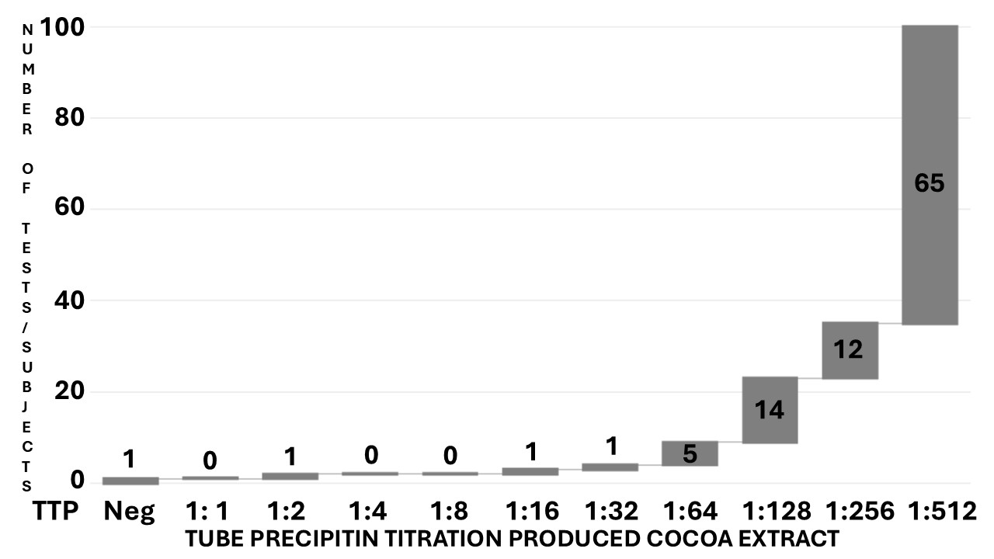
Fig. 1. Cascade distribution chart of the tube titration of precipitins (x-axis %) resulting from the cocoa extract against the serum of the TTP cohort of 100 tests/subjects (y-axis).

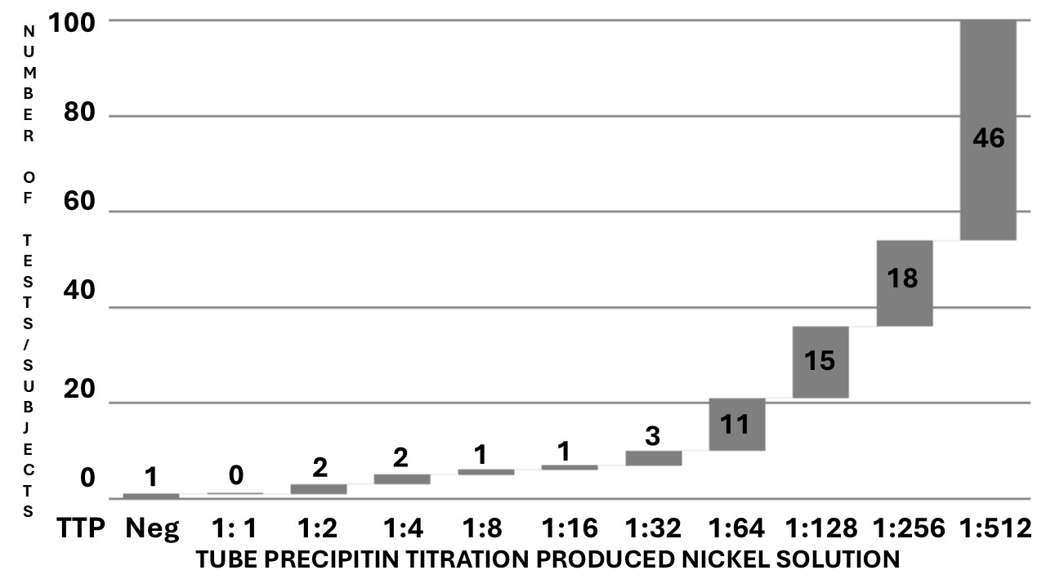
Fig. 2. Cascade distribution chart of the tube titration of precipitins (x-axis %) resulting from the nickel solution against the serum of the TTP cohort of 100 tests/subjects (y-axis).

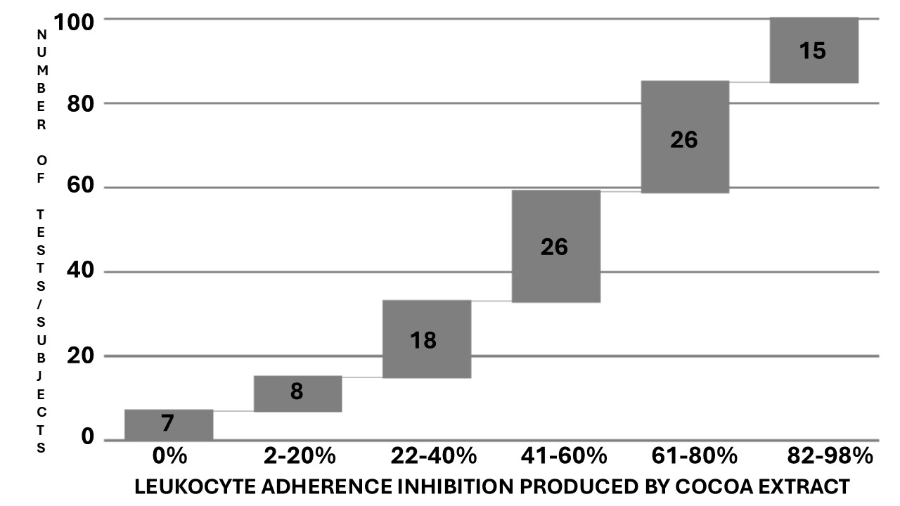
Fig. 3. Cascade distribution chart of the range groups of Leukocyte Adherence Inhibition (LAI) results (x-axis %) of the ex vivo challenge test against cocoa extract monitored by the Leukocyte Adherence Inhibition Test (LAIT), according to the respective number of outcomes over the LAIT cohort with 100 tests/subjects (y-axis).
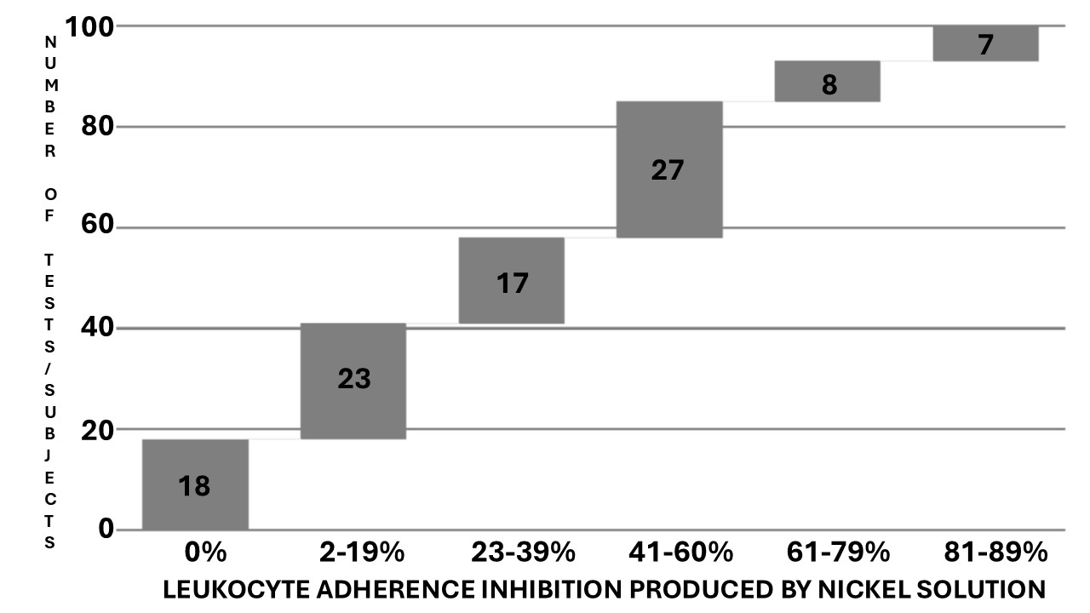
Fig. 4. Cascade distribution chart of the range groups of Leukocyte Adherence Inhibition (LAI) results (x-axis %) of ex vivo ex vivo challenge test against nickel solution monitored by the Leukocyte Adherence Inhibition Test (LAIT), according to the respective number of outcomes over the LAIT cohort with 100 tests/subjects (y-axis).
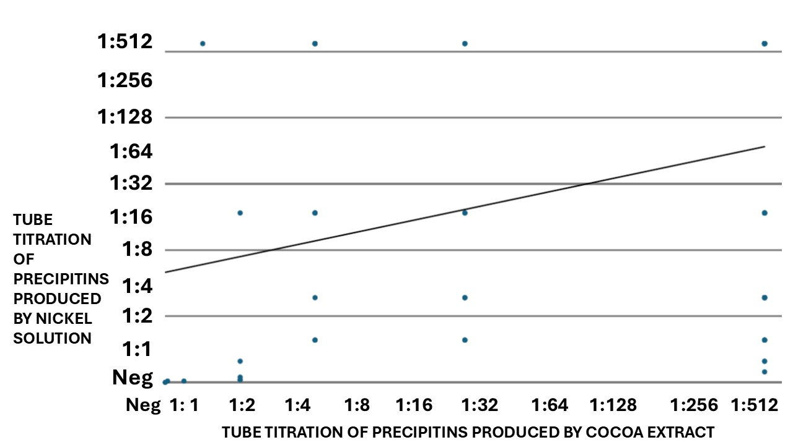
Fig. 5. Dispersion chart of the Leukocyte Adherence Inhibition (LAI) results of the Tube Titration of Precipitins against cocoa extract (x-axis %), plotted against the LAI results of the Tube Titration of Precipitins against nickel solution (y-axis %).

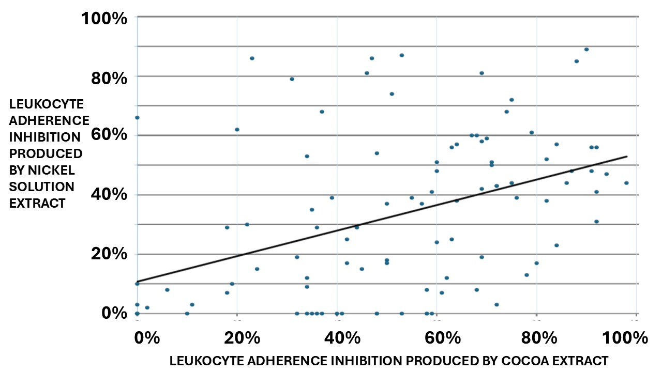
Fig. 6. Dispersion chart of the Leukocyte Adherence Inhibition (LAI) results of the ex vivo challenge test against cocoa extract (x-axis %), plotted against the LAI results of the ex vivo challenge test against nickel solution (y-axis %).

4. DISCUSSION

Cocoa polyphenols have several effects on innate inflammatory response and systemic and intestinal adaptive immune systems (Pérez-Cano et al. 2013). Animal studies have observed that polyphenols in cocoa extract prevent IgE synthesis and can suppress the development of Atopic Dermatitis by downregulating inflammatory markers, inflammatory chemokines, and cell infiltration into lesion areas, turning this food a potential therapy for patients with skin diseases; however, these preliminary data does not justify yet its empirical prescription for the treatment of allergic patients (Kang et al. 2017, Abril-Gil et al. 2012).
Despite the results demonstrating a positive correlation between cocoa and nickel immunoreactivity, the cocoa extract demonstrated significantly higher immune responses, suggesting that nickel is not the only active allergen in the cocoa extract. This infers that evaluating one allergen does not eliminate the need to evaluate the other. This observation also demonstrates that cocoa polyphenols do not directly suppress the immunoreactivity evaluated by the assays, leading to more studies about their alleged downregulation effects over inflammatory chemokines and immune cells, as reported in animal studies.
Endotyping cellular and humoral immunoreactivity biomarkers against specific allergens, haptens, and their respective cross-reactivities are tools to build effective strategies to personalize exclusion diets and desensitization treatments for allergic patients (Agache and Akdis 2020, Khan 2016). Due to the facility's ability to diagnose hypersensitivities associated with the IgE-mediated endotype, there is a tendentious bias among physicians to just "ignore" the non-IgE-mediated mechanisms (Zhang et al. 2024). To demonstrate a non–IgE-mediated allergic endotype, sometimes it is necessary to employ a multi-omics approach to differentiate the variety of clinical phenotypes and immune endotypes (Macowan et al. 2025, Yoon and Bunyavanich 2025).
The substantial number of sources for nickel is a confounding factor when investigating clinical hypersensitivity against this hapten. Initially, it may appear to be a polysensitization picture since the patients react to a confounder number of unrelated sources. The patient may also present unrelated symptoms, leading to the diagnosis of several allergic phenotypes. Until the conclusion that all phenotypes are produced by only one endotype mechanism elicited by only one allergen, it is usually a long journey requiring complex dietary interventions (Mikajiri et al. 2024).
As a hapten, even in the presence of an IgE-mediated hypersensitivity, it is almost impossible to develop a specific IgE-antibody for a commercial immunoassay against the multitude of carrier-haptens conjugates that may be produced once nickel gains blood circulation and conjugates with albumin, nickeloplasmin, or another serum protein (Barceloux 1999). The best strategy is to challenge the patients' living plasma (ex vivo) or fresh serum (in vitro) with nickel solution and quantify the resulting immunoreactivity.
The correlation and the distribution of simultaneous positive specific IgE against food and inhalant allergens is usually weak. However, polysensitization is more of a rule than an exception (Zhang et al. 2025, Čelakovská et al. 2024).
The research of precipitins is the pioneering laboratory exam upon which the bases of Immunology were constructed (Wells 1911). Precipitating antibodies testifies a humoral immune response against the tested antigens (Gell, Harington and Rivers 1946). Before the discovery of IgE, the research of precipitins was the leading way to realize in vitro diagnosis of immunoreactivity against allergens (Augustin and Hayward 1960, Augustin, Hayward and Longbottom 1960, Augustin 1953).
Precipitins against food proteins and circulating immune complexes are strongly associated with patients with selective IgA deficiency since the secretory IgA is one of the main participants of the mechanism of immune exclusion promoted into the intestinal lumen to prevent the absorption of undigested proteins to blood circulation (Cunningham-Rundles et al. 1978). Primary selective immune deficiencies (such as IgA or IgE) lead to immune dysregulation, a concept that is evolving as specific endotypes associated with secondary immunodeficiencies raised by the inflammatory conditions provided by the allergic reactions (Henrickson 2025, Olivier et al. 2023g, Sapartini et al. 2025).
The LAIT was designed as an ex vivo challenge test performed with a viable leukocyte buffy coat exploring several immune pathways, resulting in a final result quantified as the allergen-specific leukocyte adherence inhibition (Olivier et al. 2021a, Thomson 1982, Tong et al. 1979, Fink et al. 1987, Halliday, Maluish and Miller 1974).
The comparative results obtained from the TIAL cohort demonstrated a more significative immunoreactivity from the tests performed with cocoa extract than those obtained with the nickel solution. This finding states that cocoas possess more allergens responsible for cellular immunoreactivity besides nickel. This means that if a patient presents cellular immunoreactivity against cocoa, he/she will not necessarily present immunoreactivity against nickel; however, reciprocation is less probable.
This preliminary retrospective survey demonstrated extensive results from the TTP and the ex vivo challenge test monitored by LAIT against cocoa extract and nickel solution in two cohorts of patients with Allergic Contact and Atopic Dermatitis. TTP and LAIT are complementary triage tests used at our facilities to select worthwhile antigens to proceed with more laborious in vivo provocation tests when the specific IgE is undetectable. None of our patients presented an exclusive reaction to these allergens. Every patient was simultaneously tested for several chemical and biological allergens, demonstrating positive results for some of them.

5. LIMITATIONS

This study is a retrospective analysis of data collected over seven years. There was no protocol research, and the subject's data was limited to the essentials available on our electronic sheets. Therefore, we could not establish a cross-comparison between positive and negative controls to validate the results. The number of subjects is appropriate for preliminary study; however, future studies must be more comprehensive. The lack of a prospective research protocol implies the possibility of a bias produced by the physician's point of view, which indicated the exam was based on clinical suspicion led purely by anamnesis and physical examination. The study lost many of these patients to follow-up, so assuring the relationship between the immunoassay results and the patient's clinical outcome is not possible yet. The two procedures were not compared with paired tests because they were taken from distinct groups of patients.

6. CONCLUSION

Our preliminary results show that the LAIT and TTP may differentiate diverse degrees of immunoreactivity against cocoa extracts and nickel solution in patients clinically diagnosed with non–IgE-mediated atopic and allergic contact dermatitis. TIAL and TTP are inexpensive, can be performed with minimum laboratory equipment, and can be incorporated into strategies to address health disparities in managing allergies (Anagnostou et al. 2025). As a preliminary report, the propaedeutic meaning of the presented results and the possibility of interferents must be yet established (Anouar, Hazim and Brahim 2024). More studies focused on the quality-by-design approach with prospective larger double-blind cohorts need to evaluate the potential contribution of LAIT and TTP for endotyping cellular and humoral immunoreactivity in patients suspected of hypersensitivity against nickel and nickel-containing foods (Chiarentin et al. 2023).

7. FUTURE DIRECTIONS AND RECOMMENDATIONS FOR CLINICAL PRACTICE
The primary intended use of in vitro or ex vivo allergen challenge tests is to spare the patients from being submitted to unnecessary, exhaustive, and dangerous in vivo challenge tests. Exploring the humoral and the cellular arms of immune systems, the TTP and TIAL alone or combined may represent, in the near future, a tool for allergists to construct an etiologic diagnosis from their patients, as well as determine the endotypes (mechanisms) of hypersensitivity, in order to choose more convenient and personalized therapies for them. Adding data provided by TTP and TIAL may also contribute to streamlining biomedical research and improving tools such as Large Language Models, usually used by clinicians as a decision support system to enhance diagnostic accuracy (Abers and Mathias 2025).

CONSENT

As a retrospective survey of results recorded in cognito, consent was given collectively by the institution's ethics committee following the principles of the Declaration of Helsinki (WMA 2013).

ETHICAL APPROVALS

The authors have collected and preserved written ethical approval per international standards.

Disclaimer (artificial intelligence)
Authors hereby declare that NO generative AI technologies such as Large Language Models (ChatGPT, COPILOT, etc.) and text-to-image generators have been used during the writing or editing of this manuscript.

REFERENCES

Abeck, D., Traenckner, I., Steinkraus, V., Vieluf, D., & Ring, J. (1993). Chronic urticaria due to nickel intake. Acta Dermato-Venereologica, 73(6): 438-439.
Abers, M. S., & Mathias, R. A. (2025). Novel applications of large language models in clinical research. Journal of Allergy and Clinical Immunology, 155(3), 813–814.
Abril-Gil, M., Massot-Cladera, M., Pérez-Cano, F. J., Castellote, C., Franch, A., & Castell, M. (2012). A diet enriched with cocoa prevents IgE synthesis in a rat allergy model. Pharmacology Research, 65(6): 603-608.
Agache, I., & Akdis, C. A. (2020). Endotypes of allergic diseases and asthma: An important step in building blocks for the future of precision medicine. Allergology International, 65(3): 243-252.
Ahlström, M. G., Thyssen, J. P., Wennervaldt, M., Menné, T., & Johansen, J. D. (2019). Nickel allergy and allergic contact dermatitis: A clinical review of immunology, epidemiology, exposure, and treatment. Contact Dermatitis, 81(4): 227-241.
Akiba, Y., Takaoka, Y., Eguch, K., Akiba, N., Ko, N., & Uoshima, K. (2025). Metal allergy as a persistent factor for psoriasis. Journal of Prosthodontic Research.
Anagnostou, A., Wang, J., Chinthrajah, S., Gupta, R., Davis, C. M., Parrish, C., et al. (2025). Addressing health disparities in food allergy: A Position Statement of the AAAAI Prior Authorization Task Force. Journal of Allergy and Clinical Immunology, 155(1): 53-61.
Anouar, S., Hazim, R., & Brahim, A. (2024). Interferences in Immunological Assays: Causes, Detection, and Prevention. Asian Journal of Immunology, 7(1): 71-78.
Antico, A., & Soana, R. (2015). Nickel sensitization and dietary nickel are a substantial cause of symptoms provocation in patients with chronic allergic-like dermatitis syndromes. Allergy & Rhinology (Providence, R.I.), 6(1): 56-63.
Augustin, R. (1953). Precipitins to grass pollen proteins. Nature, 172(4372): 307.
Augustin, R., & Hayward, B. J. (1960). Human reagins to grass pollens and moulds: their purification and physico-chemical characterization. Immunology, 3(1): 45-73.
Augustin, R., Hayward, B. J., & Longbottom, J. L. (1960). Isolation and physico-chemical characterization of reagins, blocking antibodies and precipitins to grass pollens. Clinical and Experimental Allergy (Copenhagen), 7: 31-37.
Barceloux, D. G. (1999). Nickel. Journal of Toxicology. Clinical Toxicology, 37(2): 239-258.
Bradford, M. M. (1976). A rapid and sensitive method for the quantitation of microgram quantities of protein utilizing the principle of protein-dye binding. Analitical Biochemical, 72: 248-254.
Čelakovská, J., Čermákova, E., Andrýs, C., Boudkova, P., & Krejsek, J. (2024). Sensitization to latex and food allergens in atopic dermatitis patients according to ALEX2 Allergy Xplorer test. Molecular Immunology, 175: 89-102.
Chiarentin, L., Gonçalves, C., Augusto, C., Miranda, M., Cardoso, C., & Vitorino, C. (2023). Drilling into "Quality by Design" Approach for Analytical Methods. Critical Reviews in Analytical Chemistry: 1-42.
Coca, A. F. (1922). Studies in Specific Hypersensitiveness V. The Preparation of Fluid Extracts and Solutions for Use in the Diagnosis and Treatment of the Allergies with Notes on the Collection of Pollens. The Journal of Immunology, 7(2): 163-178.
Cubadda, F., Iacoponi, F., Ferraris, F., D'Amato, M., Aureli, F., Raggi, A., et al. (2020). Dietary exposure of the Italian population to nickel: The national Total Diet Study. Food and Chemical Toxicology, 146: 111813.
Cunningham-Rundles, C., Brandeis, W. E., Good, R. A., & Day, N. K. (1978). Milk precipitins, circulating immune complexes, and IgA deficiency. Proceedings of the National Academy of Sciences of the United States of America, 75(7): 3387-3389.
Filatova, D., & Cherpak, C. (2020). Mechanisms of Nickel-Induced Cell Damage in Allergic Contact Dermatitis and Nutritional Intervention Strategies. Endocrine Metabolic & Immune Disorders Drug Targets, 20(7): 1010-1014.
Fink, A., Heller, L., Eliraz, A., Weisman, Z., Miskin, A., Schlezinger, et al. (1987). Allergen-specific leukocyte adherence inhibition (LAI) assay: sensitivity, specificity and mechanism. Immunology Letters, 16(1): 65-70.
Frimpong, E., Ankapong, E., Boakye, K. O., Ansah, E., Gyamfi, O., Barnes, B., et al. (2024). Uptake and in-vitro bioaccessibility of toxic metals in cocoa beans: Human health risks. Environmental Geochemistry and Health, 47(2): 33.
Gell, P. G. H., Harington, C. R., & Rivers, R. P. (1946). The antigenic function of simple chemical compounds; production of precipitins in rabbits. British Journal of Experimental Pathology, 27(5): 267-286.
Gosset-Student, W. S. (1908). The probable error of a mean. Biometrika, 6(1): 1-25.
Greco, N., Pisano, A., Mezzatesta, L., Pettinelli, M., Meacci, A., Pignataro, M. G., et al. (2023). New Insights and Evidence on "Food Intolerances": Non-Celiac Gluten Sensitivity and Nickel Allergic Contact Mucositis. Nutrients, 15(10): 2353.
Halliday, W. J., Maluish, A., & Miller, S. (1974). Blocking and unblocking of cell-mediated anti-tumor immunity in mice, as detected by the leucocyte adherence inhibition test. Cellular Immunology, 10(3): 467-475.
Henrickson, S. E. (2025). Evolution of the concept of immune dysregulation and current classification. Journal of Allergy and Clinical Immunology, 155(1): 89-91.
Isufi, D., Jensen, M. B., Kursawe Larsen, C., Alinaghi, F., Schwensen, J. F. B., & Johansen, J. D. (2025). Allergens Responsible for Contact Allergy in Children From 2010 to 2024: A Systematic Review and Meta-Analysis. Contact Dermatitis.
Kang, H., Lee, C. H., Kim, J. R., Kwon, J. Y., Son, M. J., Kim, J. E., et al. (2017). Theobroma cacao extract attenuates the development of Dermatophagoides farinae-induced atopic dermatitis-like symptoms in NC/Nga mice. Food Chemistry, 216: 19-26.
Khan, M. M. (2016). Allergic Disease. In M. M. Khan (Ed.), Immunopharmacology: 197-225. Cham: Springer International Publishing.
Kuratsuji, T. (1981). Studies on leukocyte adherence inhibition test. Part II. Clinical applications of LAI test to detect delayed type hypersensitivity in infants and children. Keio Journal of Medicine, 30(2): 65-69.
Lopes, J. P., Kattan, J., Doppelt, A., Nowak-Węgrzyn, A., & Bunyavanich, S. (2019). Not so sweet: True chocolate and cocoa allergy. The Journal of Allergy and Clinical Immunology: In Practice, 7(8): 2868-2871.
Macowan, M., Pattaroni, C., Bonner, K., Chatzis, R., Daunt, C., Gore, M., et al. (2025). Deep multiomic profiling reveals molecular signatures that underpin preschool wheeze and asthma. Journal of Allergy and Clinical Immunology, 155(1): 94-106.
Menezes, S. P., dos Santos, J. L., Cardoso, T. H. S., Pirovani, C. P., Micheli, F., Noronha, F. S. M., et al. (2012). Evaluation of the Allergenicity Potential of TcPR-10 Protein from Theobroma cacao. PLOS ONE, 7(6): e37969.
Mikajiri, R., Fukunaga, A., Miyoshi, M., Maeshige, N., Washio, K., Masaki, T., et-al. (2024). Dietary Intervention for Control of Clinical Symptom in Patients with Systemic Metal Allergy: A Single Center Randomized Controlled Clinical Study. The Kobe Journal of Medical Sciences, 69(4): E129-e143.
Morris, D. L. 1998. Intradermal testing and sublingual desensitization for nickel. Cutis, 61(3): 129-132.
Mostafa, M. R., Mohamed, G. G., & Fouad, O. A. (2024). Electrochemical and statistical study of Nickel ion assessment in daily children intake samples relying on magnesium aluminate spinel nanoparticles. Scientific reports, 14(1): 16424.
Nijhawan, R. I., Molenda, M., Zirwas, M. J., & Jacob, S. E. (2009). Systemic contact dermatitis. Dermatologic Clinics, 27(3): 355-364, vii.
Nin-Valencia, A., Retes, L. S., Bartolomé-Zavala, B., Perdomo-Gutiérrez, G., & Bigorra, T. (2024). Allergy to Theobroma Cacao. Clinical Case Reports, 12(6): e8803.
Olivier, C. E., Argentão, D. G. P., Santos, R. A. P. G., Silva, M. D., Lima, R. P. S., & Zollner, R. L. (2013). Skin scrape test: an inexpensive and painless skin test for recognition of immediate hypersensitivity in children and adults. The Open Allergy Journal, 6: 9-17.
Olivier, C. E., Lima, R. P. d. S., Pinto, D. G., & Santos, R. A. P. G. d. (2021a). The Plasma Preincubation with Papain Before the Assay Suggests that a Gell and Coombs Type II Reaction is Been Demonstrated by the Leukocyte Adherence Inhibition Test. Biomedical Journal of Scientific & Technical Research, 36(3): 28647 - 28655.
Olivier, C. E., Lima, R. P. S., Pinto, D. G., Santos, R. A. P. G., Silva, G. K. M., Lorena, S. L. S., et al. (2012). In search of a tolerance-induction strategy for cow's milk allergies: significant reduction of beta-lactoglobulin allergenicity via transglutaminase/cysteine polymerization. Clinics, 67(10): 1171-1179.
Olivier, C. E., Pinto, D. G., Lima, R. P. S., Silva, M. D. d., Santos, R. A. P. G., Teixeira, A. P. M., et al. (2021b). Assessment of Immunoreactivity against Therapeutic Options Employing the Leukocyte Adherence Inhibition Test as a Tool for Precision Medicine. European Journal of Clinical Medicine, 2(3): 40-45.
Olivier, C. E., Pinto, D. G., Santos, R. A. P. G., & Lima, R. P. S. (2021c). Dextran's interference over the Leukocyte Adherence Inhibition Test. Academia Letter, Article (number): 3792.
Olivier, C. E., Pinto, D. G., Teixeira, A. P. M., Miguel, C. S., Santos, R. A. P. G., Rocha, N. S., Et-al. (2025). Endotyping Cellular and Humoral Immunoreactivity against Pollen and Citrus Fruits in Patients with Non IgE mediated Rhinoconjunctivitis. Asian Journal of Immunology, 8(1): 8-25.
Olivier, C. E., Pinto, D. G., Teixeira, A. P. M., Miguel, C. S., Santos, R. A. P. G., Santana, J. L. S. et al. (2024a). Cellular and Humoral Immunoreactivity against Hen's Egg White: Relevance in Allergic Patients. Asian Journal of Immunology, 7(1): 274-284.
Olivier, C. E., Pinto, D. G., Teixeira, A. P. M., Miguel, C. S., Santos, R. A. P. G., Santana, J. L. S., et al. (2024b). Endotyping Cellular and Humoral Immunoreactivity against Allium spices and Sulfites preservatives in Allergic Patients. A Retrospective Study. Asian Journal of Immunology, 7(1).
Olivier, C. E., Pinto, D. G., Teixeira, A. P. M., Santana, J. L. S., Santos, R. A. P. G., & Lima, R. P. S. (2021d). Self-imposed food restriction and oral food challenges are correlated with precipitin's accuracy in the diagnosis of non-IgE-mediated food-related adulthood acute episodes of urticaria. Journal of Allergy & Therapy, 12(8): 1-8.
Olivier, C. E., Pinto, D. G., Teixeira, A. P. M., Santana, J. L. S., Santos, R. A. P. G., & Lima, R. P. S. (2023ª). Contribution of the Leukocyte Adherence Inhibition Test to the Diagnosis of Immunoreactivity against Cobalt. Asian Journal of Immunology, 6(1): 174-184.
Olivier, C. E., Pinto, D. G., Teixeira, A. P. M., Santana, J. L. S., Santos, R. A. P. G., & Lima, R. P. S. (2023b). Contribution of the Leukocyte Adherence Inhibition Test to the Diagnosis of Innate Non–IgE-mediated Immunoreactivity against Saccharomyces cerevisiae. Asian Journal of Immunology, 6(1): 234-241.
Olivier, C. E., Pinto, D. G., Teixeira, A. P. M., Santana, J. L. S., Santos, R. A. P. G., & Lima, R. P. S. (2023c). Contributions of the Leukocyte Adherence Inhibition Test to the Diagnosis of Hypersensitivity Reactions Produced by Nickel. Asian Journal of Immunology, 6(1): 120-128.
Olivier, C. E., Pinto, D. G., Teixeira, A. P. M., Santana, J. L. S., Santos, R. A. P. G., & Lima, R. P. S. (2024c). Contribution of Leukocyte Adherence Inhibition Test in the Evaluation of Non–IgE-mediated Immunoreactivity against Peanut Proteins in Children and Adults with Atopic Dermatitis. Asian Journal of Immunology, 7(1): 55-62.
Olivier, C. E., Pinto, D. G., Teixeira, A. P. M., Santana, J. L. S., Santos, R. A. P. G., & Lima, R. P. S. (2024d). Endotyping Cellular and Humoral Immunoreactivity against Aluminum in Allergic Patients: A Retrospective Study. Asian Journal of Immunology, 7(1): 149-158.
Olivier, C. E., Pinto, D. G., Teixeira, A. P. M., Santana, J. L. S., Santos, R. A. P. G., & Lima, R. P. S. (2024e). Exploring the Role of Leukocyte Adherence Inhibition Test in Assessing Non-IgE Mediated Immunoreactivity to Benzoic Acid in Allergic Patients. Asian Journal of Immunology, 7(1): 63-70.
Olivier, C. E., Pinto, D. G., Teixeira, A. P. M., Santana, J. L. S., Santos, R. A. P. G., Lima, R. P. S., et al. (2023d). Contribution of the Leukocyte Adherence Inhibition Test to the Diagnosis of Innate Non–IgE-mediated Immunoreactivity against Alternaria alternata. Asian Journal of Immunology, 6(1): 243-251.
Olivier, C. E., Pinto, D. G., Teixeira, A. P. M., Santana, J. L. S., Santos, R. A. P. G., Lima, R. P. S., et al. (2023e). Contribution of the Leukocyte Adherence Inhibition Test to the Diagnosis of Non–IgE-mediated Immunoreactivity against Candida albicans in Patients with Atopic Dermatitis. Asian Journal of Immunology, 6(1): 268-276.
Olivier, C. E., Pinto, D. G., Teixeira, A. P. M., Santana, J. L. S., Santos, R. A. P. G., Lima, R. P. S., et al. (2023f). Evaluating Non-IgE-mediated Allergens' Immunoreactivity in Patients with "Intrinsic" Persistent Rhinitis with Help of the Leukocyte Adherence Inhibition Test. European Journal of Medical and Health Sciences, 5(1): 17-22.
Olivier, C. E., Pinto, D. G., Teixeira, A. P. M., Santana, J. L. S., Santos, R. A. P. G., Lima, R. P. S., et al. (2023g). Far Beyond the IgE: Insights into the Clinical Profile of Allergic Patients with Selective IgE Deficiency, Urticarial Vasculitis, Allergic Pharyngitis, and Perennial Allergic Conjunctivitis. , 7(1), 35–45. Asian Journal of Immunology, 7(1): 35-45.
Olivier, C. E., Pinto, D. G., Teixeira, A. P. M., Santana, J. L. S., Santos, R. A. P. G., Lima, R. P. S., et al. (2024f). Contribution of the Leukocyte Adherence Inhibition Test in Diagnosing Non–IgE-Mediated Immunoreactivity against Aspergillus fumigatus in Patients with Allergic Rhinitis and Asthma. Asian Journal of Immunology, 7(1): 12-20.
Olivier, C. E., Pinto, D. G., Teixeira, A. P. M., Santana, J. L. S., Santos, R. A. P. G., Lima, R. P. S., et al. (2024g). Endotyping Non-IgE-Mediated Immunoreactivity to Dermatophagoides farinae: Implications for Allergic Patients. Asian Journal of Immunology, 7(1): 90-99.
Olivier, C. E., Pinto, D. G., Teixeira, A. P. M., Santana, J. L. S., Santos, R. A. P. G. S., & Lima, R. P. S. (2021e). Immunoreactivity against Dermatophagoides pteronyssinus Assessed by the Leukocyte Adherence Inhibition Test in Patients with Intrinsic Atopic Dermatitis and Correlated "Intrinsic" Non–IgE-mediated Allergic Conditions. European Journal of Clinical Medicine, 2(6): 45-50.
Olivier, C. E., Pinto, D. G., Teixeira, A. P. M., Santana, J. L. S., Santos, R. A. P. G. S., & Lima, R. P. S. (2021f). Intrinsic Atopic Dermatitis: Titration of Precipitins in the Screening of Food Allergens for Prescription of Elimination Diets and Desensitization Strategies. European Journal of Clinical Medicine, 2(6): 1-9.
Olivier, C. E., Pinto, D. G., Teixeira, A. P. M., Santana, J. L. S., Santos, R. A. P. G. S., & Lima, R. P. S. (2022ª). Contribution of the Leukocyte Adherence Inhibition Test for the evaluation of immunoreactivity against gluten extracts in non—IgE-mediated / non-autoimmune Gluten-Related Disorders. European Journal of Clinical Medicine, 3(2): 1-7.
Olivier, C. E., Pinto, D. G., Teixeira, A. P. M., Santana, J. L. S., Santos, R. A. P. G. S., & Lima, R. P. S. (2022b). Contribution of the Leukocyte Adherence Inhibition Test to the Evaluation of Cellular Immunoreactivity against Latex Extracts for Non—IgE-Mediated Latex-Fruit-Pollen Syndrome in Allergic Candidates to Exclusion Diets and Allergic Desensitization. European Journal of Clinical Medicine, 3(1): 11-17.
Olivier, C. E., Pinto, D. G., Teixeira, A. P. M., Santana, J. L. S., Santos, R. A. P. G. S., & Lima, R. P. S. (2022c). Leukocyte Adherence Inhibition Test to the assessment of Immunoreactivity Against Cow's Milk Proteins in Non—IgE-Mediated Gastrointestinal Food Allergy. European Journal of Clinical Medicine, 3(2): 38-43.
Olivier, C. E., Pinto, D. G., Teixeira, A. P. M., Santana, J. L. S., Santos, R. A. P. G. S., Lima, R. P. S., et al. (2023h). Evaluating Non-IgE-Mediated Allergens' Immunoreactivity in Patients Formerly Classified as "Intrinsic" Asthmatics with Help of the Leukocyte Adherence Inhibition Test. European Journal of Clinical Medicine, 4(2): 1-7.
Olivier, C. E., Santos, R. A. P. G., Lima, R. P. S., Argentão, D. G. P., Silva, G. K. M., & Silva, M. D. (2014). A Novel Utility for an Old Method: The Leukocyte Adherence Inhibition Test Is an Easy Way to Detect the Immunoreactive Interference of the Collection Tube Anticoagulant on Cellular Immunoassays. Journal of Cell Adhesion, Article ID 860427(http://dx.doi.org/10.1155/2014/860427): 1-6.
Pérez-Cano, F. J., Massot-Cladera, M., Franch, À., Castellote, C., & Castell, M. (2013). The effects of cocoa on the immune system. Frontiers in Pharmacology, 4:4:71.
Pilolli, R., Lamonaca, A., Nitride, C., De Angelis, E., van Poucke, C., Gillard, N., et al. (2024). In-house validation of an LC-MS method for the multiplexed quantitative determination of total allergenic food in chocolate. Analytical and Bioanalytical Chemistry, 416(3): 809-825.
Ricciardi, L., Arena, A., Arena, E., Zambito, M., Ingrassia, A., Valenti, G., et al. (2014). Systemic nickel allergy syndrome: epidemiological data from four Italian allergy units. International Journal Immunopathology and Pharmacology, 27(1): 131-136.
Ricciardi, L., Carni, A., Loschiavo, G., Gangemi, S., Tigano, V., Arena, E., et al. (2013). Systemic nickel allergy: oral desensitization and possible role of cytokines interleukins 2 and 10. International Journal Immunopathology and Pharmacology, 26(1): 251-257.
Roediger, B., & Weninger, W. (2011). How nickel turns on innate immune cells. Immunology and Cell Biology, 89(1): 1-2.
Sapartini, G., Wong, G. W. K., Indrati, A. R., Kartasasmita, C. B., & Setiabudiawan, B. (2025). Asthma Risk Prevalence and Associated Factors in Stunted Children: A Study Using Asthma Predictive Index. Medicina (MDPI), 61(1): 140.
Schäfer, T., Böhler, E., Ruhdorfer, S., Weigl, L., Wessner, D., Filipiak, B., et al. (2001). Epidemiology of contact allergy in adults. Allergy, 56(12): 1192-1196.
Schmidt, M., Raghavan, B., Müller, V., Vogl, T., Fejer, G., Tchaptchet, S., et al. (2010). Crucial role for human Toll-like receptor 4 in the development of contact allergy to nickel. Nature Immunology, 11(9): 814-819.
Sharma, A. D. (2013). Low nickel diet in dermatology. Indian Journal of Dermatology, 58(3): 240.
Sloan, A. E., & Powers, M. E. (1986). A perspective on popular perceptions of adverse reactions to foods. The Journal of Allergy and Clinical Immunology, 78(1 Pt 2): 127-133.
Thomson, D. M. P. 1982. Assessment of immune status by the leukocyte adherence inhibition test. New York: Academic Press.
Tong, A. W., Burger, D. R., Finke, P., Barney, C., Vandenbark, A. A., & Vetto, R. M. (1979). Assessment of the mechanism of the leukocyte adherence inhibition test. Cancer Research, 39(2 Pt 2): 597-603.
Veien, N. K. (2011). Systemic contact dermatitis. International Journal of Dermatology, 50(12): 1445-1456.
Veien, N. K., Hattel, T., Justesen, O., & Nørholm, A. (1985). Dietary treatment of nickel dermatitis. Acta Dermato-Venereologica, 65(2): 138-142.
Veien, N. K., Hattel, T., Justesen, O., & Nørholm, A. (1987). Oral challenge with nickel and cobalt in patients with positive patch tests to nickel and/or cobalt. Acta Dermato-Venereologica, 67(4): 321-325.
Veien, N. K., & Menné, T. (1990). Nickel contact allergy and a nickel-restricted diet. Seminars in Dermatology, 9(3): 197-205.
Wells, H. G. (1911). Studies on the chemistry of anaphylaxis (III). Experiments with isolated proteins, especially those of the hen's egg. Journal of Infectious Diseases, 9: 147-171.
Williams, C. A., & Chase, M. W. (1971). CHAPTER 13 - Precipitation Reactions, Reactions of Antibodies with Soluble Antigens, Vol. 3: 1-102: Academic Press.
WMA. (2013). World Medical Association Declaration of Helsinki: ethical principles for medical research involving human subjects. Journal of Allergy and Clinical Immunology, 310(20): 2191-2194.
Yoon, Y., & Bunyavanich, S. (2025). Multi-omic Approaches for Endotype Discovery in Allergy/Immunology. Journal of Allergy and Clinical Immunology. Dec 31:S0091-6749(24)02473-4.
Zhang, J., Tang, Y., Yang, D., & Yu, J. (2025). Investigating allergen-specific IgE distribution and correlations in chronic urticaria: a retrospective study in Shanghai, China. European Journal of Medical Research, 30(1): 182.
Zhang, S., Zhang, X., Wei, C., Zhang, L., & Li, Z. (2024). Causality Between 91 Circulating Inflammatory Proteins and Various Asthma Phenotypes: A Mendelian Randomization Study. ImmunoTargets and Therapy, 13: 617-629.

