Peri-urbanization and land transformations in the Niamey 5 municipal district

**Abstract**

Peri-urbanization is a universal phenomenon and more and more African cities are in a dynamic of peri-urbanization. This article aims to identify and analyze the implications of this phenomenon in the Niamey 5 Communal Arrondissement. To do this, a methodological approach based on the collection of data through household surveys (a total of 388 households) in the neighborhoods and villages of ACN5 was adopted. A mapping using satellite images to assess the dynamics of urban space on the rural was done. The study highlighted that the villages of ACN5 are increasingly engulfed by the city as well as their land. The process of land mutation, which initially takes place in the peripheral areas of the commune through purchases and sales of gardens and fields, has intensified in recent years with both formal and informal subdivision operations undertaken by both public and private actors. Land changes are also reflected in the increase in land prices, but also and above all in changes in the use of spaces. The subdivided plots of 400 m2 that cost 65,000 FCFA cost 4,500 FCFA in 2022, while the unsubdivided plot that cost 800,000 FCFA in 2012 was sold in 2022 for 2,500,000 FCFA. Pasture areas, fields and gardens have unexpectedly become plots of land subject to speculation or housing.

**Keywords: peri-urban land, peri-urbanization, land transformations, spatial growth, urbanization.**

1. **Introduction**

In sub-Saharan Africa, the urban population will increase at least fivefold between 2000 and 2050, from over 200 million to over one billion people (Angel et *al.* , 2011). This rapid growth in the urban population is accompanied by significant spatial expansion. Indeed, in this region, while the number of urban dwellers is expected to increase fivefold between 2000 and 2050, the extent of urbanized land is expected to increase twelvefold during the same period.

Increasingly, cities are engulfing their peripheries by integrating rural populations and absorbing agricultural and pastoral land. This phenomenon of peri-urbanization has implications, as it occurs at the expense of natural ecosystems. Also, in cities south of the Sahara, peri-urbanization is strongly linked to issues of urban poverty, a very sustained rate of population growth, the weakness of housing policies and access to urban land. This, consequently, causes environmental difficulties and exposes inhabitants to various risks that result in the vulnerability of peri-urban territories. This vulnerability is especially high since peri-urban territories are mainly occupied by disadvantaged social classes who settle in marginal and/or unserviced spaces ( Sambieni **,** 2020). The main problems of these territories are: isolation, under-equipment, deforestation, erosion, landslides, floods, etc. Despite these worrying findings, the phenomenon of peri-urbanization remains little studied in sub-Saharan Africa (Halleux, 2015; Sambeni, 2020).

The city of Niamey, like other Sahelian cities, is expanding on its outskirts. It is engaged in a process of urban sprawl (Adamou, 2012) and then peri-urbanization on all its fronts (Yayé Saidou and Adam Elhadj Saidi, 2020). Several peri-urban villages are engulfed by the city on both the left and right banks of the river. Faced with the dynamics of urbanization, its peri-urban spaces are coveted due to their land availability (Serrano and Demazière, 2016). This study aims to identify and analyze the various land transformations induced by peri-urbanization in the Niamey 5 municipal district.

1. **Materials and methods**
   1. **Location of the study area**

The Niamey 5 communal district (ACN V), the framework of this study, is located on the right bank of the Niger River and is connected to the left bank by three bridges (the Kennedy Bridge, the China-Niger Friendship Bridge and the Seyni Kountché Bridge), built respectively in 1970, 2011 and 2021. It is bordered to the north by ACN1, 2, 3, 4 and the rural commune of Bintinkodji, to the east and south by the rural commune of Youri.

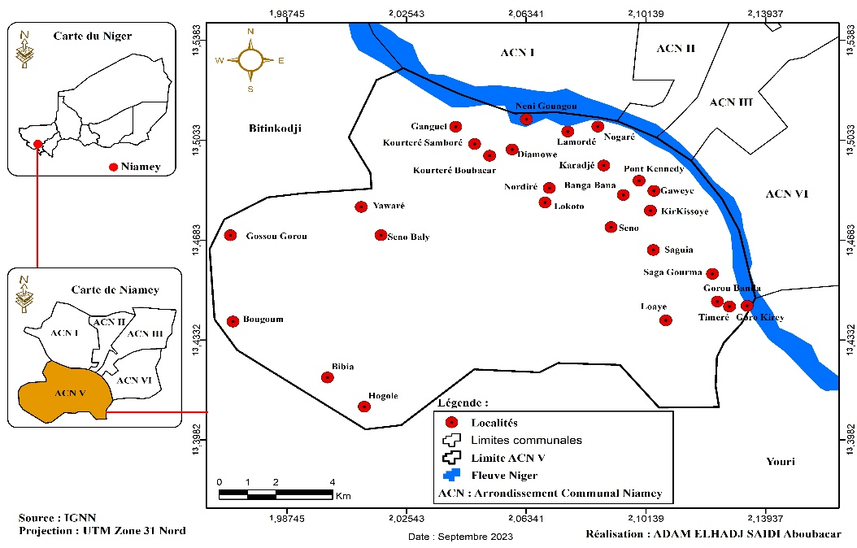

Figure 1: Location of the study area

* 1. **Household surveys**

Household surveys are conducted in villages and peri-urban neighborhoods. The stratified sampling method was adopted. This technique made it possible to consider the size of each spatial unit by giving each element the opportunity to be surveyed based on the size of its parent population.

The selection of households to be surveyed is random. The sample was calculated using the standard formula for calculating the sample in statistics. The formula is as follows:

Sample size = [z2*p (1-p)] / e2 / 1 + [z2*p (1-p)] / e2*N] *deff*TNR.

Applying the formula cited and explained above, the sample size is 383 households for a parent population of 6502 households in 2012.

To determine the number of households to be interviewed per (neighborhood), the rule of three in proportion to the total number of households in the neighborhoods (N) of the sample (n) was applied. Thus, to determine the size of each neighborhood, the following procedure was followed: Nordiré (659 households): 659 x 388/6502 = 38.81 or 39 households to be interviewed Seno (262 households): 262 x 383 /6502 = 15 households to be interviewed. The results are recorded in the following table.

**Table 1 : Number of households surveyed by district**

|  |  |  |  |
| --- | --- | --- | --- |
| **Neighborhood** | **Number of Households** |  | **Number of respondents** |
| NORDIRE | 659 | 38.81 | 42 |
| SENO | 262 | 15.43 | 15 |
| NOGARE | 1009 | 59.43 | 61 |
| BANGA BANA | 4115 | 242.39 | 242 |
| SAGUIA | 457 | 26.91 | 28 |
| **Total** | **6502** | **382.97 = 383** | **388** |

* 1. ***Satellite image processing***

Landsat images were used to conduct a diachronic analysis of land use plans in the study area over a period of 30 years. Four different image sensors were used. These are a 1990 Landsat TM (Thematic Mapper) image, two (2) images from 2000 and 2010 Landsat ETM+ (Enhanced Thematic Mapper Plus), and finally a 2020 Landsat OLI/TIRS (Operational Land Imager/Thernal Infrared Sensor) image. These different images were obtained free of charge from the United States Geological Survey (USGS) website. The resolution of the images is 30 m from sea level. All these images were also projected into the UTM (Universal Transverse Mercator) Zone 31 N coordinate system, whose reference ellipsoid is WGS 84. The area was extracted using the *Shafile* of the Niamey 5 municipal district. Table 2 gives the numerical references of the different Landsat images classified by the Maximum Likelihood method.

Table 2: Characteristics of Landsat images

|  |  |  |  |  |  |
| --- | --- | --- | --- | --- | --- |
| **References**  **Images** | **Path (P)** | **Row(r)** | **Resolution** | **Composition**  **Of bands** | **Date of acquisition** |
| **Landsat 5TM 1990** | 193 | 051 | 30 m | 4-3-2 | **11/15/1990** |
| **Landsat 7ETM 2000** | 193 | 051 | 30 m | 4-3-2 | **04/02/2000** |
| **Landsat 5TM 2010** | 193 | 051 | 30 m | 4-3-2 | **02/23/2010** |
| **Landsat 8OLI/TIRS 2020** | 193 | 051 | 30 m | 5-3-2 | **02/01/2020** |

1. **Results**
   1. **Evolution of peri-urban space**

The city of Niamey is experiencing a rapid spatial expansion that has long been taking place on the left bank of the river where the city has evolved since the installation of French settlers. From 1970, the right bank of the river was included in the urban dynamics of the city due to the construction of the Kennedy Bridge. Today, this part of Niamey is experiencing a transformation of its rural areas divided into plots for residential purposes. The process of peri-urbanization in the most rural commune of Niamey that was thus born is in fact motivated by several factors, among which we note general factors, that is to say, those which are derived from the general dynamics of the city of Niamey, and specific factors, that is to say, linked to the local dynamics of the Niamey 5 communal district.

The urban area of ACN5 has also experienced rapid spatial growth. Thus, from 474.44 ha in 1986 (S. Soumana, 2019), the area of the fifth district of Niamey increased to 5,552 ha in 2020 (Figure 2). This area is far greater than that predicted by the municipal PUR drawn up in 2009, which rather predicted an area of 2,123 ha by 2020. This growth is more remarkable from the year 2010, when it increased from 2,261 ha to 5,552 ha, almost a threefold increase in 10 years (Map 7). This situation is explained by the fact that from this time interval (2010 -2020), the community has experienced several land operations (subdivisions) carried out both by private developers and customary owners and by the city of Niamey. These operations have allowed urban populations to have their own homes within the framework of rehousing/resettlement or through the purchase and self-construction of subdivided or unsubdivided plots.



Figure 2: Evolution of the built-up urban space of ACN5 from 1986 to 2020

Source: S. Soumana Sambo; LandSat image(1990, 2000, 2010, 2020).

Also, the improvement of access to this part of the city of Niamey with the construction of bridges has favored the installation of households. In the figure, we observe that the localities Nordiré, Saguia, Kourteré, Saga Gourma, Timeré are integrated into the urban area of the commune. They are increasingly integrated into the continuous urban belt. The traditional land system in this locality based on

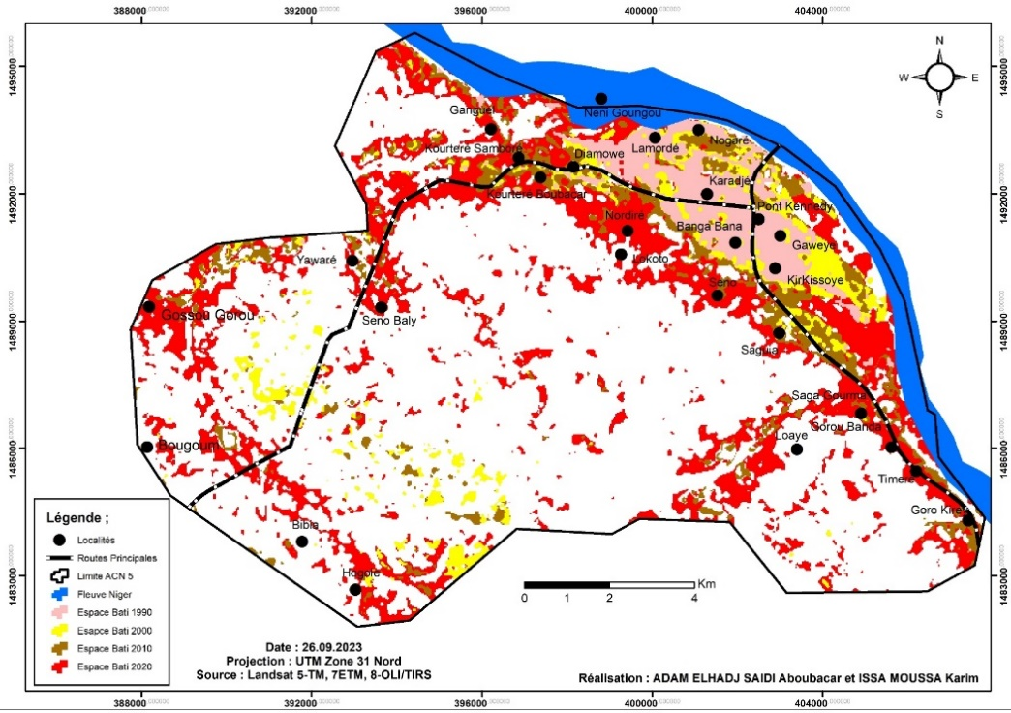

Figure 3: ACN5 evolution between 1990 and 2010

* 1. **Land transfers in ACN5**

Indicators of land changes include sales of gardens and fields, but also formal and informal subdivision operations, changes in methods of access to land and increases in plot prices.

* + 1. **Sales of gardens and fields**

In the Niamey 5 municipal district, apart from the subdivisions carried out shortly after the construction of the Kennedy Bridge in 1976, which initiated the area into an urbanization process, the sales and purchases of gardens have been more rapid. Garden purchases were generally the work of the highest officials of the First Republic regime. Until then, the well-known names of the officials of this regime, and at least their heirs, are the owners of gardens in the Niamey 5 municipal district. The first lady had, in addition to the gardens, vast spaces that served as her ranch. These plots of land were purchased at a low price. The purchase price varies from 40,000 to 150,000 CFA francs depending on the position of the land in relation to the riverbed. In most cases, they are transformed into recreational areas.

Also, according to AH Sidikou (1981), in the run-up to the construction of the first bridge linking the two banks of the river, many executives rushed to buy fields and gardens in this area. A total of 56 fields and 14 gardens were purchased in the village of Kirkissoye alone, which corresponds to 67 ha, to which must be added the 100 ha of the Hydro-Agricultural Developments (AHA) of the village. In Timeré, 21 fields and 3 gardens were purchased by the dignitaries of the regime at the time, including 5 ministers, 21 high and medium-level civil servants, army officers and non-commissioned officers, customs officers, police officers and education officials (AH Sidikou, 1981).

This phenomenon of excessive buying led the authorities, at the time, to take steps to suspend all sales and purchases of fields and gardens. But it was too late. Today, as the village chief of Ganguel points out, almost all the gardens, from Ganguel to Namaro, have been sold. The gardens have therefore undergone a change in their mode of appropriation; in other words, their use has increasingly changed considerably.

Indeed, as our interlocutors testified, the land is purchased by people from Niamey for the sole purpose of spending weekends or ceremonial days. The gardens therefore have recreational functions.

*"You know that people aren't going to spend millions on a few hectares of mango trees to make a profit from mango production. These gardens are used for weekends and other gatherings for the new owners" (interview with a garden owner in the village of Ganguel in June 2019).*

The second strategy used by customary rights holders to control land is to sell their fields to meet daily needs. The beginning of land transfers is announced in most peri-urban towns by the sale of agricultural land by owners to individuals. These are initially simple rural land transactions, even if the buyers intend to subdivide the land if large areas are created or to build a home to live in the area in the future. Indeed, these are actually transactions on rural land if we stick to the texts governing urban planning. Nevertheless, the buyers buy them in the hope of earning urban land rent or building their own house once the space is reached by the urban agglomeration.

This process takes several forms; in most cases, the plots subject to speculation are those located along the road or next to an urban indicator that portends a bright future for that location. Purchasers are generally provided with a deed of sale duly drawn up by the municipal or basic land commission (deed of sale or customary detention) or simply a private deed, even if the rules and procedures for drawing up these deeds are not respected. In the locality of Seno, which was the subject of a subdivision in 2012, more than 60% of the subdivided areas were sold in the form of unsubdivided rural land. As the letter from the monitoring committee for the subdivision of the Seno population's fields, addressed to the governor of the Niamey region in October 2013, highlights : " *The subdivision of Seno is only a restructuring, especially since the majority of village fields have already been divided up and sold."*

Buyers of undivided plots are sometimes speculators and sometimes people who want to have a plot at a low price, because they do not have the means to buy one within the framework of a formal subdivision. This is the example of Mr. IB, a primary school teacher living in Banga Bana, who bought his undivided plot of land, estimated at 400 m2, for 350,000 FCFA in 2009 in Seno. Others had bought them when they learned that the site had potentially been identified to shelter flood victims in certain neighborhoods of the city of Niamey, particularly those on the right bank. This type of highly dispersed individual land supply is only a basic form of land transfer. However, it constitutes the first form of increase in land value.

* + 1. **Formal and informal housing developments**

The second element of urbanization is the appearance, most often near village centers, of informal housing estates. These are initially small in size, and are carried out exclusively by customary landowners. These are precisely operations of unauthorized plot production, that is to say, no official authorization is given for them. The owners of the land, sensing the threat of a housing estate, call on surveyors to divide up their land by imitating the official plan. However, in these housing estates, there is no servicing operation. (H. Issaka, 2004, p.57).

These informal subdivisions of fields differ from the gross sales of portions of fields described in the previous point because the operations are most often carried out with the help of a surveyor who imitates the official subdivisions to limit risks in the event of restructuring. This is the example of certain informal operations carried out in the terroir of Saguia, Ganguel, Seno, Kirkissoye, Bangabana, Kossey.

As for formal subdivisions, they are carried out by public (the town hall, the city of Niamey) and private (private real estate developers) actors. Between 1970 and 1980, at least 990 hectares were subdivided by the CUN, and between 1990 and 2004, a number of subdivisions were carried out. These various subdivisions, as we have highlighted, concerned the localities of Lamorde, Nogaoré, Kirkissoye, Banganbana, Nordiré, and Diamowé. The land is acquired, in this case through negotiation with customary owners on the basis of a percentage agreed upon by mutual agreement, each stakeholder being convinced of benefiting from it once the operation is completed. They are also acquired through purchases, especially when it comes to private developers. The subdivision operations have contributed to the land transformations of the space of the Niamey 5 Communal District. Since 2011, many of these operations have taken place by private and public structures. We can cite the subdivision of land for the benefit of teacher-researchers carried out by the city of Niamey, the subdivision of the Baani Kaani city, the Assalam City, the city intended for the Administrative and Technical Staff (PAT) of the University of Niamey. Between 2012 and 2014, nine (9) formal subdivisions were carried out on an area of 1,008 ha in 2 years .

Today, there are several formal subdivisions carried out on the village lands of Saga Gourma, Timiré, Yawaré, Saguia, Kourteré Samboré, and Kourteré Boubacar. Comprehensive data is difficult to obtain from technical services. The completion of these operations and the construction of access roads have contributed to land transformations. In formal subdivisions, plots gain a capital gain composed of three new elements compared to their agricultural price. These include the capital gain from the initial sale in the case of acquisition by a developer, the capital gain linked to development, and finally the profit gain linked to the sale or sometimes resale of plots.

* + 1. **Land sales in neighboring municipalities of the Niamey 5 municipal district**

The dynamics of land fragmentation due to urbanization not only affect land in the Niamey 5 district, but also many other areas beyond. The effect of peri-urbanization is felt in rural communities on the outskirts of the municipality. The municipality most affected by this is Bitinkoji. Indeed, in this municipality, strategic areas reserved for livestock farming are being purchased by individuals (private persons) or real estate developers (AREN and RECA, 2015). Among these areas, known as pastoral lands, are the Ferro Wagarni, Fété Bégui, and Payray plateaus.

Developers' strategies consist of purchasing rural land and then applying for its registration. There are more than 5,000 hectares purchased and/or subdivided, representing more than 5% of the municipality's surface area. In an inventory conducted in 2016, the Association for the Revitalization of Livestock Farming (AREN) noted more than 1,000 land titles issued by land registry services to individuals generally residing in Niamey. This situation is part of a process of transforming rural land into urban land. Housing estates are already planned more than 20 km from Niamey on the Torodi road in the municipality of Bitinkoji, Tillabéry region. As seen in Photo 3, land sales are regularly advertised on social media, particularly Facebook. Certainly, this phenomenon embodies a transformation of peri-urban land, but beyond that, it is part of a process of grabbing peri-urban land for land speculation purposes.

* + 1. Evolution of modes of access to land in peri-urban neighborhoods

Land changes in the Niamey 5 municipal district, as elsewhere in Black Africa within large urban centers, are particularly marked by the emergence of new forms of land appropriation. Indeed, traditional modes of access have become increasingly rare in favor of the commercial form. Access to land ownership now takes the form of financial transactions (purchase) and rental, as shown in Figure 4.

Thus, the results of our surveys in the different districts and urban villages reveal that more than 69.0% of the households surveyed acquired their plot by purchase against 24.9% and 6.1% respectively by inheritance and donation.



Figure 4: Mode of access to the plot of the households surveyed

*Source: Field data in October and November 2020*

In the village core, inheritance is the main means of access to land. Indeed, this fact is not surprising when we know that in the village the structure of traditional housing is still in force, even if it in turn undergoes changes upon the death of the head of the family with the sequence of inheritance sharing. The mode of access varies from one sector to another. For example, in the village sector inheritance predominates while in the other sectors , purchase is the most important, which denotes a transformation of the traditional access system constituted by inheritance and gift (Table 3).

Table 3: Method of access to the plot according to the housing sector

|  |  |  |  |  |
| --- | --- | --- | --- | --- |
| **Access mode**  **Sector** | **Legacy** | **Purchase** | **Don** | **Total** |
| Formally developed area | 24.7% | 71.8% | 3.5% | 100.0% |
| Informal housing estate | 18.8% | 77.2% | 4.0% | 100.0% |
| Squatter sector | 33.3% | 44.4% | 22.2% | 100.0% |
| Village core | 55.6% | 22.2% | 22.2% | 100. 0% |
| **Total** | **24.9%** | **69.0%** | **6.1%** | **100.0%** |

*Source: Field data in October and November 2020*

* + 1. Reduction in plot size

An important sign of land practices in the peri-urbanization process is the trend towards decreasing plot sizes. Indeed, during the first subdivisions carried out on the right bank, plot sizes were in most cases 600 to 500 m 2 . Today, in new subdivisions, it is mostly 400 to 200 m 2 . The decrease in plot size partly leads to an increase in the verticality of houses in the centers and also in the peripheries. This is what Motcho (2020) underlines:

"Sprawl is ultimately a consequence of the city's horizontality. Almost all buildings are ground-floor. Two-story houses, very rare before the year 2000, are increasingly numerous due to the reduction in plot sizes, which have gone from an average of 600 m² to 400 or even 200 m² . "

The average plot size estimated at the level of our survey neighborhoods is 327 square meters, far below the size of plots produced in the 1970s and 1980s in the official subdivisions carried out in the Nogoré, Karadjé and Banga Bana neighborhoods. The average plot size has declined since the 1990s.

* + 1. Evolution of land prices in peri-urban villages

m2 plot of land increased from 65,000 FCFA to 4,500,000 FCFA between 1970 and 2022. This is an ordinary plot taken from a formal subdivision (Figure 5). The price of a plot varies depending on its position and can reach up to 8,000,000 FCFA in a subdivision on the outskirts where water and electricity are available. This is the case of the integration city located in the Saguia district. In older neighborhoods, the price of a plot of land significantly exceeds that of the outskirts and increases depending on its position and the urban amenities available. However, it should be noted that the 2020 floods caused a decrease in the price of a plot of land in some older neighborhoods on the right bank.

According to Meyer (2016), regarding the subdivisions carried out on the left bank by SONUCI, the price per m² of the remediated plot varies from 6,950 FCFA to 10,000 FCFA. For this (remediated plot), the price variation factors include the width of the road and the position. She estimates the price of a simple plot, in built-up peripheries, at 3 to 8 million FCFA; and from 1 to 4 million in peripheral areas not yet built and not serviced.

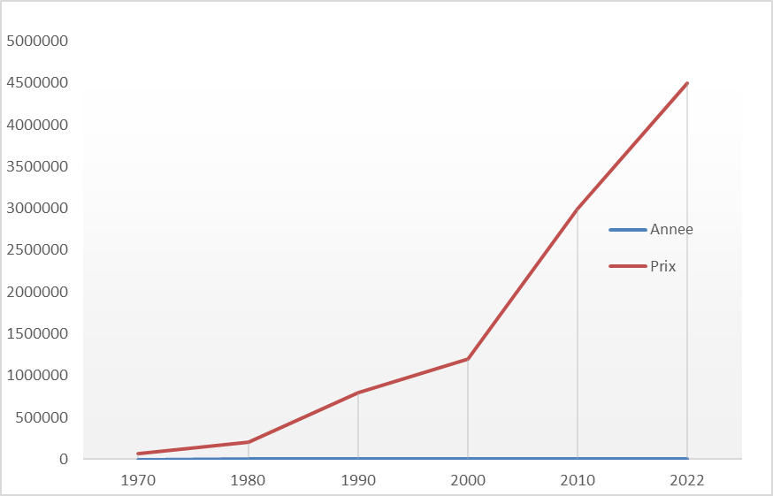

Figure 5: Price evolution of a 400 m2 plot from 1970 to 2022 at ACN5

*Source: Field data in October and November 2020*

Undivided plots of 400 m2 cost around 2,500,000 FCFA in 2022 in Saguia, compared to 800,000 FCFA in 2012. Plot prices have changed regardless of whether the subdivision is formal or informal. They vary depending on certain amenities such as the presence of water and electricity or the proximity of a road. The increase in plot prices reflects growing speculation on peri-urban land in ACN5.

**4. Discussion**

This study identified and analyzed the various land transformations induced by peri-urbanization in the Niamey 5 municipal district.

The issue of peri-urban land transformation has been widely addressed by studies on residential migration through the centrifugal approach of residential movement. According to this approach, residential mobility is the main cause of urban sprawl in the large cities of Black Africa. M. Bertrand, (2004), D. Lessault and C. Imbert (2013), A. Adamou (2012), who had to work on this subject, used several methods to analyze the factors of urban sprawl such as the biographical method (which consists of reconstructing the path of households and its members) and the so-called longitudinal method (which allows to see the geographical destination of households in the city). They have, therefore, demonstrated the role of spatial mobility, in particular residential mobility, in the distribution of populations in urban space and its consequences on urban sprawl and changes in land in African cities. Other authors have sought rather to understand the reasons which push households to settle in the urban periphery. In Lomé, A. Guézeré, (2014), notes that it is the desire of the people of Lomé to have a roof over their heads and the lack of public housing policy which are causing an anarchic expansion of the city.

As for GA Glélé (2015), in analyzing the phenomenon of peri-urbanization in Cotonou, he explained that peri-urban areas are characterized by high immigration, commuter movements, a population surge, modernization of housing, strong increases in non-agricultural activities, as well as strong needs for socio-economic infrastructure. According to this author, this peri-urban dynamic of the city leads to a land transformation marked by formal and informal fragmentation of land, land freezes and land speculation. H. Tchékoté and Ngouanet (2015), for their part, point out that the city of Yaoundé is spreading spectacularly on its outskirts. This sprawl is leading to anarchic construction due to the development by the population of multiple strategies for accessing land resources in defiance of urban planning standards.

**Conclusion**

The peri-urbanization of the Niamey 5 municipal district has led to significant changes in the local land structure. Indeed, community land management carried out under the aegis of the Amirou canton chief has gradually given way to the process of private appropriation due to the effect of urbanization. The process of land transformation, which initially took place in the outlying areas of the commune through the purchase and sale of gardens and fields, has intensified in recent years with both formal and informal subdivision operations undertaken by both public and private actors. Land transformations are also manifested by the increase in land prices but also, and above all, by changes in the vocation of spaces. The 400 m2 plots of land that cost 65,000 FCFA cost 4,500 FCFA in 2022, while the undivided plot that cost 800,000 FCFA in 2012 was sold in 2022 for 2,500,000 FCFA. Pasture areas, fields and gardens have unexpectedly become plots of land for speculation or housing.

References

BELKO-MAIGA Garba, 1985, *Land Policy in Niger: Causes and Consequences of Clashes Between Peripheral Urban Planning and the Traditional Land System Through the Example of Niamey* . Doctoral Thesis in Geography, University of Paris IV Panthéon Sorbonne. 1985.

BERTRAND Monique, 2010, From access to housing to the home-work relationship: social and spatial issues of mobility in Greater Accra (Ghana). Tiers Monde Review, 1(201), 87-106. doi:10.3917/rtm.201.0087

BERTRAND Monique, 2006, “Unbridled Land/Blocked Land. Recent Issue of Decentralization or Central Alternation in the Long History of Malian Urban Communities?”. *Decentralization and Powers in Africa. In Counterpoint, French Territorial Models,* Paris, IRD, 179-198 p.

BERTRAND Monique, 2012, FROM THE DISTRICT TO “GREAT BAMAKO” (MALI): LAND RESERVES UNDER TENSION, CONTESTED GOVERNANCE. 13th N-Aerus Conference: “The unequal city, contested spaces, governance in tension”, Nov 2012, Paris, France.

BERTRAND, Monique, 2021, Chapter 9. The land logic of urban sprawl: a future under tension In: Bamako: From the city to the agglomeration [online]. Marseille: IRD Éditions, 2021 (generated on May 25, 2023). Available on the Internet: ISBN 9782709928915. DOI: <https://doi.org/10.4000/books.irdeditions.42730>.

BERTRAND Monique, 2021, Bamako: From the city to the agglomeration. New edition [online]. Marseille: IRD Éditions, (generated on March 25, 2023). Available on the Internet: <http://books.openedition.org/irdeditions/42659?mobile=1>. ISBN: 9782709928915. DOI: <https://doi.org/10.4000/books.irdeditions.42659>.

BERENICE Bon, SIMONNEAU Claire, DENIS Eric, LAVIGNE DELVILLE Philippe, 2023, Ordinary conversions of land uses linked to urbanization in the South: Housing, capitalization, changes in agriculture. Technical Committee on Land and Development., 108 p., 2023, Collective works. ⟨ hal-04185407 ⟩

BOTTI-BITRAYIE Cyrille and KOUAKOU-DIBY Martin, 1999, Logic and strategies for integrating Ébrié villages into the Abidjan metropolis. [Online] In: Cahiers Nantais, n°51, 1999. Ivorian Geography.pp.19-23;doi: <https://doi.org/10.3406/canan.1999.1234> <https://www.persee.fr/doc/canan_0767-8436_1999_num_51_1_1234>

CHARLES-DOMINE Julie and Elisabeth DORIER, 2011, Cotonou Agglomeration: Decentralization, Land Issues and Urban Planning. Saint Dié International Geography Festival, Oct 2011, Saint Dié les Vosges, France. ⟨ halshs-01418786 ⟩

COSSI HOUEDIN, Barnabé and Maimouna DIABY, 2016, Challenges of peri-urban land conservation in Adjamé Village 1. Exchanges / National Association of Management Advisors and Controllers, 2016, vol. 3 (n°007), pp. 713-726. Ffhal-01543105f

CHALEARD Jean-Louis et al., 2016, *Metropolitanization and recomposition of predominantly rural spaces on the periphery of the metropolises of the South* (Peri-South). *Tiers Monde Review* , 199–221. <http://www.jstor.org/stable/44949834>

CHARLES-DOMINE Julie and DORIER Elisabeth, 2011, Cotonou Agglomeration: Decentralization, Land Issues and Urban Planning. Saint Dié International Geography Festival, Oct 2011, Saint Dié les Vosges, France. ⟨ halshs-01418786 ⟩

CHAUVEAU Jean et al, 2020, Introduction: Land and Political Violence in Africa: For a Continuous and Processual Approach. [Online] *International Journal of Development Studies* , 243, 7-35. <https://doi.org/10.3917/ried.243.0007>

HASSANE SALEY Alimatou, 2022, *Land dynamics in the urban commune of Birni N'Gaouré (Dosso region in Niger* ***),*** Abdou Moumouni University of Niamey, Single doctoral thesis, Pages 303 pages.

HAYETTE Nemouchi and ZEGHICHE , Anissa, 2023, “Oran: agricultural land sacrificed for wild urban planning”, [Online], 1 | 2021, *Belgeo* published on March 28, 2021, consulted on March 26, 2023. URL: http://journals.openedition.org/belgeo/46093; DOI: <https://doi.org/10.4000/belgeo.46093>

CHAVI Moise, 2013, *Metropolitanization and peri-urban dynamics: case of the urban space of Cotonou* , Thesis for obtaining a Doctorate in geography, University of Paris Nanterre, 379 pages.

BATEL Loïc, 2016 , “The challenge of African cities”, [online] *Revue Défense Nationale* , 2016/7 (No. 792), p.145-150. DOI: 10.3917/rdna.792.0145. URL: <https://www.cairn.info/revue-defense-nationale-2016-7-page-145.htm>

BELGUESMIA Sabiha, YOUSFI Badreddine and OTMANE Tayeb, 2019, “City/countryside interface and dynamics of peri-urban spaces in a South Mediterranean intermediate city. The example of Mostaganem (Algeria)”. Cahiers de géographie du Québec 63, no . 179-180 (2019): 259–279. <https://doi.org/10.7202/1084236ar>

DAMBO Lawali, (2016), “Land dynamics in the urban commune of Gaya” in the biannual journal of Geography of Benin (BenGEO) University of Abomey_calavi No. 20, December 2016. ISSN: 1840-5800. pp. 68-96.

Association for the Revitalization of Livestock Farming in Niger and National Network of Chambers of Agriculture of Niger, 2015, The “sale” of pastoral lands in Bitinkodji, [Online] National Network of Chambers of Agriculture of Niger, Information note, pages 10, <https://reca-niger.org/IMG/pdf/2015-08_Occupation_des_terres.pdf>

ANGEL S., Blei, A., Parent, J., Lamson-Hall, P., Sánchez, N., Civco, D., Lei, R., Thom, K. 2016, Atlas of Urban Expansion (Ed. 2016, Vol. 1: Areas and Densities). New York: New York University, Nairobi: UN-Habitat, and Cambridge, MA: Lincoln Institute of Land Policy, 2016.

GIRAUT Frederic, 1999, *Return of the Repressed and the Chief Town Effect. Analysis of a Virtual Political-Administrative Redesign in Niger.* Paris: UMR Prodig.

GLELE Gisèle Afiavi, 2015, *Peri-urbanization and land dynamics on the Allada plateau (South Benin): the witness space of the commune of Abomey-Calavi* . Single Doctoral Thesis in Geography, EDP/FLASH/UAC, 452 p.

GUÉZÉRÉ Assogba, 2011, “The obsession with living in one’s own house in Lomé: what impact on spatial dynamics?” *Archives of Social Sciences of Religions* , 2011, vol. 256, p. 565-590.

HALLEUX Jean-Marie, 2015, Peri-urban territories and their development in the world: a world in the process of urbanization and peri-urbanization. In J. Bogaert, & J.-M. Halleux, Peri-urban territories. Development, challenges and perspectives in the countries of the South (pp. 43-61). Gembloux: Les Presses Agronomiques de Gembloux.

HAYETTE Nemouchi and ZEGHICHE, Anissa, 2023, “Oran: agricultural land sacrificed for wild urban planning”, [Online], 1 | 2021, Belgeo published on March 28, 2021, consulted on March 26, 2023. URL: http://journals.openedition.org/belgeo/46093; DOI: https://doi.org/10.4000/belgeo.46093

HILGERS Mathie, 2008, “Urban Policies, Protest and Decentralization. Housing Development and Social Representations in Burkina Faso.” Autrepart, 47(3), 209–226.

HOUIMLI Ezzeddine, 2008, Factors of resistance and fragility of coastal agriculture in the face of urbanization: The case of the Sousse Nord region in Tunisia, Doctoral thesis in Landscape Sciences and Architecture, Institute of Life Sciences and Industries and the Environment (Agro Paris Tech), under the direction of Pierre Donadieu, 2008, 419 p.

INS, 2012. Presentation of the final overall results of the Fourth (4th) General Population and Housing Census (RGP/H) of 2012. P351

INS, 2016. Regional monograph of Niamey. Niger. 119 p.

ISSAKA Hamadou, 2004, - Spontaneous occupation spaces in Niamey: contribution to the analysis of urban practices in the Sahelian environment, Master's thesis, Department of Geography, Faculty of Letters and Human Sciences (FLSH), Abdou Moumouni University of Niamey, 2003-2004, 108p + annexes.

ISSAKA Hamadou, 2010, Mapping and territorial management of risks in Sahelian urban environments using the example of Niamey (Niger). Doctoral thesis. Strasbourg: University of Strasbourg.

ISSAKA Hamadou, 2013, Informal real estate development in Niamey. Irregularity as a response to the housing crisis. Urbanités [online], 2. Available at: http://www.revue-urbanites.fr,/la-promotion-immobiliere-informelle-a-niamey lirregularite-comme-reponse-a-la-crise-dulogement/#respond.

ISSAKA Hamadou, 2017, “Land issues on the outskirts of Niamey (Niger): surveys in the rural commune of Liboré”, Mukara Sani N°, p. 17

KEITA Boulaye, 2016, “The Bamako land market and the informal economy” in Etudes Maliennes (ISH) N0 83/2016, P 132

KOFFI-DIDIA Adjoba Marthe, 2022, “Large farms face land competition in the district of Abidjan”, [online] Métropolitiques, November 17, 2022. URL: [https://metropolitiques.eu/Les-grandes-exploitations-agricoles-face-aux concurrencesfoncieres-dans-le.html](https://metropolitiques.eu/Les-grandes-exploitations-agricoles-face-aux%20concurrencesfoncieres-dans-le.html)

SAMBIENI Kouagou Raoul, 2020, *Dynamics of the landscape of the city-province of Kinshasa under the pressure of peri-urbanization: green infrastructure as a driver of development,* Doctoral thesis in Integrated Planning and Management of Tropical Forests and Territories (ÉRAIFT, Kinshasa) Faculty of Architecture - University of Liège, Art of Building and Urban Planning (Faculty of Architecture - University of Liège), pages 295.