GIS and Mathematical Trend Surface Modeling of Groundwater Level in Parts of the Bundelkhand Craton, India

Abstract
The utilization of mathematical trend surface modeling and geostatistics has been demonstrated to be a cost-effective and reliable technique for elucidating the geological conditions of aquifers. This assertion is supported by the findings of the present study, in which the author has researched into this particular aspect. Groundwater resources in central India, particularly within the Bundelkhand craton, are being depleted due to a complex interplay of socio-political decisions, environmental changes and intensive agricultural practices. The research introduces a novel model for assessing the spatial variability of groundwater levels and the characteristics of its aquifer. This model is achieved by combining geostatistics and Geographic Information Systems (GIS). The study encompasses seven districts of the Bundelkhand region and emphasizes the critical role of trend surface modeling of groundwater levels and GIS in enhancing the understanding of regional hydrogeological conditions. Theoretical semi-variograms were fitted to experimental data to determine nugget, continuity, sill, and range of influence. Kriging was used with the given parameters to produce predictive maps of groundwater level, seasonal variations, and fluctuations. The objective of this research is twofold: first, to develop a model for analyzing polynomial surface trends by applying geostatistical methods to groundwater modeling; and second, to investigate the relationship between groundwater variability and mathematical surface trends within specific regions of the Bundelkhand craton. The estimation of groundwater levels was facilitated by employing a second-order mathematical polynomial trend surface, with the resulting positive and negative residuals providing insights into the geology of the aquifer. A positive residual of the trend surface for the groundwater level variable is indicative of a favorable rock type for aquifer recharge, while a negative residual signifies an unfavorable rock type for aquifer recharge. The analysis revealed an average kriged rise in groundwater level of 0.74 meters during fluctuations between the monsoon and post-monsoon periods. In addition, the kriged surfaces for all seasons indicate severe groundwater depletion in the central zone of the study area. This methodological approach improves the understanding of groundwater level fluctuations and is the most cost-effective technique for identifying the critical zones of groundwater level that require urgent sustainable management interventions.
Key words: Polynomial Trend Surface, Kriging, GIS, Seasonal Variation

1 Introduction

Water is a vital natural resource that is indispensable for the survival of human beings. Its availability for various processes is significantly influenced by rainfall (Saleem, M., 2018). Rainwater and groundwater (GW) are interconnected, and rainwater recharges the groundwater through infiltration and the rock type of the aquifer(s). This process is referred to as the recharge function of the aquifer (Gabrielli, C. P., 2017). Research has demonstrated that groundwater quality and quantity have diminished due to anthropogenic and geogenic activities (Gautam & Bana, 2014). A dry spell, characterized by minimal rainfall and low water levels in lakes and other resources, poses a threat, leading to poor crop yields (Gautam & Bana, 2014). The recharge function is contingent on the subsurface geology. Spatial prediction of the groundwater table beneath the ground surface can be achieved through two different modeling approaches: physics-based or process-based modeling, such as Modflow (https://www.usgs.gov), and statistical learning or machine learning models (Mello & Ponti, 2018). The former approach frequently incorporates several simplifying assumptions, which can affect the accuracy of its predictions compared to reality (Yang et al., 2008). However, these models are advantageous for understanding the process and governing equations. In contrast, statistical learning or machine learning models do not incorporate the physics or mathematics of the process but predict the response based on data patterns from input learning data (Yasuda, H., 2020). Spatial prediction of groundwater levels in this region indicates the presence of approximately 78 dug wells in an area of 69,000 square kilometers. The challenge, however, lies in predicting the level of the water table in areas devoid of wells, which can span up to more than 100 square kilometers (Akhtar, Singh, & Rehman, 2016). These zones, therefore, suffer from a lack of knowledge about groundwater table fluctuations and infiltration rates. The endeavor to predict groundwater fluctuations and the high or low rate of rainfall infiltration in such areas without wells, based on information from the approximate 78 monitoring wells, is a challenging task. The research is innovative for two reasons. First, it uses a formulated geostatistical model. Second, it incorporates inconsistencies in spatial continuity, identifying surface trends that reflect the nature of the rock type (hard or soft rock).The study area is located in the Bundelkhand craton (Figure 2), which includes seven districts: Banda, Chitrakoot, Hamirpur, Jalaun, Jhansi, Lalitpur, and Mahoba.It is noteworthy that these districts are currently grappling with a pronounced groundwater availability crisis (Patel Deepak et al.).The region is bounded by coordinates 35.50N, 97.41E to 68.18W, 6.75S. The region's mean elevation is 341 meters above mean sea level (MSL), with a topography characterized by the presence of the Indo-Gangetic Plain to the north and the Vindhyan Basin to the south (Valdiya & Valdiya, 2016). The central and southern regions are marked by the presence of rocky outcrops and broken hills, forming a stepped Vindhyan plateau that is repeated twice (Singh, G. P. 1999). The topography of the region is characterized by an incline, with infertile and uneven terrain, and sparse vegetation, a consequence of the presence of these uplands (Pati, J. K., 2020). The Bundelkhand plain is intersected by three mountain ranges, none of which exceed 600 meters in elevation (Figure 2). The direction of the flow of the region's rivers indicates a north-eastward sloping terrain, and the region is predominantly covered by Bundelkhand granite (Singh, G. P., 1999). The present study focuses on the geostatistical modeling of groundwater levels using surface trend modeling. Surface trend modeling of the groundwater level provides insights into the subsurface geology and the actual variations in water level (hydraulic head variation) conditions (Chaussard, E., 2014). The data sets of groundwater level (m, MSL) variable are organized according to seasonal variation (Akhtar & Tripathi, 2024), including pre-monsoon (March, April, May), monsoon (July, August, September), post-monsoon (October, November, December), and the fluctuation period (post-monsoon and monsoon).Delineating groundwater risk zones provides valuable guidance for sustainable groundwater management and resource sustainability in critically affected regions, such as the Bundelkhand regions within the Indo-Gangetic Basin. Spatial prediction of the variation in the depth to the groundwater table at different locations is but one dimension of the total problem of groundwater resource management (Mishra, R. K., 2023). The combined methods of this research provide a cost-effective technique and a comprehensive insight into groundwater variability and risk assessment (Akhtar, S., 2023). This approach enhances our comprehension of groundwater dynamics, facilitates the identification of disparate groundwater risk zones, and furnishes invaluable guidance for sustainable groundwater management in the study area.

2. Methodology

This study used two different methodologies to model groundwater levels (m, MSL) for 2017. The first methodology involved identifying the order of the polynomial trend surface for each seasonal variation (pre-monsoon, monsoon, post-monsoon) of the groundwater level. The second step of the modelling work aimed to geostatistically model the groundwater level data obtained from the dug-well of the same year for the same seasonal variation and fluctuation. The workflow of the entire study is shown in Figure 1.

2.1 Polynomial Trend Surface Analysis

Spatial data often do not conform to geostatistical principles (Trapp, J. S., 1972), so it is important to examine the polynomial trend surface before applying geostatistics to spatial data. Geostatistics essentially deals with spatial information, highlighting areas of high and low values (Kitanidis, P.K., 1997). This leads to the concept of a geographical trend, which is influenced by the spatial data's position. Geostatistical estimation assumes stationarity. Deviations from this are estimated using a global mean in simple kriging (Rodrigues et al., 2012). The concept of a regionalized variable, established by Matheron (1963), is based on random function theory. Measurements are assumed to reflect a specific random function for a given geographic location. Spatial data require certain constraints, referred to as the stationarity hypothesis (Vieira et al., 2010). The order of stationarity depends on the level of statistical stability required. For example, for second-order stationarity, the second-order moments, such as mean and variance, must remain constant. Consider a set of n values of Z(Xi), where the mean value E does not depend on the geographic location Xi. This is expressed as:

E{Z(Xi)} = m------------- (1)

The increase in variance [Z(Xi) –Z(Xi+h)] is finite and independent of the geographic location Xi, as shown in Equation 2:

VAR[Z(Xi)-Z(Xi+h)] = E[Z(Xi)-Z(Xi+h)]²---------------- (2)

Where 'm' represents the mean and 'h' represents a small positional increase in 'Xi'. A spatial dataset that displays a geometric trend surface indicates a consistent change in variable values across different spatial directions. The mean 'm' and the variance of the increment [Z(Xi) - Z(Xi+h)] then become location-dependent. A trend is identified when the semi-variogram lacks a stable sill, violating the inherent hypothesis (Equations 1 and 2) by showing dependency of mean and variance. Equation 3 calculated (2nd order trend surface, an example) for a simple trend surface (Trapp, J. S. 1972) variance on spatial position. In order to eliminate trends in the data, a trend surface can be fitted to the raw data by means of ordinary least squares (OLS) and the residuals can be calculated, as

Z*(X, Y) = α+ α ₁X+ α ₂Y+ α ₃X²+ α ₄XY+ α ₅Y² -------------- (3)

Where Z*(X, Y is the estimated trend surface, X and Y are the spatial coordinates, and α ₀, α ₁, α ₂, α ₃, α ₄ and α ₅ are the regression parameters determined by OLS. The residuals are then defined as:

Z (X, Y) _{residuals} = Z (X, Y)- Z*(X, Y) -------------------------(4)

For a general n-th order trend surface, the equation is extended to include higher-order terms, reflecting more complex spatial variations:

$Z* (X, Y)=\sum_{i=0}^{n}{}\sum_{j=0}^{n-1}{αij​}Xi, Yj$ --------------(5)

Where n is the trend surface order and αij are the coefficients obtained from regression analysis. If a linear geometric surface corrects the stationarity issue and results in a semi-variogram with a stable sill, further exploration of the trend surface's degree may not be necessary. It is crucial to have a high coefficient of determination (R^2) and a significant F-test to decide on the trend surface's degree (S Vieira et al., 2010).
2.2 GEOSTATISTICS
Geostatistics were used in the second method for analyzing groundwater level in the present research. Geostatistics relies on the semi-variogram, which is estimated as half the average of the quadratic difference between two observations of a variable separated by a distance-vector h (Isaak, M. & Srivastava, R.M. 1989). The semi-variogram function at distance h is defined as ϒ(h):

ϒ(h) =$\frac{1}{2N(h)}\sum_{i=1}^{N(h)}{\left[Z\left(xi\right)-Z\left(xi+h\right)\right]}$² ------------- (1)

Eq. (1) shows that N (h) is a total number of pairs of variables separated by this distance. Prior to developing geostatistical models, it is necessary to evaluate the semi-variogram model, which is designed for categories of the distance between sample pairs. The most widely used semi-variogram model is the spherical model (Sarangi et. al., 2005). When the variance of the nugget is not too significant but important, with a clear range (R) and sill (Co+C, Co-nugget, C-continuity), a spherical model of semi-variogram is a good choice among other semi-variogram models such as Gaussian or exponential (Sarangi et. al., 2005). Cross-validation is a technique used to test the acceptance and adequacy of the developed semi-variogram model (Emery, X, 2008). The semi-variogram model that best fits the data is selected using the point kriging cross-validation (PKCV) technique. This method minimises the error variance and ensures that the prediction error's mean is zero, avoiding over or underestimation (Menafoglio et al., 2013). Kriging is a reliable interpolation technique that calculates weights based on surrounding known values to predict unknown locations. This section of the research focuses on ordinary kriging as a method for analysing the spatial variability of groundwater level depth data from 1996 to 2019. No changes in content have been made. The kriged estimate of the mean value of grid G, denoted as G*, is calculated based on the values of g1, g2, g3, ..., gn and their respective weights a1, a2, a3, ..., an, where Σai=1. The language used is clear, concise, and objective, with technical terms explained when first used. The text adheres to conventional academic structure and formatting, and follows a formal register. The grammar, spelling, and punctuation are correct, and the text is free from bias and filler words. Therefore, the estimation is unbiased, with a mean error of zero for a large number of estimated values. Equation 2 provides the kriging variance.

$σ_{k}^{2}$ = Σ (G_{i} − G∗)² -------------- (2)

In order to obtain unbiased estimates in ordinary Kriging, a Lagrange multiplier (µ) is used as a coefficient for the construction of the variance minimum (equation 3) in the optimal solution of the Kriging system. The following set of equations must be solved concurrently:
$\left\{\begin{aligned}\sum_{i=1}^{n}{ƛiϒ\left(h\right)-µ=ϒ\left(h\right)} \\ \\ \sum_{i=1}^{n}{ƛi=1}\end{aligned}\right.$---------- (3)
Where λi is the weight associated with the data, and the Lagrange multiplier is represented by μ.

4 Results and discussions
The preliminary study revealed a trend (Unstable sill is observed) in groundwater level in all three seasons (pre-monsoon, monsoon, post-monsoon) as shown in figure 3 & 4. However, no trend was detected in the groundwater level fluctuations (difference between Post-monsoon and Monsoon). The directional semi-variograms (Figure 4) revealed varying trends in groundwater levels across all three seasons. Further analysis of these semi-variograms at angles of 45°, 60°, 90°, and 135° (Figure 4) highlighted the most pronounced slope in the northeast, suggesting the presence of an underlying basin-like structure. The Digital Elevation Model (DEM) map (Figure 2) is consistent with this pattern, showing the lowest elevation of the study area in the northeast, particularly in the Banda and Chitrakoot districts. The data was analyzed up to a third-order polynomial trend surface (Table 3), but the best optimum trend surface for the original dataset was identified as second order (Table 3 and Figure 5). This is shown in table 3, which indicates that the coefficient of determination (R²) and F-test value are optimal for the 2nd order trend surface. Table 1 presents statistics for the original groundwater level data. Figure 7 and Table 2 show the histogram, box plot and coefficient of variation of the residual data, respectively. It can be observed from Figure 7 that the 2nd order residual follows a normal distribution without any outliers. The semi-variogram model for the second-order residual of the groundwater level, as shown in Figure 8, exhibits a stable sill, indicating its suitability for use in geostatistical modelling. To investigate the seasonal variation of groundwater levels during pre-monsoon, monsoon, and post-monsoon periods, the experimental semi-variogram was compared with the semi-variogram model (Figure 8) to cross-validate it. The spherical model was selected due to the random distribution of sample points, and different lag distances and search radii were considered to fit the model. The Point Kriging Cross Validation Technique (PKCV) was used to cross-validate the models, which were then aligned with the fitted experimental semi-variogram models (Table 5 and Figure 8). Figure 8 shows the fitted semi-variogram models of groundwater level (2nd order residual) for the three seasons and fluctuation. The equations for the spherical models, tailored to each seasonal variation and fluctuation, are provided in Table 4. In Table 5, the semi-variogram and geostatistical parameters are detailed. The coefficient of determination (R^2) for observed versus estimated values from the fitted model for each season and fluctuation indicates high accuracy, with values of 0.86, 0.80, 0.90 and 0.80 respectively, as shown in Figure 9. The slope of the regression line indicates minimal bias, which enhances the credibility of the model. To enhance the credibility of these findings, a t-test was conducted in R, confirming the significance of the correlation coefficient for all seasonal variations and fluctuations (Table 5). The experimental semi-variogram was matched to a theoretical semi-variogram, enabling the estimation of nugget, continuity, sill, and range of influence (Table 5). Kriging was then performed using these semi-variogram parameters to create predictive maps with their kriging variance (Uncertainties) for all three seasons, and for the fluctuation between monsoon and post-monsoon (Figure 10 a to 10 d). Prior to Kriging, the block size for the study area was determined. The Bundelkhand study area spans 69,000 square kilometers and is heterogeneously distributed. Block grids of 1000m x 1000m x 2m and 1000m x 1000m x 10m were delineated for all seasonal variations (pre-monsoon, monsoon, and post-monsoon) of the residual groundwater level and the fluctuation of groundwater level, respectively. The kriging method was then applied after determining the center of each block. Figure 10a to 10d clearly show the spatial distribution of kriged estimates of groundwater (GW) levels with their uncertainties for all seasons. The maps reveal that GW levels are notably higher in the southern zone of Lalitpur district and the central and southern parts of Jhansi district. During the monsoon and post-monsoon seasons, the kriging estimate map shows an average rise in groundwater level of 0.74 metres. Figures 10a to 10d display kriging variance (error) maps illustrating seasonal variations and fluctuations in the kriging estimates. The darker black indicates maximum error, while the lighter black indicates minimum error in the kriging variance maps. The insights gained from the kriging variance (error) maps for the pre-monsoon, monsoon, post-monsoon, and fluctuation phases suggest that proximity to dug wells is correlated with reduced error. Specifically, the error decreases in proximity to dug wells and increases as distance from these points increases, as shown in Figures 10a to 10d. Reflecting the unique condition of the aquifer (s) of the groundwater table (hydraulic head), the residuals of the 2nd order polynomial trend areas visualised from the geo-visualisation maps of the positive and negative residuals (Figure 6). Figure 6 shows the positive residuals of the krigged estimate maps for each seasonal variation (pre-monsoon, monsoon and post-monsoon) in the southern part of Lalitpur, central part of Mahoba, Jalun district and western part of Jhansi region. The areas with positive residuals were found to be characterised by the presence of soft rocks (sedimentary/alluvial). The kriged estimate (KE) maps reveal that areas with positive residual estimates (Figure 6) have groundwater levels between 190 and 180 meters MSL. Conversely, areas with negative residuals correspond to hard rock formations, such as granite and metasedimentary rocks, indicating lower groundwater levels (170 to 150 meters, MSL) compared to areas with positive residuals (Figure 6). The geo-visualization maps of 2nd order residual of groundwater level for all three seasons indicate that the western parts of Lalitpur, Hamirpur, Chitrakoot, and Banda districts, as well as the southern part of the Jhansi region, have negative residuals (Figure 6).

Conclusions
The study analyzed groundwater (GW) level trends in two phases to reveal hydraulic head conditions (Groundwater level, MSL) and aquifer rock properties. The first phase determined that the majority of the subsurface areas consist of hard rock, as indicated by negative residual values of groundwater levels (Figure 6), while some regions are composed of soft rock, as demonstrated by positive residuals (Figure 6). The trend surface analysis revealed that areas in the southern Jhansi region were experiencing high stress from groundwater depletion and low surface water percolation. The second phase focused on geostatistical modeling of groundwater levels, using data from 78 monitored dug wells in the Bundelkhand region. This modeling aids in decision-making for new dug well construction and prevents groundwater overexploitation, with kriged estimates closely aligning with observed groundwater levels (Figure 10a to 10d). The kriged fluctuation analysis conducted during the post-monsoon and monsoon seasons indicated significant fluctuations in groundwater levels in Jhansi, Chitrakoot, Banda, and parts of Hamirpur and Jalun districts, which may suggest overexploitation. The groundwater level increased by 0.74 meters from the monsoon to post-monsoon season, with mean kriged estimates for pre-monsoon, monsoon, and post-monsoon at 179.43 meters, 181.56 meters, and 180.46 meters, respectively. Kriged estimate maps have revealed that central zones of the study area are affected by groundwater depletion in all seasonal variations. Experimental semi-variograms, validated against fitted models, have demonstrated the spatial coherence, anisotropy, and heterogeneity of groundwater levels. Isotropy is evidenced by consistent sill values across all seasons and directions. This analysis informs the strategic placement of new dug wells to address kriging variance (Figure 10a to 10 d).

References
Akhtar, S. (2023). Spatial-temporal Trends Mapping and Geostatistical Modelling of Groundwater Level Depth Over Northern Parts of Indo-Gangetic Basin, India. Journal of Geography, Environment and Earth Science International, 27(10), 96-112.
Akhtar, S., & Tripathi, J. N. (2024). Spatiotemporal Geostatistical Techniques Approach for Evaluation of Groundwater Quality and Its Suitability for Potable Uses in Delhi City, India. In Geospatial Technologies for Integrated Water Resources Management: Mapping, Modelling, and Decision-Making (pp. 167-187). Cham: Springer Nature Switzerland.
Akhtar, S., Singh, P., & Rehman, S. (2016). GIS based modelling of routes of the Allahabad City (UP).
Chaussard, E., Bürgmann, R., Shirzaei, M., Fielding, E. J., & Baker, B. (2014). Predictability of hydraulic head changes and characterization of aquifer‐system and fault properties from InSAR‐derived ground deformation. Journal of Geophysical Research: Solid Earth, 119(8), 6572-6590.
Gabrielli, C. P. (2017). The Role of Bedrock Groundwater in Headwater Catchments: Processes, Patterns, Storage and Transit Time (Doctoral dissertation, University of Saskatchewan).
Gautam, R. C., & Bana, R. S. (2014). Drought in India: its impact and mitigation strategies–a review. Indian Journal of Agronomy, 59(2), 179-190.
Matheron, G. (2019). Matheron's Theory of Regionalised Variables. Oxford University Press.
Mello, R. F., & Ponti, M. A. (2018). Machine learning: a practical approach on the statistical learning theory. Springer.
Menafoglio, A., Secchi, P., & Dalla Rosa, M. (2013). A Universal Kriging predictor for spatially dependent functional data of a Hilbert Space.
Mishra, R. K. (2023). Fresh water availability and its global challenge. British Journal of Multidisciplinary and Advanced Studies, 4(3), 1-78.
Pati, J. K. (2020). Evolution of Bundelkhand craton. Episodes Journal of International Geoscience, 43(1), 69-87.
Rodrigues, M. S., Corá, J. E., & Fernandes, C. (2012). Spatial relationships between soil attributes and corn yield in no-tillage system. Revista Brasileira de Ciência do Solo, 36, 599-609.
Saleem, Mohd., Athar Hussain, and Gauhar Mahmood. 2018. “A Systematic Approach for Design of Rainwater Harvesting System and Groundwater Aquifer Modeling.” Applied Water Science 8(5): 1–10. https://doi.org/10.1007/s13201-018-0769-8.
Sarangi, A., Cox, C. A., & Madramootoo, C. A. (2005). Geostatistical methods for prediction of spatial variability of rainfall in a mountainous region. Transactions of the ASAE, 48(3), 943-954.
Trapp, J. S. (1972). Trend surface analysis as an aid in exploration for Mississippi Valley type ore deposits.
U.S. Geological Survey (n.d). U.S. Department of the Interior. Retrieved March 22, 2025, from https://www.usgs.gov.
Valdiya, K. S., & Valdiya, K. S. (2016). Indo-Gangetic plains: evolution and later developments. The Making of India: Geodynamic Evolution, 723-745.
Vieira, S. R., Carvalho, J. R. P. D., Ceddia, M. B., & González, A. P. (2010). Detrending non stationary data for geostatistical applications. Bragantia, 69, 01-08.
Yasuda, H., Yamaguchi, K., Miyazawa, Y., Wiebe, R., Raney, J. R., & Yang, J. (2020). Data-driven prediction and analysis of chaotic origami dynamics. Communications Physics, 3(1), 168.

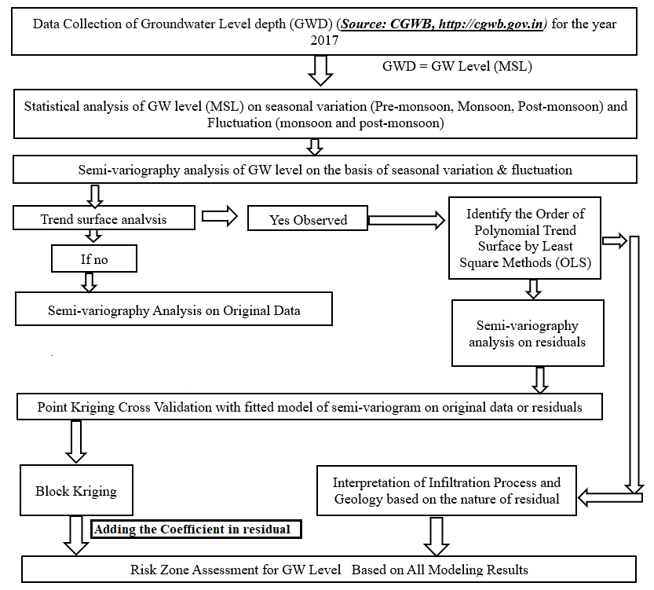
Fig 1 : Flowchart of the study

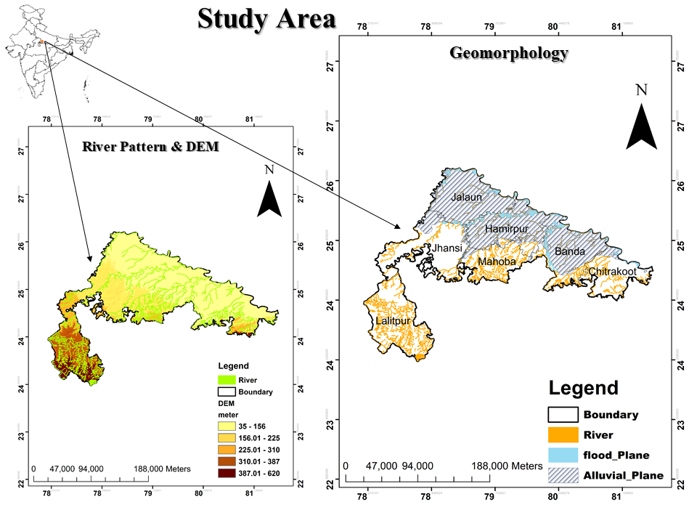
Fig 2 : Study area

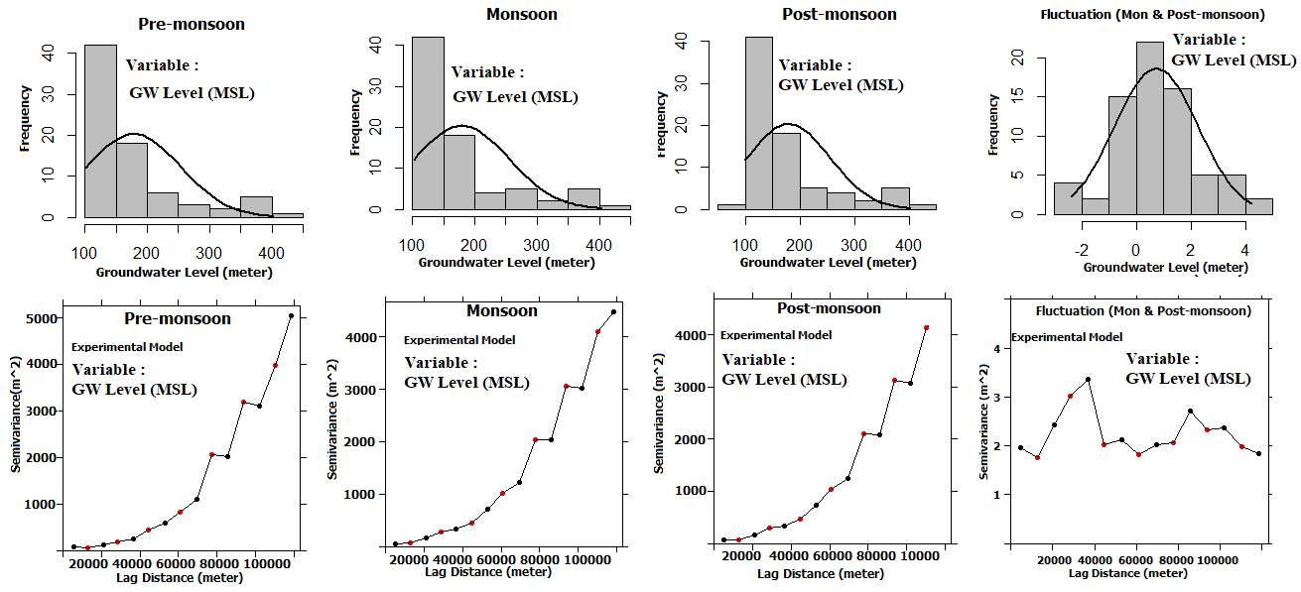
Fig 3 : Groundwater level and fluctuation in pre-monsoon, monsoon, post-monsoon

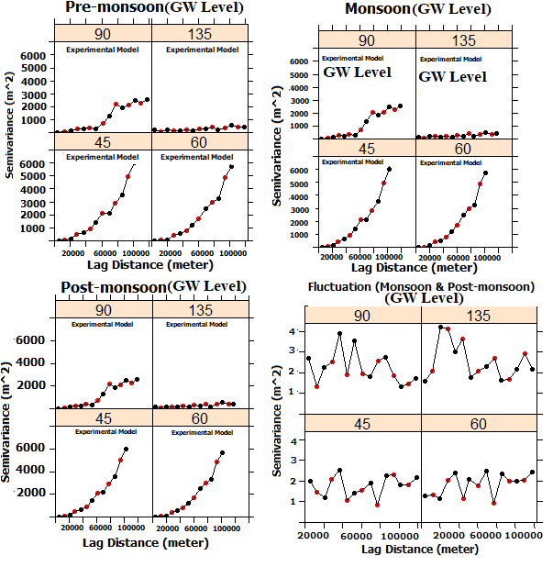
Fig 4 : Directional semi-variograms showed trends in groundwater levels across the three seasons

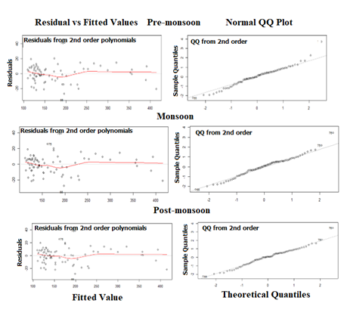
Fig 5 : Residual vs Fitted values

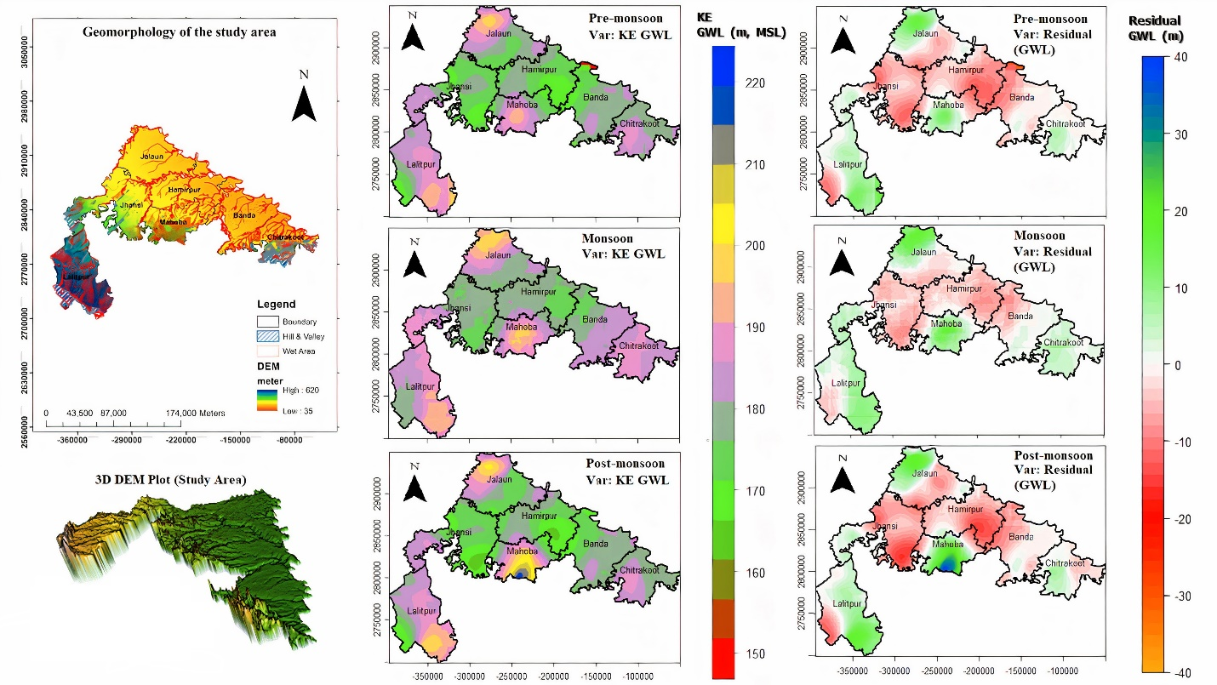

Fig 6 : Geomorphology of the study region in three different season: Pre-monsoon, Monsoon, and Post-monsoon

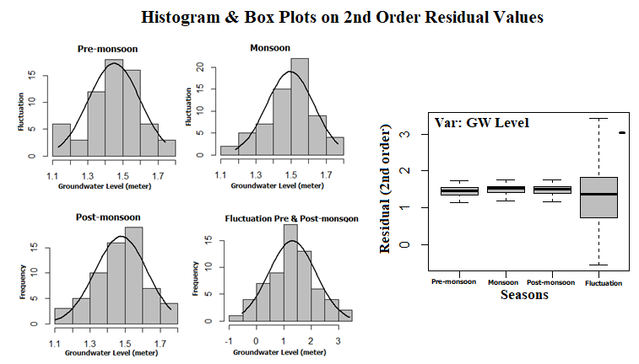
Fig 7 : Showing histogram, box plot and coefficient of variation of the residual data

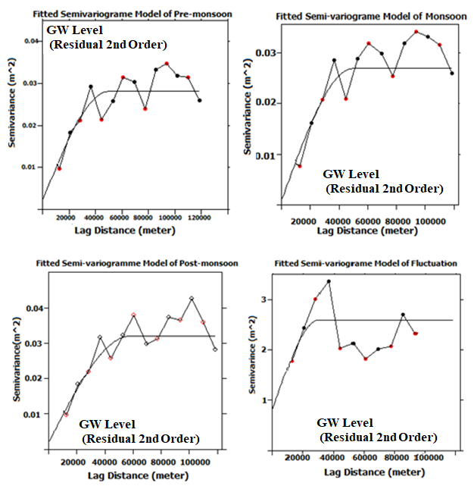
Fig 8 : Semi-variogram model for the second-order residual of the groundwater level

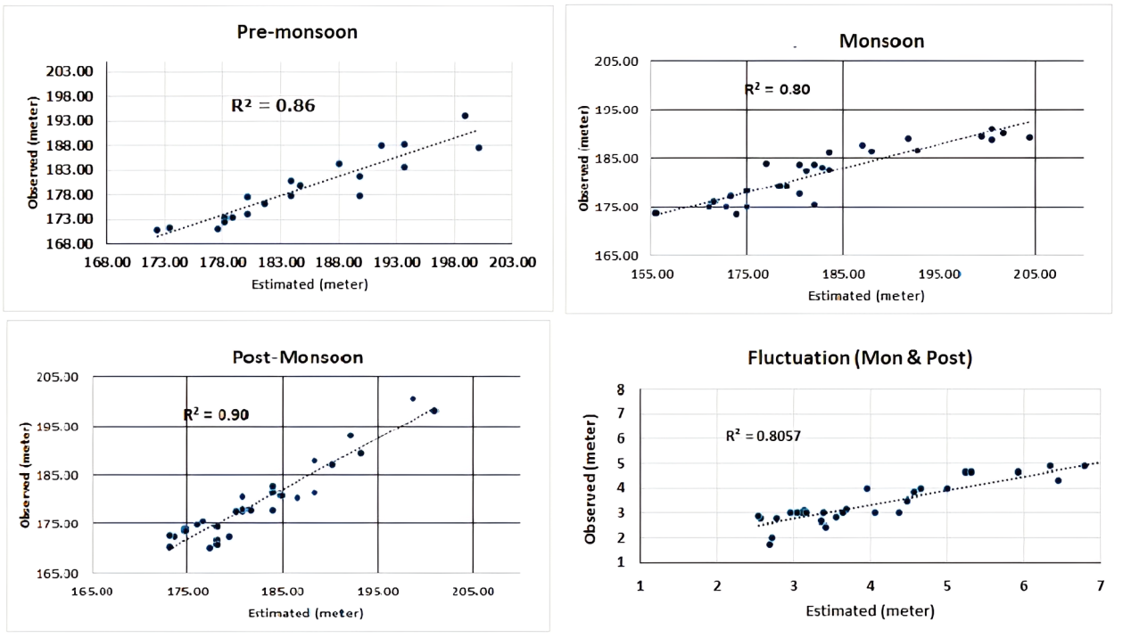

Fig 9 : The coefficient of determination (R²) for observed versus estimated values for each season and fluctuation

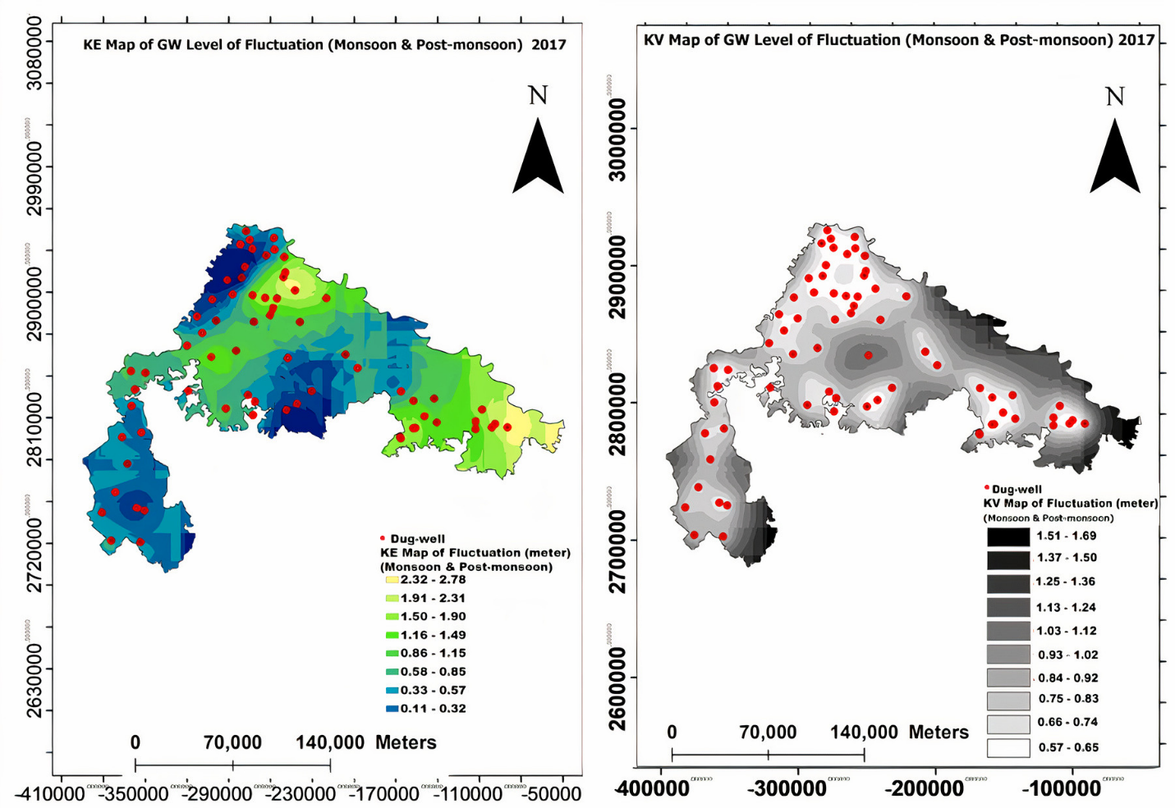

Fig 10a . Kriging map showing groundwater level fluctuations between monsoon and post-monsoon seasons in 2017

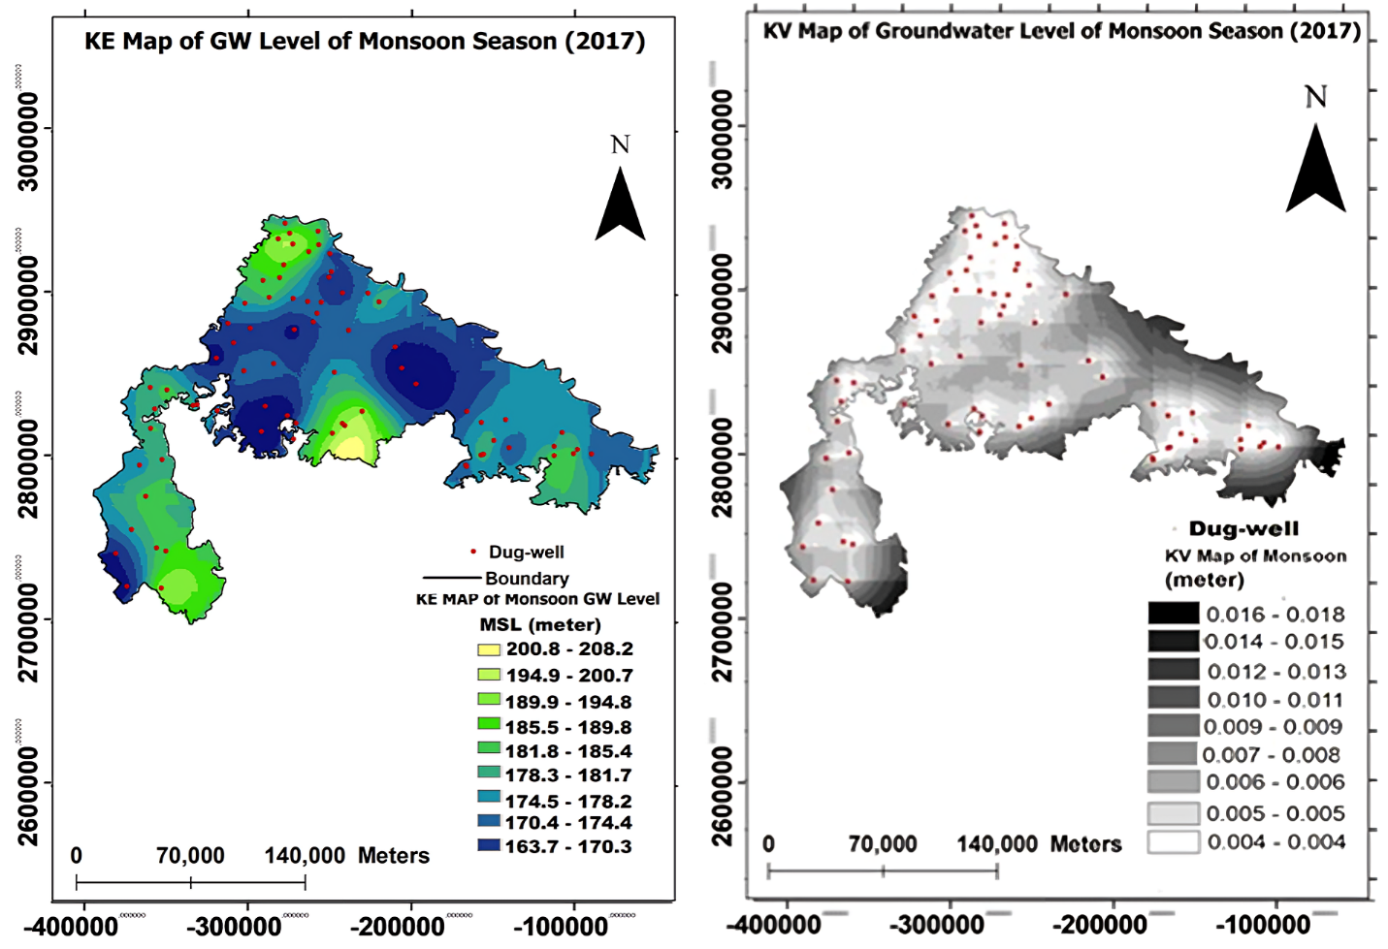
Fig 10b: Kriging map showing groundwater level of monsoon season (2017)

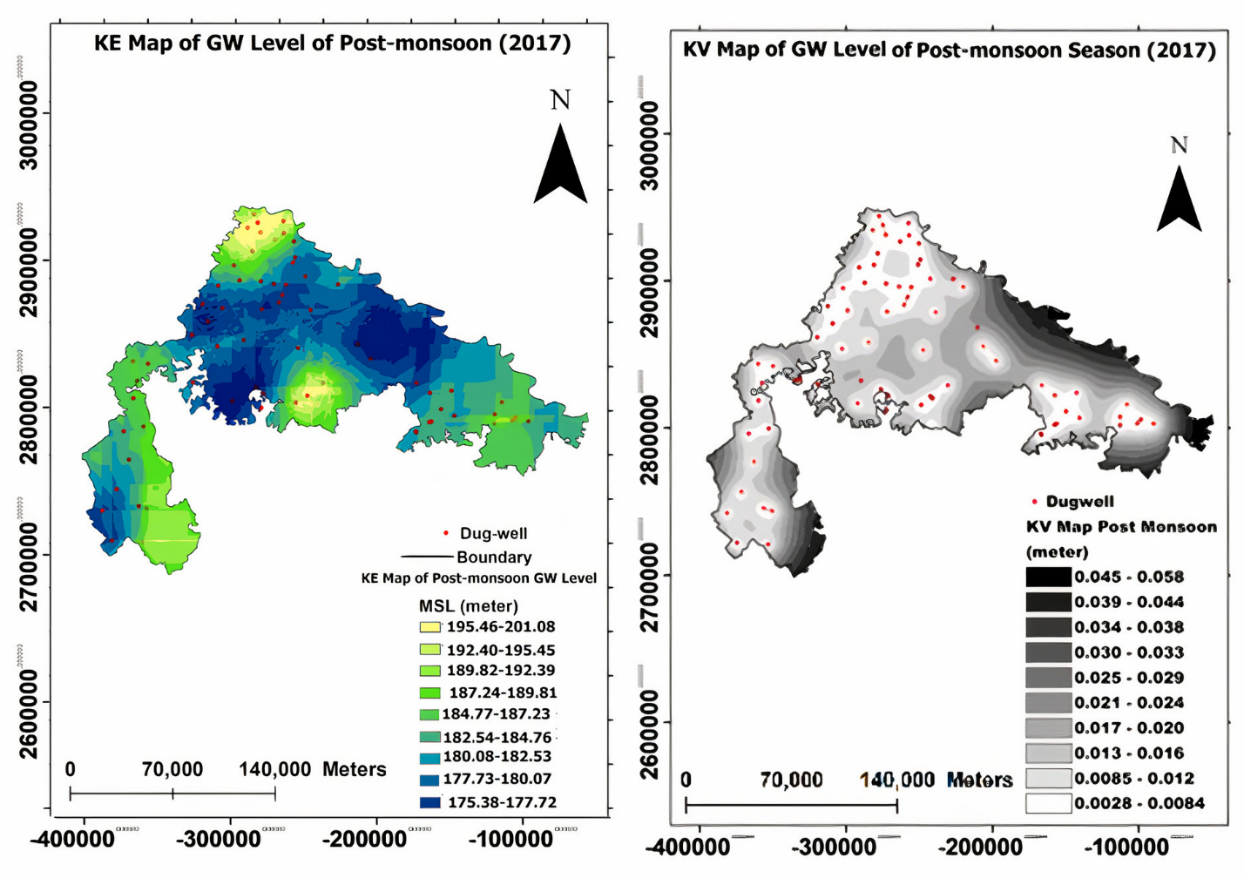

Fig 10c : Kriging map showing groundwater level of post-monsoon season (2017)

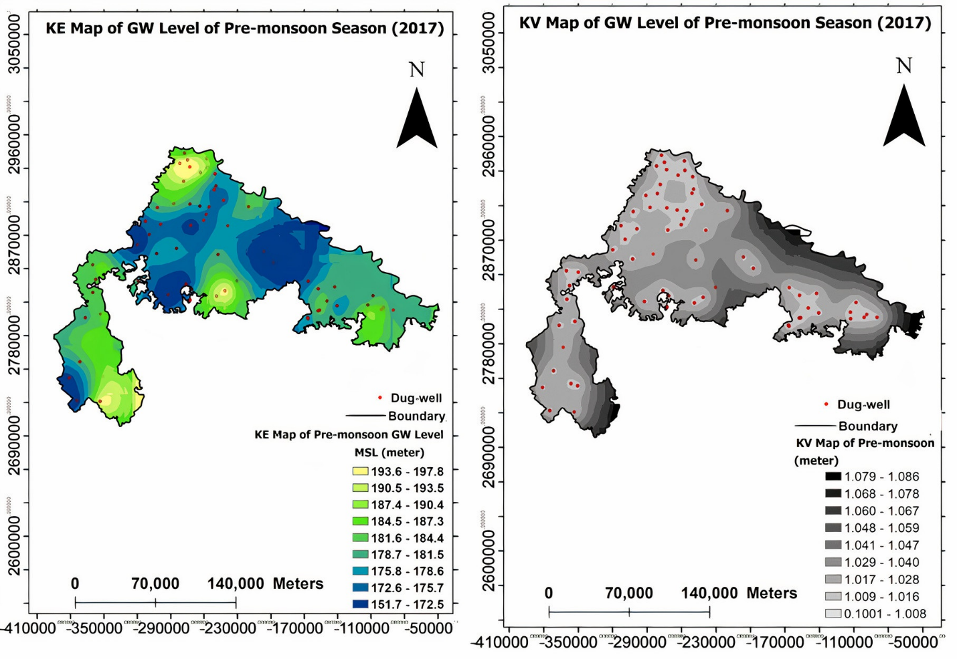
Fig 10 d : Kriging map showing groundwater level of pre-monsoon season (2017)

Table 1 Statistics of GW level (meter, MSL) of original data
Statistics | Pre-monsoon | Monsoon | Post-monsoon | Fluctuation
Mean | 178.06 | 180.46 | 179.24 | 0.73
Std. Dev. | 75.65 | 75.21 | 75.62 | 1.52
Min | 100.80 | 102.50 | 99.56 | -2.40
Max | 401.41 | 402.76 | 402.87 | 4.21
Skewness | 1.52 | 1.54 | 1.52 | 0.32
SE. Skewness | 0.27 | 0.27 | 0.27 | 0.28
Kurtosis | 1.39 | 1.43 | 1.38 | -0.04
No. of Sample | 77.00 | 77.00 | 77.00 | 71.00

Table 2 R² & F test generated from 1st,2nd & 3rd order trend surface
Seasonal Variation | R^2 1st order | R^2 2nd order  (Optimum) | R^2 3rd order | 1st order Trend Surface |  | 2nd order Trend Surface  (Optimum) |  | 3rd order Trend Surface
 |  |  |  | F test | P value | F test | P value | F test | P value
Pre-monsoon | 0.94 | 0.98 | 0.96 | 584.65 | 2.22e-15 | 564.29 | 2.22e-16 | 580.33 | 2.22e-16
Monsoon | 0.94 | 0.97 | 0.95 | 595.07 | 2.22e-13 | 572.93 | 2.22e-14 | 575.25 | 2.22e-12
Post-monsoon | 0.94 | 0.98 | 0.95 | 595.82 | 2.22e-16 | 528.3 | 2.22e-16 | 530.36 | 2.22e-17

Table 3 Coefficient of Variation Generated from 2nd order trend surface
Coefficient | Pre-monsoon |  | Monsoon |  | Post-monsoon
 | Estimate | Std. Error | Estimate | Std. Error | Estimate | Std. Error
B0 (Intercept) | 1.7898e+02 | 2.6212e+00 | 1.8014e+02 | 2.6787e+00 | 1.7953e+02 | 2.5610e+00
B1 | -7.9111e-04 | 4.9803e-05 | -8.1216e-04 | 5.1380e-05 | -8.1996e-04 | 5.3742e-05
B2 | -6.7370e-04 | 2.9827e-05 | -6.5851e-04 | 2.7927e-05 | -6.6217e-04 | 2.9211e-05
B3 | 2.7629e-09 | 5.7333e-10 | 2.8642e-09 | 5.6593e-10 | 2.8325e-09 | 5.9195e-10
B4 | 1.1403e-09 | 3.3034e-10 | 1.0715e-09 | 3.2007e-10 | 9.6621e-10 | 3.3478e-10
B5 | 2.2174e-09 | 8.2487e-10 | 1.9479e-09 | 8.1340e-10 | 1.9189e-09 | 8.5079e-10

Table 4 Spherical Model Equation of Fitted Model Semi-variogram
Sr. No. | Seasons | Spherical Model Equation
1 | Pre-Monsoon | ϒ(h)=0.007+0.02[1.5(h/50000) -0.5(h/50000)³
2 | Monsoon | ϒ(h)=0.01+0.011[1.5(h/42000) -0.5(h/42000)³
3 | Post-Monsoon | ϒ(h)=0.005+0.03[1.5(h/50000) -0.5(h/50000)³
4 | Fluctuation (monsoon & post-monsoon) | ϒ(h)=0.80+1.8[1.5(h/30000) -0.5(h/30000)³

Table 5 Semi-variogram & Geostatistical Parameters of Residuals (Generated from 2nd Order Trend Surface)

Sr. No. | Semi-variogram Parameters of fitted model used for kriging (residuals) | Pre-monsoon (m) | Monsoon (m) | Post-monsoon (m) | Fluctuation (Monsoon & Post-monsoon, m)
1 | Co (%²⁾ | 0.007 | 0.01 | 0.005 | 0.80
2 | C (%²⁾ | 0.02 | 0.011 | 0.03 | 1.8
3 | (Co:C+Co) *100
4 | Radius of search (m) X Y Z. | 33333  33333  33333 | 75543  75543  75543 | 38666  38666  38666 | 26000  26000  26000
5 | Mean Kriging Estimate (EV) | 0.11 | 1.5 | 1.49 | 3.75
6 | Mean Kriging Variance (KV) | 0.01 | 0.02 | 0.01 | 2.35
7 | KV: EV | 1.03 | 1.03 | 1.05 | 0.95
8 | Mean absolute (Z-Z*) | 0.10 | 0.09 | 0.10 | 0.02
9 | % Error due to parameters | 0.04 | 0.03 | 0.04 | 0.54
 | R² | 0.86 | 0.80 | 0.90 | 0.80
 | Student t-test on R² | Significant | Significant | Significant | Significant
Sr. No. | Geostatistical Parameters (Block Kriging) on Residuals & Back Transformation
1 | Block Dimension | 1000*1000*2 | 1000*1000*2 | 1000*1000*2 | 1000*1000*10
2 | Total number of blocks | 29750 | 29750 | 29750 | 29750
3 | No. of blocks kriged | 29665 | 29750 | 29750 | 29743
4 | Mean kriged estimate | 1.43 | 1.48 | 1.47 | 0.74
5 | Mean kriged estimate after aiding the coefficient of 2nd order trend surface (Back Transformation) | 179.43 | 181.56 | 180.46 | *****
6 | Mean kriged variance | 0.01 | 0.005 | 0.02 | 0.60
***** There is no trend in fluctuation of GW level (m, MSL)

