**PROXIMATE AND SENSORY PROPERTIES OF BISCUITS FROM WHEAT AND PROCESSED AFRICAN YAM BEAN SEED COMPOSITE FLOUR**

**ABSTRACT**

Proximate and sensory properties of biscuits from wheat and processed African yam bean seed composite flour biscuits were evaluated. The African yam bean flour samples were divided into three portions and processed by soaking, boiling and roasting for the production three different African yam bean flours for the composite biscuit samples. Optimal mixture model was used for the experimental design. The variables were wheat flour (50–100g/100g), boiled African yam bean flour (20–50g/100g), soaked African yam bean flour (20–50g/100g) and roasted African yam bean flour (20–50g/100g) with a total of thirteen samples (A-M). Proximate compositions of the composite biscuit samples evaluated were moisture, protein, fat, ash, crude fibre and carbohydrate. The study showed that boiling was more efficient to improve the proximate composition of the biscuit samples. Moisture content of the composite samples ranged from 9.58% for sample M (50%Wheat flour: 0%BAYBF: 0% SAYBF: 50% RAYBF) to 12.69% for sample H (60%Wheat flour: 0%BAYBF: 40% SAYBF: 0% RAYBF). Crude protein content of the samples ranged from 8.24% for sample A (100%Wheat flour: 0%BAYBF: 0% SAYBF: 0% RAYBF) to 18.29% for sample I (50%Wheat flour: 0%BAYBF: 50% SAYBF: 0% RAYBF). Fat content of the composite biscuit samples ranged from 4.84% for sample F (80%Wheat flour: 0%BAYBF: 20% SAYBF: 0% RAYBF to 8.79% for sample M (50%Wheat flour: 0%BAYBF: 0% SAYBF: 50% RAYBF). Ash content of the samples ranged from 1.86% for sample F (80%Wheat flour: 0%BAYBF: 20% SAYBF: 0% RAYBF) to 2.95% for sample I (50%Wheat flour: 0%BAYBF: 50% SAYBF: 0% RAYBF). Crude fiber content of the samples ranged from 1.84% for sample A (100%Wheat flour: 0%BAYBF: 0% SAYBF: 0% RAYBF) to 2.95% for sample I (50%Wheat flour: 0%BAYBF: 50% SAYBF: 0% RAYBF) and sample M (50%Wheat flour: 0%BAYBF: 50% SAYBF: 50% RAYBF).Carbohydrate content of the samples ranged from 57.57% for sample I (50%Wheat flour: 0%BAYBF: 50% SAYBF: 0% RAYBF) to 70.48% for sample A (100%Wheat flour: 0%BAYBF: 0% SAYBF: 0% RAYBF). Sensory properties of the composite biscuit samples evaluated revealed that sample K (70%Wheat flour: 0%BAYBF: 0% SAYBF: 30% RAYBF) had the highest sensory properties due to its high values in terms of taste, aroma and overall acceptability.

**Keywords**: Proximate, Sensory, Biscuit, wheat and African yam bean.

**Introduction**

Biscuit belongs to the flour confectionery. It is flat crisp and may be sweetened or unsweetened according to preference. Biscuit can be made from hard dough e.g. crackers, hard sweet dough e.g. short bread and short cake (Ekpo, 2007). It is produced by mixing various ingredients like flour, fat, sweeteners and water to form dough. The dough formed unlike bread is not allowed to ferment, and then it is baked in the oven (Adeleke, 2006). It could be baked in the primitive or modern oven, but the fundamental ingredient is wheat flour. The flours that are ground from wheat have the unique ability to form a cohesive gluten network when mixed with water. This simple discovery set the stage for the development of many yeast breads, biscuits, pastries, cakes, cookies and other baked products that are so popular today (Udensi and Okoronkwo, 2008).

Biscuit and other baked food products are important items belonging to the class of food that are sold in ready to serve form. Biscuits are of good values, contributing valuable quantities of iron, calcium, protein, calorie, fiber and some of the B-vitamins to our diet and daily food requirement Biscuits are one of the most popular bakery products made from cereals that are consumed by nearly all the people in the world. They are snacks produced from palatable dough that transformed into appetizing product through the application of heat in the oven (Kure *et al,* 2013*)*. They are made from flour, sugar, milk, flavouring agents and other chemical additives. Sometimes bakery products are used as vehicles for the incorporation of different nutritionally rich ingredients (Sudha *et al.,* 2007).

Wheat flour (*Triticum aestivum*), the main ingredients for biscuit production is imported by countries with unfavorable climates for growing wheat. This importation has placed a considerable burden on foreign exchange reserves of the economies of such importing countries. This has led to the development and use of composite flours for production of biscuits, breads and pastry products. Composite flour has been defined as a mixture of several flours obtained from roots and tubers, cereals, legumes etc, with or without the addition of wheat flour (Adeyemi and Ogazi, 2014).Wheat (*Triticum aestivum)* is perhaps the most popular cereal grain, for the production of bread and especially for the production of biscuits and other pastries. Wheat produces white flour. In addition, the unique properties of wheat protein alone can produce biscuit dough’s of the strength and elasticity required to produce low density cookies and biscuit of desirable texture and flavor. The wheat grain consists of an outer fibrous covering – the pericarp and testa which is hard and indigestible and an inner lining aleurone layer which contains a higher proportion of protein than carbohydrate an embryo attached to a small structure, the scutellum, at the lower end of the grain and the endosperm, comprising 85% of the whole grain from which the flour is derived. The nutritive value and composition of wheat varies with the variety of the seed, the nature of the soil and climate. Wheat is composed of starch 65-75%, protein 8-10%, water 10-14%, fat 1-2%, fibre 1.5-2.5%, Ash 0.4-1.0% and food energy of 334 calories (Ihekoronye and Ngoddy, 1985).

African yam bean (AYB) botanically known as (*Sphenostylis stenocarpa)* is an underutilized grain legume in Nigeria. It is an important legume in Africa, a lesser-known legume of the tropical and subtropical areas of the world which attracted research in recent times (Azeke *et al*, 2005) This legume has been reported to be of importance in the management of chronic diseases like diabetes, hypertension and cardiovascular disease because of its high dietary fibre content (Enwere, 1998). It is eaten roasted as groundnut, boiled with cooking ingredients or processed into flour for biscuit production. Composite flour has the added advantage of improving the nutrient value of biscuits and other bakery products especially when cereals are blended with legumes such as African yam bean. The food uses of African yam bean include feeding of man, cattle and pigs with the chaff. It also serves as food for poultry. African yam bean can also be used as flour for baking. Because of its nutritional value, it can be used to prepare steamed gel (moi moi) for human consumption. It can be boiled in the seed and eaten (Okaka, 2005)

African yam bean is high in protein that play important role in human nutrition and makes an excellent source of supplementing proteins in the diets. African yam bean has high vitamin and mineral contents like iron, phosphorous and calcium. It also has a high content of crude fibre and high level of sulphur containing amino acids which are limited in cereals. These compositions gave African yam bean its high nutritive and health value (Iwueke, 2016). Poor utilization of African yam bean flour in production of food products such as biscuits, bread and other baked products has really affected the people leading to insufficient protein in biscuit product. Also poor nutritional information and awareness of African yam bean flour among the rural and urban people. Also inability of food processors to diversify African yam bean flour in the production of baked food products. Also due to the overdependence of wheat flour for biscuit and other baking productions among confectionary industries. Finally inability of African yam bean flour producers to efficiently remove its beany flavor and inability to ascertain the pre-treatment methods such as boiling, soaking and roasting that will least affect nutrient and sensory properties of Wheat and African Yam composite flour biscuits. The broad objective of the study is; to carryout proximate and sensory properties of biscuits from wheat and processed African yam bean composite flour. This study will help to enlighten our people that our local raw food materials such as African yam bean flour are more reliable sources of flour for production of composite biscuits which are good to human health and affordable. The study will reveal the best processing method that is most efficient to reduce the anti-nutrients in African yam bean flour. The study will reveal the best pretreatment method that will not affect the nutrient composition of the composite biscuit samples. It will also show best pretreatment method that will not affect the proximate and sensory properties of the wheat-African yam bean composite biscuit samples.

**2.0 MATERIALS AND METHODS**

**2.1 Sources of materials**

Wheat flour and raw African yam bean seeds and baking ingredients such as, strawberry flavorants, nutmeg, margarine, milk, eggs and vanilla flavour were purchased from Relief Market in Owerri Municipal Local Government Area of Imo State, Nigeria. Equipments used which include; baking oven, stainless plates, weighing scale, flour mixer and baking trays were made available by the Department of Food Science and Technology Imo State University Owerri.

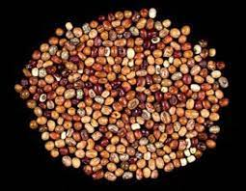

**Plate 1: Raw African yam bean.**

**2.2 Sample preparation**

**2.2.1Preparation of boiled African Yam Bean Flour**

Two kilogram (2kg) of the African yam bean seeds was sorted, weighed and boiled for 30minutes. It was drained, dehulled and oven dried at 600C for 3hr. After oven-drying, the sample was cooled, milled using attrition mill (MODEL 594), sieved with muslin cloth and packaged. The sample was labelled as boiled African yam bean (AYB) flour. Flow chart is shown in figure 1 below.

**2.2.2 Preparation of Soaked African Yam Bean Flour**

Two kilograms (2kg) of the African yam bean seeds was sorted, weighed, soaked for 24hours, drained, dehulled, oven dried at 600C for 6hrs for each of the samples was cooled, milled using attrition mill (MODEL 594) sieved using muslin cloth, packaged and labelled as soaked African yam bean flour. Flow chart is shown in figure 2 below.

**2.2.3 Preparation of Roasted African Yam Bean Flour**

Two kilogram(2kg) of the African yam bean seeds was, sorted, weighed, roasted for 30minutes, dehulled, milled using attrition mill (MODEL 594) sieved using muslin cloth, packaged and labelled as roasted African yam bean flour. Flow chart is shown in figure 3 below.

**RAW AFRICAN YAM BEAN SEED**

Sorting

Weighing

Boiling (30mins at 100OC)

Draining

Dehulling

Oven drying (60OC for 3hr)

Milling (using attrition mill)

Sieving (0.02nm mesh size sieve)

**Boiled African yam bean flour**

**Figure 1:** Flow chart for the production of Boiled African yam bean flour samples (According to Adeyemi, 2020).

**RAW AFRICAN YAM BEAN SEED**

Sorting

Weighing

Soaking in water (for 30min at 27OC)

Draining

Dehulling

Oven drying (60OC for 3hr)

Milling (using attrition mill)

Sieving (0.02nm mesh size sieve)

**Soaked African yam bean flour**

**Figure 2:** Flow chart for the production of Soaked African yam bean flour samples (According to Adeyemi, 2020).

**RAW AFRICAN YAM BEAN SEED**

Sorting

Weighing

Roasting (for 30min at 70OC)

Dehulling

Milling (using attrition mill)

Sieving (0.02nm mesh size sieve)

**Roasted African yam bean flour**

**Figure 3: Flow chart for the production of Roasted African yam bean flour samples (According to Adeyemi, 2020).**

**Experimental Design**

Optimal mixture model was used for the experimental design. The variables were Wheat flour (50–100g/100g), boiled African yam bean flour (20– 50g/100g), Soaked African yam bean flour (20–50g/100g) and roasted African yam bean flour (20–50g/100g) flour. Experimental design done is shown in Table 1 below

**Table 1: Experimental Design**

|  |  |  |  |  |
| --- | --- | --- | --- | --- |
| **Samples** | **Wheat flour (%)** | **Boiled African yam bean flour**  **(%)** | **Soaked African yam bean flour (%)** | **Roasted African yam bean flour**  **(%)** |
| A | 100 | 0 | 0 | 0 |
| B | 80 | 20 | 0 | 0 |
| C | 70 | 30 | 0 | 0 |
| D | 60 | 40 | 0 | 0 |
| E | 50 | 50 | 0 | 0 |
| F | 80 | 0 | 20 | 0 |
| G | 70 | 0 | 30 | 0 |
| H | 60 | 0 | 40 | 0 |
| I | 50 | 0 | 50 | 0 |
| J | 80 | 0 | 0 | 20 |
| K | 70 | 0 | 0 | 30 |
| L | 60 | 0 | 0 | 40 |
| M | 50 | 0 | 0 | 50 |

**Table 2: Recipe for biscuit Production**

|  |  |  |  |  |  |  |  |  |  |
| --- | --- | --- | --- | --- | --- | --- | --- | --- | --- |
| **SAMPLES** | **WHEATFLOUR**  **(%)** | **BAYBF**  **(%)** | **SAYBF**  **(%)** | **RAYBF**  **(%)** | **SUGAR**  **(g)** | **MARGARINE**  **(g)** | **SALT(g)** | **BAKING POWDER**  **(g)** | **MILKg)** |
| A | 100 | 0 | 0 | 0 | 30 | 30 | 1 | 5 | 10 |
| B | 80 | 20 | 0 | 0 | 30 | 30 | 1 | 5 | 10 |
| C | 70 | 30 | 0 | 0 | 30 | 30 | 1 | 5 | 10 |
| D | 60 | 40 | 0 | 0 | 30 | 30 | 1 | 5 | 10 |
| E | 50 | 50 | 0 | 0 | 30 | 30 | 1 | 5 | 10 |
| F | 80 | 0 | 20 | 0 | 30 | 30 | 1 | 5 | 10 |
| G | 70 | 0 | 30 | 0 | 30 | 30 | 1 | 5 | 10 |
| H | 60 | 0 | 40 | 0 | 30 | 30 | 1 | 5 | 10 |
| I | 50 | 0 | 50 | 0 | 30 | 30 | 1 | 5 | 10 |
| J | 80 | 0 | 0 | 20 | 30 | 30 | 1 | 5 | 10 |
| K | 70 | 0 | 0 | 30 | 30 | 30 | 1 | 5 | 10 |
| L | 60 | 0 | 0 | 40 | 30 | 30 | 1 | 5 | 10 |
| M | 50 | 0 | 0 | 50 | 30 | 30 | 1 | 5 | 10 |

**Key**

Sample BAYBF = Boiled African yam bean flour

Sample SAYBF = Soaked African yam bean flour

Sample RAYBF = Roasted African yam bean flour

**2.2.4 Preparation of the Biscuit samples**

Biscuit was prepared with slight modification of (Cookery, 2018) method. Wheat flour and boiled African yam bean flour were formulated according to dilution in Table 2. Wheat flour and roasted African yam bean flour, Sugar, margarine baking powder and salt were added and mixed until a stiff paste (batter) was obtained. The batter was rolled on a floured board using rolling pin to a thickness of 0.2-0.3cm. The rolled batter was cut into shapes and arranged on greased trays and baked at 200oC for 30minutes. The biscuit was brought out, cooled and packaged. The flow diagram in figure 4 was followed for the biscuit production.

**Composite flour, margarine, flavor, baking powder, salt, egg and sugar**

Mixing

Shaping

Baking (200OC for 30minutes)

Depanning

Cooling

**Composite biscuit**

**Figure 4**: Flow chart for production of composite biscuit from wheat and African yam bean flour biscuit.

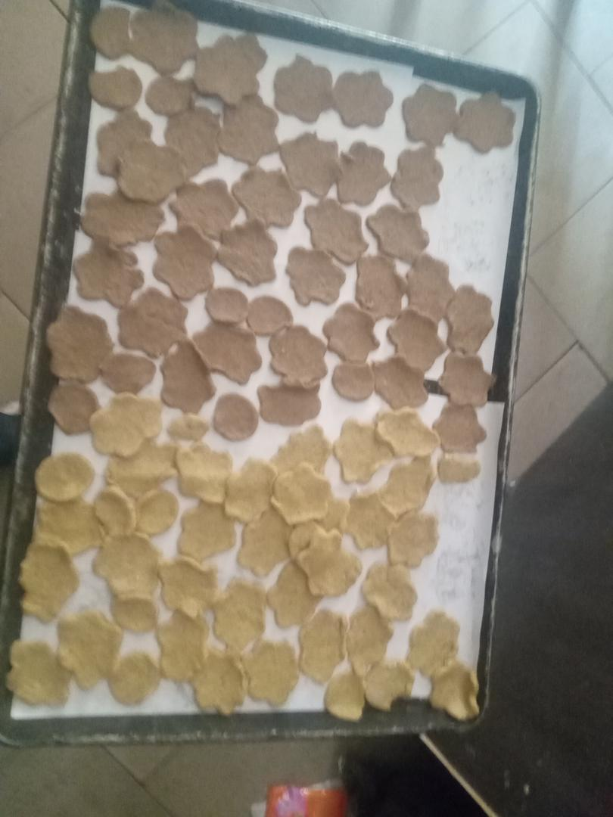

**Sample A**

**Sample B**

**Plate 2: Wheat and processed African yam bean seed composite flour biscuit samples (Sample A and B)**

**Key**

Sample A = 100% Wheat flour: 0% BAYBF: 0% SAYBF: 0% RAYBF

Sample B = 80% Wheat flour: 20% BAYBF: 0% SAYBF: 0% RAYBF

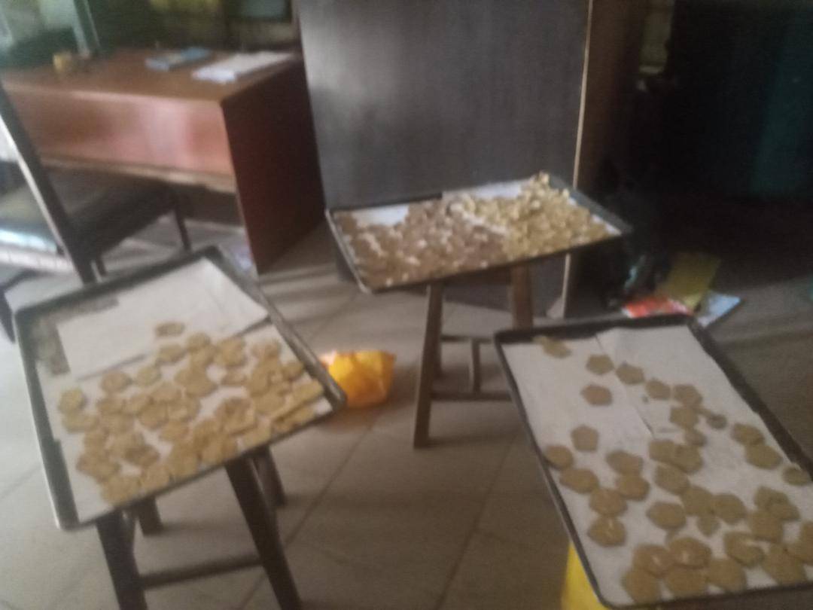

**Sample C**

**Sample E**

**Sample D**

**Plate 3: Wheat and processed African yam bean seed composite flour biscuit samples (Sample C, D and E)**

**Key**

Sample C **=** 70%Wheat flour: 30%BAYBF: 0% SAYBF: 0% RAYBF

Sample D **=** 60%Wheat flour: 40%BAYBF: 0% SAYBF: 0% RAYBF

Sample E **=** 50%Wheat flour: 50%BAYBF: 0% SAYBF: 0% RAYBF

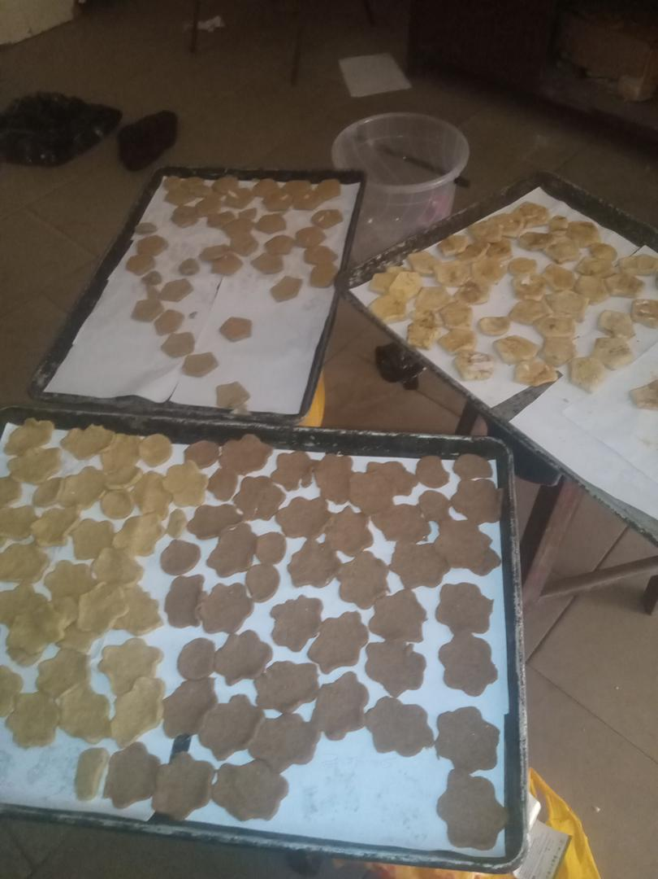

**Sample I**

**Sample H**

**Sample G**

**Sample F**

**Plate 4: Wheat and processed African yam bean seed composite flour biscuit samples (Sample F, G, H and I)**

**Key**

Sample F **=** 80%Wheat flour: 0%BAYBF: 20% SAYBF: 0% RAYBF

Sample G **=** 70%Wheat flour: 0%BAYBF: 30% SAYBF: 0% RAYBF

Sample H **=** 60%Wheat flour: 0%BAYBF: 40% SAYBF: 0% RAYBF

Sample I **=** 50%Wheat flour: 0%BAYBF: 50% SAYBF: 0% RAYBF

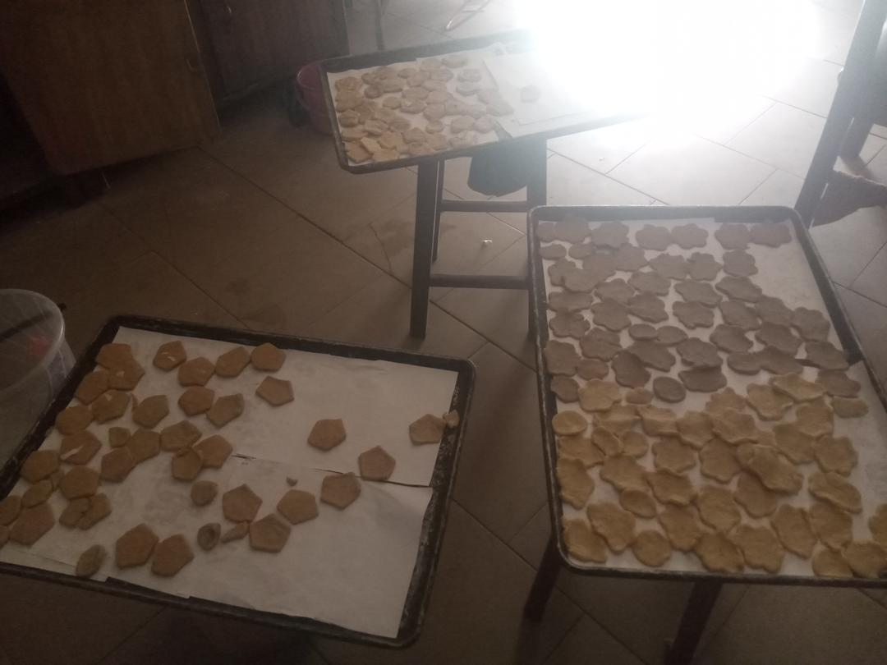

**Sample K**

**Sample M**

**Sample L**

**Sample J**

**Plate 5: Wheat and processed African yam bean seed composite flour biscuit samples (Sample J, K, L and M)**

**Key**

Sample J **=** 80%Wheat flour: 0%BAYBF: 0% SAYBF: 20% RAYBF

Sample K**=** 70%Wheat flour: 0%BAYBF: 0% SAYBF: 30% RAYBF

Sample L **=**60%Wheat flour: 0%BAYBF: 0% SAYBF: 40% RAYBF

Sample M **=**50%Wheat flour: 0%BAYBF: 0% SAYBF: 50% RAYBF

**2.3 Proximate analysis of the biscuit samples**

The standard method of AOAC (2010) was used to determine the proximate compositions of the biscuit samples.

**2.3.1 Moisture Content Determination**

Two grammes (2g) each of the grated samples was weighed into previously weighed dry crucible. The samples was oven dried in an oven (Astel Hearson England model 262) at 105OC for 2hrs .The crucibles with their contents was cooled in a desiccators and reweighed, then put back into the oven and the operation was repeated until a constant weight was obtained. The loss in weight represents the moisture content and calculated with the following formula.

% Moisture content = Weight loss x 100……….(1)

Weight of sample 1

**2.3.2 Ash Content Determination**

Two grammes portion of each sample was weighed into a clean, dried crucible and placed on the muffle furnace set at 550OC. The sample was allowed to ash to a whitish grey colour and cooled in a desiccators. Then finally it weighed to get the weight W3. The weight of the ash was calculated from the difference in weight.

% Ash = Weight of ash x 100……….(2)

Weight of original sample 1

**2.3.3 Determination of Crude Protein**

The crude protein was determined using the micro-kjedahl technique. One gramme (1g) portion of each of the samples was weighed into filter paper and added into the dry digestion Kjeldahl flask, followed by 0.12g of copper sulphate (CUSO4). And 2.50ml of concentrated sulphuric acid (H2S04) was added with 3g selenium catalyst and a few anti bumping chips. It was then heated in a flame chamber until the solution became clear (colorless). The solution was cooled to room temperature after which 80mls of distilled water was added. Then, 50mls of 2% boric acid was placed in the receiving flask under the condenser with two drops of methyl red in desiccators added. The digestion flask was heated until 100ml distillate was collected. And 10mls of the distillate was titrated with 0.649MoLH2S04 to get pink colour. The sample procedure was carried out on the blank.

The amount of nitrogen was calculated as shown below

Weight of sample = 1.0g

Volume of H2S04 required for the titration = 2.50ml

Normality of H2S04 = 0.649

Nitrogen content of sample (%N) = Titre – Blank x Normality of acid ……(3)

Weight of sample

Crude Protein = %N x 6.25

**2.3.4 Determination of Fat Content**

This was carried out using the method of (AOAC, 2010). Clean and dried thimble was weighted (W1) and two grammes of the sample was added and reweighed (W2). The round bottom flask was filled with N-hexane at 60OC up to ¾ of the flask. Solvent extractor was fixed with a reflux condenser to adjust the heat sources so that the solvent boils gently, the samples was put inside the thimble and inserted into the solvent apparatus and extraction under reflux was carried out with N-hexane for 4 hours. The sample was removed from the boiling flask and solvent recovered flask containing oil dried and weighed. The weight of the extract was calculated by difference as expressed as percentage total lipid.

% Fat = Weight of fat extract x 100 ……….(4)

Weight of sample 1

**2.3.5 Determination of Crude fibre**

Two grammes of the samples was defatted as n fat determination and boiled for 30 minutes under reflux in 200ml of 1.25% H2S04 solution after which the sample was heated with hot water to remove the acid using a must in cloth to trap the sample. The residue was scraped back to flask and 200mls of 1.25% of NaOH solution was added and the mixture was allowed to boil for another 30minutes under reflux after which it was again, allowed to drain, transferred to a weighed crucible and dried in the oven at 105OC to a constant weight (W2).

Finally it was incinerated to ash in a muffle furnace at 550OC, cooled in a desicator and reweighed (W3). By difference, the weight of the fibre was determined and expressed as a percentage of the sample weight analyzed.

% Crudefibre = Weight loss x 100 ……….(5)

Weight of sample 1

**2.3.6 Determination of Carbohydrate Content**

The carbohydrate content of the samples was determined by difference using the formula.

%Carbohydrate = 100 - (% Moisture% + Ash% + Protein% + % Crudefibre% + % Fat) Equation……….(6)

**2.3.7 Sensory evaluation**

The sensory attributes of the biscuit samples appearance, taste; aroma, mouth feel and overall acceptability was evaluated using forty (40) panelists selected from the Department of Food Science and Technology Imo State University, Owerri using a nine point hedonic scale as described by Iwe(2002), as presented below:

9 = Like extremely

8 = Like very much

7 = Like very moderately

6 = Like slightly

5 = Like nor dislike

4 = Dislike slightly

3 = Dislike moderately

2 = Dislike very much

1 = Dislike extremely

**2.3.8 Statistical analysis**

Data obtained from analysis was subjected to statistical analysis of variance (ANOVA) with the mean value separated by Duncan’s multiple range tests at 95% level of significance using SPSS version 2022.

**3.0 RESULTS AND DISCUSSION**

**3.1:** **Proximate composition of composite biscuit from blends of wheat and African yam bean flour.**

Presented in Table 1 is the proximate composition of composite biscuit samples from blends of wheat and African yam bean flour. The parameters evaluated were moisture, protein, fat, ash, crude fibre and carbohydrate in the thirteen biscuit samples formulated. The moisture content of the composite samples ranged from 9.58% for sample M (50%Wheat flour: 0%BAYBF: 0% SAYBF: 50% RAYBF) to 12.69% for sample H (60%Wheat flour: 0%BAYBF: 40% SAYBF: 0% RAYBF).The sample M had the least moisture content with the value 9.58%. The values obtained from this study were within the acceptable limit of moisture content of biscuit (Agu, 2015). The relatively low moisture content of sample M (50%Wheat flour: 0%BAYBF: 0% SAYBF: 50% RAYBF) showed that the biscuit sample will have longer shelf life due to it how moisture content as a result of the roasting heat treatment given 50% roasted African yam bean flour sample used during its formulation. Also the relatively low moisture content of the sample M will inhibit the development of contaminating micro-organisms whose growth and activities are favoured by the presence of high moisture (Ugwu, 2014). Crude protein content of the samples ranged from 8.24% for sample A (100%Wheat flour: 0%BAYBF: 0% SAYBF: 0% RAYBF) to 18.29% for sample I (50%Wheat flour: 0%BAYBF: 50% SAYBF: 0% RAYBF).The crude protein content of the composite biscuit samples were significantly different (p≤0.05). Protein content of the composite biscuit samples were higher in protein compared to the control sample I (50%Wheat flour: 0%BAYBF: 50% SAYBF: 0% RAYBF). The result showed that consumption of the composite biscuit samples will help to supply protein to the body which will help to reduce protein-energy malnutrition among biscuit consumers (Obasi, 2000). Fat content of the composite biscuit samples ranged from 4.84% for sample F (80%Wheat flour: 0%BAYBF: 20% SAYBF: 0% RAYBF to 8.79% for sample M (50%Wheat flour: 0%BAYBF: 0% SAYBF: 50% RAYBF).The fat content of the composite biscuit samples were significantly different (p ≤ 0.05). The sample F had the least fat content which could be attributed to the 20% soaked African yam bean flour used in the biscuit formulation. The sample M (50%Wheat flour: 0%BAYBF: 0% SAYBF: 50% RAYBF) had the highest fat content which could be attributed to effect of roasting treatment given to the 50% roasted African yam bean flour which lead to the melting and increase in the fat content of the composite biscuit sample M (50%Wheat flour: 0%BAYBF: 0% SAYBF: 50% RAYBF). Fat content of any food sample aids in the improvement of mouth feel and flavor. It will also help to improve the texture of food samples which increases consumers demand (Uzozie, 2006).

Ash content of the samples ranged from 1.86% for sample F (80%Wheat flour: 0%BAYBF: 20% SAYBF: 0% RAYBF) to 2.95% for sample I (50%Wheat flour: 0%BAYBF: 50% SAYBF: 0% RAYBF). Ash content shows the level of minerals present in a particular food sample. The ash content of the sample I (50%Wheat flour: 0%BAYBF: 50% SAYBF: 0% RAYBF) was significantly different (p≤0.05). Also sample I (50%Wheat flour: 0%BAYBF: 50% SAYBF: 0% RAYBF) had the highest ash content when compared to the other samples. Also the ash content values obtained in this study are higher when compared to the range 0.64% to 0.92% reported by (Femi, 2003) in some selected biscuit samples produced using legume seed flours..According to Hadiza, (2021) crude fiber helps in the removal of waste products from the body, thereby preventing constipation and reduction high blood glucose absorption in the body. It will also help to prevent diseases such as diabetes mellitus, cardiovascular disease, obesity and colon cancer. Crude fiber content of the samples ranged from 1.84% for sample A (100%Wheat flour: 0%BAYBF: 0% SAYBF: 0% RAYBF) to 2.95% for sample I (50%Wheat flour: 0%BAYBF: 50% SAYBF: 0% RAYBF) and sample M (50%Wheat flour: 0%BAYBF: 50% SAYBF: 50% RAYBF). Crude fibre content of the samples is of good value. Carbohydrate content of the samples ranged from 57.57% for sample I (50%Wheat flour: 0%BAYBF: 50% SAYBF: 0% RAYBF) to 70.48% for sample A (100%Wheat flour: 0%BAYBF: 0% SAYBF: 0% RAYBF). Carbohydrate content of a sample aids in determination of energy content of the food. The carbohydrate content of the samples was significantly different (p≤0.05). The samples were of good standard as a biscuit sample. Also the high carbohydrate content of the sample A could be attributed to non addition African yam bean flour in the sample A biscuit sample.

**Table 3: Proximate composition of composite biscuit from blends of wheat and African yam bean flour**

|  |  |  |  |  |  |  |  |
| --- | --- | --- | --- | --- | --- | --- | --- |
| **Samples** | **Moisture**  **(%)** | | **Protein**  **(%)** | **Fat**  **(%)** | **Ash**  **(%)** | **Crudefiber**  **(%)** | **Carbohydrate**  **(%)** |
| A | | 10.84e + 0.02 | 8.24a + 0.02 | 6.83f + 0.03 | 1.75h + 0.01 | 1.84h + 0.02 | 70.48a + 0.35 |
| B | | 11.31d + 0.09 | 10.26g + 0.03 | 6.65g + 0.02 | 1.96f + 0.02 | 2.22g + 0.02 | 67.59d + 0.09 |
| C | | 11.84c + 0.02 | 12.48e + 0.02 | 6.85f + 0.02 | 2.21e + 0.01 | 2.45e + 0.03 | 64.17g + 0.06 |
| D | | 12.19b + 0.03 | 14.19c + 0.08 | 7.22e + 0.08 | 2.25e + 0.02 | 2.85b + 0.01 | 61.28J + 0.13 |
| E | | 10.63f + 0.03 | 16.28b + 0.02 | 8.04c + 0.02 | 2.66b + 0.02 | 2.94a + 0.01 | 59.47k + 0.05 |
| F | | 11.72c + 0.14 | 10.32g + 0.04 | 4.84j + 0.13 | 1.86g + 0.02 | 2.29f + 0.10 | 69.04b + 0.08 |
| G | | 11.88c + 0.01 | 12.92d + 0.09 | 5.66i + 0.02 | 2.24e + 0.09 | 2.55d + 0.01 | 64.72f + 0.08 |
| H | | 12.69a + 0.01 | 14.49c + 0.01 | 6.23h+ 0.03 | 2.28e + 0.02 | 2.66c + 0.02 | 61.65i + 0.05 |
| I | | 10.79e + 0.02 | 18.29a + 0.01 | 7.64d + 0.03 | 2.95a + 0.03 | 2.95a + 0.03 | 57.57L + 0.07 |
| J | | 9.64g + 0.04 | 10.41g + 0.38 | 6.86f + 0.01 | 2.43d + 0.02 | 2.43e + 0.02 | 68.54c + 0.06 |
| K | | 10.24h + 0.03 | 11.85f + 0.12 | 7.64d + 0.03 | 2.46cd + 0.06 | 2.64c + 0.04 | 65.11e + 0.01 |
| L | | 10.34f + 0.02 | 12.47e + 0.03 | 8.22b + 0.03 | 2.54c + 0.02 | 2.85b + 0.03 | 63.68h + 0.03 |
| M | | 9.58h+ 0.02 | 14.27c + 0.12 | 8.79a + 0.11 | 2.65b + 0.03 | 2.95a + 0.12 | 61.75I + 0.06 |
| **LSD** | | **0.0439** | **0.0926** | **0.0316** | **0.0273** | **0.0182** | **0.05709** |

**Mean values having different superscripts along the same column are significantly different (P≤0.05).**

**Key:** Wheat flour **(WF),** Boiled African yam bean flour **(BAYBF),** Soaked African yam bean flour **(SAYBF)** and Roasted African yam bean flour **(RAYBF).**

Sample A **=** 100%Wheat flour: 0%BAYBF: 0% SAYBF: 0% RAYBF

Sample B **=** 80%Wheat flour: 20%BAYBF: 0% SAYBF: 0% RAYBF

Sample C **=** 70%Wheat flour: 30%BAYBF: 0% SAYBF: 0% RAYBF

Sample D **=** 60%Wheat flour: 40%BAYBF: 0% SAYBF: 0% RAYBF

Sample E **=** 50%Wheat flour: 50%BAYBF: 0% SAYBF: 0% RAYBF

Sample F **=** 80%Wheat flour: 0%BAYBF: 20% SAYBF: 0% RAYBF

Sample G **=** 70%Wheat flour: 0%BAYBF: 30% SAYBF: 0% RAYBF

Sample H **=** 60%Wheat flour: 0%BAYBF: 40% SAYBF: 0% RAYBF

Sample I **=** 50%Wheat flour: 0%BAYBF: 50% SAYBF: 0% RAYBF

Sample J **=** 80%Wheat flour: 0%BAYBF: 0% SAYBF: 20% RAYBF

Sample K**=** 70%Wheat flour: 0%BAYBF: 0% SAYBF: 30% RAYBF

Sample L **=**60%Wheat flour: 0%BAYBF: 0% SAYBF: 40% RAYBF

Sample M **=**50%Wheat flour: 0%BAYBF: 0% SAYBF: 50% RAYBF

**3.3** **Sensory properties of composite biscuit from blends wheat and African yam bean flour samples.**

Presented in Table 4 are the sensory properties of the composite biscuit samples from blends wheat and African yam bean flour samples. The sensory parameters evaluated were appearance, taste, aroma, texture and overall acceptability. The appearance of the composite biscuit samples analyzed ranged from 6.52 for sample H (60%Wheat flour: 0%BAYBF: 40% SAYBF: 0% RAYBF) to 8.15 for sample A (control) (100%Wheat flour: 0%BAYBF: 0% SAYBF: 0% RAYBF). The sample A (100%Wheat flour: 0%BAYBF: 0% SAYBF: 0% RAYBF) was significantly different (P ≤ 0.05). Appearance is an important sensory attribute of any food product because of its influence on acceptability among consumers (Falola, 2012). Taste is the degree of sweetness, bitterness sourness and saltiness of a food product. The taste of the samples ranged from 6.37 for sample D(60%Wheat flour: 40%BAYBF: 0% SAYBF: 0% RAYBF) to 7.60 for sample A (control) (100%Wheat flour: 0%BAYBF: 0% SAYBF: 0% RAYBF). The sample A (100%Wheat flour: 0%BAYBF: 0% SAYBF: 0% RAYBF) had the highest value in terms of the taste which could be attributed to the panelists familiarity with the taste of biscuit produced with only wheat flour. Also according to (Ayodele, 2003) sweetening agents helps in improving the taste food samples. Aroma of the samples ranged from 5.80 for sample B (80%Wheat flour: 20%BAYBF: 0% SAYBF: 0% RAYBF) to 7.35 for sample K (70%Wheat flour: 0%BAYBF: 0% SAYBF: 30% RAYBF). The aroma of sample A, C, E, F, G, I and M are not significantly different (P ≤ 0.05). The aroma of the samples was highest in sample A. This could be attributed to the absence of beany flavor in sample A biscuit sample. According to Ayodele (2003) presence of beany flavor or aroma from legumes used in composite flour formulation affects sensory properties of foods. Texture measures the degree of hardness or smoothness and roughness of a food product especially baked food products. The texture of the samples ranged from 6.25 for sample D (60%Wheat flour: 40%BAYBF: 0% SAYBF: 0% RAYBF) to 7.61 for sample L (60%Wheat flour: 0%BAYBF: 0% SAYBF: 40% RAYBF). The sample L (60%Wheat flour: 0%BAYBF: 30% SAYBF: 0% RAYBF) had the highest value in terms of texture, while sample D had the least value in terms of texture and was significantly different (P ≤ 0.05). Overall acceptability of the samples analyzed showed that the composite biscuit samples ranged from 6.57 for sample G (70%Wheat flour: 0%BAYBF: 30% SAYBF: 0% RAYBF) and H (60%Wheat flour: 0%BAYBF: 40% SAYBF: 0% RAYBF) to 9.67 for sample K (70%Wheat flour: 0%BAYBF: 0% SAYBF: 30% RAYBF). The high overall acceptability of the sample K could be attributed to its high values in terms of taste, aroma and overall acceptability. sample K (70%Wheat flour: 0%BAYBF: 0% SAYBF: 30% RAYBF) was significantly different (P ≤0.05) among all the samples.

**Table 4: Sensory properties of composite biscuit samples from blends of wheat and African yam bean flour**

|  |  |  |  |  |  |
| --- | --- | --- | --- | --- | --- |
| **Samples** | **Appearance** | **Taste** | **Aroma** | **Texture** | **Overall acceptability** |
| A | 8.15a + 1.31 | 7.60a + 1.76 | 6.90abcd + 1.95 | 7.43ab + 1.78 | 7.73a + 1.50 |
| B | 7.55abc + 1.15 | 6.90ab + 1.64 | 5.80d+ 1.32 | 6.52bc + 1.67 | 7.10a + 1.59 |
| C | 7.50abc + 1.46 | 7.13ab + 1.55 | 6.85abcd + 1.51 | 6.83abc + 1.64 | 7.47a + 1.19 |
| D | 6.90cd + 1.59 | 6.37b + 1.25 | 6.07cd+ 1.22 | 6.25c + 1.44 | 7.62a+ 1.23 |
| E | 6.97bcd + 1.14 | 6.37b + 1.25 | 6.55abcd + 1.41 | 6.47ab + 1.34 | 7.20a + 1.23 |
| F | 7.23bcd + 0.94 | 6.70ab + 1.16 | 6.90abcd + 1.37 | 7.05abc + 1.41 | 7.50a + 1.06 |
| G | 7.15bcd + 1.25 | 7.15ab + 1.21 | 6.90abcd + 1.64 | 6.90abc + 1.82 | 6.57a + 1.10 |
| H | 6.52d + 1.34 | 6.85ab + 1.18 | 6.23bcd+ 1.68 | 6.60abc + 1.82 | 6.57a + 1.22 |
| I | 7.17bcd + 1.24 | 6.87ab + 1.23 | 6.75abcd + 1.68 | 7.34abc + 1.31 | 7.24a + 0.84 |
| J | 7.40abcd + 1.35 | 7.37a+ 1.27 | 7.07abc + 1.42 | 6.75abc + 1.12 | 7.75a + 1.43 |
| K | 7.65abc + 0.92 | 7.43a + 1.29 | 7.35a + 1.09 | 7.05abc + 1.46 | 9.67a + 0.25 |
| L | 7.87ab + 0.95 | 7.66a + 1.22 | 7.25b + 1.74 | 7.61a + 1.28 | 7.44a + 1.23 |
| M | 6.67cd+ 1.24 | 7.05ab + 1.25 | 6.65abcd + 1.51 | 7.12abc + 1.11 | 7.53a + 1.24 |
| **LSD** | **0.27750** | **0.29857** | **0.33194** | **0.33001** | **0.93160** |

**Mean values having different superscripts along the same column are significantly different (P≤0.05).**

**Key: Wheat flour (WF), Boiled African yam bean flour (BAYBF), Soaked African yam bean flour (SAYBF) and Roasted African yam bean flour (RAYBF).**

Sample A **=** 100%Wheat flour: 0%BAYBF: 0% SAYBF: 0% RAYBF

Sample B **=** 80%Wheat flour: 20%BAYBF: 0% SAYBF: 0% RAYBF

Sample C **=** 70%Wheat flour: 30%BAYBF: 0% SAYBF: 0% RAYBF

Sample D **=** 60%Wheat flour: 40%BAYBF: 0% SAYBF: 0% RAYBF

Sample E **=** 50%Wheat flour: 50%BAYBF: 0% SAYBF: 0% RAYBF

Sample F **=** 80%Wheat flour: 0%BAYBF: 20% SAYBF: 0% RAYBF

Sample G **=** 70%Wheat flour: 0%BAYBF: 30% SAYBF: 0% RAYBF

Sample H **=** 60%Wheat flour: 0%BAYBF: 40% SAYBF: 0% RAYBF

Sample I **=** 50%Wheat flour: 0%BAYBF: 50% SAYBF: 0% RAYBF

Sample J **=** 80%Wheat flour: 0%BAYBF: 0% SAYBF: 20% RAYBF

Sample K**=** 70%Wheat flour: 0%BAYBF: 0% SAYBF: 30% RAYBF

Sample L **=**60%Wheat flour: 0%BAYBF: 0% SAYBF: 40% RAYBF

Sample M **=**50%Wheat flour: 0%BAYBF: 0% SAYBF: 50% RAYBF

**3.3.1 Conclusion**

The proximate and sensory properties of biscuits from wheat and processed African yam bean seed composite flour were evaluated. The nutritional composition of the composite biscuit samples in terms of proximate composition revealed that the composite biscuit sample I (50%Wheat flour: 0%BAYBF: 50% SAYBF: 0% RAYBF) had the highest protein and sample A (100%Wheat flour: 0%BAYBF: 0% SAYBF:0% RAYBF) had the highest carbohydrate content. Sensory properties of the composite biscuit samples evaluated revealed that sample K (70%Wheat flour: 0%BAYBF: 0% SAYBF: 30% RAYBF) had the highest sensory properties due to its high values in terms of taste, aroma and overall acceptability. On the baked biscuit samples, sample K (70%Wheat flour: 0%BAYBF: 0% SAYBF: 30% RAYBF) had the best sensory acceptability among the samples.

* + 1. **Recommendation**

Boiling method was able to improve the proximate composition of the African yam bean flour more than soaking and roasting methods. Food scientists and food nutritionists should also ensure that African yam bean flour is used in fortification of most flour products that are highly carbohydrate based in order to increase their protein content.

**REFERENCES**

Adeleke, A.D (2006)Fortification of baked foods with African yam bean flours and its nutritional benefits. Vol. (1): 142-143.

Adeyemi , B.C and Ogazi, P.O. (2014). Nutritional value of biscuit from blends of maize, sorghum and millet.  *Journal of Bangladesh*. Vol 6: 30-31.

Adeyemi, C.A. (2020). Nutritional benefits of legumes and cereal foods. *Journal of Innovation, Food Science Emergency Technology. 41, 279-284*

AOAC, (2010), Official Methods of Analysis, 17th ed. *Association of Official Analytical Chemist Washington D.C.* PP. 70-83.

Ayodele, G.O (2008) Evaluation of proximate, mineral and anti-nutritional factor of home processed biscuit diet from locally available food material (sorghum bicolor and *sphenostylis stenocarpa*). *Journal of Food Science* Vol.12: 339-344

Ekpo, C., (2007). Physico-chemical and functional properties of six varieties of maize grains (*Zea may)* four. *Journal of Food Technology*  4:135-142.

Enwere P.O., (1998) Effect of blending of cereals on the nutritional content of yellow root cassava and sorghum. *Journal of Food Science.* Vol. 23. Pp 52-53.

Falola, B.A. (2012). Laboratory methods of sensory evaluation of foods. *Canada Publication Department of Agriculture, Canada*. Pp.6-13.

Hadiza, A.R. (2021). Nutritional and sensory analysis of soybean and wheat flour composite flour. *Pakistan Journal of Nutrition*. Vol. 13:61-62.

Ihekoronye, A.I. and Ngoddy, P.O. (1985) Integrated Food Science for the Tropics. *Macmillan publishers limited.* Pp 185-187.

Iwe, M. O. (2002) *Handbook of Sensory Methods and Analysis.* Rojoint Communication publishers Ltd. Enugu*.*pp.1-50.

Iwueke, A.S,(2016). Biochemical composition of biscuit foods formulated from blends of cereals and soybean. *Journal of Food Chemistry.* VOL. 26:63-65.

Obasi, N.E. (2000) Production and evaluation of biscuits from maize, wheat and groundnut flour. *Nutrition Journal.* Pp. 30-31.

Okaka, J.C. (2005). Development and quality evaluation of cowpea wheat biscuit. In: *Handling storage and processing of plant foods.CJ Publishers*, Enugu 45-78.

Sudha,R.O and Adeyemi C.A (2007). Nutritional benefits of legumes and cereal foods. *Journal of Innovation, Food Science Emergency Technology.* VOL*.41, 279-284.*

Udensi, A.U. and Okoronkwo, B.C. (2018). Tropical root crop production, storage, processing and marketing. *African Regional Center for Technology (ARCT) Dakar*. Pp.141-168.

Ugwu, G.O. (2014). Physiochemical and functional properties of winged bean flour and isolate compared with soy isolate. *J. Food Science:* 53 (11) 450-454.

Uzozie, R.B (2006). Studies on the proximate composition and effect of particle size on acceptability of biscuit produced from blends of soybeans and plantain flours.  *Food Science Journal.*  Pp. 30-38.