Original Research Article

Enhancing Computational Thinking in Graduate Education: Curriculum Reform in Modern Sensing and Control Technology

.

ABSTRACT

|  |
| --- |
| The integration of advanced computational techniques into "Modern Sensing and Control Technology" has become a key component of educational reform in engineering disciplines. This paper outlines the innovative incorporation of data processing, artificial intelligence (AI), and signal processing methods into the course curriculum to meet the demands of modern engineering education. The reform focuses on three core areas: content enrichment with AI-driven methodologies and IoT applications, diversified teaching approaches leveraging programming and simulation tools, and practical components emphasizing computational modeling and algorithm development. These reforms aim to enhance students’ computational literacy, interdisciplinary thinking, and real-world problem-solving capabilities, better equipping them to meet the challenges of intelligent manufacturing and modern systems engineering. Through these measures, students' comprehensive quality and engineering practice abilities have been significantly improved, laying a solid foundation for them to become high-quality engineering talents. |

*Keywords: Computational techniques, Innovating, Collaborative Curriculum Reform*

1. INTRODUCTION

"Modern Sensing and Control Technology" serves as a cornerstone in engineering education, bridging disciplines such as control engineering, data science, and intelligent systems [1, 2]. With rapid technological advancements, incorporating computational tools and artificial intelligence (AI) techniques has become essential to address the growing demand for data-driven problem-solving skills among graduates. Recent studies emphasize the necessity of integrating interdisciplinary computational elements to meet the evolving requirements of engineering education [3, 4]. The course content spans multiple domains, including sensor and detection technologies, data acquisition, signal processing, control algorithms, and system design. Its interdisciplinary nature often poses significant comprehension challenges for students, leading to suboptimal learning outcomes. Given these challenges, it is critical to explore innovative teaching methodologies and interdisciplinary approaches that can bridge these gaps and enhance educational outcomes effectively.

Reforming and innovating the "Modern Sensing and Control Technology" course is therefore imperative. By optimizing curriculum content, improving teaching methodologies, and strengthening practical components, students' understanding and practical application of modern sensing and control technologies can be significantly enhanced. Recent literature suggests that effective integration of cutting-edge technology and active learning methodologies substantially improves students' competencies and satisfaction [5-7]. This approach aligns well with the growing demand for high-level scientific and engineering talents driven by rapid technological advancements.

In terms of course content, colleges and universities have been actively updating course content to integrate cutting-edge technological advancements. For instance, institutions such as Tsinghua University and Zhejiang University have incorporated applications of emerging technologies, such as the Internet of Things (IoT) and artificial intelligence (AI), making the curriculum more aligned with real-world engineering needs and industrial developments. Many universities have increased the emphasis on topics like sensor technologies and data acquisition and processing, exposing students to current industry trends and technological hotspots. World-renowned institutions like the Massachusetts Institute of Technology (MIT) and Stanford University have further enhanced their courses by integrating cutting-edge technologies and the latest research findings [8-11]. For example, MIT's "Modern Sensing and Control Technology" course includes topics such as robotic control technologies and intelligent system design, enabling students to stay abreast of the latest global advancements in engineering technologies. Such efforts ensure that the knowledge and skills imparted remain relevant to the fast-paced scientific and technological landscape.

Innovative teaching methods have also received increased attention. Traditional lecture-based teaching has been progressively replaced by active learning methods such as project-based learning (PBL) and flipped classrooms, demonstrating significant improvements in student engagement and learning outcomes [12-14]. Universities like Tianjin University and Harbin Institute of Technology have significantly enhanced student participation by incorporating real-world engineering projects and case-based teaching. These approaches not only deepen students' understanding but also enhance their ability to apply theoretical knowledge in practical scenarios. Institutions like Olin College of Engineering and Minerva University have adopted student-centered teaching models, leveraging personalized learning and multimodal instructional techniques to ignite students' enthusiasm for learning.

Practical teaching has also been enhanced significantly, with universities providing increased practical opportunities through laboratory construction and school-enterprise cooperation [15-18]. Shanghai Jiao Tong University has established joint laboratories in cooperation with many companies to enable students to develop their hands-on skills and ability to solve practical problems through actual engineering projects. Germany adopts the “learning factory” model, which provides a highly simulated production environment, enabling students to engage in practical activities that mirror real engineering challenges. This approach not only facilitates the application of fundamental engineering principles but also cultivates innovative thinking and the ability to tackle complex engineering problems.

Although some progress has been made by colleges and universities in the innovation and practice of the "Modern Sensing and Control Technology" course, the content still needs to align closely with cutting-edge scientific advancements, the teaching methods require further diversification, and practical components must better foster students' independent innovation [19]. Strengthening course content updates, refining teaching methods, and deepening practical engagement will collectively enhance course quality and improve student learning outcomes. Under the "industry-university-research collaborative training" model, such innovations in the "Modern Sensing and Control Technology" course will significantly enhance students' comprehensive capabilities and engineering practice skills, supporting holistic development and advancing educational reforms, ultimately cultivating high-quality engineering talents with strong innovative and practical abilities essential for meeting contemporary societal demands.

2. A Overeview of the Curriculum Reform

With the rapid advancement of science and technology, the cultivation of high-quality engineering and technical talents has become a critical objective of higher education. However, traditional teaching models, methods, and course content are increasingly inadequate to address the demands for high-end engineering talent in this era of accelerated technological progress. The reform emphasizes the integration of computational elements into the curriculum. Cutting-edge technologies such as AI algorithms, IoT frameworks, and real-time data analysis tools are incorporated into the course content. Figure 1 illustrates the conceptual framework for reform, which integrates computational and engineering principles into teaching and practice.

The reform and innovation of the course will focus on three key aspects: course content, teaching methods, and practical components. First, the introduction of interdisciplinary advanced technologies and the latest engineering application cases will enable students to understand and master cutting-edge knowledge in modern sensing and control technology. Second, diversified teaching methods, such as outcome-based education (OBE)-oriented instructional design, project-based learning, and case-based teaching, will be employed to enhance students' engagement and interest in the course. Finally, practical components, including comprehensive and design-oriented experiments, will be expanded. Corporate experts will be invited to participate in teaching and provide career development guidance, thereby improving students' ability to solve complex engineering problems and enhancing their professional competencies.

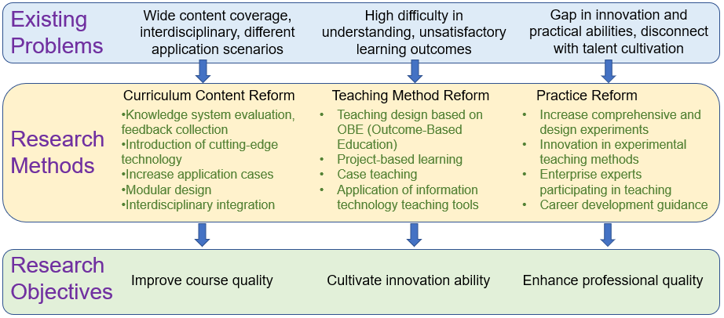

**Fig. 1. Conceptual framework of the "Modern Sensing and Control Technology"**

3. Methods of Curriculum ReforM

**3.1 Course Content Reform**

Introduce the latest advancements in modern sensing and intelligent control technologies, including tactile sensors, chemical sensors, wearable sensors, and intelligent control systems, among other cutting-edge technologies. Specific measures include:

1. Introduced AI-driven technologies such as machine learning algorithms for sensor data analysis and predictive maintenance. Updates will include advanced emerging sensor technologies, Internet of Things (IoT) technologies, artificial intelligence (AI), deep learning algorithms, and other innovations currently in the exploratory stage.
2. Expanded IoT applications and real-time signal processing to connect theoretical knowledge with industry requirements. These cases may cover various practical engineering domains, such as system integration and automation, robotic intelligent control, and intelligent manufacturing.
3. Modular course structures now include "AI in Control Systems" and "Data Analytics for Sensors." Each module can focus on a specific technical field or application scenario, enabling students to freely combine modules and encouraging their innovative thinking.

**3.2 Teaching Method Reform**

Outcome-Based Education (OBE) now incorporates programming exercises with Python and MATLAB for data simulation and analysis. These methods include defining learning outcomes and teaching activities, implementing project-based learning, and conducting analysis and discussions of classic cases. Specific measures include:

1. Defining learning outcomes and designing teaching activities. Learning outcomes should be specific, measurable, and reflect students' comprehensive development in knowledge, skills, and attitudes. Students are expected to design and implement basic control systems, analyze and solve real-world engineering problems, and demonstrate teamwork and communication skills. Teaching activities are diversified, incorporating experiments, projects, and case analyses to ensure students apply their knowledge in practice, thereby improving their problem-solving abilities.
2. Implementing project-based learning. Project-Based Learning (PBL) focuses on designing intelligent systems using AI models and integrating IoT devices, enhancing their ability to transition from theoretical learning to practical application while fostering innovative thinking.
3. Case studies on real-world applications of AI in intelligent manufacturing and smart systems are emphasized. Students analyze and discuss real-world engineering cases to strengthen their ability to apply theoretical knowledge to practical scenarios and solve actual problems. This approach also enhances their analytical skills and their ability to integrate and apply knowledge comprehensively.

**3.3 Practice Reform**

By strengthening the development of open laboratories and fostering school-enterprise cooperation, students’ engineering practice abilities can be enhanced, helping them plan their careers early and improve their professional qualities. Specific measures include:

1. Practical sessions include experiments on data preprocessing and predictive analytics using TensorFlow and PyTorch. Design-oriented experiments, on the other hand, allow students to achieve experimental objectives through modular and independent design, fostering their innovative thinking and ability to solve complex practical problems.
2. Virtual simulation labs enable real-time algorithm testing and refinement for control systems. Experimental teaching incorporates virtual simulation experiments and open experiments. Virtual simulation experiments leverage high-performance computers to simulate complex experimental processes, offering efficient, safe, and convenient experimental operations and validations. Open experiments provide flexibility in scheduling experimental time and content, enabling both theoretical verification and exploratory experimental research.
3. Enhanced collaboration with industry through workshops on computational tools and AI-driven diagnostics. Invite industry experts to participate in course teaching through various forms such as lectures, seminars, enterprise visits, and training. These activities allow experts to share computational tools and AI industry technologies and practical experience with students. Through school-enterprise collaboration, students gain a better understanding of industry trends and demands, enabling them to plan their careers early, enhance their employment competitiveness, and improve their professional qualities.

4. Application and Examples in Curriculum RefoRM

**4.1 Updating the Cutting-edge Technologies**

Cutting-edge modern sensor technologies have been incorporated into the course content, covering some of the most advanced sensor technologies available today. The curriculum introduces wearable sensors and AI-based algorithms for tactile data analysis. For example, a neural network-driven tactile sensor system for texture recognition is explored, enhancing students' understanding of sensor-AI integration.

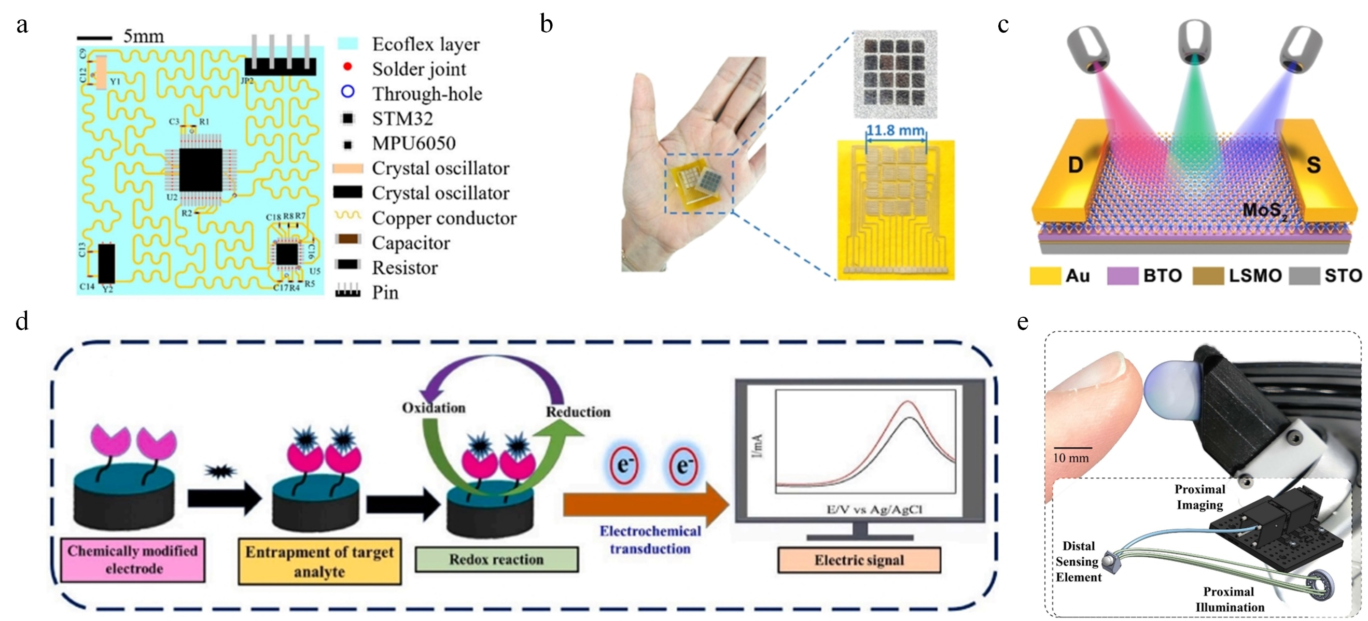

**Fig. 2. (a) A wearable flexible acceleration sensor, (b) Laser-induced-graphene-based tactile sensors, (c) A robust neuromorphic vision sensor, (d) Scheme of chemically modified electrode and detection mechanism, (e) Miniaturize vision-based tactile sensors**

The updated cutting-edge content in the curriculum is illustrated in Figure 2. Figure 2(a) showcases a wearable flexible accelerometer, designed by integrating circuits with flexible materials, allowing it to conform to human skin for efficient daily activity monitoring [20]. Figure 2(b) depicts a tactile sensor based on template laser-induced graphene (TLIG), utilizing a deep neural network to identify object characteristics and achieve high-efficiency tactile perception [21]. Figure 2(c) presents a neuromorphic visual sensor based on phototransistors, whose light-adjustable synaptic functionality significantly enhances visual preprocessing capabilities [22]. As shown in Figure 2(d), an enzyme-free indirect detection sensor employs a stable indirect detection method to enable efficient and reliable pesticide residue detection [23]. Lastly, Figure 2(e) features a tactile sensor miniaturized using optical fiber bundles, offering the combined advantages of high spatial resolution and extremely fine force resolution [24].

**4.2 Student Project Design**

Student projects now include designing IoT-enabled systems with cloud-based data analytics. One project developed a wall-climbing robot equipped with AI-enhanced fault detection algorithms.

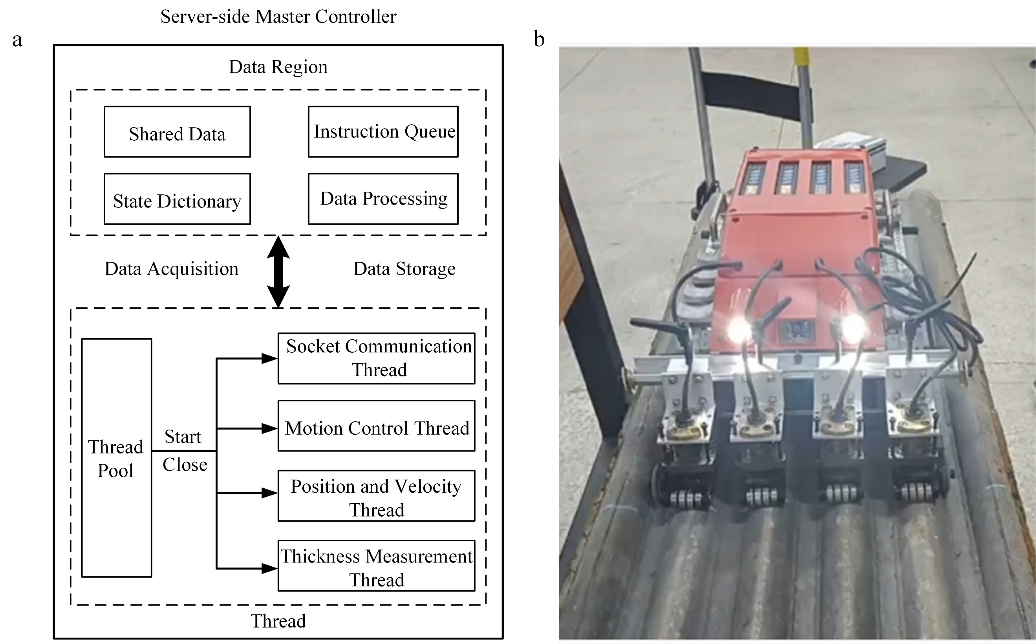

**Fig. 3. (a) Programming of robot main controller, (b) Wall-climbing robot**

The students designed a wall-climbing robot to address issues in the inspection of boiler water wall tubes using innovative technology. The wall-climbing robot is equipped with a temperature sensor, an incremental photoelectric shaft angle encoder, and a pen-type electromagnetic ultrasonic thickness gauge. The temperature sensor monitors the pipeline temperature in real time to prevent high temperatures from damaging the robot; the incremental encoder accurately measures speed and position; and the electromagnetic ultrasonic thickness gauge measures the pipeline thickness with high sensitivity. The control system employs the MVC framework, C/S architecture, and modular multi-threaded design concepts to ensure the coordinated operation of each sensor and module, as shown in Figure 3(a). The physical design of the wall-climbing robot is illustrated in Figure 3(b), demonstrating its capability to monitor the pipeline.

Another student design project is a vibration signal acquisition system for mechanical fault diagnosis, as shown in Figure 4. With STM32F407 at its core, the system uses a three-axis accelerometer ADXL345 to collect acceleration signals and performs time-domain integration and Fourier transform through STM32 to display acceleration, velocity, displacement, and spectral information in real time (Fig. 4(b)). The data is stored on an SD card and transmitted to a host computer via the SPI bus for analysis. By acquiring the vibration signal of the device and performing the Fourier transform, the total vibration level is calculated. The amplitude spectra of PT-H and PT-A are shown in Fig. 4(c) and Fig. 4(d), respectively. This method evaluates the energy distribution over a specific frequency range to help determine the operating status of the equipment and the location of the fault.

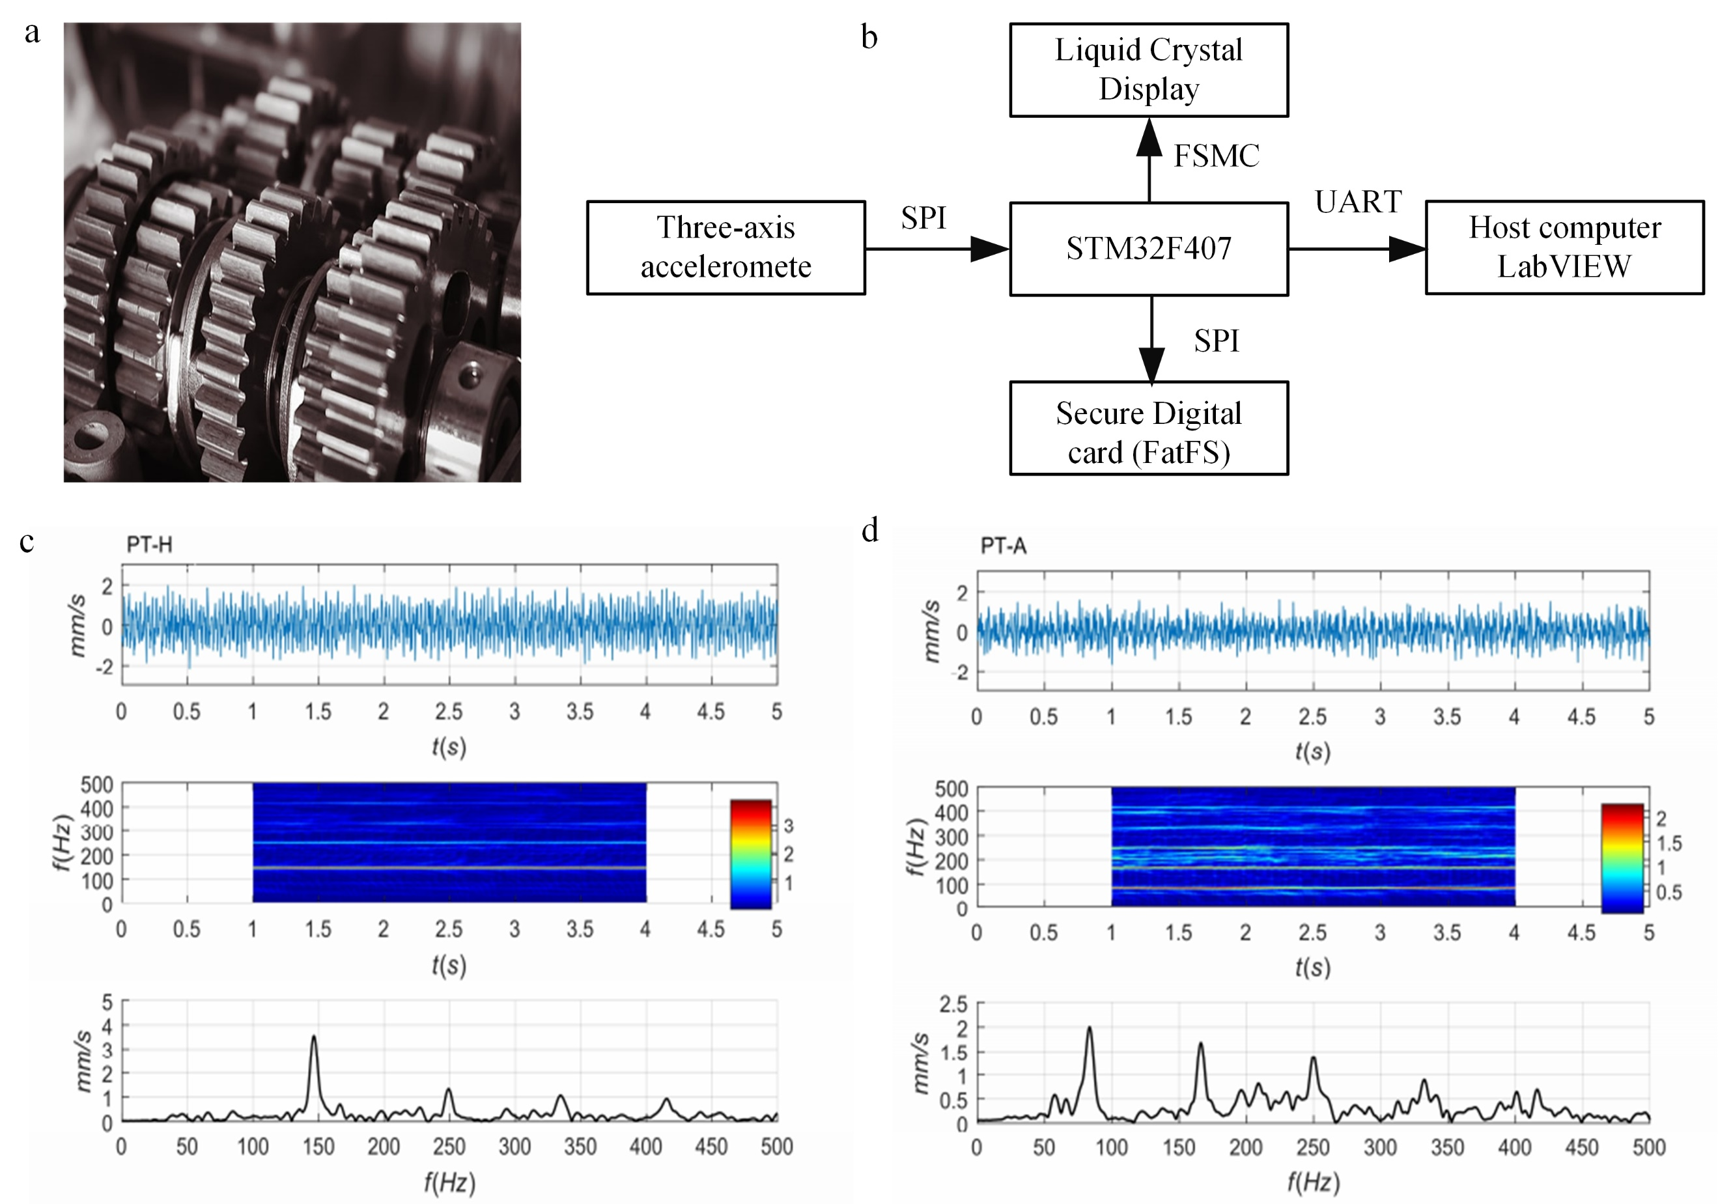

**Fig. 4. (a) Application Scenarios of Mechanical Fault Diagnosis Technology, (b) Hardware Design of Vibration Signal Acquisition System, (c) Amplitude spectrum of measuring point PT-H, (d) Amplitude spectrum of measuring point PT-A.**

Through project design, students can deeply explore the technical fields of their interest, conduct system design and hardware construction, and cultivate their ability to integrate the knowledge they have learned. This approach fosters innovative thinking and practical skills, laying a solid foundation for their subsequent scientific research work.

**4.3 School-Enterprise Cooperation**

Collaborations with industry now feature workshops on using computational platforms for system diagnostics. Students gain hands-on experience in deploying AI models to solve real-world problems. University-industry collaboration enables students to gain an in-depth understanding of industry trends and demands, plan their careers in advance, and enhance their employability and professional skills. Through cooperation with enterprises, students can gain practical work experience, learn about the latest technologies and industry standards, and better adapt to their future career development.

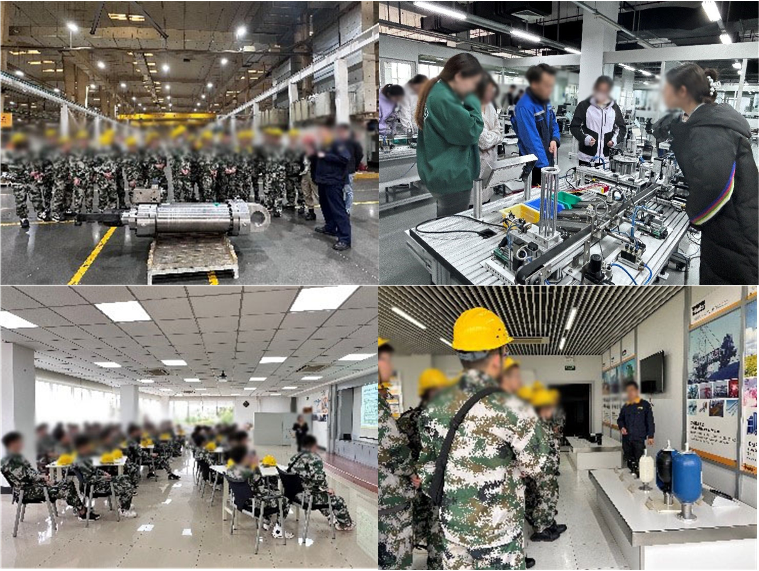

**Fig. 5. Students visit the company's R&D laboratory.**

We invited experts from technology companies to participate in the teaching, introducing the company's industry background and core business, and sharing the current employment environment and career development trends in the fields of intelligent manufacturing, mechanical control, intelligent algorithms, etc. The students were taken to visit the company's R&D laboratories and production lines to learn about the latest system hardware and technical tools. The students were able to participate in specific engineering projects in depth and improve their practical skills (Figure 5). This series of training and practical activities not only improved the practicality and applicability of the course but also enhanced students' hands-on ability and innovative thinking. It also increased students' interest and enabled them to spontaneously carry out their own career planning.

**4.4 Summary of Curriculum Reform Implementation and Effectiveness**

This study systematically addresses the reform and optimization of the “Modern Sensing and Control Technology” course within the framework of New Engineering Education. The reform targeted three core areas: curriculum content, teaching methodologies, and practical components, aiming to cultivate high-quality engineering talents with strong innovative and practical capabilities. Advanced technologies—including sensor systems, data acquisition and processing, and intelligent control—were integrated into the curriculum. An Outcome-Based Education (OBE) framework guided the implementation of diversified instructional strategies such as project-based learning and case-based teaching. Practical components were reinforced through comprehensive and design-oriented experiments, complemented by extensive industry collaboration to strengthen students’ engineering practice and employability. To evaluate the effectiveness of the reform, data were collected from graduate students enrolled in the course at Tianjin University of Technology. Student achievement was measured via coursework, examinations, and project outcomes. Satisfaction was assessed using structured Likert-scale questionnaires focusing on curriculum content, teaching methods, and practical exercises. Statistical analysis was conducted to compare pre- and post-reform performance, ensuring the validity of the evaluation.

Following the implementation of these reforms, significant improvements were observed in both student learning outcomes and satisfaction levels, as detailed in Table 1 and Table 2. Notably, the greatest gains were recorded in practical components, underscoring the critical role of hands-on experience and real-world application in enhancing engineering education effectiveness.

**Table 1. Comparison of student achievement before and after curriculum reform**

| **Course Objectives** | **Reform Measures** | **Before Reform Achievement** | **After Reform Achievement** | **Percentage Increase** |
| --- | --- | --- | --- | --- |
| Master basic concepts and methods of sensing and detection technologies | Updated curriculum content with cutting-edge technologies | 0.72 | 0.85 | 18.06% |
| Develop the ability to analyze complex engineering problems | Innovative teaching methods: Project-based and case-study teaching | 0.71 | 0.84 | 18.31% |
| Improve experimental skills and innovative thinking | Enhanced practical training: Comprehensive and design-oriented experiments | 0.69 | 0.83 | 20.29% |

**Table 2. Comparison of student satisfaction before and after curriculum reform**

| **Course Objectives** | **Reform Measures** | **Before Reform Achievement** | **After Reform Achievement** | **Percentage Increase** |
| --- | --- | --- | --- | --- |
| Master basic concepts and methods of sensing and detection technologies | Updated curriculum content with cutting-edge technologies | 0.74 | 0.86 | 16.22% |
| Develop the ability to analyze complex engineering problems | Innovative teaching methods: Project-based and case-study teaching | 0.75 | 0.89 | 18.67% |
| Improve experimental skills and innovative thinking | Enhanced practical training: Comprehensive and design-oriented experiments | 0.73 | 0.89 | 21.92% |

The data indicate substantial improvements across all evaluated metrics. Notably, practical training exhibited the greatest improvement, underscoring the critical role that hands-on experience and direct engagement with real-world engineering scenarios play in enhancing student capabilities. Among all evaluated parameters, practical training components exhibited the highest improvement rates (20.29% achievement, 21.92% satisfaction). This significant rise underscores the critical importance of experiential learning and practical applications in enhancing engineering education effectiveness. It suggests that direct engagement with real-world scenarios considerably strengthens students’ abilities to integrate theoretical knowledge with practical skills, emphasizing the pivotal role practical education plays in engineering disciplines.

To sustain these positive outcomes, it is essential to continually update curriculum content and teaching methods to align with evolving industry needs. Future research should focus on developing long-term industry collaboration frameworks to ensure ongoing relevance and effectiveness of the curriculum, further enhancing students' innovative and practical capabilities.

For ongoing and future curriculum enhancements, establishing systematic, long-term industry partnerships and regularly updating curriculum content to reflect evolving technological trends is crucial. Further research should explore innovative assessment methodologies and feedback systems to continually refine educational practices. Additionally, expanding interdisciplinary collaboration among different engineering and technological domains can significantly broaden students’ academic horizons and practical skills, preparing them comprehensively for future technological developments.

5. Conclusion

Aiming at curriculum innovation and practice under the 'industry-university-research collaborative training' model, the 'Modern Sensing and Control Technology' course has effectively enhanced students' understanding and practical skills by optimizing course content, refining teaching methodologies, and reinforcing practical training. Integrating AI and computational tools significantly aligns the curriculum with contemporary engineering demands, equipping students with advanced computational and problem-solving competencies. This prepares students effectively for leadership roles in intelligent systems and interdisciplinary projects, establishing a benchmark for future engineering education reforms.

To sustain and further enhance these positive outcomes, continuous updates to the curriculum content and teaching strategies are essential. Ongoing collaboration with industry experts should be prioritized, ensuring that curriculum remains relevant and responsive to emerging technological trends and market needs. Future research should explore long-term frameworks for integrating cutting-edge technology developments and pedagogical innovations systematically. Additionally, establishing robust assessment mechanisms and feedback systems will facilitate continuous improvement and maintain high standards of educational excellence. These strategies will not only uphold but also advance the effectiveness and sustainability of the curriculum reforms, thereby continuing to cultivate high-quality engineering talents capable of meeting evolving societal and industrial challenges.

Competing Interests

Authors have declared that no competing interests exist.

References

1. Haiyun W., Yong W., Yanhong D., Yuan L., & Xiaoying G. Construction of Practical Teaching System of Measurement & Control Technology and Instrument Major based on CDIO Engineering Education Mode. Proceedings of the 2017 International Conference on Education Science and Economic Management (ICESEM 2017). 2017: 572-575.
2. Wang W., & Wu X. (2018). Reform and practice of teaching a sensor technology course based on engineering concepts. International Journal of Continuing Engineering Education and Life Long Learning, 28(3-4), 358-372.
3. Singh B., & Kaunert C. (2024). Computational Thinking for Innovative Solutions and Problem-Solving Techniques: Transforming Conventional Education to Futuristic Interdisciplinary Higher Education. In: M. M. Fonkam, N. R. Vajjhala (Eds.), Revolutionizing Curricula Through Computational Thinking, Logic, and Problem Solving (60-82), IGI Global, Hershey, PA, USA.
4. Li Q. (2021). Computational thinking and teacher education: An expert interview study. Human Behavior and Emerging Technologies, 3(2), 324-338.
5. Tembrevilla G., Phillion A., & Zeadin M. (2024). Experiential learning in engineering education: A systematic literature review. Journal of Engineering Education, 113(1), 195-218.
6. Prince M. J., & Felder R. M. (2006). Inductive Teaching and Learning Methods: Definitions, Comparisons, and Research Bases. Journal of Engineering Education, 95(2), 123-138.
7. Braun D., & Huwer J. (2022). Computational literacy in science education–A systematic review. Frontiers in Education, 7 (2022): 937048.
8. Li Ying Y. (2020). Teaching Reform Practice of Sensor and Detection Technology Course Based on Engineering Education Certification. DEStech Transactions on Social Science, Education and Human Science icesd.
9. Lv D., & Zhang Y. Teaching Reform and Practice of “Sensor and Detection Technology” Course Based on “Specialty and Innovation Integration” and Project-Based Education. Advances in Computer Science for Engineering and Education VI. 2023: 1033-1045.
10. Xu D., Zhao Y., Zhou X., & Li N. (2020). Research on innovative personnel training system of measurement and control specialty under the background of engineering education professional certification. Open Journal of Social Sciences, 8(3), 205-216.
11. Yang C., Chen S., Huang H., Ji J., & Wang X. The Sensor and Detection Technology Educational Reform Facing to Engineering Education Accreditation Standards. 2022 41st Chinese Control Conference (CCC). 2022: 7551-7554.
12. Nan J., Zheng K., & Wang J. Research on the Reform of Sensors and Automatic Detection Technology Courses based on IOT Environment. 1st International Symposium on Innovation and Education. 2019: 362-365.
13. Song Z., Shao X., Chen H., & Lu M. Reform of the Experimental Teaching Mode of the Course “Sensor and Detection Technology” Under the Background of Engineering Education. Proceedings of the 4th International Conference on Education, Knowledge and Information Management. 2023.
14. Yen T.-F. (2020). The Performance of Online Teaching for Flipped Classroom Based on COVID-19 Aspect. Asian Journal of Education and Social Studies, 8(3), 57-64.
15. Anselmann S., Faß U., & Windelband L. (2024). Investigating Learning Factories as a Learning Environment in Vocational Education and Training. Creative Education, 15(7), 1337-1358.
16. Li Yinping P. Y. (2022). Research on Practical Teaching Rreform based on School-enterprise Cooperation. The Theory and Practice of Innovation and Enntrepreneurship, 5(8), 188-190.
17. Mian S. H., Salah B., Ameen W., Moiduddin K., & Alkhalefah H. (2020). Adapting Universities for Sustainability Education in Industry 4.0: Channel of Challenges and Opportunities. Sustainability, 12(15).
18. Mudriadi W., Yahya M., & Supriadi. (2024). Effectiveness of Project-oriented Problem-based Learning (POPBL) in Manufacturing Product Design for Vocational Higher Education. Asian Journal of Education and Social Studies, 50(2), 31-42.
19. Chunyue P. (2022). Teaching Reform of ＂Sensor and Detection Technology＂ Based on Online Open Course. International Journal of Social Science and Education Research, 5(12), 91-95.
20. He Z., Wang K., Zhao Z., Zhang T., Li Y., & Wang L. (2022). A Wearable Flexible Acceleration Sensor for Monitoring Human Motion. Biosensors, 12(8), 620.
21. Ji J., Zhao W., Wang Y., Li Q., & Wang G. (2023). Templated Laser-Induced-Graphene-Based Tactile Sensors Enable Wearable Health Monitoring and Texture Recognition via Deep Neural Network. ACS Nano, 17(20), 20153-20166.
22. Du J., Xie D., Zhang Q., Zhong H., Meng F., Fu X., et al. (2021). A robust neuromorphic vision sensor with optical control of ferroelectric switching. Nano Energy, 89 106439.
23. Abedeen M. Z., Sharma M., Singh Kushwaha H., & Gupta R. (2024). Sensitive enzyme-free electrochemical sensors for the detection of pesticide residues in food and water. TrAC Trends in Analytical Chemistry, 176 117729.
24. Di J., Dugonjic Z., Fu W., Wu T., Mercado R., Sawyer K., et al. (2025). Using Fiber Optic Bundles to Miniaturize Vision-Based Tactile Sensors. IEEE Transactions on Robotics, 41 62-81.