Educational Conditions of Climate Migrants: A Study on Slum Children in Dhaka City

Abstract
Climate Change creates one of the greatest developmental challenges of the current era. Bangladesh, since most of the children of migrants of the school going age are being left in the village when one or both of their parents move to the city. Climate migrants who have started living in urban slums are in search of a better and more secure life. This paper is a descriptive type of qualitative study conducted in Dhaka to explore the socio-economic status and educational condition of climate migrant children of slum people. The target groups for the interview are the mothers of the children who are supported to be well informed about children’s lifestyle while the purposive sample size was 50. This study also investigated the government and non-government programs for slum children. The study conducted at one of the slums of Dhaka with observation, KII, and semi-structured interview schedules were used for selected climate migrant slum dwellers. Protected socioeconomic support and planned migration are suggested in this paper to explore further poverty and educational insecurity of the urban poor.

Keywords: Climate change, migrants, slum dwellers, education.

- Introduction
Bangladesh has a long history of migration within the country and beyond. Migration to urban areas is an ordinary fact but over recent years there has been an issue of concern that climate-induced displacement is forced to migrate to cities. Bangladesh is one of the most vulnerable countries facing the adverse effects of climate change, including migration (Sikder, 2015). Bangladeshi citizens have been focused on migrating out of their communities due to climate change-induced pressures such as more frequent extreme weather events, rising sea levels, soil salinity, and flooding (Ismail, 2016).

These poor migrants regularly turn to slums and squatter settlements for shelter. All major urban centres in Bangladesh have slums, but the largest attentions are in Dhaka city (Mahamud, 2007). In accumulation, they appear to be a subset of households that are extremely poor and for whom even relatively low education costs can be too expensive. However, there is an earlier problem that slum populations are minimally not documented in the formulation of policy or educational planning (Mahamud, 2007).

According to a UNESCO (2010) report, educational information for slums in Dhaka city is among the most terrible in the South-Asian Country. Allowing for the overall educational situation in the slums of Dhaka, a challenge has been made in this study to know the scenario of education of the slum children in Dhaka city and how families in slums make decisions about schooling, which are related to their economic, social, and migration background. Their aspirations and expectations concerning their children’s futures about education.

However, as this study explains, slums are a long-standing and considerable part of Dhaka that will not cleanly withdraw. Moreover, slum dwellers and their children play a progressively more important part in Bangladesh’s growing economy and should be invested rather than ignored.

- Objectives of the Study
- To know the socio-economic status of climate migrant slum dwellers.
- To identify reasons of migration for the settlement of urban slums.
- To identify and investigate the government and non-government education programs of slum children.
- To disclose the factors responsible for obstructing the way of elevating the poor urban slum dwellers from the child education condition.

- Rationale of the Study
The problems of access to education faced by slum dwellers are elemental. There are extensive areas lacking access to any government school and which are too poor for even the lowest cost private provider. Urban migration is aggravating the problems. The percentage of children who never enroll in school in the urban sample (15%) is double that of the rural sample. One in the ten pupils who are enrolled drop out before reaching Grade 5. A large proportion of children are ‘silently excluded’ from education, who attend infrequently repeat years of schooling, and have poor achievement. Upon achieving primary education, very few children from these slums make the conversion to secondary schooling (Cameron, 2010).

According to statistics from the Local Government Engineering Department (LGED), 26% of slums have a government school; 27% have an NGO-operated school (Baker, 2007). According to the Centre for Urban Studies survey (CUS et al., 2006), 11% of Dhaka slums received services from one NGO, and 59% from more than one. Bangladeshi 5 NGOs have traditionally had a strong focus on how to expand their provision to the growing population of poor urban people. Thirty NGOs were reported to work in Dhaka in 2003; the Coalition for the Urban Poor, an umbrella organization of Urban NGOs, has 44 members (Baker, 2007).

Many people living in slums are migrants from rural areas. For instance, in the Aparajeyo study, 42% were recent migrants and their children would possibly have attended primary school in rural areas. The same study found that after migration the rate of attending primary school had deteriorated in slum areas (Aparajeyo, 2005). Besides, Limitations to access to education their precarious work and living conditions make them a particularly vulnerable group (Cameron, 2010).

In the context of Bangladesh, the climate migrant slum children education related researchers are limited. Specially, the urban trends are practically absent. So, this paper can be helpful to academic learners, professionals and further researchers to enrich their knowledge, social programmers, policymakers and urban planners can get help from this study. This researcher will help take preventive measures against climate change migration and helpful for the mother to save their children from the downside of lacking of education. Once more, different government and non-government organizations can get instructions against climate change movement from this study.

Assume that, this study confidently can open a new path for further research on the study of poverty and adaptation of slum dwellers in urban living. Expectantly, it will be able to help to solve multidimensional problems and can enhance its literature, so that people can get the actual image of the urban region in the context of Bangladesh.

- Literature Review
A survey (Rashid and Hossain, 2005) of NGOs and donors about delivering services in slums in Bangladesh found a host of barriers. Donor agencies such as UNICEF recognized the problem of incapability to provide enough for the slum population. NGO interviewees acknowledged the lack of suitable infrastructure which is a key constraint to education service arrangements in slums. The children in slum areas who need to do work may face problems because government schools usually have no scheme to compromise the volume of urban slums students in their areas and the number of schools was stated to be far too low compared to the number of children. There were some physical difficulties in NGO education centres like drainage and flooding problems during the monsoon seasons. Besides, the face of local gang violence was another barrier to attendance in slum schools. The interviewees in Rashid and Hossain’s study identified three major constraints: lack of policy providing specially for the urban poor; expulsion of slum residents; and the role of mastaans. The government was usually unwilling to take responsibility of households who were residing in an area illegally. Those NGOs invest to set up permanent structures for schools that face problems. Slums are controlled by local leaders known as mastaan who have liked political leaders and local police. Slums are controlled by local leaders known as mastaan who have linked with political leaders and local police. When NGOs need to set up services in slums, must have to gain permission from those mastaas (Cameron, 2010).

According to Household Income and Expenditure Survey data from 2000 reported in Baker (2007), households in the poorest quintile expend the large volume of their income on food and 3.2% of total income on health and education in Dhaka. Whereas total expenditure is also very low, thus quartile health and education expenditure amount to only around TK. 20 (US$ 0.29) per household member per month. In this poorest quintile this expenditure is also a large number of children because the quantity of children is higher. Some of the government schools pay of up to Tk 100 per learner per month 5.5 million rural students, the families of these areas aware to send their children to school UNICEF, 2009). It had little outcome on educational distinctions (Al-Samarrai, 2009) and an assessment of in the impact of the programme during 2000 to 2006 advise that it had negligible impact on school enrollments or household expendetures (Baulch,2010).

For example, Shafiq (2007) find out the ratio of return to primary school of approximately 14%. Asadullah (2006) recommends around 7%, which is lower rate but finds higher rates for urban than rural areas. However, school education possibly is more important than money, training, social link and make qualified to search (Hossain, 2005; Opel, 2000). Recently migrant households who were livings in slums specially lack these resources.

The research by Cameron (2009) represents households concerned about the aspirations and expectations connecting their children’s futures, as a result, they take decisions about the schooling of their children and its relation with economic, social, and migration backgrounds. The approach is generally consequent from the economics of returns to education and thinks that parents and children make balanced decisions about where or not a child will go to school. And this approach is not only for how long and think about the results in the light of human and social capital theories but also ideas about the duplicate of social class through schooling. Whereas, Algeria (2007) has shown that the impact of Non Formal Education (NFE) program on working children’s lives in Bangladesh taking into consideration the principle of the “best interest of the child” and assuming the importance of ‘educational opportunities’ which are as challenging child labour and allowing children to make informed rational choices. Mainly he focused on both working and studying children in the 9-14 years age group, living in urban slums through NFE programs. At last, it is realized the structured intervention is necessary for children that mentioned above principle in the study context and to assurance their continuing education in order to really change their lives. On the other hand, Cameron (2010) demonstrated that urban slum dwellers in Bangladesh are at least as marginalized as the rural poor. Though national, international NGOs and the Government of Bangladesh has ready to concert and innovative policy efforts to include the rural poor in education through alternative education, stipend schemes, and school building programmes, on the other hand, these interventions have been extended on the same scale to the growing numbers of the urban poor. Though the problems of access to education faced by slum dwellers are fundamental, the slum dwellers have come from villages many of them have been living there for a long time (Kadir, 1975). They create various problems in the lifestyle of urban people, afflict the urban economy in various ways and are apically blamed for the unemployment problem of urban. The immigrant people of rural areas bring a huge burden of rural poverty (Mozumder, 1992).

Previous studies have written about migrant people’s present condition of slum areas in Dhaka city, but they did not mention the education condition of slum children after migrating because of climate change. From this perspective, this paper study on the illustration of the education of urban slum children and discloses the factors responsible for obstructing the way of elevating the poor urban slum dwellers from the child education condition.

- Research Methodology
It was a descriptive type of quantitative study carried out from November 2017 to February 2018. General information was collected from the Jilpar Slams Shahjadpur area of Dhaka. A purposive sampling technique was adopted. A total of 50 participants were interviewed. The target group of the respondents was mothers of the children who were supposed as well informed about children’s education and living conditions. For this research, the target age group of children has taken from 4 years to 15 years. This research has been conducted with the respondents as well as key informants at certain points of the migration routes of climate change. A multi-data collection technique is implied such as observation and face-to-face interviews with the respondents. KII (key Informant Interview) has been applied to collect information about respondents’ current socio-economic situation and their children's educational condition who have moved to urban as slam dwellers. It is very crucial to select a sample size based on the total population of the study area. That is, the number of samples to be interviewed among the total population of the selected slum should have been selected using purposive sampling that will be perfectly appropriate to represent the entire slum’s climate migrant children’s education condition. The selection of 50 respondents is convenient, not time-consuming, cost-effective and attainable in this study. A pre-tested, modified, semi-structured, self-administrated interview schedule was designed based on the climate migrant people in the area to collect the information. All respondent’s data outcomes have been analyzed by frequency distribution and processed with the help of Excel (2019 version) and the data have been measured with numerical value against each item of the variable. Data were checked and edited properly before entry and analysis. Multi-variant tables and figures (pie charts, bar charts, etc.) are used to present different data presentations.

Table 1: Matrix of Research Method
Objectives | Data source | Method | Tools and technique
The socio-economic status regarding the climate migrant slum dwellers | Mothers of the children and neighbours | purposive sample survey | Observation,  Face-to-face interview with semi-structured interview schedule
The reason for migration for the settlement of urban slam | Mothers of the children | Purposively selected | Interview schedule and KII
The government and non-government education programs for slum children. | Newspapers, books, journals, websites, and annual reports of GO and NGO, etc. | Documentation | Reviewed literature
Educational condition of Jilpar slum children | 4 years to 15 years children and their mothers | purposive sample survey | Interview schedule and KII
The factors responsible for abstracting the poor urban slum dwellers from uplifting their child education condition | Mothers of the children and authority person of one NGO school and One GO school in selected slum area | Purposively selected | Interview schedule and KII

Location of study area
The area of Jilppar slum located at shahjadpur nearby Shahjadpur Lake beside Manarat International University. It is situated under Dhaka North City Corporation, shshjadpur is a ward under number 18 (fig1).
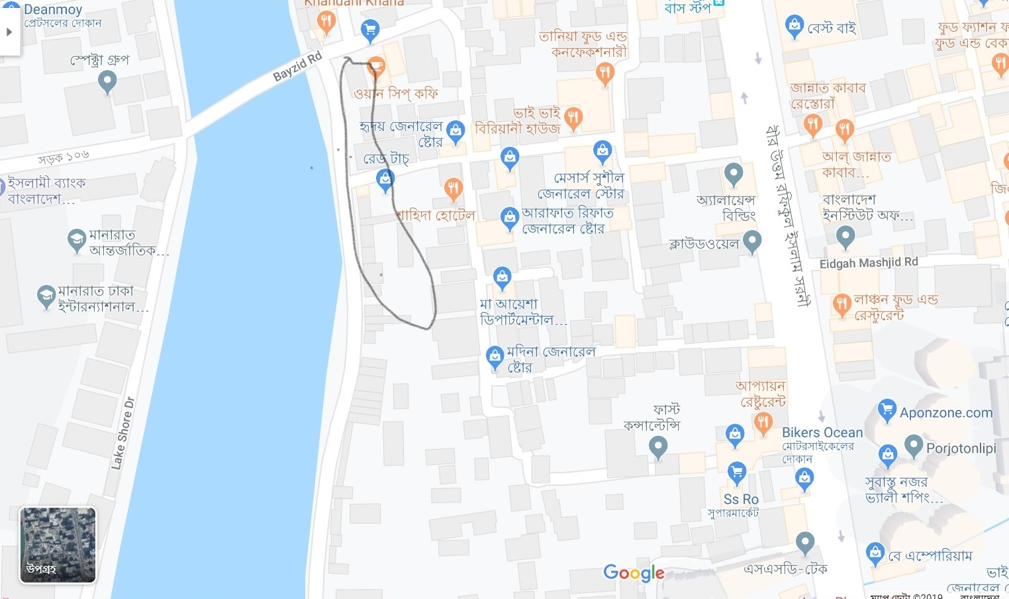
Fig 1: Jilpar slum Shahjadpur

The School System in Bangladesh
There are many types of primary school in Bangladesh. Most common are government primary schools (GPS), which accounted for around 55% enrolments in 2005 (BANBEIS, n.d.). Registered non-government primary schools (RNGPS) are privately operated but largely government funded. A large number of NGOs, most famously BRAC, engage in education provision, running an estimated 30,000 classroom. Primary grades may be attached to government or private secondary schools, usually without government support (Ahmed et., 2005).
Table 2: Number of institutions providing Pre Primary Education by types of School
Division | General Primary School (GPS) | Newly Nationalized Primary School (NNPS) | Registered Non-Government Primary School (RNGPRS) | Non- Registered Non-Government Primary School (NRNGPS) | Experimental  School | Ebtedssyee Madrasa | Community School | Others School | Total
Dhaka City | 10,126 | 5212 | 29 | 301 | 1 | 245 | 28 | 11268 | 27210
Source: Annual Primary School Census, 2015
Table 3: Number of institutions providing Primary Education by types of School
Division | General Primary School (GPS) | Newly Nationalized Primary School (NNPS) | Registered Non-Government Primary School (RNGPRS) | Non- Registered Non-Government Primary School (NRNGPS) | Experimental  School | Ebtedssyee Madrasa | Community School
Dhaka City | 315811 | 40927 | 362 | 2363 | 0 | 6824 | 628
Note. Annual Primary School Census, 2015
There are also a number of madrasa, some of which receive government funding, and small number of community, experimental and satellite schools and kindergartens.
Table 4: Educational institutions of the study area at Jilpar slams in Shahjadpur
Educational Institutions | Amount
Government high school | 1
Non-Government high school | 2
Government primary school | 1
Non-government primary school | 5
NGO school | 1
Madrasa | 4

- Analysis and Findings of the Study
The findings of the study have been described. The results have been made with obtained data and presented with tables, charts, diagrams, and other formats. Data collection from the field has been shown with tables and diagrams with a short description. The results obtained are shown below:
6.1 Types of migrants
A major portion (76%) of climate migrants migrated as a whole family. Whereas 24% of climate migrants migrated alone.
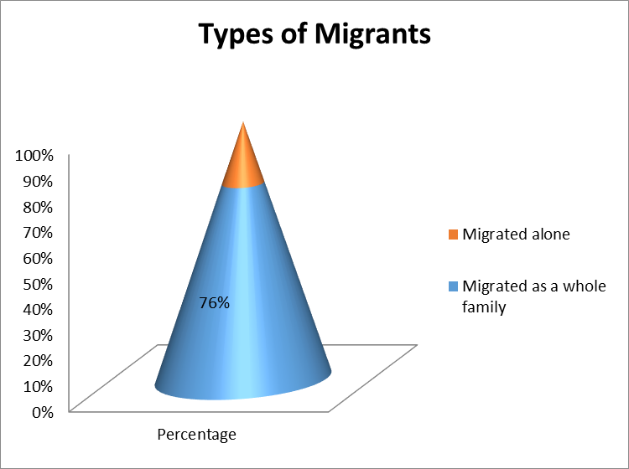
Figure 2. Types of migrants

6.2 Reasons for migration
During the study, it has been seen that 30% of the respondents migrated because of cyclone and no agriculture work available during the off-season (Mongra period). Among the respondents 20% of them migrated for the reason of river erosion.
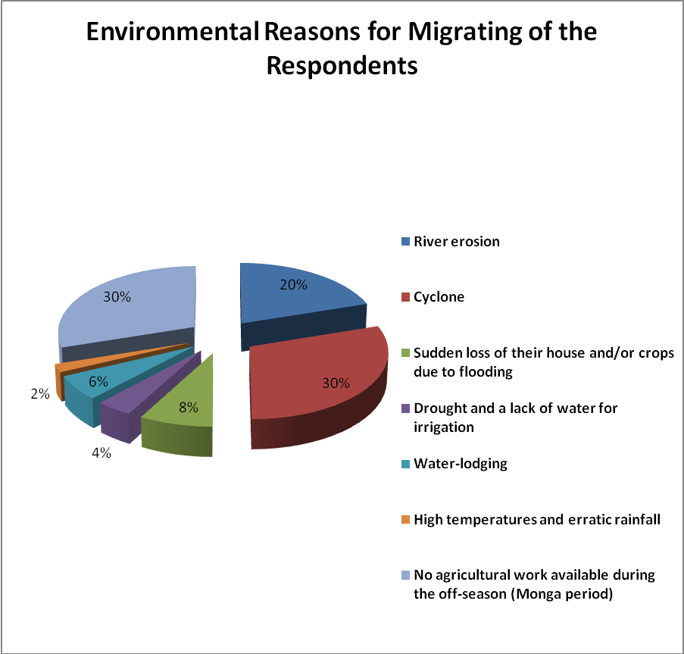
Figure 3. Reasons for migration

6.3 Size of family members
Among the respondents, the greatest proportion is that 50% of the respondents have to live with 7 to 9 person of family members.
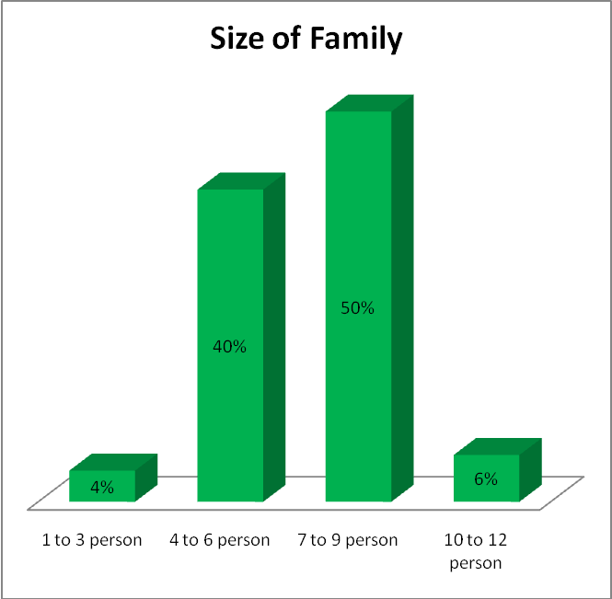
Figure 4 Size of family members

6.4 Income of household
According to survey data, 14% of household have income less than Tk.5000. On the other hand, 60.00% of households have income Tk. 10,000-< 20,000.
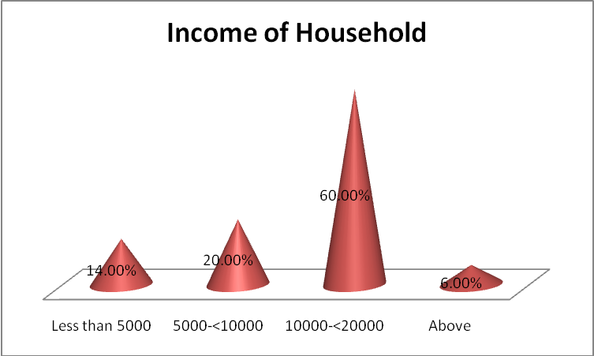
Figure 5. Income of household

6.5 Level of schooling of household head
Most of the urban poor are illiterate. 40% have never attended school, another 30% have attended primary school.

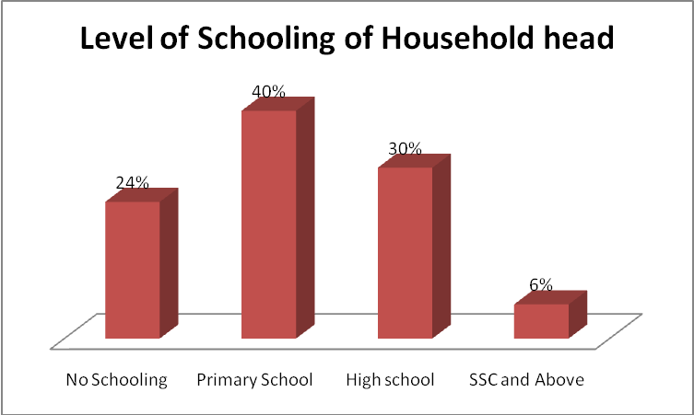
Figure 6. Level of schooling of household head
6.6 Occupational structure of the household’s head
According to the survey data, 30% of the respondents are employed in pulling Rickshaws in the city. Most of these rickshaw pullers are illiterate and have no formal education or employment training.

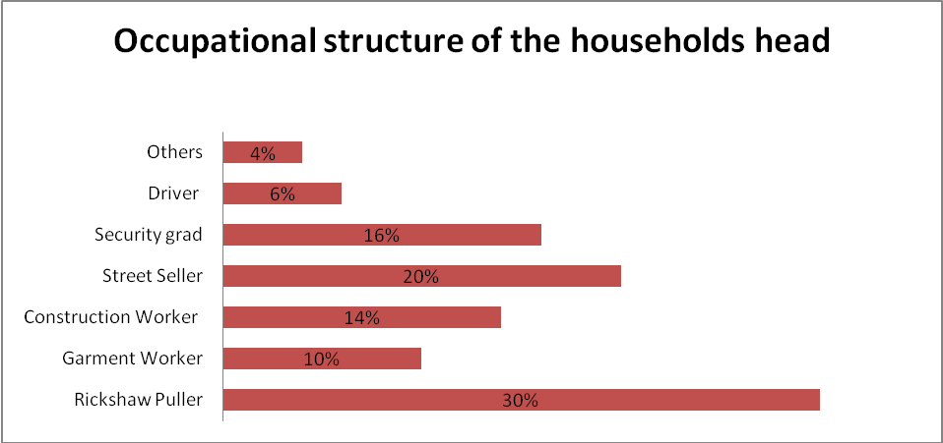
Figure 7. Occupational structure of the household’s head

6.7 Types of schooling
According to the survey data, 20 school going children as a sample from 50 respondents. A large portion of school going children at primary level in the slums surveyed were going to government primary schools. However, around 15 percent went to Madrasa.
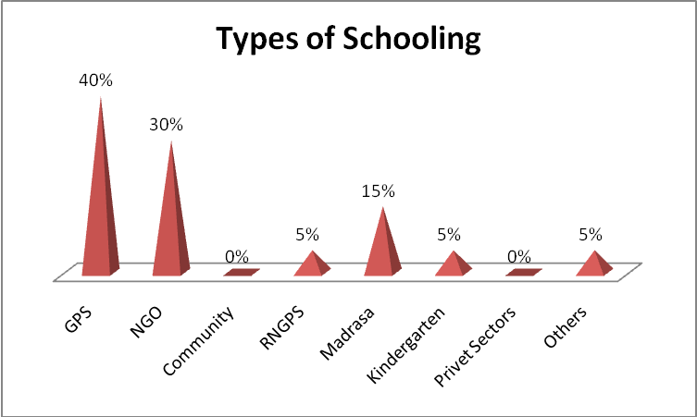
Figure 8. Types of schooling

Note. GPS=Government Primary School. NGOS=Non-Government Primary School. CS=Community School. RNGPS=Registered Non-Government Primary School. (N=20)

6.8 Expenditure in education
Here Sample size were 20. If primary education is free, however they need to pay extra cost to buy their exercise book, pencils, and tiffin but most of the children cannot study at primary school, so some children are going to NGO Schools and Madrasa also.
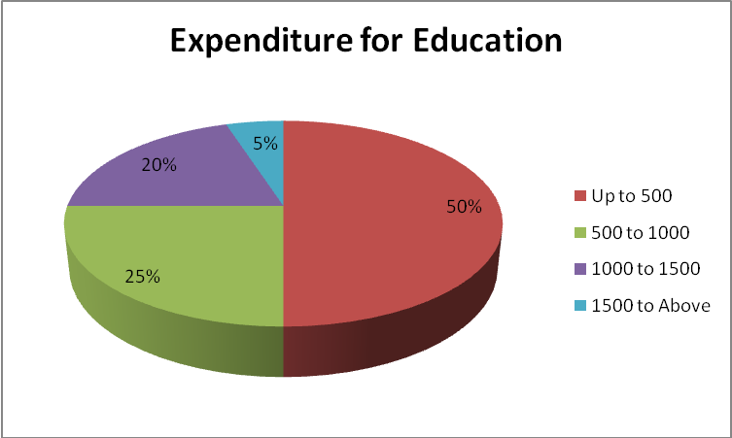
Figure 9. Expenditure in education (N=20)

6.9 Children’s school status according to age
According to the survey data, 20 school children a sample from 50. In the present study, it explains that in the study area, most of the children at ages 7-11 are ongoing in their study, most of the children at ages 11-14 are dropped out and most of the children at ages 4-6 are never enrolled.

Table 5: Children’s school status according to age
Age | Children’s School Status According to Age
Age | Ongoing | Drop out | Never enrolled
4 to 5 years | 4% | 0% | 96%
5 to 6years | 22% | 0% | 78%
6 to 7 years | 58% | 2% | 40%
7 to 8 years | 72% | 2% | 24%
8 to 9 years | 76% | 6% | 18%
9 to 10 years | 74% | 10% | 16%
10 to 11 years | 70% | 18% | 12%
11 to 12 years | 70% | 22% | 8%
12 to 13 years | 66% | 24% | 10%
13 to 14 years | 54% | 28% | 18%
14 to 15 years | 52% | 32% | 16%

- Discussion
First of all, even though they passed a long time of scientific disaster, still they are carrying the effect of that. 60.00% of households have an income of Tk. 10,000-< 20,000. Most of the urban poor are illiterate. They are employed as rickshaw pullers. Some of them are not capable of spending money after migration. By SDG 2030, ensure that all girls and boys complete free education. However, they are not much more aware of the continuation of their children's study after displacement. Some of the children have lost their inspiration because of migration.

The study found that the maximum number of respondents migrated because of cyclones, river erosion, and no agriculture work available during the off-season (Monga Period). Most of the respondents in this study belonged to the lower income group. They were unable to take preventive measures for disaster. They tried their best to stay in their homeland, however, when they started migrating towards the city. By SGD 2030, appreciation of cultural diversity and culture’s contribution to sustainable development, they try to adapt to the city environment.
The study states that the largest portion of school going children at the primary level in the slums surveyed were going to government primary schools. If primary education is free, they need extra costs for study tools. So, some children are going to NGO Schools and Madrasa also. It is expected that relevant parties can plan to meet the desires for educational support of children in slum areas to provide service according to the probable requirement. However, there is a need for proper training for sustainable results in the long run.

Last of all, the study result stands for improving the livelihood of climate migrant children are the focus of action before a disaster at national policy, planning, and programming. The sub-national operational level must include poverty alleviation programmes that address the needs of children and treat them as a priority group in education programmes. Besides, the highest support needs to be obtained from credit facilities by the government for education and support during natural disaster off time and increase awareness programs by GO, and NGO. By SDG 2030, all levels of education and vocational training for the vulnerable. GO and NGOs should invest more in vocational education for vulnerable groups of climate migrants. This paper suggests some recommendations for policymakers of the country to develop policies for climate migrated children.

- Ethical Considerations
The aim and purpose of the study were explained to the participants and then different questions were asked to them based on that they expressed their responses and comments. All the participants were given confidentiality before conducting the interview. The interview was conducted with privacy as much as possible. Alongside these, the study also tries to show respect to all participants in the same manner and maintain local norms, values, and believes.
In the part of building conceptual framework through using of literature review and secondary source of data in this study, there are some limitations in terms of ethical consideration. This study gave proper credit by using citation of their name through APA style of referencing rather than contacting the main author.

- Limitations of the Study
It is complicated to get access to information sometimes because of given respondents own suitable place and time. The sample of the respondents were found co-operative and failed to give a proper response. Finally, the study would have been more efficient in representing the authentic picture of the study area if the financial and time constraints could be eradicated.

- Recommendations
Growing up children are the vulnerable groups in society in terms of climate change, movement, haphazard growth, and unhealthy environment. These vulnerable children are the target group for this study. This paper recommends some issues in relation to the education expansion of SGD.
- By SDG 2030, ensure that all girls and boys complete free education, Government schools of Bangladesh are providing free primary education. Needs to monitor this free primary education program properly.
- By SDG 2030, all levels of education and vocational training for vulnerable, NGOs should invest more in vocational education besides the formal education system for climate migrant poor children considering as vulnerable group.
- The authorities of GO and NGO schools should increase education assistance tools and make sure that tools are attractive to students.
- By SDG 2030, the supply of qualified teachers substantially increases, including through international cooperation, NGOs can take attractive and efficient policies for strengthen international relationships.
- By SDG 2030, appreciation of cultural diversity and culture’s contribution to sustainable development, local governments take action such as counseling, propagation, and advocacy to inhale climatic mental stress.
- Fully inclusive schools and general or special education policies and programs should be taken by civil society and federal initiatives.
- GO and NGOs should provide educational services with daycare facilities for climate migrant children in the slum areas which has a strong connection with economic growth.
- Local administration takes steps to develop proper education facilities which can play a vital role in influencing parent’s knowledge about child discrimination to drop out of education.
- The government should take supportive adaptation measures for climate change to help to make planned migration of climate-induced displacement.

References

Algeria, G. (2007). Listening to the children: Case study on child labourers and Non Formal Education in Dhaka. Bangladesh.
Al-Samarrai, S. (2009). The Impact of Governance on Education Inequality: Evidence from Bangladesh. Public Administration and Development, 29 (3) 167-179.
Aparajeyo. (2005). Slum Observatory: A Study on the Slum of Dhaka City, Aparajeyo Bangladesh.
Annual Primary School Census. (2015). Monitoring and Evaluation Division. Directorate of Primary Education. Ministry of Primary and Mass Education.
Asadullah, M.N. (2006). Returns to Education in Bangladesh. Education Economics, 14 (4) 453-468.
Baker, J.L. (2007). Dhaka: Improving Living Condition for the Urban Poor. Bangladesh Development Series. World Bank.
BANBEIS. (n.d). Key Educational Indicators. Retrieve November 3, 2017, from http://www.banbeis.gov.bd/trend_analysis1.htm
Baulch, B. (2010). The Medium-Term Impact of the Primary education stipend in rural Bangladesh. IFPRI Division Paper. International Food Policy Research Institute (IFPRI).
Cameron, S. (2009). Education in Slums of Dhaka, Bangladesh. The 10th UKFIET International Conference on Education and Development. Bangladesh.
Cameron, S. (2010). Access to Exclusion from Primary Education in Slums of Dhaka, Bangladesh. University of Sussex, Center for International Education.
CUS, NIPORT, and Measure Evaluation. (2006). Slums of Urban Bangladesh: Mapping and Census 2005. Centre for Urban Studies.
Hossain, N. (2005). Productivity and Virtue: Elite Categories of the Poor in Bangladesh. World Development, 33 (6) 965-977.
Ismail, H. (2006). Climate Change, Food and Water Security in Bangladesh, Global Food and Water Crises Research.
Kadir, R.S. (1975). Bastes of Dacca: A Study of Squatter Settlement. Bangladesh.
Mozumder, P. (1992). Urban Poverty, Types of Problem and Expansion. Bangladesh.
Muhammad, A. J. S. (2007). Education in slum Children of Dhaka City: Where is the End? University of Dhaka.
Opel, A.E.A. (2000). The Social Content of Labour Markets in Dhaka Slums. Journal of International Development, 12 (5) 735-750.
Rashid, S. F. and Hossain, Y. (2005). Constraints in Delivering Services to the Urban Poor Living in Slums in Dhaka, Bangladesh. Background paper for the World Bank report, Dhaka: improving living conditions for the urban poor.
Shafiq, M.N. (2007). Household Rates of Return to Education in Rural Bangladesh: Accounting for Direct Costs, Child Labour, and Option Value. Education Economics, 15 (3) 343-358.
Sikder, M. J. U. and Bhuiyan, R.A. (2015). Adaptation Strategies of Poor Urban Migrants in the Context of Climate Change: A Case Study of Informal Settlements in Natore, Sirajgang and Rajshahi. LAB and University of Dhaka.
UNICEF. (2009). National report, Bangladesh. Global study on child and disparities. United Nations Children’s Fund (UNICRF).
UNICEF. (2010). National report, Bangladesh. Global study on child poverty and disparities. United Nations Children’s Fund (UNICEF).

