Review Article

Global Trend in Child Labour Development and Implications of International Labour Standards: A Chronological Sum-up

.

ABSTRACT

|  |
| --- |
| Child labour is presently a worldwide concern and as such stands out among people in different parts. It is the result of a general public where bad form wins. Neediness arises out of inconsistent dissemination of riches and this essentially drives children to go for work. It is characterized as a movement that denies offspring of their adolescence; their latent capacity and poise lead those not to take training and reduce their physical and emotional well-being. Numerous children in their working environments face multi-dimensional types of viciousness that cause durable damage to their normal turn of events. Children reliably express their interests in the nonattendance of a sheltered situation, which leads to brutality, misuse and abuse inside the families, networks, boulevards, workplaces and schools. The principal focal point of this article is to investigate the ordered advancement of the worldwide child labour denial framework. It is evident that a majority of countries have now adopted legislation to prohibit or place severe restrictions on the employment and work of children, much of it following the ratification of the Child Labour Conventions. Despite these efforts, child labour continues to exist on a massive scale, sometimes in appalling conditions, particularly in the developing world. This is because child labour is an immensely complex issue. It cannot be made to disappear simply by the stroke of a pen. Nevertheless, the basis of determined and concerted action must be legislation, which sets the total elimination of child labour as the ultimate goal of policy, puts measures into place for this purpose, and explicitly identifies and prohibits the worst forms of child labour to be eliminated as a matter of priority. |

*Keywords: Child; child labour; children development; childhood; social justice; participation; physical and mental development; poverty; violence and environment.*

1. INTRODUCTION

Children constitute the foundation of a nation. The country's future development generally depends on the present children's development process. Childhood is the time of growing up of a child in holistic terms: healthy individual development (involving physical and mental health, social and spiritual dimensions), positive relationships, and a context that provides safety, social justice, and participation in civil society (Desai & Wane, 2022).

These developments come up in different life cycles of a child (0-5 years, 6-11, and 12-17). Children's rights are a relatively new concept (Weisman et al., 2021). Although 'Human Rights' have been discussed since the 17th century, it did not become fruitful until the 19th and 20th centuries that the rights of children began to be considered (Horii, 2021). Initially, discussion of children's rights tended primarily to be focused more on protection rights e.g. outlawing child labour, rather than any concept that children were entitled to their rights as equal citizens of the world (Save the Children, 2017:1). Child labour is defined as work that deprives children of their childhood, their potential and dignity and that is harmful to their physical and mental development. Child labour is both a cause and a consequence of poverty, and it perpetuates the bad condition of children in our society. With early involvement in the labour force (Mahedi et al., 2024), most children delay entering school, fail to complete a basic education or never attend school at all. It inevitably reduces their educational attainment and achievement (Alam et al., 2023). Many children in their workplaces face multi-dimensional forms of violence that cause long lasting harm to their natural development. Child labour is a global problem and it hampers the future development of a nation. Child labour violates the child rights and it is a barrier for natural development of a child. The principal objective of the paper is to present how international instruments working globally to prohibit child labour.

**Objectives of the Study**

The specific objectives of the study are:

1. to examine the mechanisms to prohibit global child labour

2. to identify the causes and impacts of child labour;

3. to assess the present status of global child labour; and

4. to set recommendations to prohibit global child labour based on findings.

2. Study Method

The target of this research article is to explore the history of growth, development, and effectiveness of global child labour prohibition-related covenants, declarations, and conventions which have been taken by several international and regional organizations. This study has used data of International Labour Organizations. At the same time, it has also used the document analysis method for its purpose. Beside these, the researchers have reviewed reports of the NGOs and research articles.

3. Review of Literature

To understand the study issue and to reach in a specific decision to determine the context of the study, a good number of books, articles in journals, reports, and policies have been reviewed. A summary of the review of literatures are as follows:

**ICF International** (2012) focused on child labour and forced child labour in informal garment production in Bangladesh (Taş & Ahmed, 2024), using a mixed research method based on the supply chain methodology. Researcher focused on basic characteristics of children and their families, condition of works, educational status of working children. Children worked in dangers and hazards environment, loud noise, inadequate fresh air, machinery, machine oil, extreme temperatures and sharp tools. Sometimes children have been mistreated by their employer at the workplace, overwhelmingly in the form of verbal abuse and they became injured at their workplace in the form of burns, broken bones, skin infections etc. Researcher shortly focused on related child labour laws and policies in Bangladesh but did not analyze international child labour related instruments.

**Sharmin Aktar and ASM Abdullah** (2013) used qualitative method to examine the current scenario, causes and the trends of child labour in Bangladesh (Sharmin et al., 2022). Rural working children are mainly engaged in agricultural activities and urban working children are mostly involved with formal working sectors where they are always faced with dismal, deplorable and abject working conditions, unfixed wages, health hazards, lack of recreation and are exposed to mental, physical and sexual harassment. Case study result shows that children consistently expressed their concerns about the absence of a safe environment, which leads to violence, abuse and exploitation within family, community, street, work place and school, in state and non-state institutions and also in the justice system. They discussed the existing domestic and international laws but did not identify the weakness of laws or policies and the law enforcement authorities to implement the laws.

**Haradhan Kumar Mohajan** (2014) discussed basic rights of children such as rights of food nutrition, health and rights of education (Mohajan, 2014). He also discussed child labour, worst forms of child labour, domestic house works and its impact over childhood and how are they deprived of other rights. Researcher tried to identify the impact of child labour over the psychological and physical health of children. Gender based discrimination that puts girls at risk of poverty, violence, ill health and a poor education and deprive of them from basic needs are also described. Child abuse, gender discrimination, eve teasing of girls, disaster, child trafficking, nature and involvement of child crimes are also discussed shortly. But the related international acts and regulations regarding of child rights have not been described.

**Terre das Hommes** (2017) discuss the impact of environmental factors on children's lives. It identifies the causal relations between climate change and children's engagement in labour (Daly et al., 2020). This research illustrates environmental push factor such as; poverty, economic shocks, social acceptance of child labour, insufficient educational opportunities, lack of parental guidance and pull factors such as; attraction of earning an income, unprotected migrants seeking opportunities, family enterprises relying on children in favour of child labour. The analysis was based on a desk review of UN agencies, non-governmental organizations and academic research. The researcher shortly reviewed and analyzed international legal and political framework in this work using case study method in five selected countries. The research did not identify the weakness of laws or policies and the law enforcement authorities to implement the laws and did not mention the way out of global child labour crisis.

4. Definition of Key Terms

**Child**

A child is an individual who is under the age of 18 years according to the United Nations Convention on the Rights of the Child (UNCRC) 1989 (Freeman, 2009). (United Nations, 1989) and the International Labour Organization (ILO) Convention on the Worst Forms of Child Labour (No. 182), 1999 (Langille, 1999). According to the article 3(d) of the Protocol to Prevent Suppress, and Punish Trafficking in Persons, Especially Women and Children, Supplementing the United Nations Convention against Transnational Organized Crime, 2000 ‘Child’ shall mean any person under eighteen years of age. (UNCATROC, 2000)

**Child Labour**

According to the ILO Minimum Age Convention-138 of 1973, the minimum age for entry into work should not be less than 15 years under Article 2(3) and not less that the age of 14 under Article 2(4) for those countries whose economic and educational facilities are insufficiently developed. By Article 7(4) of the Convention 'light work' is allowed for children from the age of 12 in a developing country (Calitz, 2013). The minimum age for hazardous work that is likely to jeopardize the health, safety or morals of young person shall not be less than 18 years under Article 3 (1) of the Convention (ILO, 1973).

5. Growth and Development of Global Child Labour Prohibition System

International Labour Organization is the focal organization which is working globally to restrain child labour. In this purpose, last hundred years ILO has formulated and enacted different policies, conventions and conferences. Article 2 of the Minimum Age (Industry) Convention, 1919 defines that children under the age of fourteen years should not be employed to work in any public or private industrial sectors or any branch thereof, other than an undertaking in which only members of the same family are employed. But in India, children under twelve years of age would not be employed by article 6 (Van Der Linden, 2019a). The Minimum Age (Sea) Convention, of 1920 defines that children under the age of fourteen years would not be employed or work on ships and boats (Edgücan Sahin & Baum-Talmor, 2024). The Minimum Age (Trimmers and Stokers) Convention mentioned that a young person under the age of eighteen years would not be employed or work on vessels as trimmers or stokers (Van Der Linden, 2019b). The Minimum Age (Non-Industrial Employment) Convention, 1932 said that children under fourteen years of age, or children over fourteen years who were still required by national laws or regulations to attend primary school, should not be employed in any employment to which this Convention applied except as hereinafter otherwise provided. But in India, the employment of children under ten must be prohibited (Windmuller, 1961). Article 2 of the Minimum Age (Sea) Convention, 1936 fixed that children under the age of fifteen years would not be employed or work on ships and boats other than vessels on which only members of the same family are employed (Van Der Linden, 2019b). The Minimum Age (Industry) Convention (Revised) 1937 fixed that globally, children under the age of fifteen years would not be employed or work in any public or private industrial undertaking, or any branch. In India children under the age of twelve years must not be employed (ILO, 1937). In the same year the Minimum Age (Non-Industrial Employment) Convention (Revised), 1937 (Van Der Linden, 2019b) mentioned that children under fifteen years of age, or children over fifteen years who were required by national laws or regulations to attend primary school, would not be employed in any employment. The Convention classified the light work for children which was not harmful to their health or normal development and was not such as to prejudice their attendance at school or capacity to benefit from the instruction there given. Children over thirteen years of age could be employed on this type of light work.

According to the Article 2 of the ILO-Minimum Age (Fishermen) Convention, 1959, children under the age of fifteen years shall not be employed or work on fishing vessels. Young person under the age of eighteen years shall not be employed or work on coal-burning fishing vessels as trimmers or stokers (ILO, 1959). In 1965, the ILO-Minimum Age (Underground Work) Convention specified that children less than 16 years would not be employed or works in underground areas of mines (ILO, 1965).

6. International Conventions, Declarations and Programmes those are acting restrain Child Labour

**The ILO Minimum Age Convention 138, 1973**

The ILO Minimum Age Convention 138 (ILO, 1973) requires ratifying states to pursue a national policy designed to ensure the effective abolition of child labour and to rise progressively the minimum age for admission to employment or work. This Contention replaces several similar ILO Conventions in specific fields of labour. However, the minimum age for entry into work should not be less than 15 years and not less that the age of completing compulsory schooling under Article 2(3) of the Convention or 14 under Article 2(4) for countries "Whose economic and educational facilities are insufficiently developed". By Article 7(4) of the Convention 'light work' is allowed for children from the age of 12 in a developing country.

**The United Nations Convention on the Rights of the Child (UNCRC), 1989**

The UNCRC (United Nations, 1989) is the most valuable treaty in the armory of human rights law with protecting and defending the rights of children all over the world. Article 7 defines that state parties shall in particular provide for a minimum age or minimum wages for admission to employment and provide for appropriate regulation of the hours and conditions of employment. Every child also has a right to play, rest and leisure under Article 31.

**International Program on the Elimination of Child Labour, 1992**

The International Program on the Elimination of Child Labour (IPEC) (ILO, 1992) had been taken by ILO was launched in 1992 to progressively eliminate child labour through strengthening national capacities to address child labour problems and promoting a worldwide movement to combat child labour. While IPEC's goal remains the prevention and elimination of 'all forms of child labour', the priority targets for IPEC's action are the 'worst forms of child labour', which are defined in Convention No. 182. IPEC also calls for the provision of alternatives for children and families to ensure that children truly benefit from child labour interventions.

The ILO’s International Programme on the Elimination of Child Labour (IPEC) was established in 1992 and has played a key role in promoting international and national awareness of child labour as a major rights issue and development concern. Through IPEC, the ILO has made a major contribution to global knowledge on child labour. A statistical programme has supported more than 250 child labour surveys, 60 of which were national in scope. Since 2000 the programme has provided regular global and regional estimates of the numbers of child labourers. Knowledge about concrete steps towards eliminating child labour has been gathered and documented through evaluations and collections of good practice examples of different interventions and types of child labour.

The Understanding Children’s Work (UCW) programme, a research initiative of the ILO, UNICEF and the World Bank, has been an important partner of IPEC in extending the knowledge base on child labour. At the national level, IPEC has been active in more than 100 countries. Through policy-focused work it has encouraged the development of appropriate legal and policy frameworks in line with international standards on child labour. At the same time, many of its projects have also worked at the community level, helping to remove children from child labour by equipping them with education and skills. These community-level efforts provide models of good practice for replication on a broader scale. IPEC has also played an important role in increasing public and political awareness of child labour as a problem that needs to be tackle (ILO, World Report on Child Labour.., 2015:8-9).

**The Worst Forms of Child Labour Convention, 1999**

Article 1 of the Worst Forms of Child Labour Convention, 1999 (ILO, 1999) states that each member who ratifies this Convention shall take immediate and effective measures to secure the prohibition and elimination of the worst forms of child labour as a matter of urgency. The term 'child' shall be applied to all persons under the age of 18 by Article 2. Article 3 specifies that the term the worst forms of child labour comprises: (a) all forms of slavery or practices similar to slavery, such as the sale and trafficking of children, debt bondage and serfdom and forced or compulsory labour, including forced or compulsory recruitment of children for use in armed conflict; (b) the use, procuring or offering of a child for prostitution, for the production of pornography or for pornographic performances; (c) the use, procuring or offering of a child for illicit activities, in particular for the production and trafficking of drugs as defined in the relevant international treaties; and (d) work which, by its nature or the circumstances in which it is carried out, is likely to harm the health, safety or morals of children.

Article 7 defines that each member shall, taking into account the importance of education in eliminating child labour, take effective and time-bound measures to: (a) prevent the engagement of children in the worst forms of child labour; (b) provide the necessary and appropriate direct assistance for the removal of children from the worst forms of child labour and for their rehabilitation and social integration; (c) ensure access to free basic education, and, wherever possible and appropriate, vocational training, for all children removed from the worst forms of child labour; (d) identify and reach out special risk to children; and (e) take account of the special situation of girls.

**Worst Forms of Child Labour Recommendation, 1999**

ILO- Worst Forms of Child Labour Recommendation, 1999 (ILO, 1999) defines that the provisions of this Recommendation supplement those of the Worst Forms of Child Labour Convention, 1999 (hereafter referred to as "the Convention"), and should be applied in conjunction with them. The programmes of action referred to in Article 6 of the Convention should be designed and implemented as a matter of urgency, in consultation with relevant government institutions and employer's and worker's organizations, taking into consideration the views of the children directly affected by the worst forms of child labour, their families and, as appropriate, other concerned groups committed to the aims of the Convention and this Recommendation.

Such programmes should aim at, inter alia: (a) identifying and denouncing the worst forms of child labour; (b) preventing the engagement of children in or removing them from the worst forms of child labour, protecting them from reprisals and providing their rehabilitation and social integration through measures which address their educational, physical and psychological needs; (c) giving special attention to younger children, the girl child, the problem of hidden work situations, in which girls are at special risk, and other groups of children are with special vulnerabilities or needs; (d) identifying, reaching out to and working with communities where children are at special risk; and (e) informing, sensitizing and mobilizing public opinion and concerned groups, including children and their families.

**The Domestic Workers Convention, 2001**

At the very inception on 21st century, the ILO has organized the Domestic Workers Convention in 2001. Article 3 of this Convention specifies that each member shall, about domestic workers, take the measures to promote and to realize the fundamental principles and rights at work, including the effective abolition of child labour. Article 4 defines that each member shall set a minimum age for domestic workers in consistent with the provisions of the Minimum Age Convention, 1973 (No. 138), and the Worst Forms of Child Labour Convention, 1999 (No. 182), and not lower than that established by national laws and regulations for workers generally. Each member shall take measures to ensure rights of domestic workers who are under the age of 18 and above the minimum age of employment.

**United Nations Sustainable Development Goal (SDG), 2015**

International community has recognized the importance of ending child labour as part of achieving SDG 8 on decent work and economic growth (Islam et al., 2013). Under this goal, target 8.7 is to end child labour in all its forms by 2025. Ending child labour will also contribute to progress on many other SDGs, especially on education and health (Thi et al., 2023).

7. Causes of Child Labour

Children are engaged in industries, workshops, tanneries, agricultural sectors, transport sectors, construction sectors, tobacco factories, ship-breaking yards, restaurants and tea-stalls. They also work as maids and domestic servants (BSAF, 2013:44). Poverty is one of the main reasons of child labour. Socio-economic adversity affects the child labour situation. Employers often prefer to employ children because child labour is cheaper and children are considered more compliant and obedient than adults (Tuttle, 2006). Lack of education, poverty and lack of awareness, many parents consider education as a non-gainful activity. Poverty-ridden family cannot afford to carry the educational expenses. As a result, children involve themselves as worker in various occupations (Anthias, 1983). Due to the culture of excessive dependence on the domestic help and way of living in urban life, young people preferably girl children in rural areas are picked up and brought to the town areas for domestic works. Two-thirds of working middle class people employs children as domestic aides (BSAF, 2016:87). Many people employed children through violating the labour laws and parents are forcing their children for work but there is no punishment for such violation. There are so many laws related to child labour but these laws have no accurate use. Non-implementation of laws is encouraging the employers to use child labour in making their products or in performing their business (Venkatesan, 2019).

8. Consequences of Child Labour

Child labour damages children's health, threatens their education and leads to further exploitation and abuse. It deprives children of the opportunity to go to school, or in addition to schoolwork and household responsibilities, additional work done in other places, which enslaves children and separates them from their families (Sawyer, 2022). Working children are not going to school or they are irregular in school. Finally, they dropout of school and involve themselves in various occupations (Beckmann, 2023). The domestic working children have to work from morning to mid-night without any break and intake very low qualities of food and also receive very low quality of dresses. According to the International Labour Organization (ILO) supported survey, 19 per cent of child domestic workers said that they were slapped or beaten, and 0.8 per cent of the girls reported that they experienced sexual abuse (Mohajan2014:215-217). They are also deprived of education and health care, adequate nutrition, safe water, sanitation facilities, and legal protection. Leisure, rest, and recreation after work are almost unknown to working children (GOB, 2005:34-36). Most of the child labourers come from very poor families and they are physically unfit due to malnutrition. Hence risky of the children create various diseases and they cannot get proper treatment because of the financial crisis (Pervez, 2018).

9. Present Status of Global Child Labour

Involvement in child labour is more common for boys than girls. Data shows that in 2012, globally 99.7 million boys (59.41 percent of working children) and 68.1 million girls (40.5 percent of working children) were involved in child labour (ILO, Making Progress., 2013:15). Another data shows that in 2020, 97.0 million (60.7 percent) boys and 62.9 million girls (39.3 percent) were involved in child labour (ILO & UNICEF,Global Estimate., 2021:31).

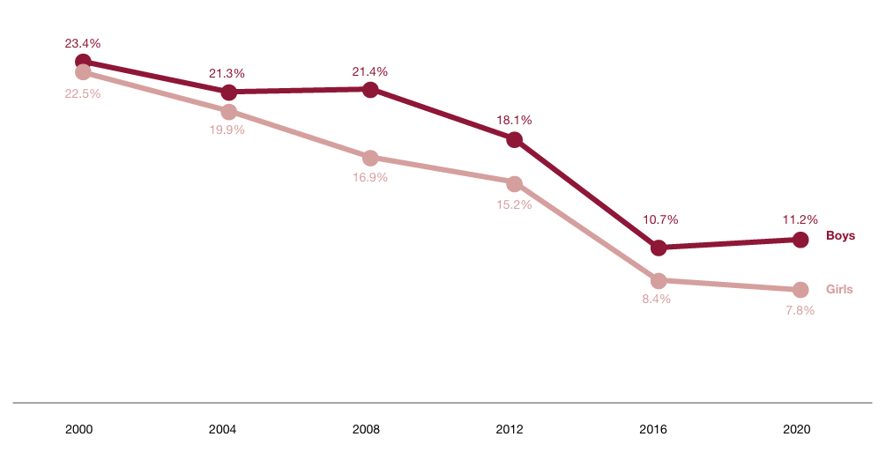

**Fig. 1. Trend of child labour, by sex, 2000-2020**

**Source: ILO, Making Progress against Child Labour, Global Estimate and Trends 2000-2012, (Geneva, 2013:4); ILO & UNICEF, Global Estimates 2020., 2021:32)**

Child labour has declined faster among girls than boys. Data shows that in 2000, 23.4 percent boys aged 5 to 17 years were engaged in child labour; it declined 21.3 percent in 2004, 21.4 percent in 2008, 18.1 percent in 2012, 10.7 percent in 2016 and 11.2 percent in 2020. At the same time, girls' child labour were 22.5 percent in 2000, 19.9 percent in 2004, 16.9 percent in 2008, 15.2 percent in 2012, 8.4 percent in 2016 and 7.8 percent in 2020 (ILO, Ending Child Labour…2017:16;ILO & UNICEF,Global Estimate., 2021:31-32).

The number of children in child labour has increased in sub-Saharan Africa, while it has declined in other parts of the world. The number of child labour in sub-Saharan Africa was 65.1 million in 2008, which increased 86.6 million (32.87 percent) in 2020. In Asia and the Pacific, the result is the opposite, it was 113.6 million in 2008 which declined to 48.7 million (57.13 percent) in 2020. At the same time, it declined 8.2 million from 14.1 million in Latin America and the Caribbean (ILO & UNICEF,Global Estimate., 2021:24).

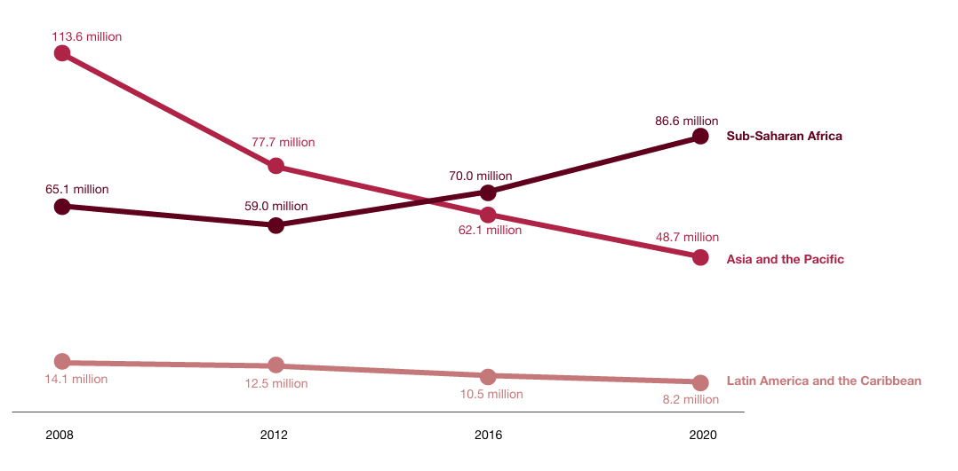

**Fig. 2. Number and trends of children aged 5 to 17 years in child labour by region, 2000-2020**

**Source: ILO, Making Progress against Child Labour, Global Estimate and Trends 2000-2012, (Geneva, 2013:4-5); ILO, Ending Child Labour…2017:13; ILO & UNICEF, Global Estimate of Child Labour…, 2021:24)**

Percentage and number of child labour is highest in Sub-Saharan Africa, which is 23.9 percent (86.6 million of 362.3 million) and lowest in Europe and North America which is 2.3 percent (3.8 million of 165.2 million). It is 7.8 percent (10.1 million of 129.4 million) in Northern Africa and Western Asia, 6.0 percent (8.2 million of 136.6 million) in Latin America and Caribbean, 6.2 percent (24.3 million of 391.9 million) in Eastern and South-Eastern Asia and 5.5% percent (26.3 million of 478.1 million) in Central and Southern Asia (ILO & UNICEF,Global Estimate., 2021:12-13).

**Table 1: Child labour distribution by level of national income, 5-17 years age group, 2012**

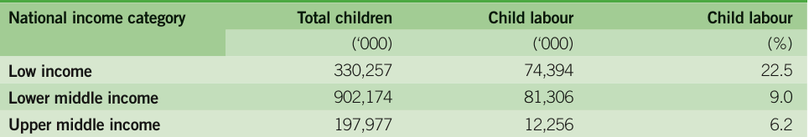

**Source: ILO, Making Progress against Child Labour, Global Estimate and Trends 2000-2012**

**Notes: Low-income countries had a GNI per capita in 2016 of $1,035 or less, lower-middle-income countries of between $1,036 and $4,085, upper-middle-income countries of between $4,086 and $12,615, and high-income countries of $12,616 or more, see-**[**World Development Indicators 2014**](https://openknowledge.worldbank.org/server/api/core/bitstreams/8fc28be8-aedb-599f-a20d-50a32d0423c5/content)

There is close relation between national income and involvement of children in child labour. ILO study data shoes that in 2012, total 167.9 million children were involved in labour, in which 74.39 million (22.5 percent of 330.2 million) children from low-income countries, 81.3 million (9.0 percent of 902.1 million) in lower-middle-income countries and12.25 million (6.2 percent of 197.9 million) in upper-middle-income countries (ILO, Making Progress., 2013:7).

Another data which has given below shoes that in 2016, total 151.6 million children were involved in labour, in which 65.2 million (43.0 percent) children from low-income countries, 58.18 million (38.4 percent) in lower-middle-income countries, 26.2 million (17.3 percent) in upper-middle-income countries and 2.0 million (1.3percent) in high-income countries (ILO, Global Estimate., 2017:33).

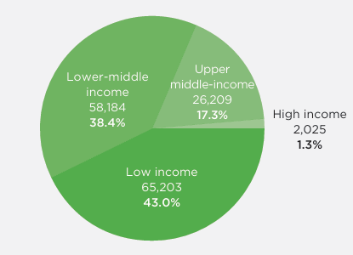

**Fig. 3. Percentage distribution of children in child labour, 5–17 years age group, by national income grouping, 2016**

**Source: ILO, Global Estimate of Child Labour, Results and Trends 2012-2016 (Geneva, 2017:33)**

Notes: Low-income countries had a GNI per capita in 2016 of $1,005 or less, lower-middle-income countries of between $1,006 and $3,955, upper-middle-income countries of between $3,956 and $12,235, and high-income countries of $12,236 or more; [World-by-income-sdg-atlas-2018.pdf](https://datatopics.worldbank.org/world-development-indicators/images/figures-png/world-by-income-sdg-atlas-2018.pdf)

On the contrary figure shows that in 2020, total 160 million children were involved in labour, in which 65.0 million (40.7 percent) children from low-income countries, 69.7 million (43.6 percent) in lower-middle-income countries, 23.7 million (14.8 percent) in upper-middle-income countries and 1.6 million (1.0 percent) in high-income countries (ILO and UNICEF, Global Estimate .., 2021:51). So, it is clear that child labour is higher in low-income countries than higher.

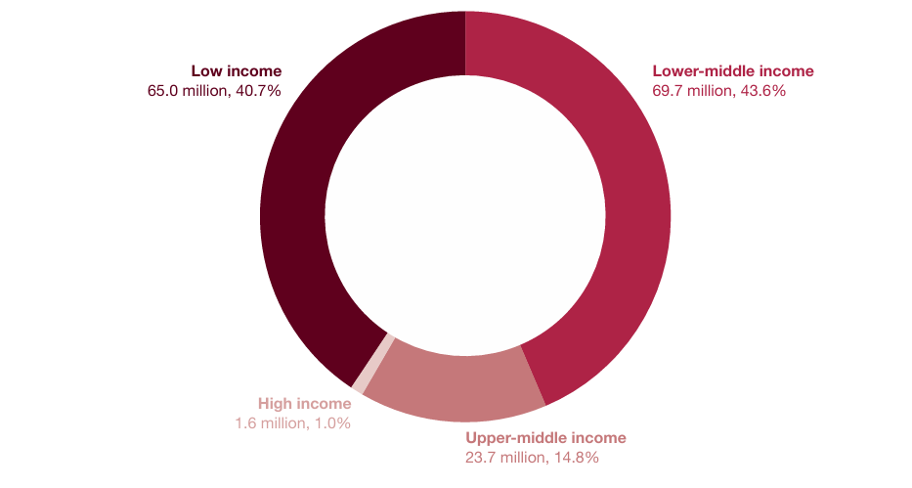

**Fig. 4. Number and percentage distribution of children aged 5 to 17 years in child labour, by national income group in 2020**

**Source: ILO and UNICEF, Child Labour, Global Estimates 2020, Trends and the Road Forward, 2021**

**Notes: Low-income countries had a GNI per capita in 2020 of $1,045 or less, lower-middle-income countries of between $1,046 and $4,125, upper-middle-income countries of between $4,126 and $12,735, and high-income countries of $12,736 or more; see:** [**New World Bank country classifications by income level: 2020-2021**](https://blogs.worldbank.org/en/opendata/new-world-bank-country-classifications-income-level-2020-2021)

Child labour is more common in rural than in urban areas in almost all the regions. Globally, 76.7 percent (122.7 million) child labour in rural area, on the counterpart 23.3 percent (37.3 million) in urban area. In Sub-Saharan Africa 82.1 percent working children are from rural area and 17.9 percent from urban.

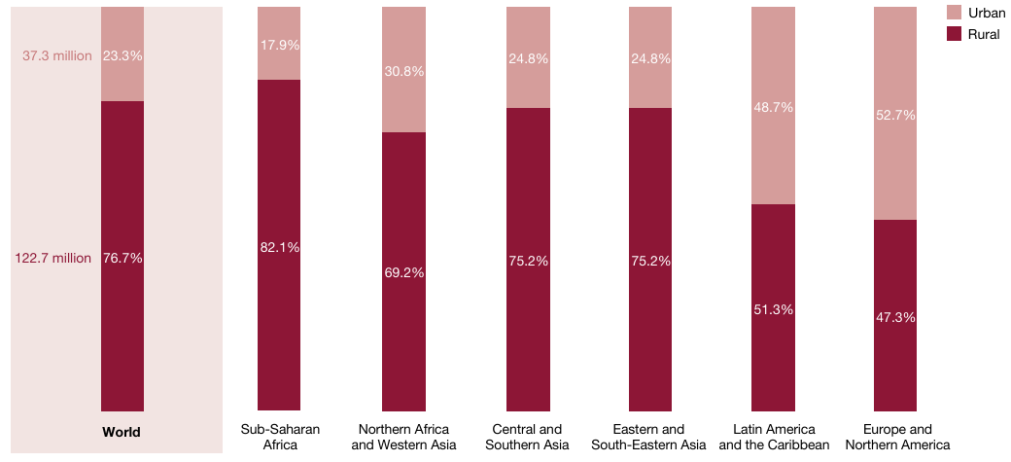

**Fig. 5. Percentage distribution of children aged 5 to 17 years in child labour, by residence and region**

**Source: Source: ILO and UNICEF, Child Labour, Global Estimates 2020, Trends and the Road Forward, 2021**

It is gradually 69.2 percent and 30.8 percent in Northern Africa and Western Asia, 75.2 percent and 24.8 percent in Central, Southern, Eastern and Southeastern Asia and 51.3 percent and 48.7 percent in Latin America and the Caribbean (ILO & UNICEF, Ending Child Labour…2021:35).

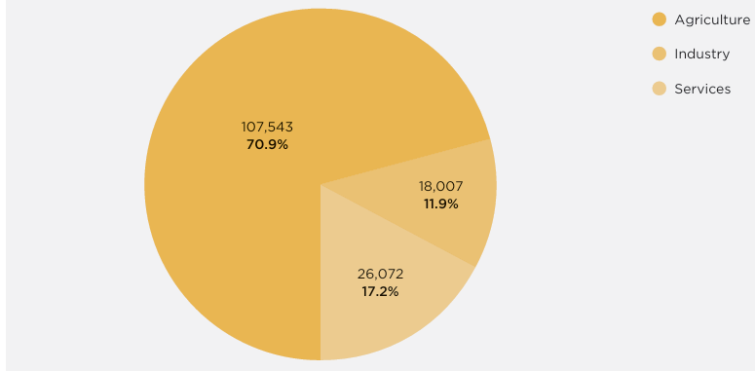

**Fig. 6. Percentage distribution of children in child labour by sector employment, 5–17 years age group, 2016**

**Source: ILO, Global Estimate of Child Labour, Results and Trends 2012-2016**

Most child labour for boys and girls alike occurs in agriculture. Above figure shows that in 2016, globally 107.5 million (70.9 percent of 151.6 million) child labour worked in the agricultural sector, 26 million (17.2 percent) in industry and 18 million (11.9 percent) in service in which 104 million (69 percent of 151.6 million) worked in their own family (ILO, Global Estimate…2017:35-37).

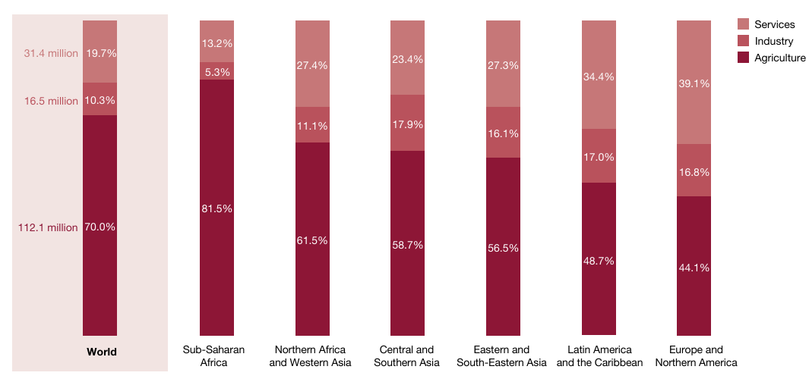

**Fig. 7. Percentage distribution of children aged 5 to 17 years in child labour, by sector of economic activity and region**

**Source: ILO and UNICEF, Child Labour, Global Estimates 2020, Trends and the Road Forward, 2021**

In 2020, globally 115.3 million (72.1 percent of 160.0 million) children aged 5 to 17 years in child labour contributed family works, 27.6 million (17.3 percent) involved in employees and 17 million (10.7 percent) were own-account works. In which, 112.2 million (70.0 percent of 160.0) children were engaged in agriculture, 16.5 million (10.3 percent) were engaged in industry and 31.4 million (19.7 percent) were engaged in service. Worldwide 7.1 million children are engaged in forms of domestic work in which 4.4 million are girl and 2.8 million are boys (ILO & UNICEF,Global Estimate., 2021:39-42).

There is a close relation between child labour and out of school. Hazardous child labour constitutes an even great barrier to school attendance. More than one third of all children in child labour are excluded from school (ILO & UNICEF, Global Estimate., 2021:29-35).

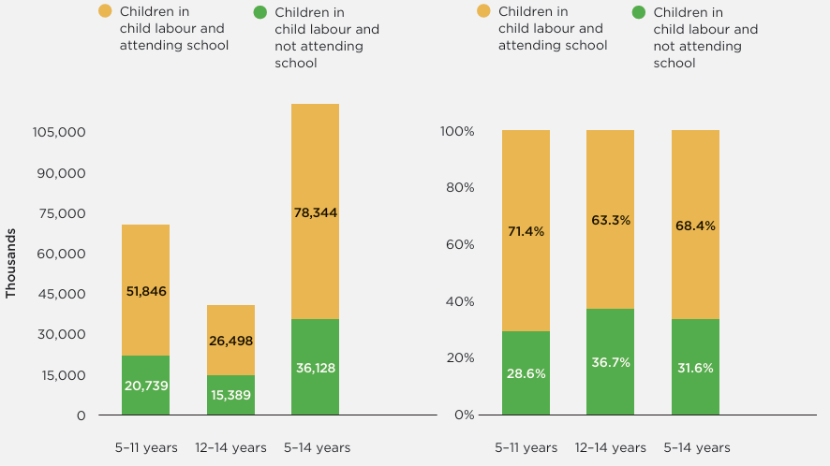

**Fig. 8. Number and Percentage distribution of children in child labour, 5-14 years age range, by school attendance status, 2016**

**Source: ILO, Global Estimate of Child Labour, Results and Trends 2012-2016**

Above data shoes that in 2016, globally 36.1 million (31.6 percent) aged 5 to 14 years children in child labour are not attend in school. Among them,20.7 million (28.6 percent) aged 5 to 11 years, 15.3 million (36.7 percent) aged 12 to 14 years age group.

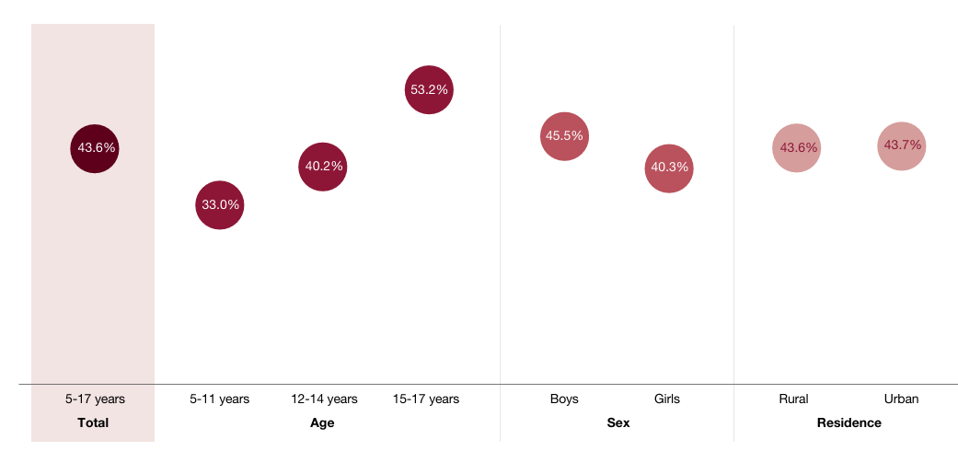

**Fig. 9. Percentage of children aged 5 to 17 years in hazardous work not attending school, by age, sex and residence**

**Source: ILO and UNICEF, Child Labour, Global Estimates 2020, Trends and the Road Forward, 2021**

In 2020, globally 35.0 percent children aged 5 to 17 years in child labour not attend in school in which 27.7 percent of 5 to 11 years old, 35.2 percent of 12 to14 years old and 53.2 percent of 15 to 17 years old working children are not attending in school. It presents that 36.3 percent working boys and 32.8 percent working girls are not attend in school. At the same time, children aged 5 to 17 years old those are involved in hazardous work, 43.6 percent are not attend in school. Among them, 33.0 percent of 5 to 11 years old, 40.2 percent of 12 to 14 years old and 53.2 percent of 15 to 17 years old hazardous worker children are not attend in school. In sex, 45.5 percent of hazardous worker boys and 40.3 percent of girls are not attending in school. 43.6 percent of rural hazard workers and 43.7 percent of urban hazard workers are not attending in school. In Eastern and South Eastern Asia, 37.2 percent working children are not attending in school. In Central and South Eastern Asia it is 35.3 percent, 28.1 percent in sub-Saharan Africa, Northern Africa and Western Asia and 15.5 percent in Latin America and the Caribbean (ILO & UNICEF, 2021:48-49).

**Table 2: Children in employment, child labour and hazardous work by age group, 2000-2012**

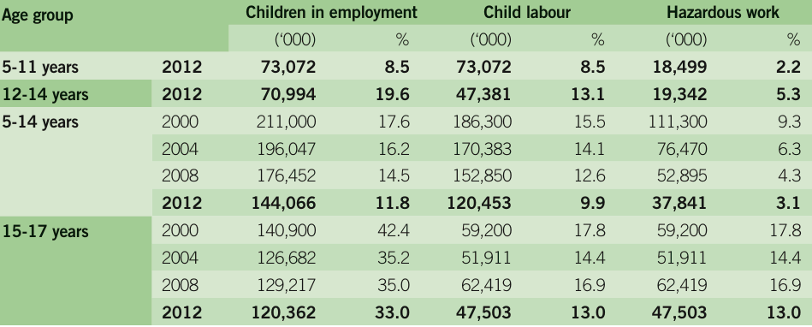

**Source: ILO, Making Progress against Child Labour, Global Estimate and Trends 2000-2012**

In 2000, 245.5 million children aged 5 to 17 years in child labour and 170.5 million (69.4 percent) were engaged in hazardous work. In 2004, the number of child labour was 222.3 million in which 128.3 million (57.7 percent) were engaged in hazardous work. In 2008, 215.2 million children were engaged in work in which 115.3 million (53.6 percent) were engaged in hazardous work and 2012 it was 85.3 million (50.7 percent of 167.9 million) in hazardous work (ILO, Making Progress., 2013:4).

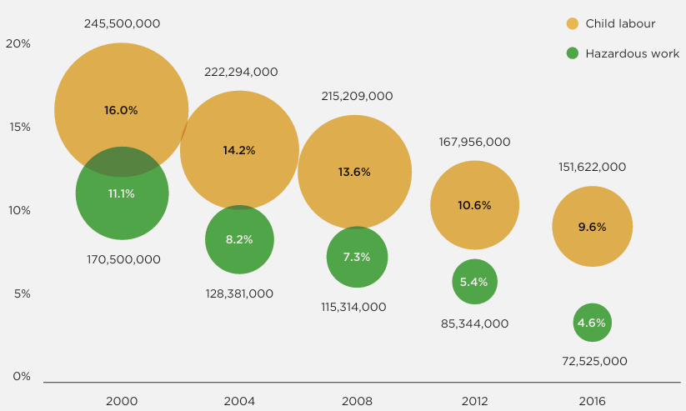

**Fig. 10. Children in employment, child labour and hazardous work by age group, 2000-2016**

**Source: ILO, Global Estimate of Child Labour, Results and Trends 2012-2016**

It has decreased conically until 2016. In 2016, 151.6 million children were engaged in child labour in which 72.5 million (47.8 percent) were engaged in hazardous work, (ILO, Global Estimate., 2017:23-24).

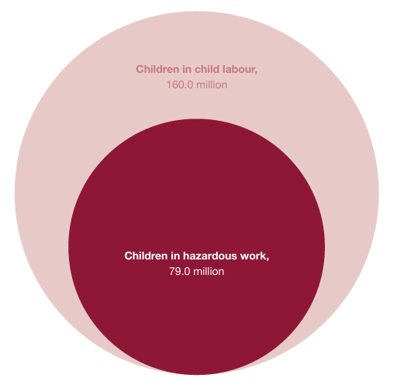

**Fig. 11. Number of children aged 5 to 17 years in child labour and hazardous work**

**Source: ILO and UNICEF, Child Labour, Global Estimates 2020, Trends and the Road Forward, 2021**

In 2020, for the crisis of COVID-19, the child labour situation was upward and it was 160.0 million in which 79.0 million (49.3 percent) children were engaged in hazardous work (ILO and UNICEF, Global Estimates., 2021:22). Data shows that the number of hazardous child labourer is about 50 per cent.

10. Findings and Suggestions

The ILO Minimum Age Convention 138 (ILO, 1973) allowed 12 years for light work in developing countries which encourages child labour, influencing state parties and opening opportunities for the family head to recruit children in child labour. It must be amended and replaced 15 years for light work like networkglobally. At the same time, ILO will ensure that ratifying parties should design and enact their national policy according to the guidelines of this Convention.

IPEC is working in more than 100 countries to encourage the development of appropriate legal and policy frameworks in line with international standards on child labour. At the same time, many of its projects have also worked at the community level, helping to remove children from child labour. IPEC has also played an important role in increasing public and political awareness of child labour as a problem that needs to be tackled. IPEC should take more projects in different countries, especially low-income countries to eliminate child labour.

The Worst Forms of Child Labour Convention, 1999, emphasises that each of the ratifying members takes into account the importance of access to free basic education and appropriate direct assistance for the removal of children from the worst form of child labour in eliminating child labour. Worst Forms of Child Labour Recommendation, 1999, mentioned that such programmes should aim at giving special attention to younger children, the girl child, the problem of hidden work situations, in which girls are at special risk, and other groups of children with special vulnerabilities or needs. ILO should take a proper time-bound legal framework so that the state parties implement those initiatives within the fixed time.

Child labour is more common for boys than girls and globally it has declined faster among girls than boys. International authority should take proper gender based initiatives so that child labour situation declined equally both boys and girls.

Child labour rate is highest in low-income countries especially Sub-Saharan Africa and lowest in high income countries like Europe and North America. So, it is clear that there is a close relation between national income and involvement of children in paid work. International communities like United Nations, World Bank, International NGOs, development partners, and developed countries should emphasis on fundings to implementation child labourelimination policies and programmes in the low-income countries.

Globally, child labour is more common in rural area than urban. Approximately two third working children are involved in agriculture and contributing their family works. State party should take family need based policies so that children can get release from agriculture based labour involvement (Md Shahriar Kabir et al., 2025).

Globally, about half of the working children are involved in hazardous child labour and about one-third of the hazardous child labourer are excluded from school. International development partners, NGOs and state parties should take schooling programmes for working children so that they can continue their education. ILO should strengthen their monitoring policy so that state parties provide the list of hazardous work to protect children from enrolment children in hazardous work.

11. Conclusion

Children are the future hope for a nation. If they are exploited at the very early age, they would not be able to contribute to the country and it would hamper the progress of a nation. Children were less important in the society before 19th century. In the middle of the 19th century, the idea appears to give children special protection. At the beginning of the 20th century, children's protection starts to be put in place, including protection in the medical, social and judicial fields. From the beginning of the 20th century, International Labour Organization played a vital role for the working children. Different countries formulate individual policy to eliminate child labour. Every state party shall take initiative to implement the policy within a short time. At the same time 15 years must be applicable for light work as like as entry into work. At the same time ILO should include the child's domestic work in the list of hazardous work. Governments of different countries must take immediate and effective measures to ensure the prohibition and eliminate of the worst forms of child labour. At the same time governments of different countries should provide necessary and appropriate direct assistance for the removal of children from worst forms of child labour. Finally, it can be said that if the state parties provide need based programmes and policies and essure the implementation of all these programmes and policies then child labour will be eliminate from the world. In this purpose ILO must play leading role with the support of global development partners.

The discussion should not repeat the results, but provide detailed interpretation of data. This should interpret the significance of the findings of the work. Citations should be given in support of the findings. The results and discussion part can also be described as separate, if appropriate.

12. References

1. Alam, M., Pervez, A. K. M., Kabir, M., Amin, M., & Bhuiya, R. (2023). The Challenges and Prospects of E-learning in Higher Education in Bangladesh- A Review. *Asian Journal of Education and Social Studies*, *43*, 10–19. https://doi.org/10.9734/ajess/2023/v43i1931
2. Anthias, F. (1983). Sexual divisions and ethnic adaptation: The case of Greek-Cypriot women. In *One Way Ticket*. Routledge.
3. Beckmann, J. (2023). Why do they leave? Examining dropout behaviour in gender-atypical vocational education and training in Germany. *Journal of Vocational Education & Training*, 1–25. https://doi.org/10.1080/13636820.2023.2211546
4. Calitz, K. (2013). The Failure of the Minimum Age Convention to Eradicate Child Labour in Developing Countries, with Particular Reference to the Southern African Development Community. *International Journal of Comparative Labour Law and Industrial Relations*, *29*(1). https://kluwerlawonline.com/api/Product/CitationPDFURL?file=Journals\IJCL\IJCL2013006.pdf
5. Daly, A., Hillis, A., Shrestha, S. M., & Shrestha, B. K. (2020). Bricks in the wall: A review of the issues that affect children of in‐country seasonal migrant workers in the brick kilns of Nepal. *Geography Compass*, *14*(12), e12547. https://doi.org/10.1111/gec3.12547
6. Desai, S., & Wane, N. (2022). Educating courageously: Transformative pedagogy infusing spirituality in K-12 education for fostering civil society and democracy. *International Journal of Educational Research*, *115*, 102017. https://doi.org/10.1016/j.ijer.2022.102017
7. Edgücan Sahin, C., & Baum-Talmor, P. (2024). Navigating Uncertainty: Exploring Future Perspectives on Precarious Employment in the Shipping Industry. *Sociologia del lavoro : 169, 2, 2024*, 73–98. https://doi.org/10.3280/SL2024-169004
8. Freeman, M. (2009). Children’s Rights as Human Rights: Reading the UNCRC. In J. Qvortrup, W. A. Corsaro, & M.-S. Honig (Eds.), *The Palgrave Handbook of Childhood Studies* (pp. 377–393). Palgrave Macmillan UK. https://doi.org/10.1007/978-0-230-27468-6_26
9. Horii, H. (2021). *Child Marriage, Rights and Choice: Rethinking Agency in International Human Rights* (1st ed.). Routledge. https://doi.org/10.4324/9781003184546
10. Islam, M. R., Rahman, M. M. U., Pervez, A. K. M., & Kamaly, M. H. K. (2013). PERCEPTION OF EXTENSION AGENTS ABOUT SUSTAINABLE AGRICULTURAL PRACTICES IN BANGLADESH. *International Journal of Agricultural Extension*, *1*(1), Article 1. https://www.journals.esciencepress.net/index.php/IJAE/article/view/461
11. Langille, B. (1999). The ILO and the New Economy: Recent Developments. *International Journal of Comparative Labour Law and Industrial Relations*, *15*(Issue 3), 229–258. https://doi.org/10.54648/243818
12. Mahedi, M., Shaili, S. J., & Shihab, A. (2024). *Livelihood Diversification as a Reduce to Rural Vulnerability in Bangladesh: A Review*.
13. Md Shahriar Kabir, Md Mahedi, A K M Kanak Pervez, Md Jahangir Alam, & Shabrin Jahan Shaili. (2025). Bibliometric analysis of “precision agriculture” in the Scopus database. *World Journal of Advanced Research and Reviews*, *25*(3), 1087–1098. https://doi.org/10.30574/wjarr.2025.25.3.0733
14. Mohajan, H. (2014, January 10). *Child Rights in Bangladesh* [MPRA Paper]. https://mpra.ub.uni-muenchen.de/58424/
15. Pervez, A. K. M. (2018). Microfinance Institutions of Bangladesh: The Effects of Credit Risk Management on Credit Performance. *International Journal of Innovation and Sustainable Development*, *09*, 104–114.
16. Sawyer, R. (2022). *Children Enslaved* (1st ed.). Routledge. https://doi.org/10.4324/9781003307877
17. Sharmin, S., Matin, M. Z., Kim, M., Sayem, A. S. M., Rahman, F., Abdullah, A. S. M., Chaudhury, M. B., & Halim, A. (2022). *Assessment of the Performance of selected Special Care Newborn Units (SCANUs) in Bangladesh*. Research Square. https://doi.org/10.21203/rs.3.rs-1595564/v1
18. Taş, E. O., & Ahmed, T. (2024). Women’s Economic Participation, Time Use, and Access to Childcare in Urban Bangladesh. *Forum for Social Economics*, 1–23. https://doi.org/10.1080/07360932.2024.2422955
19. Thi, A. M., Zimmerman, C., & Ranganathan, M. (2023). Hazardous Child Labour, Psychosocial Functioning, and School Dropouts among Children in Bangladesh: A Cross-Sectional Analysis of UNICEF’s Multiple Indicator Cluster Surveys (MICS). *Children*, *10*(6), 1021. https://doi.org/10.3390/children10061021
20. Tuttle, C. (2006). History Repeats Itself: Child Labor in Latin America. *Employee Responsibilities and Rights Journal*, *18*(2), 143–154. https://doi.org/10.1007/s10672-006-9012-0
21. Van Der Linden, M. (2019a). The International Labour Organization, 1919–2019. *Labor*, *16*(2), 11–41. https://doi.org/10.1215/15476715-7323601
22. Van Der Linden, M. (2019b). The International Labour Organization, 1919–2019. *Labor*, *16*(2), 11–41. https://doi.org/10.1215/15476715-7323601
23. Venkatesan, R. (2019). The UN Framework on Business and Human Rights: A Workers’ Rights Critique. *Journal of Business Ethics*, *157*(3), 635–652. https://doi.org/10.1007/s10551-017-3664-6
24. Weisman, K., Legare, C. H., Smith, R. E., Dzokoto, V. A., Aulino, F., Ng, E., Dulin, J. C., Ross-Zehnder, N., Brahinsky, J. D., & Luhrmann, T. M. (2021). Similarities and differences in concepts of mental life among adults and children in five cultures. *Nature Human Behaviour*, *5*(10), 1358–1368. https://doi.org/10.1038/s41562-021-01184-8
25. Windmuller, J. P. (1961). Soviet Employers in the ILO: The Experience of the 1930’s. *International Review of Social History*, *6*(3), 353–374. https://doi.org/10.1017/S0020859000001899