The relationship between Landscape Patterns and Nearshore Water Quality: A Case Study of Erhai Lake, Southwest China

.
ABSTRACT

Landscape patterns play a crucial role in non-point source pollution processes. Due to scale effects, the mechanisms through which landscape patterns influence nearshore lake water quality are highly complex. Based on 2017 water quality monitoring data from the nearshore area of Erhai Lake in southwestern China, this study employed redundancy analysis (RDA) and Pearson correlation analysis to investigate the relationship between nearshore water quality and landscape patterns at multiple spatial scales. Results indicated that: (1) RDA revealed that the landscape composition and configuration within all buffer zones have explanatory power for the nearshore water quality parameters of Erhai Lake. Pearson correlation analysis further demonstrated that landscape composition had a stronger influence on water quality than landscape configuration. (2) Within the 500 m buffer zone, both landscape composition and configuration had an explanatory power exceeding 86% for RDA1. Pearson correlation analysis indicated that the effects of different landscape types and their proportions on water quality parameters varied with buffer zone. Meanwhile, the influence of landscape configuration on water quality parameters tended to weaken as the buffer distance increased. (3) Wetlands had the most pronounced influence on nearshore water quality parameters within the 500 m buffer zone and beyond 3000 m. These findings contribute to a better understanding of how nearshore landscape patterns influence water quality and provide essential information for effective nearshore landscape planning and water quality management in Erhai Lake.

Keywords: Landscape patterns; Water quality; Redundancy analysis; Erhai Lake

1. INTRODUCTION

Lakes constitute a critical component of global surface water resources, fulfilling essential functions in potable water provision, fisheries, recreational activities, agricultural irrigation, and ecosystem stability (Wang et al., 2023). Water quality is a key limiting factor affecting the various functions of lakes. The deterioration of lake water quality, driven by climate variability, landscape transformations, and anthropogenic pollution, has become a pressing global environmental issue (Mo et al., 2023; Cai et al., 2020). Landscape spatial structures exert significant control over nutrient fluxes and hydrological processes within lake basins (Yao et al., 2016; Liu et al., 2023), thereby modulating pollutant loads, compositional characteristics, and transformation dynamics in receiving waters (Wu and Lu, 2019). Lakes, as the primary sink for non-point source pollutants within watersheds, exhibit water quality highly susceptible to the surrounding landscape patterns (Zhou et al., 2016; Xu et al., 2023a; Li et al., 2023). Understanding the response of water quality to landscape pattern dynamics remains a key research priority in the domain of lake ecosystem management and pollution control (Wang et al., 2023; Zhou et al., 2016). Investigating the relationship between landscape patterns and water quality facilitates the formulation of watershed management measures and the control of terrestrial pollution along lake shores, which is of critical importance for improving aquatic environmental quality in lake ecosystems (Wu and Lu, 2019; Lee et al., 2009; Cheng et al., 2023).

Since the 1970s, extensive research efforts have been dedicated to elucidating the interactions between landscape spatial patterns and water quality (Rimer et al., 1978; Dou et al., 2022; Xiao et al., 2024; Zhang et al., 2019). Studies have confirmed that landscape patterns directly or indirectly influence hydrological processes, energy flows, and nutrient cycling within lake systems (Liu et al., 2023; Lee et al., 2009; Cheng et al., 2023; Shehab et al., 2021; Xu et al., 2023b), thereby exerting impacts on water quality. Landscape patterns encompass both the composition of patches (including types and proportions) and their spatial configurations (such as size, density, shape, and spatial connectivity). Numerous studies demonstrate that both landscape composition and configuration affect water quality. Some research identifies landscape composition as critical to water quality outcomes (Li et al., 2023; Xu et al., 2023b; Li et al., 2018; Shi et al., 2017; Wei et al., 2020; Bu et al., 2014), while others highlight significant associations between spatial configurations and water quality (Wu and Lu, 2019; Xiao et al., 2024; Li et al., 2018; Qiu et al., 2023). Among the multitude of pattern indices quantifying composition and configuration, few studies conclusively identify which metrics exert significant impacts on water quality (Liu et al., 2023; Liu et al., 2020). This knowledge gap creates uncertainties in implementing landscape planning to improve lake water quality and aquatic ecological services (Liu et al., 2020). Therefore, we still need more research to evaluate the contribution of these indices to water quality and identify the most valuable indices for landscape planning (Xu et al., 2023a; Qiu et al., 2023; Liu et al., 2020), advancing our understanding of how landscape patterns affect water quality.

Moreover, the impact of landscape patterns on water quality is highly scale-dependent (Shi et al., 2017; Xu et al., 2020). In practical planning and management, a significant challenge lies in determining the most effective spatial scale of landscape patterns for water quality protection. Clarifying the spatial scale effects of landscape patterns on water quality can shed light on the mechanisms driving water quality deterioration or maintenance (Xu et al., 2023a), ultimately guiding more effective landscape planning for water quality conservation (Zhang et al., 2019; Xu et al., 2020). The nearshore scale, sub-watershed scale, and watershed scale are frequently employed in studies examining the impact of landscape patterns on lake water quality (Dou et al., 2022). Extensive research suggests that the nearshore buffer zone is critical in determining the influence of landscape metrics on water quality (Mo et al., 2023; Cheng et al., 2023; Li et al., 2018; Shi et al., 2017; Tran et al., 2010; Wu and Lu, 2021; Shen et al., 2015; Liu et al., 2022). However, due to geographical and environmental variability, debate persists over which nearshore buffer zone exerts the greatest impact on water quality (Xu et al., 2023a). Thus, further investigation is required to examine the relationship between landscape patterns and water quality across different buffer scales in specific study regions (Dou et al., 2022; Lei et al., 2021).

Erhai Lake is a globally significant tourist destination and a quintessential peri-urban lake, whose ecological health and sustainable development are of strategic importance to Yunnan Province and China at large. As one of the priority lakes under the "New Three Lakes" protection initiative (Xu et al., 2023a), Erhai Lake serves as a primary drinking water source for Dali City, Yunnan Province (Lin et al., 2020). The watershed of Erhai Lake is characterized by a highly developed tourism sector and extensive agricultural land use, leading to dual pollution pressures from urban built-up areas and farmlands. Continuous landscape transformation driven by land use changes has substantially altered the spatial patterns of the region, accelerating Erhai Lake’s transition from a mesotrophic to a eutrophic state (Li et al., 2020a). Investigating the relationship between nearshore landscape patterns and water quality, particularly the spatial scale effects of buffer zones, is essential for informing water quality conservation strategies and optimizing nearshore landscape management. These insights are critical for developing targeted management interventions to curb water quality degradation. While some studies have examined the linkage between sub-watershed landscape patterns and Erhai Lake’s water quality (Xu et al., 2023a), research on the multi-buffer-scale effects of nearshore landscape patterns on water quality remains insufficient.

Accordingly, this study leverages Landsat 8 satellite imagery to characterize landscape patterns across multiple nearshore buffer zones of Erhai Lake. Coupled with in situ water quality measurements, the analysis identifies key landscape metrics that govern nearshore water quality dynamics, shedding light on the mechanisms and scale-dependent variations in landscape influences on water quality. The findings aim to inform water quality protection strategies through the management and optimization of nearshore buffer zone landscape characteristics. Specifically, this study aims to: (1) examine the relationship between landscape patterns and water quality variables; and (2) analyze the characteristics of these relationships in response to buffer zone changes.

2. material and methods

2.1 Study area

Erhai Lake is located in Dali City, Yunnan Province, China, within the geographical coordinates of 25°25′–26°16′N and 99°32′–100°27′E (Fig. 1). It ranks as the second-largest freshwater plateau lake in Yunnan Province, with a watershed area of approximately 2,565 km² and a lake area of about 250 km² (Zheng et al., 2021). The lake is situated in the subtropical southwest monsoon climate zone, characterized as a low-latitude plateau monsoon climate (Li et al., 2020b). The region experiences distinct wet and dry seasons throughout the year, with negligible temperature fluctuations across the four seasons.

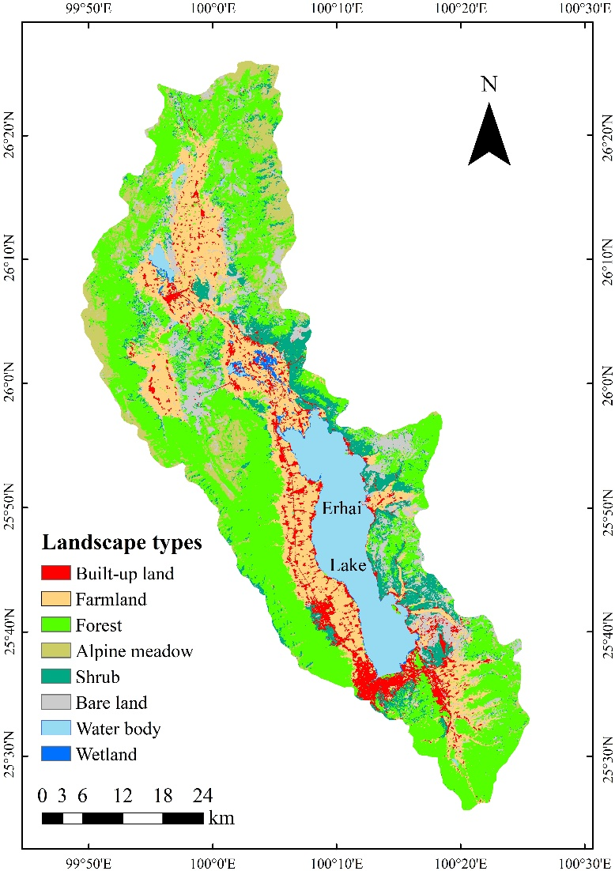

Fig. 1. Location of Erhai Lake and distribution of landscape types in the Erhai Basin.

2.2 Data and pre-processing

Landsat 8 satellite imagery was acquired from the United States Geological Survey, and field surveys were conducted to obtain training samples for computer-based classification and validation samples for accuracy assessment. Using a support vector machine (SVM) classifier, the Erhai Lake watershed was categorized into eight landscape types (Fig. 1): water body (WB), built-up land (BU), wetland (WL), alpine meadow (AW), shrub (SH), farmland (FL), forest (FO), and bare land (BL), achieving an overall classification accuracy of 88%.

From August to December 2017, seven water quality sampling sites were established along the nearshore areas of Erhai Lake (Fig. 2), with samples collected every three days or two weeks. To enhance data reliability, each site was sampled at two depths, separated by 50 cm, and the final water quality parameters were obtained by averaging the measurements from both depths. Six key water quality parameters were analyzed: dissolved oxygen (DO), pH, total nitrogen (TN), total phosphorus (TP), chemical oxygen demand (COD), and chlorophyll-α (Chl-α). DO and pH were measured in situ using the SKY rapid water quality analyzer (SKYJPB-607), while TN, TP, COD, and Chl-α were analyzed in the laboratory. TN was quantified using the alkaline persulfate digestion ultraviolet spectrophotometry method, TP was measured using the ammonium molybdate spectrophotometry method, COD was determined via the dichromate method, and Chl-α was extracted and analyzed using the acetone extraction method.

2.3 Methods

2.3.1 Buffer generation and landscape pattern index calculation

Taking each sampling site as the center, ten concentric buffer zones were established at 500 m intervals to investigate the impact of landscape pattern variations on water quality at different spatial scales (Fig. 2). The landscape composition within each buffer was quantified based on the proportional area of various landscape types. Additionally, at the landscape level, six configuration metrics were selected to characterize patch size, shape, density, fragmentation, and connectivity: patch density (PD), landscape shape index (LSI), largest patch index (LPI), percentage of like adjacencies (PLA), interspersion and juxtaposition index (IJI), and patch cohesion index (PCI). Detailed descriptions and computational methodologies for these indices are available in the Fragstats 4.3 software documentation.

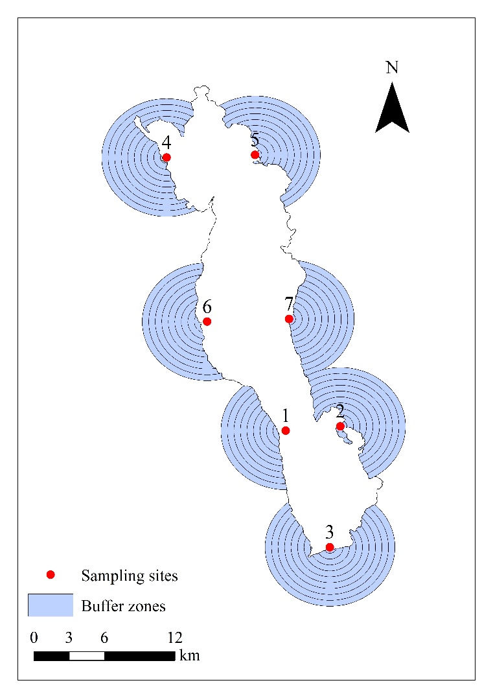

Fig. 2. Schematic of sampling sites and their buffer zones.

2.3.2 Analysis of the Correlation Between Landscape Pattern and Water Quality Parameters

Initially, normality tests were conducted on all variables, and for datasets that did not conform to a normal distribution, logarithmic transformation was applied to ensure compliance with normality assumptions. Based on this, redundancy analysis (RDA) was employed to examine the effects of landscape composition and structure on water quality across multiple buffer scales. Prior to RDA, detrended correspondence analysis (DCA) was performed to identify the most suitable ordination method. The DCA results indicated that the gradient length was less than 3, suggesting that redundancy analysis (RDA), which operates under a linear model, was the optimal approach for revealing the relationships between landscape composition, configuration, and water quality parameters at varying buffer zones. Furthermore, Pearson correlation analysis was utilized to assess the pairwise relationships between individual landscape pattern indices and water quality parameters.

All data analyses and visualizations were performed using R statistical software (version 4.3.4).

3. results and discussion

3.1 Changes in water quality

Based on the analysis of the collected water samples, we investigated the feature of six water quality parameters across different sampling sites (Table 1). The mean values of various water quality parameters exhibit varying patterns across different sampling points. However, the overall differences among the sampling points remain relatively minor. Sampling site 4 exhibited the highest mean values for all water quality parameters compared to the other sampling locations.

Table 1. The mean values of water quality parameters at different nearshore sampling points in Erhai Lake during the study period.

Sampling sites | DO | pH | TN | TP | COD | Chl-a
1 | 7.647 | 8.801 | 0.646 | 0.028 | 16.224 | 17.379
2 | 7.446 | 8.772 | 0.608 | 0.028 | 14.934 | 15.517
3 | 7.562 | 8.714 | 0.627 | 0.029 | 15.998 | 16.510
4 | 7.963 | 8.929 | 0.747 | 0.034 | 18.924 | 25.244
5 | 7.708 | 8.910 | 0.695 | 0.032 | 17.359 | 22.778
6 | 7.254 | 8.800 | 0.644 | 0.032 | 15.276 | 18.074
7 | 7.283 | 8.830 | 0.637 | 0.027 | 15.514 | 18.810

3.2 Analysis of landscape patterns in different buffer zones

Fig. 3 presents the variations in landscape composition across different buffer zones. With an increasing buffer scale, the proportion of farmland exhibits a progressive rise, reaching its peak at 36.6% within the 3500 m buffer. BU has the highest proportion in the 500 m buffer (34.2%), followed by the 1000 m (30.6%) and 2000 m (29.2%) buffers, whereas at the 3500 m buffer scale, its proportion declines to the lowest (12.9%). Across all buffer zones, FL and BU collectively account for more than 45% of the total area, with the highest combined proportion (65%) observed within the 2000 m buffer. Notably, FO is most prominent within the 500 m buffer (25.1%) but decreases to its lowest proportion (6.9%) within the 3500 m buffer. SH reach their maximum coverage within the 3500 m buffer (22.4%) and their minimum within the 500 m buffer (7%). WL constitute 16.7% of the area in the 500 m buffer but decline progressively with increasing buffer scale, reaching only 1.6% within the 5000 m buffer. The proportion of BL is minimal (<0.1%) within the 500 m buffer but follows an initial increase before decreasing, peaking at 19.6% within the 4000 m buffer.

WB are primarily distributed across the 2000 m, 2500 m, 3000 m, 3500 m, 4500 m, and 5000 m buffers, while AW are exclusively found in the 4500 m and 5000 m buffers. Since the area proportions of WB and AW within these buffers are both below 0.1%, they are excluded from subsequent correlation analyses between landscape composition and water quality parameters.

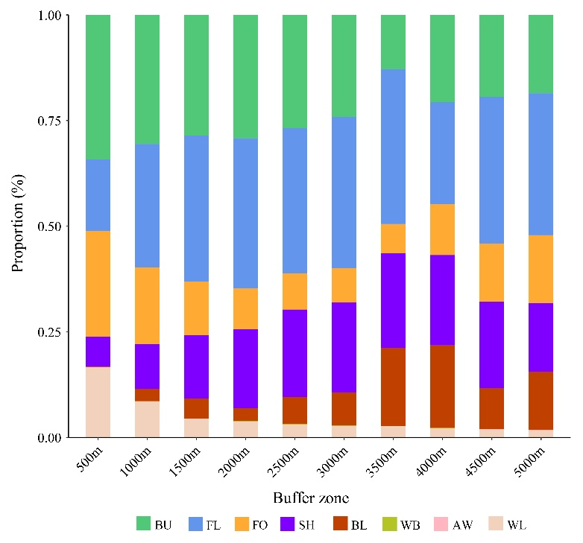

Fig. 3. Changes in landscape components in different buffer zones.

Fig. 4 illustrates the variation trends of landscape configuration indices across different buffer zones. The PD index reaches its highest value within the 500 m buffer. As the buffer scale expands, the PD index exhibits a declining trend, stabilizing at its minimum within the 2000 m buffer. The LPI index follows an increasing trend initially, reaching its peak at the 3000 m buffer before subsequently declining. In contrast, the LSI index demonstrates a continuous increase with expanding buffer scales. The IJI index first rises and then falls between the 500 m and 2500 m buffers, while displaying a similar fluctuation pattern between the 2500 m and 5000 m buffers. The PLA index increases initially, peaks at the 3000 m buffer, and then declines as the buffer scale expands. Meanwhile, the PCI index gradually increases with buffer scale expansion, maintaining a stable level between the 3000 m and 4000 m buffers.

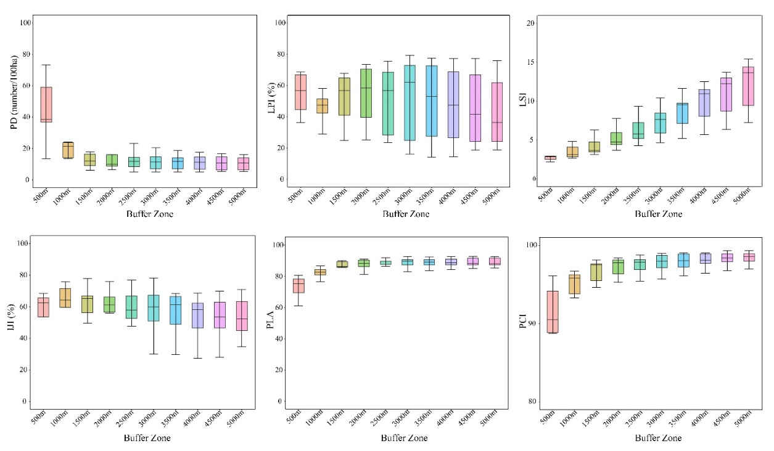

Fig. 4. Changes in landscape configuration indices in different buffer zones.

3.3 Relationship between landscape patterns and water quality

3.3.1 Relationship between landscape composition and water quality in different buffer zones

The RDA results showed that landscape composition was effective in explaining variation in water quality parameters, with the first axis (RDA1) explaining more than 80% of the total variation across all buffers (Fig. 5). The landscape composition within the 500 m buffer zone demonstrated the highest explanatory power for water quality. As the buffer zone scale increased, the variation in the explanatory power of landscape composition remained relatively insignificant.

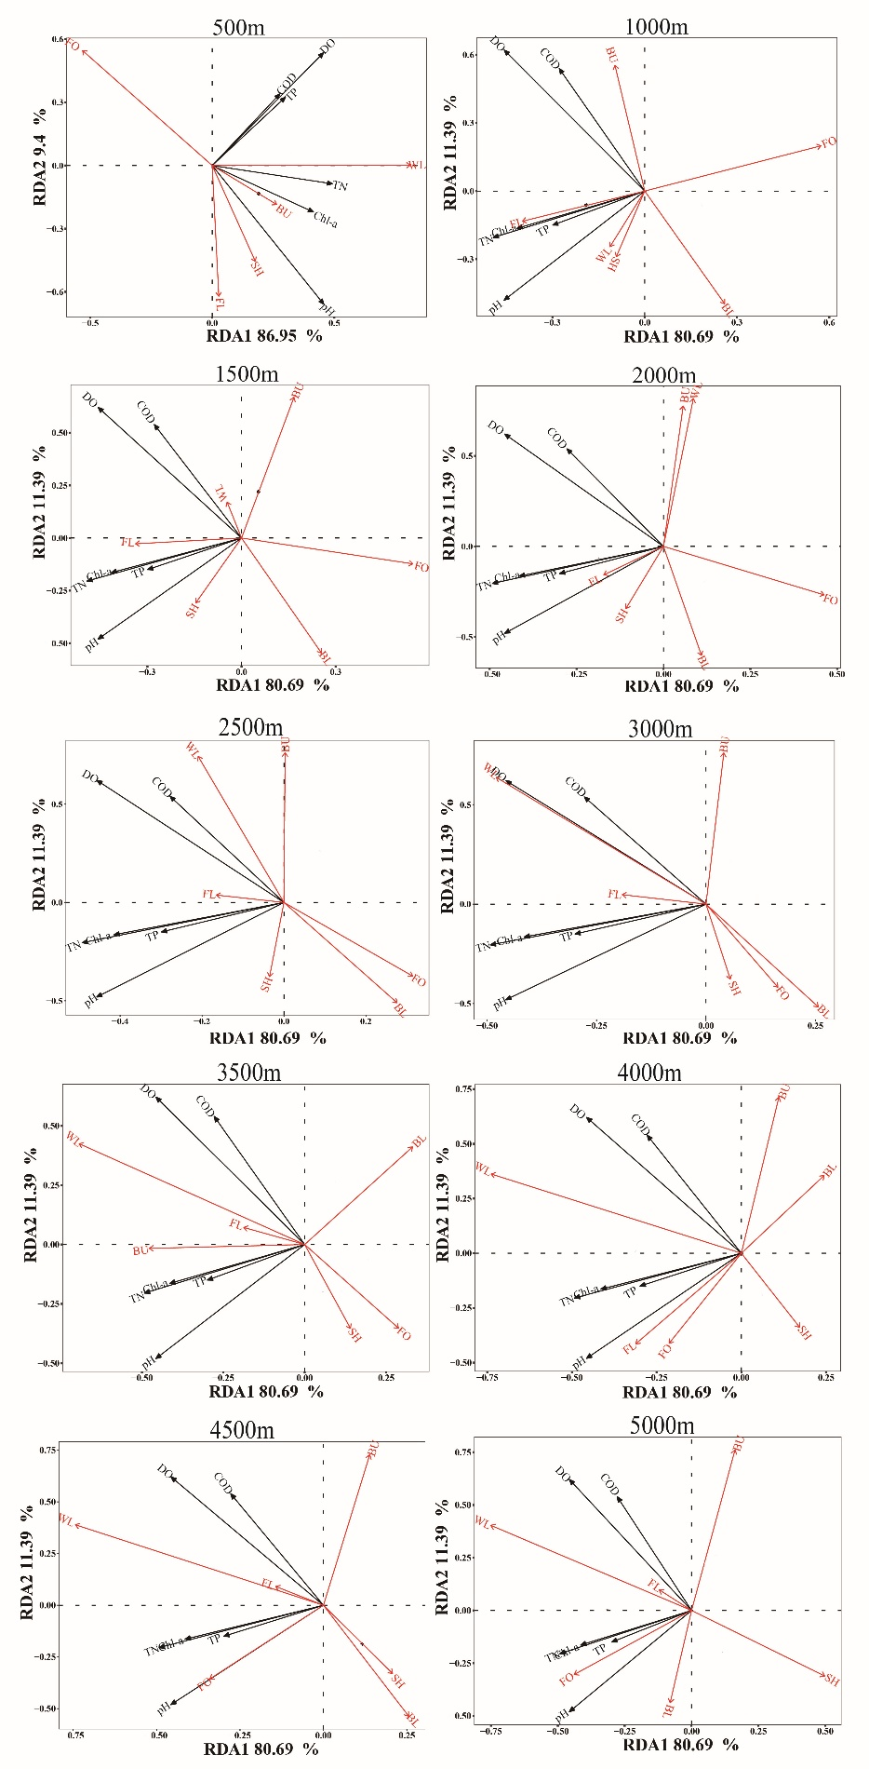

Fig. 5. Plots of RDA between landscape components and water quality parameters.

Pearson correlation analysis was conducted to further investigate the relationship between landscape composition and water quality parameters (Fig. 6). Results indicated that within the 500 m buffer zone, WL displayed a highly significant positive correlation with DO, pH, and TN (P = .01), as well as a significant positive correlation with TP and Chl-α (P = .05). As the buffer zone scale expanded, the influence of WL on water quality gradually diminished. However, when the buffer zone scale reached 3500 m, the influence of WL on water quality parameters, particularly DO, tended to strengthen. Within the 500 to 1500 m buffer zones, FO exhibited a significant negative correlation with TN (P = .05); within the 500 to 1000 m buffer zones, FO showed a significant negative correlation with pH (P = .05). As the buffer distance exceeded 3500 m, the relationship between FO and water quality parameters gradually shifted to a positive correlation. SH exhibited a gradually emerging negative correlation with water quality when the buffer distance exceeded 3000 m. With the exception of a weak negative correlation between FL and certain water quality parameters within the 500 m buffer zone, FL generally showed an insignificant positive correlation with all water quality parameters across other buffer zones. Across all buffer zones, the correlation between BU and water quality parameters exhibited considerable variability. Notably, within the 5000 m buffer zone, BU showed a significant negative correlation with pH. With the exception of the 5000 m buffer zone, BL consistently exhibited a negative correlation with water quality parameters.

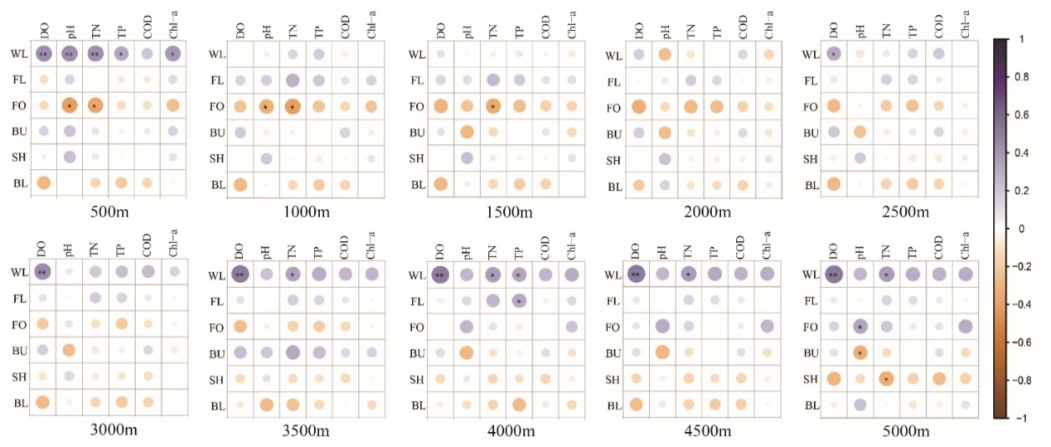

Fig. 6. Plots of Pearson correlation analysis between landscape components and water quality parameters in different buffer zones. * indicates P = .05, ** indicates P = .01

Although wetlands occupy a relatively small area, they exert a significant influence on multiple water quality parameters. This effect is particularly notable within the 500 m buffer zone, where wetlands play a crucial role in improving nearshore water quality in the study area (Fig. 6).

3.3.2 Relationship between landscape configuration and water quality in different buffer zones

The RDA results presented in Fig. 7 demonstrate that landscape configuration effectively explains the variation in water quality parameters, with the RDA1 explaining more than 80% of the total variance across all buffer zones. The landscape configuration within the 500 m buffer zone demonstrated the highest explanatory power for water quality. With increasing buffer scale, the total explanatory power of landscape configuration on water quality showed little variation, consistent with the RDA results for landscape composition and water quality parameters.

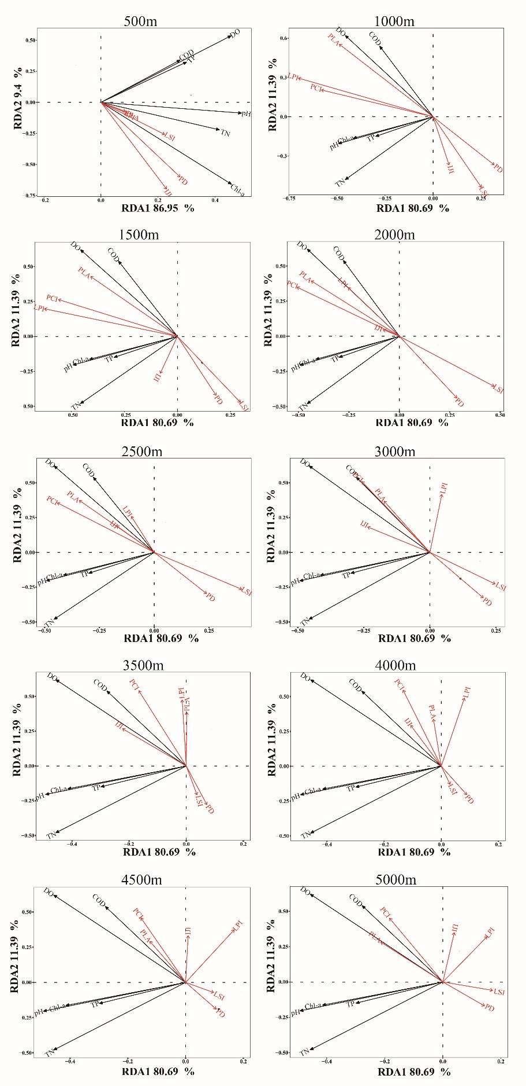

Fig. 7. Plots of RDA between landscape configuration and water quality parameters

Pearson correlation analysis indicated that, in comparison to landscape composition, the correlation between landscape configuration and water quality parameters was weaker and less significant (Fig. 8). Fig. 8 further illustrates that within the 1000 m buffer zone, PLA demonstrated a strong and highly significant correlation with DO, while LPI and PCI displayed a significant positive correlation with DO. At the 1500 m buffer zone, LPI, PLA, and PCI continued to exhibit significant positive correlations with DO. As the buffer scale increased, the correlation between landscape pattern indices and water quality parameters weakened (for both negative and positive correlations), with reduced statistical significance.

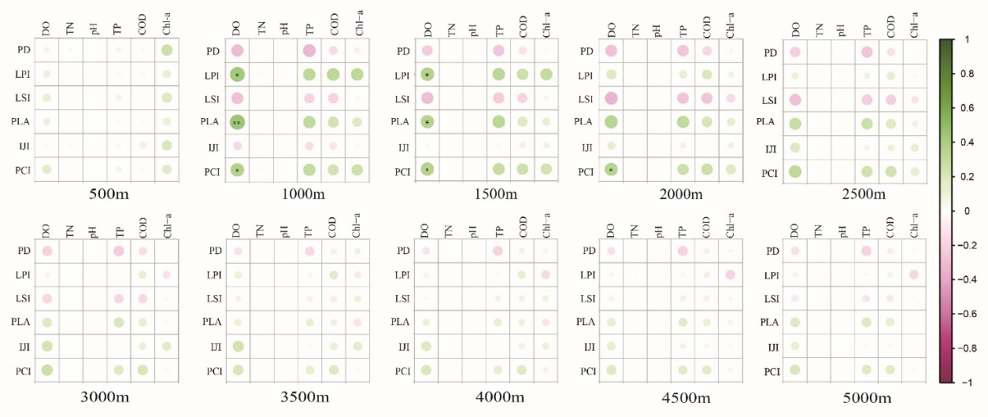

Fig. 8. Plots of Pearson correlation analysis between landscape configuration and water quality parameters in different buffer zones. * indicates P = .05, ** indicates P = .01

4. Conclusion

In the study, based on different nearshore buffer zones, the relationship between landscape patterns and water quality was identified at the landscape level. The findings are intended to provide fundamental reference data for nearshore water quality management and landscape pattern optimization in Erhai Lake. The key conclusions drawn from this study are as follows:

(1) Redundancy analysis demonstrated that both landscape composition and configuration significantly influenced nearshore water quality in Erhai Lake across all buffer zones (RDA1> 80%). Additionally, Pearson correlation analysis indicated that landscape composition exerted a stronger influence on Erhai Lake's nearshore water quality compared to landscape configuration.

(2) The influence of landscape composition and configuration on water quality parameters exhibits scale dependency. Within the 500 m buffer zone, both landscape composition and configuration exhibited an explanatory power exceeding 86% for RDA1, with little variation in explanatory power across increasing buffer distances. Pearson correlation analysis further indicated that the impact of different landscape types and their proportions on water quality parameters varied across buffer scales, while the effect of landscape configuration gradually diminished as the buffer distance increased.

(3) Wetlands exerted the most pronounced influence on nearshore water quality parameters within the 500 m buffer zone and at distances exceeding 3000 m.

This study represents an initial exploration of the relationship between Erhai Lake's nearshore water quality and landscape patterns, with several aspects requiring deeper investigation. For example, the next research will aim to examine the potential presence of landscape pattern thresholds within key buffer zones (such as 500 m, 3000 m).

References

Wang, W., Yang, P., Xia, J., et al. (2023) Impact of land use on water quality in buffer zones at different scales in the Poyang Lake, middle reaches of the Yangtze River basin. Science of The Total Environment, 896.

Mo, W., Yang, N., Zhao, Y., et al. (2023) Impacts of land use patterns on river water quality: the case of Dongjiang Lake Basin, China. Ecological Informatics, 75.

Cai, H., Mei, Y., Chen, J., et al. (2020) An analysis of the relation between water pollution and economic growth in China by considering the contemporaneous correlation of water pollutants. Journal of Cleaner Production, 276.

Yao, J., He, X., Chen, W., et al. (2016) A local-scale spatial analysis of ecosystem services and ecosystem service bundles in the upper Hun River catchment, China. Ecosystem Services, 22, 104-110.

Liu, Z., Liu, L., Li, Y., et al. (2023) Influence of urban green space landscape pattern on river water quality in a highly urbanized river network of Hangzhou city. Journal of Hydrology, 621.

Wu, J. and Lu, J. (2019) Landscape patterns regulate non-point source nutrient pollution in an agricultural watershed. Science of The Total Environment, 669, 377-388.

Zhou, P., Huang, J., Pontius, R.G., et al. (2016) New insight into the correlations between land use and water quality in a coastal watershed of China: Does point source pollution weaken it? Science of The Total Environment, 543, 591-600.

Xu, Q., Yan, T., Wang, C., et al. (2023a) Managing landscape patterns at the riparian zone and sub-basin scale is equally important for water quality protection. Water Research, 229.

Li, Q., Zhang, J., Zhang, J., et al. (2023) Spatial and temporal distribution characteristics and prediction analysis of nitrogen and phosphorus surface source pollution in Shandong Province under the climate and land use changes. Frontiers in Ecology and Evolution, 11.

Lee, S.-W., Hwang, S.-J., Lee, S.-B., et al. (2009) Landscape ecological approach to the relationships of land use patterns in watersheds to water quality characteristics. Landscape and Urban Planning, 92, 80-89.

Cheng, X., Song, J. and Yan, J. (2023) Influences of landscape pattern on water quality at multiple scales in an agricultural basin of western China. Environmental Pollution, 319.

Rimer, A.E., Nissen, J.A. and Reynolds, D.E. (1978) Characterization and Impact of Stormwater Runoff from Various Land Cover Types. Journal (Water Pollution Control Federation), 50, 252-264.

Dou, J., Xia, R., Chen, Y., et al. (2022) Mixed spatial scale effects of landscape structure on water quality in the Yellow River. Journal of Cleaner Production, 368.
Xiao, H., Su, R., Luo, Y., et al. (2024) Effects of land cover patterns on pond water nitrogen and phosphorus concentrations in a small agricultural watershed in Central China. Catena, 237.

Zhang, J., Li, S., Dong, R., et al. (2019) Influences of land use metrics at multi-spatial scales on seasonal water quality: A case study of river systems in the Three Gorges Reservoir Area, China. Journal of Cleaner Production, 206, 76-85.

Shehab, Z.N., Jamil, N.R., Aris, A.Z., et al. (2021) Spatial variation impact of landscape patterns and land use on water quality across an urbanized watershed in Bentong, Malaysia. Ecological Indicators, 122.

Xu, M., Xu, G., Li, Z., et al. (2023b) Effects of comprehensive landscape patterns on water quality and identification of key metrics thresholds causing its abrupt changes. Environmental Pollution, 333.

Li, K., Chi, G., Wang, L., et al. (2018) Identifying the critical riparian buffer zone with the strongest linkage between landscape characteristics and surface water quality. Ecological Indicators, 93, 741-752.

Shi, P., Zhang, Y., Li, Z., et al. (2017) Influence of land use and land cover patterns on seasonal water quality at multi-spatial scales. Catena, 151, 182-190.

Wei, W., Gao, Y., Huang, J., et al. (2020) Exploring the effect of basin land degradation on lake and reservoir water quality in China. Journal of Cleaner Production, 268.

Bu, H., Meng, W., Zhang, Y., et al. (2014) Relationships between land use patterns and water quality in the Taizi River basin, China. Ecological Indicators, 41, 187-197.

Qiu, M., Wei, X., Hou, Y., et al. (2023) Forest cover, landscape patterns, and water quality: a meta-analysis. Landscape Ecology, 38, 877-901.

Liu, J., Liu, X., Wang, Y., et al. (2020) Landscape pattern at the class level regulates the stream water nitrogen and phosphorus levels in a Chinese subtropical agricultural catchment. Agriculture, Ecosystems & Environment, 295.

Xu, S., Li, S.-L., Zhong, J., et al. (2020) Spatial scale effects of the variable relationships between landscape pattern and water quality: Example from an agricultural karst river basin, Southwestern China. Agriculture, Ecosystems & Environment, 300.

Tran, C.P., Bode, R.W., Smith, A.J., et al. (2010) Land-use proximity as a basis for assessing stream water quality in New York State (USA). Ecological Indicators, 10, 727-733.

Wu, J. and Lu, J. (2021) Spatial scale effects of landscape metrics on stream water quality and their seasonal changes. Water Research, 191.

Shen, Z., Hou, X., Li, W., et al. (2015) Impact of landscape pattern at multiple spatial scales on water quality: A case study in a typical urbanised watershed in China. Ecological Indicators, 48, 417-427.

Liu, H., Meng, C., Wang, Y., et al. (2022) Multi-spatial scale effects of multidimensional landscape pattern on stream water nitrogen pollution in a subtropical agricultural watershed. Journal of Environmental Management, 321.

Lei, C., Wagner, P.D. and Fohrer, N. (2021) Effects of land cover, topography, and soil on stream water quality at multiple spatial and seasonal scales in a German lowland catchment. Ecological Indicators, 120.

Lin, S.-S., Shen, S.-L., Zhou, A., et al. (2020) Sustainable development and environmental restoration in Lake Erhai, China. Journal of Cleaner Production, 258.

Li, Y., Yen, H., Lei, Q., et al. (2020a) Impact of human activities on phosphorus flows on an early eutrophic plateau: A case study in Southwest China. Science of The Total Environment, 714.

Zheng, L., An, Z., Chen, X., et al. (2021) Changes in Water Environment in Erhai Lake and Its Influencing Factors. Water, 13.

Li, J., Bai, Y. and Alatalo, J.M. (2020b) Impacts of rural tourism-driven land use change on ecosystems services provision in Erhai Lake Basin, China. Ecosystem Services, 42.

