**Spatial Inventory of Potable Water Sources in Khana Local Government Area of Rivers State, Nigeria**

Abstract

Water, as a basic necessity of life, its availability, affordability, and accessibility remain very important to mankind. In pursuit of the actualization of Goal 6 of the Sustainable Development Goal (SDG), none of the SDG 6 targets are on track to be met. As of 2022, 2.2 billion people were without access to safely managed drinking water and 3.5 billion lacked access to safely managed sanitation. Khana LGA in Rivers State is the domain of the Ogoni ethnic nationality of the state, predominantly an agrarian society with Oil and Gas installations. The main thrust of this study is to map the potable water sources in Khana LGA. The specific objective is the development of the spatial distribution characteristics of these sources with an associated database. The study adopted the descriptive research approach with Geospatial technology to analyze the pattern and interrelationship within the study area. The spatial information of potable water sources within the study area was determined using a handheld GPS receiver (Garmin 78csx). The data acquired were charted using QGIS software to validate the position of points acquired, shape files were also created, and the proximity of water sources was analyzed. The study showed that four (4) basic potable water sources, viz, flowing streams, earth dug-out wells, borehole water (private and public), and hand-pump water, were identified in the study area. Furthermore, we have a total of 598 identified water sources, 492 are functional, while 106 are non-functional. A comprehensive database of water sources and a spatial distribution of thematic maps of water sources was produced. The flow characteristics of the flow direction of streams within the study area were analyzed. Geospatial capabilities deployed in critical natural resource inventory proved to be veritable as tool for necessary for National development and appraisal of the SDG goals.

**(Keywords: SDG, Potable Water, Geospatial, GPS, Thematic Map, Database)**

**Introduction**

# Background to the Study

Man’s survival on earth depends on three basic resources: water, air, and soil, and since water is a basic necessity of life, its availability, affordability, and accessibility remain very important to mankind (Dwivedi, 2017). Water is an essential resource that can be replenished and is required for the existence of life, production of food, economic development, and general satisfaction. Water is essential for life and economic activities; however, there seems to be a challenge in the global supply of water due to the increasing demand for water. A larger part of urban Africa is confronted by an inadequate water supply that is mainly obtained from rainfall and surface water sources such as streams, rivers, springs, and lakes. However, due to the non-existence or lack of adequate quantities of water facilities to satisfy the populace, groundwater sources are exploited in the form of wells and boreholes to provide vital body requirements (Habibu and Lawali, 2021).

The word Potable comes from a Latin word called ‘potare’ which means ‘to drink’; Potable water is defined as water used for all usual domestic purposes, including consumption, bathing, and cooking. Potable water is any water that is safe enough for these domestic uses and does not contain hazardous constituents that render it unfit or unsafe for drinking and other domestic purposes (Oyenekenwa, 2007). This is in line with the United Nations Sustainable Development Goals (SDGS- Goal 6), which aims to ensure availability and sustainable management of clean water and sanitation for all. Clean water with respect to SDG 6 implies that the water is drinkable as well as safe.

Okwere, Hart, and Jackson, (2015). Further posited that the issue of water shortages is exacerbated due to population growth, economic expansion, improved living conditions, and changes in rural residents' lifestyles in parts of Rivers State. As urbanization continually takes place, it simultaneously enhances the issue of water supply in relation to available water quantity and quality. Consequently, there is an alarming gap between consumption and potentially available safe water resources. Therefore, creating efficient public policies and strategies for managing water in areas with access to better water supplies is urgently needed.

Mapping is one of the essential aspects of Surveying and Geomatics are carried out to determine the locations of natural and cultural features on the Earth's surface and to define the configuration (relief) of that surface. once located, these features can be represented on maps. The integrated approach of mapping was deployed for the study. These include ground positioning, GIS analysis, and production of map models (Ghilani and Wolf, 2015).

The residents of Khana LGA of Rivers State face a critical challenge associated with potable water unavailability and inaccessibility. Also, there seems to be an uneven or clustered pattern of distribution of water sources, which has made most communities within the study area lack access to water, thereby leading to a high rate of inaccessibility to water sources. Residents have to travel long distances to have access to the water sources within the study area, hence, causing severe inconveniences to them, this is also exacerbated by the inadequacy and inefficiency of some water sources such as streams and ground wells that intermittently get dry most especially during the dry seasons and the most commonly used water source is stream water which flows across various communities in the study area. In a recent case, an occurrence of oil spillage in the Kpean community, which has a stream that flows from Kpean through Tenam to Andoni creek, which is also a major source of water within the communities in Khana LGA, demonstrates the challenge of the availability of a potable water source. The lack of a comprehensive database to study the situation, thereby giving insight into the locations of water sources within the study area, is of serious concern. This necessitated the need for the study, which seeks to address the problem by mapping the spatial distribution of water sources in the study area, as this would serve as a basis to proffer a solution to the recurring problem.

**1.1 Study Area Description**

Khana local government is the largest local government in Ogoniland and Rivers state by extension, and has its administrative seat in Bori. The region is divided administratively into four local government areas: Eleme, Gokana, Khana, and Tai (Aogo, Ono, Ojiko, Akpee, and Uchenna, 2021). Khana is one of the LGAs that make up the Ogoni Kingdom in Rivers State, Nigeria. The LGA houses the Ken-Saro-Wiwa Polytechnic (Weje, Emeruem and Nwieke, 2016). Khana local government area is one of the 23 local government areas in Rivers State of Nigeria, which has Port Harcourt as its capital city. It has a population of 294,217 and a land area of 560 km2. It was created in 1992. It is located within the Niger delta region of Nigeria which is prone to environmental pollution by hydrocarbons from oil exploration. The region is shallow and, as such, makes the groundwater susceptible to microbiological and chemical pollution. The inhabitants of this area are predominantly traders, peasant farmers, and fishermen (Izah, Ngun, and Richard, 2022).

Khana LGA is spatially located within the projected coordinates 513968.71m. N, 320971. 07mN to 513000. 95m N, 321051. 68m. E in UTM, Zone 32N, with Origin in WGS-84.

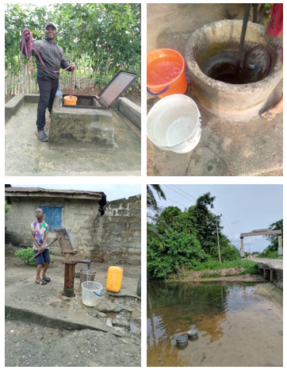

**Plate 1: Specimen of Some Water Sources in Khana LGA of Rivers State**

**S****ource: Authors Field Data, 2024**

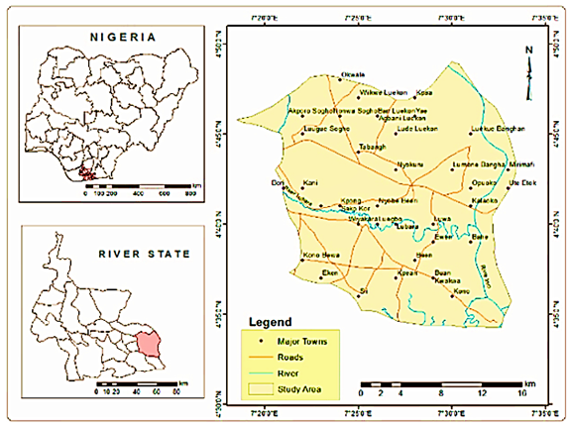

**Figure 1: Map of the Study Area Khana L.G.A; Source: Kaananwii and Aigboghosa, 2021**

**2.0 Material and Methods**

Materials/Instruments used in course of this research work are; Garmin 76csx GPS receiver, 100m Steel tape, Personal Protective Equipment (PPE), field book, calculator and car for transportation. Software and hardware selection include QGIS, Microsoft packages, Open Street Map (OSM, Google Earth, Dell Latitude Laptop E6540, 6-gig, 64 bits operating system, Camera and Printer amongst others.

**Table 1:** Software and Hardware Selection

|  |  |  |
| --- | --- | --- |
| **S/N** | **Software** | **Hardware** |
| 1 | QGIS | Laptop |
| 2 | Microsoft Word | Phone |
| 3 | Microsoft Excel | Camera |
| 4 | Google earth | Printer |
| 5 | UTM Geo Map | Garmin 76csx GPS |
| 6 | Area from Coordinate | Field Book |

### **2.1 Data Acquisition** **/ Processing**

### **Primary Data Sources**

**Reconnaissance Survey:** Office reconnaissance was done using Google Earth satellite imagery to scrutinize some communities within the study area in order to prepare a framework for field observation.

**Ground Truth Observation: T**he Handheld GPS receiver (Garmin 76csx) was used to obtain the coordinates of various water facilities within the study area, and a camera was also used to take photographs of some water facilities in the study area.

**Creation of Shapefile:** The shapefile of water sources was created by saving the coordinates of various water facilities as CSV (Comma Separated Value, delimited text) file extension through Microsoft Excel and was later imported to the QGIS environment/software through the layer tool, and further exported as a shapefile. This is shown in Figure 4.

**Charting/ Validation of Coordinate Points:** The coordinates acquired were charted or validated on QGIS to ascertain if the position of the various water sources falls within the boundary of the study area, and this was achieved by launching Google Earth and importing the shapefile of Khana LGA and the coordinates of the water sources. This was done to ascertain if the obtained coordinates during data acquisition are in situ.

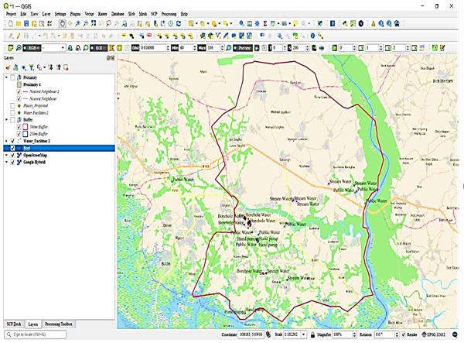

**Figure 2: Screen Print of Coordinate Charting of Water Sources Position**

**On-screen vectorization:** importing the shape file of the water facilities to the QGIS environment as a layer, an open source data known as Open Street Map (OSM) was used to show the roads leading to the various borrow pits and other necessary features needed for the map, where some vector operations were also performed.

**2.2 Data Analysis**

**Proximity and Spatial Pattern Analysis:** The proximity/neighborhood analysis of water facilities to the residence was determined using radii distances of 250m and 500m in order to ascertain the rate of accessibility of the water facilities to the residence.

**3.0 Results**

The study identified a total of 598 potable water sources within the study area. These sources of water include flowing streams, public and private boreholes, dug-out earth wells, and mono pumps. Table 2 shows the sample of the spatial characteristics and inventory of identified water sources in the study area.

**Table 2:** Spatial Distribution and Inventory of Water Sources in Khana LGA

|  |  |  |  |  |  |  |  |  |
| --- | --- | --- | --- | --- | --- | --- | --- | --- |
| **Spatial Locations** | | | | | | | | |
| **S/N** | **Communities** | **Location** | **Water Sources**  **Type** | **Eastings (m)** | **Northings (m)** | **Tenure** | **Vendors** | **Status** |
| 1 | Akporo - Sogho | Market | Monopu mp | 318940.000 | 525954.000 | Public | State Govt. | Functional |
| 2 | Akporo - Sogho | Town  Hall | Borehole | 318941.000 | 525961.000 | Public | NDDC | Non  Functional |
| 3 | Akporo - Sogho | Compou  nd | Well | 318969.000 | 525987.000 | Private | Individual | Functional |
| 4 | Akporo - Sogho | Compou nd | Well | 318843.000 | 525990.000 | Private | Individual | Functional |
| 5 | Akporo - Sogho | Compou  nd | Well | 318918.000 | 526024.000 | Private | Individual | Functional |
| 6 | Akporo - Sogho | Compou  nd | Borehole | 318891.000 | 525944.000 | Private | Individual | Functional |
| 7 | Akporo - Sogho | Compou  nd | Borehole | 318846.000 | 525751.000 | Private | Individual | Functional |
| 8 | Akporo - Sogho | Compou  nd | Well | 318943.000 | 525891.000 | Private | Individual | Functional |
| 9 | Akporo - Sogho | Compou  nd | Well | 318972.000 | 525635.000 | Private | Individual | Functional |
| 10 | Akporo - Sogho | Compou  nd | Borehole | 318612.000 | 525023.000 | Private | Individual | Functional |
| 11 | Akporo - Sogho | Compou  nd | Borehole | 318164.000 | 525534.000 | Private | Individual | Functional |
| 12 | Akporo - Sogho | Compou  nd | Borehole | 318317.000 | 525045.000 | Private | Individual | Functional |
| 13 | Akporo - Sogho | Compou  nd | Monopu  Mp | 318735.000 | 525165.000 | Public | State  Govt. | Non  Functional |
| 14 | Akporo - Sogho | Compou  nd | Well | 318436.000 | 525052.000 | Private | Individual | Functional |
| 15 | Akporo - Sogho | Compou  nd | Well | 318433.000 | 525056.000 | Private | Individual | Functional |
| 16 | Akporo - Sogho | Compou  nd | Well | 318916.000 | 525713.000 | Private | Individual | Functional |
| 17 | Akporo - Sogho | Akporo  - Sogho | Stream | 318980.000 | 525812.000 | Public | Natural  Source | Functional |
| 18 | Akporo - Sogho | Akporo  - Sogho | Stream | 318061.000 | 524316.000 | Public | Natural source | Functional |
| 19 | Baah - Lorre | Market | Well | 326238.000 | 531385.000 | Public | Communit  y Leader | Functional |
| 20 | Baah - Lorre | Compou  nd | Borehole | 326273.000 | 531423.000 | Private | Individual | Functional |
| 21 | Baah - Lorre | Compou nd | Borehole | 326263.000 | 531468.000 | Private | Individual | Functional |
| 22 | Baah - Lorre | Compou  nd | Borehole | 326202.000 | 531331.000 | Private | Individual | Functional |
| 23 | Baah - Lorre | Compou  Nd | Borehole | 326612.000 | 531056.000 | Private | Individual | Non  Functional |
| 24 | Baah - Lorre | Compou nd | Borehole | 326608.000 | 531092.000 | Private | Individual | Functional |
| 25 | Baah - Lorre | Compou  Nd | Borehole  water | 326320.000 | 531351.000 | Private | Individual | Functional |

**Table 3:** **Statistics of Public Water Sources in Khana LGA, Rivers State**

|  |  |  |  |  |
| --- | --- | --- | --- | --- |
| **S/N** | **Public Water Sources (PWS)** | **No.  of PWS** | **Status of PWS** | |
| **Func.** | **Non Func.** |
| 1. | Natural Sources (Stream) | 65 | 59 | 6 |
| 2. | NDDC | 28 | 8 | 20 |
| 3. | State Govt. | 29 | 13 | 16 |
| 4. | Local Govt. | 23 | 15 | 8 |
| 5. | NGO's | 21 | 16 | 5 |
| **6.** | **Total** | **166** | **111** | **55** |

**Figure 3: Spatial Pattern Analysis based on Community in Khana LGA, Rivers State**

**Table 4:** Ownership of Water Sources in Khana LGA

|  |  |  |
| --- | --- | --- |
| **S/N** | **Ownership** | **No. of Water Sources** |
| 1. | Private Water Sources | 432 |
| 2. | Public Water Sources | 166 |
| **3.** | **Total** | **598** |

**Table 5:** **Statistics of Public Water Sources in Khana LGA**

|  |  |  |  |  |
| --- | --- | --- | --- | --- |
| **S/N** | **Public Water Sources (PWS)** | **No.  of PWS** | **Status of PWS** | |
| **Func.** | **Non Func.** |
| 1. | Natural Sources (Stream) | 65 | 59 | 6 |
| 2. | NDDC | 28 | 8 | 20 |
| 3. | State Govt. | 29 | 13 | 16 |
| 4. | Local Govt. | 23 | 15 | 8 |
| 5. | NGO's | 21 | 16 | 5 |
| **6.** | **Total** | **166** | **111** | **55** |

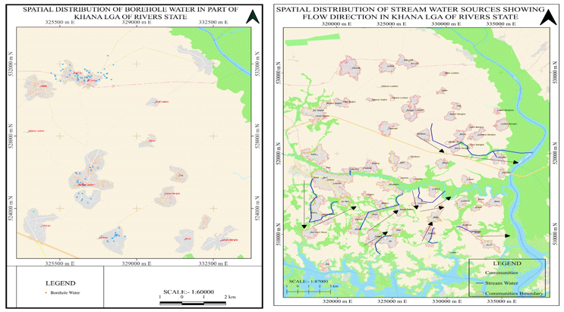

**Figure 4: Specimen of Map Models for Borehole Distribution and Direction of Flow of Stream Water in the Study Area.**

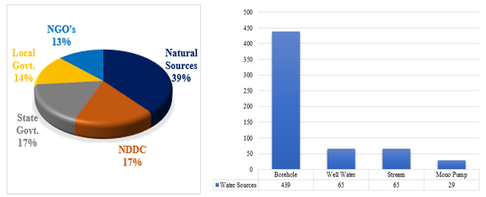

**Figure 5: Percentage (%) of Water Sources Providers and Number of Potable Water Sources in Khana LGA**

**3.1 Findings and Discussion**

The findings of this study are presented using various visual aids, including tables, charts, and figures. A total of 598 water sources were identified, as shown in Table 5, whereas Figure 3 shows the spatial spread of water sources across communities in Khana LGA of Rivers State. Table 3 shows the spatial distribution and inventory of water sources within the study area, this gave insight to the inventory analysis of the water sources, Table 4 provided information with regards to the inventory of public water sources totaling 166 with a total of 111 (66.9%) functional public water sources and 55 (33.1%) non-functional water sources within the study area. A total of 432 (72.2%) potable water sources are privately owned as against 166 (27.8%) public water sources, as shown in Table 5. However, Figure 5 and Table 6 reveal that the study identified 439 Boreholes, 65 Well water, 65 Stream Water, and 29 Mono Pump, which cuts across communities in Khana LGA of Rivers State. The potable water sources providers showed that Natural water sources (streams) represent 39%, water sources provided by the Rivers State Government represent 17%, water sources provided by the Khana Local Government Area was 14%, the regional development agency (NDDC) had 17% of water sources and Non-Governmental Agencies (NGO’s) provided 13% of the water sources. The analysis further reveals that Gumako Bori has the highest number of boreholes (56), while Eeken has only 1 borehole, Teka Sogho has the highest number of wells (13), Kekara has the highest number of stream water (17) and mono pumps (12) amongst others. The specimen flow direction of the natural streams and the concentration of the borehole water sources are shown in Figure 4. It demonstrates the accessibility of the water sources to the populace with the proximal location of the various settlements of the study area.

Findings of the study also reveal a high concentration of potable water sources in the developed region of the study area, such as the Bori community, which has not only more potable water but also modern water sources such as boreholes, while most communities within the study area lack access to potable water sources. Additionally, the non-functionality of 33% of public water sources indicates that there is a poor management structure to sustain potable water facilities within the Khana LGA. In another vein, the spread of potable water sources in the study area was not uniform, thereby presenting skewed and unequal access to water sources. This aligns with the key problems identified by SDG 6 2030’s agenda on the rising inequality of water resources in rural areas.

**4.0. Conclusion**

The efficacy of the geospatial technique was showcased in data acquisition and processing to achieve the aim of the study. Measures were taken to ensure that the obtained field results and map models reflect the ground position and status of water sources in the study area. The significance of the study provides useful data for Regional Development Agencies such as the Niger Delta Development Commission (NDDC), Rivers State Ministry of Water Resources, Federal Ministry of Water Resources and Hydrocarbon Pollution Remediation Project (HYPREP) in their quest to provide basic social amenities, inclusive of potable water amongst others to communities that lacks sufficient potable water sources.

**5.0. Recommendation**

Measures should be put in place by relevant Government Agencies and NGOs to ensure the immediate provision of potable water sources in the noted areas with no or insufficient water sources in Khana. The spatial inventory of potable water sources generated in this work should serve as baseline data for the provision of water sources by the Rivers State Ministry of Water Resources, HYPREP, NDDC, and NGO’s in order to close the gap in accessibility of potable water sources and the SDG No. 6 agenda. This work can be expanded to include the physicochemical characteristics of these water sources in line with the World Health Organization standard.

**References**

Aogo, O. J., Ono, M. N., Ojiko, J. C., Akpee, D and Uchenna, U. D. (2021). Evaluation of crime pattern in Khana local government area using geographic information system. World Journal of Advanced Research and Reviews. Doi: 10.30574/wjarr

Abambagade, A, M, (2020). ‘Water Pollution: Causes and Prevention.’ College of Natural Sciences, Department of Chemistry, Ethiopia.

Dwivedi, A, K (2017). ‘Researches in Water Pollution: A Review’ International Research Journal of Natural and Applied Sciences, Vol. 4(01). ISSN: 2349-4077

Ghilani, C, D, and Wolf P, R, (2012). ‘Elementary Surveying, An Introduction to Geomatics; Thirteenth edition, Pearson Education Inc. New Jersey ISBN 13:978-0-13-255434-3.

Habibu, L.G., Lawali, R., (2021). ‘Analysis of Spatial Distribution Pattern of Boreholes in Geidam Town, Yobe State, Nigeria.’ International Journal of Advances in Engineering and Management (IJAEM) Volume 3, Issue 5. pp: 1501-1511. ISSN: 2395-5252

Izah, S. C., Ngun, C. T. and Richard, G. (2022). Microbial quality of groundwater in the Niger Delta region of Nigeria: Health implications and effective treatment technologies. Current Direction in Water Scarcity Research, 6, 2022: 149 – 172. Doi: 10.1016/B978-0-323-91838-1.00010-5

Kaananwii, D. P. and Aigboghosa, S. U. (2021). Evaluation of land suitability for citrus cultivation in Khana Local Government Area of Rivers State, Southern Nigeria. Iimu pertanian, Agricultural Sciences, 6(1), 2021. Doi: 10.22146/ipas.60307

Okwere, A.O., Hart, L., Jackson, K.P., (2015). ‘Mapping the Spatial Distribution of Water Borehole Facilities in Part of Rivers States using Geographical Information System (GIS) Techniques.’FIG Working week 2015, From the Wisdom Ages to the Challenges of the Modern World, Sofia, Bulgaria, 17-21 May 2015.

Weje, I. I., Emeruem, J. and Nwieke, Namene, (2016). Land value dynamics in Khana Local Government Area of Rivers State, Nigeria. The international journal of Humanities and social studies, 4(8).