**Evaluation of Land Suitability for Surface Irrigation in Kilosa district, Morogoro-Tanzania**

**Abstract**

The increasing demand for land resources to support a growing global population necessitates the optimization of land utilization for food and essential resources. Efficient land planning is critical, especially in Sub-Saharan Africa, where only a small portion of cultivated land is irrigated. This study focused on evaluating land suitability for surface irrigation in Kilosa district located in Tanzania, which has significant potential for paddy production. Utilizing the GIS-based Multi-Criteria Evaluation (MCE) approach, the study evaluated climatic factors, topography, soil properties, river proximity and land use/cover. Data from CHIRPS and ERA5 Ag datasets were utilized as a representative of ground data for precipitation and temperature respectively, revealing their suitability for long-term climate analysis. The factors were categorized for land suitability for surface irrigation, indicating that a majority of the area is moderately suitable. Land use/cover analysis identified significant portions as either not suitable or marginally suitable, with cultivated land being highly suitable. Overall, 16.23% (242,119.14 ha) of the district is highly suitable for Surface irrigation, 37.13% (553,905.34 ha) is moderately suitable, 43.72% (652,214.96 ha) is marginally suitable while the remaining area 2.92% (43,560.56 ha) is not suitable. The study concluded that expanding irrigation infrastructure particularly of surface irrigation system is feasible and necessary for improving surplus production for export, emphasizing the need for integrated land planning and management. Also, the findings provide a basis for upcoming irrigation expansion and strategic irrigation planning, specifically for reviewing the National Irrigation Master Plan (NIMP).

**Key words:** Land Suitability, Surface Irrigation, GIS-based Multi-Criteria Evaluation (MCE), Kilosa District, Tanzania

1. **Introduction**

The increasing demand for land resources to accommodate the agricultural needs of a global population increase emphasizes the urgent necessity for optimizing land utilization, particularly to meet the increasing requirements for food (Mishenin *et al.,* 2021). A main purpose of agricultural land planning is to archive the efficient use of the land to enhance food production and profitability (Hemathilake *et al.,* 2022). Despite irrigated land contributing more than 50 percent of the global agricultural product, not more than 4 percent (6 million hectares) of Sub-Saharan Africa's entire cultivated land, is irrigated (Darko *et al.,* 2020).

Land suitability evaluation for surface irrigation involves solid policy and planning, thereby enhancing the long-term agricultural land resources management (Ozsahin & Ozdes, 2022). It plays a crucial role in sustaining and advancing of irrigation on a spatial scale by identifying geographical patterns, biophysical factors and assesses the potential size of agricultural land for long-term irrigation uses (Hagos *et al.,* 2022).

Evaluation procedure for land suitability involves assessing and categorizing land areas relative to their suitability for particular uses such as agriculture (Mushtaq *et al.,* 2023). The evaluation is a crucial step in development planning as it provides essential insights into the constraints and opportunities associated with the land, primarily focusing on its inherent capabilities (Zhang *et al.,* 2024). The evaluation is derived from various relevant sources and available data. For surface irrigation, physical land features like land use/cover, soil composition, topography, distance from water source and climatic data including precipitation and temperature are emphasized (Akpoti & Zwart, 2019). The biophysical database undergoes characterization and geo-referencing through the collection and reclassification of datasets into different suitability classes (Fentaye, 2017). This study used GIS-based Multi-Criteria Evaluation (MCE) approach to investigate the spatial arrangement of land suitability for surface irrigation as recommended by Hussien & Birhanu, 2019. To comprehend this phenomenon, several studies have been done in Tanzania (Al-Hanbali *et al*., 2022). However, majority of the studies focused on a regional scale rather than local scale. For this study, it scaled down to district level.

Agriculture forms the foundation of Tanzania's economy, employing more than 65% of the people, either formally or informally (Mpogole *et al.,* 2020). This industry accounts for around 33% of the GDP and has a significant impact on export revenues (USAD, 2024). It provides for the livelihoods of a great percentage of the people and is critical to the nation's economic stability and progress (Östberg *et al.,* 2018). The country is progressively enhancing food security and emphasizing on producing a surplus for export to meet the significant demand in East African markets, including Kenya and South Sudan (John, 2024). It is estimated that irrigated land accounts for less than 2.3% of Tanzania's total cultivable land (Uisso & Tanrıvermiş, 2021). Because of the minimal use of irrigation, the great majority of agricultural activities rely on variable rainfall, posing problems to consistent production of surplus for export (Kweka, 2023). Expanding irrigation infrastructure, specifically surface irrigation system as cost effective and practical method in Tanzania, could significantly enhance agricultural output in the area with insufficient rainfall (Gwambene & Mung'ong'o, 2023). The government's policy focuses on transition from rainfed to irrigation-based agriculture. The aim is to increase irrigated land from 0.2 million hectares in 2004 to 1.0 million hectares by 2035 (NIMP, 2018). It is a essential for the planning to take into account the land suitability planning. Thus, the primary objective of this study was to evaluate land suitability for surface irrigation in Kilosa district by examining factors that influence its efficiency. Specifically, the study focused on: (1) evaluating the suitability of individual factors influencing surface irrigation and (2) determining the overall land suitability for surface irrigation.

1. **Materials and Methods**
   1. **Description of the Study Area**

Kilosa district is in Morogoro region of Tanzania with latitude -6.8525 (6°51'9" S) and longitude 36.9916 (36°59'30" E) covering an area of approximately 14,918 square kilometers (Boku, 2014). Geographically the district is dominated by plains terrains, which create a perfect environment for varied ecosystems to succeed (Mselle, 2015). The local economy is driven by agriculture, with a considerable portion of the population engaged in farming activities (Luanda, 2020), this is due to its potential in fertile land and favorable climate which both contribute to the cultivation of various crops, consequently making the district a vital hub for food production in the region (Ntumva, 2020).

The district has a huge potential for paddy production, contributing significantly to Morogoro's agricultural output (Mkubya & Mahoo, 2023). The rainfall in the district varies spatially and seasonally, resulting in uneven distribution patterns (Kitasho *et al.,* 2020). The seasons are dry season which is spanning from May to October with little or no rains, and wet season which is from November to April, generally the rainfall regime is described as unimodal (Wilson & Ouedraogo, 2017). The variations are influenced by climatic factors such as latitude, altitude and prevailing wind patterns (Hamisi, 2013).

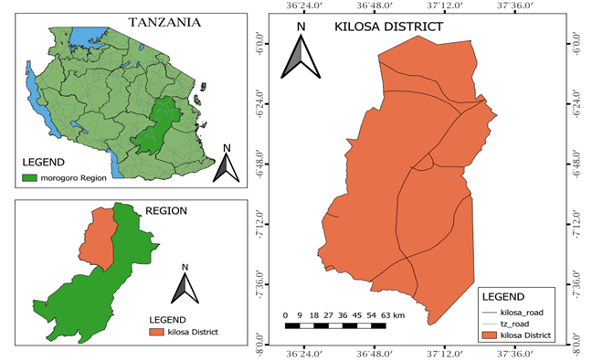

**Figure 1:** Maps showing Tanzania, Morogoro region and Kilosa district as the study area (Source: Kambi *et al* 2024a).

* 1. **Suitability of individual factors**

**2.2.1 Precipitation and Temperature**

Precipitation data from the validated dataset (CHIRPS) ranging from 1981 to 2005 year were used (Gebrechorkos *et al.,* 2018). Thirty-five (35) gridded points of coverage area 500 km2 each were used as a representative of ground rainfall stations (Espinosa *et al*., 2023). The evaluation based on rainfall categorized areas, exceeding 1200mm as highly, 800mm/year to 1200mm/year as moderately, 600mm/year to 800mm/year as marginal, and the rainfall below 600mm as not suitable (Table 2). The spatial rainfall distribution map was produced by interpolating the point rainfall data.

Temperature data from the validated dataset (ERA5 Ag) ranging from 1981 to 2005 year were used (Gebrechorkos *et al.,* 2018). Nine (9) gridded points of coverage area 500 km2 each were used as a representative of ground stations as temperature is influenced by global factors rather than localized geography (Espinosa *et al*., 2023). The evaluation based on temperature categorized areas exceeding 250C as not suitable, those between 200C and 250C as moderately suitable, while temperatures less than 200C as highly suitable (Table 2). The spatial temperature distribution map was as well produced by interpolating the point data.

**2.2.2 Soil properties**

The key soil properties essential for surface irrigation evaluation which are texture, drainage, and soil depth were categorized (Wang *et al.,* 2021). Soil texture was categorized as, clay and clay-loam as highly, clay and sand-clay-loam as moderately, and sand-loam as marginal. For drainage, well-drained soil was classified as highly, moderately well-drained soil as moderately, imperfectly drained-soil as marginal, and poor drained-soil as not suitable for surface irrigation. Regarding soil depth, soil exceeding 100cm was classified as highly, those between 50-100cm as moderately, soils between 10-50cm as marginal, and those less than 10cm as not suitable (Table 2).

**2.2.3 Topographic factors**

Topographic features (slopes and altitudes) significantly influenced the evaluation of land suitability for surface irrigation (Girma *et al.,* 2020). Using the Digital Elevation Model (DEM) data of a 30m resolution from the freely available Shuttle Radar Topography Mission (SRTM), slope and altitude were reclassified using QGIS package (Naranjo *et al*., 2021). Slope rated, 0–2% as highly suitable, 2–5% as moderately suitable, 5–8% as marginal, and >8% as not suitable. For altitude, the region classified 1500–2000m was assigned as moderately, 2000-3000m as highly suitable, and less than 1500m as not suitable (Table 2).

**3.2.4 Land use/cover (LU/LC)**

Map of the year 2023 Land use/cover (LULC) assessment of Kilosa district was analyzed in QGIS package. Land suitability evaluation for surface irrigation based on land use/cover rated, cultivated land as highly suitable, grass land as moderately, bushland as marginal, while natural forest, plantation forest, wood land, permanent swamp, urban area, water bodies, and bare soil as not suitable for surface irrigation (Table 2).

**3.2.5 Distance from water source**

Distance from the water sources (river proximity) were one of the vital criteria in evaluation of land suitability for surface irrigation (Balew *et., al* 2021). The evaluation rated, the regions with range 0-1000m as highly suitable, 1000-3000m as moderately suitable, 3000-5000 as marginal, and those exceeds 5000m as not suitable (Table 2).

* 1. **Overall land suitability for surface irrigation**

The overall land suitability shows areas categorized as highly suitable (S1), moderately suitable (S2), marginally suitable (S3), and not suitable (N) (Table 1). The general conceptual methodology utilized through the study is illustrated in the Figure 2, while Table 2 outlines the weights assigned to separately contributing parameter and its respective classes, along with the sources of the information.

**Table 1:** Land suitability classification (FAO, 1976)

|  |  |
| --- | --- |
| **Class Suitability** | **Description** |
| S1 Highly suitable | Land without major limitations |
| S2 Moderately suitable | Moderate limitations that reduce productivity, or increase the required inputs |
| S3 Marginally suitable | Significant limitations, making land only marginally justifiable. |
| N Not suitable | Limitations that cannot currently be overcomed with existing knowledge at an acceptable cost. |

**Table 2:** Land suitability criteria established for the studied parameters.

|  |  |  |  |  |  |  |
| --- | --- | --- | --- | --- | --- | --- |
| **Main factor** | **Sub factor** | **Factor rating** | | | | **Source** |
| S1 | S2 | S3 | N |
| Topography | Slope (%) | 0-2 | 2-5 | 5-8 | >8 | FAO (1984) |
| Altitude (m) | 2000-3000 | 1500-2000 | 3300-3800 | <1500 | FAO (1984) |
| Soil | Drainage class | Well | Moderately well | Imperfectly | Poor | Adem, A. F., & Danbara, J. H. (2022) |
| Depth (cm) | >100 (Very deep) | 50-100 (Moderately deep) | 10-50 (Shallow) | <10 (Very shallow) | Mandal *et al*., 2018 |
| Texture | Loam, Clay-Loam | Clay, Sand-Clay-Loam | Sand-Loam | N/A | Kilosa DC (2020). |
| Distance from water source | Euclidian distance (m) | 0-1000 | 1000-3000 | 3000-5000 | >5000 | Han *et al.,* 2021. |
| LU/LC | LU/LC | Cultivated land | Grass land | Bushland | Constraints (Forest, Build-up, water, ponds) | Barman, J., & Das, P. (2023) |
| Precipitation | Precipitation (mm) | 1200 | 800-1200 | 600-800 | <600 | Angelakιs *et al.,* (2020). |
| Temperature | Temperature (0C) | <20 | 20-23 | 23-25 | >25 | NIMP, (2018) |

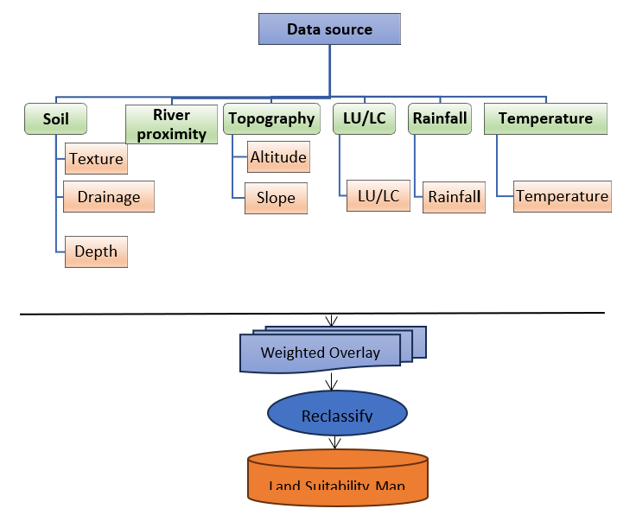

**Figure 2:** The Overall conceptual framework utilized in the study

The Analytical Hierarchy Process (AHP) incorporated weighting to individually contributing criterion. AHP implemented a process for identifying and criteria for classifying and assessing the context of spatial planning decisions (Morales *et al.,* 2021). Three key principles guided AHP were decomposition, comparative judgment, and synthesis of priorities (Darko *et al.,* 2019). A matrix of pairwise comparisons among parameters influencing land suitability for to surface irrigation was constructed by AHP. A scale ranging from 1 to 9 was utilized to indicate the relative importance of two factors. The prioritization of the factors for the study area was guided by insights from Tanzania's experience (NIMP, 2018). Reciprocal values from 1/1 to 1/9, represented the relative significance between the criteria (Table 3). Criteria weights were then determined by calculating eigenvalues (equation i) through pairwise comparisons of contributing factors and finally they were normalized (Odu, 2019). The random consistency indices (RI) established by Saaty (1980) were employed to calculate the consistency ratio (CR) (equation ii) for gauging the degree of consistency (Table 4).

**Table 3**: Saaty’s scale in AHP (Saaty 1980)

|  |  |  |
| --- | --- | --- |
| **Definition** | **Index** | **Definition Index** |
| Equally important | 1 | Equally important 1/1 |
| Equally or slightly more important | 2 | Equally or slightly less important 1/2 |
| Moderately/Slightly more important | 3 | Moderately/Slightly less important: Experience and judgment slightly favor one option over the other (with a ratio of 1/3). |
| Slightly to much more important | 4 | Slightly to weigh less important 1/4 |
| Strongly more important / Much more important | 5 | Way less important: Experience and judgment strongly favor one option over the other. 1/5 |
| Much to far more important | 6 | Way to far less important 1/6 |
| Very much more important/Far more important | 7 | Far less important: Experience and judgment strongly favor one option over the other. 1/7 |
| Far more important to extremely more important | 8 | Far less important to extremely less important 1/8 |
| Absolutely more important / Extremely more important | 9 | Extremely less important: The evidence supporting one option over the other (with a ratio of 1/9) is of the highest possible validity. |

**Table 4:** Values of random index (RI)

|  |  |  |  |  |  |  |  |  |  |  |
| --- | --- | --- | --- | --- | --- | --- | --- | --- | --- | --- |
| n | 1 | 2 | 3 | 4 | 5 | 6 | 7 | 8 | 9 | 10 |
| RI | 0.00 | 0.00 | 0.58 | 0.90 | 1.12 | 1.24 | 1.32 | 1.41 | 1.45 | 1.49 |

The consistency index (CI) was calculated using the formula provided below.

$CI=\frac{λ_{max}-n}{n-1}$……………………………………i

Where λmax is the largest eigenvalue of the pairwise comparison matrix and n is the number of classes.

The consistency ratio (eqn. ii) is defined as

$CR=\frac{CI}{RI}$………………………………………. ii

where RI is ratio index/average value of CI for random matrices using Saaty scale.

The consistency index (CI) (equation i) was compared to a random index (RI) (Table 4) (Pant, 2022). The RI represents the average CI of randomly generated reciprocal matrices, utilized the scale from 1/9 to 9/1 (Peláez *et al.,* 2018). Saaty (1980) generated random matrices of varying dimensions (n) (Table 4) and determined their mean CI values. For matrices with n≥5, a consistency ratio (CR) of lower than 0.1 was accepted (Saaty, 1979). The QGIS weighted overlay analysis tool (Figure 2) assessed the overall land suitability spatially, generated a suitability map by aggregating the output from AHP (Salifu *et al.,* 2022).

1. **Results**
   1. **Suitability of individual factors**

**3.1.2 Precipitation and Temperature**

Rainfall suitability showed that 1,320,988.90(88.55%) hectares of the study area was dominated by moderately suitable. Only 50,721.20(3.40%) hectares of the area was highly suitable. Finally, the remaining 120,089.90(8.05%) hectares was assigned under marginal suitable (Figure 3a&b). Temperature suitability showed that the majority 1,013,976.46(67.97%) hectares of the study area was moderately suitable. A smaller portion of the area 300,597.70(20.15%) hectares was assigned as marginal suitable. Where the remaining 177,225.84(11.88%) hectares was assigned under highly suitable (Figure 3c&d).

**3.1.2 Soil** **properties**

Based on the soil texture, the area 1,019,496.12(68.34%) hectares was dominated by loam and clay-loam, which was allocated as highly suitable. The area 337,146.80(22.60%) hectares was dominated by sand-loam, which was classified under moderately suitable class. The remaining area 135,157.08(9.06%) hectares was dominated by sand-clay-loam, which was classified under marginal suitable class (Figure 3e&f).

Soil drainage analysis showed that the area 1,113,927.06(74.67%) hectares was dominated by somewhat excessive and well, which was classified under highly suitable. The area 73,247.38(4.91%) hectares was dominated by imperfect and moderately well, which was classified under moderately suitable. The area 197,365.14(13.23%) hectares was dominated by poor drainage, which was classified under marginal suitable. While the remaining area 107,260.42(7.19%) hectares was dominated by very poor drainage, which was classified under not suitable (Figure 3g&h).

Soil depth analysis of the study area was classified into two regions which were 75-100cm 1,135,707.34(76.13%) hectares and the one exceeding 100cm, 356,092.66(23.87%) hectares, which were moderately suitable and highly suitable respectively (Figure 3i&4j).

**3.1.3 Distance from water source (river proximity)**

The analysis showed that 256,440.42(17.19%) hectares, fell within 0-1000 meters from the water source and was classified as highly suitable. The area 10,890.14(0.73%) hectares fell under 1000-3000m, which was classified under moderately suitable class. The area 224,814.26(15.07%) hectares fell under 3000-5000m, which was classified under marginal suitable class. while the remaining area 999,655.18(67.01%) hectares exceeding 5000m, which was classified under not suitable class (Figure 4k&l).

**3.1.4 Topographic factor**

The slope analysis showed that the area 606,715.06(40.67%) hectares was below 2%, which was assigned as highly suitable. In contrast, 199,006.12 (13.34%) hectares was ranging between 2-5% slope, which was moderately suitable. A significant portion of the study area 366,386.08(24.56%) hectares lied between 5-8% slope range, which was marginal. Finally, 319,692.74 (21.43%) hectares of the study area exceeded 8%, which was steep slope and not suitable for surface irrigation (Figure 4m&n).

The altitude analysis showed that the area 1,091,102.52(73.14%) hectares was between 2000-3000m, which was highly suitable. The area 255,246.98(17.11%) hectares ranged between 1500-2000m, which was moderately suitable. The remaining portion 145,450.50(9.75%) hectares was not exceeding 1500m altitude range, which was marginal (Figure 4o&p).

**3.1.5 Land use/cover (LU/LC)**

The study area's land use/land cover classification reveals a significant portion, 885,830.84(59.37%) hectares, including areas with plantation forest, water, urban regions, bare soil, natural forest, woodland, and permanent swamp, was not suitable. Grassland, covers 301,194.42(20.19%) hectares, was classified as moderately suitable, while bushland, accounting for 161,711.12 (10.84%) hectares, was marginally suitable. The highly suitable areas, comprising 885,830.84(9.59%) hectares of cultivated land (Figure 4q&r).

* 1. **Overall suitability/Weighting of factors using AHP**

The pair-wise comparison matrix and the overall weights of the factors nominated for the study area are presented in table 5 and 6 consecutively. The nine (9) factors were mentioned in both columns and rows. Consequently, the factors in row and column were compared to assess their significance for surface irrigation. Using the scoring method outlined by Saaty (1977), as shown in Table 5, the pairwise comparison matrix in Table 6 was then prepared.

The distance from water source (measured as Euclidean distance) was the most critical factor, as all the values in its corresponding row exceeded 1(Table 5). It was followed by soil depth and rainfall. The least important factor was temperature, as its row values were all less than 1. Subsequently, the factor’s weights were then computed by normalizing the respective eigenvector with the cumulative eigenvector. The vector of eigenvalue is the nth root of the row’s product of the rows. The weights of each factor, determined using the pairwise technique, were presented in the last columns of Table 6, where a higher value showed a greater importance. The sum of the last columns was 100. The consistency ratio (CR) 0.02, showed that the comparisons and relative weights were consistent and properly assigned respectively.

The overall land suitability evaluation for Surface irrigation based on the overlaid individual layers showed that about 16.23% of the study area were potentially highly suitable, 37.13% was moderately suitable, 43.72% was marginal suitable, whereas 2.92% of the district was accounted for not suitable (Table 7 and Figure 5).

**Figure 3**(a, b, c, d, e, f, g, h, i): Factors map and degree of land suitability to assess the ideal location for surface irrigation

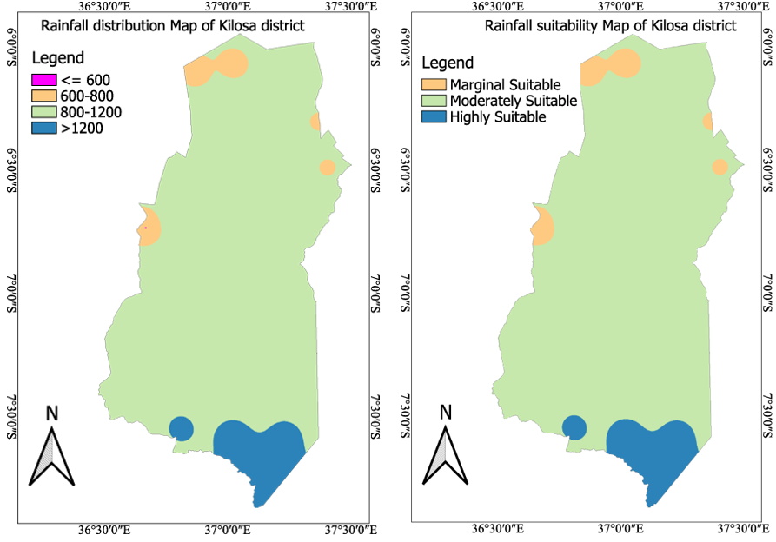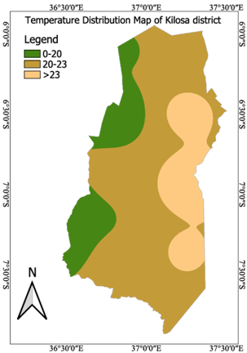

a b c

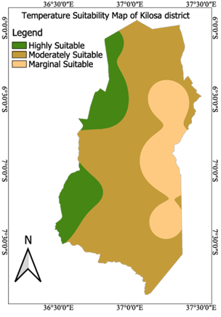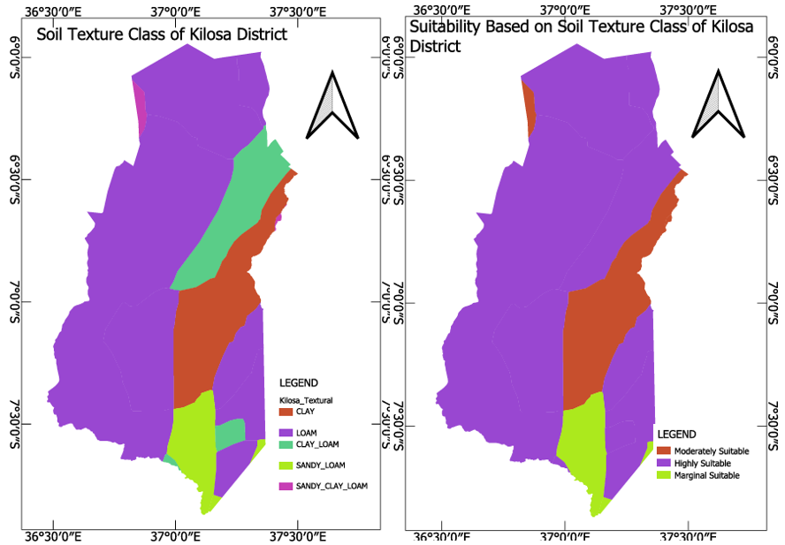

d e f

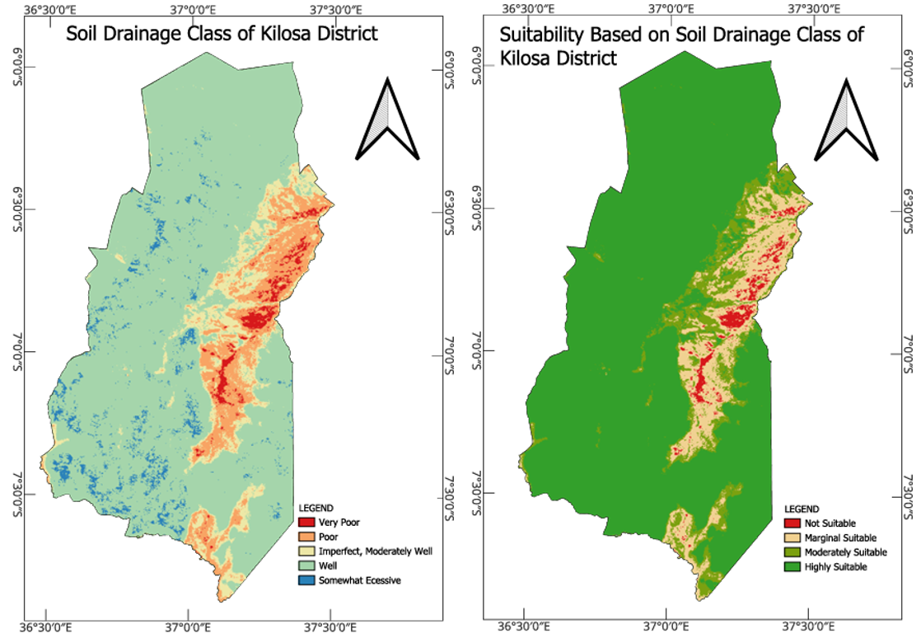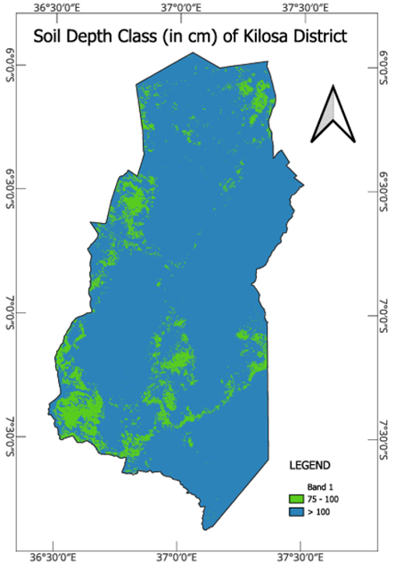

g h i

**Figure 4**(j, k, l, m, n, o, p, q, r): Factors map and degree of land suitability to assess the ideal location for surface irrigation

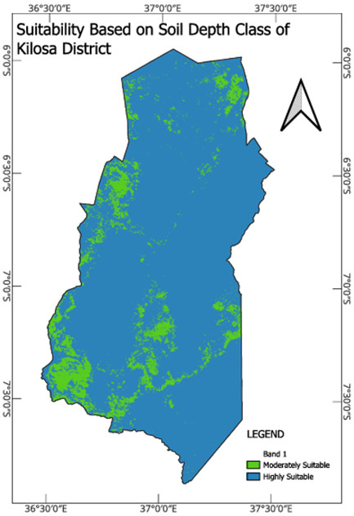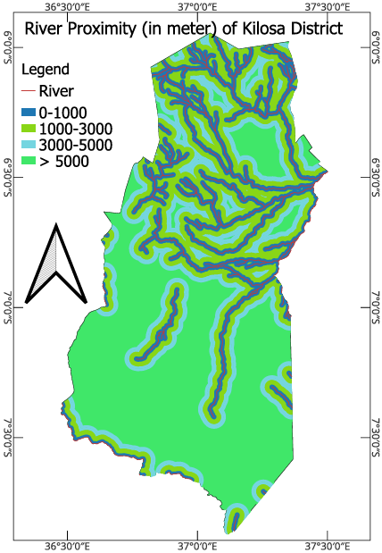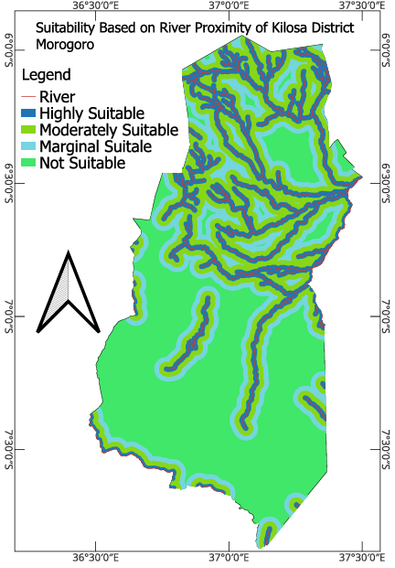

j k l

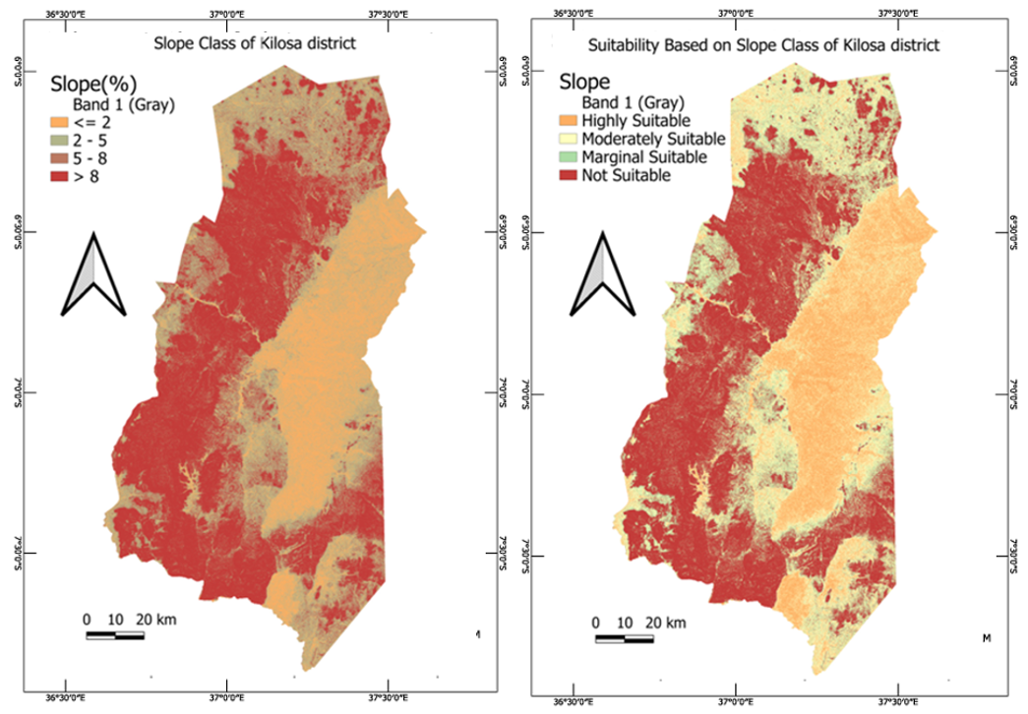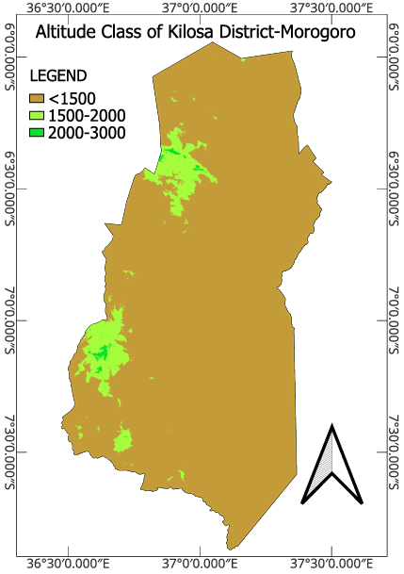

m n o

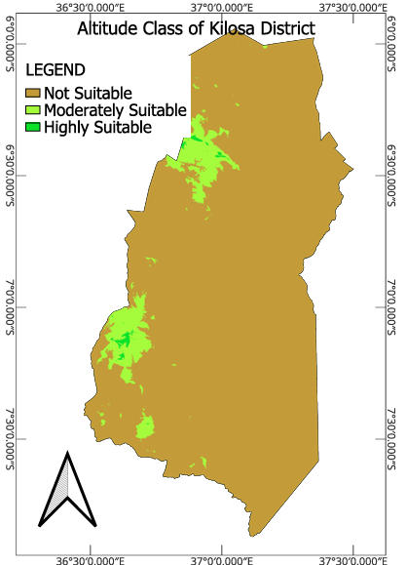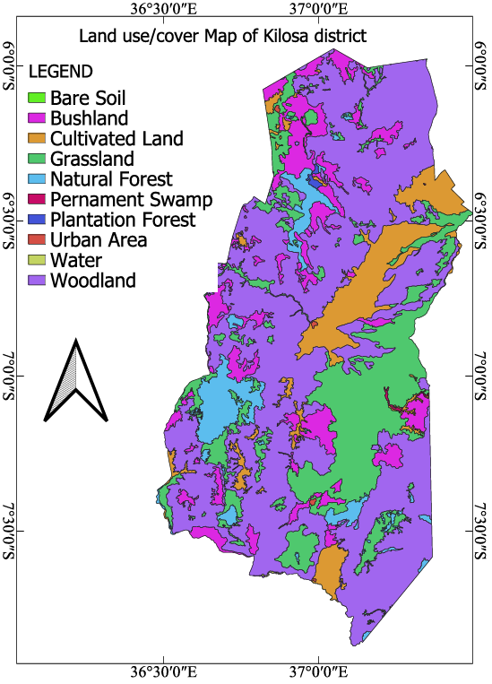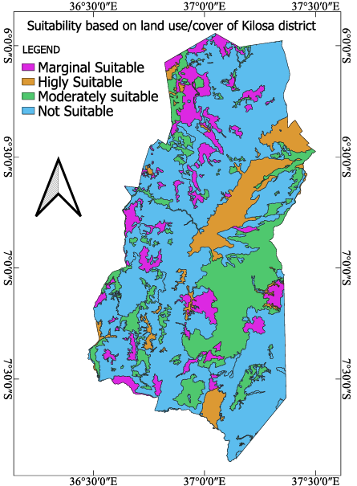

p q r

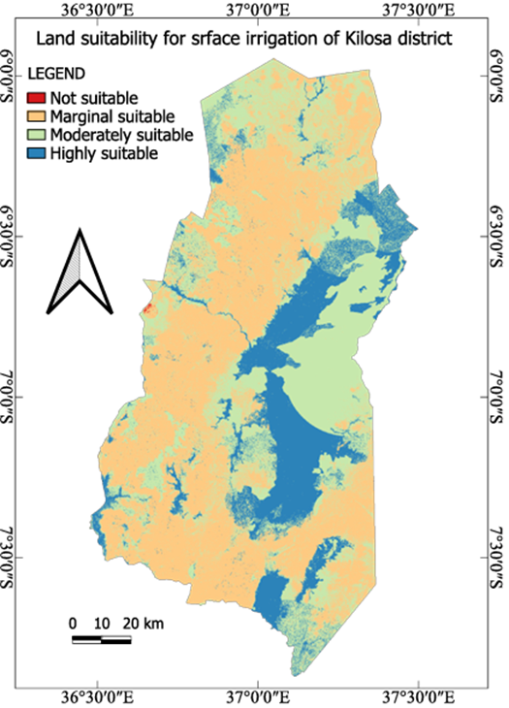

**Figure 5:** Overall land suitability for surface irrigation.

1. **Discussion**

The results of the research revealed that a major proportion of Kilosa district is moderately to highly suitable for surface irrigation, especially in the eastern part. This can be explained by regular rainfall, temperate temperatures, soft slopes, and closeness to water bodies like the Mkondoa and Wami rivers. These conditions minimize the use of supplemental irrigation and decrease costs of operation, consistent with insights by Gebrechorkos *et al.* (2019b) highlighting the significance of good precipitation and temperature regimes in the sustainability of irrigation. Regions in the western, northeastern, and eastern parts were less favorable because of the existence of Rubeho and Ukaguru mountain ranges, whose high slopes and poor drainage restrict surface irrigation potential. These regions also have increased rates of evaporation due to hot temperatures, causing excessive water loss. The reduced water-holding capacity in these areas requires the use of supplemental irrigation systems, like drip or sprinkler irrigation, compared to conventional surface irrigation. This assertion agrees with existing research by Wanyama *et al.* (2024) in East Africa, where it was established that topography and climate variability influence irrigation potential considerably.

Analysis of soil properties is also giving back-up to the trend of favorable zones of irrigation. Loamy, clay-loamy, and sandy-loamy soils predominantly covering the west, north-east, and portions of the east research area were much favorable because they have good water storage, permeability, and drainage. These decrease percolation losses of water and the number of times irrigation has to be done and are thus best suited for surface irrigation. However, the extremely waterlogged poor-draining soils of the south were unsuitable because of excessive waterlogging risk, and therefore had to involve huge land preparation and draining to be suitable. Water supplies constituted a major constraint in amenability to irrigation as well. Marginally suitable and unsuitable lands dominated in the south and the central region of the district, where large water supply distances made irrigation operations hugely costly and inconvenient. These zones need closed conduit systems and sophisticated water management in order to reduce conveyance losses, as recommended by Mengistu *et al.* (2021) in the case of arid regions where there is a water scarcity problem.

Topographical limitations were the key to setting suitability for irrigation. The southern section of Kilosa district, whose slope was gentle (less than 2%), was highly appropriate since there would not be much to change for effective water distribution. Steep areas with moderate slope (2–5%) were also favorable in terms of suitability but might need basic leveling of land to increase irrigation efficiency. But steeper slopes (5–8%) and over 8% in the western and southwestern parts proved challenging with increased runoff and danger of soil erosion, requiring measures of soil conservation like terracing and contour tillage. Water distribution was affected by altitude, too, so that below an altitude of 1500 meters, it was constrained by a decrease in the movement of water and irregularity of distribution and hence less so for gravity surface irrigation. Conversely, brief sections of the higher elevations in the western part of the country witnessed enhanced natural flow and water distribution and were moderately to highly appropriate for surface irrigation. The present results support the research study done by Mitiku *et al.* (2024), which highlighted the significance of altitude and slope in irrigation suitability assessment.

Land cover/use was one of the significant factors in determining irrigation potential. Open soils, water retention limitations, and competing uses like urbanization and conservation were reasons for which areas in the west, northeast, and southeast proved to be unsuitable. Urbanization in Gairo, Kilosa, Mikumi, Kimamba, and Dumila was occurring so fast that it resulted in soil loss, forest cover, and land arability and therefore reduced irrigation suitability. But the eastern part of the region, moving towards the center, recorded maximum coverage by very and fairly well-fitted lands for irrigation. They were grassland and cropland whose improvement through efforts of focused water management and infrastructural development is feasible. Although bushland zones are challenging owing to uneven topography and cover vegetation, they would still be suitable for irrigation supply with appropriate land preparation and water management practices. Deforestation in Rubeho and Ukaguru forest reserves due to charcoal burning and agricultural encroachment has resulted in land degradation and disturbance of local water catchments. The practice negates long-term potential for irrigation by lowering water supply and enhancing soil erosion. The same patterns are reported in other deforestation and land-use change-hotspots, according to Sharma *et al.* (2024).

The research mentioned the implementation of climate-resilient irrigation management to mitigate the effect of climate change, topographic limitations, and anthropogenic forces. The decrease in highly suitable places under the future climate (RCP 4.5 and RCP 8.5) means that sophisticated irrigation planning is required to maintain agricultural productivity. Some of the most significant suggestions are encouraging water saving irrigation methods, like sprinkler and drip irrigation, in favorably marginal lands to reduce water losses. Where the slope is steep and drainage is bad, soil conservation methods like contour plowing and terracing can be employed to prevent erosion and enhance the soil retention. Closed conduit and water storage structures also need to be installed to increase the efficiency of irrigation in water-scarce regions. In addition, sustainable land-use legislation must be passed to limit deforestation and urbanization in areas of high suitability for irrigation, maintaining water catchments and soil integrity.

While the study offers useful information, certain limitations need to be noted. Accuracy of suitability depends on input data resolution and quality, e.g., climate projections and soil type. In addition, future studies should also include socioeconomic variables like farmers' flexibility, cost-benefit of irrigation facilities, and institutional assistance in the development of irrigation. Multi-scale and high-resolution advanced hydrological models must be investigated in more studies to better predict impacts of climate change on water resources. Remote sensing and GIS-based methods can also improve spatial accuracy in determining feasible irrigated areas.

Generally, the research identifies the eastern Kilosa district as being most appropriate for surface irrigation in terms of climate, topography, and soil. Western and northeastern areas are constrained by mountainous topography, low drainage, and impacts of deforestation. For the purpose of sustainable development of irrigation, it is important to incorporate high technology in irrigation, land conservation measures, and adaptive policy.

Table 7: Overall suitability class for Kilosa district

|  |  |  |  |
| --- | --- | --- | --- |
| **Area (ha)** | **Suitability** | **Description** | **Percentage (%)** |
| 242,119.14 | S1 | Highly Suitable | 16.23 |
| 553,905.34 | S2 | Moderately Suitable | 37.13 |
| 652,214.96 | S3 | Marginal Suitable | 43.72 |
| 43,560.56 | N | Not Suitable | 2.92 |

1. **Conclusion**

Surface irrigation land suitability evaluations indicated that 53.36% (796,024.48 Hectares) of the study area is suitable and recommended for irrigation as an overall land suitability. The areas are from eastern and central parts of Kilosa District on the favorable conditions such as adequate rainfall with moderate temperatures and proximity to the major water sources, Mkondoa and Wami rivers which contribute to the irrigation potential. The modification in these areas are minimal, which constitute an opportunity for sustainable agricultural expansion.

Conversely, the remaining 695,775,52 hectares (46.64%) are not recommended for surface irrigation. The areas are in the western, northeastern, and some parts of the southern region of the district, noting that they are characterized by steep slopes, lack of drainage, farthest away from water sources and unsuitable land use. In addition, the Rubeho and Ukaguru mountain ranges, as well as protected forest reserves such as Kilangali are also another limitation due to very limited land availability and environmental considerations. To address these challenges, there would be a need for considerable investments in irrigation infrastructure, alternative farming techniques or land management approaches in order to increase water accessibility and minimize environmental risks.

**COMPETING INTERESTS DISCLAIMER:**

Authors have declared that they have no known competing financial interests OR non-financial interests OR personal relationships that could have appeared to influence the work reported in this paper.

**Table 5:** Pairwise comparison matrix for the selected criteria

|  |  |  |  |  |  |  |  |  |  |
| --- | --- | --- | --- | --- | --- | --- | --- | --- | --- |
| Factors | Euclidian | Soil Depth | Soil Texture | Soil Drainage | Slope | Land use | Altitude | Rainfall | Temperature |
| Euclidian | 1 | 2 | 3 | 3 | 3 | 7 | 9 | 2 | 5 |
| Soil Depth | 1/2 | 1 | 2 | 2 | 2 | 9 | 7 | 1/2 | 2 |
| Soil Texture | 1/3 | 1/2 | 1 | 2 | 1 | 7 | 7 | 1/2 | 5 |
| Soil Drainage | 1/3 | 1/2 | 1/2 | 1 | 1 | 7 | 7 | 1/2 | 5 |
| Slope | 1/3 | 1/2 | 1 | 1 | 1 | 7 | 5 | 1/5 | 3 |
| Land use/cover | 1/7 | 1/9 | 1/7 | 1/7 | 1/7 | 1 | 2 | 1/5 | 2 |
| Altitude | 1/9 | 1/7 | 1/7 | 1/7 | 1/5 | 1/2 | 1 | 1/7 | 5 |
| Rainfall | 1/2 | 2 | 2 | 2 | 5 | 5 | 7 | 1 | 5 |
| Temperature | 1/5 | 1/2 | 1/5 | 1/5 | 1/3 | 1/2 | 1/5 | 1/5 | 1 |

**Table 6;** Normalized pairwise comparison matrix and computation of criterion weights

|  |  |  |  |  |  |  |  |  |  |  |
| --- | --- | --- | --- | --- | --- | --- | --- | --- | --- | --- |
| Factors | Euclidian  distance(m) | Soil Depth | Soil Texture | Soil Drainage | Slope | Land use/cover | Altitude | Rainfall | Temperature | Criteria Weight (%) |
| Euclidian(m) | 0.290 | 0.276 | 0.300 | 0.261 | 0.219 | 0.159 | 0.199 | 0.381 | 0.152 | 24.86 |
| Soil Depth | 0.145 | 0.138 | 0.200 | 0.174 | 0.146 | 0.205 | 0.155 | 0.095 | 0.061 | 14.65 |
| Soil Texture | 0.097 | 0.069 | 0.100 | 0.174 | 0.073 | 0.159 | 0.155 | 0.095 | 0.152 | 11.93 |
| Soil Drainage | 0.097 | 0.069 | 0.050 | 0.087 | 0.073 | 0.159 | 0.155 | 0.095 | 0.152 | 10.41 |
| Slope | 0.097 | 0.069 | 0.100 | 0.087 | 0.073 | 0.159 | 0.111 | 0.038 | 0.091 | 9.16 |
| Land use/cover | 0.041 | 0.015 | 0.014 | 0.012 | 0.010 | 0.023 | 0.044 | 0.038 | 0.061 | 2.88 |
| Altitude | 0.032 | 0.020 | 0.014 | 0.012 | 0.015 | 0.011 | 0.022 | 0.027 | 0.152 | 3.39 |
| Rainfall | 0.145 | 0.276 | 0.200 | 0.174 | 0.366 | 0.114 | 0.155 | 0.191 | 0.152 | 19.68 |
| Temperature | 0.058 | 0.069 | 0.020 | 0.017 | 0.024 | 0.011 | 0.004 | 0.038 | 0.030 | 3.03 |

*CR=0.02 Lambda (λmax ) that is the Maximum Eigen Value = 9.23*

**REFERENCES**

1. Adem, A. F., & Danbara, J. H. (2022). "Land Suitability Mapping for Surface Irrigation Using GIS-Based Techniques in Ethiopia." Water Resources Management, 36(2), 101-123. DOI: 10.1007/s11269-022-03177-3.
2. Al-Hanbali, A., Shibuta, K., Alsaaideh, B., & Tawara, Y. (2022). Analysis of the land suitability for paddy fields in Tanzania using a GIS-based analytical hierarchy process. Geo-Spatial Information Science, 25(2), 212-228.
3. Angelakιs, A. N., Zaccaria, D., Krasilnikoff, J., Salgot, M., Bazza, M., Roccaro, P., ... & Fereres, E. (2020). Irrigation of world agricultural lands: Evolution through the millennia. Water, 12(5), 1285.
4. Balew, A., Nega, W., Legese, B., & Semaw, F. (2021). Suitable potential land evaluation for surface water irrigation using remote sensing and GIS–MCE in the case of rib–gumara watershed, Ethiopia. Journal of the Indian Society of Remote Sensing, 49, 2273-2290.
5. Barman, J., & Das, P. (2023). A multi-criteria decision-making approach for land suitability assessment for tea cultivation in Hilly Aizawl district in Mizoram, India. In Advancement of GI-Science and Sustainable Agriculture: A Multi-dimensional Approach (pp. 135-147). Cham: Springer Nature Switzerland.
6. Boku, K. (2014). Land use and land cover change detection using remote sensing techniques: The case of Kilosa district, Tanzania. International Journal of Remote Sensing, 35(5), 1007-1019.
7. Darko, A., Chan, A. P. C., Ameyaw, E. E., Owusu, E. K., Pärn, E., & Edwards, D. J. (2019). Review of application of analytic hierarchy process (AHP) in construction. International journal of construction management, 19(5), 436-452.
8. Darko, R. O., Liu, J., Yuan, S., Sam-Amoah, L. K., & Yan, H. (2020). Irrigated agriculture for food self-sufficiency in the sub-Saharan African region. International Journal of Agricultural and Biological Engineering, 13(3), 1-12.
9. Espinosa, L. A., Portela, M. M., Moreira Freitas, L. M., & Gharbia, S. (2023). Addressing the Spatiotemporal Patterns of Heatwaves in Portugal with a Validated ERA5-Land Dataset (1980–2021). Water, 15(17), 3102.
10. FAO (1976). A Framework for Land Evaluation. Rome: Food and Agriculture Organization.
11. FAO (1984). Guidelines: Land Evaluation for Irrigated Agriculture. FAO Soils Bulletin 55. Rome: Food and Agriculture Organization of the United Nations.
12. FENTAYE, B. (2017). GIS BASED LAND SUITABILITY ASSESSMENT FOR SURFACE IRRIGATION: CASE STUDY IN KOBO VALLEY, EASTERN AMHARA.
13. Gebrechorkos, S. H., Hülsmann, S., & Bernhofer, C. (2018). Evaluation of multiple climate data sources for managing environmental resources in East Africa. Hydrology and Earth System Sciences, 22(8), 4547-4564.
14. Girma, A., Teshome, A., & Wale, M. (2020). Slope suitability classification for surface irrigation development. International Soil and Water Conservation Research, 8(2), 135-145.
15. Gwambene, B., & Mung'ong'o, C. (2023). Prospects of irrigation infrastructure expansion in Tanzania. African Journal of Agricultural Research, 18(4), 125-136.
16. Hagos, Y. G., Mengie, M. A., Andualem, T. G., Yibeltal, M., Linh, N. T. T., Tenagashaw, D. Y., & Hewa, G. (2022). Land suitability assessment for surface irrigation development at Ethiopian highlands using geospatial technology. Applied Water Science, 12(5), 98.
17. Hamisi, Y. (2013). Seasonal climate variability and its impact on agriculture in Kilosa District, Tanzania. Weather and Climate Extremes, 2, 25-33.
18. Han, C., Chen, S., Yu, Y., Xu, Z., Zhu, B., Xu, X., & Wang, Z. (2021). Evaluation of agricultural land suitability based on RS, AHP, and MEA: A case study in Jilin Province, China. Agriculture, 11(4), 370.
19. Hemathilake, D. M. K. S., & Gunathilake, D. M. C. C. (2022). Agricultural productivity and food supply to meet increased demands. In Future foods (pp. 539-553). Academic Press.
20. Hussien, B., & Birhanu, T. (2019). GIS-based multi-criteria evaluation for land suitability analysis. Journal of Geography and Regional Planning, 12(4), 49-59.
21. John, K. (2024). Market opportunities for Tanzanian agricultural products in East Africa. East African Agricultural Review, 22(1), 35-49.
22. Kilosa District Council, Agricultural Development Plan Report, Morogoro, Tanzania, 2020
23. Kitasho, F. T., Mawiti, R., & Ulimwengu, J. (2020). Rainfall variability and its impact on agriculture in Kilosa district, Tanzania. Agricultural Water Management, 234, 106123.
24. Kweka, G. J. (2023). Agricultural Commodity price changes, food security and households’ welfare in Tanzania.
25. Luanda, D. (2020). The role of agriculture in the local economy of Kilosa District, Tanzania. Journal of Agriculture and Rural Development in the Tropics and Subtropics, 121(1), 45-56.
26. Mandal, D., Majumdar, K., & Singh, S. K. (2018). "Evaluation of Land Suitability for Surface Irrigation Based on Soil Depth and Other Physical Parameters." Agricultural Water Management, 202(4), 94-104. DOI: 10.1016/j.agwat.2018.02.013.
27. Mazungunye, P. P. (2020). Industrialisation for economic transformation: Economy-wide impacts of agro-processing development in Tanzania (Doctoral dissertation, Stellenbosch: Stellenbosch University).
28. Mishenin, Y., Yarova, I., & Koblianska, I. (2021). Ecologically harmonized agricultural management for global food security. Ecological intensification of natural resources for sustainable agriculture, 29-76.
29. Mitiku, A., Deribew, K. T., Moisa, M. B., & Worku, K. (2024). Spatial evaluation of surface water irrigation potential areas to improve rural crop productivity in the Gomma district, southwestern Ethiopia. Cogent Food & Agriculture, 10(1), 2328424.
30. Mkubya, J. D., & Mahoo, H. F. (2023). Potential for paddy production in Kilosa District, Tanzania. Journal of Agricultural Extension and Rural Development, 15(2), 98-109.
31. Mngumi, E. M. (2016). Challenges of rainfed agriculture in Tanzania. Journal of Agriculture and Ecology Research International, 9(2), 1-12.
32. Morales Jr, F., & de Vries, W. T. (2021). Establishment of land use suitability mapping criteria using analytic hierarchy process (AHP) with practitioners and beneficiaries. Land, 10(3), 235.
33. Mpogole, H., Dimoso, P., & Mayaya, H. (2020). Agriculture for Rural Development in Tanzania. TEMA Publishers Co. Limited, Dar es Salaam.
34. Mselle, L. (2015). Climate variability and its impacts on agricultural productivity in Kilosa District, Tanzania. Climate Research, 62(3), 213-223.
35. Mushtaq, R., Yadav, R. K., Fayaz Fayaz, A., Ahmed, P., & Singh, H. (2023). Multi-criteria land suitability assessment for mulberry-based agroforestry using AHP and GIS approach in Anantnag district of the Kashmir valley, India, to achieve sustainable agriculture. Environment, Development and Sustainability, 1-23.
36. Naranjo, S., Rodrigues Jr, F. A., Cadisch, G., Lopez-Ridaura, S., Fuentes Ponce, M., & Marohn, C. (2021). Effects of spatial resolution of terrain models on modelled discharge and soil loss in Oaxaca, Mexico. Hydrology and Earth System Sciences, 25(10), 5561-5588.
37. NIMP (2018). National Irrigation Master Plan. Dar es Salaam: Ministry of Agriculture.
38. Ntumva, F. (2020). Socio-economic impact of agriculture in Kilosa District, Tanzania. Journal of Development Studies, 56(5), 745-762.
39. Östberg, W., Howland, O., Mduma, J., & Brockington, D. (2018). Tracing improving livelihoods in rural Africa using local measures of wealth: A case study from central Tanzania, 1991–2016. Land, 7(2), 44.
40. Ozsahin, E., & Ozdes, M. (2022). Agricultural land suitability assessment for agricultural productivity based on GIS modeling and multi-criteria decision analysis: the case of Tekirdağ province. Environmental Monitoring and Assessment, 194(1), 41.
41. Pant, S., Kumar, A., Ram, M., Klochkov, Y., & Sharma, H. K. (2022). Consistency indices in analytic hierarchy process: a review. Mathematics, 10(8), 1206.
42. Peláez, J. I., Martínez, E. A., & Vargas, L. G. (2018). Consistency in positive reciprocal matrices: an improvement in measurement methods. IEEE access, 6, 25600-25609.
43. Sharma, N., Bora, R., & Bordoloi, J. (2024). Hotspots of Land Use Land Cover Change: World’s Largest Riverine Island Scenario. Indian Journal of Science and Technology, 17(43), 4536-4545.
44. Uisso, A. M., & Tanrıvermiş, H. (2021). Driving factors and assessment of changes in the use of arable land in Tanzania. Land Use Policy, 104, 105359.
45. USAID. "Tanzania Agriculture Factsheet - February 2024
46. Wang, D., Wang, Z., Zhang, J., Zhou, B., Lv, T., & Li, W. (2021). Effects of soil texture on soil leaching and cotton (Gossypium hirsutum l.) growth under combined irrigation and drainage. Water, 13(24), 3614.
47. Wanyama, J., Nakawuka, P., Bwambale, E., Kiraga, S., Kiggundu, N., Barasa, B., & Katimbo, A. (2024). Evaluation of land suitability for surface irrigation under changing climate in a tropical setting of Uganda, East Africa. Agricultural Systems, 217, 103937.
48. Zhang, W., Yuan, Q., & Cai, H. (2024). Unravelling regional development through the production-living-ecological perspective: Assessing heterogeneity and expert insights. Urban Climate, 55, 101937.