RANSOMWARE AND THE VULNERABILITY OF CRITICAL INFRASTRUCTURE: A NATIONAL SECURITY AND ECONOMIC ANALYSIS

ABSTRACT

Objective: This study examines the fast-growing threat of ransomware attacks on critical infrastructure and their implications for national security and economic stability. It explores the evolution of ransomware, its financial and operational impact on key sectors, and strategies for combating its effects.
Study Design: A detailed review of existing literature, case studies, and industry reports between 2018 and 2024 to assess the recent trends and impact of ransomware attacks on national infrastructure.
Methodology: The research draws from peer-reviewed journal articles, government reports, and cybersecurity industry analyses. It follows a qualitative review approach, including data visualization to represent trends in ransomware incidents, economic losses, and sector-specific vulnerabilities.
Results: The rate of ransomware attacks have increased in number and in degree of threat, with key sectors such as healthcare, energy, and government infrastructure and organizations facing the most attacks. Additionally, the rise of Ransomware-as-a-Service (RaaS) has lowered the barrier for cybercriminals, further increasing the financial and economic damages. Some case studies, mentioned include the Colonial Pipeline, Royal mail and other popular attacks, highlighting the high costs associated with recovery and response.
Conclusions: Ransomware remains a significant economic and security challenge. Strengthening oversight, investing in AI-driven threat detection, and enhancing public-private collaboration are crucial to mitigating risks. Future research should explore evolving cybercrime tactics, international policy frameworks, and proactive defense mechanisms.
.

Keywords: Ransomware, Cybersecurity, Ransomware-as-a-service (RaaS), Critical Infrastructure,

1. INTRODUCTION

Ransomware is a portmanteau of 2 words, which are ransom and malware, respectively. It is a malicious software that is used to block users from accessing its computer system or necessary data till a ransom is paid [1]. There are 2 types of ransomwares, where the most common type is encrypting ransomware, where threat actors use locked data as hostages and demand ransom in return for the decryption key, or non-encrypting ransomware [2], which locks the victim’s device by blocking access to its computer system and usually leads to the device displaying a screen that requests ransom.
The continuous rise of these ransomware attacks has affected many industries, from government institutions, where, in May 2019, Baltimore's government servers were crippled by a ransomware attack that demanded $100,000 worth of Bitcoin, to critical infrastructure, where, in May 2021, the Colonial Pipeline, a major fuel supplier in the U.S., was targeted by the Darkside ransomware group. The attack led to a precautionary shutdown of pipeline operations, causing widespread fuel shortages across the East Coast. The company paid nearly $5 million in ransom to restore operations. All these incidents emphasize the growing sophistication and dynamic nature of ransomware operators, particularly through Ransomware-as-a-Service (RaaS) models [3, 4]
Simultaneously, technological advancements have led to greater dependence on cyber-based systems across various sectors, especially in critical infrastructure. These dependencies have given rise to new threats against the government, key sectors, businesses, and the economy at large. Among these threats, ransomware is regarded as one of the most sophisticated and harmful to industrial systems, capable of yielding catastrophic effects on public safety as well as substantial financial repercussions [5,6]. Economically, ransomware attacks have already cost U.S. businesses billions of dollars, with the healthcare sector alone losing over $31 billion from 2018 to 2022 [6]. Aside from the monetary losses that organizations and government infrastructures that are victimized by ransomware attacks suffer, these attacks also cause disruptions in operations, exposure of data, and loss of trust and reliability of the victim [6]. According to Tripwire [6], in a survey of IT security professionals in industrial firms, ransomware was identified as one of the most damaging threats to their IoT infrastructure.
A different security report published by Telstra [7] has emphasized the emerging threat of ransomware attacks on the operational technology (OT) sector. In addition, the recent frequent incidence and success of customized ransomware on information technology (IT) networks across a broad array of critical sectors have caused heightened concern for the potential future vulnerability of critical Industrial Internet of Things (IoT) devices and networks.
They deliver critical services that enhance economic development, public security, and general welfare. Transport networks allow for the circulation of goods and individuals, promoting trade and day-to-day mobility. Electrical power grids distribute power to allow businesses, health centers, and households to function. Telecommunications systems link people worldwide, permitting communication, trade, and emergency services. Water supply networks ensure access to safe drinking water, a basic requirement for sanitation and health. Financial infrastructures underpin economic transactions, supporting trade, investment, and overall well-being. Breakdown or failure in these infrastructures has wide-ranging implications for individuals, businesses, and even nations. America's economic and national security depend heavily on the robust and operational critical infrastructure (CIs). Nevertheless, we must understand the heightened risks inherent in such dependency. Today, strategically digitized and networked critical infrastructures, including the health and energy sectors, are exposed to varied threats from both state-sponsored and domestic threat actors. Cybersecurity posture in critical infrastructure must be about safeguarding the confidentiality, integrity, and availability of assets. This involves guarding the origin, processing, storage, and transit of assets throughout the system against persistent, advanced, systematic, and well-funded attacks by internal and external threat agents [4].
The White House Fact Sheet (2021) places the United States of America at position 13 in the world's ranking of the overall quality of protection of infrastructure, even though it is the wealthiest country globally. To sustain economic and security objectives, a certain level of dependability must exist for systems, products, and services that offer Critical Infrastructures Protection (CIP), with a view to enhancing the abilities of critical infrastructure operators and operating technologies. The urgency of protecting critical infrastructures should be recognized against cyber threats, natural disasters, and nation-sponsored terrorist activities to avoid direct effects on the security and resilience of numerous sectors that could cause harm with catastrophic consequences.
Ransomware attacks have emerged as a significant threat to the national security and economic balance of the United States. Such attacks involve malicious software that encrypts data, rendering it inaccessible until a ransom is paid. The implications for national security are far-reaching, considering that ransomware can target critical infrastructure, including healthcare, energy, and government services. A case in point is the 2021 Colonial Pipeline attack, which disrupted fuel supply across the southeastern United States, thus highlighting the vulnerability of essential services.
The spread of ransomware-as-a-service (RaaS) has lowered the barriers for cybercriminals, thereby escalating the number and complexity of such attacks. Accordingly, ransomware continues to be an effective national security threat, calling for stringent cybersecurity measures and international collaboration to counter its effects.
It is certain that we need to understand the behavior of ransomware in order to efficiently prevent, detect, and respond to future attacks. A ransomware attack can be launched via a malicious link, attachment via email, exploited vulnerability, attack campaign, or worm. Most ransomware victims are targeted via phishing attacks. Phishing is a method of stealing sensitive data, such as passwords and payment details, through a seemingly innocuous source. Phishing emails are the most common form of phishing attack. The victims are presented with a legitimate-appearing email, but when they click on a link, they're inadvertently initiating a cyber threat. RaaS affiliates present victims with a very realistic phishing email. When a link is clicked, victims are directed to the exploit site where the ransomware is discreetly downloaded.
The dark web is a network full of criminals, and hence any information leaked on the platform will provide several cybercriminal gangs free access to your confidential data and that of your clients. The threat of further exploitation forces most ransomware victims to act in accordance with cybercriminal instructions. Victims are asked to download a dark web browser to affect the ransom payment via a special payment gateway. Most ransomware payments are made in cryptocurrency, usually Bitcoin, since they are untraceable. All ransom payments are made to a money launderer who makes the money trail untraceable so that it cannot be associated with the RaaS affiliate or the ransomware developer, as illustrated in Fig. 1 below.
This research seeks to present an in-depth examination of existing research literature relating to the effects of ransomware on critical infrastructure. It discusses economic effects, investigates major case studies, and looks at various countermeasures. Identifying parallels between the most recent research and reports, this discussion seeks to educate policymakers, industry stakeholders, and security professionals on suitable mechanisms to combat the emerging threat from ransomware.

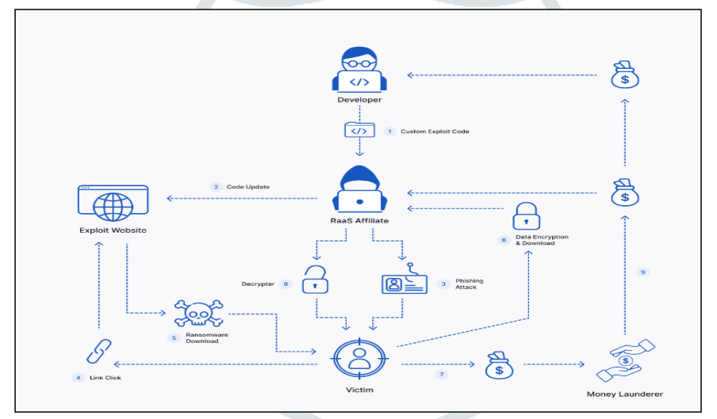
Fig 1: RaaS affiliate structure

2. METHODOLOGY
This research employs a systematic literature review approach to synthesize and evaluate the current body of literature on the impacts of ransomware on critical infrastructure, national security, and economic sustainability. The objective was to analyze the effects of ransomware attacks, specifically those facilitated by Ransomware-as-a-Service (RaaS), on critical sectors including healthcare, energy, and government operations.
To facilitate a comprehensive analysis, a methodical search of applicable academic and industry literature was carried out. The subsequent digital repositories and databases were employed to obtain relevant scholarly material, i.e., IEEE Xplore (to learn from cybersecurity and engineering viewpoints), Google Scholar (to provide a broad-based academic review), ScienceDirect (to obtain peer-reviewed journal articles), SpringerLink (to conduct computer science and information security research studies), and ResearchGate (to obtain industry white papers and security reviews), IBM Security (2023), Verizon DBIR (2023), Kaspersky (2023), and CISA (2023) as sources for analyzing attack trends.
The research was conducted between 2018 and 2024 to ensure the inclusion of the most current research, given the rapidly evolving nature of ransomware threats. To remain focused and on the subject, studies were selected by the following: Journal articles, conference papers, and government reports that were published between 2018 and 2024; research that focused on ransomware attacks against critical infrastructure sectors (healthcare, energy, finance, government, and transportation); economic cost of ransomware articles with cost analysis and financial losses; papers on the topic of how RaaS has propelled ransomware attacks. Excluded were articles published before 2018, except those providing primary insight into the development of ransomware; articles specific to single company or individual ransomware incidents outside of broader national security or infrastructure interest; and non-peer-reviewed content such as blog posts and opinion pieces.
Once relevant papers were identified, important information was extracted and thematically constructed to cover the following categories: Economic Impact: the financial damages incurred by ransomware, such as ransom paid, disruption of operations, and restoration expenses. Development of Ransomware-as-a-Service (RaaS), the ways in which the commercialization of ransomware has reduced the threshold for cyber attackers. Mitigation techniques and policy proposals, cybersecurity policies, government regulations, and international cooperation efforts to counter ransomware. Comparative analysis was conducted among studies to determine patterns, new threats, and shortcomings of existing cybersecurity measures. Although the approach used ensured a rigorous and high-quality examination of the current literature, there were certain limitations to be observed. The primary limitation is the relatively low number of studies included in the final evaluation, which restricts the generalizability of the findings. Some of the most important studies may be paywalled or not available in publicly accessible databases. Some studies have also concentrated on ransomware attacks in Western countries, which can result in inadequate representation of attacks in developing nations.
Due to the extremely dynamic profile of cyber threats, it is possible that current ransomware strains are not comprehensively addressed in available literature. However, even then, this study remains a detailed and organized examination of the effects of ransomware on critical infrastructure, weighing national security threats against economic costs and offering insights into the changing threat landscape of ransomware and possible mitigation measures.

3. RESULTS AND DISCUSSIONS
According to Verizon’s 2024 Data Breach Investigations Report (DBIR), roughly one-third of all breaches involved ransomware or some other extortion technique. Pure extortion attacks have risen over the past year and are now a component of 9% of all breaches. The shift of traditional ransomware actors toward these newer techniques resulted in a bit of a decline in ransomware to 23%. However, when combined, given that they share threat actors, they represent strong growth to 32% of breaches. Ransomware was a top threat across 92% of industries. Verizon revised their calculation of the involvement of the human element to exclude malicious privilege misuse to provide a clearer metric of what security awareness can affect. For this year’s dataset, the human element was a component of 68% of breaches, roughly the same as the previous period described in the 2023 DBIR. In the 2024 DBIR, they introduced an expanded concept of a breach involving a third party that includes partner infrastructure being affected and direct or indirect software supply chain issues, including when an organization is affected by vulnerabilities in third-party software. In short, those are breaches an organization could potentially mitigate or prevent by trying to select vendors with better security track records. They recorded this figure at 15% this year, a 68% increase from the previous year, mostly fueled using zero-day exploits for ransomware and extortion attacks. (See Fig. 2.)
Financially motivated threat actors will typically stick to the attack techniques that will give them the most return on investment. Over the past three years, the combination of ransomware and other extortion breaches accounted for almost two-thirds (fluctuating between 59% and 66%) of those attacks. According to the FBI’s Internet Crime Complaint Center (IC3) ransomware complaint data, the median loss associated with the combination of ransomware and other extortion breaches has been $46,000, ranging between $3 (three dollars) and $1,141,467 for 95% of the cases. Also from ransomware negotiation data contributors, the median ratio of initially requested ransom and company revenue is 1.34%, but it fluctuated between 0.13% and 8.30% for 80% of the cases. (See Fig. 3.)

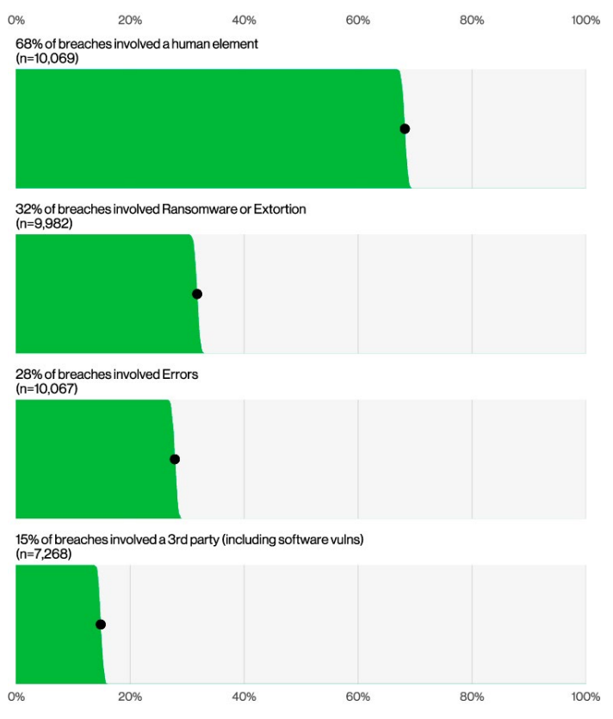
Fig. 2: Increased Data breaches

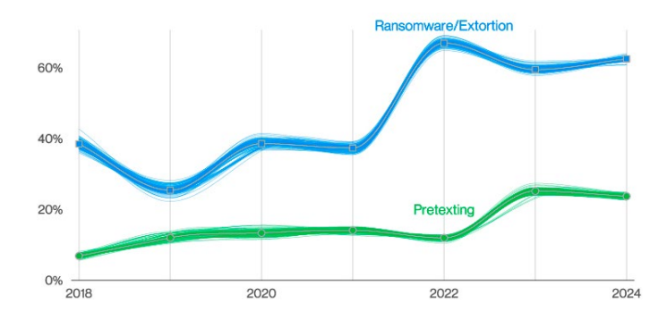
Fig 3: Increased pretexting and ransomware/extortion attacks

The Growing Threat of Ransomware on Critical Infrastructure
Ransomware attacks have evolved from targeting individual users and businesses to critical infrastructure, posing severe threats to national security and economic stability. The 2021 Colonial Pipeline attack serves as a primary case study, where a ransomware group disrupted fuel supplies across the southeastern U.S., causing widespread panic and economic losses [8]. Similar incidents have affected hospitals, power grids, and water treatment facilities, raising concerns over cybersecurity preparedness in critical sectors [9].
A review of ransomware incidents affecting industrial control systems (ICS) and operational technology (OT) between 2018 and 2024 revealed that:
- 68% of attacks targeted healthcare, energy, and financial sectors [6]
- 42% of organizations paid the ransom, yet only 65% regained full access to their systems [10].
- 94% of affected firms suffered operational downtime, with a median of 5.4 days before systems were restored [7].
These findings indicate a growing strategic shift in ransomware campaigns from opportunistic financial crimes to nation-state-level cyber warfare [11].

Year | Ransomware attack | Sector affected | Impact/Implication | Method of Attack
2018 | SamSam on Atlanta | Municipal Government | the attack crippled city services, and Atlanta refused to pay, leading to $17M in recovery costs | Exploited weak network security and used brute-force attacks
2019 | RobbinHood on Baltimore | Municipal Government | Baltimore was hit, and they refused to pay the 13 BTC ransom; they ended up spending over $18M on recovery. | Targeted outdated IT infrastructure, demanded Bitcoin ransom
2020 | NetWalker on UCSF | Education | UCSF School of Medicine paid $1.14M in Bitcoin after negotiations with hackers to restore their medical research data | Used phishing emails and encrypted research files
2021 | DarkSide on Colonial Pipeline | Energy Infrastructure | This attack led to fuel shortages in the U.S., and Colonial Pipeline paid $4.4M in ransom. | Targeted critical infrastructure, used RaaS model
2021 | REvil on Kaseya | IT Supply Chain | REvil exploited Kaseya’s VSA software to infect 1,500 businesses worldwide. | Exploited software supply chain to spread ransomware
2023 | Clop on MOVEit | Financial & Government | a vulnerability in MOVEit was exploited, affecting banks, healthcare, and government agencies. | Used zero-day exploits in widely used file transfer software
2023 | LockBit on Royal Mail | Logistics & Postal Services | Royal Mail suffered severe service disruption due to LockBit RaaS. | RaaS model, exfiltrated data for double extortion
2024 | Unknown Group on Change Healthcare | Healthcare | This recent attack disrupted patient billing and services, but full details are still emerging. | Targeted critical patient data.
Table 1: Comparing different ransomware attacks from 2018 to 2024

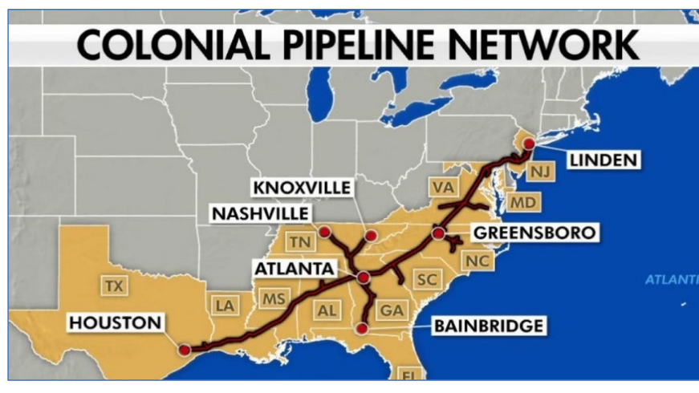
Fig. 4 Colonial Pipeline 2021

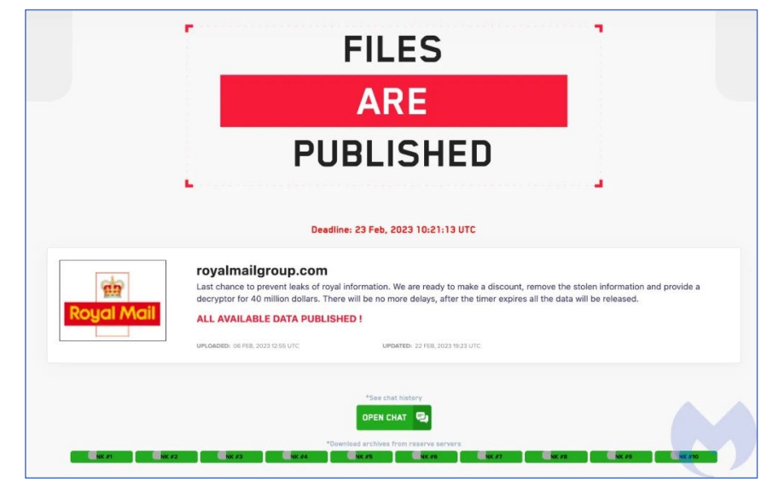
Fig. 5 Royal Mail, LockBit Ransomware

The Financial Impact of Ransomware Attacks
Ransomware has crippled industries financially, with damages projected to exceed $20 billion annually by 2025 [12]. A sectoral breakdown of financial losses reveals:
- Healthcare: Over $31 billion in losses (2018–2022) due to patient data encryption and system downtime [13].
- Energy and Utilities: An average downtime cost of $500,000 per hour, as seen in the Norsk Hydro attack.[20]
- Small and Medium Businesses (SMBs): 60% shut down within six months of a ransomware attack due to financial strain [14].
Interestingly, research highlights that paying the ransom does not guarantee data recovery. A 2022 survey found that 92% of companies that paid ransoms suffered repeat attacks within 12 months [15]. This suggests that ransom payments fund further cybercriminal activities, making them an unsustainable solution.

The Rise of Ransomware-as-a-Service (RaaS) and Its Implications
The proliferation of ransomware-as-a-service (RaaS) has dramatically increased the frequency and sophistication of attacks. RaaS operates similarly to legitimate SaaS models, where cybercriminals purchase or lease ransomware kits from developers [16]. The ease of access has led to
- A 400% increase in ransomware incidents since 2019 [18].
- Lower barriers to entry for cybercriminals with limited technical expertise.
- Affiliation-based profit sharing, where operators take 20–40% of ransom earnings [17]
Notable RaaS groups like REvil, Conti, and LockBit have launched highly disruptive attacks, targeting governments and multinational corporations. Their rapid adaptation to law enforcement crackdowns suggests a resilient and decentralized cybercrime ecosystem [18].

Defensive Strategies and Cybersecurity Countermeasures
Governments and private sector entities have implemented various countermeasures to combat ransomware, but challenges persist. The Biden Administration’s 2021 Executive Order on Cybersecurity mandated stricter security frameworks, yet compliance gaps remain, particularly among municipal agencies and small businesses [19]. Here are some recommended countermeasure strategies:
- Behavior Monitoring: Behavioral monitoring is a feature of contemporary antivirus software that helps identify ransomware by keeping an eye out for odd system activity, like unannounced file encryption or connection with command-and-control servers. This method is a more proactive defensive strategy because it can detect ransomware even if it has never been seen before [1].
- Implement Multi-Factor Authentication (MFA): Like in the case of the Colonial Pipeline attack, it exploited a weak password stored on the dark web, which was linked to a VPN account. Enforcing MFA adds an extra layer of security, making it harder for unauthorized users to gain access, even if they have the password [1].
- Using Antivirus and Antimalware to Detect and Block Suspicious Email and Web Traffic: In the Royal Mail case, antivirus and antimalware solutions would have been instrumental in detecting the LockBit ransomware and alerting the IT team to the potential threat. These programs scan email and online traffic for signs of ransomware assaults, like malware downloads or phishing emails. They can stop ransomware from ever infecting the user's machine by filtering potentially harmful content [1]
- Implement AI-driven threat detection; utilizing AI-based security solutions also helps with threat detection. An example of an AI security solution is XDR. It can detect threats in real time within hours, whereas it may take weeks without AI assistance. [1]

4. CONCLUSION
As advancement in technology increases, ransomware attack also evolves and continues to pose threat to critical infrastructure, national security, and economic stability. With the rise of Ransomware-as-a-Service (RaaS), cybercriminals may have unrestricted access to sophisticated attack methods, increasing the number and degree of attacks. This review projects the negative impact of ransomware attacks on vital sectors such as healthcare, energy, private businesses and government infrastructure, emphasizing the need for advanced and equally sophisticated cybersecurity measures. Moving forward, a proactive approach involving AI-driven innovations, initiating foolproof security measures, cross-sector collaboration, and international cooperation is crucial to mitigating the risks posed by ransomware and safeguarding critical systems against future threats.

REFERENCES

- Y. J. Seng et al., “In-Depth Analysis and Countermeasures for Ransomware attacks: case studies and recommendations,” : Case Studies and Recommendations, Sep. 2024, doi: 10.20944/preprints202408.2261.v1.
- N. B. T. Familoni, “CYBERSECURITY CHALLENGES IN THE AGE OF AI: THEORETICAL APPROACHES AND PRACTICAL SOLUTIONS,” Computer Science & IT Research Journal, vol. 5, no. 3, pp. 703–724, Mar. 2024, doi: 10.51594/csitrj.v5i3.930.
- S. Vesić and M. Bjelajac, “Cyber security of a critical infrastructure,” Pravo - Teorija I Praksa, vol. 40, no. 2, pp. 77–88, Jan. 2023, doi: 10.5937/ptp2302077v.
- S. Hurzhii, “The special features of using the artificial intelligence in the matters of cybersecurity,” INFORMATION AND LAW, no. 4(47), pp. 207–216, Nov. 2023, doi: 10.37750/2616-6798.2023.4(47).291669.
- P. Lis and J. Mendel, “Cyberattacks on Critical Infrastructure: an Economic Perspective,” Economics and Business Review/the Poznań University of Economics Review, vol. 5, no. 2, pp. 24–47, Jan. 2019, doi: 10.18559/ebr.2019.2.2.
- E. Berrueta, D. Morato, E. Magaña, and M. Izal, “Crypto-ransomware detection using machine learning models in file-sharing network scenarios with encrypted traffic,” Expert Systems With Applications, vol. 209, p. 118299, Jul. 2022, doi: 10.1016/j.eswa.2022.118299.
- J. Chen, E. Henry, and X. Jiang, “Is Cybersecurity Risk Factor Disclosure Informative? Evidence from Disclosures Following a Data Breach,” Journal of Business Ethics, vol. 187, no. 1, pp. 199–224, Apr. 2022, doi: 10.1007/s10551-022-05107-z.
- D. C. Smith, “Cybersecurity in the energy sector: are we really prepared?,” Journal of Energy & Natural Resources Law, vol. 39, no. 3, pp. 265–270, Jul. 2021, doi: 10.1080/02646811.2021.1943935.
- M. W. Twain, “Assessing the effectiveness of cybersecurity measures in the United States Telecommunications industry: A Comprehensive analysis,” Journal of Marketing and Communication, vol. 6, no. 1, pp. 1–10, Jun. 2023, doi: 10.53819/81018102t4159.
- S. Nazah, S. Huda, J. Abawajy, and M. M. Hassan, “Evolution of Dark Web Threat Analysis and Detection: A Systematic approach,” IEEE Access, vol. 8, pp. 171796–171819, Jan. 2020, doi: 10.1109/access.2020.3024198.
- A. I. Jony and S. A. Hamim, “Navigating the Cyber Threat Landscape: A comprehensive analysis of attacks and security in the digital age,” Journal of Information Technology and Cyber Security, vol. 1, no. 2, pp. 53–67, Jan. 2024, doi: 10.30996/jitcs.9715.
- M. A. Kafi and N. Akter, “Securing Financial Information in the Digital realm: Case studies in Cybersecurity for Accounting Data Protection,” American Journal of Trade and Policy, vol. 10, no. 1, pp. 15–26, Apr. 2023, doi: 10.18034/ajtp.v10i1.659.
- IBM, “IBM Security X-Force Threat Intelligence Index 2024,” 2024.​IBM - United States Available: https://www.ibm.com/reports/threat-intelligence
- Verizon, “2024 Data Breach Investigations Report,” 2024.​Verizon+1Verizon+1 Available: https://www.verizon.com/business/resources/reports/dbir/
- Kaspersky, “Kaspersky Security Bulletin 2023,” 2023. Available: https://securelist.com/ksb-2023/
- Cybersecurity and Infrastructure Security Agency (CISA), “2023 Year In Review,” 2023.​CISA+1CISA+1 Available: https://www.cisa.gov/about/2023YIR
- S. Razaulla et al., “The Age of Ransomware: A survey on the evolution, taxonomy, and research directions,” IEEE Access, vol. 11, pp. 40698–40723, Jan. 2023, doi: 10.1109/access.2023.3268535.
- H. Yarovenko, A. Lopatka, T. Vasilyeva, and I. Vida, “Socio-economic profiles of countries - cybercrime victims,” Economics & Sociology, vol. 16, no. 2, pp. 167–194, Jun. 2023, doi: 10.14254/2071-789x.2023/16-2/11.
- N. Sun et al., “Cyber Threat Intelligence Mining for Proactive Cybersecurity Defense: A survey and New Perspectives,” IEEE Communications Surveys & Tutorials, vol. 25, no. 3, pp. 1748–1774, Jan. 2023, doi: 10.1109/comst.2023.3273282.
- K. Begovic, A. Al-Ali, and Q. Malluhi, “Cryptographic ransomware encryption detection: Survey,” Computers & Security, vol. 132, p. 103349, Jun. 2023, doi: 10.1016/j.cose.2023.103349.

