***Original Research Article***

**Analysis of the prevalence of mental nerve loop in Local Indian population using Cone-beam Computed Tomography – a retrospective study**

**ABSTRACT**

**Aims:** This study aims to assess the prevalence and length of the mental nerve loop in a local Indian population using CBCT, providing essential data to guide safe surgical procedures in the interforaminal region.

**Study Design**: Retrospective Study

**Place and Duration of the Study:** Department of Prosthodontics and Crown & BridgeAdhiparasakthi Dental College and Hospital, Melmaruvathur. Between January 2024 and December 2024.

**Methodology:** A retrospective analysis was conducted on 70 CBCT scans selected from a pool of 450 scans obtained between January 2024 and December 2024. The CBCT images were evaluated using Bluesky Plan Software Version 4.13 to identify the presence and measure the length of the mental nerve loop. Descriptive and inferential statistical analyses were performed using SPSS software.

**Results:** The mental nerve loop was identified in 24.3% of the study population, with a higher prevalence on the left side (18.6%) than on the right (11.4%). The mean length of the anterior nerve loop was measured, with notable variations between sexes and sides. Only 5 participants exhibited bilateral nerve loops.

**Conclusion**: The study highlights the anatomical variation in mental nerve loop prevalence, emphasizing the necessity of preoperative CBCT evaluation for implant planning and surgical procedures in the mandibular region. Given the potential for nerve injury, clinicians should consider these findings to optimize patient safety and treatment outcomes. Further research with a larger sample size is recommended to strengthen these findings

*Keywords: Mental nerve loop, Cone Beam Computed Tomography (CBCT), mandibular canal, dental implants, anatomical variation.*

**INTRODUCTION:**

A meticulous knowledge of anatomical structures, their variations, and their specific location is of ultimate importance in any surgical procedure, including implant placement. (1) The inferior alveolar nerve canal or mandibular canal is one such feature in the mandible that should be considered during the surgical placement of the dental implant. This canal encloses the neuro-vascular bundle, which through the mental foramen gives off a mental nerve branch that provides somatic afferent fibres to the gingiva anterior to the premolar and general sensations to the lips and chin. The inferior alveolar nerve in some instances may extend beyond the mental foramen like an intraosseous path in both anterior and inferior directions and then curve in the backward direction thereby forming a loop, which has been termed as mental nerve loop or anterior loop of the inferior alveolar nerve. (2)

To reduce iatrogenic problems and assure the successful outcome of surgical treatments carried out in this region, the identification of this nerve loop anatomical variation serves as essential for surgical planning, especially for the placement of dental implants. (3)

The literature has surprisingly divergent results about the prevalence of anterior loops of the inferior alveolar nerve, ranging from 22% to 28%.6 to 88% with a maximum length of 11mm. (4) So, it is fundamental to employ a diagnostic technique that enables accurate measurement and adequate visualisation of this type of minute anatomical variations thereby preventing damage to the neurovascular bundle in the interforaminal region.

The Cone Beam Computed Tomography (CBCT) has the advantage of producing a 3-dimensional image of the craniofacial structures without any distortion or overlapping of the pictures. In addition to this, the CBCT has a lower radiation dosage and it is regarded as the gold standard for evaluating bone tissues, therefore the CBCT can reliably and accurately evaluate the existence and the length of the mental nerve loop. (5)

This study aims to evaluate the prevalence and the length of the mental nerve loop using Cone Beam Computed Tomography in the local Indian sample population, thereby providing the typical length of safe margin that must be maintained when working in the area of the mental nerve loop.

**MATERIALS AND METHODS:**

This retrospective study was performed with the approval of the Research Ethics Committee of the Adhiparasakthi Dental College and Hospital, Melmaruvathur, Tamil Nadu, India.

From a pool of 450 consecutive CBCT scans of the patient's jaws retrieved between the period of January 2024 to December 2024 from the Department of Prosthodontics, Adhiparasakthi Dental College, and 100 CBCT images were randomly selected.

CBCT images of patients ranging between 18 to 45 years old, with adequate diagnostic qualities without any pathology or fractures in the mental foramen region were included, and those CBCT images of patients under 18 and with any pathology in the inter-foraminal region were excluded. After inclusion and exclusion criteria were analysed only 70 CBCT images were taken into the study.

The CBCT images are then incorporated into the Bluesky Plan Software Version 4.13 for the evaluation of the existence of the nerve loop and to determine its length. After deploying into the software the panoramic curve was drawn over the occlusal surface of the mandible portion. Then the inferior alveolar nerve mapping was performed in all the axial coronal and sagittal sections along with the mental nerve loop. (Fig.1)

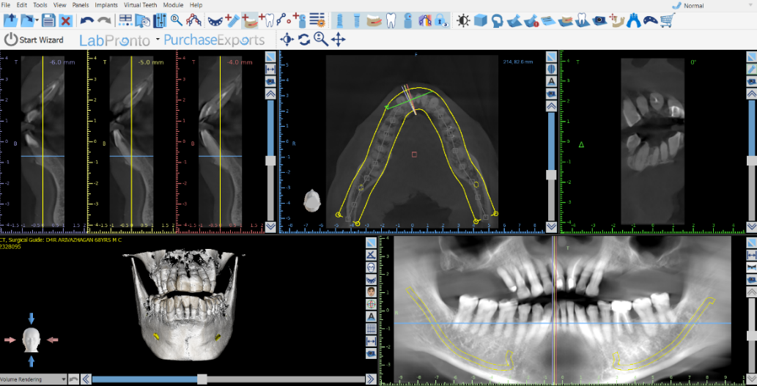

Fig. No. 1 Inferior Alveolar Nerve mapping done in Bluesky Plan software.

The cross-sectional picture was then used to determine the entrance and exit of the mental foramen. (Fig.2)

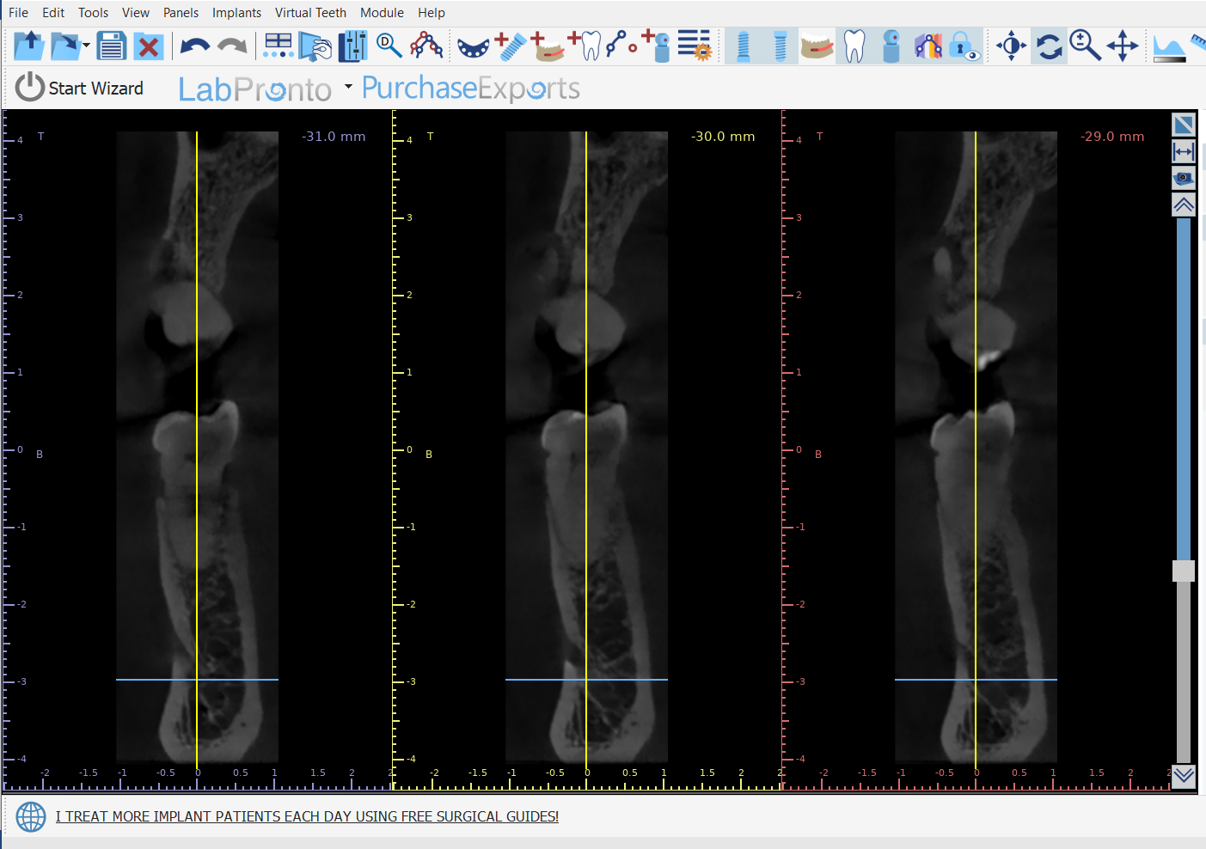

Fig. No.2 Cross Sectional View of the mental foramen.

On the panoramic image, vertical lines representing the most anterior point of the mental nerve loop as viewed from the cross-sectional view, and the anterior and posterior walls of the mental foramen were drawn from the slice. (Fig.3)

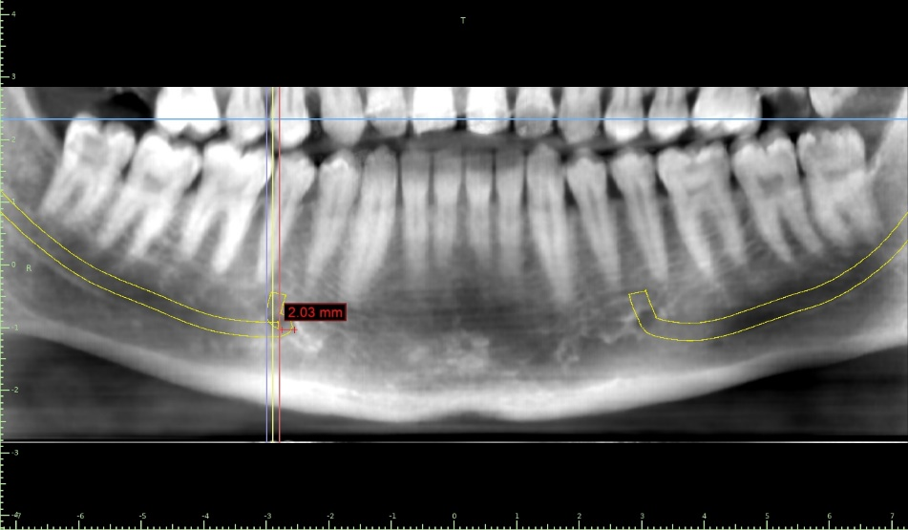

Fig. No. 3 Vertical lines resembling the anterior and posterior walls of the mental foramen

Two points in the CBCT image measure the actual Antero-posterior length of the anterior nerve loop. (Fig.4)

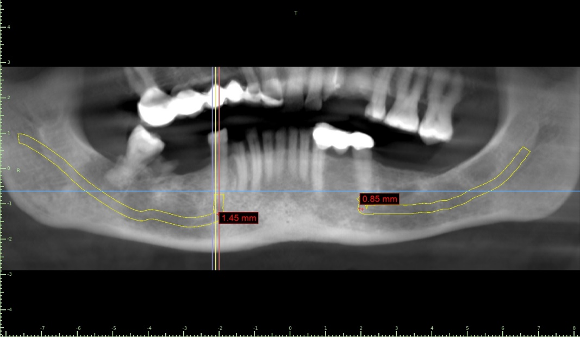

Fig. No.4 Anterio- posterior length of the anterior nerve loop

Point 1 – Opening of the mental foramen

Point 2 – most anterior confinement of the anterior loop

The distance between the two points is the length of the anterior loop of the mental nerve.

The measured length of the mental nerve loop was tabulated and the statistics were performed using SPSS software version 29. The relationship of the length of the anterior mental nerve loop with the sex of the individual and its corresponding side of existence was evaluated. The entire workflow of this study was tabulated in Fig.5

Fig. 5 Workflow of the study

**RESULTS:**

Table 1 represents the distribution of the study population based on gender in which it states that both males and females are distributed equally 50% in each group around a total of 70 study participants. Likewise, the presence and absence of mandibular canals were also assessed in which 24.3% had the presence of mental nerve canals AND 75.7 % showed no canals in them respectively. (Table no.1)

**Table 1 represents the descriptive statistics for the study population based on gender, number of mental nerve canals**

|  |  |  |  |
| --- | --- | --- | --- |
| **FACTOR** | **PARAMETER** | **FREQUENCY** | **PERCENTAGE** |
| **GENDER** | **MALE** | 35 | 50.0 |
| **FEMALE** | 35 | 50.0 |
| **MENTAL NERVE CANAL** | **ABSENT** | 53 | 75.7 |
| **PRESENT** | 17 | 24.3 |

Table 2 represents the prevalence of mental nerve canals among the study population when considered on the site of mental nerve canals the left side had a mean of 1.90±0.731 and the right side showed a mean of 1.66±0.434. The prevalence of left-side mental nerve canals was 18.6% (13 canals) & right-side mental nerve canals were 11.4% (08 canals) respectively. (Table no.2)

**Table 2 represents the prevalence of mental nerve canal present in the study population**

|  |  |  |  |  |  |
| --- | --- | --- | --- | --- | --- |
| **PARAMETER** | **SITE** | **N** | **MEAN±S.D** | **FREQUENCY** | **PERCENTAGE** |
| **MENTAL NERVE**  **CANAL** | **LEFT** | 70 | 1.90 ± 0.731 | **13** | **18.6%** |
| **RIGHT** | 70 | 1.66 ± 0.434 | **08** | **11.4%** |

**DISCUSSION:**

Detailed anatomical knowledge of the precise location of the regional structures is necessary for the design of dental implants and jaw treatment procedures. A lot of research on the mandibular canal's anterior loop has been done in the last several years, thus making it an increasingly popular area of study. The increasing number of dental implant surgical placement procedures directly correlates with the growing interest in this particular topic.

This study presents data on the prevalence and distribution of mental nerve canals among a population sample of 70 individuals, with equal representation of males and females. The study population consisted of 70 participants, with an equal distribution of males and females (50% each). This balance in gender distribution is important as it ensures that the results are not biased toward one gender and can be generalized across both genders.

Among the sample population studied, only 24.3% of the population had the presence of an anterior loop of mental nerve, and the remaining 75.7% showed no nerve loop in the inter-foraminal region of the mandible. (Fig.6)

Fig. 6 Presence of anterior nerve loop in the study population.

The findings were significant as they indicate that the absence of mental nerve canals is more common in the general population and relatively low prevalence suggests that the presence of these canals is not a common anatomical feature in the studied population. Maxillofacial Surgeons and dentists need to be aware of this anatomical variation to avoid potential nerve damage during procedures such as surgical dental implant placement, mandibular surgeries, or local anesthesia administration.

The mean values and standard deviations provided in Table 2 offer insights into the variability of mental nerve canals in the population. The left side of the mandible showed a higher prevalence of mental nerve canals (18.6%) compared to the right side (11.4%). The mean value for the left side was 1.90 ± 0.731, indicating a slightly higher number of nerve loops on this side (13 nerve loops). The right side had a lower prevalence of mental nerve canals (11.4%), with a mean value of 1.66 ± 0.434. (Fig.7)

Fig.7 Site specificity of mental nerve loop among the study population

In a CBCT study performed in a Malaysian population by Wong et.al, the mean length of the anterior nerve loop was found to be 3.69 ± 1.75 mm on the left side and 3.85 ±1.73 mm on the right side. (6)

The largest anterior loop measured in this study was found to be 2.76mm which was far lower than the maximum length of 11mm reported by Neiva et.al in 2004 (4)

Among the 24.3% of the population with anterior nerve loops, only 5 patients have bilateral presence of nerve loops of which 3 were males and 2 were females. (Fig.8).

Fig.8 Presence of Bilateral Anterior Nerve Loop in the study population

These results were similar to a study performed by Filo et.al, in 2014, in which most of the patients who participated in the survey had a bilateral presence of the mental nerve loop, accounting for about 78.84% of the total population studied which was comparatively higher prevalence than this current study. (7)

In our study, it has been reported that the prevalence of bilateral mental nerve loop was associated with the male population which is similar to the study conducted by Uchida et.al, in 2006. (8)

The substantial proportion of patients (24.3%) involved in this study shows that the existence of a mental nerve loop might complicate dental treatments like implant placement and surgical procedures. Preoperative imaging may be necessary to identify these anatomical variations to avoid iatrogenic injuries. As previously stated, CBCT is most often preferred in dental practices due to its low radiation dosage, lower cost, and even superior to that of multi-slice CT for evaluating dentomaxillofacial structures. (9)

The findings show that the distribution of mental nerve loops is uneven, with the left side being more common than the right. In clinical situations, this asymmetry may be important, particularly when preparing surgical procedures or delivering local anaesthesia to the mandibular area.

**CONCLUSION:**

The study provides valuable insights into the prevalence and distribution of mental nerve loops in the mandible. The findings indicate that mental nerve loops are present in approximately 24.3% of the study population, with a higher prevalence on the left side compared to the right side. These results have important clinical implications, particularly in dental and surgical procedures involving the mandibular region. Clinicians should be aware of the potential for the asymmetrical distribution and the presence of anterior extension of mental nerve loops to minimize the risk of complications. Further research with larger sample sizes and more detailed anatomical analyses is recommended to confirm these findings and explore additional factors that may influence the prevalence of mental nerve loops.

**COMPETING INTERESTS DISCLAIMER:**

Authors have declared that they have no known competing financial interests OR non-financial interests OR personal relationships that could have appeared to influence the work reported in this paper.

**REFERENCES**

1. Shaban B, Khajavi A, Khaki N, Mohiti Y, Mehri T, Kermani H. Assessment of the anterior loop of the inferior alveolar nerve via cone-beam computed tomography. J Korean Assoc Oral Maxillofac Surg. 2017 Dec;43(6):395-400. doi: 10.5125/jkaoms.2017.43.6.395. Epub 2017 Dec 26. PMID: 29333369; PMCID: PMC5756796.

2. Apostolakis D, Brown JE. The anterior loop of the inferior alveolar nerve: prevalence, measurement of its length, and a recommendation for interforaminal implant installation based on cone beam CT imaging. Clin Oral Implants Res. 2012 Sep;23(9):1022-30. doi: 10.1111/j.1600-0501.2011.02261.x. Epub 2011 Aug 3. PMID: 22092440.

3. Greenstein G, Tarnow D. The mental foramen and nerve: clinical and anatomical factors related to dental implant placement: a literature review. J Periodontol. 2006 Dec;77(12):1933-43. doi: 10.1902/jop.2006.060197. PMID: 17209776.

4. Neiva RF, Gapski R, Wang HL. Morphometric analysis of implant-related anatomy in Caucasian skulls. J Periodontol. 2004 Aug;75(8):1061-7. doi: 10.1902/jop.2004.75.8.1061. PMID: 15455732.

5. do Nascimento EH, dos Anjos Pontual ML, dos Anjos Pontual A, da Cruz Perez DE, Figueiroa JN, Frazão MA, Ramos-Perez FM. Assessment of the anterior loop of the mandibular canal: A study using cone-beam computed tomography. Imaging Sci Dent. 2016 Jun;46(2):69-75.

6. Wong SK, Patil PG. Measuring anterior loop length of the inferior alveolar nerve to estimate safe zone in implant planning: A CBCT study in a Malaysian population. J Prosthet Dent. 2018 Aug;120(2):210-213. doi: 10.1016/j.prosdent.2017.10.019. Epub 2018 Mar 15. PMID: 29551376.

7. Filo K, Schneider T, Locher MC, Kruse AL, Lübbers HT. The inferior alveolar nerve's loop at the mental foramen and its implications for surgery. J Am Dent Assoc. 2014 Mar;145(3):260-9. doi: 10.14219/jada.2013.34. PMID: 24583891.

8. Uchida Y, Noguchi N, Goto M, Yamashita Y, Hanihara T, Takamori H, Sato I, Kawai T, Yosue T. Measurement of anterior loop length for the mandibular canal and diameter of the mandibular incisive canal to avoid nerve damage when installing endosseous implants in the interforaminal region: a second attempt introducing cone beam computed tomography. J Oral Maxillofac Surg. 2009 Apr;67(4):744-50. doi: 10.1016/j.joms.2008.05.352. PMID: 19304029.

9. Suomalainen A, Kiljunen T, Käser Y, Peltola J, Kortesniemi M. Dosimetry and image quality of four dental cone beam computed tomography scanners compared with multislice computed tomography scanners. Dentomaxillofac Radiol. 2009 Sep;38(6):367-78. doi: 10.1259/dmfr/15779208. Erratum in: Dentomaxillofac Radiol. 2009 Dec;38(8):554. PMID: 19700530.