**Case report**

**"Benign But Troubling fat ball”: behind the scenes of a rare tumor: A Case Report of Intracardiac Lipoma**

**Abstract:**

**Background:**

Primary intra cardiac tumors are very rare, accounting for less than 5% of all cardiac tumors.Cardiac lipomas are the commonest non-myxomatous benign primary intra cardiac neoplasms.They may cause non-specific symptoms or be completely asymptomatic even in large dimensions.The diagnosis relies on multimodality imaging methods, especially magnetic resonance imaging (MRI) which can be crucial in identifying and characterizing these cardiac masses. To this day, management of cardiac lipomas remains controversial.

**Case report:**

We present the case of a 72year old woman with history of hypertension, who came to our department for routine check-up. She was completely asymptomatic. Transthoracic echocardiography revealed a fortuitous hyperechoic mass in the left atrium. Complementary cardiac magnetic resonance imaging (MRI) described characteristic features compatible with intra atrial lipoma. It revealed an oval immobile smooth mass, measuring 26x36mm, attached to the interatrial septum, with increased signal T1-weighted images with decreased fat-saturated sequences. Conservative management was chosen, and the patient was scheduled for regular follow-ups with stable outcome.

**Conclusion:**

This case emphasizes the relevance of cardiac MRI in diagnosing cardiac lipomas after incidental finding. Surgery is recommended for treating symptomatic patients. In asymptomatic patients, management can be conservative with clinical observation, although prophylactic resection could be discussed.

**Key words:**Lipoma, intracardiac, magnetic resonance imaging, echocardiography, benign

**Introduction:**

Primary cardiactumors are uncommon, representing only 5% of all cardiac tumors[1]. Importantly, the majority of them (75%) are benign[2].In this category, cardiac lipomas are the commonest non-myxomatous benign primary intra cardiac neoplasms, with a reported incidence of 8.4%[3].

They can be asymptomatic for a long time even in large dimensions, or present a wide range of non-specific symptoms.Diagnosis relies on Multimodality imaging methods. Magnetic resonance imaging (MRI) is the modality of choice, and happens to be crucial in identifying and characterizing these cardiac masses.

In the absence of clear guidelines about managing intracardiac lipomas, different approaches can be advocated. While surgery can be proposed for large tumors in symptomatic patients, the necessity of removing small benign tumors like lipomas in asymptomatic patients remains debatable. Hence, the importance of prompt diagnosis before making this decision.

**Case report:**

We present the case of an incidental finding of intra atrial lipoma in a 72year old female with history of hypertension.

The patient was initially presented to our department for regular checkup. She was completely asymptomatic with no reported chest pain, dyspnea nor syncope. She had no family history of cardiac diseases.

A transthoracic echocardiography (TTE) revealed a fortuitous hyperechoic mass in the right atrium. Both ventricles have normal dimensions and good ejection fraction.Complementary cardiac magnetic resonance image (CMR) revealed characteristic features compatible with intra atrial lipoma. It revealed an oval immobile smooth mass, measuring 26x36mm, attached to the interatrial septum respecting the foramen ovale, with increased signal T1-weighted images and decreased fat-saturated sequences. There was no gadolinium enhancement. The adipose infiltration extended from the valve of the inferior vena cava to the joining end of the superior vena cava. (Figures)

Upon multidisciplinary discussion, conservative management was chosen for our patient. Factors leaning in favor of this approach were: the patient’s age, the absence of symptoms or harmful characteristics of the benign mass.

She was then scheduled for regular follow-ups. In the next 6 months, the patient remained asymptomatic, and echocardiographic characteristics of the lipoma unchanged.

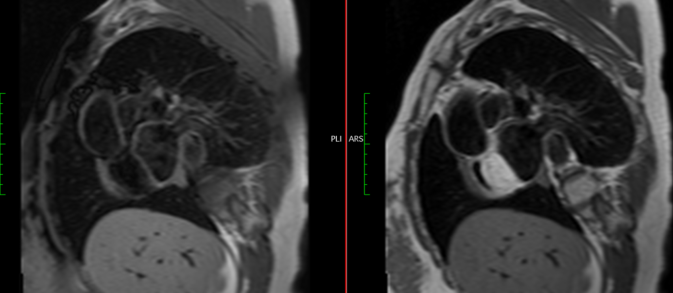 **Figure 1. CMR T1W sequences showing the ovale mass in hypersignal in apical 4 chambers (1A) and Short axis view (1B)**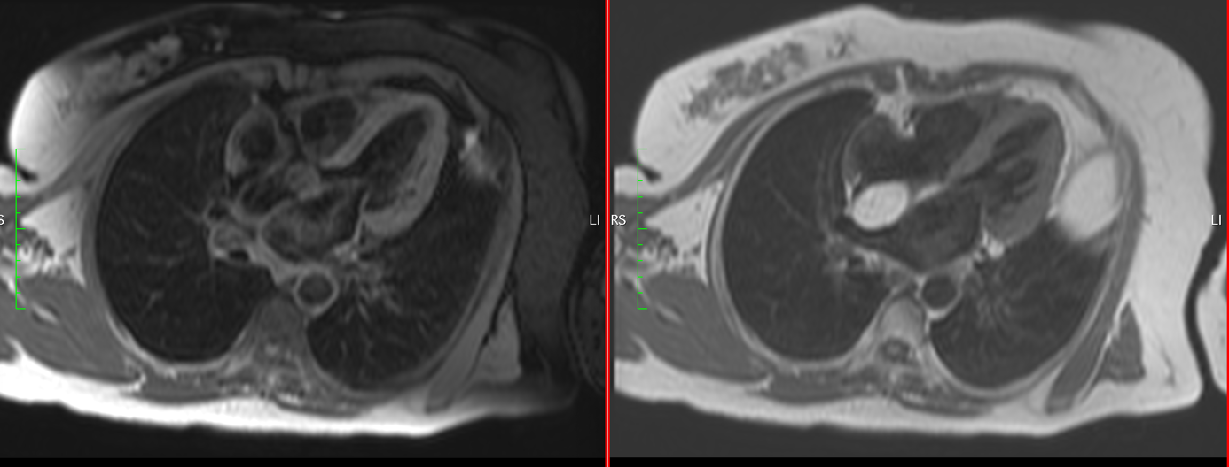

**1A 1B**



**2A 2B**

**Figure 2. CMR T1W Opposed-phase (fat supressed) sequences showing disappearing of the tumor hyper signal in apical 4 chambers (2A) and Short axis view (2B)**

**Discussion:**

Intracardiac lipomas are rare and benign entities. They are encapsulated tumors of mature fat cells which can take origin from all three cardiac layers (subendocardial, subpericardial and finally myocardial).The usual intracardiac location is the right atrium, which was the case of our patient[4]. Additionally, in Fang’s review, interatrial septum was the most common position in 38.5% of cases[5].

Cardiac lipomas are mostly asymptomatic, growing silently for years. Depending on their size and location, they can cause a broad spectrum of symptoms such as chest pain, dyspnea, arrythmias, syncope and even stroke when obstructing intracardiac blood flow pr cardiac valves[6]. Fortunately, in our case, the mass seems to not cause any obstruction or surrounding damage, as it is firmly attached to the interatrial septum.

Unlike other benign tumors like myxoma, cardiac lipoma tends to be more stable, and embolization phenomenon is rare because lipomas are very well encapsulated. Actually, thromboembolic events responsible for strokes are more a consequence of disruptive laminar blood flow caused by the presence of mass[7], raising the issue of weather prophylactic anticoagulation should be discussed.

When a cardiac mass is incidentally uncovered, multimodality imaging is necessary for characterization. Standard TTE is the first line modality, often used for its availability. However, the nature of cardiac lipoma cannot be assessed with TTE’s acoustic properties.

For better characterization of the mass, CMR is ideal as it distinguishes fat-lesions from other intracardiac masses such as thrombus.Lipomas have homogeneous composition of mature adipocytes, explaining same imaging appearance with subcutaneous fat in computed tomography and MRI.Lipidic masses are revealed by pathognomonic hypersignal in T1 sequences with fat suppression images in T2 sequence[8].

Differential diagnosis includes: lipomatous hypertrophy of atrial septum which are unencapsulated mass of mature and fetal adipocytes. Also, lipoma shouldn’t be mistaken for liposarcomas. These rare malignant primary tumors tend to be wider, irregular with a heterogeneous signal on T2 with fat saturation.

Given their rarity, there are no current guidelines surrounding the management of intracardiac lipomas.In literature, two options (surgical treatment and conservative management) are still debated.

The decision of which approach to choose generally depends on symptomatology, surgical candidacy and the patient’s preference. Also, size and location can dictate surgical feasibility.

In asymptomatic patients, some surgeons prefer radical resection for the risk of potential overgrowth and myocardium infiltration.Other specialists choose conservative management with close monitoring of the symptoms. In fact, cardiac lipomas do not always need to be surgically removed. In literature, there is no clear evidence of malignant transformation. Additionally, several cases reported did not report tumor growth in a “wait and see” strategy.Thus, the importance of CMR, which can give accurate diagnosis and avoid unnecessary surgery.

To support our reasoning, MacGillivray describes in his article the case of 33year old woman with large intracardiac tumor in the right ventricle with no major clinical nor echocardiographic consequences. No CMR was done to better identify the mass. Surgical resection was successful but the tumor, which was initially suspected to be a liposarcoma, turned out to be a benign lipoma. Despite a positive outcome, MacGillivray underlines the benefit of CMR before planning surgical removal, and even questions the initial indication of surgery.

In the end, in the absence of clear recommendations, the decision is made based on the clinician’s best judgement.

**Conclusion:**

We reported a case report of incidental intra atrial lipoma. Imaging techniques are necessary for assessing intra cardiac lipomas, and CMR plays an important role in diagnosis and management decisions. While surgery is the gold standard for symptomatic patients, conservative management can be discussed in selected asymptomatic patients.

**COMPETING INTERESTS DISCLAIMER:**

Authors have declared that they have no known competing financial interests OR non-financial interests OR personal relationships that could have appeared to influence the work reported in this paper.

**References:**

[1]. Murphy, Joseph G., and R. Scott Wright (ed.), 'Cardiac Tumors', in Joseph G. Murphy, and Margaret A. Lloyd (eds), Mayo Clinic Cardiology: Concise Textbook, 4 edn, Mayo Clinic Scientific Press (New York, 2012; online edn, Oxford Academic, 1 May 2013), <https://doi.org/10.1093/med/9780199915712.003.1682>, accessed 25 Apr. 2023.

[2]. Paraskevaidis IA, Michalakeas CA, Papadopoulos CH, Anastasiou-Nana M. Cardiac tumors. ISRN Oncol. 2011;2011:208929. doi: 10.5402/2011/208929. Epub 2011 May 26. PMID: 22091416; PMCID: PMC3195386.

[3]. Daniel L, Syed WY, Ashish S.: Tumors affecting the cardiovascular system. Braunwald’s Heart Disease: A Textbook of Cardiovascular Medicine. Tenth Edition. Mann DL, Zipes DP, Libby P, Bonow RO, Braunwald E (ed): Elsevier/Saunders, Philadelphia, PA; 2015. 4622-8.

[4]. Naseerullah FS, Javaiya H, Murthy A. Cardiac Lipoma: An Uncharacteristically Large Intra-Atrial Mass Causing Symptoms. Case Rep Cardiol. 2018 Feb 6;2018:3531982. doi: 10.1155/2018/3531982. PMID: 29552360; PMCID: PMC5818884.

[5]. Fang L, He L, Chen Y, Xie M, Wang J. Infiltrating lipoma of the right ventricle involving the interventricular septum and tricuspid valve: report of a rare case and literature review. *Medicine (Baltimore)*2016;95(3):e2561. [[PMC free article](https://www.ncbi.nlm.nih.gov/pmc/articles/PMC4998283/)] [[PubMed](https://pubmed.ncbi.nlm.nih.gov/26817909)] [Google Scholar]

[6]. W. Shengjun, T. Peng, Z. Yuhan, and N. Yiming, “A rare case report of giant epicardial lipoma compressing the right atrium with septal enhancement,” *Journal of Cardiothoracic Surgery*, vol. 10, no. 1, p. 150, 2015.

[7]. Abdelradi A, Yekta A. A Case of Asymptomatic Cardiac Lipoma and Literature Review. CJC Open. 2020 Oct 12;3(2):207-209. doi: 10.1016/j.cjco.2020.10.002. PMID: 33644736; PMCID: PMC7893199.

[8]. Shu, S., Wang, J. & Zheng, C. From pathogenesis to treatment, a systemic review of cardiac lipoma. *J Cardiothorac Surg* **16**, 1 (2021). https://doi.org/10.1186/s13019-020-01379-6