***Case report***

**Myocardial Hypertrophy and Post-Exercise Malaise: A Diagnostic Trap Not to Be Overlooked**

**Abstract:**

Asymmetric myocardial hypertrophy with dynamic obstruction during the post-exercise recovery phase is a rare complication that can occur in patients suffering from chronic hypertension. We report the case of a 60-year-old man with a 20-year history of hypertension and poor treatment adherence, without a family history of hypertrophic cardiomyopathy (HCM) or sudden death. He presented with recurrent episodes of malaise occurring immediately after stopping a routine physical effort. Clinical examination revealed no particular abnormalities. Electrocardiogram (ECG) showed left ventricular hypertrophy, while transthoracic echocardiography (TTE) revealed asymmetric myocardial hypertrophy with an interventricular septum measuring 14 mm, without intraventricular gradient at rest. Holter ECG showed no significant findings. A stress echocardiogram revealed a significant increase in the intraventricular gradient, reaching 150 mmHg during the recovery phase. Due to the inefficacy of maximum-dose beta-blocker therapy, septal alcohol ablation was performed after the temporary implantation of an external pacemaker to prevent potential atrioventricular block. Post-procedure echocardiography showed a marked reduction in the intraventricular gradient from 83 mmHg to 42 mmHg during the post-recovery phase. This case illustrates an atypical form of post-exercise obstructive hypertrophic cardiomyopathy in a patient with chronic hypertension. Septal artery alcoholization led to significant hemodynamic improvement, requiring close follow-up to monitor clinical progression and assess the potential need for permanent cardiac pacing.

**Keywords**: Myocardial hypertrophy, intraventricular gradient, stress echocardiography, septal artery alcoholization

**Introduction**:

Asymmetric myocardial hypertrophy is commonly associated with primary hypertrophic cardiomyopathy but can also develop in the context of prolonged hypertension (1). While dynamic intra-LV obstruction is well documented at rest and during exercise, its occurrence during the recovery phase is rare and may be underestimated (2). It manifests as symptoms such as malaise and syncope, necessitating appropriate management (3). The first-line treatment relies on beta-blockers or calcium channel blockers to limit obstruction (4). However, in cases of drug resistance, an invasive approach may be considered (5). Septal artery alcohol ablation is a less invasive alternative to surgical myectomy for reducing obstruction and improving symptoms (6). We describe a case of asymmetric myocardial hypertrophy with an increase in intra-LV gradient during the recovery phase, requiring invasive management.

**Case Presentation**:

A 60-year-old man had been receiving antihypertensive treatment for 20 years, though his adherence was inconsistent. He had no family history of HCM or sudden death. He presented with recurrent episodes of malaise occurring immediately after stopping routine physical exertion. Clinical examination found a conscious, eupneic patient at rest, with poorly controlled blood pressure but no notable findings on cardiac auscultation. ECG showed normal sinus rhythm with left ventricular electrical hypertrophy, without rhythm or conduction abnormalities. TTE revealed a subaortic septal bulge measuring 14 mm, with no intra-LV gradient at rest. The mitral valve was normal, without significant regurgitation, and diastolic function was normal. Pulmonary arterial pressures were within normal limits. Holter monitoring revealed no significant arrhythmias. Cardiac MRI showed normal left ventricular ejection fraction, with a subaortic septal bulge measuring 14 mm. There were no notable abnormalities of the mitral valve, nor any myocardial enhancement on late gadolinium imaging (Figure 1). A stress echocardiogram was performed, where the patient reached more than 85% of his theoretical exercise capacity. No intra-LV gradient was observed during exercise, but a sudden elevation to 83 mmHg (Figure 2) was noted immediately after stopping exertion.

Maximum-dose beta-blocker therapy was initiated, along with proper hydration and the discontinuation of any medication that could worsen the gradient. However, due to the persistence of symptoms, septal artery alcoholization was performed after the temporary implantation of an external pacemaker set at 40 bpm to prevent potential atrioventricular block. Coronary angiography was conducted to locate the target septal artery, allowing the slow injection of alcohol until successful occlusion of a septal branch. ECG recorded a complete left bundle branch block without other conduction disturbances. The external pacemaker was removed after telemetry monitoring, which revealed no major conduction disturbances requiring permanent pacemaker implantation. Post-procedure echocardiography showed moderate hypokinesia of the proximal and mid-septal segments, with a significant reduction in intra-LV gradient, dropping from 83 mmHg to 41 mmHg during the recovery phase. The patient reported clinical improvement.

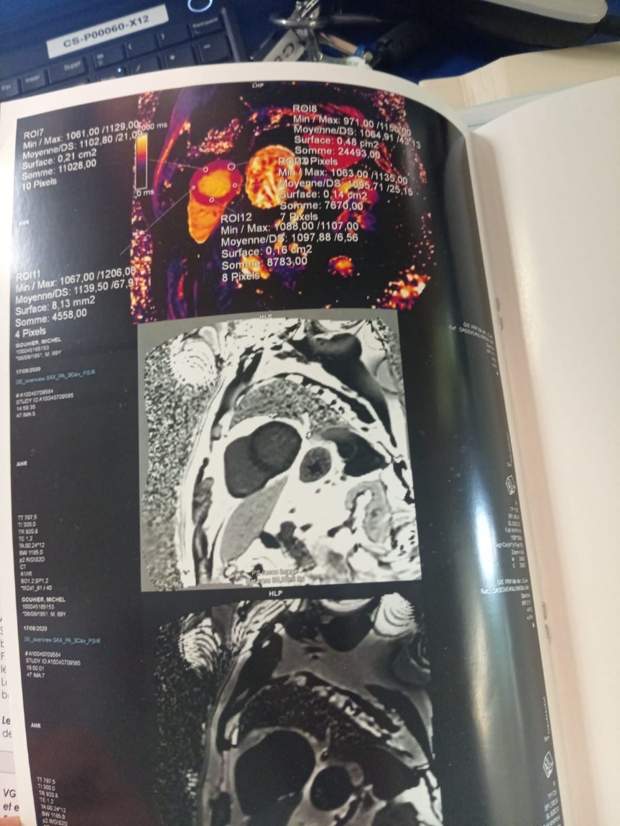

Figure 1: Absence of late enhancement in the minor axis

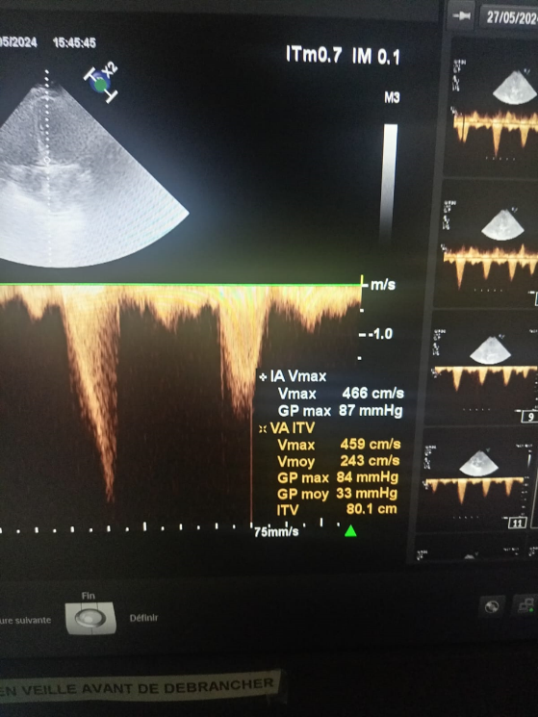

**Figure 2: Intra-VG obstruction with max gradient at 84 mmhg at 1min post-exercise recovery**

**Discussion:**

Hypertensive heart disease encompasses a series of changes in the left ventricle, left atrium, and coronary arteries resulting from chronic blood pressure elevation. Hypertension increases cardiac workload, leading to structural and functional myocardial changes, including left ventricular hypertrophy, which may progress to heart failure (6). Most hypertensive patients suffer from primary hypertension, whose etiology remains poorly understood but likely results from a complex interplay of genetic and environmental factors. Risk factors for hypertension include age, family history, obesity, high sodium intake, sedentary lifestyle, and excessive alcohol consumption. Studies have shown that hypertension precedes heart failure development by an average of 14.1 years (7).

There is significant morphological overlap (location and degree of hypertrophy) between hypertensive heart disease and hypertrophic cardiomyopathy. The conventional threshold of left ventricular wall thickness (EDWT) ≥ 15 mm and ventricular asymmetry are poor discriminators. Increased indexed myocardial mass (LVM), absence of systolic anterior motion (SAM), and absence of late gadolinium enhancement (LGE) are significant predictors of hypertensive heart disease (8).

Dynamic intra-LV obstruction may be present at rest or provoked by exercise testing (9). This obstruction results from septal hypertrophy, anterior papillary muscle displacement, and subvalvular apparatus deformation. During systolic contraction, increased pressure in the LV outflow tract creates a Venturi effect, drawing the anterior mitral leaflet forward and causing obstruction. This obstruction may lead to concomitant mitral regurgitation (10).

Alcoholisation of the septal artery is a viable alternative to surgical myectomy for treating obstructive hypertrophic cardiomyopathy. It reduces obstruction in the subaortic region responsible for the obstruction. It is indicated for symptomatic patients resistant to optimal medical therapy with an intra-LV gradient ≥ 50 mmHg, whether spontaneous or exercise-induced. Patient selection must be rigorous, and the procedure should be performed in an experienced center with interventionalists and echocardiographers. Alcoholisation of the septal artery is quick, effective, and safe, with benefits comparable to surgical myectomy regarding gradient reduction and exercise capacity improvement. The main complication remains complete atrioventricular block, potentially requiring permanent pacemaker implantation, though this risk has decreased with ultrasound-guided techniques (11). In our case, Alcoholisation of the septal artery was chosen due to the high subaortic gradient (>50 mmHg) and symptom persistence despite well-managed medical treatment.

Alcoholisation of the septal artery has been shown to be safe in both the short and long term. Long-term results are comparable to those obtained after surgical septal myomectomy(12). A multicentre study demonstrated that alcoholisation of the septal artery is an effective and safe method of treating intramyocardial obstruction, with good short- and long-term results. The 30-day mortality rate was 0.7%. Permanent pacemakers were implanted in 7% of cases during the 30-day follow-up. Resting LVOT gradient decreased from 64 ± 28 to 20 ± 13 mmHg (p < 0.0001), and mean NYHA class decreased from 2.3 ± 0.7 to 1.3 ± 0.5 (p < 0.001)(13). The prognosis depends on the preoperative subaortic gradient and the existence of a postoperative residual gradient. Factors associated with recurrence, according to the literature, include complex anatomical shape, insufficient initial muscle resection, a post-operative residual subaortic gradient ≥ 30 mmHg and the presence of valvular anomalies. The prognosis depends on the preoperative subaortic gradient and the existence of a postoperative residual gradient. Factors associated with recurrence, according to the literature, include complex anatomical shape, insufficient initial muscle resection, a post-operative residual subaortic gradient ≥ 30 mmHg and the presence of valvular anomalies. In our patient, alcoholisation of the septal artery resulted in immediate haemodynamic improvement, with a significant reduction in the intra-GV gradient. However, there are risks associated with this procedure, including the potential development of atrioventricular block, which may require a permanent pacemaker, or excessive septal hypokinesia that may impair left ventricular function. Close follow-up is essential to assess the patient's progress, adapt management and monitor the possible need for a permanent pacemaker. (14).

**Conclusion**:

This case illustrates a rare and complex form of asymmetric myocardial hypertrophy with dynamic obstruction occurring during the post-exercise recovery phase in a patient with poorly controlled chronic hypertension. Identifying this condition requires vigilance and thorough investigations, including stress echocardiography, to detect intraventricular gradient variations that may go unnoticed outside the post-exercise phase. Septal artery alcoholization is an effective therapeutic option for managing dynamic obstruction in drug-resistant patients. Long-term follow-up is essential to assess clinical evolution and adjust interventions accordingly.

**References :**

(1)Maron BJ, et al. (2014). Hypertrophic cardiomyopathy: for diagnosis and treatment. Circulation.

(2) Spirito P, et al. (2009). Hypertrophic cardiomyopathy and the role of beta-blockers and calcium antagonists in treatment. Heart Failure Clinics.

(3) Elliott PM, et al. (2008). Hypertrophic cardiomyopathy: for diagnosis and treatment. European Heart Journal.

(4) Hirano T, et al. (2013). Invasive treatment of hypertrophic obstructive cardiomyopathy. Journal of the American College of Cardiology.

(5) Kato S, et al. (2020). Long-term follow-up of patients with hypertrophic obstructive cardiomyopathy treated with alcohol septal ablation. European Heart Journal.

(6) Alam, M., Dokainish, H., & Lakkis, N. (2006). Alcohol Septal Ablation for Hypertrophic Obstructive Cardiomyopathy : A Systematic Review of Published Studies. Journal Of Interventional Cardiology, 19(4), 319‑327. https://doi.org/10.1111/j.1540-8183.2006.00153.x

(7) Messerli FH, Rimoldi SF, Bangalore S. La transition de l'hypertension à l'insuffisance cardiaque : mise à jour contemporaine. JACC Heart Fail. Août 2017 ; 5 (8) : 543-551.

(8) Rodrigues, J. C., Rohan, S., Dastidar, A. G., Burchell, A. E., Ratcliffe, L. E., Hart, E. C., Paton, J. F., Hamilton, M., Nightingale, A. K., & Manghat, N. E. (2016). Hypertensive heart disease versus hypertrophic cardiomyopathy : multi-parametric CMR predictors beyond end-diastolic wall thickness ≥15mm. Journal Of Cardiovascular Magnetic Resonance, 18, P264. https://doi.org/10.1186/1532-429x-18-s1-p264

(9) Marwick TH, Nakatani S, Haluska B, et al. . Provocation of latent left ventricular outflow tract gradients with amyl nitrite and exercise in hypertrophic cardiomyopathy. Am J Cardiol 1995; 75: 805–

(10) Jiang L, Levine RA, King ME, Weyman AE. An integrated mechanism for systolic anterior motion of the mitral valve in hypertrophic cardiomyopathy based on echocardiographic observations. Am Heart J 1987; 113: 633–44.

(11) Alcohol septal ablation for obstructive hypertrophic cardiomopathy]. (2019). PubMed. <https://pubmed.ncbi.nlm.nih.gov/31070317/>

(12) Fifer, M. A. (2018). Choice of Septal Reduction Therapies and Alcohol Septal Ablation. Cardiology Clinics, 37(1), 83‑93. https://doi.org/10.1016/j.ccl.2018.08.009

(13) Brown JW, Ruzmetov M, Okada Y, Vijay P, Rodefeld MD, Turrentine MW. Outcomes in patients with interrupted aortic arch and associated anomalies: a 20-year experience. European journal of cardio-thoracic surgery. 2006;29(5):666–673. doi: 10.1016/j.ejcts.2006.01.060

(14) Shloido, E., Popov, K., Chernyshov, S., & Kashtanov, M. (2024). National experience of alcohol septal ablation in patients with obstructive hypertrophic cardiomyopathy : A long-term multicenter retrospective study. Indian Heart Journal. https://doi.org/10.1016/j.ihj.2024.11.248