Case report

TRAUMATIC TRANSECTION OF THE APPENDIX DUE TO BLUNT ABDOMINAL TRAUMA: A CASE REPORT

ABSTRACT

Aims. Trauma is a complex entity encompassing a wide spectrum of clinical scenarios. Blunt hollow visucs injury accounts for less than 1% of total trauma admissions, but the incidence varies from 4-15%.
Presentation of case. A 20-year-old male patient was admitted by an ambulance car to emergency department with complaints of abdominal pain along the seat belt area, after car accident. On evaluation, contrast-enhanced computed tomography of the abdomen demonstrated: haematoma in abdominal wall in the right illiac region; a small amounth of fluid around the liver and in hepatorenal recess; wall thickening of the small bowell loop posterior to urin bladder and fluid in rectovesical recess. The patient underwent emergency laparoscopic exploration. During exploration there were found: blood in all peritoneal recesses; transection of appendix in the middle third and lession of the mesoappendix; a few large lacerration of the omentum with active bleeding; contusion the wall of the terminal ileal loop and the sigmoid colon without signs of deserosation. The surgical team decided to perform laparoscopic appendectomy with lavage and drainage abdominal cavity with one drain. The postoperative course was stable, and the patient was discharged after 5 days of hospitalization.
Conclusions. In this case report we described traumatic transection of the appendix due to blunt abdominal trauma. Early diagnosis and management are essential to prevent associated morbidity and mortality. Laparoscopy for stable patients is feasible and safe.

Keywords. Appendiceal transection, blunt abdominal trauma, laparoscopy

- INTRODUCTION

Trauma is a complex entity encompassing a wide spectrum of clinical scenarios. Despite tecnological and diagnostic inovationes, blunt abdominal traumas (BAT) remain a serious challenge for physicians (1). Traumatic injuries are the leading cause of mortality and morbidity among patients aged 12-45 years. Blunt hollow visucs injury accounts for less than 1% of total trauma admissions, but the incidence varies from 4-15% (2). Multidetector computed tomography (MDCT) stands as the most valuable diagnostic tool in assessing these trauma patients. Due to mechanisms such as mesenteric tearing and resulting ischemia, an injury may occur after admission and thus be missed by the initial MDCT (1). Early surgical intervention is of (a) significant importance in case of hollow viscus injury because late diagnosis and missed injuries increased mortality and morbidity in these patients (2). The incidence of appendicitis following blunt abdominal trauma is reported in literature, but reports of appendiceal transections are uncommon (3).

- PRESENATION OF CASE

A 20-year-old male patient was admitted by an ambulance car to emergency department with complaints of abdominal pain along the seat belt area, after car accident (!!!). With no underlying health conditions or surgical history, the patient recounted a vehicular accident occurring 8 hours prior as the driver and he had fasten belt. He denied any other sympthom during examination. He described that abdominal pain was diffuse, predominantly in lower parts of the abdomen and it worse if he stand up.
Upon admission, vital signs were stable (heart rate 85 beats per minute, blood pressure 140/80 mmHg, SpO2 98%), with no visual impairment. Physical examination revealed abrasions over the right and left lower abdominal quadrant, painful in lower parts of the abdomen with no signs of pelvic instability or guarding upon palpation. Additionally, there were abrasions over the knees and one small wound in right elbow region.
Laboratory tests revealed decreased red blood cells at 4,186 x 10⁹ /L (normal range: 4,5-6,2 x 10⁹ /L), decreased hemoglobin level at 122 g/L (normal range: 137-175 g/L), decreased hematocrit level at 0,35 (normal range: 0,4-0,51). The leucocyte count was elevated at 17,30 x 10⁹ /L (normal range: 4-10 x 10⁹ /L) with a predominance of polymorphonuclear cells (85%).
Abdominal ultrasound detected a small amount of fluid in the hepatorenal and rectovesical recess. Noncontrast chest CT did not reveal any abnormalities. Contrast-enhanced computed tomography of the abdomen demonstrated: haematoma in abdominal wall in the right illiac region; a small amounth of fluid around the liver (8 mm) and in hepatorenal recess; wall thickening of the small bowell loop posterior to urin bladder and fluid in rectovesical recess.
The patient underwent emergency surgery. We did laparoscopic exploration with three ports (one 10mm and two 5 mm ports). During exploration there were found: blood in all peritoneal recesses (figure 1); transection of appendix in the middle third and lession of the mesoappendix (figure 2); a few large lacerration of the omentum with active bleeding; contusion the wall of the terminal ileal loop (figure 3) and the sigmoid colon without signs of deserosation. The surgical team decided to perform laparoscopic appendectomy with lavage and drainage abdominal cavity with one drain. The postoperative course was stable, and the patient was discharged after 5 days of hospitalization.

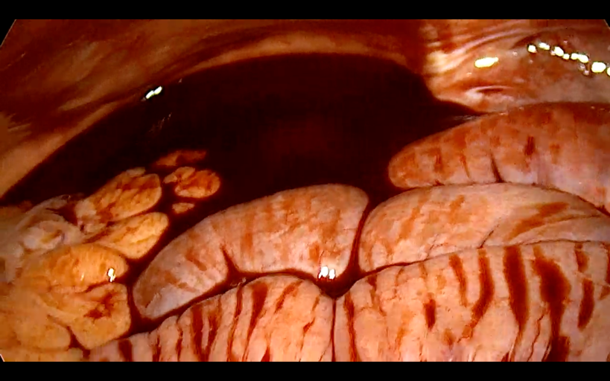
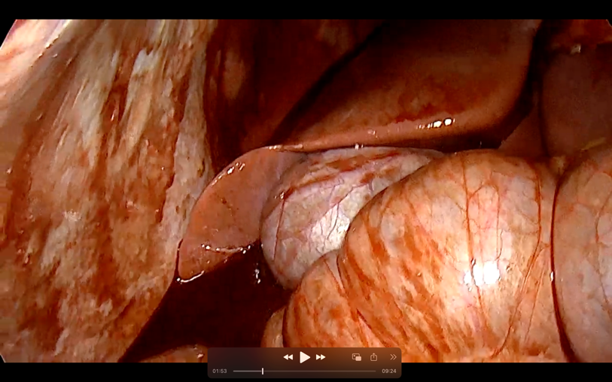
Figure 1. Haematoperitoneum

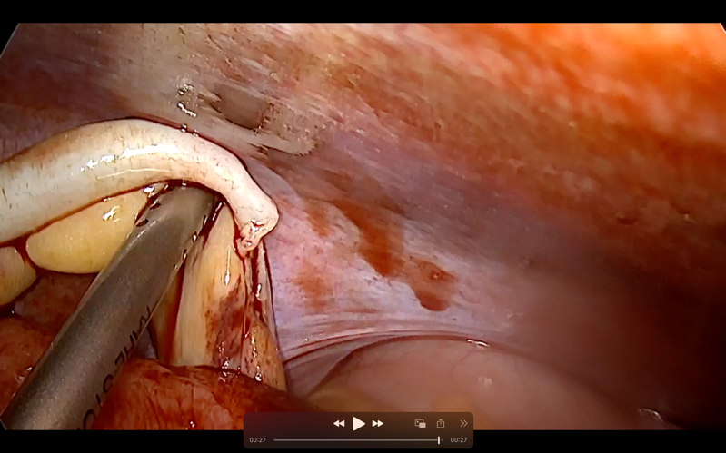
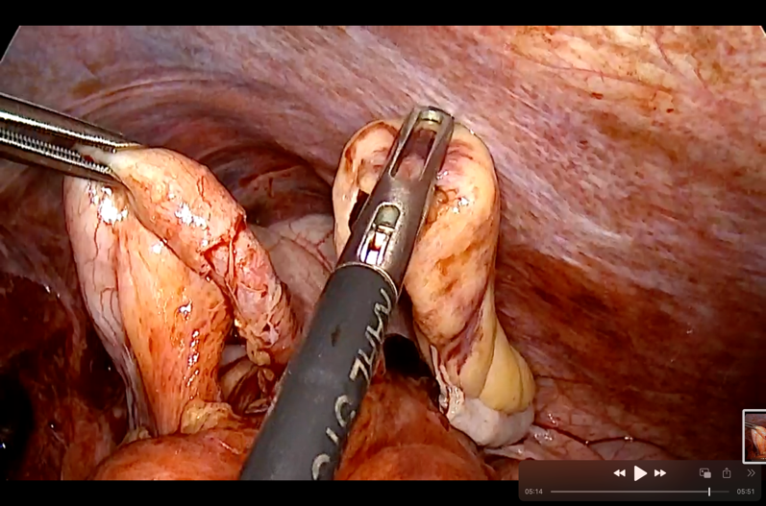
Figure 2. Appendiceal transection.

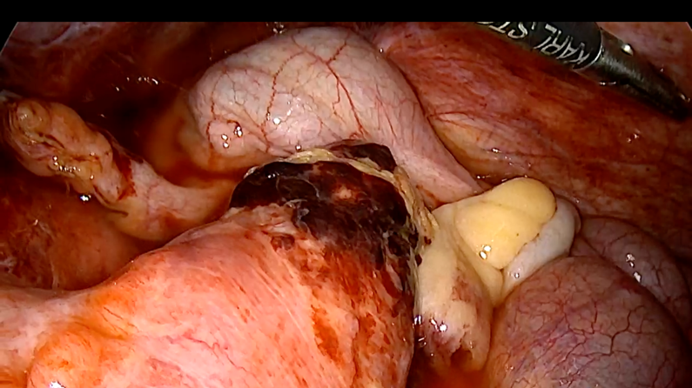
Figure 3. Contusion the wall of the terminal ileal loop.

- DISCUSSION

Bowel injury in seat belt syndrome after blunt abdominal trauma is rare. Delayed diagnosis undoubtedly increases the occurrence of postoperative complications and, in the worst cases, leads to death. Therefore, knowing the characteristics of intestinal and mesenteric injury in seat belt syndrome after BAT and making an early diagnosis are important (4). In case of a seat belt sign (ecchymosis and/or abrasions of the abdomen) a surgeon have to excercise great caution, as they increase the risc of hollow viscus injury (1). Abdominal pain and rigidity were the main presentig sympthoms upon admission and the rebound fenomenon was less commonly encountered. Even a soft abdomen on admission should not rule out the possibility of potential hollow viscus injury. However, it is known that accompanying injuries, such as head or spinal injury or being under the influence, compomise the reliability of physical examination (5).
MDCT is often the initial imaging modality used to assess patients with BAT. MDCT provides excellent anatomic details and diagnostic specificity by directly imaging the intestinal wall, detecting secondary signs of intestinal disease within the surrounding mesentery, and depicting even small amounts of extraluminal air into the peritoneal cavity (4). Intraperitoneal or retroperitoneal air, intra-abdominal free fluid without accompanying solid organ injury, diffuse bowel wall thickening, contrast extravasation from the mesentery and mesenteric haematoma have been described as powerful indicators of possible hollow viscus injury (6,7). Fakhry et al. has reported that abdominal MDCT may not detect intestinal injury in 13% of cases (8).
The normal appendix is rarely affected by direct trauma owing to its high mobility and small dimensions, which are protective factors. However, the appendix isn't immune to injury. Anatomically, factors increasing susceptibility include a narrow lumen, a lack of a mesentery to help absorb congestion, and an end arterial blood supply. The mechanisms of appendiceal injury in patients wearing seat belt is likely related to the sudden increase in intraluminal pressure with displacement of feces and gas into the appendix and mucosal injury, or to the displacement of mobile viscera with traction at fixed points, or due to direct traumatic injury (9). Upon review of literature on appendiceal transection after abdominal trauma, only a few cases were reported. Appendiceal transection was first reported in 1938 after a two-week history of pneumatic drill use while resting on the right iliac fossa. The patient felt a sudden onset, severe pain in the right lower quadrant while drilling; however, it initially improved, but returned the next day with increasing severity, eventually leading to a rigid abdomen. During an exploratory laparotomy, the appendix tip was found to be amputated (9).
In our case, the patient presented after a car vehicle accident and was hemodynamically stable. He did have a seatbelt sign on the right and left lower quadrant, which raised the suspicion for bowel injury. As the patient was stable, he underwent a MDCT that showed haematoma in abdominal wall, small amounth of fluid around the liver and hepatorenal recess, wall thickening of the small bowel loop and fluid in rectovesical recess. The decision was made to do the laparoscopic exploration. During the laparoscopic exploration we found a completely transected appendix and a few large lacerration of the omentum with active bleeding. In all cases in literature, the patient had a delayed presentation and only started having abdominal pain and peritoneal signs on day two of admission, and, none of these patients, including our patient, presented with hemodynamic instability or peritoneal signs from the onset of injury (9).
Laparoscopy is widely applied in patients with penetrating abdominal trauma (PAT) and proven to be accurate, associated with low morbidity, faster recovery, and shorter length of hospital stay. On the contrary, laparoscopy for BAT encounters many challenges and is rarely reported in literature (10). Koto MZ et al., in their study presented that all stable trauma patients requiring surgical exploration will undergo laparoscopy and there are no doubts that BAT patients with signs of peritonitis, positive findings on imaging, or with high suspicions for injuries (like seatbelt sign) require surgical exploration and their choice for stable patients is laparoscopy. They concluded that more studies are needed to draw the line between indications for diagnostic laparoscopy and non-operative management (10).

- CONCLUSION

Traumatic appendiceal transection is a rare posibility in blunt abdominal trauma, but this is potential injury from seat belt compression. A seat belt ecchymosis pattern must raise the suspicion for such injuries. The mechanism of appendiceal transection, in our case, was due to deceleration forces being transmitted to fixed points of mobile viscera. Pre-operative abdominal CT scan can help to select patients for non-operative management, although, the low accuracy of CT scan in detecting hollow viscus injuries should be taken into consideration. Laparoscopy for stable patients with BAT is feasible, accurate, and safe; however, it faces multiple challenges. More studies are needed to confirm our findings with the laparoscopy for blunt trauma patients.

REFERENCES

- Ozpek, A., Yidirak, M.K., Ezberci, F. (2024). Hollow visuc injury due to blunt abdominal trauma: a tertiary trauma center experience. Ulus ravma Acil Cerrahi Derg, 30(2), 123-128.
- Wadhwa, M., Kumar, R., Trehan, M., et al. (2021). Blunt Abdominal Trauma With Hollow Viscus and Mesenteric Injury: A proscepctive Study of 50 Cases. Cureus, 13(2).
- Sharma, K., Tomar, S., Sharma, S., et al. (2021). Floating appendix: post-traumatic amputation of the appendix as sequela or complication?: a case report. J Med Case Reports, 15(192).
- Suzuki, T., Sugiki, D., Matsumoto, A., et al. (2024). Ascending colon injury and ileal perforation due to blunt abdominal trauma: A case report. Radiol Case Rep, 19(5), 1776-1780.
- Schurink, G.W., Bode, P.J., van Lujit, P.A., et al. (1997). The value of physical examination in the diagnosis of patients with blunt abdominal trauma: a retrospective study. Injury, 28, 261-265.
- Cho, H.S., Woo, J.Y., Hong, H.S., et al. (2013). Multidetector CT findings of bowel transection in blunt abdominal trauma. Korean J Radiol, 14, 607-615.
- Polat, A.V., Aydin, R., Nural, M.S., et al. (2014). Bowel and mesenteric injury in blunt trauma: diagnostic efficiency ad importance of expirience in using multidetector computed tomography. Ulus Travma Acil Cerrahi Derg, 20, 417-422.
- Fakhry, S.M., Watts, D.D., Luchette, F.A., et al. (2003). EAST Multi-Institutional Hollow Viscus Injury Research Group Current diagnostic approaches lack sensitivity in the diagnosis of perforated blunt small bowel injury: analysis from 275,557 trauma admissions from the EAST multi-institutional HVI trial. J Trauma, 54(2), 295–306.
- AlJaberi, L.M., Salameh, A.E.K., Almarzooqi, R.M., et al. (2018). Transection of the appendix and omentum following a seat belt injury; case report and literature review. Ann Med Surg, 34, 11-13.
- Koto, M.Z., Matsevych, O.Y., Mosai, F., et al. (2019). Laparoscopy for blunt abdominal trauma: a challenging endeavor. Scandinavian Joural of Surgery, 108(4), 273-279.

