**Case Report**

**The impact of mismanagement in Malignant Parotid Tumors: challenges in treatment –A Two Case Report**

**ABSTRACR**

|  |
| --- |
| Malignant salivary gland tumors are diverse group pf neoplasm with unpredictable biological behavior and recurrence patterns, several factors contribute to recurrence malignant salivary gland tumors include tumor histology, initial surgical treatment, margin condition, perineural and lymph nodes involvement, we present a two cases of recurrent malignant parotid gland tumors, in which recurrence is likely due to incomplete initial resection of the tumor. Additionally, we highlight the impact of recurrence on patient management. |

*Key words: head and neck oncology, malignant salivary gland, parotid cancer. recurrent parotid tumors*

**1. INTRODUCTION**

Malignant salivary gland tumors are rare neoplasm that account for 5% of all head and neck cancer.More than 25 different types are recognized [1]. Many risk factors attribute to the recurrence of malignant salivary gland tumors, one of the most important factors is incomplete tumor resection, which can lead to recurrence within six months due to persistent tumor cells [2]. The most effective strategy for managing recurrent salivary gland tumors is to prevent their occurrence initially, this can be achieved through proper utilization of preoperative investigations, including imaging which provides valuable information that assists in treatment planning. In particular, imaging helps determine the tumor relation­ship to surrounding structures and demonstrates tumor extension. Additionally, fine needle aspiration biopsy plays a crucial role in correctly establishing the diagnosis as benign or malignant, with accuracy ranging from 81% to 98%. During surgery, the extent of resection for a malignant tumor is determined by factors such as tumor size, facial nerve involvement, and lymph node metastasis. Furthermore, Postoperative, adjuvant radiotherapy has been shown to decrease the recurrence rate in high-risk parotid tumors. The appropriate application of all these measures significantly reduce the recurrence of malignant salivary gland tumors [3,4,5].

**2. CASE REPORT 1**

A 30 year old male presented to the department of oral and maxillofacial surgery at alsalam teaching hospital with recurrent swelling in the parotid gland, the patient chief complaint was discomfort and progressive swelling. He had a history of a mass at the same site five months ago, for which he underwent surgical resection at another institution, the post-operative histopathological report from that surgery revealed a low grade mucoepidermoid carcinoma. Clinical examination showed a fixed mass in the parotid gland with normal facial nerve function and no palpable lymph nodes in the neck. A clinical diagnosis of recurrent malignant parotid tumor was established (Fig.1).

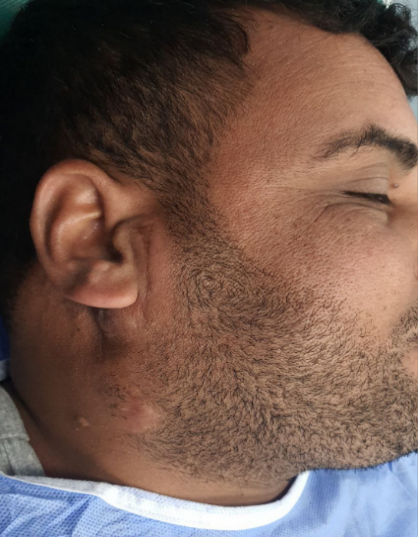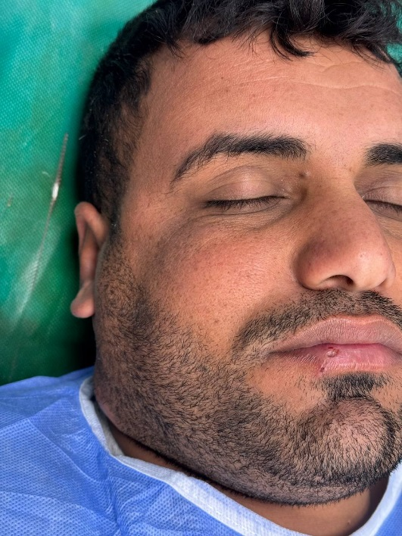

Fig .1. Swelling in the right side (black arrow)

Patient was sent for an MRI to determine the extent of the tumor and lymph nodes status, which showed an irregular mass occupying the parotid region and normal lymph nodes in the neck (Fig.2).

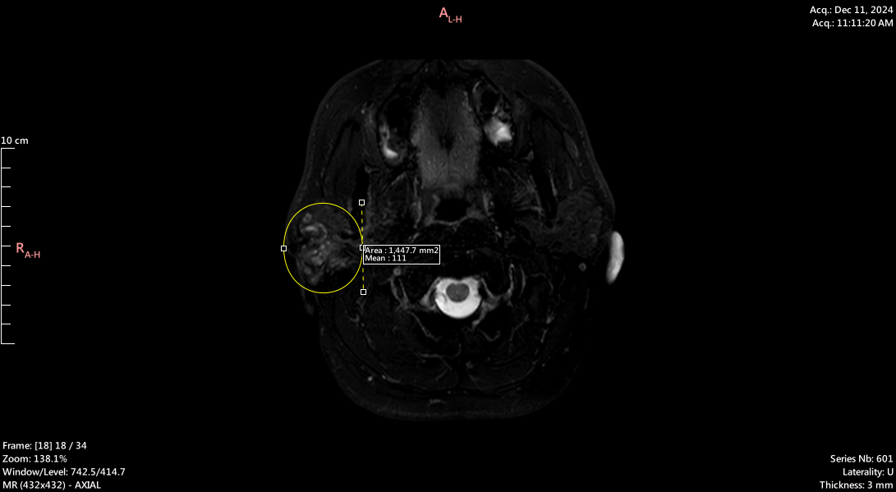Fig. 2. MRI T2W demonstrated irregular mass (yellow circle)

The treatment plan included total parotidectomy, facial nerve preservation and selective neck dissection at level 2A (Fig.3)

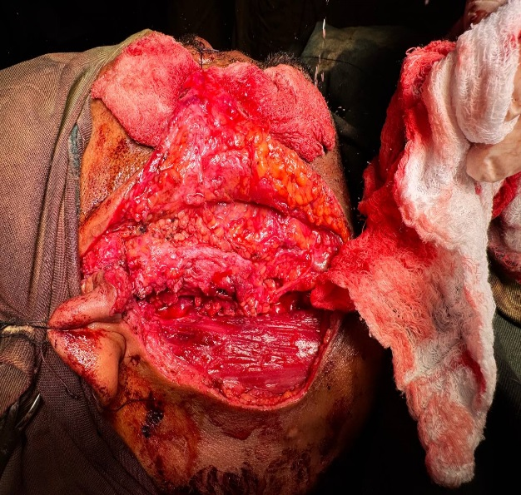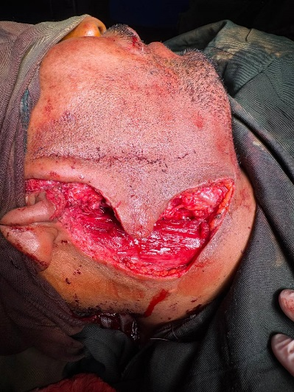

A

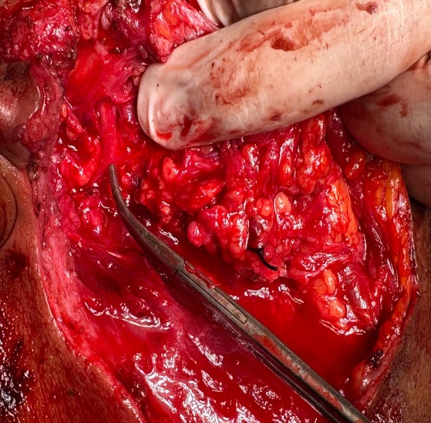

C

B

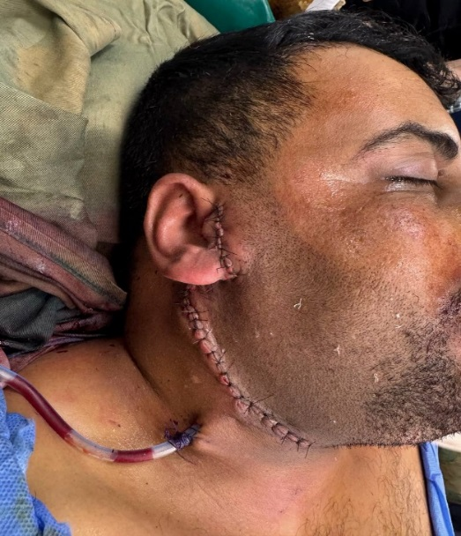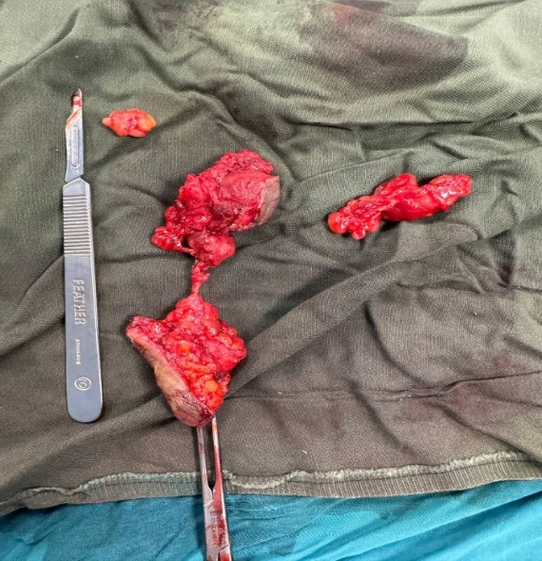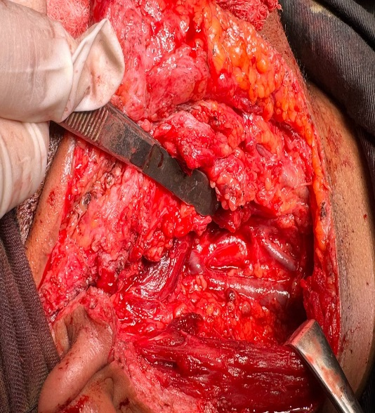

F

E

D

Fig .3. (A) surgical incision(modified Blaire) extended to perform selective level 2A neck dissection.(B) tumor exposed.(c) tumor excision with preservation of the facial nerve(black arrow).(D) selective neck dissection, level 2A.(E) tumor specimen(white arrows) and selective lymph nodes removal(yellow arrows).(F) skin closure.

Histological examination reveals intermediate-grade mucoepidermoid carcinoma infiltrating the extra parotid tissue reaching the subcutaneous tissue.the tumor was totally excised with a free margin of 3 mm all around, metastatic lymph nodes were observed in only one lymph node.

one day post-operative, facial nerve function was intact, except for the mandibular nerve branch, which was resected along with the tumor (Fig.4)

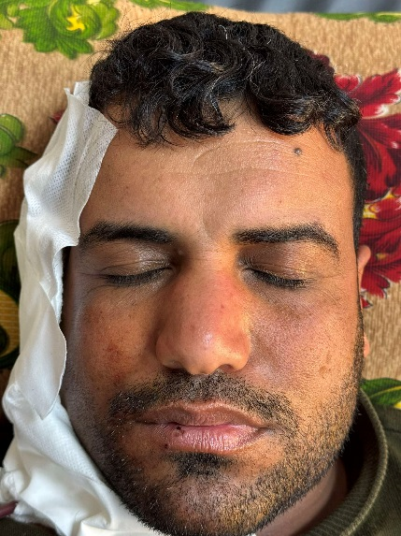 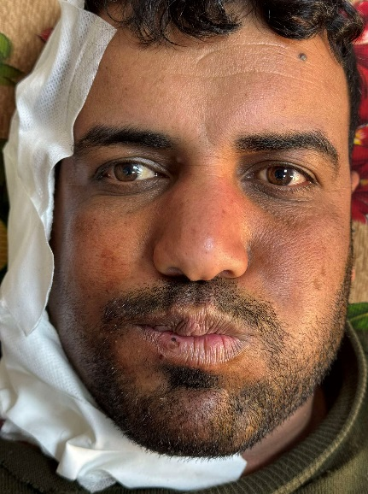 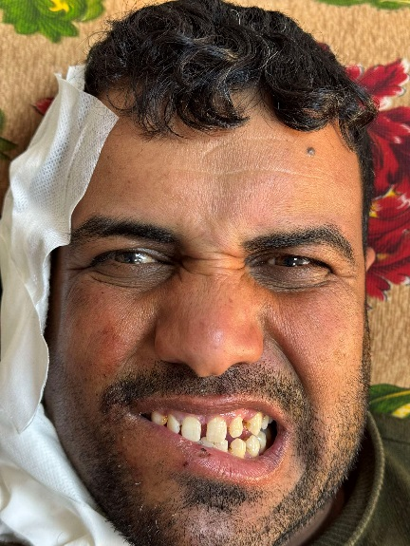

Fig. 4. Day one post-operative intact facial nerve branches except marginal mandibular nerve.

The patient was discharged on day one in stable condition and was referred for radiotherapy as part of treatment plan.

**3. CASE REPORT 2**

A 55 year old female was referred to the department of oral and maxillofacial surgery at alsalam teaching hospital due to recurrent swelling in the parotid gland. The patient chief complaint was discomfort and rapid swelling. She had a previous history of a tumor at the same site two months ago, for which she underwent surgical resection at another hospital. The post-operative histopathological report from the previous surgery showed carcinoma ex pleomorphic adenoma, the patient didn’t receive adjuvant treatment. Clinical examination revealed a hard immobile mass in the parotid gland with normal facial nerve function and no palpable lymph nodes in the neck, the Patient was sent for an MRI to determine the extent of

the tumor and the status of the lymph nodes, which showed an ill- demarcated mass occupying the parotid region and normal lymph nodes in the neck, the clinical diagnosis was recurrent malignant parotid tumor (Fig.5).

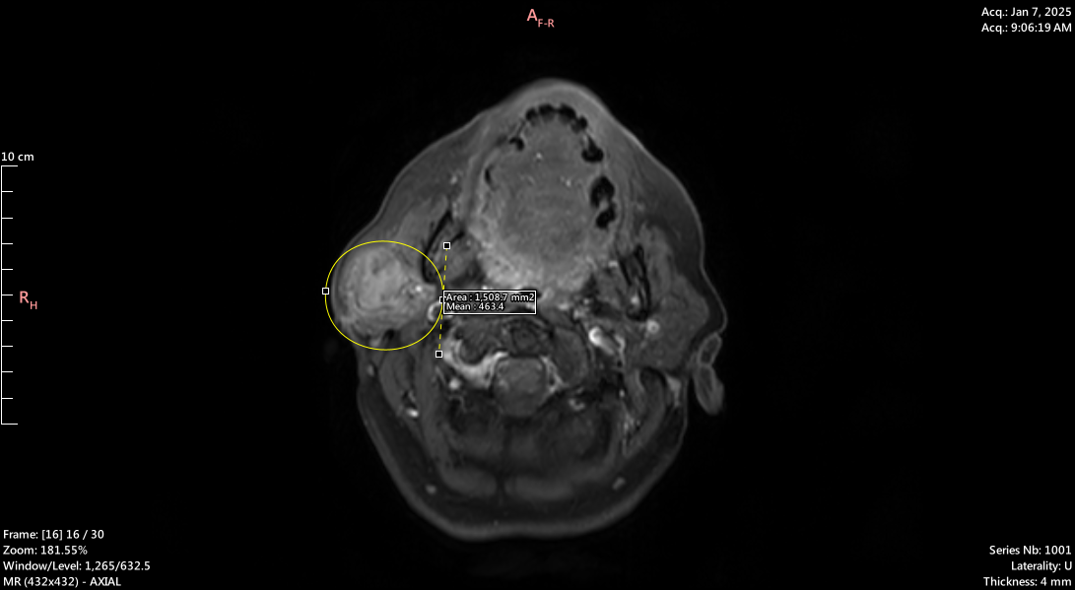

Fig. 5. MRI T1W reveal irregular mass in the right parotid gland (yellowish circle)

The treatment plan included total parotidectomy , facial nerve preservation and selective neck dissection level 2A (Fig.6).

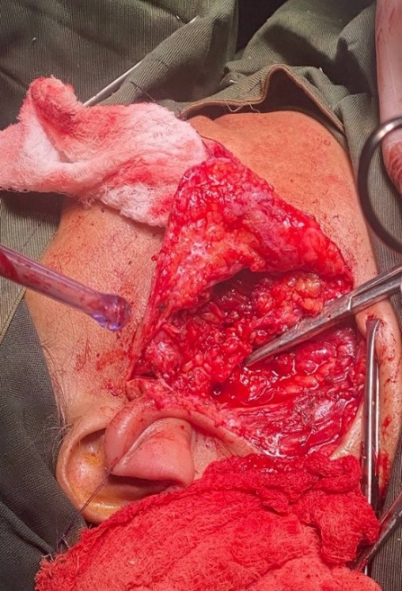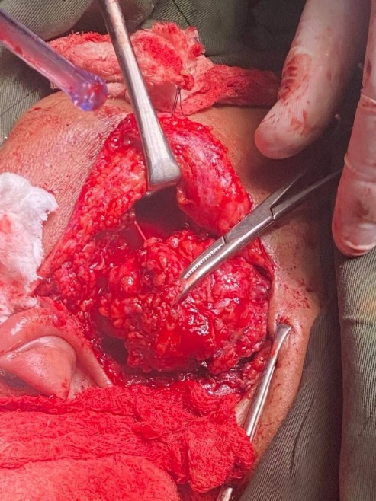

C

B

A

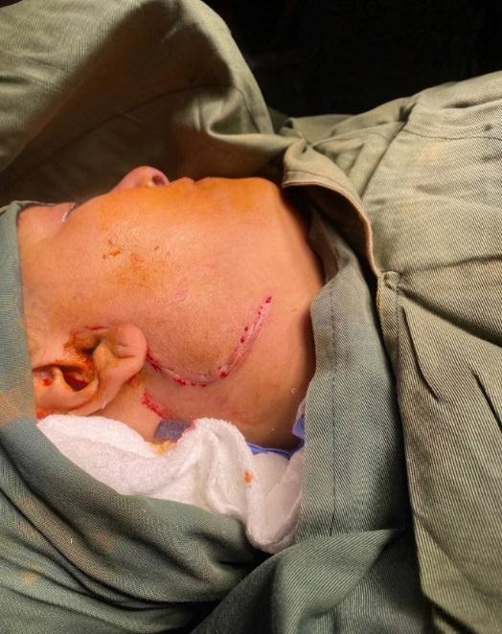

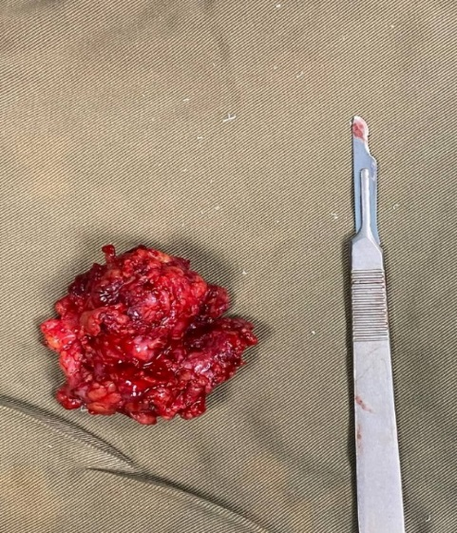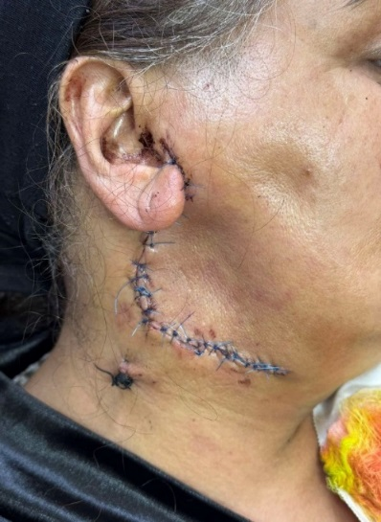

D

E

Fig .6. (A) Skin marking with previous surgery.(B) tumor within parotid bed.(C) complete clearance of the parotid bed with preservation of facial nerve and selective lymph node level 2A dissection.(D) tumor specimen.(E) post-operative closure.

Histological examination shows invasive carcinoma, completely excised with a free surgical margin 4mm all around, with no evidence of lymph nodes involvement.

One day post-operative facial nerve function was intact except for the marginal mandibular nerve branch which was resected with the tumor

The patient was discharged on day one in stable condition and was sent for radiotherapy as part of treatment (Fig.7).

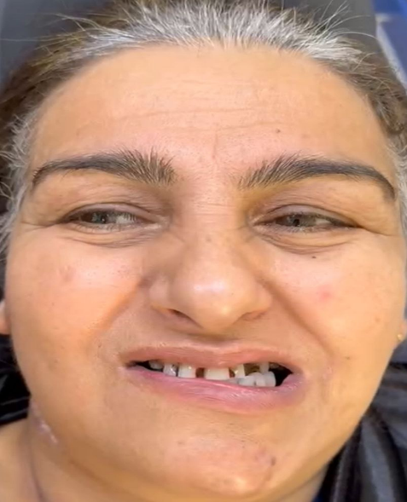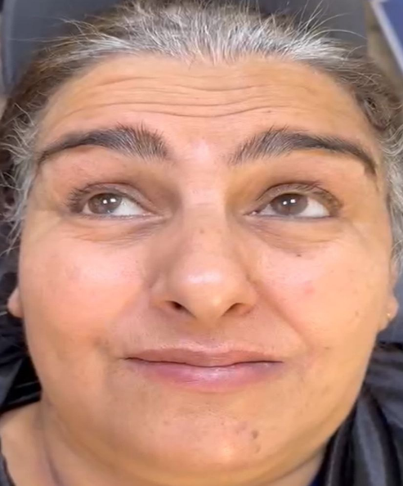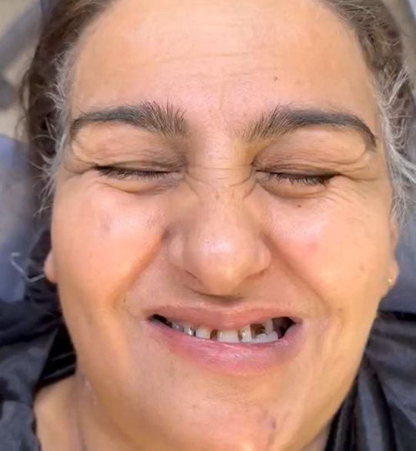

Fig .7. One week post-operative intact facial nerve branch except marginal mandibular nerve.

**4. DISCUSSION**

Malignant salivary gland tumors are rare neoplasms that present therapeutic challenges, particularly in recurrent cases [6].malignant salivary gland tumor are quit challenging as they can be misdiagnosed as benign tumors [7]. Fortunately, parotid recurrence most commonly present as local recurrence and less commonly as distant recurrence [6].

In these two cases there was unappropriated management resulting in recurrence, the first challenge was fibrosis which made it difficult to differentiate between the tumor and the fibrotic tissue. This, in turn made complete tumor eradication challenging. Additionally, fibrosis promotes a tumor microenvironment which significantly enhancing cancer behavior and acting as a physical barrier to chemotherapy [8, 9]. In both cases, the marginal mandibular nerve was surrounded by the tumor due to altered anatomical planes from previous surgery.as a result, tumor removal could not be performed without sacrificing the nerve, leading to aesthetic and functional deformities that affected the patients, quality of life [10].

Incomplete tumor excision disrupts both the tumor and the surrounding normal tissue, leading to tumor cell seeding into healthy tissue and metastasis to other sites [11]. One of the most significant impacts of tumor recurrence is its effect on the patient’s psychological condition, often leading to depression, loss of hope for healing, anxiety, and fear of death [12]. Recurrent malignant salivary gland tumors are considered high risk tumor so aggressive treatment is required in almost all cases with adjuvant radiotherapy to gain sufficient local control and disease free outcomes [13].

**5. CONCLUSION**

Recurrent malignant salivary gland and their complications can be avoided through accurate preoperative assessment, including thorough history taking, clinical examination, and investigations such as MRI, CT scan, and fine needle aspiration cytology, This approach ensures an accurate diagnosis and allows for the selection of the most appropriate surgical and adjuvant treatments when indicated.

**Ethical Considerations**

Compliance with ethical guidelines

Informed consent was obtained from patients, to publish these cases for academic purpose.

**DISCLAIMER (ARTIFICIAL INTELLIGENCE):**

Author(s) hereby declare that NO generative AI technologies such as Large Language Models (ChatGPT, COPILOT, etc) and text-to-image generators have been used during writing or editing of this manuscript

**References**

1. Bell, R. B., Dierks, E. J., Homer, L., & Potter, B. E. (2005). Management and outcome of patients with malignant salivary gland tumors. *Journal of oral and maxillofacial surgery*, *63*(7), 917-928.‏.

2. Mehanna, H., Kong, A., & Ahmed, S. K. (2016). Recurrent head and neck cancer: United Kingdom national multidisciplinary guidelines. *The Journal of Laryngology & Otology*, *130*(S2), S181-S190.‏

3. Merdad, M., Richmon, J. D., & Quon, H. (2016). Management of Recurrent Malignant Salivary Neoplasms. *Advances in Oto-rhino-laryngology*, *78*, 168-174.‏

4. Lee, Y. Y. P., Wong, K. T., King, A. D., & Ahuja, A. T. (2008). Imaging of salivary gland tumours. *European journal of radiology*, *66*(3), 419-436.‏

**5.** Shah, J. P. (2020). Head and neck oncology and surgery (5th ed.). Elsevier..

6Nachtsheim, L., Jansen, L., Shabli, S., Arolt, C., Quaas, A., Klussmann, J. P., ... & Wolber, P. (2025). Recurrence after primary salivary gland carcinoma: Frequency, survival, and risk factors. *Head & Neck*, *47*(1), 47-56.‏

7. Peravali, R. K., Bhat, H. H. K., Upadya, V. H., Agarwal, A., & Naag, S. (2015). Salivary gland tumors: a diagnostic dilemma!. *Journal of maxillofacial and oral surgery*, *14*, 438-442.‏

8. Chandler, C., Liu, T., Buckanovich, R., & Coffman, L. G. (2019). The double edge sword of fibrosis in cancer. *Translational Research*, *209*, 55-67.‏

9. Chen, H., Xu, X., Li, J., Xue, Y., Li, X., Zhang, K., ... & Li, M. (2024). Decoding tumor-fibrosis interplay: mechanisms, impact on progression, and innovative therapeutic strategies. *Frontiers in Pharmacology*, *15*, 1491400.‏.

10. Kudva, A., Babu, K., Saha, M., Puri, S., Pandey, L., & Gunashekhar, S. (2021). Marginal mandibular nerve—a wandering enigma and ways to tackle it. *The Egyptian Journal of Otolaryngology*, *37*, 1-20.‏

11. Alieva, M., van Rheenen, J., & Broekman, M. L. (2018). Potential impact of invasive surgical procedures on primary tumor growth and metastasis. *Clinical & experimental metastasis*, *35*, 319-331.‏

12. Smith, H. R. (2015). Depression in cancer patients: Pathogenesis, implications and treatment. *Oncology letters*, *9*(4), 1509-1514.‏

13. Gillespie, M. B., Albergotti, W. G., & Eisele, D. W. (2012). Recurrent salivary gland cancer. *Current treatment options in oncology*, *13*, 58-70.‏