***Case report***

UNRAVELLING TRICHELLEMAL CARCINOMA- A RARE SCALP MALIGNANCY WITH DIAGNOSTIC DILEMMAS AND ITS MULTIFACETED MANAGEMENT.

ABSTRACT:

Trichilemmal carcinoma is a rare skin adnexal malignancy, with incidence of 0.05%, primarily affecting the elderly in sun-exposed areas, arising from external sheath of hair follicle. We report a 60-year-old male with a scalp swelling initially diagnosed as sebaceous cyst. Swelling with atypical features require high clinical suspicion for diagnosis.Biopsy suggestive of skin adnexal tumour. After wide local excision and double rotation flap reconstruction, the patient showed good recovery. Post operative HPE confirmed to be trichellemal carcinoma. Regular follow-up is essential for recurrence or metastasis, although no formal guidelines exist. This case underscores the critical importance of employing a methodical and structured approach in evaluation of swelling to avert potentially adverse outcomes

KEYWORDS: Trichellemal carcinoma, wide local excision, double rotation flap, follow up

 Introduction

“Trichilemmal carcinoma (TC) is a rare, low-grade, malignant adnexal tumor. It is usually less than 3 cm long and arises from the external root sheath of the hair follicle, most commonly in sun-exposed areas of the body.”[8] “It manifests as an ulcerated nodule, papule, asymptomatic exophytic or polypoid mass, usually affecting sun-exposed skin.”[9] The most involved areas are the forehead, scalp, neck, back of hands and trunk in older adults with an indolent clinical course.”[10]

CASE PRESENTATION :

 A 60-year-old male presented with a  swelling on the scalp, present for one month. Examination revealed a 3x3 cm hemispherical mass in the left parietal region with well-defined margins and a nodular surface. The overlying skin appeared normal, with minimal crusting, and the lesion was mobile , non-tender with variable consistency. Initially suspected as a sebaceous cyst, further investigation was performed due to atypical features like nodularity, crusting & variable consistency. Ultrasonography showed a hypoechoic lesion in the subcutaneous plane without increased vascularity or deeper tissue invasion. FNAC identified a skin adnexal tumor, and CT confirmed a subcutaneous mass with no intracranial extension.

The patient underwent wide local excision with  1 cm margin, extending to the galea aponeurotica. The defect measuring 6x5 cm, was reconstructed with a double rotation flap. Histopathological examination confirmed to be trichilemmal carcinoma. After  3 months follow-up, the patient had excellent  cosmetic results with no evidence of metastasis.

DISCUSSION:

Trichilemmal carcinoma  primarily affecting the elderly has no gender preference. It is linked to sun exposure, UV radiation, skin burns, immunosuppression and genetic conditions like Cowden syndrome and xeroderma pigmentosa.[[1]](#_top ) Its exact pathogenesis is unclear. TC originates from the external epithelial sheath of hair follicles.Clinically, TC appears as a painless exophytic mass, which may ulcerate or show telangiectasia. It is often misinterpreted, as was in our case, highlighting the importance of high clinical suspicion.Differential diagnoses include basal cell carcinoma, squamous cell carcinoma and keratoacanthoma. [[2]](#_top )

The preferred treatment for trichilemmal carcinoma is surgical excision with 1cm margin clearance.[[7]](#_top )Tumors in cosmetically sensitive areas, like the head and neck, may benefit from Mohs micrographic surgery, which allows precise tumor removal while preserving tissue. Post-excision, scalp defects can be reconstructed using secondary intention for smaller defects or grafts/flaps for larger ones. Techniques like rotation-advancement flaps, including the double hatchet and O-Z flaps, are useful for larger defects, promoting healing and aesthetic outcomes due to their rich blood supply and reduced infection risk.[[3,4]](#_top )

Simple excision is effective for non-metastatic trichilemmal carcinoma, with a 7.55% recurrence rate when margins are clear. Metastasis is rare but may involve cervical lymph nodes in this case. If metastatic, chemotherapy with cisplatin and cyclophosphamide or vindesine is used[[6]](#_top ) Immunomodulation with topical imiquimod may treat superficial lesions[[2,5]](#_top )Close follow-up is essential for recurrence detection.

CONCLUSION:

Trichilemmal carcinoma is challenging to diagnose due to its rarity and slow progression. Surgical excision with adequate margins is effective in non-metastatic cases. For scalp reconstruction, techniques like the O-Z flap offer improved cosmetic results.An exceptional presentation which piqued clinical curiosity, was approached with careful suspicion, systematic analysis and meticulous surgical intervention, ultimately leading to an outstanding recovery.

DECLARATION

The authors confirm patient consent for publication of images and clinical information, with identity protection but no guaranteed anonymity.

Ethical approval: Not required

REFERENCE:

1. http://Rhoul C, Miry A, Bennani A, Serji B, El Harroudi T. A Rare Case Report of Trichilemmal Carcinoma. Cureus. 2022 Nov 8;14(11):e31261. doi: 10.7759/cureus.31261. PMID: 36505152; PMCID: PMC9731728.

2. http://Fronek L, Brahs A, Farsi M, Miller R. A Rare Case of Trichilemmal Carcinoma: Histology and Management. J Clin Aesthet Dermatol. 2021 Jun;14(6):25-30. Epub 2021 Jun 1. PMID: 34804352; PMCID: PMC8594537.

3. http://Varela-Veiga A, Suárez-Magdalena O, Suárez-Amor Ó, Monteagudo B. Reconstrucción de defecto en cuero cabelludo mediante doble colgajo en hacha. Actas Dermosifiliogr. 2017;108:878-880.

4. http://Lin, Jian MM; Wei, Peng MD; Xu, Yi MM; Wang, Guoyao MD; Wu, Kerong MM; Lin, Bingjiang MD; Wang, Yangjian MD. Use of the O-Z Flap to Repair Scalp Defects After Cancer Tumor Resection. Journal of Craniofacial Surgery 33(3):p 892-894, May 2022. | DOI: 10.1097/SCS.0000000000008300

5. http://Kannan K, Mahesh KC, Manickam N, Ramdas A. Trichilemmal Carcinoma of Scalp Masquerading as Squamous Cell Carcinoma: A Report of a Rare Case with Histogenesis and Literature Review. Int J Trichology. 2020 Mar-Apr;12(2):82-85. doi: 10.4103/ijt.ijt_12_20. Epub 2020 May 5. PMID: 32684681; PMCID: PMC7362972.

6. http://Xu B, Wang T, Liao Z. Surgical Treatment of Trichilemmal Carcinoma. World J Oncol. 2018 Nov;9(5-6):141-144. doi: 10.14740/wjon1143w. Epub 2018 Nov 23. PMID: 30524638; PMCID: PMC6279458.

7. http://Shetty PK, Jagirdar S, Balaiah K, Shetty D. Malignant proliferating trichilemmal tumor in young male. Indian J Surg Oncol. 2014 Mar;5(1):43-5. doi: 10.1007/s13193-013-0259-2. Epub 2013 Aug 21. PMID: 24669164; PMCID: PMC3964243.

8. Macasaet, R., Arty, F. N. U., du Toit, J., Gaddameedi, S. R., Shah, S. M., & Du Toit, J. (2024). A Rare Case of Trichilemmal Carcinoma of the Scalp. *Cureus*, *16*(6).

9. Liu, L., Long, T., Wei, N., Zhang, H., Tang, C., & Gao, J. (2024). Successful treatment of trichilemmal carcinoma with distant metastasis using pembrolizumab: a case report and review. *Immunotherapy*, *16*(10), 659-667.

10. Qidiao, L., Liu, Y., Hu, D., Tao, X., & Yao, C. (2024). Trichilemmal carcinoma treated by excision combined with photodynamic therapy: a case report and review of literature. *Frontiers in Oncology*, *14*, 1436399.

Image 1 : swelling in scalp ( Pre Op )

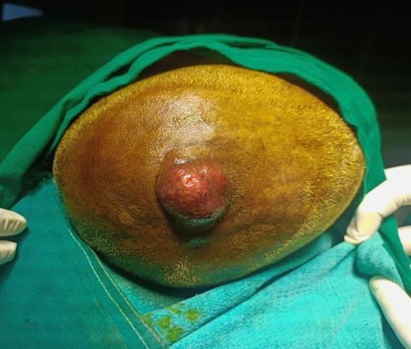

Image 2: wide local excision done ,defect area seen with intact periosteum

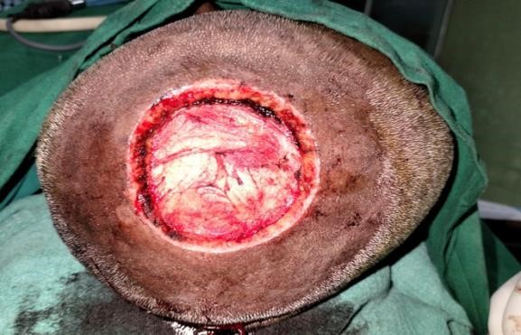

IMAGE 3: Flaps raised on both sides with twice the size of defect

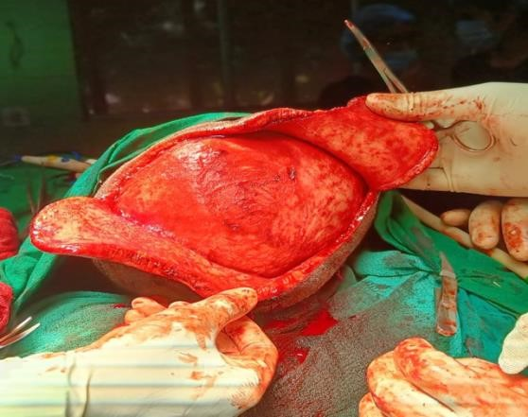

Image 4 : Reconstruction by double rotation flap with placement of drain

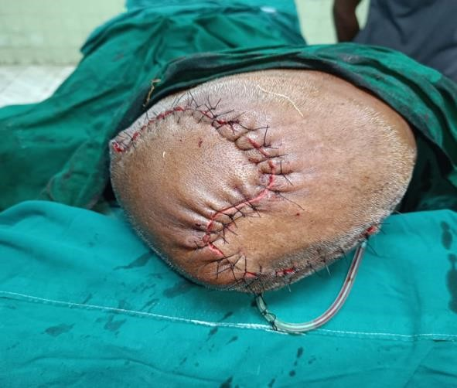

Image 5: Post operative, after 3 months

