**A COMMON CLINICAL PRESENTATION AND AN UNCOMMON DIAGNOSIS, ‘GANGLIOCYTIC PARAGANGLIOMA’: CASE REPORT**

**ABSTRACT**: A common clinical presentation, however the diagnosis was different from the common differentials. Presenting to you a case of malena, headache, dizziness, fatigue. He presented as a diagnostic dilemma. A battery of tests performed to ascertain the diagnosis. A definitive diagnosis was not available. After multidisciplinary team approach, it was unanimously decided to subject the patient to surgery. The histopathological examination showed spindle cells, epitheloid cells and ganglion cells, thereby clinching the diagnosis of ‘Duodenal Gangliocytic Paraganglioma’. The first case was reported in 1957, however only a few hundred cases are available in the literature mostly in the form of case reports. Existing case series contain only single digit cases. Because of the rarity of the case, it is important to report thereby adding to the existing literature.

**KEYWORDS: Duodenum, Gangliocytic Paraganglioma, Case Report, Excision**

**INTRODUCTION**

Gangliocytic Paraganglioma (GP) was first described in 1957 as duodenal ganglioneuroma by Dahl et al.1 In 1971, Kepes and Zacharias first described these tumors as GP because of the presence of both ganglion cells and epithelioid cells.2 Gangliocytic [paraganglioma](https://www.sciencedirect.com/topics/medicine-and-dentistry/paraganglioma) mainly arises from the second part of the [duodenum](https://www.sciencedirect.com/topics/medicine-and-dentistry/duodenum) in close proximity to the [ampulla of Vater](https://www.sciencedirect.com/topics/medicine-and-dentistry/ampulla-of-vater), although the tumor can be seen throughout the [gastrointestinal tract](https://www.sciencedirect.com/topics/medicine-and-dentistry/gastrointestinal-tract).6 GPs are exceedingly rare tumors, with approximately 280 cases identified in a MEDLINE search through November 2022.3,4,5  Hence it is important to report this case. Thereby adding to the existing literature.

This case report has been reported in line with the SCARE Criteria 2023.7

**CASE REPORT**

**Patient Information**

A 39yr/Male presented to a peripheral hospital with complains of headache, weakness, giddiness, fatigue, malena for a period of 1 week. On subsequent evaluation, Hb- 12.6gm/dl, Stool- occult blood positive. Upper GI endoscopy showed hiatal hernia, antral gastritis and duodenal ulcer. He was given symptomatic treatment and discharged home in 2 days.

Clinical Findings

After 2 weeks he presented to our hospital with complains of headache, giddiness and malena. He was again subjected to a battery of investigations, the reports were as follows: Hb- 9.4gm/dl, Platelets- 2,87,000.

**Diagnostic Assessment**

Upper GI scopy showed bleeding from ampulla, with a bulky ampulla (Fig 1). Side viewing duodenoscopy was done which showed periampullary neoplasm with ulcerations. Biopsy was taken from it. Lower GI Endoscopy was within normal limits. Histopathology report: benign ampullary mucosa, lamina propria shows mild inflammatory infiltrate of lymphocytes and plasma cells. No evidence of granulomas, dysplasia or malignancy. CEA: <0.5ng/ml. CA 19-9: 16.77 U/ml.

Computed Tomography (CT) Scan of abdomen and pelvis with oral+ IV contrast: polypoidal, heterogeneously enhancing lesion of size 2.4*1.5*1.5 cm seen in second part of the duodenum along medial wall just below periampullary region (Fig 2). No dilation of pancreatic duct or common bile duct. Periduodenal fat planes appear normal. Possibility of gastrointestinal stromal tumour (GIST) likely. No significant abdominal lymphadenopathy.

During this his Hb dropped to 8gm/dl. He was transfused with 2 pints of packed cell volume (PCV). Whole body PET CT showed small, intraluminal, polypoidal lesion in 2nd part of duodenum, closely abutting ampulla. (SUVmax: 3.6, size: 14*15mm) (Fig 2)

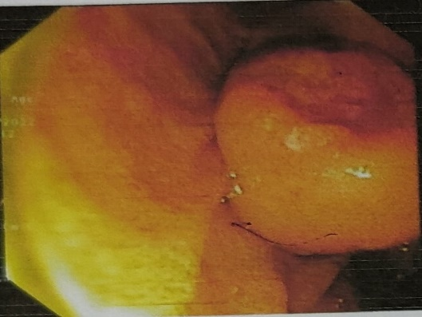

Fig 1. Showing upper GI endoscopy appearance

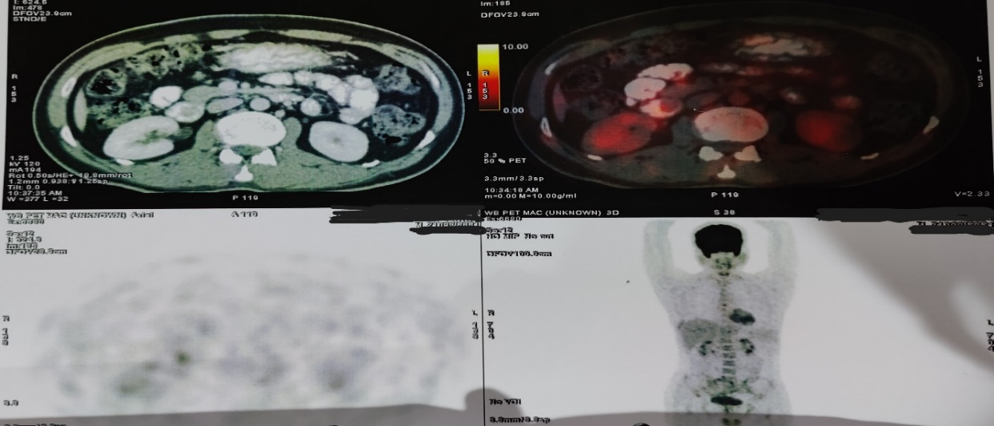 Fig 2. Showing CT Scan and PET CT Appearance

**Therapeutic Intervention**

Now this patient presented a diagnostic dilemma. With no definite diagnosis to the exact nature of the periampullary lesion, further management was contemplated. Being in close proximity to the ampulla and owing to ambiguity about the nature of the lesion and its size, gastroenterology opinion did not favour endoscopic management. Hence, we decided to go ahead with surgery.

An upper midline vertical incision was taken. 2nd part of duodenum was opened in right lateral part vertically. Lesion was seen in very close proximity to ampulla. Wide excision of the lesion was done. Duodenal incision was closed primarily in two layers. Drain kept. Patient did well postoperatively. He was discharged on post-op day 5, tolerating full diet. Histopathology report showed gross size of 1.5*1.2*0.8cm. Submucosal tumor with relatively circumscribed borders composed of spindle cells, small clusters of epitheloid cells and ganglion cells. These features are suggestive of duodenal gangliocytic paraganglioma. Resection margins are free.

**Follow up and Outcome**

On routine subsequent follow up of 20 months, patient is doing well. There is no evidence of local or systemic recurrence of the disease.

**DISCUSSION**

GP is a rare diagnosis, usually not even considered in the differentials in the early diagnostic stages. GP shows slight male predominance (1.5:1) and a mean tumor size of approximately 2.57 cm, the most common clinical presentation is gastrointestinal bleeding; other symptoms include abdominal pain, anemia, nausea, weight loss, fatigue, and jaundice.3 Our case report has a male patient with symptoms suggestive of anaemia and upper GI bleeding. Initially, on endoscopy he was diagnosed as antral gastritis and duodenal ulcer and was discharged with symptomatic treatment.

GP is difficult to diagnose. Radiologically, GP usually presents a diagnostic dilemma.8 Due to the submucosal location of this tumor, preoperative pathologic diagnosis is difficult based on endoscopic biopsy alone with a diagnostic rate of only 11.4%.9 As in this case preoperative biopsy was inconclusive showing mild inflammatory infiltrate. Ct scan report suggested it to be tumor of 2.4cm, with possibility of it being GIST. Due to diagnostic uncertainty, a PET Scan was performed. Whole body PET CT showed small, intraluminal, polypoidal lesion in 2nd part of duodenum, closely abutting ampulla (SUVmax: 3.6, size: 14*15mm).

A multidisciplinary team decided that surgical resection should be undertaken. Hence open D2 duodenotomy with wide excision of the lesion was done. Postoperative HPE report diagnosed it as GP. Resection of the tumor is the only definitive treatment.10

Patients with local disease and no malignant features or lymph node metastasis on preoperative workup can be considered for endoscopic mucosal resection.11 Depending on the size and location of the tumor and the expertise available, laparoscopic or robotic or open approach can be undertaken. Complete resection of the tumor with free margins constitutes adequate treatment. On routine follow up of 20 months the patient is doing well with no evidence of recurrence or metastasis.

**CONCLUSION**

Duodenal gangliocytic paraganglioma is a rare lesion commonly arising in the 2nd part of duodenum. It is usually benign. Preoperative radiology or histopathology diagnosis is very difficult and requires a high degree of suspicion. Resection constitutes definitive treatment for GP.

Consent: A written informed consent was taken from the patient for reporting the case and the accompanying images.

**COMPETING INTERESTS DISCLAIMER:**

Authors have declared that they have no known competing financial interests OR non-financial interests OR personal relationships that could have appeared to influence the work reported in this paper.

**REFERENCES**

1. Dahl EV, Waugh JM, Dahlin DC. Gastrointestinal ganglioneuromas; brief review with report of a duodenal ganglioneuroma. Am J Pathol. 1957;33(5):953-965. [PubMed](https://www.ochsnerjournal.org/lookup/external-ref?access_num=13458330&link_type=MED&atom=%2Fochjnl%2Fearly%2F2023%2F07%2F10%2Ftoj.23.0010.atom) [Google Scholar](https://www.ochsnerjournal.org/lookup/google-scholar?link_type=googlescholar&gs_type=article&author%5b0%5d=EV+Dahl&author%5b1%5d=JM+Waugh&author%5b2%5d=DC+Dahlin&title=Gastrointestinal+ganglioneuromas;+brief+review+with+report+of+a+duodenal+ganglioneuroma&publication_year=1957&journal=Am+J+Pathol&volume=33&pages=953-965)
2. Kepes JJ, Zacharias DL. Gangliocytic paragangliomas of the duodenum. A report of two cases with light and electron microscopic examination. Cancer. 1971;27(1):61-67. doi: 10.1002/1097-0142(197101)27:1<61::aid-cncr2820270111>3.0.co;2-I [CrossRef](https://www.ochsnerjournal.org/lookup/external-ref?access_num=10.1002/1097-0142(197101)27:1%3C61::AID-CNCR2820270111%3E3.0.CO;2-I&link_type=DOI) [PubMed](https://www.ochsnerjournal.org/lookup/external-ref?access_num=4099700&link_type=MED&atom=%2Fochjnl%2Fearly%2F2023%2F07%2F10%2Ftoj.23.0010.atom) [Google Scholar](https://www.ochsnerjournal.org/lookup/google-scholar?link_type=googlescholar&gs_type=article&author%5b0%5d=JJ+Kepes&author%5b1%5d=DL+Zacharias&title=Gangliocytic+paragangliomas+of+the+duodenum.+A+report+of+two+cases+with+light+and+electron+microscopic+examination&publication_year=1971&journal=Cancer&volume=27&pages=61-67)
3. Okubo Y, Yoshioka E, Suzuki M, et al. Diagnosis, pathological findings, and clinical management of gangliocytic paraganglioma: a systematic review. Front Oncol. 2018;8:291. doi: 10.3389/fonc.2018.00291 [CrossRef](https://www.ochsnerjournal.org/lookup/external-ref?access_num=10.3389/fonc.2018.00291&link_type=DOI) [Google Scholar](https://www.ochsnerjournal.org/lookup/google-scholar?link_type=googlescholar&gs_type=article&author%5b0%5d=Y+Okubo&author%5b1%5d=E+Yoshioka&author%5b2%5d=M+Suzuki&title=Diagnosis,+pathological+findings,+and+clinical+management+of+gangliocytic+paraganglioma:+a+systematic+review&publication_year=2018&journal=Front+Oncol&volume=8)
4. Nguyen BD, Guo R. Multimodality imaging of multiple duodenal gangliocytic paragangliomas with post-surgical recurrence. Dig Liver Dis. 2021;53(1):122-124. doi: 10.1016/j.dld.2020.06.001 [CrossRef](https://www.ochsnerjournal.org/lookup/external-ref?access_num=10.1016/j.dld.2020.06.001&link_type=DOI) [Google Scholar](https://www.ochsnerjournal.org/lookup/google-scholar?link_type=googlescholar&gs_type=article&author%5b0%5d=BD+Nguyen&author%5b1%5d=R+Guo&title=Multimodality+imaging+of+multiple+duodenal+gangliocytic+paragangliomas+with+post-surgical+recurrence&publication_year=2021&journal=Dig+Liver+Dis&volume=53&pages=122-124)
5. Reis D, Damião F, Noronha Ferreira C, et al. Duodenal gangliocytic paraganglioma: a unique cause of abdominal pain. ACG Case Rep J. 2019;7(1):e00272. doi: 10.14309/crj.0000000000000272 [CrossRef](https://www.ochsnerjournal.org/lookup/external-ref?access_num=10.14309/crj.0000000000000272&link_type=DOI) [Google Scholar](https://www.ochsnerjournal.org/lookup/google-scholar?link_type=googlescholar&gs_type=article&author%5b0%5d=D+Reis&author%5b1%5d=F+Dami%C3%A3o&author%5b2%5d=C+Noronha%20Ferreira&title=Duodenal+gangliocytic+paraganglioma:+a+unique+cause+of+abdominal+pain&publication_year=2019&journal=ACG+Case+Rep+J&volume=7)
6. B. Wang, Y. Zou, H. Zhang, L. Xu, X. Jiang, K. Sun Duodenal gangliocytic paraganglioma: report of two cases and review of literature Int. J. Clin. Exp. Pathol., 8 (9) (2015), p. 9752 [Scopus](https://www.scopus.com/inward/record.url?eid=2-s2.0-85012977571&partnerID=10&rel=R3.0.0) [Google Scholar](https://scholar.google.com/scholar_lookup?title=Duodenal%20gangliocytic%20paraganglioma%3A%20report%20of%20two%20cases%20and%20review%20of%20literature&publication_year=2015&author=B.%20Wang&author=Y.%20Zou&author=H.%20Zhang&author=L.%20Xu&author=X.%20Jiang&author=K.%20Sun)
7. Sohrabi, Catrin BSc, PhD, MBBSa; Mathew, Ginimol BSc, MBBSb; Maria, Nicola MD, MRCSc; Kerwan, Ahmed MBBS, MScd; Franchi, Thomas MBChB, MSc, FHEA, MAcadMEde; Agha, Riaz A MBBS, MSc (Oxon), DPhil (Oxon), MRCS Eng, FHEA, FRSA, FRSPH, FRCS Glasg (Plast), FRCS (Ed), FRCS (Plast), FEBOPRASf; Collaborators. The SCARE 2023 guideline: updating consensus Surgical CAse REport (SCARE) guidelines. International Journal of Surgery 109(5):p 1136-1140, May 2023. | DOI: 10.1097/JS9.0000000000000373
8. Jain V, Selvakumar B, Varshney VK, Vishwajeet V, Taywade S, Agarwal L, Yadav T, Pandey R. Gangliocytic Paraganglioma of the Duodenum: A Masquerader. Ochsner J. 2023 Fall;23(3):251-256. doi: 10.31486/toj.23.0010. PMID: 37711472; PMCID: PMC10498948.
9. Okubo Y, Wakayama M, Nemoto T, Kitahara K, Nakayama H, Shibuya K, et al Literature survey on epidemiology and pathology of gangliocytic paraganglioma BMC Cancer. 2011;11:187[Cited Here](https://journals.lww.com/ijpm/fulltext/2018/61040/duodenal_gangliocytic_paraganglioma__a_rare_cause.25.aspx#O3-25-2) [Google Scholar](https://scholar.google.com/scholar_lookup?title=Literature+survey+on+epidemiology+and+pathology+of+gangliocytic+paraganglioma&publication_year=2011&author=Y+Okubo&author=M+Wakayama&author=T+Nemoto&author=K+Kitahara&author=H+Nakayama&author=K+Shibuya)
10. Okubo Y, Nemoto T, Wakayama M, et al. Gangliocytic paraganglioma: a multi-institutional retrospective study in Japan. BMC Cancer. 2015;15:269. [PubMed](http://www.ncbi.nlm.nih.gov/pubmed/25886293)  [Google Scholar](https://scholar.google.com/scholar_lookup?title=Gangliocytic+paraganglioma%3a+a+multi-institutional+retrospective+study+in+Japan.&publication_year=2015&author=Y+Okubo&author=T+Nemoto&author=M+Wakayama)
11. Loftus TJ, Kresak JL, Gonzalo DH, Sarosi GA Jr, Behrns KE. Duodenal gangliocytic paraganglioma: a case report and literature review. *Int J Surg Case Rep*. 2015;8C:5-8. doi:  10.1016/j.ijscr.2015.01.003 [PMC free article](https://www.ncbi.nlm.nih.gov/pmc/articles/PMC4353939/) [PubMed](https://pubmed.ncbi.nlm.nih.gov/25600615) [CrossRef](https://doi.org/10.1016%2Fj.ijscr.2015.01.003) [Google Scholar](https://scholar.google.com/scholar_lookup?journal=Int+J+Surg+Case+Rep&title=Duodenal+gangliocytic+paraganglioma:+a+case+report+and+literature+review&author=TJ+Loftus&author=JL+Kresak&author=DH+Gonzalo&author=GA+Sarosi&author=KE+Behrns&volume=8C&publication_year=2015&pages=5-8&pmid=25600615&doi=10.1016/j.ijscr.2015.01.003&)