***Case report***

**Birdshot's chorioretinopathy in a young patient with a good response to the combination of corticosteroids and cyclophosphamide**

**Abstract :**

Birdshot's chorioretinopathy is a well-known form of posterior uveitis, often chronic, bilateral and of unknown etiology. Its prevalence varies between 0.69 and 1.73 cases per 100,000 population. It is characterized by multiple, distinctive, hypopigmented choroidal lesions, and is strongly associated with human leukocyte antigen (HLA)-A29. The mean age at presentation is 53 years, with a slight female predominance (54.1%). It is a slowly progressive disease accompanied by profound visual dysfunction that may not be reflected by visual acuity unless associated macular edema is present. We report the case of a young 21-year-old patient who presented for an etiological work-up of bilateral ocular involvement with profound visual acuity impairment probably complicating macular edema, and in whom the diagnosis of Birdshot chorioretinopatrhoea was retained with HLA A29 positive after exclusion of other etiologies of posterior uveitis and who responded well to a combination of corticoid boluses and cyclophosphamides**.**

**Keywords :** Birdshot chorioretinopath, posterior uveitis, HLA-A29, corticoid, cyclophosphamide

**Introduction :**

Birdshot's chorioretinopathy (BSCR) is a rare form of posterior uveitis, often chronic, bilateral and of unknown etiology. Its prevalence varies between 0.69 and 1.73 cases per 100,000 population. It usually occurs in the fifth decade of life with a slight female predominance (54.1%) (1). The BCR is characterized by multiple, distinctive, hypopigmented [choroidal lesions](https://www.sciencedirect.com/topics/pharmacology-toxicology-and-pharmaceutical-science/choroid-disease" \o "Learn more about choroidal lesions from ScienceDirect's AI-generated Topic Pages), and strongly associated with [human leukocyte antigen](https://www.sciencedirect.com/topics/medicine-and-dentistry/human-leukocyte-antigen" \o "Learn more about human leukocyte antigen from ScienceDirect's AI-generated Topic Pages) (HLA)-A29 (2). BCR is rarely observed in young patients. We report the case of a young patient with Birdshot chorioretinopathy, confirmed by ophthalmological examinations and genetic study, which progressed well under corticosteroid therapy and cyclophosphamid.

**Case Presentation :**

A 21-year-old patient with no specific pathological history admitted for etiological assessment of nyctalopia and bilateral ocular damage consisting of visual acuity at CF, diffuse macular edema, epiretinal membrane, cottony nodules and normal papilla bilaterally with extensive multiple DSRs on optical coherence tomography macular OCT, and hypofluorescent patches related to delayed choroidal filling and hyperfluorescent leakage points without diffusion on angiography,

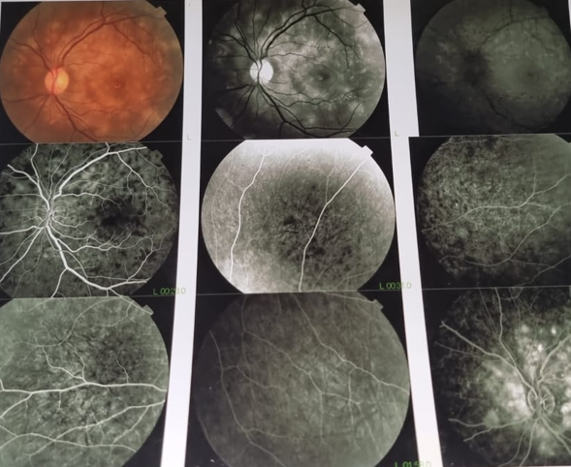

Figure 1 : initial angiographic appearance of the left eye

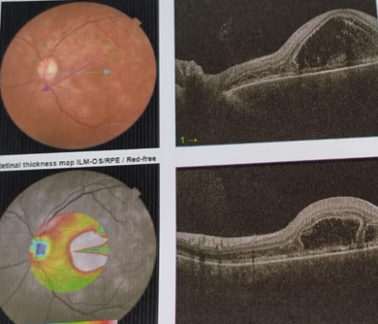

Figure 2 : diffuse macular edema on OCT of the left eye

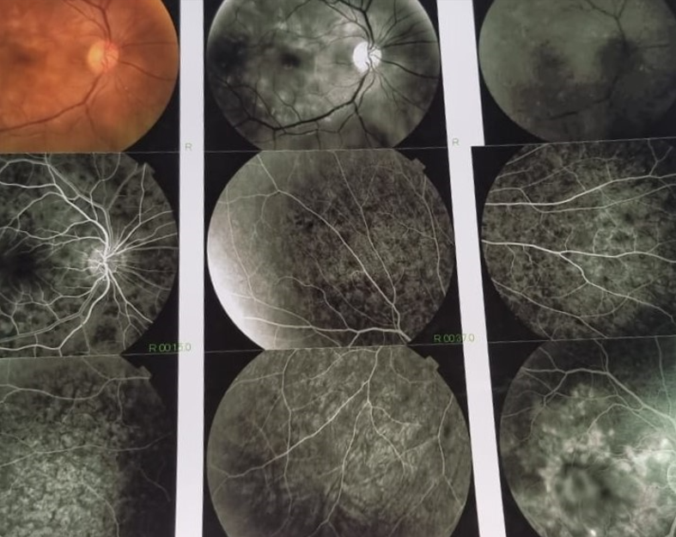

Figure 3 : initial angiographic appearance of the right eye

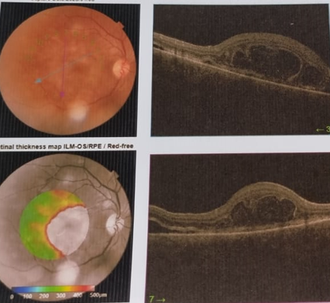

Figure 4 : diffuse macular edema on OCT of the right eye ( 03/01/2023)

The questioning and clinical examination did not reveal any associated extraocular signs in favor of an infectious or inflammatory origin. Given this picture, an infectious origin, notably viral (HSV, EVB, CMV, HIV, HVB, HVC), syphilitic, toxoplasmic or tuberculosis, was first ruled out, with a negative immunological and sarcoidosis work-up. A work-up in the sense of Vogt-Koyanagi-Harada disease, consisting of brain imaging, lumbar puncture and audiogram, was unremarkable. Genetic studies revealed the presence of HLA A29, confirming the diagnosis of Birdshot chorioretinopathy. In view of the severity of ocular damage, the patient received 3 boluses of methyl prednisolone 1g and 3 boluses of endoxan 1g, followed by oral corticosteroids and imurel 150 mg/day. Visual acuity improved: 10/10 bilaterally, with complete regression of macular edema and improvement in angiographic control signs.

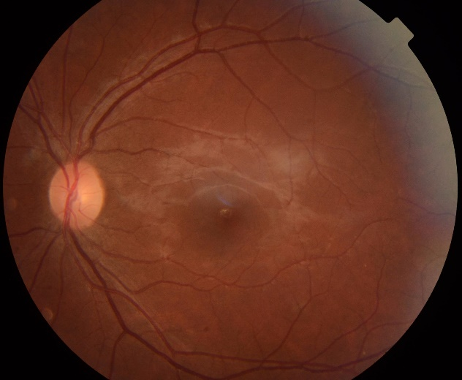

Figure 5 : control retinography of the left eye ( 18/10/2024)

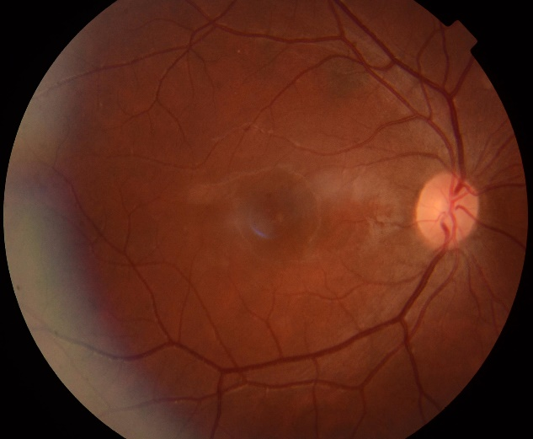

Figure 6 : control retinography of the rightt eye ( 18/10/2024)

**Discussion :**

Birdshot chorioretinopathy (BSCR) is a relatively rare subtype of noninfectious posterior uveitis. The typical BSCR patient is a Caucasian female in the third to sixth decade of life. In a systematic review of over 500 patients, the mean age of presentation was 53 years (2). Unlike what has been reported in the literature, our patient is a young male. Children and adolescents are rarely affected. A review of the literature revealed at least seven previous paediatric cases, but these were not well described, with insufficient examination findings to support the clinical diagnosis. The youngest was a 6-year-old child, five patients were under 16 years of age and one case was 15 years old, all of which have been reported in various journals (2) (3).

The BSCR is strongly correlated with the human leukocyte antigen (HLA)-A29 allele even though this is not required for the diagnosis (4). Its clinical diagnosis is based on the following features: bilateral disease, low grade or absent anterior segment inflammation, low grade to moderate vitreous inflammation, and yellow-white choroidal spots known as “birdshot lesions” clustered around the optic nerve and radiating towards the periphery (5). In our case, the clinical picture was consistent with BSCR and the positive HLA-A29 confirmed our clinical diagnosis.

In most patients, visual acuity declines very slowly, but remains fairly well preserved overall. macular edema is the main cause of visual acuity deterioration, as in our patient's case.

Several infectious or inflammatory pathologies can mimic the signs of BSCR, particularly in the early stages of the disease. the presence of systemic signs, granulomatous precipitates, synechiae, or a hypopyon theoretically exclude the diagnosis, and should suggest another etiology, such as sarcoidosis, tuberculosis, syphilis, or vogt-koyanagi-Harada (6). An exaustive work-up in the sense of infectious and inflammatory etiologies was fairly negative, which led to the suspicion of BSCR, which was finally confirmed.

Systemic corticosteroids are commonly used in the management of acute inflammatory manifestations of the disease. However, their efficacy is limited for long-term control of the disease at a low dose, and their side effects prevent their long-term use at a high dose (7). They are usually associated with an immunosuppressive or biological drug, allowing the tapering of oral corticosteroid to a level which is safe for long-term use (<7.5 mg/d). The immunosuppressive drugs can be used alone or in combination in refractory cases (8). Ciclosporin is an effective treatment to maintain visual acuity and limit the disease progression (8) (7). However, the use of cyclosporin is limited by its side effects of nephrotoxicity and hypertension. Tacrolimus is another immunosuppressive drug inhibiting the T-cell proliferation. The safety profile of tacrolimus is better than ciclosporin in term of renal toxicity and risk of hypertension (9). Antimetabolites agents such as azathioprine, methotrexate, or mycophenolate mofetil (MMF) have been used as steroid sparing agents with favorable results. MMF is a widely used drug, which has been proven effective and well tolerated (10).

Biologic agents have been used successfully to treat BSCR. The TNF alpha inhibitors infliximab, a monoclonal chimeric antibody, and more recently adalimumab, a humanized anti-TNF alpha antibody have been used for the treatment of BSCR patients refractory to conventional immunosuppressive therapy. Daclizumab, a monoclonal antibody against the IL-2 receptor of T cells, was effective in decreasing inflammation in 8 patients with BSCR whose disease was either refractory or were intolerant to immunosuppressive therapy (11).

Evidence supporting the use of anti-IL6 receptor, tocilizumab, is limited to a case series showing inflammation being controlled by BSCR refractory to anti-TNF-alpha treatment (12) (13).

Despite the limited data on the efficacy of cyclophosphamide in BCR, it was decided to treat the patient with a combination of corticosteroid therapy and cyclophosphamide, due to the patient's lack of resources for biotherapy and MMF, and the severity of ocular involvement and risk of relapse of the disease with a good therapeutic response ( reapplication of the retina and normalization of visual acuity.

**Conclusion :**

Birdshot chorioretinopathy (BSCR) is presumably an auto-immune disease of the eye, it is a potentially severe and blinding chronic uveitis. Knowledge of the clinical picture enables an early diagnosis and, consequently, early management to avoid complications that can be irreversible. Management requires collaboration with an internist in the case of systemic treatment. Referral to a specialized referral center can be an effective way of achieving these goals.

Références :

1. *A.E. Yahyaoui 1, M.S. Hamdi 1, I.I. Kechaou 2, C. Eya 1, S. Azzabi 3, K. Chakib 4, A. Hariz 3, I. Boukhris 1, L. Ben Hassine 3 , Vascularite rétinienne dans la choriorétinopathie de Birdshot, La Revue de Médecine Interne Volume 43, Supplement 1, June 2022.*

2. *Kayur H. Shah MD, Birdshot Chorioretinopathy, Survey of Ophthalmology,November–December 2005, Pages 519-541.*

3. *P Pivetti-Pezzi, Uveitis in children, Eur J OphthalmolEur J Ophthalmol. 1996 Jul-Sep;6(3):293-8 doi: 10.1177/112067219600600313.*

4. *Kiss S, Anzaar F, Foster C Birdshot retinochoroidopathy. Int Ophthalmol Clin 2006, 46:39–55, .*

5. *Ralph D Levinson 1, Antoine Brezin, Aniki Rothova, Massimo Accorinti, Gary N Holland, Research criteria for the diagnosis of birdshot chorioretinopathy: results of an international consensus conference, Am J Ophthalmol. 2006 Jan;141(1):185-7. doi: 10.1016.*

6. *Levinson, R. D., Brezin, A., Rothova, A., Accorinti, M., & Holland, G. N. (2006). Research Criteria for the Diagnosis of Birdshot Chorioretinopathy: Results of an International Consensus Conference. American Journal of Ophthalmology, 141(1), 185–187. doi:.*

7. *Kiss, S.; Ahmed, M.; Letko, E.; Foster, C.S. Long-term follow-up of patients with birdshot retinochoroidopathy treated with corticosteroid-sparing systemic immunomodulatory therapy. Ophthalmology 2005, 112, 1066–1071.e2. [Google Scholar] [CrossRef].*

8. *Minos, E.; Barry, R.J.; Southworth, S.; Folkard, A.; Murray, P.I.; Duker, J.S.; Keane, P.A.; Denniston, A.K. Birdshot chorioretinopathy: Current knowledge and new concepts in pathophysiology, diagnosis, monitoring and treatment. Orphanet J. Rare Dis. 2016.*

9. *Islam, F.; Westcott, M.; Rees, A.; Robson, A.G.; Kapoor, B.; Holder, G.; Pavesio, C. Safety Profile and Efficacy of Tacrolimus in the Treatment of Birdshot Retinochoroiditis: A Retrospective Case Series Review. Br. J. Ophthalmol. 2018, 102, 983–990. [Goog.*

10. *Doycheva, D.; Zierhut, M.; Blumenstock, G.; Stuebiger, N.; Deuter, C. Long-term results of therapy with mycophenolate mofetil in chronic non-infectious uveitis. Graefe’s Arch. Clin. Exp. Ophthalmol. 2011, 249, 1235–1243. [Google Scholar] [CrossRef] [PubMe.*

11. *Sobrin, L.; Huang, J.J.; Christen, W.; Kafkala, C.; Choopong, P.; Foster, C.S. Daclizumab for treatment of birdshot chorioretinopathy. Arch. Ophthalmol. 2008, 126, 186–191. [Google Scholar] [CrossRef].*

12. *Leclercq, M et al. Tocilizumab for the treatment of birdshot uveitis that failed interferon alpha and anti-tumor necrosis factor-alpha therapy, Clin Rheumatol. 2018 Mar;37(3):849-853.*

13. *Uveitic Cystoid Macular Edema: Multicenter Study of 25 Patients, Am J Ophthalmol. 2019 Apr:200:85-94. doi: 10.1016/j.ajo.2018.12.019. Epub 2019 Jan 17.*