# *Case report*

# Relapsing Polychondritis in a 48-Year-Old Male: A Case Report and Literature Review.

## Abstract :

Relapsing polychondritis (RP) is a rare, immune-mediated systemic condition characterized by episodic and progressive inflammation of cartilaginous and proteoglycan-rich structures. The disease has a predilection for the auricles, nasal cartilage, respiratory tract, joints, eyes, and inner ear. This case report describes a 48-year-old male presenting with a two-year history of recurrent bilateral auricular chondritis, nasal pain without deformity, ocular inflammation (scleritis), and arthralgias. The diagnosis was primarily clinical, supported by elevated inflammatory markers (CRP 50 mg/L) and the exclusion of alternative diagnoses via an extensive immunological workup. The patient responded favorably to systemic corticosteroid therapy. We discuss the diagnostic criteria, differential diagnosis, and current therapeutic strategies based on recent literature.

## Keywords : Relapsing Polychondritis , Autoimmune Diseases , Immunosuppressive Agents.

## Introduction :

Relapsing polychondritis is an uncommon systemic inflammatory disorder first described in 1923 and further characterized by McAdam in 1976 (1). The condition is distinguished by episodic inflammation and progressive destruction of cartilaginous structures throughout the body. The disease typically affects individuals in the 4th to 6th decade of life, with no significant gender predisposition. Its rarity and clinical heterogeneity often delay diagnosis. Approximately 30% of patients have associated autoimmune diseases, most commonly rheumatoid arthritis, systemic lupus erythematosus, or vasculitides (2,3). The pathogenesis is not fully understood but involves immune-mediated mechanisms targeting type II collagen and matrilin-1, although these antibodies are neither sensitive nor specific for diagnosis (4).

## Case Presentation :

A 48-year-old man presented to our department with a 24-month history of recurrent, painful inflammation of both ears, with sparing of the ear lobules. Episodes were associated with warmth, erythema, and tenderness of the cartilaginous portions. He also reported nasal discomfort, primarily at the base, without any nasal deformity or obstruction. Ophthalmologic assessment during flares revealed unilateral non-infectious scleritis (figure 2), accompanied by photophobia. The patient experienced intermittent joint pain without signs of synovitis or deformities.  
  
On examination, bilateral auricular chondritis was evident (figure 2). The lobules remained unaffected, supporting the diagnosis of RP. There was no tracheal tenderness, dyspnea, or hoarseness, suggesting an absence of airway involvement. Laboratory findings revealed an elevated CRP (50 mg/L), with a normal ESR. A comprehensive autoimmune panel including ANA, rheumatoid factor, anti-CCP, and ANCA (both anti-MPO and anti-PR3) returned negative. Imaging studies including chest X-ray and sinus CT were unremarkable. Audiometry and laryngoscopy did not reveal cochleovestibular or airway involvement.

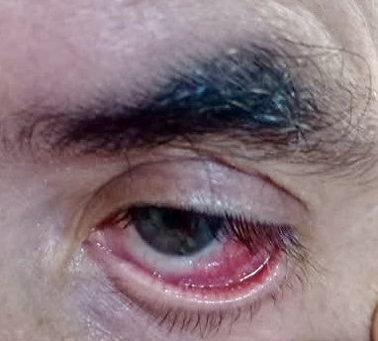

**Figure 1:** scleritis.

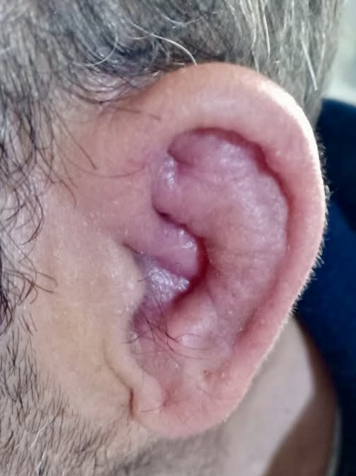

**Figure 2 :** chondritis of the auricle.

Based on McAdam’s criteria : auricular chondritis, nasal chondritis, ocular inflammation, and polyarthralgia, the diagnosis of RP was established (1). The patient was started on oral prednisone at 1 mg/kg/day. At 4-week follow-up, he showed marked clinical improvement with resolution of auricular and ocular symptoms. A steroid-sparing agent (methotrexate) was considered for maintenance therapy (4).

## Discussion:

Relapsing polychondritis is a multisystem disease with an unpredictable relapsing-remitting or chronic progressive course. Its diagnosis relies heavily on clinical criteria as histopathological confirmation is rarely feasible and serologic markers are non-specific. The McAdam criteria, proposed in 1976, and later modified by Damiani and Levine, remain the cornerstone for diagnosis. At least three of the following six features are required: bilateral auricular chondritis, seronegative inflammatory arthritis, nasal chondritis, ocular inflammation (e.g., scleritis, episcleritis), respiratory tract chondritis, and cochleo-vestibular dysfunction (1,5).  
  
Cartilage-sparing of the lobule is a distinguishing clinical sign that helps differentiate RP from other causes of auriculitis. In our patient, the absence of tracheobronchial involvement was reassuring, given that airway involvement can lead to significant morbidity and mortality. Cardiac complications such as aortitis or valvular disease, and neurological involvement, though rare, are well-documented and warrant vigilance (6).  
  
Treatment is guided by the severity and organ involvement. Corticosteroids are the first-line therapy. In steroid-refractory or dependent cases, immunosuppressants such as methotrexate, azathioprine, or mycophenolate mofetil are commonly used. Cyclophosphamide is reserved for life-threatening manifestations such as airway collapse or aortitis (4). Biologic agents targeting TNF-α, IL-6 (tocilizumab), or IL-1 (anakinra) have been used with success in selected refractory cases, though evidence is limited to case reports and small series (7,8).  
  
Early recognition and intervention are essential to prevent irreversible cartilage damage, particularly in the airways and eyes, and to maintain quality of life. Multidisciplinary care is often required.

## Conclusion :

This case highlights the classic presentation of relapsing polychondritis involving bilateral auricular chondritis with sparing of the lobules, nasal discomfort, scleritis, and elevated inflammatory markers. The diagnosis remains clinical, supported by exclusion of mimicking diseases. Prompt initiation of corticosteroids can result in significant clinical improvement. Long-term management may require immunosuppressive therapy tailored to organ involvement and disease severity.

**CONSENT :**

As per international standards or university standards, patient(s) written consent has been collected and preserved by the author(s).

**ETHICAL APPROVAL :**

Ethical approval was exempted by the Ethical Committee at Ibn Roch university hospital for reporting this case.

**COMPETING INTERESTS :**

Authors have declared that no competing interests exist.

## References

1. McAdam LP, et al. Relapsing polychondritis: a clinical review. Medicine (Baltimore). 1976;55(3):193–215.  
2. Damiani JM, Levine HL. Relapsing polychondritis—report of ten cases. Laryngoscope. 1979;89(6 Pt 1):929–46.  
3. Michet CJ, et al. Relapsing polychondritis: survival and predictive role of early disease manifestations. Ann Intern Med. 1986;104(1):74–8.  
4. Kent PD, et al. Relapsing polychondritis. Curr Opin Rheumatol. 2004;16(1):56–61.  
5. Dion J, et al. Relapsing polychondritis: an update on clinical features, diagnostic tools, treatment, and biological drug use. Autoimmun Rev. 2016;15(5):407–13.  
6. Borgia F, et al. Cardiac involvement in relapsing polychondritis: a case report and review. Eur J Intern Med. 2004;15(3):183–6.  
7. Yamashita H, et al. Tocilizumab for relapsing polychondritis: efficacy in patients with refractory disease. Rheumatol Int. 2012;32(10):3289–95.  
8. Ferrada MA, et al. Treatment of relapsing polychondritis with biologic agents: a single-center experience. Clin Rheumatol. 2014;33(8):1095–101.