**Case report**

**A Case Report on a Rare Diagnosis - Kikuchi’s Disease (Kikuchi-Fujimoto Disease)**

**Abstract**

Kikuchi’s disease (Kikuchi-Fujimoto disease) is a rare, self-limiting condition characterized by necrotizing lymphadenitis, typically affecting young women, although it can also present in men. We present a case of a 27-year-old male who presented with a 20-day history of fever, nausea, generalized body aches, and significant weight loss.

All basic investigations were initially inconclusive. On further workup, CT scan showed enlarged lymph nodes raising our suspicion. Biopsy was performed, and histopathology showed necrotizing lymphadenitis. Immunohistochemistry confirmed the diagnosis of Kikuchi’s disease. The patient was treated and eventually discharged in stable condition. This case highlights the importance of considering Kikuchi’s disease in the differential diagnosis of young adults with fever, lymphadenopathy, and weight loss. Timely diagnosis through histopathological and immunohistochemical examination is crucial to avoid unnecessary interventions and ensure appropriate management.

**Introduction**

Kikuchi’s disease, also known as Kikuchi-Fujimoto disease, is a rare, benign, and self-limiting condition characterized by necrotizing lymphadenitis, often involving the cervical lymph nodes. Although the disease primarily affects young women, it can also occur in men, as demonstrated in this case. The etiology of Kikuchi’s disease remains unclear, but it is believed to be associated with viral infections, particularly Epstein-Barr virus (EBV), human herpesvirus 6 (HHV-6), and others. The clinical presentation typically includes fever, tender lymphadenopathy, weight loss, and malaise, which can sometimes be mistaken for more serious conditions, such as lymphoma or tuberculosis. Diagnosis is based on a combination of clinical features, imaging studies, and histopathological examination of affected lymph nodes. Given its similarity to more aggressive lymphatic disorders, Kikuchi’s disease poses a diagnostic challenge, particularly in young patients presenting with systemic symptoms like fever, body aches, and generalized weakness. In this case report, we describe a 27-year-old male who presented with a prolonged febrile illness, lymphadenopathy, and significant weight loss, ultimately diagnosed with Kikuchi’s disease after a thorough investigation.

**Case report**

The patient presented with a 20-day history of fever associated with chills, nausea, generalized body aches, and progressive weakness. Additionally, he reported unintentional weight loss of 5-6 kg over the past month. There was no significant history of comorbidities, travel, exposure to known infections, or prior illnesses.

On physical examination, the patient appeared febrile with signs of malaise and generalized weakness. No other significant findings were noted during the initial examination.

The patient was admitted to the hospital for further evaluation and management. Empirical treatment was initiated, including broad-spectrum antibiotics as well as supportive care such as hydration and symptomatic management.

In blood investigations, patient had persistent neutropenia, absolute neutrophil count – 1221 (mild neutropenia) and liver enzymes were mildly deranged. Tropical workup was done, found to be Negative . TB Gold was negative

CMV IgG – positive , IgM - negative

Blood and urine cultures were negative.

Abdominal ultrasound was suggestive of bilateral mild hydronephrosis, raising suspicion for pyelonephritis. A CT-KUB was scheduled.

In Imaging:

* Non-contrast CT KUB: Multiple sub-centimetric lymph nodes in the aortocaval, preaortic, and left paraaortic regions were noted. Additionally, enlarged bilateral inguinal lymph nodes were present.
* High-Resolution CT (HRCT) Chest: Small mediastinal lymph nodes, bilateral axillary lymph nodes, and retroperitoneal lymph nodes suggested systemic lymphadenopathy.

Despite initial antibiotic treatment, the patient’s symptoms evolved. He developed persistent fever, headache, generalized weakness, and facial numbness, which led to a transfer to the High Dependency Unit (HDU) for closer monitoring and management. Due to persistent leucopenia, a hematology consultation was sought, and a bone marrow biopsy was planned to rule out hematological malignancies or disorders. In parallel, steroid therapy was initiated to reduce inflammation and manage the patient’s symptoms.

Given the persistent fever, generalized weakness, and widespread lymphadenopathy, a lymph node biopsy was recommended for further investigation. Histopathology (HPE) was performed on a formalin-fixed lymph node specimen. In addition, tests such as AFB culture, GeneXpert, and saline microscopy were conducted to rule out tuberculosis and other infections.

The lymph node biopsy revealed necrotizing lymphadenitis. The histopathological findings were suggestive of Hodgkin’s lymphoma, prompting further investigation with immunohistochemistry (IHC). The IHC results were consistent with Kikuchi’s Necrotizing Lymphadenopathy, ultimately confirming the diagnosis of Kikuchi’s disease (Kikuchi-Fujimoto disease).

Following the diagnosis of Kikuchi’s disease, the patient was continued on steroids. Patient’s leucopenia began to improve. He became afebrile, with gradual signs of recovery, including a reduction in weakness and normalization of vital signs. The patient was subsequently transferred back to the general ward, where his condition continued to improve. He was discharged in stable condition with scheduled follow-up visits to monitor his recovery.

**Discussion**

Kikuchi’s disease (Kikuchi-Fujimoto disease) is a rare, self-limiting condition characterized by **necrotizing lymphadenitis**. First described by Kikuchi and Fujimoto in 1972, the disease primarily affects young adults, particularly women, although cases in men, such as the one reported here, have also been documented. The exact etiology remains unclear, but **viral infections** (e.g., **Epstein-Barr virus (EBV)**, **human herpesvirus 6 (HHV-6)**, and **enterovirus**) have been implicated as possible triggers. Studies have shown that autoimmune mechanisms may also play a role, with **systemic lupus erythematosus (SLE)** and other autoimmune conditions occasionally coexisting with Kikuchi’s disease. (1,2,3,4)

Diagnostic Challenge : Kikuchi’s disease typically presents with fever, tender lymphadenopathy (most often cervical), weight loss, and malaise. These symptoms can mimic more serious conditions, such as **lymphoma** or **tuberculosis**, which can delay diagnosis. Our patient, a 27-year-old male, presented with fever, generalized weakness, body aches, and significant weight loss over the span of 20 days. This constellation of symptoms was initially suggestive of an infectious or systemic inflammatory condition, leading to empirical antibiotic therapy. Such presentation is consistent with earlier case reports by **Magnani G et al.** (5), where patients also presented with fever and generalized symptoms, making it difficult to distinguish it from other febrile illnesses.

In a cases published by **Deb A et al., Hoan et al., Sudhakar et al., Mohamad AA et al**. (6,7,8,9), the authors noted that patients often present with **cervical lymphadenopathy** and fever, but there can be involvement of peripheral lymph nodes as seen in our patient. **Imaging studies**, such as **CT** and **ultrasound**, were useful in localizing enlarged lymph nodes, but these findings alone are not diagnostic. **HRCT chest** and **CT KUB** in our case revealed multiple enlarged lymph nodes in the aortocaval, retroperitoneal, and axillary regions, consistent with previously published literature that described systemic lymphadenopathy as a hallmark feature of Kikuchi’s disease (2).

The gold standard for diagnosing Kikuchi’s disease is **histopathological examination** of affected lymph nodes. The hallmark of Kikuchi's disease is **necrotizing lymphadenitis** with a mixed inflammatory infiltrate consisting primarily of **T-lymphocytes**, histiocytes, and plasma cells, with no granulomas or caseous necrosis (10). In our case, the **lymph node biopsy** revealed **necrotizing lymphadenitis**, and **immunohistochemistry (IHC)** confirmed the diagnosis of Kikuchi’s disease, which is consistent with the findings in the literature. As **Kikuchi’s disease** can mimic **Hodgkin’s lymphoma** or **non-Hodgkin lymphoma**, IHC staining plays a crucial role in differentiating these conditions (11). The utility of IHC markers, particularly the identification of **HLA-DR** positive cells and **CD68+ histiocytes**, in diagnosing Kikuchi’s disease has been proven in various studies. (12, 13)

The treatment of Kikuchi’s disease is predominantly supportive, as the disease is usually self-limiting. However, in some patients, especially those with severe or prolonged symptoms, **steroid therapy** may be indicated. Steroids help reduce inflammation and can be beneficial in patients with **neurological symptoms** or other complications, although their use remains controversial due to the generally benign nature of the disease. **Steroid therapy** was started in our patient after prolonged fever and persistent **leucopenia**, which led to an improvement in symptoms. This approach is supported by findings in a study by **Yalcin et al.** and **Semavi et al.** who reported that steroid treatment was effective in alleviating symptoms in few cases, especially when there was severe systemic involvement.(14, 15)

Kikuchi’s disease generally has a favorable prognosis, with most patients recovering within 1 to 6 months. **Relapses** are rare but have been reported in the literature (16). The patient in our case showed significant improvement in both **leucopenia** and systemic symptoms after starting steroid therapy and was ultimately discharged in stable condition. **Close monitoring** is essential to detect any potential complications or relapses, and follow-up care is recommended to ensure complete resolution of symptoms. **Relapse** of Kikuchi’s disease is often seen in patients with associated autoimmune disorders, such as **SLE**, but our patient had no known comorbidities, and recovery was uneventful.

Kikuchi’s disease shares clinical and histological features with other common conditions, including **systemic lupus erythematosus (SLE)**, **tuberculosis**, and **lymphoma.** Therefore, it is important to distinguish Kikuchi’s disease from these other conditions through a combination of clinical evaluation, imaging studies, and **histopathological** and **immunohistochemical** findings. While Kikuchi’s disease can present with similar clinical features to **Hodgkin’s lymphoma**, the absence of **Reed-Sternberg cells** in the biopsy specimen and the specific IHC pattern in Kikuchi’s disease are key differentiators.(17)

**Conclusion**

Kikuchi’s disease remains a challenging diagnosis, particularly in young adults presenting with fever, generalized weakness, weight loss, and lymphadenopathy. A high index of suspicion is essential, and diagnosis is confirmed through **histopathological examination** and **immunohistochemical** analysis of affected lymph nodes. As demonstrated in this case, timely diagnosis and supportive management, including the use of steroids in selected cases, can lead to a favourable outcome. Given the nonspecific nature of the symptoms and the overlap with other more serious conditions, Kikuchi’s disease should be included in the differential diagnosis of patients with lymphadenopathy and fever. Future research into the pathophysiology and optimal management of this condition will help refine therapeutic approaches and improve patient outcomes.

**References:**

1. Fujimoto Y. Cervical subacute necrotizing lymphadenitis. Naika. 1972;30:920-7.
2. Masab M, Surmachevska N, Farooq H. Kikuchi-Fujimoto Disease. [Updated 2023 Oct 29]. In: StatPearls [Internet]. Treasure Island (FL): StatPearls Publishing; 2025 Jan-Available from: https://www.ncbi.nlm.nih.gov/books/NBK430830/
3. Lencastre Monteiro R, Cabaço S, Soares L, Inácio H, Nazário Leão R. Kikuchi-Fujimoto Disease: A Case of SARS-CoV-2 Infection Triggering the Rare Disease. Cureus. 2023 Mar;15(3):e35858. [[PMC free article](https://www.ncbi.nlm.nih.gov/pmc/articles/PMC10077921/)] [[PubMed](https://pubmed.ncbi.nlm.nih.gov/37033518)] [[Reference list](https://www.ncbi.nlm.nih.gov/books/NBK430830/#article-23893.r9)]
4. Viallard JF, Parrens M, Lazaro E, Caubet O, Pellegrin JL. Lymphadénite histiocytaire nécrosante ou maladie de Kikuchi-Fujimoto [Subacute necrotizing lymphadenitis or Kikuchi-Fujimoto disease]. Presse Med. 2007 Nov;36(11 Pt 2):1683-93. French. doi: 10.1016/j.lpm.2007.06.004. Epub 2007 Jul 3. PMID: 17611068.
5. Magnani G, Cocca G, Mezzadri S, Pilato FP. Kikuchi's disease: an uncommon cause of fever of unknown origin. Ann Ital Med Int. 1999 Jul-Sep;14(3):205-8. PMID: 10566188.
6. Deb A, Fernandez V, Kilinc E, Bahmad HF, Camps NS, Sriganeshan V, Medina AM. Kikuchi-Fujimoto Disease: A Case Series and Review of the Literature. Diseases. 2024 Nov 1;12(11):271. doi: 10.3390/diseases12110271. PMID: 39589945; PMCID: PMC11592699.
7. Hoan, L., Hang, L. M., Linh, L. T., My, T. T. T., Minh, T. N., Thinh, D. D., & Cuong, N. N. (2021). A rare case of Kikuchi-Fujimoto disease in a young female patient. *American Journal of Case Reports*, *22*. <https://doi.org/10.12659/ajcr.933377>
8. Sudhakar M K, Sathyamurthy P, Indhumathi E, Rajendran A, Vivek B. Kikuchi's disease: A case report from south India. International Journal of Case Reports and Images 2011;2(2):15-18
9. Mohamad AA, Zahid M, Khan AA, Alani B, Khalil M, Saeed A, Elzouki AN. Kikuchi-Fujimoto disease: review of 11 cases diagnosed over 10 years at a tertiary care hospital in Doha, Qatar.*EJCRIM* 2020;**7** doi:10.12890/2020_001598.
10. Kikuchi M. Lymphadenitis showing focal hyperplasia with nuclear debris and phagocytes: a clinicopathological study. Acta Haematol Jpn. 1972;35:379.
11. Kristiani, E., Natalia, S., Ritonga, E. V. F., Djokomuljanto, S., & Kan, E. F. (2021). Kikuchi-Fujimoto Disease in pediatrics. *Journal of Pediatric Surgery Case Reports*, *73*, 101989. <https://doi.org/10.1016/j.epsc.2021.101989>
12. Hassan M, Anees A, Zaheer S. Kikuchi-fujimoto disease: diagnostic dilemma and the role of immunohistochemistry. J Clin Med Res. 2009 Oct;1(4):244-6. doi: 10.4021/jocmr2009.09.1258. Epub 2009 Oct 16. PMID: 22461878; PMCID: PMC3299190.
13. Sumiyoshi, Y., Kikuchi, M., Takeshita, M., Ohshima, K., Masuda, Y., & Parwaresch, M. R. (1993). Immunohistologic studies of Kikuchi’s disease. *Human Pathology*, *24*(10), 1114–1119. <https://doi.org/10.1016/0046-8177(93)90192-j>
14. Yalcin, S., Toprak, S. K., Erismis, B., Altundag, O., Ozdemir, H., & Topcuoglu, N. (2011). Management of Kikuchi-Fujimoto Disease using glucocorticoid: a case report. *Case Reports in Medicine*, *2011*, 1–3. <https://doi.org/10.1155/2011/230840>
15. Semavi̇, D. G., & Ulaş, T. (2022). Highlighting steroid indications for Kikuchi Fujimoto disease: a case report. *ÇUkurova Medical Journal (Online)/ÇUkurova Medical Journal*, *47*(4), 1753–1755. https://doi.org/10.17826/cumj.1176368
16. Faria C, Fernandes M, Cunha R, Moreira H, Costa R. Kikuchi-Fujimoto Disease: Diagnosis in a Relapsing Case. Cureus. 2021 Nov 13;13(11):e19542. doi: 10.7759/cureus.19542. PMID: 34934560; PMCID: PMC8668199.
17. Dumas G, Prendki V, Haroche J, Amoura Z, Cacoub P, Galicier L, Meyer O, Rapp C, Deligny C, Godeau B, Aslangul E, Lambotte O, Papo T, Pouchot J, Hamidou M, Bachmeyer C, Hachulla E, Carmoi T, Dhote R, Gerin M, Mekinian A, Stirnemann J, Charlotte F, Farge D, Molina T, Fain O. Kikuchi-Fujimoto disease: retrospective study of 91 cases and review of the literature. Medicine (Baltimore). 2014 Nov;93(24):372-382. doi: 10.1097/MD.0000000000000220. Erratum in: Medicine (Baltimore). 2014 Nov;93(24):414. PMID: 25500707; PMCID: PMC4602439.

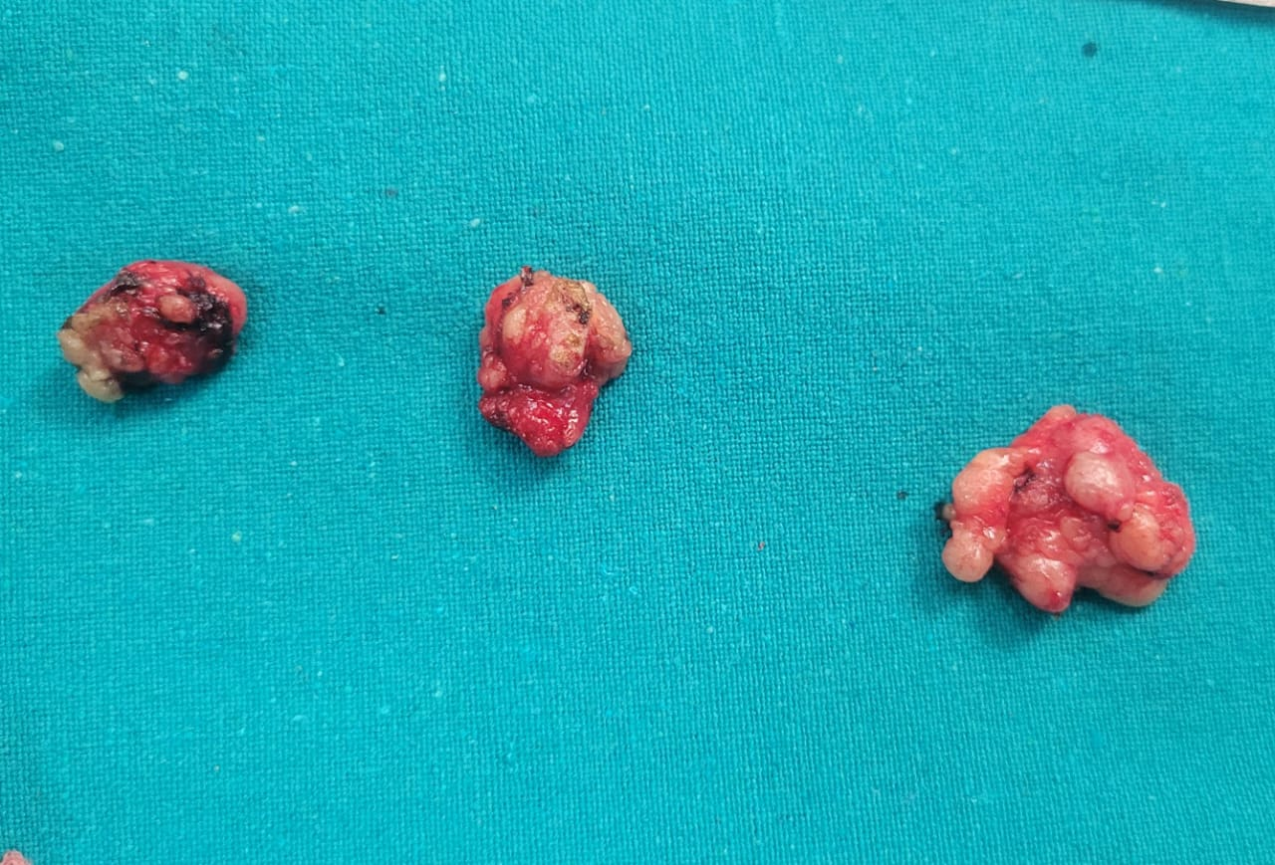

Fig. 1. Lymph node kikuchi disease

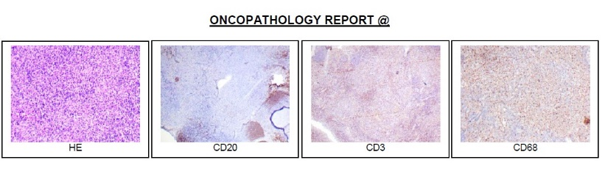

Fig. 2. Oncopathology report

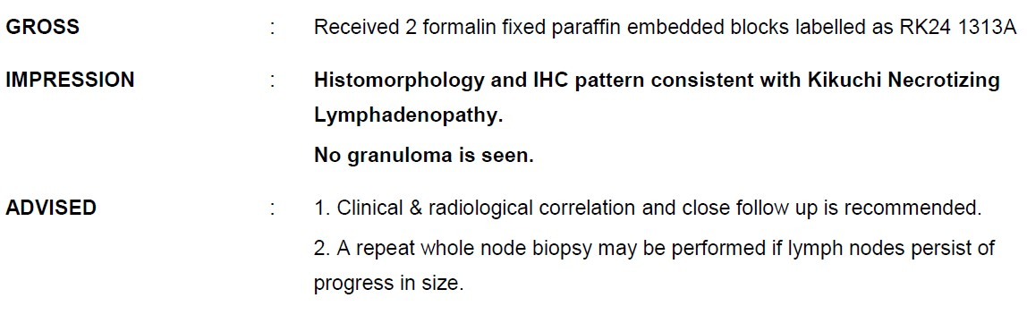

Fig. 3. Oncopathology report 2