**Original Research Article**

**Structural Performance of Reused GFRP bars in Reinforced Concrete Beams: A Sustainable Approach to Concrete Reinforcement**

**ABSTRACT**

Construction demolition waste is a growing environmental concern in developing countries like Ghana due to rapid urban expansion. Glass Fiber Reinforced Polymer (GFRP) bars, known for their high tensile strength, full linear -elastic response, corrosion resistance, non-conductive and lightweight nature, offer a sustainable alternative to steel reinforcement. However, their disposal remains challenging due to their non-biodegradable nature. Reusing and recycling GFRP bars present a viable solution, minimizing waste and reducing the construction sector’s carbon footprint. This research focused on reused GFRP bars recovered from previously tested beams that failed due to concrete crushing, based on concrete controlled sections, while leaving the GFRP bars intact. The mechanical properties of the reused GFRP were evaluated to provide holistic data for this study. Five beam specimens were prepared using the reused GFRP bars with varying tensile reinforcement ratios (1.21%, 1.5%, 1.45%, 2.26%, 2.26%), concrete compressive strengths (23.1 N/mm2, 15.6 N/mm2, 16.90 N/mm2, 16.02 N/mm2, 22.86 N/mm2) and tested under four-point monotonic loading to evaluate their structural performance. Key parameters examined included ultimate flexural strength, deflection, cracking mode and failure mode. Experimental findings revealed that the reused GFRP bars retained their mechanical properties upon reusage. All reused GFRP-reinforced concrete beams exhibited linear-elastic behavior up to failure, with average experimental failure loads exceeding theoretical predictions by a factor of 1.47. The beams demonstrated significant deformability prior to failure and returned to their original position post-failure, indicating zero residual deformation. Failure modes included diagonal tension failure and concrete crushing were predicted by theoretical analysis. Increasing the concrete compressive strength and tensile reinforcement ratio of reused GFRP bars improved structural behavior under bending loads, attributed to the high tensile capacity, improved stiffness, and bonding properties of the bars, similar to the findings observed in the virgin GFRP RC beams in its maiden form. These results highlight the superior durability and reusability of GFRP bars in enhancing sustainability of reinforced concrete structures, aligning with global initiatives for reducing waste and promoting eco-friendly construction practices.

**Keywords:**  
Reused GFRP bar, RC Beams, Compressive strength, Tensile strength, Monotonic Loading

1. **INTRODUCTION**

Structural materials play a crucial role throughout their life cycle, supporting the development of resilient and sustainable infrastructure in developing countries like Ghana. As urbanization increases, the demand for innovative materials that enhance performance while minimizing environmental impact has grown. In this context, composite materials like Glass Fiber Reinforced Polymer (GFRP) bars have emerged as a promising alternative to traditional steel reinforcing bars in reinforced concrete (RC) structures. GFRP bars, known for their high strength-to-weight ratio, corrosion resistance, and durability, are particularly valuable in environments prone to moisture and chemical exposure. Additionally, their lightweight properties reduce transportation and installation costs, while their non-conductive nature makes it ideal for electromagnetic-sensitive areas [1].

GFRP composites are primarily composed of glass fibers embedded within a matrix of polyester, vinyl ester, or epoxy resins. The fibers primarily provide strength and stiffness, while the resin's role is to bind the fibers together, transfer forces between them, and protect them [2]. Fibre-reinforced polymer (FRP) composites are now being used across a broader range of industries than ever before, including transportation, aerospace, and construction sectors. The use of FRP composites in civil engineering spans a broad spectrum of applications, from strengthening, retrofitting, and repairing existing structures to incorporating GFRP composites as reinforcement in new projects, either partially or fully, similar to concrete-GFRP structures [3, 4]. American Concrete Institute (ACI) committee 440 (2015) outlines the guide for the design and construction of concrete reinforced with FRP bars which underscores their alignment with global initiatives for sustainable construction and long-term infrastructure reliability [5].

The mechanical properties of GFRP bars offer several advantages over steel bars [6, 7]. Boateng et al. [8] evaluated the mechanical properties of GFRP bars of various diameters. Findings revealed that GFRP bars typically exhibit a full linear-elastic tensile stress-strain response without a distinct yielding point up to failure, resulting in reduced elongation capacity and failure strain. This failure is characterized as brittle behavior, which happens abruptly and with little warning, due to the reduced Young’s modulus of elasticity compared to steel bars. The authors further recorded that this unique behavior of the GFRP bar makes it anisotropic and heterogeneous. These findings further confirm prior research [9, 10]. Issa et al. [11] reported that GFRP reinforcing bars possess a comparatively low modulus of elasticity, ductility, and stiffness compared to conventional steel. This reduced stiffness, along with factors such as distinct bond behavior and lower tension stiffening, leads to greater deflections in GFRP-reinforced members than those observed in steel-reinforced members under any load stage. Ohene-Coffie et al. [12] in another research examined the anchorage bond strength of GFRP reinforcing bars in normal weight and lightweight concrete. Using 48 double pull-out prismatic specimens with varying embedment lengths and GFRP bar diameters, the research recorded average bond strengths of 4.684 N/mm² and 3.558 N/mm² for 12mm and 16mm bars at a 100 mm embedment length, with a maximum strength of 6.174 N/mm² at 300 mm embedment [12].

Experimental studies have validated the ability of GFRP-reinforced beams to achieve improved flexural strength [13-15] and shear capacity [16, 17] under varying loading conditions. Kpo et al. [18] investigated the strength and deformation characteristics of concrete beams reinforced with virgin GFRP bars through experimental testing and theoretical validation. The results indicated that the GFRP-reinforced concrete beams exhibited linear elastic load-deflection responses with reduced stiffness after first cracking, which resulted in significant initial deflections. The authors reported that increasing the concrete compressive strength from 23.4 N/mm² to 30.4 N/mm² in GFRP-reinforced beam specimens resulted in a 28.6% increase in ultimate failure load, while raising the GFRP longitudinal tensile reinforcement ratio from 0.7% to 1.13% notably improved the beams’ ultimate flexural capacity. Kpo et al. [18] also found that in stark contrast to steel RC beams, GFRP RC beams experienced sudden brittle failure by concrete crushing at higher ultimate loads and final deflections due to their non-yielding, relatively higher tensile strength and reduced modulus of elasticity. Furthermore, Johnson [19] examined the suitability of GFRP as reinforcement for concrete structures. The research findings revealed that GFRP stirrups achieved stress levels surpassing the minimum design requirements. This enhancement in stirrup strength contributed to overall beam capacity that exceeded the predicted values based on design code provisions. Studies conducted by Mohammed et al. [20] yielded encouraging results regarding the use of GFRP bars in concrete structures. The findings demonstrated higher failure loads and greater deflections compared to traditional steel reinforcement, especially in beams made of lower-strength concrete.

GFRP-reinforced elements are typically over-reinforced, meaning the proportion of GFRP bars to concrete exceeds the balanced ratio due to its high tensile strength and elastic behavior. As a result, the design is based on concrete controlled section and failure mode is governed by concrete crushing in the structural member [21, 22]. Due to this, the GFRP bar in the failed member may remain intact and be recovered for reuse. There is therefore the need to investigate the structural performance of beams reinforced with this reused GFRP bars recycled from failed structural members.

**Sustainability and Recycling of GFRP bars**

The production of virgin GFRP bars poses minimal environmental challenges due to energy-intensive manufacturing and the disposal of waste in comparison to steel bars. The environmental and economic implications of disposing of GFRP waste in landfills highlights the increasing demand for sustainable construction practices, including recycling and reusing materials to reduce waste and carbon footprints [23, 24]. United Nations (UN) has established 17 Sustainable Development Goals (SDGs), with Goal 11 focusing on creating sustainable cities and human settlements. Promoting sustainable practices within the construction industry is a key aspect of this goal. Efforts such as recycling and repurposing waste materials in building projects play a crucial role in supporting this objective and contribute toward achieving the 2030 targets outlined in the agenda [25]. Recycling glass fiber reinforcement from concrete beams is crucial for promoting sustainability in the construction industry, reducing waste, conserving resources, improving the economic viability and enhancing structural material performance [26].

While existing research has largely focused on GFRP bars as an innovative alternative to steel reinforcing bars, there remains a significant gap in understanding the structural performance, superior durability, and reusability of GFRP reinforcing bars. By promoting the use of reused GFRP in reinforced concrete structures, this research aligns with global efforts to reduce construction waste and advance eco-friendly, resilient infrastructure.

1. **EXPERIMENTAL PROGRAM**

**2.1 Materials**

The experiment utilized locally sourced materials, including fine aggregate (natural pit sand, max particle size 4.75 mm), coarse aggregate (crushed granite, max size 12.5 mm), ordinary Portland cement, 12 mm nominal size ribbed and sand-coated reused GFRP reinforcing bars, 8 mm steel stirrups aimed at hybrid reinforcement, and potable water. Three concrete mix designs 1: 1.5: 3, 1: 2: 3, and 1:2:4 (cement: fine aggregate: coarse aggregate) by weight were used in casting the beams following the guidelines of IS: 10262 [27].

**2.2 Preparation of Control Specimens**

Concrete cubes (150 x 150 x 150 mm) were cast in accordance with BS EN 12390-3 [28], as well as concrete cylinders (150 mm x 300 mm) specified by BS EN 12390-6 [29] were cast as control for compressive strength and tensile strength respectively.

**2.3 Preparation of Reused GFRP Bars**

The use of recycled GFRP bars conformed to ACI 440.1R-06 [5]. The virgin GFRP bars were initially tested in beams, and the beams failed due to concrete crushing as reported by Kpo et al. [18]. However, the GFRP bars remained intact due to their high tensile strength and full elastic behavior [8]. The recycling process involved the meticulous breaking of the concrete off the tested beams, leaving the GFRP reinforcing bars intact to ensure their effective reuse. The extracted GFRP reinforcing bars were thoroughly cleaned and inspected to evaluate their condition and suitability for reuse. The recycled bars were found to be in excellent condition, making them suitable for reintegration into this experimental study. Reinforcement percentages of 1.21%, 1.5%, 1.45%, 2.26%, 2.26% reused GFRP bars were adopted for Beams 1, 2, 3, 4, 5 respectively. Similarly, a constant shear reinforcement of 8 mm steel stirrups spaced at 200 mm was used. These reinforcement details are depicted in Fig. 1.

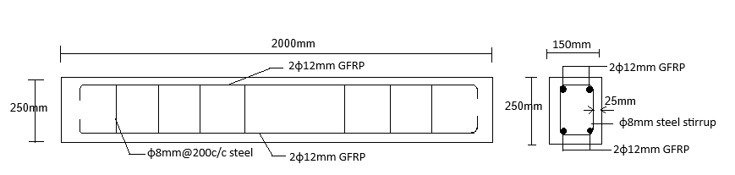

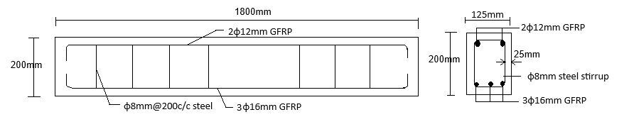

**Fig. 1. Reinforcement details**

**2.4 Preparation of Reinforced Concrete Beams**

A total of five beams, of various dimensions (see Table 1), were fabricated using recycled GRFP longitudinal reinforcement bars for the testing procedure (Table 2). Tables 3 presents the mechanical properties of the reinforcing bars. The fresh concrete was placed into wooden formworks in layers and compacted with a poker vibrator to eliminate air pockets. After pouring the concrete, the beam and control specimens were left to set for 24 hours, then demolded and cured under wet hessian sacks for 28 days. Following curing, the beams were cleaned and left to dry for approximately one hour.

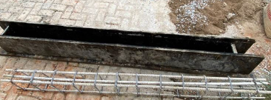

**Fig. 2 Reused GFRP bar cage and wooden formwork**

**2.5 Test Procedures**

**2.5.1 Concrete compressive strength test**

After removing the cubes (150 x 150 x 150 mm) from the wet sack and wiping them clean, their actual dimensions and weight were recorded. Each test cube was positioned in the compression machine so that the load was gradually and centrally applied to opposing sides until failure occurred, at which point the maximum load was noted. The compressive strength was calculated as the ratio of the maximum load to the cross-sectional area of the cube. The average compressive strength of the cured concrete cubes was tested at 7, 14, and 28 days using a Universal Testing Machine (UTM).

**2.5.2 Concrete Splitting tensile test**

The test specimens (150 mm x 300 mm) stored under wet sacks were tested immediately after removal, while still in a wet state. The actual dimensions of each cylinder were measured. Each plain concrete cylinder was tested in the UTM along its length until failure.

**2.5.3 Tensile test of reused GFRP bars**

The tensile strength test of the reused GFRP reinforcing bars was conducted in accordance with ASTM D7205 [30]. This was tested in a similar procedure as was carried out by Boateng et al. [8] on the virgin GFRP before its initial testing in RC beams by Kpo et al. [18]. The test specimens with diameters of 12 mm were prepared by securing each end with a 25 mm steel pipe featuring an inner diameter of 22 mm. The reused GFRP bars were inserted 150 mm into the steel pipes on both ends, leaving a free length of 300 mm. To fill the gap between the steel pipe and the reused GFRP bar, an epoxy mixture (Bisphenol A) with high-strength, non-shrink, and expanding additive properties was applied. The specimens were sealed and allowed to cure for 24 hours, followed by an additional three days for hardening. The tensile testing was conducted using a 1000 kN ELE Universal Testing Machine equipped with a 50 mm gauge length extensometer (Fig. 3). A constant tension rate of 3 mm per minute was applied until the specimens failed. Tensile strength, Young's modulus, failure strain, and stress-strain curves were recorded automatically during the test. The reinforcing steel bars also underwent tensile testing. The results for both reused and virgin GFRP are presented in Tables 3.

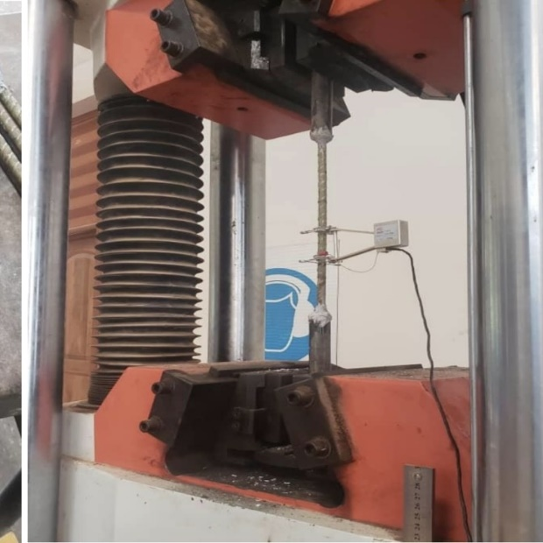

**Fig. 3. Testing of tensile strength of reused GFRP bar**

**2.5.4 Testing of reinforced concrete beams**

The cured reinforced concrete beams, at 28 days of maturity, were cleaned to facilitate crack detection. They were painted with white emulsion paint to enhance visibility and left to dry. The beams were mounted on a rigid steel loading frame equipped with two supports positioned 100 mm from each beam end. A 200 kN capacity hydraulic jack actuator of 2 kN intervals with an attached load cell was used to apply the load incrementally through a rigid steel spreader beam. This spreader beam distributed the load symmetrically to the specimen at two points, 400 mm apart, and located 600 mm or 700 mm from the nearest support. The testing setup included a digital dial gauge mounted beneath the beam center to measure deflection, along with permanent markers, a measuring rule, a magnifying glass, and thread. Cracks were monitored intermittently using the magnifying glass during incremental loading. Recorded parameters included deflection, initial crack load, total cracks, crack spacing, maximum crack width, crack length, and final failure load. At failure, crack propagation details—width, spacing, and types—were analyzed to evaluate beam performance. The data established the load-deflection relationship and provided insights into structural behavior. Fig. 4 shows the beam testing setup.

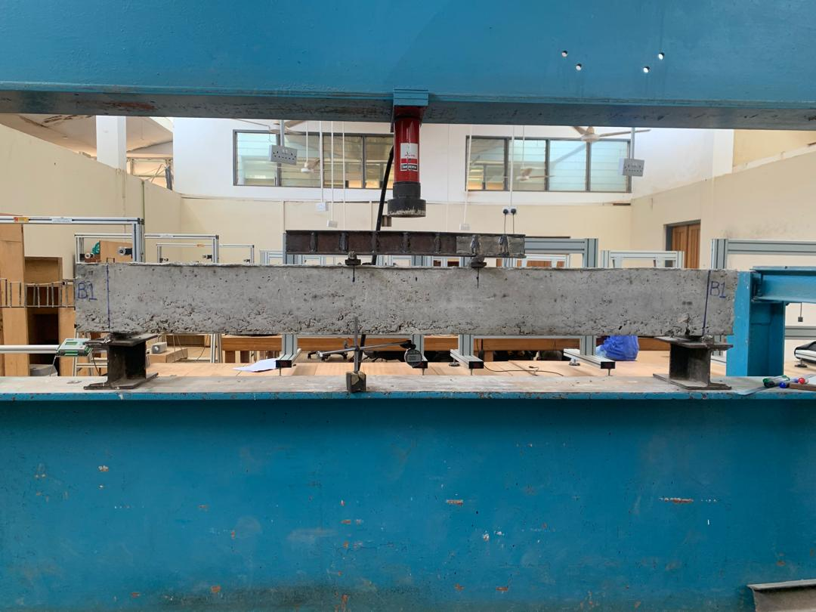  
**Fig. 4. Beam testing set-up**

**Table 1. Details of beams**

|  |  |  |  |  |
| --- | --- | --- | --- | --- |
| **Beam ID** | **Beam Dimensions** | | | **Effective depth (mm)** |
| **Length, L**  **(mm)** | **Width, B**  **(mm)** | **Overall Depth, D**  **(mm)** |
| Beam 1 | 1800 | 150 | 250 | 211 |
| Beam 2 | 2000 | 150 | 200 | 211 |
| Beam 3 | 2000 | 125 | 250 | 211 |
| Beam 4 | 1800 | 100 | 200 | 211 |
| Beam 5 | 1800 | 100 | 200 | 211 |

**Table 2. Properties of beam**

|  |  |  |  |  |  |  |
| --- | --- | --- | --- | --- | --- | --- |
| **Beam ID** | **Concrete** | | **Reused GFRP Bar Reinforcement** | | **Steel stirrup size and spacing** | |
|  | **Compressive strength (N/mm2)** | **Tensile strength (N/mm2)** | **Bar Diameter (mm)** | **% Reinforcement ratio** | **Bar size (mm)** | **Bar spacing (mm)** |
| Beam 1 | 23.1 | 2.23 | 12 | 1.21 | 8 | 200 |
| Beam 2 | 15.6 | 1.89 | 12 | 1.5 | 8 | 200 |
| Beam 3 | 16.90 | 1.73 | 12 | 1.45 | 8 | 200 |
| Beam 4 | 16.02 | 1.84 | 12 | 2.26 | 8 | 200 |
| Beam 5 | 22.86 | 2.03 | 12 | 2.26 | 8 | 200 |

1. **RESULTS AND DISCUSSIONS**

**3.1 Mechanical properties of reinforcement bars**

Summarized in Table 3 are the mechanical properties of the reused GFRP bar used in this study as compared with the original virgin GFRP bar [8] used as the longitudinal tension and compression reinforcement. The 10 mm, 12 mm, and 16 mm diameter reused GFRP bars developed ultimate tensile strengths of 1056.2 N/mm², 799.5 N/mm², and 713.8 N/mm² respectively by slippage failure mode (delamination of fiber) compared to the virgin GFRP bars that developed 920 N/mm², 829 N/mm², and 573 N/mm² ultimate tensile strength respectively by slippage failure mode. The slight difference in the tensile strength was due to the heterogenous nature of GFRP bars as the tests involved the different test bar specimens in spite of being taken from the same supplied stock [8]. Additionally, the modulus of elasticity and ultimate elongation for the reused and virgin GFRP bars developed similar values as presented in Table 3. The test results revealed that the smallest bar size, 10 mm, exhibited the highest tensile strength and Young’s modulus among all bar sizes. This may be attributed to its more compact molecular or atomic structure, which enhances its resistance to deformation or failure under load. The strength and stiffness of GFRP bars appear to increase with decreasing bar size, likely due to stronger intermolecular or interatomic bonding—an observation consistent with the behavior of virgin GFRP bars in their original form [8].

The stress-strain relationship for the 10 mm, 12 mm and 16 mm diameter reused GFRP bars in comparison with the virgin GFRP bars are depicted in Fig. 5. The graph shows that the reused GFRP bars exhibited a typical linear elastic stress-strain response (Fig. 5) without a distinct yield point up to failure, at which point they failed suddenly without prior warning, as was seen in the original GFRP bars. The results indicate that the GFRP bars retained their high tensile strength and mechanical integrity even after their initial use in the tested beams [18], demonstrating their potential for multiple reuses. This can be attributed to the non-yielding, perfect linear-elastic behavior of GFRP bars, which lack a defined plastic deformation stage [8]. Unlike reinforcing steel bar, which undergoes yielding and plastic strain accumulation upon exceeding its yield strength, GFRP bars remain within their elastic limit until failure. In contrast, steel reinforcing bars experience permanent plastic deformation after yielding, leading to strain hardening and eventual failure due to necking and fracture [31]. Once steel bar yields in an initial test, it cannot fully recover its mechanical properties, making it unsuitable for reuse in structural applications. On the other hand, GFRP bar, due to its inherently higher tensile strength, maintains its structural integrity after multiple usage, provided it does not reach its ultimate tensile strength and failure. This key distinction highlights the superior reusability of GFRP reinforcement over conventional steel bars.

**Table 3. Mechanical properties of reused vs virgin GFRP bar**

|  |  |  |  |  |  |  |
| --- | --- | --- | --- | --- | --- | --- |
|  | **Reused GFRP bar** | | | **Virgin GFRP bar [8]** | | |
| Diameter (mm) | 10 | 12 | 16 | 10 | 12 | 16 |
| Failure mode | Slippage | Slippage | Slippage | Slippage | Slippage | Slippage |
| Tensile strength (N/mm2) | 1056.2 | 799.5 | 713.8 | 920 | 829 | 573 |
| Modulus of elasticity (kN/mm2) | 57.1 | 46.52 | 41.10 | 53.51 | 47.57 | 33.10 |
| Ultimate elongation (%) | 1.78 | 1.7 | 1.68 | 1.7 | 1.7 | 1.7 |

**Fig. 5. Stress-strain curves for reused vs virgin GFRP bars**

**Table 4. Deflections and crack modes**

|  |  |  |  |  |  |  |
| --- | --- | --- | --- | --- | --- | --- |
| **Beam ID** | **Final deflection at failure (mm)** | **Average crack width (mm)** | **Average crack spacing (mm)** | **Types and No. of cracks** | | |
| **No. of pure flexural cracks** | **No. of flexural shear cracks** | **No. of diagonal shear cracks** |
| Beam 1 | 25.21 | 1 | 86.51 | 11 | 8 | 8 |
| Beam 2 | 23.59 | 2 | 100.0 | 6 | 6 | 7 |
| Beam 3 | 22.63 | 1 | 71.62 | 8 | 4 | 3 |
| Beam 4 | 16.63 | 1 | 98.56 | 4 | 7 | 6 |
| Beam 5 | 17.99 | 1 | 68.22 | 8 | 8 | 12 |

**3.2 THEORETICAL FLEXURAL ANALYSIS**

**3.2.1 Tensile strength of concrete**

The tensile strength of plain concrete was determined using the split cylinder test results. The split cylinder strength of concrete is calculated using Eqn. 1.

*ft* = ……………... (1)

where;

*ft* = Split cylinder strength (N/mm2).

*P* = Maximum crushing load (N).

*D* = Diameter of cylinder (mm).

*L* = Length of cylinder (mm).

3.2.2 **Cracking moment**

**3.2.2.1 Cracking moment of reinforced concrete beam (Mcr)**

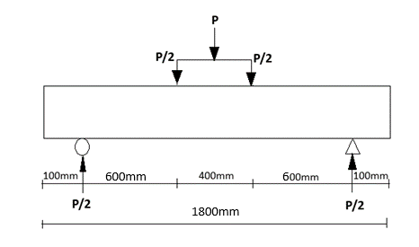

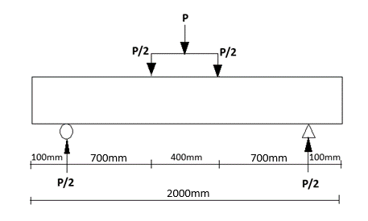

**b)**

**Fig. 6. Schematic diagram of loaded beams a) Beams 2 and 3 b) Beams 1, 4 and 5**

The cracking moment (*Mcr*) for a reinforced concrete beam loaded at two points as shown in Fig. 6, is obtained using the tensile strength (*ft*) in the expression as in Eqn. 2, assuming elastic behavior;

$$M_{cr}=f_{t}\frac{bd^{2}}{6}………………………\left(2\right)$$

where;

*Mcr* is the cracking moment (Nmm).

*ft* is the tensile strength (N/mm2).

*b* = width of beam (mm).

*d* = depth of beam (mm).

**3.2.2.2 Theoretical cracking load of RC beam**

From the 4-point loading system of the RC beam in Fig. 6*.*, the theoretical cracking load of the beam can be expressed as shown in Eqn. 3;

$$P=\frac{2M}{L_{1}}………………………….\left(3\right)$$

where;

*P* = Pcr;

*Pcr* is the theoretical cracking load (kN).

*M* = Mcr is the cracking moment (kNm).

*L*1 is distance from the support to the nearest load point.

Results of the computations for theoretical cracking loads are captured in Table 5.

**3.2.3 Analyses of theoretical failure load**

**3.2.3.1 Theoretical failure load based on GFRP bar failing first**

For the simply supported beam illustrated in Fig. 6, the ultimate load is expressed by Eqn. 4;

$$P_{ult}=\frac{2M_{rf}}{L_{1}}…………………………\left(4\right)$$

where;

*Mrf* is the moment of resistance of GFRP bar in tension (kNm).

*Pult* is the ultimate failure load for GFRP bar (kN).

*L*1 is distance from the support to the nearest load point.

Using a partial factor of safety $γ_{m}$ = 1.52 [8], the moment of resistance of the reused GFRP in tension is given by;

$$M_{rf}=\frac{1}{γ_{m}}f_{yf}A_{f} x 0.775d$$

or

$$M_{rf}=0.66f_{yf}A_{f} x 0.775d…………………..\left(5\right)$$

where;

*fy* is the tensile strength of GFRP bar (N/mm2).

*Af* isarea of GFRP in tension zone(mm2).

*d* is the effective depth of beam (mm).

**3.2.3.2 Theoretical failure load based on concrete crushing first**

The theoretical failure load of a reinforced concrete beam, considering concrete crushing in compression (including the contribution of compression bars, if any), is given by Eqn. 6.

$$P_{ult}=\frac{2M_{rc}}{L}………………………\left(6\right)$$

$$M_{rc} = 0.156f_{cu}{bd}^{2}+\frac{f_{fs}}{γ_{m}} A_{f}\left(d-d^{1}\right)…………….(7)$$

where;

*Mrc* is the Moment of resistance of concrete beam (kNm).

*Pult* is the Concrete crushing load (kN).

*fcu*is the concrete compressive strength (N/mm2).

*γm* is the partial factor of safety.

*d1* is the effective depth of compression GFRP bar.

*Af* is the area of GFRP bars in compression (mm2).

*ffc* is the compressive strength of GFRP bar. *ffc* = 170 N/mm2 [33].

This compressive strength of GFRP is relatively low coupled with likely a very high value of factor of safety $γ_{m}$, in compression and therefore contribution by GFRP bar in compression is ignored.

**3.2.3.3 Theoretical failure load based on the assumption of shear failure occurring first**

The shear failure load in the beams is given by:

$$V_{f}=0.87\frac{A_{sv}}{ S_{v}}f_{y}*d+V_{c}bd………………\left(8\right)$$

where *Vf* is the shear failure load (kN).

*fy* is the yield strength of steel stirrups (N/mm2).

*Vc* is the design concrete shear strength (kN).

*Asv* is the area of shear reinforcement (mm2).

*Sv* is the spacing of stirrups.

*b* is the width of the beam (mm).

**Table 5. Cracking and failure loads of beams**

|  |  |  |  |  |  |  |  |  |  |
| --- | --- | --- | --- | --- | --- | --- | --- | --- | --- |
|  | **Theoretical cracking load,**  **Pcr (kN)** | **Experimental cracking load,**  **P'cr (kN)** | **Theoretical failure load based on** | | | **Experimental failure load**  **P'ult (kN)** | **P'cr/Pcr** | **P'ult/Pult** | **P'cr/P'ult** |
| **GFRP Yielding (kN)** | **Concrete Crushing (kN)** | **Shear Failure (kN)** |
| Beam 1 | 7.1 | 8.5 | 71.61 | **\*68.78** | 104.70 | 62 | 1.20 | 0.90 | 0.14 |
| Beam 2 | 3.5 | 4.5 | 54.64 | **\*27.03** | 81.10 | 28 | 1.29 | 1.04 | 0.16 |
| Beam 3 | 4.6 | 6 | 71.61 | **\*41.92** | 104.70 | 70 | 1.30 | 1.67 | 0.09 |
| Beam 4 | 2.3 | 4 | 54.64 | **\*18.51** | 81.10 | 38 | 1.74 | 2.05 | 0.11 |
| Beam 5 | 2.5 | 3.5 | 54.64 | **\*26.41** | 81.10 | 44 | 1.4 | 1.67 | 0.08 |
|  |  |  |  |  |  | Average | **1.39** | **1.47** | **0.12** |

Note: *Governing failure load of beam

1. **THEORETICAL AND EXPERIMENTAL ANALYSIS**

**4.1 Load-Deflection Response**

A comparison between the Load-deflection curves for the reused GFRP RC beams and the virgin GFRP RC beams [18] are presented in Fig. 7. Each of the beams was subjected to a monotonic loading, wherein load increments of 2 kN were applied, and deflection measurements were recorded at each increment. The load at which cracking initiated was carefully recorded, and the beam underwent incremental loading until the failure point was achieved. The load applied to the beam was increased until failure, at which point the failure load was recorded. The load-deflection behavior of the beams (Fig. 7) initially exhibited elastic responses by their steep and linear curves before cracking occurred. This linear phase of the curve depicts the beam's capacity to withstand loads without permanent deformation. However, as the load increased, flexural cracks began to develop, leading to a noticeable change in the slope of the curves. Despite this shift, the curves remained relatively linear for a period, reflecting the beam's continued resistance under load. Eventually, after significant deflection and a reduction in the flexural stiffness, the beams predominantly failed due to the crushing of concrete, with cracks extending deep into the compression zone. Furthermore, the load-deflection (Fig. 7) illustrates the similarity in ultimate load values between the reused GFRP RC beams (28 kN – 70 kN) and the original GFRP RC beams (28 kN – 80 kN), with comparable deflection ranges of 16.63 mm – 25.21 mm for the reused beams and 15.4 mm – 20.38 mm for the original beams. This indicates that reused GFRP RC beams displayed comparable load-deflection behavior to their original (virgin) form, as previously observed by Kpo et al. [17, 18].

**a)**

**b)**

**Fig. 7. Load - deflection curves a) Reused GFRP RC beams b) Virgin GFRP RC beams**

**4.2 Cracking loads**

The theoretical and experimental cracking loads for the monotonically loaded beams are presented in Table 5. The average ratio of experimental cracking loads (P’cr) to theoretical cracking loads (Pcr) for beams reinforced with reused GFRP bars was 1.39. Beam 5 recorded the lowest experimental cracking load of 3.5 kN, followed by Beam 4 of 4 kN cracking load with Beam 1 recording the highest experimental cracking load. The average experimental cracking load for the five beams was of 5.3 kN. Also presented in Table 5, the ratio of experimental cracking load to the experimental failure load (P’cr/P’ult) ranged from 0.08 to 0.16 with an average of 0.12. This demonstrates that reused GFRP RC beams can carry an average of 12% of its ultimate load before the initial crack develops. Due to the lower modulus of elasticity of GFRP bars compared to steel, GFRP-RC beams exhibited larger deflections and wider cracks after first cracking [17, 18]. However, their high tensile strength allowed them to sustain higher loads beyond cracking, further increasing the gap between cracking and ultimate load, resulting in a low cracking-to-failure load ratio.

**4.3 Failure Loads**

Table 5 summarizes the theoretical and experimental failure loads of the beams subjected to monotonic loading. The average experimental failure loads (P’ult) for the reused GFRP RC beams exceeded the theoretical failure load (Pult) by a factor of 1.47. The experimental failure loads (P’ult) for beams 2, 3, 4 and 5 exceeded the theoretical failure loads (Pult) by 4%, 67%, 105% and 67%. Furthermore, Table 5 shows that the experimental failure loads (P’ult) of the reused GFRP RC beams ranged from 28 kN to 70 kN. Beams 1, 2, 3, 4, and 5, with respective average compressive strengths of 30.4 N/mm², 23.1 N/mm², 15.6 N/mm², 16.9 N/mm², 16.02 N/mm², and 22.86 N/mm², recorded ultimate failure loads of 62 kN, 28 kN, 70 kN, 38 kN, and 44 kN, respectively. It is worth highlighting that the ultimate failure loads were similar to those recorded for the original GFRP RC beams tested by Kpo et al. [18], which ranged from 28 kN to 80 kN (Fig. 7). A noticeable trend, is that an increase in the concrete compressive strength of the beam generally corresponded to an increase in its load-carrying capacity when reinforced with reused GFRP bars, and vice versa as confirmed by earlier literature [3, 32]. Similarly, reused GFRP-reinforced beams with higher longitudinal reinforcement ratios exhibited higher failure loads compared to the lower failure loads observed in the beam with a lower tensile reinforcement ratio of GFRP bars due to the enhanced stiffness and bonding properties. This underscores the preservation of structural integrity, indicating that the GFRP RC beams maintained their performance even in the reuse application, consistent with the findings from their original form as reported in studies [17, 18].

**4.4 Cracking Mode**

Table 4 provides details on the types of cracks, their propagation, and crack widths. For the reused GFRP reinforced beams, the average crack spacing ranged from 68.22 mm to 100.0 mm. Additionally, Table 4 presents the types and quantity of cracks formed. The types of cracks observed on the beam at failure were pure flexural cracks, flexural-shear, and diagonal-shear cracks. Beam 1 recorded 11 pure flexural cracks within the constant moment area, 8 flexural-shear cracks outside the constant moment area, and 8 diagonal-shear cracks. Beam 2 exhibited 6 pure flexural cracks, 6 flexural-shear cracks and 7 diagonal-shear cracks. Beam 3 recorded 8 pure flexural cracks, 4 flexural-shear cracks and 3 diagonal-shear cracks. A total of 4 pure flexural cracks, 7 flexural-shear cracks and 6 diagonal-shear cracks were observed for Beam 4. Furthermore, Beam 5 exhibited 8 pure flexural cracks, 8 flexural-shear cracks and 12 diagonal-shear cracks. The discernible trend observed is that, higher concrete strength reduced crack width by enhancing the tensile resistance of the concrete prior to cracking. Additionally, it increased crack spacing, as higher strength concrete delayed crack initiation and facilitated stress redistribution over a larger area. A higher GFRP reinforcement ratio reduced crack width by providing greater resistance to tensile forces and improving stress distribution by bonding along the reinforcement. The cracking mode of the concrete beams reinforced with reused GFRP bars were similar to those with original virgin GFRP bars as studied by Kpo et al. [18].

**4.5 Failure Mode**

The mode of failure for beams subjected to monotonic loading is influenced by various factors, including the bond between the reused GFRP bar and the concrete, the strength of the concrete, size of the reinforcing bar in the compression and tension zones, as well as the size and spacing of the stirrups. The simply supported beam analyzed in this study, under monotonic loading, exhibited a maximum constant bending moment and zero shear force across the central span. Conversely, the outer spans experienced maximum shear forces and varying bending moment magnitudes depending on the applied loads. The first crack consistently appeared in the central span of each beam specimen, highlighting it as the region of highest strain. Figures 8 to 12 illustrate the failure modes of the beams at failure. Beam 1 developed its first crack at a load of 8.5 kN and experienced sudden brittle failure at 62 kN, with a final deflection of 31.72 mm due to concrete crushing. Similarly, Beam 2 developed its first crack at 4.5 kN and failed abruptly at 28 kN with a final deflection of 31.59 mm. Beam 3 showed its first crack at 6 kN and reached failure at 70 kN, recording a final deflection of 22.63 mm. For Beam 4, the first crack occurred at 4 kN, and failure ensued at 38 kN with a final deflection of 16.63 mm. Lastly, Beam 5 developed its first crack at 3.5 kN and underwent sudden brittle failure at 44 kN, with a final deflection of 17.99 mm. This was attributed to diagonal tension failure within the concrete, and flexural failure caused by concrete crushing, as was seen in the GFRP RC in its original form [18]. The findings reveal that the structural performance of reused GFRP-reinforced concrete beams is primarily influenced by the combined effect of the reused GFRP bars’ high tensile strength and the concrete’s compressive strength, which together improve post-cracking stiffness, consistent with observations from the earlier study on virgin GFRP-RC beams by Kpo et al. [18].

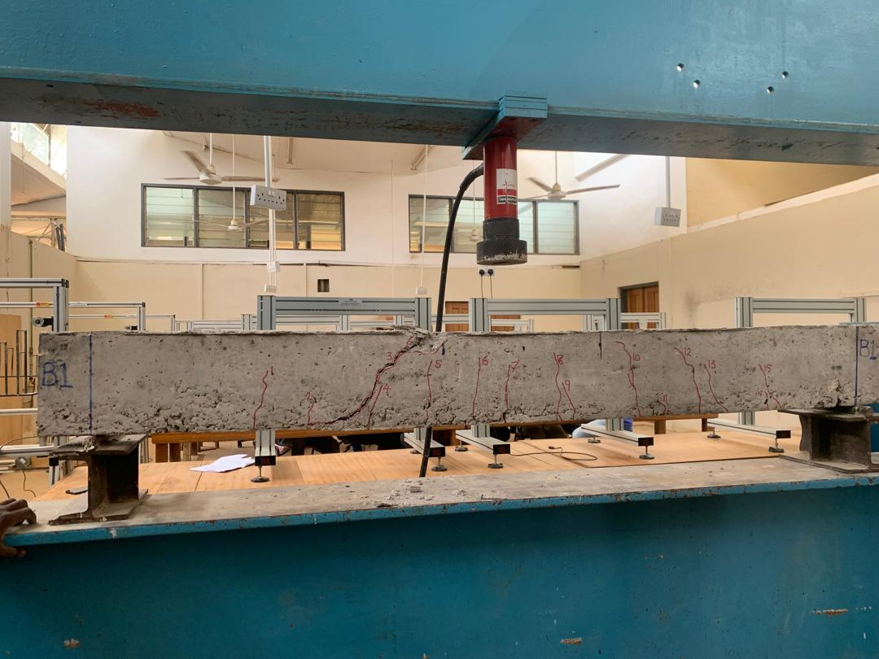

**Fig. 8.** **Beam 1 failure mode**

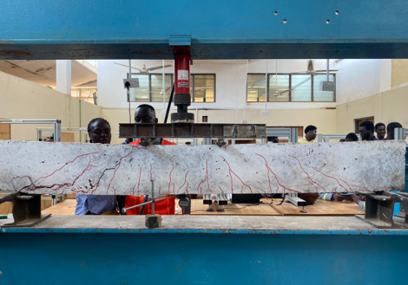

**Fig. 9. Beam 2 failure mode**

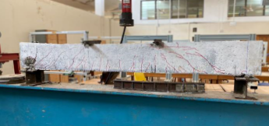

**Fig. 10.** **Beam 3 failure mode**

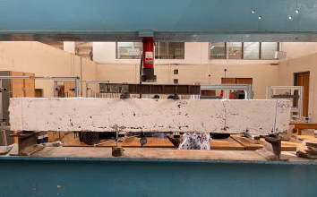

**Fig. 11. Beam 4 failure mode**

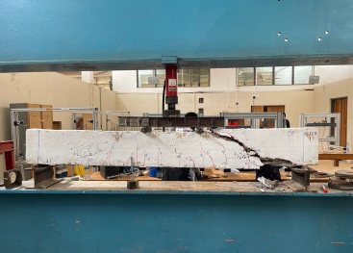

**Fig. 12.** **Beam 5 at failure**

**CONCLUSIONS**

This research explored the structural behavior of concrete beams reinforced with reused GFRP bars, offering a sustainable alternative to traditional steel reinforcing bars. The study focused on the impact of varying concrete compressive strengths and tensile reinforcement ratios with constant hybrid steel shear reinforcement on the structural performance of beams, which were subjected to a four-point monotonic loading system. Through a detailed evaluation of both theoretical and experimental findings, the following conclusions were reached:

1. Reused GFRP bars retained their mechanical properties comparable to their original form, highlighting their potential for multiple reuse in structural applications, as demonstrated in this study. This presents a clear advantage over steel reinforcement, which yields and undergoes permanent deformation at relatively lower tensile strength, limiting its suitability for repeated structural use.
2. The experimental failure loads (P’ult) of the recycled GFRP RC beams averaged 1.47 of the theoretical failure loads (Pult), highlighting the improved flexural performance of reused GFRP bars in the beams.
3. Reused GFRP-reinforced beams developed initial cracks at approximately 12% of their ultimate load due to the bars' lower modulus of elasticity, which led to greater initial deformations. However, their high tensile strength enabled them to carry significantly higher loads beyond the cracking point, thereby widening the gap between the cracking and ultimate loads and resulting in a low cracking-to-failure load ratio.
4. The reused GFRP-reinforced concrete beams displayed a comparable linear-elastic load-deflection response to those in their original form from the previous study and ultimately failed in a sudden brittle manner—either through diagonal tension or concrete crushing—as confirmed by theoretical analysis. This behavior is attributed to the inherently non-yielding nature of GFRP bars.
5. The beam specimen exhibited remarkable deformability prior to failure, showcasing superior flexibility. However, there was zero residual deformation after failure of beam, evidenced by the beams returning to their original position after failure by concrete crushing.
6. Increasing concrete strength and tensile reinforcement ratio significantly improved the flexural performance of the reused GFRP RC beams, consistent with findings from the previous study on the original (virgin) GFRP bars. Higher concrete strength enhanced stiffness and crack spacing, while a greater reinforcement ratio reduced crack width, spacing, and deflections.

**REFERENCES:**

[1] Tahmouresi Kasra BM, Mohseni Ehsan. Flexural response of FRP-strengthened lightweight RC beams: hybrid bond efficiency of L‐shape ribbed bars and NSM technique, Archives of Civil and Mechanical Engineering. 2022;22(2). <https://doi.org/10.1007/s43452-022-00410-y>.

[2] Ahmed Dilshad Kakasor HQJ, Yaseen, S. A.. “Flexural capacity and behaviour of geopolymer concrete beams reinforced with glass fibre-reinforced Polymer Bars”, International Journal of Concrete Structures and Materials. 2020; 14(1):1–1. <https://doi.org/10.1186/s40069-019-0389-1>.

[3] Attia, M.M., El-Latief, A.A., and Eita, M.A., 2023. Performance of RC beams with novelty GFRP under the bending load: An experimental and FE study. Case Studies in Construction Materials, 18, P.e02000. <https://doi.org/10.1016/j.cscm.2023.e02000>.

[4] Abbood, I.S., Odaa, S.,Hasan, K.F., Jasim, M.A., 2021. Properties evaluation of fiber reinforced polymers and their constituent materials used in structures–A review. Materials Today: Proceedings, 43, pp. 1003–1008. <https://doi.org/10.1016/j.matpr.2020.07.636>.

[5] ACI Committee 440. (2006). *Guide for the Design and Construction of Structural Concrete Reinforced with FRP bars*. Farmington Hills, Mich: American Concrete Institute.

[6] Feng, G., Zhu, D., Guo, S., Zillur Rahman, MD, Jin, Z., Shi, C.. “A review on mechanical properties and deterioration mechanisms of FRP bars under severe environmental and loading conditions”. Cement and Concrete Composites, 134 (2022), Article 104758. <https://doi.org/10.1016/j.cemconcomp.2022.104758>.

[7] Liu, T.Q., Liu, X., Feng, P.. “A comprehensive review on mechanical properties of pultruded FRP composites subjected to long-term environmental effects”. Compos B Eng, 191 (2020), Article 107958

[8] Boateng G. O, Kankam C. K., Mansal E. C., Afrifa R. O., Kwarteng F., Ohene-Coffie F., and Kpo S. A. K.. 2024. “Evaluating the Mechanical Properties of Fiberglass-Reinforced Polymer Bar”. Journal of Engineering Research and Reports 26 (7):150-60. <https://doi.org/10.9734/jerr/2024/v26i71200>.

[9] Shaoce Chenggao, D. L.; Guijun, X. “Environmental Impacts of Glass- and Carbon-Fiber-Reinforced Polymer Bar-Reinforced Seawater and Sea Sand Concrete Beams Used in Marine Environments: An LCA Case Study,” Polymers, vol. 13, no. 1, pp. 154-NA, 2021, doi: 10.3390/polym13010154.

[10] Ifrahim, M.S., Sangi, A.J., and Ahmad, S.H., 2023. Experimental and numerical investigation of flexural behaviour of concrete beams reinforced with GFRP bars. Structures, 56, P. 104951. <https://doi.org/10.1016/j.istruc.2023.104951>.

[11] Issa Ibrahim MSM, Elzeiny M, Sherif M. Influence of fibers on flexural behavior and ductility of concrete beams reinforced with GFRP rebars, Engineering Structures. 2011;33(5):1754–1763. <https://doi.org/10.1016/j.engstruct.2011.02.014>.

[12] Ohene-Coffie, F., Kankam, C. K., Kpo, S. A. K., Boateng, G. O., & Nanor, E. S. (2024). “Anchorage Bond Strength of Glass Fibre Polymer Reinforced Concrete with Palm Kernel Shells as Partial Coarse Aggregate.” Journal of Engineering Research and Reports, 26(7): 1–16. <https://doi.org/10.9734/jerr/2024/v26i71189>.

[13] Ahmed HQ, Jaf DK, Yaseen SA (2020) Flexural capacity and behavior of geopolymer concrete beams reinforced with glass fibre-reinforced polymer bars. Int J Concrete Struct Mater (1976-0485) 14:460–9 DOI: [10.1186/s40069-019-0389-1](http://dx.doi.org/10.1186/s40069-019-0389-1)

[14] Gora, A.M., 2022b. Behaviour of rectangular RC columns confined with bi-directional GFRP under combined axial and bending loadings. Ph.D. thesis, Department of Civil Engineering, University of Nottingham. <https://eprints.nottingham.ac.uk/67463/>.

[15] Ma E, Adam Abeer M, Habib Fatma A, El-Sayed, Taha A. Structural Behavior of High-Strength Concrete Slabs Reinforced with GFRP Bars. Polymers. 2021;13(17): 2997-NA.

<https://doi.org/10.3390/polym13172997>.

[16] Liang, X.; Peng, J.; Ren, R. A state-of-the-art review: Shear performance of the concrete beams reinforced with FRP bars. Constr. Build. Mater. (2023), 364, 129996.

[17] Kpo, S. A. K., Kankam C. K., Ababio C. O., Tackie D. T.. 2025. “Investigation on the Shear Performance of Concrete Beams Reinforced With Glass Fiber Reinforced Polymer (GFRP) Bars”. Asian Journal of Advanced Research and Reports 19 (4):119-37. <https://doi.org/10.9734/ajarr/2025/v19i4969>.

[18] Kpo, S. A. K., Kankam C. K, Ohene-Coffie F., Boateng G. O., Nanor E. S., Junior J. K. Q., Mansal E. C.. 2024. “Strength and Deformation Characteristics of Concrete Beams Reinforced With Glass Fibre Reinforced Polymer Bars”. Asian Journal of Advanced Research and Reports 18 (9):151-69. <https://doi.org/10.9734/ajarr/2024/v18i9741>.

[19] Johnson, D. (2014). Investigation of Glass Fibre Reinforced Polymer (GFRP) Bars as Internal Reinforcement for Concrete Structures. Doctor of Philosophy, Department of Civil Engineering, University of Toronto.

[20] Mohammed S. A. and Said A. I., “A Comparative Study of the Structural Behavior of Concrete Beams Reinforced with Different Configurations of GFRP and Steel Bars,” jcoeng, vol. 30, no. 04, pp. 200–218, Apr. 2024, <https://doi.org/10.31026/j.eng.2024.04.12>.

[21] Sasikumar, P. and Manju, R.. “Flexural behaviour of reinforced concrete beams reinforced with Glass Fibre Reinforced Polymer (GFRP) bars: experimental and analytical study.” Asian Journal of Civil Engineering 25, 3623–3636 (2024). <https://doi.org/10.1007/s42107-024-01000-4>.

[22] ACI 440.1R-15, Guide for the Design and Construction of Structural Concrete Reinforced with Fiber-Reinforced Polymer (FRP) Bars, ACI Committee. 2015;440.

[23] Gharde S, Kandasubramanian B (2019) Mechanothermal and chemical recycling methodologies for the Fibre Reinforced Plastic (FRP). Environ Technol Innov 14:100311. <https://doi.org/10.1016/j.eti.2019.01.005>.

[24] Krauklis AE, Karl CW, Gagani AI and Jorgensen, JK. (2021) Composite material recycling technology—State-of-the-Art and sustainable development for the 2020s. J Compos Sci 5(1):28.

[25] UnitedNations. Sustainable cities and human settlements. Available from: <https://sustainabledevelopment.un.org/topics/sustainablecities>. Google Scholar

[26] Ramin, J., Elizei, MHA, Ziaei, M. and Abadi, RE. "Experimental investigation of the behavior of concrete beams containing recycled materials reinforced with composite rebars." Materiales de Construcción 73, no. 352 (2023): e329e329.

[27] Indian standard, Recommended Guidelines for Concrete Mix Design, IS 10262:1982, Bureau of India Standard, New Delhi.

[28] BS EN 12390-3 (2009). Testing hardened concrete-Part 3: Compressive Strength of Test Specimens. British Standard Institution, London; 2009.

[29] BS EN 12390-6 (2009). Testing hardened concrete-Part 4: Tensile splitting strength of test specimens. British Standard Institution, London; 2009.

[30] ASTM D7205 (2006). Standard Test Method for Tensile Properties of Fiber Reinforced Polymer Matrix Composite Bars. ASTM Committee D30; 2006.

[31] Kankam C.K., Adom-Asamoah M. (2002). Strength and ductility characteristics of reinforcing steel bars milled from scrap metals. Materials Design, 23(6), 537-545, <https://doi.org/10.1016/S0261-3069(02)00028-6>.

[32] Al-Sunna Kypros RP, Hajirasouliha I., Guadagnini M. “Deflection behaviour of FRP reinforced concrete beams and slabs: An experimental investigation”, Composites Part B: Engineering. 2012; 43(5):2125–2134. <https://doi.org/10.1016/j.compositesb.2012.03.007>.

[33] McClure G. and Mohammadi Y., (1995). “Compression creep of Pultruded E-glass-Reinforced-Plastic Angels” Journal of Materials in Civil Engineering, Volume 7, Issue 4. <https://doi.org/10.1061/(ASCE)0899-1561(1995)7:4(269)>.