*Original Research Article*

Characteristics of Patients with a Diagnosis of Herniated Nucleus Pulposus

.

ABSTRACT

|  |
| --- |
| Herniated nucleus pulposus is a disorder in which the spinal disc moves and protrudes, pressing on the spinal nerves. It can occur in several places, including the back of the neck, upper back, and lower back. According to PERDOSSI (Indonesian Neurologists Association), findings show that 819 people (18.37%) suffer from HNP. LBP is 18% common in Indonesia, according to the Ministry of Health. Herniated Nucleus Pulposus is still largely unknown, which causes people to start treatment late and accelerates the progression of the disease. This study was conducted to identify the profile of patients with herniated nucleus pulposus. The design of this study was a retrospective descriptive cross-sectional study by examining the medical records of patients at the Indonesian Christian University General Hospital for the period January 2018 to January 2022. In this study, there were 71 patients as samples. The results of this study showed that 52 female patients (73.2%) and 18 male patients (25.3%). The dominant age group was 61-70 years old with a total of 26 patients (37.1%). It was found that the patients with the most jobs were housewives with a total of 32 patients (45.7%). The classification of HNP based on the location of the lesion was dominated by patients with a diagnosis of Lumbar HNP, with a total of 51 patients (72.9%). The body mass index of patients was dominated by patients who had a BMI of 25-29.9 (Obesity I) with a total of 26 patients (37.1%). The history of trauma in this study was less with a total of 7 patients (10%). Patients with smoking habits in this study were more numerous than patients who did not smoke with a total of 36 people (51.4%) |

*Keywords: Herniated Nucleus Pulposus, Lower Back Pain*

1. INTRODUCTION

Herniated nucleus pulposus, commonly abbreviated as HNP or known as pinched nerve disease, is a condition where one of the pads or discs in the cartilage of the spine protrudes out and causes the nerves around it to be pinched (Berlina, L., & Ichwanuddin, I.,2024). Common causes of pain in the spine can occur in various locations such as the back of the neck, upper back, and lower back caused by conditions when the spinal nerves are pinched by shifting pressure from the spinal pads (Irvan, M., & Sulistyani, S., 2024). Unlike normal mechanical pain, herniated disc pain often feels like burning, electric shocks, or stabbing, and can spread to the upper or lower ends. Herniated Nucleus Pulposus can occur in all parts of the spine from the neck, and chest to the waist. Herniated Nucleus Pulposus often occurs in the lower back or waist which is called lumbar HNP, around 90% of all HNP cases, are related to the L5-S1 and L4-L5 intervertebral discs. Only 8% of all HNP cases occur in the upper back and neck, so they are rare (De Cicco, F. L., & GO, C. W., 2019).

The causes of HNP vary widely and are present in our lives. For example, the wrong way of sleeping or sitting. Various work factors also pose a risk of HNP. Risk factors for HNP in the workplace include standing or sitting for long periods, operating vibrating equipment, frequently lifting or carrying large objects, and frequently turning or bending (Hatlah, N. N, et al, 2021; Lumbantobing, M., et al, 2020). Herniated Nucleus Pulposus generally occurs in the elderly and is thought to be caused by a degeneration process. However, in young age groups, trauma to the vertebrae can be a cause. Trauma can be severe or repeated. In single trauma, if asked to the patient about the pain they feel, usually the patient knows for sure, for example when the patient is pulling out a tree, pushing a car, lifting (heavy) objects, slipping, falling sitting down, and so on. So in this situation, HNP can occur without previous trauma (Arsyad M., et al, 2021; Sholicha Dyananti, A. L., et al, 2023).

The most common complaint from HNP patients is pain. The location and intensity of the clamping affect HNP symptoms differently. Cervical disc herniation causes symptoms in the form of pain that radiates to the shoulder, upper arm, lower arm, and fingers and pain that occurs when the neck is moved. In addition, numbness can also be found in the same area as the pain (Agape, K., 2024; Fitriyani, F., 2024). Coughing, sneezing, or straining can worsen HNP pain. Severe HNP conditions can be found in paralysis of the extremities. Initial symptoms include a weak grip, followed by difficulty lifting the arm, such as when buttoning clothes or combing hair (Alfarizi, M., 2022; Muh Samsul Huda, M. S. H. 2021).

Hernia Nucleus Pulposus in the lumbar or waist, the symptoms are similar to HNP neck. The waist, buttocks, and calves feel painful, as well as the legs. Tingling and thick sensations in one or both lower legs also often occur (Durahim D., et al, 2023). As with HNP neck, symptoms of HNP waist are also aggravated by coughing, sneezing or straining. When the pain symptoms become more severe, they will be aggravated by walking or standing still, HNP lumbar and waist can also experience paralysis. Increased back pain, activities such as sitting for a long time. HNP cases are not emergency cases but often occur and affect 1-2% of the world's population (Adityawarma, A., 2021; Utami A., et al, 2023). Herniated Nucleus Pulposus is a condition that often affects the spine and is commonly found worldwide, including in Indonesia. Lack of understanding of HNP results in delayed treatment so that the disease can get worse and until now no current data is showing the profile of HNP patients at RSU UKI. Therefore, the author reports the profile of HNP patients at the General Hospital of the Indonesian Christian University in the period January 2018 to January 2022.

2. material and methods

**2.1. Research Design**

This study uses a retrospective descriptive cross-sectional research design by examining patient medical records. The research data comes from patient medical records at the Indonesian Christian University General Hospital, East Jakarta.

**2.2. Location and Time of Research**

The research was located at the General Hospital of the Christian University of Indonesia, East Jakarta. The time required by researchers from submitting the proposal to the end of the thesis is June 2022 – July 2023.

**2.3. Research Instrument**

This study uses secondary data as a research instrument. Secondary data was obtained from the medical records of HNP patients at the Indonesian Christian Hospital for the period January 2018 to January 2022.

**2.4. Population and Sample**

The population in this study were all patients with Hernia Nucleus Pulposus who were treated at the Indonesian Christian Hospital from January 2018 to January 2022. The sample in this study were patients with Hernia Nucleus Pulposus who were treated at the Indonesian Christian University Hospital from January 2018 to January 2022, totaling 70 medical records of patients who met the inclusion criteria, namely: Patients diagnosed with HNP in the period January 2018 to January 2022 and the exclusion criteria, namely: medical records of HNP patients with incomplete records.

**2.5. Data Collection**

Data collection was conducted using secondary data from medical records of patients with HNP at the Indonesian Christian General Hospital. Researchers will conduct data selection according to the inclusion criteria and exclusion criteria that have been set and will obtain the data used in this study.

**2.6. Data Analysis**

The statistical data analysis used in this study uses descriptive statistical data methods with frequency analysis.

3. results and discussion

**3.1. Result**

In this study, 70 patients were found who met the inclusion criteria. The data were obtained from medical records of Hernia Nucleus Pulposus patients from January 2017 to January 2022 at the Indonesian Christian University Hospital. The results of the study regarding the profile of HNP patients at RSU UKI are presented in Table 1, where gender is dominated by women as many as 52 out of 70 patients or 74.3 percent; for age, it is dominated by patients aged 61-70 years, namely 26 people or 37.1 percent and followed by those aged 71-80 years, namely 15 people or 21.4 percent. Meanwhile, the type of patient's occupation, it is dominated by housewives as many as 32 people or 45.7 percent, and retirees as many as 20 people or 28.6 percent.

**Table 1. Distribution of HNP Patients based on Gender, Age and Job Type**

|  |  |  |
| --- | --- | --- |
| Description | Frequency | Percentage |
| 1. Gender | | |
| Male  Female | 18  52 | 25.7  74.3 |
| 1. Age | | |
| 31-40 year  41-50 year  51-60 year  61-70 year  71-80 year  > 80 year | 1  6  15  26  19  3 | 1.4  8.6  21.4  37.1  27.2  4.3 |
| 1. Job Type | | |
| Housewife  Private Employee  Civil Servant  Freelancer  Retiree  Self-Employed | 32  8  6  1  20  3 | 45.7  11.4  8.6  1.4  28.6  4.3 |

Furthermore, patient characteristics based on body mass index in Table 2 show that HNP patients at RSU UKI in the period January 2018 - January 2022 were dominated by patients who had a body mass index of 25 -29.9 (Obesity I) with a total of 26 patients with a presentation of 37.1%.

**Table 2. Distribution of HNP Patients Based on Body Mass Index (BMI)**

|  |  |  |
| --- | --- | --- |
| **BMI** | **Frequency (n)** | **Percentage(%)** |
| < 18.5 | 0 | 0 |
| 18.5 – 22.9 | 22 | 31.4 |
| 23 – 24.9 | 9 | 12.9 |
| 25 – 29.9 | 26 | 37.1 |
| ≥30 | 13 | 18.6 |
| **Total** | **70** | **100** |

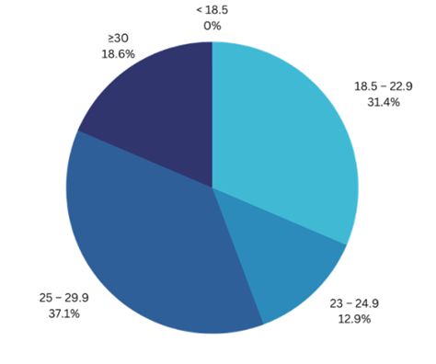

**Figure 1. Distribution Diagram of HNP Patients Based on Body Mass Index**

Table 3 shows that HNP patients at RSU UKI in the period January 2018 - January 2022 were dominated by patients who had a Lumbar HNP Diagnosis with a total of 51 patients with a presentation of 72.9%.

**Table 3. HNP Location Distribution**

|  |  |  |
| --- | --- | --- |
| Diagnosis | **Frequency (n)** | **Percentage** |
| Cervical HNP | 19 | 27.1 |
| Lumbar HNP | 51 | 72.9 |
| Thoracic HNP | 0 | 0 |
| **Total** | **70** | **100** |

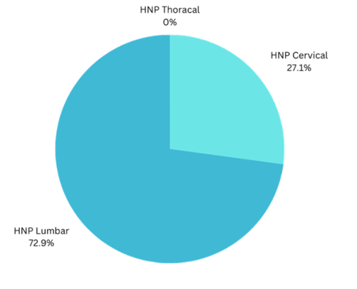

**Figure 2. HNP Location Distribution Diagram**

Table 4 shows that all HNP patients at RSU UKI in the period January 2018 - January 2022 were dominated by a history of non-trauma with a total of 63 patients with a presentation of 90%.

**Table 4. Distribution of HNP Patients Based on Trauma History**

|  |  |  |
| --- | --- | --- |
| **Trauma History** | **Frequency (n)** | **Percentage (%)** |
| Trauma | 7 | 10 |
| Non-Trauma | 63 | 90 |
| **Total** | **70** | **100** |

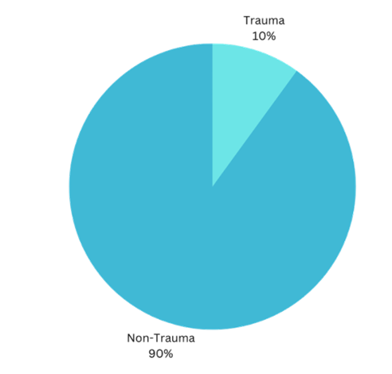

**Figure 3. Distribution Diagram of HNP Patients Based on Trauma History**

Table 5 shows that the majority of HNP patients at RSU UKI in the period January 2018 - January 2022 had a smoking habit with a total of 36 patients with a presentation of 51.4%.

**Table 5. Distribution of HNP Patients Based on Smoking Habits**

|  |  |  |
| --- | --- | --- |
| **Smoking Habit** | **Frequency (n)** | **Percentage(%)** |
| Smoking | 36 | 51.4 |
| Not Smoking | 34 | 48.6 |
| **Total** | **70** | **100** |

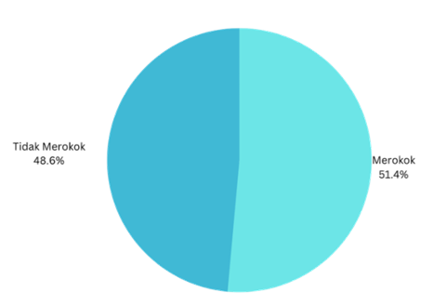

**Figure 4. Distribution Diagram of HNP Patients Based on Smoking Habits**

**3.2. Discussion**

**3.2.1. Gender**

Based on medical records of patients with Hernia Nucleus Pulposus for the period January 2017 - January 2022 at the Indonesian Christian University Hospital, there were 71 patients, who met the inclusion criteria, with more females than males with a total of 52 people and a percentage of 73.2%. This result is supported by research conducted by Rabanimukram Desyauri, Freddy H. Aritonang, Charles A. Simanjuntak in 2021, with 22 people (73.3%) female (the gender with the highest percentage of HNP) and 8 people (26.7%) male who experienced HNP. This is because back pain is a complaint that is more common in women, and the menopause process can also cause loss of bone density in women due to decreased estrogen hormone, which causes back pain (Desyauri, R., et al, 2021). By reducing bone resorption and preventing bone fragility, estrogen is responsible for bone remodeling (Howay SY., et al, 2023).

* + 1. **Age**

In this study, the most results were obtained from patients in the 61-70 year age group with a total of 26 patients (21.4%), then followed by the second largest number from the 71-80 year age group with a total of 19 patients (27%), then in third place from the 51-60 year age group totaling 15 patients (21.4%), and the smallest number in the 31-40 year age group totaling 1 patient (1.4%). This is in line with research conducted by Susan Yulia Laura Howay, Sutarto, TA Larasati in 2022, namely the increase in the prevalence of HNP is caused by changes in bone structure or shape that begin to appear between the ages of 40 and 70 years, which causes spinal degeneration. Changes in the shape or structure of the spine affect the spine, increasing structural stiffness, reducing the density of the nucleus pulposus, and changing the chemical composition of the intervertebral discs, which makes inflammation more likely and causes lower back pain (Desyauri, R., et al, 2021). This study is also supported by research conducted on HNP Patients at Dr. Wahidin Sudirohusodo Makassar General Hospital in 2017, where the study showed that 13 samples or 29.5% of the total HNP patient samples were aged between 51 - 60 years. The ability of the disc to perform its function decreases with aging, and the disc also becomes drier. The inner wall of the disc becomes weak and fibrous, and may not be able to hold the gel core as it does in the center. Because of the pressure it puts on the nerves, this results in a bulge or rupture through a tear in the disc wall. Around the age of 50 to 60, the likelihood of experiencing back pain increases (Howay SY., et al, 2023).

* + 1. **Job Type**

Based on the results of medical record data in this study, there were more patients with jobs as housewives with a total of 32 patients with a presentation of 45.7%. This is similar to the study conducted by Rabanimukram Desyauri, Freddy H. Aritonang, Charles A. Simanjuntak in 2021, where it was found that the respondents who experienced HNP worked as housewives were the largest number, namely 17 people (56.7%) (Desyauri, R., et al, 2021). This is the result of annulus fibrosus injury caused by repetitive trauma, work habits that include heavy lifting by bending, twisting, or a combination of both, or due to stress caused by trauma. This causes the pulposus to move to the posterolateral or posterior area (Yusuf, A., & Syarat, D. 2017).

* + 1. **Body Mass Index (BMI)**

The study conducted on HNP patients at UKI Hospital in the period January 2018 - January 2022 was dominated by patients who had a body mass index of 25-29.9 (Obesity I) with a total of 26 patients with a presentation of 37.1%. This study is in line with the study conducted at the Neurological Disease Polyclinic, Abdul Manap Hospital, Jambi City in February-March 2017, namely that respondents in the BMI ≥23 kg/m2 group and diagnosed with suspected HNP were 26 people (61.9%). In the study, it was also found that respondents with a BMI ≥23 kg/m2 group had a 3.656 times greater risk of experiencing suspected HNP compared to respondents in the BMI <23 kg/m2 group. The degree of forward hunchback increases when obese people sit or stand and causes an increased load on the intervertebral discs. Obesity is associated with biomechanical changes that lead to diseases in the spinal area such as disc degeneration, spinal ligament hypertrophy, OA, disc herniation, and spinal stenosis (Desyauri, R., et al, 2021).

* + 1. **Most HNP Locations**

This study found that HNP patients at RSU UKI in the period January 2018 - January 2022 were dominated by patients who had the most locations being Lumbar HNP with a total of 51 patients with a presentation of 72.9%. Based on Dian Fatmasari's research, HNP or intervertebral disc herniation, which is often referred to as Lumbar Disc Syndrome or Lumbosacral radiculopathies is the most common cause of acute, chronic or recurrent lower back pain. Herniated Nucleus Pulposus most often occurs in the L5-S1 intervertebral disc (45-50%) followed by (40-45%) and L3-L4 (<10%). Herniated Nucleus Pulposus at L1-L2 is rarely found. This is caused by a hernia or ruptured disc which can occur when the intervertebral disc is compressed and protrudes out (herniation) or ruptures, causing lower back pain (Hatilah N., et al, 2021).

* + 1. **History of Trauma**

Based on this study, it was determined that most HNP patients at RSU UKI from January 2018 to January 2022 did not have a history of trauma, with a total of 63 people and a presentation rate of 90%. According to Fithri Nur's research, 13.4% of HNP patients had a history of trauma, such as a history of falls or accidents that caused trauma or spinal injuries that caused HNP. Most HNP patients have no history of trauma and are commonly referred to as non-trauma. Non-traumatic conditions can be spinal degeneration due to physiological factors, such as age and other causes, without a history of spinal trauma (Fatmasari D., 2023).

* + 1. **Smoking Habits**

Based on the findings of this study, the majority of HNP patients at RSU UKI between January 2018 and January 2022, as many as 36 patients or 51.4%, were smokers. According to research conducted by Howay, more HNP patients were smokers (65.9%) compared to non-smokers (34.1%). The underlying mechanism is that smoking causes narrowing of the capillaries at the bone-disc junction and interferes with the blood supply that delivers oxygen and nutrients to the disc. According to Andersen et al., smoking has a close relationship with HNP, and smoking can also cause HNP recurrence (Desyauri, R., et al, 2021).

4. Conclusion

Based on the description of the research results and discussion regarding the Profile of Hernia Nucleus Pulposus Patients at the Indonesian Christian University Hospital in the period January 2018 - January 2022, the following can be concluded: 1) Women are more at risk of HNP than men, 2) The age group 61-70 years is more at risk of HNP, 3) Body Mass Index values ​​25-29.9 (Obesity I) are more at risk of HNP than other values, 4) Housewives are more at risk of HNP than other types of work, 5) The most common location of HNP is lumbar HNP, 6) HNP incidents are more frequent with a history of non-trauma and 7) Smoking can increase the risk of HNP.

References

Berlina, L., & Ichwanuddin, I. (2024). Herniated Nucleus Pulposus. Thermometer: Scientific Journal of Health and Medical Sciences, 2(3), 175-197.

Irvan, M., & Sulistyani, S. (2024). Comprehensive Management of Herniated Nucleus Pulposus (HNP) Cases. Proceeding Book Call for Papers, Faculty of Medicine, Muhammadiyah University of Surakarta, 664-675.

De Cicco, F. L., & GO, C. W. (2019). Nucleus pulposus herniation.

Hatlah, N. N., Veni Fatmawati, S. S. T., Fis, M., Diniyah, K., & S. T., M. M. R. (2021). FACTORS INFLUENCING THE OCCURRENCE OF HERNIATED NUCLEUS PULPOSUS (HNP): NARRATIVE REVIEW.

Lumbantobing, M., Siagian, L., & Silangit, T. (2020). FACTORS INFLUENCING THE SUCCESS OF PHYSIOTHERAPY TO REDUCE PAIN IN PATIENTS WITH HERNIATED NUCLEUS PULPOSUS (HNP). Methodist Medical Journal, 13(1), 37-42.

Arsyad, M., Dewi, S. N., Rad, S. T., Utami, A. P., & KM, S. (2021). Literature Study of Cervical Radiography Examination Techniques in Cases of HNP (Herniated Nucleus Pulposus) (Doctoral dissertation, Universitas ‘Aisyiyah Yogyakarta).

Sholicha Dyananti, A. L., Yekti, M., & Rohmani, A. (2023). RELATIONSHIP BETWEEN PAIN INTENSITY AND SLEEP QUALITY: A STUDY IN PATIENTS WITH HERNIATED NUCLEUS PULPOSUS (HNP) OF THE LUMBAR. Cerdika: Indonesian Scientific Journal, 3(9).

Agave, K. (2022). Characteristics of Low Back Pain Et Causa Hernia Nukleus Pulposus at Dr. Wahidin Sudirohusodo Hospital Makassar Period January 2020-December 2020 = Characteristics of Low Back Pain Et Causa Hernia Nukleus Pulposus at Dr. Hospital. Wahidin Sudirohusodo Makassar Period January 2020-December 2020 (Doctoral dissertation, Hasanuddin University).

Fitriyani, F., & Putri, S. M. (2024). Lumbar Nucleus Pulposus Hernia: A Case Report. Medical Profession Journal of Lampung, 14(4), 795-798.

Durahim, D., Halimah, A., & Suharto, S. (2023). Physiotherapy Management of Lumbar Functional Disorders Due to Herniated Nucleus Pulposus (Hnp) in the Tamalanrea Area of ​​Makassar. Physiotherapy Media, Makassar Health Polytechnic, 14(2), 27-34.

Adityawarma, A. A. N. A. H., & Wahyudana, I. N. G. (2021). Multiple lumbar nucleus pulposus herniation accompanied by canal stenosis with drop foot syndrome and unilateral muscle atrophy: a case report. Digest of Medical Science, 12(3), 728-731.

Utami, A., Yamin, A., & Lukman, M. (2023). Intervention description of mc. Kenzie exercise in elderly patients with low back pain due to herniated nucleus pulposus: A Case Study. SENTRI: Scientific Research Journal, 2(7), 2704-2713.

Alfarizi, M. (2022). EFFECTIVENESS OF CORE STABILITY EXERCISE ON REDUCING PAIN IN CASES OF HERNIATED NUCLEUS PULPOSUS (LITERATURE REVIEW) (Doctoral dissertation, Binawan University).

MUH SAMSUL HUDA, M. S. H. (2021). NURSING CARE FOR PATIENTS WITH HERNIATED NUCLEUS PULPOSUS (HNP) IN FULFILLING SAFE AND COMFORTABLE NEEDS (Doctoral dissertation, Kusuma Husada University, Surakarta).

Desyauri, R., Aritonang, F. H., & Simanjuntak, C. A. (2021). Body Mass Index (BMI) as a Risk Factor in Suspected Lumbar Herniated Nucleus Pulposus (HNP). Journal of Medical Studies, 1(2), 1-7.)

Howay, S. Y. L., Sutarto, S., & Larasati, T. A. (2022). IDENTIFICATION OF RISK FACTORS FOR HERNIATED NUCLEUS PULPOSUS (HNP). Journal of Agromedicine, 8(2).

Yusuf, A., & Syarat, D. (2017). Relationship between the degree of herniated nucleus pulposus (HNP) and the degree of lower back pain at Dr. Wahidin Sudirohusodo General Hospital, Makassar.

Hatlah, N. N., Veni Fatmawati, S. S. T., Fis, M., Diniyah, K., & S. S. T., M. M. R. (2021). FACTORS INFLUENCING THE OCCURRENCE OF HERNIATED NUCLEUS PULPOSUS (HNP): NARRATIVE REVIEW. Fatmasari, D. (2016). The Relationship Between Central Obesity and the Degree of Herniated Nucleus Pulposus at the Physiotherapy Clinic in Makassar City. Thesis. Makassar: Hasanuddin University.