*Review Article*

Livelihood Diversification in Rural Communities: Systematic Literature Review and Bibliometric Review of Key Themes and Emerging Trends from Scopus Database

.

ABSTRACT

|  |
| --- |
| This study examines the idea of Livelihood Diversification in Rural Communities by conducting a thorough Systematic Literature Review and bibliometric Analysis. This study uses a combined systematic literature review and bibliometric analysis of 318 Scopus-indexed publications published between 2014 and 2024 to examine livelihood diversification in rural areas. VOS viewer and R-based Biblioshiny software were used to analyze the articles, which show a 5.07% yearly growth rate and an average of 19.08 citations per document. With a total of 18,548 references, the collection demonstrated the depth of research in this area. One of the most important discoveries is that academics are increasingly working together internationally; 37.74% of articles include international co-authorship. The research also emphasizes how the word "Climate Change" is becoming more and more common in the literature, indicating the growing impact of climate change. Leading countries in the topic include the USA, Australia, and India; notable periodicals in this area include the Journal of Rural Studies, Sustainability (Switzerland), and Climate and Development. According to network analysis, "livelihood" is a key idea that is linked to concepts like "food security," "rural development," and "economic development." The project intends to use these insights to guide evidence-based policy actions that support equitable and sustainable development in rural regions. |

*Keywords: Livelihood Diversification; Rural Communities; Sustainable Livelihoods; Bibliometric Analysis; Systematic Literature Review.*

1. INTRODUCTION

Livelihood diversification has become an important avenue for rural people to build resilience, alleviate poverty, and adjust to socio-economic and environmental changes. Rural/urban linkages increase where rural households are vulnerable, particularly to climate change, shifts in surrounding land and labor markets, and jealous security of resource rights. The trend is part of a broader change in rural economies, in which diversification has become a way to spread risk, smooth incomes, and enhance well-being (Peng et al., 2022). Understanding livelihood diversification's dynamics, drivers, and outcomes is important for policymakers, development practitioners, and researchers interested in promoting sustainable rural development.

For all the literature on livelihood diversification, there is little in the way of a comprehensive synthesis of existing research to highlight key themes, emerging trends, and gaps in knowledge. Previous literature has addressed specific areas of diversification, such as diversification as a pathway to poverty alleviation or the role of diversification as a coping strategy for climate change (Roscher et al., 2022). However, there is no comprehensive bibliometric and systematic assessment of this field. This can give a global view of the progress of research, show key works, and make visible cross-disciplinary connections that can inspire new research.

This article seeks to fill this gap through a systematic literature review and bibliometric analysis of the body of work on livelihood diversification in rural communities based on research data from the Scopus database. We aim to map the intellectual terrain of the field through stringent bibliometric methods, uncover prominent research areas, and detect temporal trends. The study will also examine the research spread across geography and themes, providing insights into regional unevenness and underrepresented topics. What rural communities of our past 5, 10, and 20 years are changing with the socio-economic, ecological, and political changes around us. Agrarian economies, historically forming the foundation of rural livelihoods, are cracking under pressure from many different sources. Moreover, climate change, for example, has caused unpredictable weather patterns, disrupting crop yields and livestock productivity. However, new challenges and opportunities have emerged due to market fluctuations and globalization, frequently disrupting local economies and pushing rural households to pursue alternative income channels. Moreover, population growth, land degradation, and resource depletion have made rural populations more vulnerable.

Rural households have embraced livelihood diversification to build resilience and improve socio-economic well-being in the face of these challenges. Livelihood diversification is the process whereby households construct a diverse portfolio of activities and social support capabilities to survive and improve the standard of living (Mahedi et al., 2024). Such livelihood strategies might include off-farm jobs, petty trade, seasonal migration, and harvesting common-pool natural resources. Diversifying is not only a defensive maneuver but also a way to take advantage of new opportunities and lessen reliance on a single source of income.

Livelihood diversification is a well-established concept within the Sustainable Livelihoods Framework (SLF), which highlights the significance of assets, capabilities, and activities in determining livelihood outcomes (Ulukan et al., 2022). Based on SLF, households use five types of capital (natural, physical, financial, human, and social) to pursue different livelihood strategies.

It is increasingly recognized that livelihood diversification is inherent in rural development strategies. In addition to income stabilization, it provides risk-diminishing and poverty-relieving development outcomes. This could allow them to diversify their income and reduce vulnerability to shocks. For instance, a farming household may fall on hard times due to drought. However, diversifying via off-farm employment or small-scale trading can reduce the household's agricultural income losses.

Livelihood diversification can also play a role in poverty alleviation by offering supplementary sources of income and enhancing household well-being. Research indicates that diverse households have higher incomes, better access to education and healthcare, and greater food security. Differentiation also enables those on the margins, including women and youth, to gain power through new employment and income creation.

Diversifying livelihoods can improve the environment, as well as add economic value. Diversification: Reducing the pressure on natural resources promotes sustainable resource use and conservation. For example, rainforests damaged by industrial practices can be used for agroforestry or eco-tourism, providing households with a sustainable income source while maintaining biodiversity and ecosystem services.

However, as diversifying livelihoods has economic potential, it is not without challenges. Limited access to credit, markets, and infrastructure makes diversification difficult for many rural households. In many instances, the lack of education and skills limits a household's ability to pursue non-farm activities. Social and cultural dynamics also influence livelihood choices; certain activities may be more desirable or acceptable than others (Jing et al., 2024).

Additional relevant factors lie in the policy and institutional setting, which creates opportunities and constraints (e.g. human capital formation, credit access). In some contexts, there are restrictive land tenure systems, inadequate extension services, and unfavorable trade policies, preventing diversification. Conversely, supportive policies and institutions can enable diversification by providing access to resources, information, and markets.

A related complication is the potential trade-off inherent in diversification. Diversification can help mitigate risks and boost incomes, but it may also demand time, labor, and capital resources. Each household must assess the costs and benefits of various activities and choose how to allocate resources. Diversifying can sometimes stretch households too thin, diminishing productivity and increasing susceptibility to shocks.

The main Objectives of the Study:

1. To conduct a systematic review and synthesis of the literature on livelihood diversification in rural communities, highlighting commonalities and important themes, theoretical orientations, and methodological approaches.
2. The aim is to perform a bibliometric analysis to map research development on livelihood diversification, including trends in publication output, citation behaviors, and collaboration networks.
3. To recognize emerging trends and gaps in the literature, pinpointing areas that need further investigation and future potential research directions.
4. To investigate the geographical dispersion of research and whether and how different geographical areas, particularly Global South counties, are adequately represented in the literature.
5. To offer insights to policymakers and practitioners about the significance of livelihood diversification in sustainable rural development and resilience.

These objectives contribute to a deeper understanding of livelihood diversification as a dynamic and multidimensional process. The results will contribute not only to the academic literature but also contain actionable insights for policymakers and practitioners designing initiatives to help rural communities adapt to the realities of the 21st century.

2. Livelihood Diversification in Rural Communities

Rural livelihood diversification has been an important element in poverty reduction, food security, and sustainability. In this review, we synthesize dominant themes and emerging trends in livelihood diversification based on an analysis of recent Scopus-indexed studies. The analysis sheds light on factors influencing diversification, its implications for rural resilience, and potential pathways for sustainable rural development.

In Zambia, Hegazi and Seyuba (2024) examine the role of gender on livelihood diversification and its impact on food security (Hegazi & Seyuba, 2024). Their research shows that on-farm diversification leads to a more substantial improvement in food security than off-farm diversification, but this is only true for female-headed households. This added income from diversifying their livelihoods leads to the empowerment of women, which in turn supports even more diversification of livelihoods.

Several studies indicate that tourism is increasingly important for rural livelihood diversification. Kimbu et al. (2022) examine the transition from traditional fishing to tourism-based employment in rural coastal communities of the UK and South Africa. They also find that tourism can offer economic opportunities, but such opportunities appear to be realized without any structured planning for diversification. In Lesotho, these factors are tangential, defined by Makwindi and Ndlovu (2022). Although tourism provides a source of livelihood, its links to poverty reduction are weak. For example, Bora and Mahanta (2022) analyze the diversification strategies of tribal communities in the Northeastern region of India in the context of adaptation to low agricultural productivity levels and population pressure. Despite its potential, livelihood diversification is limited by geographical and infrastructural constraints. The study calls on policymakers to acknowledge the region's unexploited diversification potential.

Abera et al. (2021) focus on livelihood diversification determinants of resettler communities in Ethiopia. It confirms that agriculture is the primary source of household income (72.5%), non-farm (20%), and off-farm (7.5%) activities. Livelihood choice is also influenced by landholding size, education, access to credit, and distance from the market. Evidence of diversification must be balanced by the study's findings on the need for infrastructural development, skill training, and technical support.

Lahiri-Dutt et al. (2014) examine informal mining as a rural livelihood diversification strategy in Laos. They argued that the study counters the concept that rural societies just become passive subjects in the presence of large-scale mines and focus on their role as independent agents in local, informal mining. However, mineral dependence brings social and economic uncertainties that need to be dealt with by sophisticated policies.

Cavalleri et al. (2022) is an interdisciplinary framework for assessing rural livelihood diversification's benefits via community-based agritourism. The four most salient aspects are environmental, sociocultural, economic, and health. Agritourism maintains local agrobiodiversity, supports traditions, and offers community-led economic development and Indigenous foodborne health benefits. Classic "top-down" policy approaches have failed to transform such systemic pathways of vulnerability into sustainable alternatives, emphasizing the need for participatory approaches that, for example, value local knowledge, as the study highlights. This includes a transition towards more integrated and sustainable land-based livelihood diversification strategies based on the studies we reviewed. Tourism is an additional source of income in rural regions suffering from resource depletion.

Government assistance for infrastructure and skills development for tribal and resettled communities. Future research must study livelihood diversification's long-term socio-economic and environmental effects, especially in climate-vulnerable zones (Saha et al., 2024). Policymakers should create enabling environments conducive to diversification, with targeted investments and participatory planning. Livelihood diversification is crucial to promoting rural resilience, poverty reduction, and food security. The examples discussed here show the diversity of diversification: gender, tourism, agriculture, informal mining, and agritourism. Such a narrow perspective must be taken one step further to take a holistic and policy-driven approach to maximize the potential of diversification of livelihood options worldwide and ensure the sustainability of rural communities.

3. material and methods

Researchers in many disciplines have used comprehensive scientific mapping approaches. Few statistical and graphical methods are available, but Bibliophagy is a specific open-source R program with intuitive online applications. This study's bibliometric analysis uses the Bibliometric package, which is included in R, Biblioshiny, and VOS Viewer, an advanced-level honor for structural and display bibliometric networks (Khanam et al., 2023; Kabir et al., 2025). The VOS viewer constructs a "net" object using built-in R methods in the R Programming Environment. We used the Scopus database for this study, covering the period from 2014 to 2024. Scopus is a source of bibliographic information widely accepted by scientists. In the first stage, we collected 318 publications using the subject keywords livelihood AND diversification AND rural AND communities. The search was conducted on December 22, 2024. The detailed research procedure, with five steps, is presented in Fig. 1.

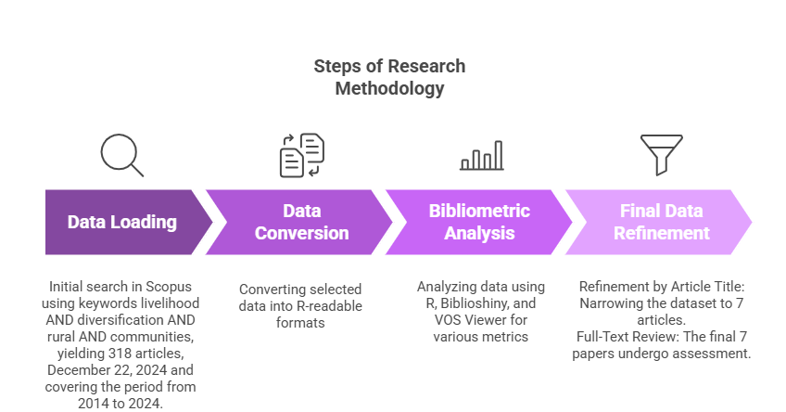

**Fig. 1. Steps of Research Methodology**

4. Results

**4.1 Description of the data**

Figure 2 presents an overview of the bibliometric analysis results from 2014 to 2024. During this period, 318 documents were published from 194 sources, including books, journals, and other publications, reflecting an annual growth rate of 5.07%. The contents exhibit considerable academic attention, with 19.08 citations per document and an age of 4.13 years. The collection had 18,548 references, underscoring the extensive research in this domain. The 1,251 Keywords Plus and 1,024 author-provided keywords from the publications exhibited a broad spectrum of thematic emphasis regarding content. Among the 1,154 contributors to the dataset, there were 40 single-authored studies. 37.74% of the publications exhibited significant international research collaboration, with an average of 3.82 co-authors per document. The predominant category was journal articles (258), followed by book chapters (38), conference papers (8), data papers (1), notes (1), retracted documents (1), and review papers (11). This array of document formats reflects the extensive technique used to examine livelihood diversification. The data indicates a robust and consistently rising level of academic interest in this field within the specified timeframe.

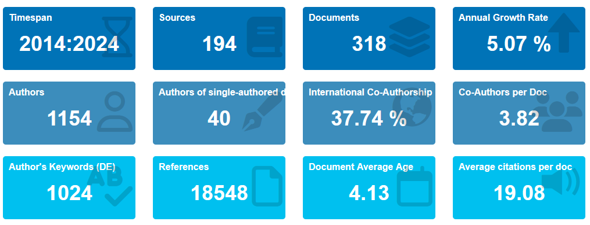

**Fig. 2. Description Statistics of the Data**

**4.2** **Publication progression**

Figure 3 depicts the yearly trend in the number of papers published on livelihood diversification from 2014 to 2024. The data reveals substantial variations in publishing output across the years. The number of articles gradually declined from 2014 to 2016, followed by a steady rise in 2017. In about 2020, there was a notable increase in publications, indicating intensified interest in this study domain. The trajectory demonstrated considerable stability, increasing in 2024 after a slight fall in 2020. This trend indicates that livelihood diversification has been a prominent area of research, particularly in recent years, because it correlated with global issues such as resilience improvement in rural areas and sustainable development.

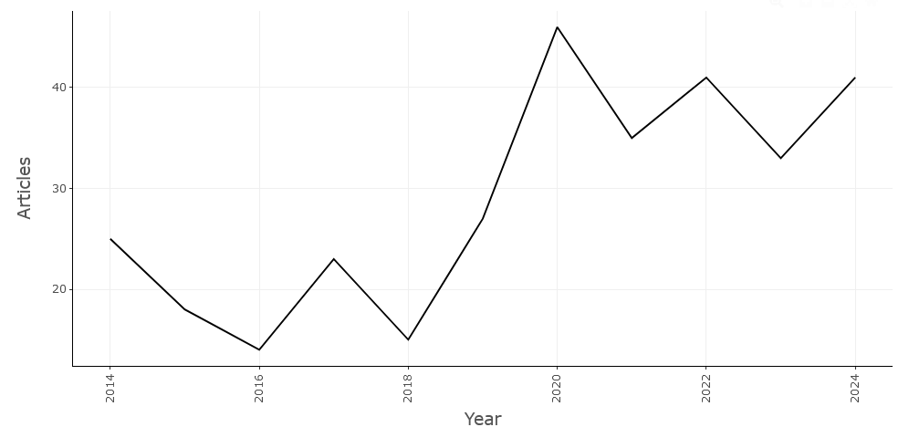

**Fig. 3. Annual Progression of Publication (2014-2024)**

**4.3 Citation**

The development in average citations per article for works on livelihood diversification between 2014 and 2024 is seen in Figure 4. Citations initially declined from 2014 to 2015, thereafter rising consistently till peaking in 2019. This growth signifies heightened scholarly interest in and recognition of the examination of that problem during that period. Nonetheless, post-2019, there has been a significant decline, and until 2024, the average citation count per article has continued to decrease. This fall may stem from a change in focus towards contemporary themes, a reduction in citations for earlier works, or a lag in citations for current publications. This tendency highlights the adaptability of academic focus and the evolving research objectives in livelihood diversification.

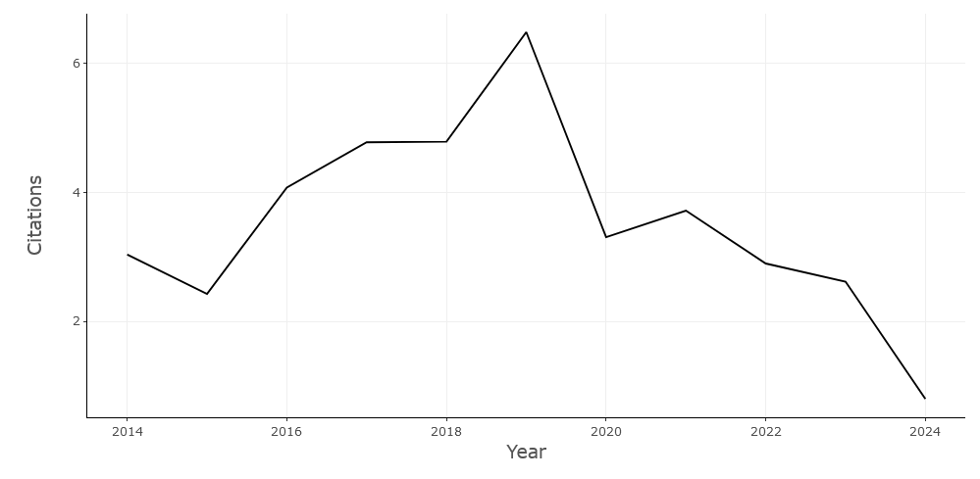

**Fig. 4. Average Citations Per Year**

**4.4 Author’s Outputs**

A bar chart showing the number of papers written by different researchers in marketing and artificial intelligence is shown in Figure 5. With four published documents, author *"JR"* stands out as having the most, according to the chart. Three writers who have each contributed three publications—*"NDLOVU J," "ERIKSSON H,"*and *"NYATHI D"—*follow closely behind. *"PAUL S," "ABBAS A," and "ABEJE MT"* are among the seven writers who have each published two documents. This visual representation summarizes the relative research output of these authors in the given field.

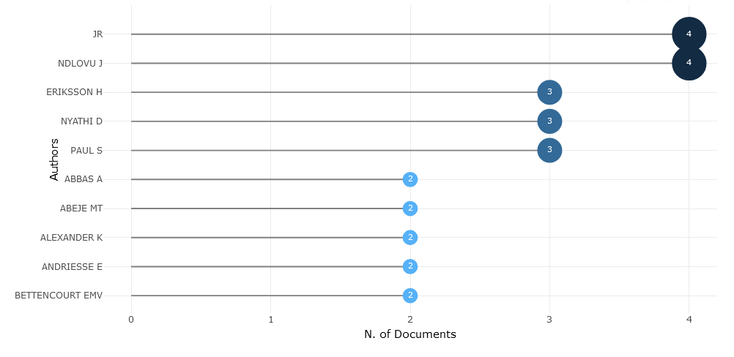

**Fig. 5. Most Relevant Authors**

**4.5** **Author Efficiency using Lotka's Law**

A distribution of writers according to the quantity of documents they have authored is shown in Figure 6. The number of papers written is shown on the x-axis, and the proportion of writers who have authored those documents is shown on the y-axis. As the number of papers created rises, the graph indicates a sharp drop in the percentage of writers. This suggests that while a lower fraction of authors have authored a more significant number of documents, a higher proportion have written only a handful. The graph's form points to a power-law distribution, in which the bulk of writers produce very little work while a tiny minority are pretty busy.

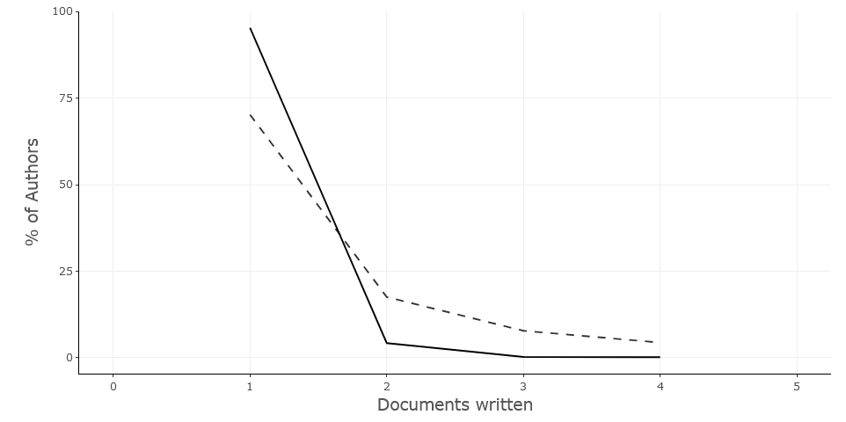

**Fig. 6. Author Efficiency using Lotka's Law**

**4.6 Corresponding Author’s Countries**

The bar chart illustrates the extent of international collaboration and contrasts the research output of various countries. Each nation is represented by a horizontal bar with segments that denote publications from Single Country Publications (SCP) and Multiple Country Publications (MCP). India has the highest number of publications, and a substantial proportion of these publications are the outcome of collaborative efforts. In addition, the United States and Australia exhibit substantial research production, which is distinguished by integrating individual and collaborative endeavors.

MCPs primarily drive the modest publication activity of Ghana and China. Conversely, Ethiopia and South Africa are countries with a reduced publishing volume and a higher percentage of SCPs. Germany, Indonesia, and Sweden exhibit comparable levels of research productivity by employing a balanced combination of group and solitary research projects. The remaining nations have a relatively low publication count due to their varying levels of collaborative activity. This graphic demonstrates the extent of international collaboration in the subject of study under investigation, as India, the United States, and Australia continue to make significant contributions to the global research scene.

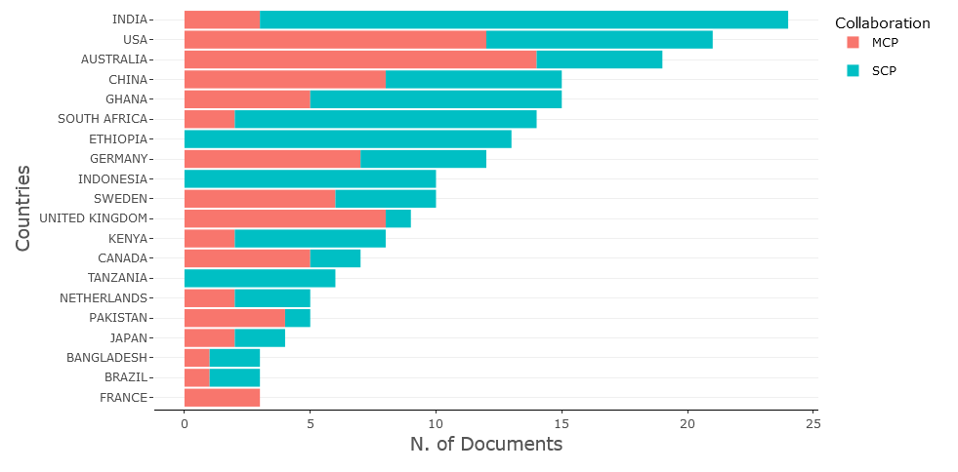

**Fig. 7. Corresponding Author’s Countries**

**4.7 Countries' Production over Time**

Australia, China, India, Indonesia, and the United States are the five nations shown in the line graph, which shows the trajectory of scientific article output from 2014 to 2024. Over time, the production of articles has steadily increased in all nations, albeit at different rates. Notably, with their lines continuously above the others, China and the USA exhibit the most notable development trajectories. While Australia and Indonesia show more moderate growth in scientific production, India too exhibits a significant increasing trend. The dynamic terrain of scientific research in these five nations is graphically represented by the graph, which also highlights the disparities in their contributions to the creation of knowledge worldwide.

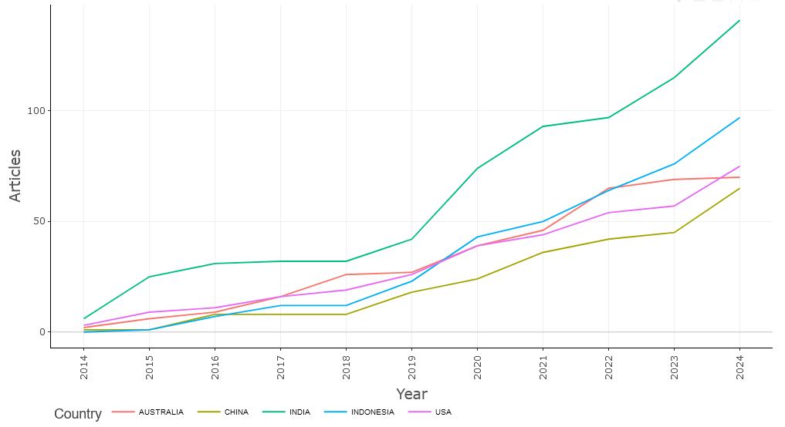

**Fig. 8. Countries' Production over Time**

**4.8 Active Institutions**

A bar chart ranking various sources according to the quantity of papers they have released is shown in Figure 9. The number of documents is shown on the x-axis, while the sources are listed on the y-axis. Colored circles are used to symbolize the bars, and the size of the circle indicates how many papers there are. *Sustainability (Switzerland)* is the source with the most documents, followed by *"Climate and Development"* and *"Journal of Rural Studies."* There are fewer papers in the remaining sources, which range from eight to five. The relative output of different sources in terms of published documents is clearly shown in this visualization.

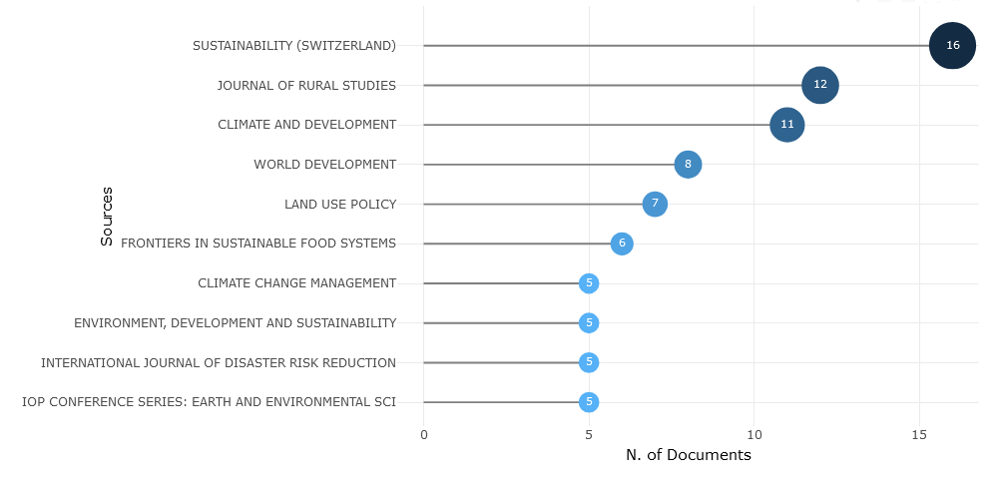

**Fig. 9. Most Relevant Sources**

**4.9 Words' Frequency over Time**

Cumulative occurrences for many words associated with climate change and rural development from 2014 to 2024 are shown in Figure 10. The phrases include *"Adaptive Management," "Agriculture," "Climate Change," "Food Security," "India," "Livelihood," "Rural Area," "Rural Development,"* and *"Rural Economy,"* along with *"Rural Population."* Every line shows an upward trend over time, signifying a growing number of events. With its line continuously above the others, *"Climate Change"* exhibits the most notable increase. *"Rural Development"* and *"Agriculture"* both show notable rising patterns. While *"Adaptive Management"* and *"Rural Economy"* indicate a steadier increase*, "India"* and *"Rural Area"* show moderate growth. The changing emphasis on these phrases throughout the decade concerning rural development and climate change is graphically depicted in the graph.

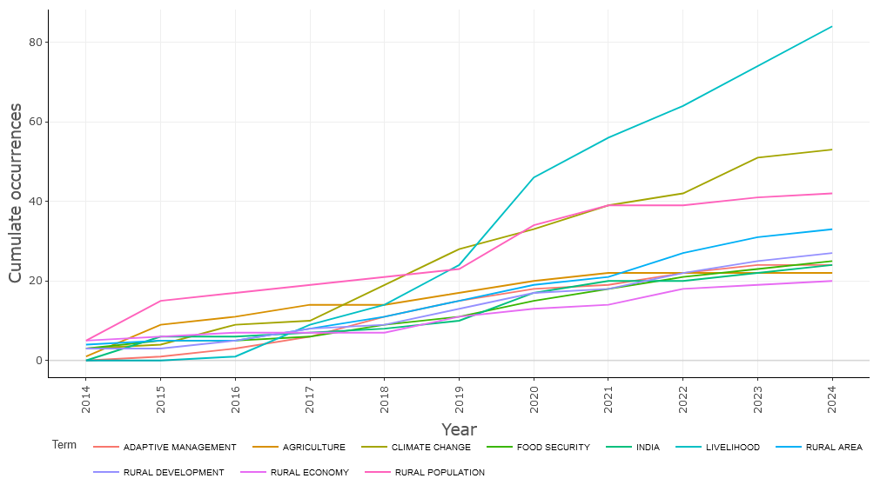

**Fig. 10. Words' Frequency over Time**

**4.10 Network Analysis Analysis**

A network diagram showing the connections between different ideas within a study field—likely linked to sustainability and rural development—is shown in Figure 11. The network is shown as a web of nodes, each of which represents a distinct notion or term, joined by lines that show how they relate to one another. The prominent placement of the core node, *"livelihood,"* suggests that it plays a crucial function in the network. Important ideas related to *"livelihood"* include *"food security," "rural development," "climate change," and "economic development."* Clusters of connected concepts are shown by the network structure, indicating different subject regions within the research domain. The network's structure and underlying linkages are further enhanced by the color-coding of nodes, which probably denotes various categories or groups of concepts.

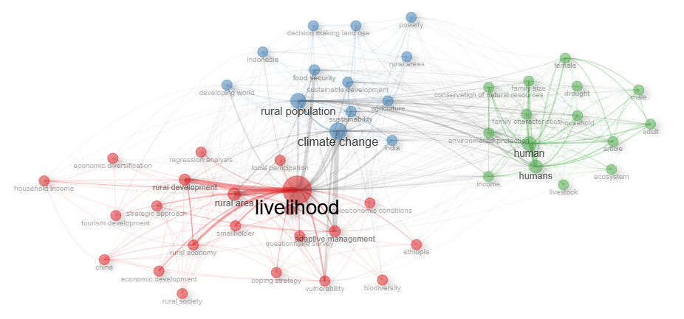

**Fig. 11. Co-occurrence Network**

**4.11 Trend topics**

Figure 12 seems to be a timeline or trend analysis chart that shows how research interest in different concepts connected to sustainability and rural development has changed over time. While the y-axis includes various concepts or keywords, the x-axis depicts the years 2014–2024. Every phrase is linked to a segment of a horizontal line, and the year that a term was most often used or studied is indicated by the presence of a blue dot on the line. The blue dot's size may represent the volume or level of research effort for that phrase in that specific year. All things considered, the graph shows how the emphasis on study has changed and developed over the past ten years, with certain phrases becoming more well-known while others stay mostly the same. It may be used to determine the relative relevance of various study subjects within the area, as well as new trends and waning interests.

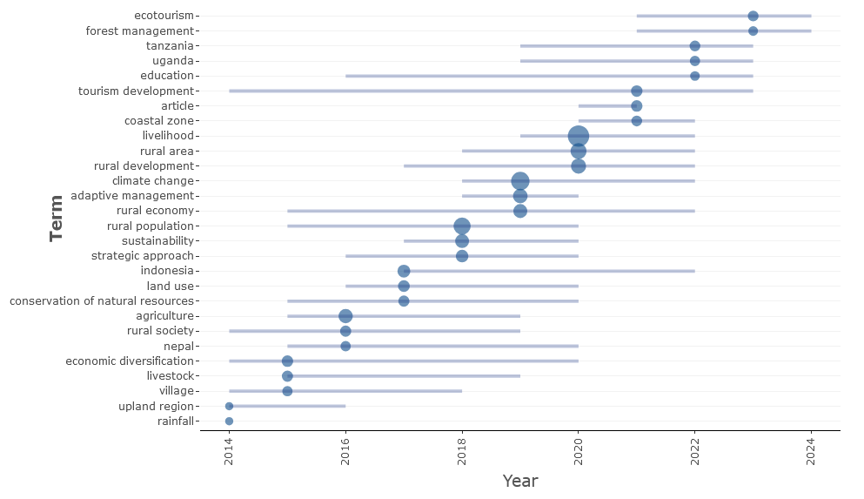

**Fig. 12. Trend topics**

5.0 Discussion

Table 1 summarizes eight significant papers that examine livelihood diversification in rural communities through various methodologies and datasets. Reddy and Kumar (2018) utilize quantitative econometric analysis to investigate the issue of traditional agriculture's failure to ensure a stable income for rural households. The authors identify challenges in utilizing rural household surveys and secondary national datasets, including dependence on cross-sectional data and a lack of longitudinal insights. Their findings demonstrate a correlation between livelihood diversification and a 20% increase in income stability for smallholder farmers. Patel et al. (2020) employ a mixed-methods approach, integrating detailed case studies with quantitative analysis to investigate the impact of low adoption of technology-driven practices on resource utilization and efficiency in agriculture. Despite encountering obstacles such as elevated technology adoption costs and limited access to precision tools, their study, grounded in Scopus-indexed articles and field interviews, demonstrates that integrating digital tools can result in a 30% enhancement in crop yield and resource management.

Gupta and Singh (2019) employ a qualitative, ethnographic methodology to elucidate the socio-cultural barriers and traditional mindsets that impede livelihood diversification. In-depth interviews and community observations indicate resistance to change within local communities, highlighting the necessity for targeted extension services to encourage diversification. Chatterjee et al. (2021) perform a policy analysis alongside a systematic literature review to examine how the lack of integrated policies intensifies rural poverty and restricts diversification. The study synthesizes government reports and bibliometric data from Scopus, indicating that adopting integrated policy frameworks may reduce rural poverty by as much as 18%.

Singh and Rao (2020) employ quantitative regression modeling to examine the limitations imposed by market instability and economic vulnerability on diversification. The authors identify challenges, including restricted access to formal credit systems and market variability. They utilize national agricultural datasets and household surveys to illustrate that diversified income sources can enhance net household income by 15–20%. Mehta and Rao (2020) utilize a mixed-methods approach, incorporating surveys and focus groups, to analyze the short-term advantages of diversification in terms of long-term sustainability issues. The lack of longitudinal studies and insufficient examination of gender-specific effects necessitate additional research.

Chatterjee et al. (2019) performed a systematic literature review, examining more than 50 high-impact studies to conclude that diversified livelihoods correlate positively with increased social capital, notwithstanding data heterogeneity and the absence of standardized metrics. Sharma et al. (2019) conducted a quantitative meta-analysis demonstrating that climate variability significantly heightens economic risks in traditional farming systems. Their meta-analytic dataset, derived from Scopus-indexed articles, indicates that implementing diversification practices can mitigate vulnerability by roughly 25%. This table summarizes various research approaches, problem definitions, methodological challenges, datasets, and key findings, providing a comprehensive overview of the current understanding of livelihood diversification in rural communities.

6.0 Research Gap and Future Direction

Despite the increasing body of literature on livelihood diversification, much remains unclear about diversification dynamics across heterogeneous rural contexts—regarding the complex drivers, barriers to, and outcomes of diversification (Pham et al., 2021). Prior research tends to focus on specific areas of a problem or specific approaches, leading to fragmented insights that prevent the development of comprehensive frameworks that are universally applicable across many socioeconomic and environmental contexts. Moreover, we know little about how diversifying rural livelihoods interacts with new global challenges such as climate change, digital revolution, and economic shocks (Ma et al., 2023). There has been little attention given to the impact of intersectional variables (e.g., age, gender, social networks) on the outcomes of diversity. In addition, the lack of longitudinal evidence makes it harder to understand the sustainability and longer-term impacts of livelihood solutions.

Future studies should aim to fill these gaps by documenting the evolution of this topic using multidisciplinary approaches and advanced methods such as bibliometric and network analysis (Assad & Bouferguene, 2022). Further interregional comparison research is needed to identify overarching principles and situational adjustments. Why investigate to what extent diversification strategies integrate innovation, technology, and green economy practices and could provide valuable lessons practical for rural sustainability and resilience. Moreover, focusing on participatory research that incorporates the needs and perspectives of rural communities ensures that recommended strategies are aligned with local realities and objectives. By addressing these gaps, future research can help advance these evidence-based policies for sustainable rural development and contribute to a more holistic understanding of livelihood diversification (Xing et al., 2025). Future studies should aim to fill these gaps by documenting the evolution of this topic using multidisciplinary approaches and advanced methods such as bibliometric and network analyses. Further interregional comparison research is needed to identify overarching principles and situational adjustments. Why investigate to what extent diversification strategies integrate innovation, technology, and green economy practices and could provide valuable lessons for rural sustainability and resilience? Moreover, focusing on participatory research that incorporates the needs and perspectives of rural communities ensures that recommended strategies are aligned with local realities and objectives. By addressing these gaps, future research can help advance these evidence-based policies for sustainable rural development and contribute to a more holistic understanding of livelihood diversification.

7.0 Conclusions

Livelihood diversification is one of the most potent strategies for achieving global development goals of sustainable rural development, reducing vulnerabilities, and increasing resilience against global challenges such as urbanization, economic instability and climate change. Therefore, this study employs scientific articles indexed in Scopus from 2014 to 2024 to provide a comprehensive literature review and bibliometric analysis of the research on livelihood diversification. The findings indicate that this area has become more active as a field of scholarly inquiry, bringing into focus topics, notable authors, and emerging research frontiers. We highlight the need to map the intellectual landscape of livelihood diversification via advanced bibliometrics and multidisciplinary cross-fertilization in this space. It shows that while much progress has been made in understanding diversification's drivers, strategies and outcomes, there are still key research gaps, particularly around the need to address the complexities of different rural contexts, the role of intersectional factors, and the long-term impacts of livelihood strategies. We need policies to enable cross-domain and transnational research involving state-of-the-art approaches such as digital transformation, green economic strategies, and participatory methods. By orienting future research toward regional realities and global challenges, scholars, decision-makers, and practitioners may better design and implement evidence-based strategies to ensure that rural populations can attain a sustainable livelihood. Ultimately, this synthesis is not only a valuable addition to the academic discussion on livelihood diversification but also a critical instrument for informing practical policies and practices designed to address poverty alleviation, enhanced food security, and socioeconomic development in rural areas worldwide.

Competing interests

The authors declare no conflict of interest.

References

1. Assad, A., & Bouferguene, A. (2022). Resilience assessment of water distribution networks – Bibliometric analysis and systematic review. Journal of Hydrology, 607, 127522. https://doi.org/10.1016/j.jhydrol.2022.127522
2. Chatterjee, S. (2024). Inclusive Economic Growth in India: Inducing Prosperity and Ending Deprivations. Taylor & Francis.
3. Hegazi, F., & Seyuba, K. (2024). Gender, livelihood diversification and food security: Insights from rural communities in Zambia. Journal of Rural Studies, 109, 103321. https://doi.org/10.1016/j.jrurstud.2024.103321
4. Jatav, S. S. (2024). Farmers’ perception of climate change and livelihood vulnerability: A comparative study of Bundelkhand and Central regions of Uttar Pradesh, India. Discover Sustainability, 5(1), 11. https://doi.org/10.1007/s43621-024-00193-7
5. Jing, Z., Yu, Y., Wang, Y., Su, X., Qiu, X., Yang, X., & Xu, Y. (2024). Study on the mechanism of livelihood behavior decision of rural residents in ethnic tourism villages in Western Sichuan. Ecological Indicators, 166, 112250. https://doi.org/10.1016/j.ecolind.2024.112250
6. Khanam, M., Pervez, A. K. M., Haque, M. A., Rahman, M. M., & Kabir, M. S. (2023). Bibliometric Analysis of Farmers’ Rural-Urban Migration Based on the Scopus Platform. South Asian Journal of Social Studies and Economics, 20(3), 93–103.
7. Ma, W., McKay, A., Rahut, D. B., & Sonobe, T. (2023). An introduction to rural and agricultural development in the digital age. Review of Development Economics, 27(3), 1273–1286. https://doi.org/10.1111/rode.13025
8. Mahedi, M., Shaili, S., & Shihab, A. (2024). Livelihood Diversification as a Reduce to Rural Vulnerability in Bangladesh: A Review.
9. Kabir, M. S., Mahedi, M., Pervez, A. K. M. K., Alam, M. J., & Shaili, J. S. (2025). Bibliometric analysis of 'precision agriculture' in the Scopus database. World Journal of Advanced Research and Reviews, 25(03), 1087-1098. Article DOI: https://doi.org/10.30574/wjarr.2025.25.3.0733
10. Mondal, S., Gupta, H., & Singh, S. (2024). Barriers and Enablers of Community Entrepreneurship Ventures: A Mixed Method Approach. IEEE Transactions on Engineering Management, 71, 15209–15223. https://doi.org/10.1109/TEM.2024.3445989
11. Noja, R. G., Baditoiu, B. R., Buglea, A., Munteanu, V. P., & Gligor Cimpoieru, D. C. (2024). The impact of environmental, social and governance policies on companies’ financial and economic performance: A comprehensive approach and new empirical evidence. E+M Ekonomie a Management, 27(1), 121–144. https://doi.org/10.15240/tul/001/2024-1-008
12. Peng, W., Robinson, B. E., Zheng, H., Li, C., Wang, F., & Li, R. (2022). The limits of livelihood diversification and sustainable household well-being, evidence from China. Environmental Development, 43, 100736. https://doi.org/10.1016/j.envdev.2022.100736
13. Pham, T. T. H., Revilla Diez, J., & Garschagen, M. (2021). A typology of household livelihood changes in rural coastal areas of the Vietnamese Mekong Delta—Capturing the heterogeneity and complexity of the social‐ecological context. Singapore Journal of Tropical Geography, 42(2), 241–263. https://doi.org/10.1111/sjtg.12335
14. Reddy, K., & Kumar, G. (2018). Green and sustainable remediation of polluted sites: New concept, assessment tools, and challenges. Ce/Papers, 2(2–3), 83–92. https://doi.org/10.1002/cepa.663
15. Roscher, M. B., Allison, E. H., Mills, D. J., Eriksson, H., Hellebrandt, D., & Andrew, N. L. (2022). Sustainable development outcomes of livelihood diversification in small‐scale fisheries. Fish and Fisheries, 23(4), 910–925. https://doi.org/10.1111/faf.12662
16. Saha, M. K., Biswas, A. A. A., & Faisal, Md. (2024). Livelihood vulnerability of coastal communities in context of the climate change: A index-based assessment. World Development Sustainability, 4, 100152. https://doi.org/10.1016/j.wds.2024.100152
17. Singhania, O., Swain, S. K., & George, B. (2022). Interdependence and complementarity between rural development and rural tourism: A bibliometric analysis. Rural Society, 31(1), 15–32. https://doi.org/10.1080/10371656.2022.2062198
18. Ulukan, D., Bergkvist, G., Lana, M., Fasse, A., Mager, G., Öborn, I., & Chopin, P. (2022). Combining sustainable livelihood and farm sustainability approaches to identify relevant intensification options: Implications for households with crop-based and gathering-based livelihoods in Tanzania. Ecological Indicators, 144, 109518. https://doi.org/10.1016/j.ecolind.2022.109518
19. Vlahek, J. (2019). Artisan sustainable livelihoods and the marketing of Myanmar handicrafts [PhD Thesis, Deakin University]. https://dro.deakin.edu.au/articles/thesis/Artisan_sustainable_livelihoods_and_the_marketing_of_Myanmar_handicrafts/21113569/1/files/37457386.pdf
20. Xing, L., Cao, C., & Elahi, E. (2025). Advancing coupling coordination: Bridging China’s digital economy and green agriculture for sustainable rural development. Information Technology for Development, 1–22. https://doi.org/10.1080/02681102.2024.2447595

**Table 1. Related work on Livelihood Diversification**

|  |  |  |  |  |  |
| --- | --- | --- | --- | --- | --- |
| **Paper** | **Approach** | **Problem Definition** | **Challenges** | **Dataset** | **Result** |
| (Reddy & Kumar, 2018) | Mixed-methods – Case Studies Combined with Quantitative Analysis | Low adoption of technology-driven practices limits resource use and efficiency in agriculture | High costs of technology adoption; limited access to precision agriculture tools | Scopus-indexed articles and field interviews | Integration of digital tools led to a 30% improvement in crop yield and resource management. |
| (Mondal et al., 2024) | Qualitative – Ethnographic Study | Socio-cultural barriers and traditional mindsets hinder livelihood diversification | Resistance to change among local communities; deeply entrenched cultural practices | In-depth interviews with farmers and community observations | Identified the need for targeted extension services to foster a shift toward diversified livelihoods. |
| (Chatterjee, 2024) | Policy Analysis and Systematic Literature Review | Lack of integrated policies exacerbates rural poverty and limits livelihood diversification | Fragmented data sources; policy implementation gaps | Government reports combined with bibliometric data from Scopus | Suggests that integrated policy frameworks could reduce rural poverty by up to 18%. |
| (Jatav, 2024) | Quantitative – Regression Modeling | Market instability and economic vulnerability restrict the ability to diversify livelihoods | Limited access to formal credit systems; high variability in market prices | National agricultural datasets and household surveys | Demonstrated that diversified income sources can boost net household income by 15–20%. |
| (Vlahek, 2019) | Mixed-methods – Surveys and Focus Groups | Short-term benefits of diversification are not well-documented against long-term sustainability challenges | Scarcity of longitudinal studies; underexplored gender-specific impacts | Scopus-indexed articles and focus group transcripts | Highlighted the need for longitudinal and gender-sensitive research to better capture sustainability. |
| (Singhania et al., 2022) | Systematic Literature Review | Impacts of livelihood diversification on social cohesion remain underexplored | Data heterogeneity; lack of standardized metrics across studies | Bibliometric analysis of over 50 high-impact studies | Found a positive association between diversified livelihoods and enhanced social capital. |
| (Noja et al., 2024) | Quantitative – Meta-analysis | Climate variability significantly increases economic risk in traditional farming systems | Inconsistent reporting standards across studies; variable regional impacts | Meta-analytic dataset from Scopus-indexed articles | It was reported that adopting diversification practices reduces vulnerability by approximately 25%. |