**EVALUATION of SECONDARY METABOLITES and FUNCTIONAL GROUPS in *Derris elliptica (Wall) Benth* for NATURAL PEST CONTROL**

**ABSTRACT**

This study aimed to evaluate the secondary metabolites and functional groups present in *Derris elliptica (Wall) Benth* leaves and roots, the significant difference on efficacy of the extracts and commercially available pesticide. The results revealed that the pure leaf extract has a flavonoids, steroids and tannins, whereas in the root extract were alkaloids, flavonoids, saponins, steroids, and tannins. This implied that the root extract has secondary metabolites pesticide presence of alkaloids and has a direct rotenone toxicity symptom leading to inhibition of growth which ultimately results in the death of insect. **Fourier Transform Infrared Spectroscopy (FT-IR) analysis** identified key functional groups, including **carbonyl (C=O), aliphatic (C-H), and hydroxyl (O-H) groups**, supporting the bioactivity of Tubli. Statistical analysis using **ANOVA** revealed a **significant difference** in cockroach mortality rates across different extract concentrations. The **100% root extract concentration showed the highest efficacy**, comparable to that of a commercial pesticide. These findings highlight the **potential of** Derris elliptica **root extract as a natural, eco-friendly, and cost-effective alternative to synthetic pesticides**. Future studies should focus on **the exploration of other plant species within the Fabaceae or Faboideae family** for their pesticidal properties and or other properties. This research contributes to the **development of sustainable and environmentally friendly pest management solutions** using plant-based insecticides.

**Keywords:** Rotenone, secondary metabolites, pesticide

**I. INTRODUCTION**

The *Derris elliptica (Wall) Benth* genus of vines is found in the Old World tropics, especially South East Asia. In the province of Pambujan, Northern Samar, *Derris elliptica* is commonly known as Tubli. It was often found in forest, along rivers and roadsides.

Pest control in the recent years has become a major problem in almost all agricultural countries. A number of pest control strategies have been developed to manage various pests under different situation. However, pesticides continue to be the single most widely used pest control due to their ease of application and rapidity of action (Ecobichon, 2001).

To overcome increasing problems encountered with the excessive use of pesticides, efforts was being made to turn to the use of alternative methods that was environmentally friendly and relatively lower cost compared to the chemical pesticides. A large number of plants have been reported to possess insecticidal properties (Bohmon, 2000).

Plant extracts provide a safe and viable alternative to synthetic pesticides and was compatible with the use of beneficial organism, pest- resistant plants and to preserving a healthy environment in an effort to decrease reliance on synthetic pesticides. (Erdogan, et al.,2012).

This study was conducted to evaluate the secondary metabolites and functional groups present in*Derris elliptica (Wall) Benth* leaf and root as an agent for being a natural pest control.

**II. MATERIALS AND METHODS**

**Materials**

The researchers used the following materials and instruments according to their respective applications:

**Cockroaches-** conceptually define as a seavenging insects that resembles a beetle, having long antennae and legs typically a broad, flattened body. Operationally the test insect that will use by the researcher in order to test the effectiveness of formulated from Derris elliptica.

**Derris elliptica-** conceptually, a species leguminous plant from Southeast Asia and the Southwest Pacific Islands. Operationally, a scientific name of “tubli” the experimental plant that will use in this study to test the effectiveness of plant extracts from Derris elliptica.

**Research Design**

This study employed an experimental research design with six treatments and three replications to determine the pesticidal efficacy of the experimental sample and positive control.

**Research Methods and Procedures**

**Preliminary Activities**

The fresh leaves of Tubli were collected in Barangay Cababto-an, Pambujan, Northern Samar. The Tubli leaves were washed with water and dried. After that, the Tubli leaves were cut into smaller pieces with the use of scissors. The cut leaves were juiced using a manual juicer. The extracts of the plant sample were filtered using a funnel with filter paper to remove leaf particles and all other solid substances from the extract. The collected pure extracts of the plant sample were poured separately into a bottle, and was tightly capped and stored in a refrigerator until used in the test for determining the physical properties and secondary metabolites. On the other hand, fresh Tubli roots were collected in Barangay Cababto-an, Pambujan, Northern Samar. One kilogram (1kg) of roots were washed and air dried for one day. After drying, the roots were cut into smaller pieces and placed an oven for drying then it was pulverized using a grinder. Pulverized roots were kept in dry bottle, macerated, and soaked in 80% analytical grade ethanol for three (3) days. The resulting suspension was filtered and subjected to rotary evaporator for extraction at 70°C. After rotary extraction, the Tubli root extract was incubated at 60°C to 70°C to remove the remaining alcohol.

**Phytochemical Screening**

For secondary metabolites determination of Derris Elliptica (Tubli) Extracts, procedures were done in triplicate. The applied procedures are adopted in Guevara, et al. (2004)

**Detection of Alkaloids:**

Dragendorff’s reagent, and Mayer’s reagent were used to test the presence of alkaloid on the tubli leaf, and root extracts. By adding one (1) mL of Dragendorff’s reagent to two (2) mL of leaf, and root extracts in the separate test tubes, an orange red precipitate was formed, indicating the presence of alkaloids. While on Mayer’s test, few drops of Mayer’s reagent were added to one (1) mL of leaf,and root extracts. A yellowish or white precipitate was formed, indicating the presence of alkaloids.

**Detection of Flavonoids**

To detect the presence of flavonoids, a five(5) mL of the tubli leaf, and root extracts in the separate test tubes, was mixed with 0.1g of Metallic Zinc, and added eight (8)mL of concentrated sulfuric acid. The mixture was observed for red color as indicative of flavonoid.

**Detection of Saponins**

Saponin test used the standard Froth, and Foam tests to detect and confirm the presence of saponin in tubli leaf, and root extracts.

Froth Test: A 5mL of leaf and root extracts of

Tubli in a separate test tubes were added with

20 mL distilled water and shaken vigorously for5 minutes. It was allowed to stand for 10 minutes and observed for honeycomb froth, which

was indicative of the presence of saponins.

Foam Test: A five (5) mL of tubli leaf, and root extracts was shaken vigorously in the separate test tube for five (5) minutes. Development of stable foam suggested the presence of

saponin.

**Detection of Steroids**

Salkowski test was used to detect the presence of steroids. Placed one (1)mL of tubli leaf, and root extracts into the separate test tubes then added two (2)mL of chloroform and wait for a few seconds then added five (5) drops concentrated sulfuric acid, and if a green color was produced in the forms of ring, the presence of steroids was confirmed.

**Detection of Tannins**

Ferric chloride test was used to detect the presence of tannins.

A two (2)mL of tubli leaf, and root extracts in a

separate test tubes were added with three (3

mL of distilled water and then added three (3)

drops of 10% ferric chloride. It gave a blue-bla

ck color that indicated the presence of hydroly

zable tannins while a brownish-green color ind

icated the presence of condensed tannins.

**Preparation of the Tubli leaf , root extract and positive control at different concentration.**

The different concentration from the filtered leaves, and roots extract of tubli samples were prepared as follows.

1.50% concentration- 5 mL of pure tubli leaves extract was added with 5 mL distilled water.

2.100% concentration- the pure tubli leaves extract without adding water.

3.50% concentration- 5 mL of pure tubli root extract was added with 5 mL distilled water.

4.100% concentration- the ethanolic tubli root extract without adding water.

5. 50% concentration - 5 mL of commercial pesticide was added with 5 mL distilled water.

6.100% concentration - 10 mL of commercial

pesticide.

**Collection of Experimental Insects**

Cockroaches were collected from several locations, a total of 90 cockroaches were used in this study. Fishing was used in collecting the insects that were transferred to clear round disposable plastic containers.

**Administration of the Test Substances to the Cockroaches.**

In testing the efficacy of plant extracts as pesticides, five (5) cockroaches was placed in a cages covered with a clear net. Four (4) mL of each concentration (50%, and 100%) of the fresh leaves, roots extract and commercial pesticide were poured separately in a bottle spray, then sprayed on the cage containing the test insects. The number of dead cockroaches was recorded (the efficacy) after 15 minutes, 30 minutes, 45 minutes, and 60 minutes. This

was done thrice.

**Data Analysis Procedure**

Analysis of Variance (ANOVA) was used to determine the significant differences between the average of mortality of cockroaches in the different concentration based on different treatments. The percentile was employed to compare the pesticidal efficacy between the extracts and commercial pesticide / positive control.

**III. RESULTS**

**Phytochemical Screening on Tubli Extracts**

The table below illustrates the results of secondary metabolites for Tubli leaf, and root extracts in terms of Alkaloids, Flavonoids, Saponins, Steroids and Tannins.

Phytochemical screening revealed that Tubli leaf extract contains flavonoids, steroids, and tannins, while the root extract contains alkaloids, flavonoids, saponins, steroids, and tannins. This indicates that the root extract possesses secondary metabolites with pesticidal properties, particularly due to the presence of alkaloids. Rotenone is an alkaloid, a key compound, exhibits toxicity symptoms that inhibit insect growth, ultimately leading to their death. (Int J Mol Sci. 2022).

**Table 1. Secondary metabolites of Tubli Extracts**

|  |  |  |
| --- | --- | --- |
| **Phytochemical Screening** | **Tubli leaf extract** | **Tubli root extract** |
| **Alkaloids** | Negative | Positive |
| **Flavonoids** | Positive | Positive |
| **Saponins** | Negative | Positive |
| **Steroids** | Positive | Positive |
| **Tannins** | Positive | Positive |

**FT-IR Analysis of Tubli Samples**

The FT-IR spectra for the Tubli leaf and root powder were analyzed using FTIR spectrometer. When infrared radiation passes through a material, intensity passes through without interacting with molecules, while the remainder interacts with molecules and is absorbed. This makes infrared spectroscopy useful several types of analysis. (Marichelvam et al., 2018). The result of the characterization of the Tubli leaves and root samples using FT-IR Analysis was presented.

**Table 2. FT-IR Characterization on Tubli Leaf**

|  |  |  |
| --- | --- | --- |
| **FT-IR Analysis Result on Tubli Leaf** | | |
| **Observed Peaks**  **(cm-¹)** | **IR Assignment** | |
| **Functional Group** | **Range (cm-¹)** |
| 1610.81 | -C=O (Carbonyl group) | 1730-1650 |
| 2917.79 | -C-H (Aliphatic) | 2850-2950 |
| 3287.15 | -O-H (Hydroxyl group) | 3570-3200 |

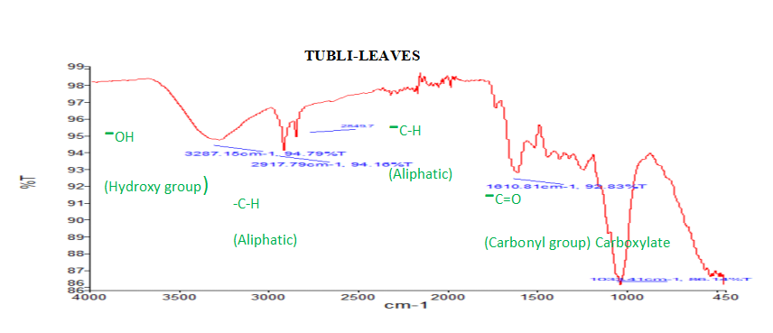

**Figure 1. FT-IR Analysis on Tubli Leaves**

**Table 3. FT- IR Characterization on Tubli Root**

|  |  |  |
| --- | --- | --- |
| **FT-IR Result on Tubli Root** | | |
| **Observed Peaks (cm-¹)** | **IR Assignment** | |
| **Functional Group** | **Range (cm-¹)** |
| 1606.95 | -C=O(Carbonyl group) | 1730-1650 |
| 1611.64 | -C=C-C (Aromatic ring) | 1600-1580 |
| 2922.7 | -C-H (Aliphatic) | 2850-2950 |
| 32888.16 | -O-H (Hydroxyl group) | 3570-3200 |

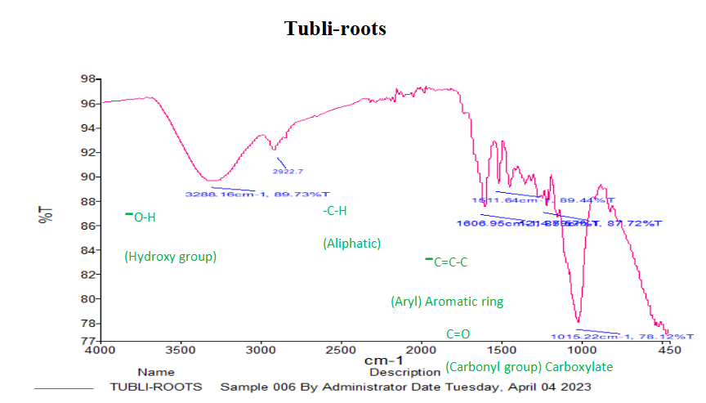

**Figure 2. FT-IR Analysis Result on Tubli Root**

Fourier Transform Infrared Spectroscopy (FTIR) analysis was conducted to identify the functional groups present in Tubli leaves and roots. The analysis revealed broad peaks in the range of 3287.15–3288.16 cm⁻¹, with additional peaks forming between 3200–3600 cm⁻¹, which are characteristic of the O-H (hydroxyl) functional group. These peaks can be attributed to the presence of glycerin, a polyol that contains multiple hydroxyl groups (Tahir et al., 2018). This suggests that Tubli contains compounds with hydroxyl-rich structures, which may contribute to its bioactivity.

The column graph below presents data on the pesticidal efficacy of Tubli (Derris elliptica) leaf and root extracts against cockroaches, compared to a commercial insecticide (positive control). The results are shown for different concentrations (50% and 100%) of each extracts, with the number of dead cockroaches recorded.

No cockroach mortality (0%) was observed at both 50% and 100% concentrations of Tubli leaf extract. Only that the cockroaches became weak after 45 minutes and revive after 60 mins. This indicates that Tubli leaf extract has a slight pesticidal effect on the cockroach.

While at 50% concentration of Tubli root extract has a 66.67% efficacy wherein, 10 out of 15 cockroaches died. In addition, 100% concentration of Tubli root extract has a 93.33% efficacy wherein, 14 out of 15 cockroaches died. The root extract showed a significant pesticidal effect, with higher mortality at 100% concentration. This confirms that Tubli roots contain bioactive compounds, particularly rotenone, which is known for its high toxicity to insects.

As to compare at 50% concentration of commercial pesticide with 86.67% efficacy, wherein 13 out of 15 cockroaches died. In addition, a 100% concentration of positive control has a 100% efficacy wherein all 15 cockroaches died.

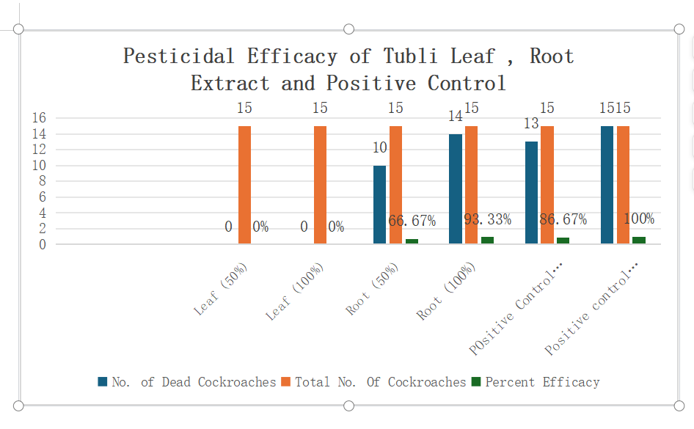

**Figure 3. Pesticidal Efficacy of Tubli Leaf, Root Extract and Positive Control**

**Analysis of Variance (ANOVA) for Pesticidal Efficacy of Tubli Extract**

The analysis of variance (ANOVA) examined the variability in cockroach mortality across the four treatment groups: **Tubli root 50%, Tubli root 100%, commercial pesticide 50%, and commercial pesticide 100%**.

Since the computed F-value **(3.90) is greater than the critical value (3.49)**, this means **at least one of the treatments has a significantly different effect** from the others, based on Table 4.

**Table 4. ANOVA data on Pesticidal Efficacy of Tubli root extract and Positive Control**

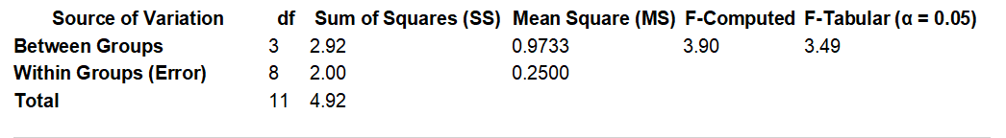

**Table 5. Comparative Analysis on Pesticidal Efficacy of Tubli root extract and Positive Control**

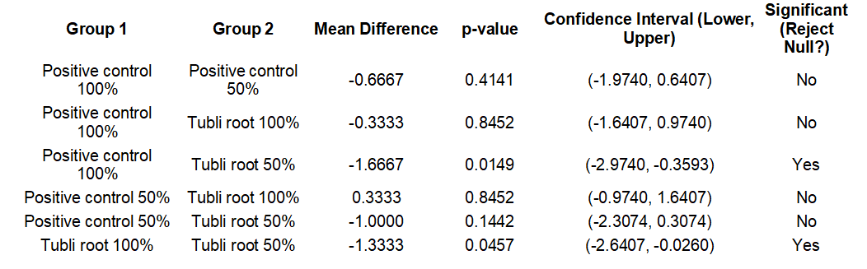

Table 5 indicated that the effectiveness of Derris elliptica (Tubli root) extract varies depending on concentration. The 100% concentration of Tubli root extract performs comparably to the positive control at both 100% and 50%, suggesting its potential as a natural pesticide. However, Tubli root extract at 50% concentration is significantly less effective than the positive control at 100%, indicating a reduction in pesticidal efficacy at lower concentrations. The significant difference between Tubli root 100% and Tubli root 50% suggests that higher concentrations are necessary for effective pesticidal action.

**IV. DISCUSSION**

This study was conducted to compare the pesticide efficacy of Derris elliptica (tubli) leaf and root extracts for the reason that these plant samples might contain active constituents that was effective as pesticidal agents. It also aimed to determine the secondary metabolites and functional group present in the leaves and roots of Derris elliptica (tubli).

Based on phytochemical screening, that Tubli root extract may be more effective as a bio-pesticide compared to the leaf extract due to the presence of alkaloids and saponins. Saponins have been reported to enhance permeability in insect cell membranes, which may facilitate the action of rotenone and other toxic compounds. Additionally, flavonoids and tannins may contribute to antioxidant and defensive mechanisms that further strengthen the plant’s insecticidal properties.

The FTIR spectra interactions between different components in the Tubli leaf and root samples. The leaf extracts caused weakening and reduced movement of the cockroaches after one hour, no significant mortality was observed. This suggests that Tubli leaves lack potent pesticidal properties, likely due to the absence of rotenone, the primary insecticidal compound found in the plant. Instead, the leaves are rich in flavonoids and tannins, which are known for their antioxidant and medicinal properties rather than insecticidal effects (Trease & Evans, 1983; Ayinde et al., 2007). Although these compounds may contribute to general plant defense mechanisms, they do not exhibit strong toxicity against insects.

In contrast, the ethanolic root extracts showed clear pesticidal activity, with mortality increasing over time. Treatment 4 recorded the highest number of dead cockroaches (14) after one hour, confirming the effectiveness of the root extract as an insecticide. The superior efficacy of Tubli roots can be attributed to rotenone, a well-documented natural insecticide that interferes with the mitochondrial electron transport chain, leading to energy depletion and eventual insect death (Binas, 2021). Additionally, Tubli roots contain lipid-based compounds, ceramides, and polyhydroxyl octadecenoic acid, which further enhance their pesticidal properties against a variety of insects, including aphids, flies, caterpillars, and ticks (Evans, 2002). Positive **c**ontrol confirming its high toxicity and rapid action. The commercial insecticide remains the most effective, killing all cockroaches at full concentration.

The ANOVA results indicate that there is a **statistically significant difference among the treatment groups** at the **0.05 significance level**. This means that at least one of the treatment groups differs significantly from the others in terms of efficacy. Further post-hoc analysis may be needed to determine **which specific groups** are significantly different from each other. This finding supports the hypothesis that Derris elliptica extracts may exhibit pesticidal activity at varying concentrations, and at least one concentration shows a distinct effect compared to others.

Based on **Tukey’s HSD test**, we observed that **Tubli root extract at 100% performs similarly to the positive control at 100%** but differs from Tubli root extract at 50%.

This supports the idea that **higher concentrations of Tubli root extract increase effectiveness**, making it a viable alternative to commercial insecticides at full strength.

**V. CONCLUSION**

Based on the research findings from the series of laboratory tests on the evaluation of secondary metabolites and functional groups in *derris elliptica (wall) benth* for natural pest control the researchers derived the following conclusions:

1. This study successfully evaluated the **secondary metabolites and functional groups** present in Derris elliptica (Tubli) leaves and roots, determining their potential use as a **natural pest control agent**. The phytochemical screening confirmed the presence of **alkaloids, flavonoids, saponins, steroids, and tannins**, which are known for their pesticidal properties. Notably, the root extract exhibited **higher pesticidal efficacy** due to the presence of alkaloids, particularly rotenone, a compound known for its insecticidal activity.
2. The **FT-IR analysis** identified key functional groups such as **carbonyl (C=O), aliphatic (C-H), and hydroxyl (O-H) groups**, further supporting the bioactivity of Tubli.
3. The **ANOVA results** revealed a **statistically significant difference** in the mortality rate of cockroaches treated with different extract concentrations, confirming the pesticidal potential of Tubli root extract, particularly at **100% concentration**.
4. Comparative analysis with a **commercial pesticide** indicated that **Tubli root extract at 100% concentration exhibited a comparable effect** on cockroach mortality, highlighting its potential as an alternative, eco-friendly, and cost-effective pesticide.

This research supports the **sustainable use of natural plant extracts** as an alternative to synthetic pesticides, contributing to safer and more environmentally friendly pest management solutions.

References

1. Ayinde B.A.,E.K., Omogboi, F.C. Amaechina, (2007). Pharmacognosy And Hypertensive Evaluation Of Ficus Exasperate Vahl (Moraceae) Leaf. Pharmacological Article 64. Page 543-546.
2. Bala, A. Y., & Sule, H. (2012). Vectorial potential of cockroaches in transmitting parasites of medical importance in Arkilla, Sokoto, Nigeria. Nigerian Journal of Basic Applied Science, 20(2), 111–115.
3. Balico, E.C(2013). Anti-termicidal of Gliricidea sepium Steud. (Kakawate), Piper bettle Linn. (Buyo), and Jatropha curcas Linn. (Tubang Bakod) leaf extracts. University of Eastern Philippines.Unpublished.
4. Binas, Enrique, (2021). Tubli Plant Used as Organic Pesticide: Input toward Sustainable Agriculture. Jose Rizal Memorial State University.
5. Broto, A.S. (2008). Statistics Made Simple. 2nd ed. Mandaluyong City: National Book Store, p.96.
6. Christian Alcera, (2021). “EFFICACY of Derris elliptica (TUBLI), Annona Squamosa Linn. (ATIS) and Lantana Camara Linn. (KORONITAS) LEAVES EXTRACT AS TERMICIDAL AGENT,” University of Eastern Philippines. Unpublished.
7. Eiman, A. (2018). Diospyros blancoi(kamagong) leaf and Decayed Fruit Extracts as Pesticide for Termites. Unpublished Thesis. College of Science. University of Eastern Philippines.
8. Erdogan,P., A. Yildirim, B. Server, (2012). Investigation on the Effects of Five Different Plant Extracts on the Two-Spotted Mite Tetranychus urticae Koch (Arachnida: Tetranychidae). Journal of entomology. Volume (2012), Article ID 125284, 5 pages.
9. Evans, W.C. (2002). Trease and Evans Pharmacognosy, 15th Ed; W.B, Saunders: London, 2002; pp.510-511. Date access: June 202
10. Jessa, O.E., R.B, Ikomi, and S.O. Asagba. (2015). The Effect of Dry Extract of Derris elliptica Stem on some Enzymatic changes in the Plasma of African Catfish Clarias gariepinus Jordan Journal of Biological Sciences volume 8, Number 2, June. (2015) ISSN 1995-6643 Pages 101-105.
11. Junaid S. and Mk P. (2020). Qualitative test for preliminary phytochemical screening: An overview. International Journal of chemical studies: 603-608
12. Lu,H.Y., and J.Y. Liang (2009). Rotenoids from the Root of Derris elliptica (Roxb.) Benth. II. Chinese Journal of Natural Medicines Volume, 2009, 7, Issue 1, Pages 24-37.
13. Moges, F., Eshetie, S., Endris, M., Huruy, K., Muluye, D., Feleke, T., … Nagappan, R. (2016). Cockroaches as a source of high bacterial pathogens with multidrug resistant strains in Gondar Town, Ethiopia. BioMed Research International, Article ID 2825056. <https://doi.org/10.1155/2016/2825056.>
14. Nguyen, A, and Y. Phan. (2014). Preliminary Phytochemical analysis of different solvent extract of Derris elliptica (Roxb.) Benth leaves. International Journal of Innovative and

Applied Research Volume 2, 2014, Issue (12): 74-76.

1. Olufayo, M. (2009). Haematological Characteristics of Clarias gariepinus (Burchell 1822) Juveniles Exposed to Derris Elliptica “ROOT POWDER” Ajfand, volume 9 No.3 2009. Date access: July 10,2011.
2. Orwa C., A. Mutual, R. Kindt, R. Jamnadass, S. Anthony. (2009). Derris elliptica. Agroforestry Database 4.0.
3. Premree, P. and N. Sukhapanth. (1990). Phytochemical toxicity of the crude extract from Derris elliptica Benth. On mosquito larvae. J. Sci. Soc. Thailand, 16, 133-139.
4. Rattanapan, A. (2009). “Effect of rotenone from Derris crude extract on esterase enzyme mechanism in the beet armyworm, spodoptera exigua (Hubner). Research Support, Non-U.S. Gov’t, Journal Article, 2009, 74 (2): 437-444].
5. Starr, F., F. Starr, L. Loope. (2003) Derris elliptica. United States Geological Survey—Biological Resources Division Haleakala Field Station, Maui, Hawaii.
6. Trease G.E. and M.C. Evans. (1983). Textbook of Pharmacognosy, 12th ed. Tindall, London. Page: 343-383.
7. Tunaz, H., Er, M. K., & Isikber, A. A. (2009). Fumigant toxicity of essential oils and selected monoterpenoid components against German cockroach, Blattella germanica (L.) (Dictyoptera: Blattellidae). Turkish Journal of Agriculture and Forestry, 33, 211–217.