***Original Research Article***

**Studies on the Hydrolysis, Dissociation Constant and Limiting Molar Conductance of Dopamine Hydrochloride**

**ABSTRACT**

Dopamine hydrochloride (C₈H₁₁NO₂•HCl) is a stable, water-soluble salt form of dopamine, crucial for regulating motor control, reward mechanisms, and cognitive functions. In this study, a 0.1 M solution of dopamine hydrochloride was prepared, and its pH was measured, followed by dilutions to 0.05 M and 0.025 M. The hydrolysis constant (Kh) and dissociation constant (Kb) were determined to be 3.5677 × 10-6 and 2.833 × 10-9 respectively. Also conductance measurements were carried out for the dopamine hydrochloride solution at different concentrations. Using the conductance values, the limiting molar conductance of dopamine hydrochloride was obtained (Λmo = 14.55 Scm2mol-1. These results provide insights into the physical parameters which are crucial towards understanding the chemical behaviour of dopamine hydrochloride in aqueous solutions.

**Key words:** Hydrolysis, hydrolysis constant, conductance, limiting molar conductance, dopamine hydrochloride

**1. INTRODUCTION**

Dopamine being a member of the catecholamine family, plays a central role in both the central and peripheral nervous systems. Dopamine is extensively used to study dopaminergic systems, including receptor interactions, neurotransmitter release and signal transduction pathways (Costa, et al., 2022). It is also employed as a precursor in the synthesis of other biologically active molecules and is a key tool in exploring the underlying mechanisms of neurological disorders such as Parkinson’s disease, schizophrenia and addiction (Latif et al., 2021). Beyond neuroscience, its role in modulating cardiovascular and renal functions has made it a valuable compound in physiological and pharmacological studies. The unique chemical and physical properties of dopamine hydrochloride, including its stability under controlled conditions and its reactivity in biochemical pathways, underscore its importance in both fundamental and applied research.

Dopamine hydrochloride (C₈H₁₁NO₂·HCl) is a stable, water-soluble salt form of dopamine characterized as typically appearing as a white to off-white powder, a vital neurotransmitter and hormone involved in regulating key physiological processes such as motor control, reward mechanisms and cognitive functions. The hydrochloride derivative is particularly favored in research and clinical applications due to its enhanced stability, solubility and ease of use compared to the freebase form of dopamine. Its structure includes a catechol group (a benzene ring with two adjacent hydroxyl groups) and an ethylamine side chain, with the addition of a hydrochloride group that improves its ionic properties and shelf life (Vallone et al., 2000). This modification makes it highly suitable for experimental studies, including pharmacological investigations, biochemical assays, and neurochemical research.

When dopamine hydrochloride (C₈H₁₁NO₂·HCl) is dissolved in water, it undergoes hydrolysis according to the following equilibrium:

C₈H₇(OH)₂NH₃⁺+H₂O ⇌ C₈H₇(OH)₂NH₂+H₃O⁺

where [C₈H₇(OH)₂NH₃⁺], [H₂O] and [C₈H₇(OH)₂NH₂] represent the concentrations of the dopaminium ion, water and dopamine (free base) in solution, respectively. The hydrolysis constant (Kh​) can be related to the base dissociation constant (Kb​) through the ionic product of water (Kw​) by the expression: Kh = Kw/Kb, where Kw = 1 × 10-14  
Hydrolysis constant can be related to the dissociation constant of base through the ionic product of water Kw as Kh = Kw/Kb, where Kw = 1 × 10-14 at 298 K (Atkins *et al*., 2017). Hydrolysis (h) is calculated using h = √($K_{h}$/c). The solution is prepared by dissolving ‘c’ equivalents of dopamine hydrochloride in one liter of water, the degree of hydrolysis (α) results in the formation of (c−α) equivalents of the free base (dopamine) and α equivalents of hydronium ions (H₃O⁺). The pH of the solution can be expressed as: pH= −log[H⁺] = −log(cα) (Atkins *et al*., 2017).

The hydrolysis constant (Kh​) can be calculated using the relationship:

Kh = cα2/1-α

Additionally, the base dissociation constant (Kb​) can be determined from Kb = Kw/Kh, where Kw = 1 × 10-14. The degree of hydrolysis (α) can be derived from the measured pH using the equation: α = antilog(-pH + logC) (Atkins *et al*., 2017).

Understanding the relationship between electrolyte concentration and solution conductivity is essential for analyzing its behavior under varying experimental conditions. The conductivity of an electrolyte is determined by the mobility and quantity of its dissociated ions (Atkins *et al*., 2017). Specific conductivity reflects the ion concentration in the solution, which directly influences molar conductivity (Λₘ)- a measure of an electrolyte capacity to conduct electricity based on all dissociated ions.

In strong electrolytes, which dissociate completely, conductivity follows Kohlrausch’s law, demonstrating a predictable dependence on concentration. Conversely, weak electrolytes, which only partially dissociate, adhere to Ostwald’s dilution law, particularly in aqueous solutions. These distinctions are critical for interpreting conductivity data in different chemical systems.

Dopamine hydrochloride exhibits minimal hydrolysis in solution, as evidenced by its low hydrolysis constant, confirming its classification as a weak electrolyte. To experimentally validate this behavior, conductivity measurements were performed on dopamine hydrochloride solutions across a range of concentrations (0.1M to 0.003125 M). The resulting molar conductivity values were analyzed to test the applicability of Kohlrausch’s law for strong electrolytes and Ostwald’s dilution law for weak electrolytes (Samuel Glassstone, 2008). This analysis enabled the determination of the limiting molar conductance (Λ₀), which characterizes the conductive properties at infinite dilution of an electrolyte.

**2. MATERIALS AND METHODS**

***2.1. Materials******Used****:*

Dopamine hydrochloride was purchased from Loba Chemie Private Limited, India and used as received. Distilled water was used to prepare the solutions.

To experimentally investigate these relationships, a 0.1 M solution of dopamine hydrochloride was prepared, and its pH was measured using a calibrated pH meter. Successive dilutions of the initial 0.1 M dopamine hydrochloride solution were made to concentrations of 0.05 M and 0.025 M using distilled water. The pH of each solution was recorded (at 296 K) and the results are summarized in Table 1. In separate experiments conducted in duplicate, we prepared a concentration gradient of dopamine hydrochloride solutions (0.1 M to 0.003125 M, in successive half-dilutions). The electrical conductance of each solution was measured using an Elico CM-180 conductivity meter equipped with a standard conductivity cell. Prior to sample measurements, the cell constant was determined by calibrating the system with a 0.1 M potassium chloride reference solution.

**3. RESULTS AND DISCUSSION**

From the experimental data, the degree of hydrolysis (α), hydrolysis constant (Kh​) and base dissociation constant (Kb​) were calculated and the details are provided in Table 1.

**Table 1. Concentrations of dopamine hydrochloride and their respective pH, hydrolysis constant (Kh), hydrolysis (h) and dissociation constant (Kb)**

|  |  |  |  |  |  |
| --- | --- | --- | --- | --- | --- |
| **Concentration (c) (M)** | **pH** | **α** | **Kh** | **h** | **Kb** |
| 0.1 | 5.40 | 39.810 × 10-6 | 3.981 × 10-6 | 6.309 × 10-3 | 2.5116 × 10-9 |
| 0.05 | 5.44 | 72.610 × 10-6 | 3.630 × 10-6 | 8.520 × 10-3 | 2.7548 × 10-9 |
| 0.025 | 5.52 | 120.78 × 10-6 | 3.091 × 10-6 | 123.67 × 10-3 | 3.2340 × 10-9 |
|  |  |  | Kh (average) =  3.5677 × 10-6 |  | Kb (average) =  2.833 × 10-9 |

The results demonstrate the dependence of the degree of hydrolysis and dissociation constants on the concentration of dopamine hydrochloride in aqueous solution. The extent of solute dissociation in aqueous solutions was evaluated through conductivity measurements across a concentration series (0.1 M to 0.003125 M). Since ionic conductivity varies with solute concentration, we derived molar conductivity (Λₘ) values from the measured specific conductivity (κ) data. Figure 1 presents the relationship between Λₘ and dopamine hydrochloride concentration. For strong electrolytes, Kohlrausch's law predicts decreasing molar conductivity with increasing concentration (Laidler *et al*., 2003; Atkins *et al*., 2017). However, the results demonstrate the opposite trend i.e Λₘ values increase as concentration decreases. This characteristic behaviour confirms dopamine hydrochloride acts as a weak electrolyte, where incomplete dissociation leads to greater relative ion availability at lower concentrations.

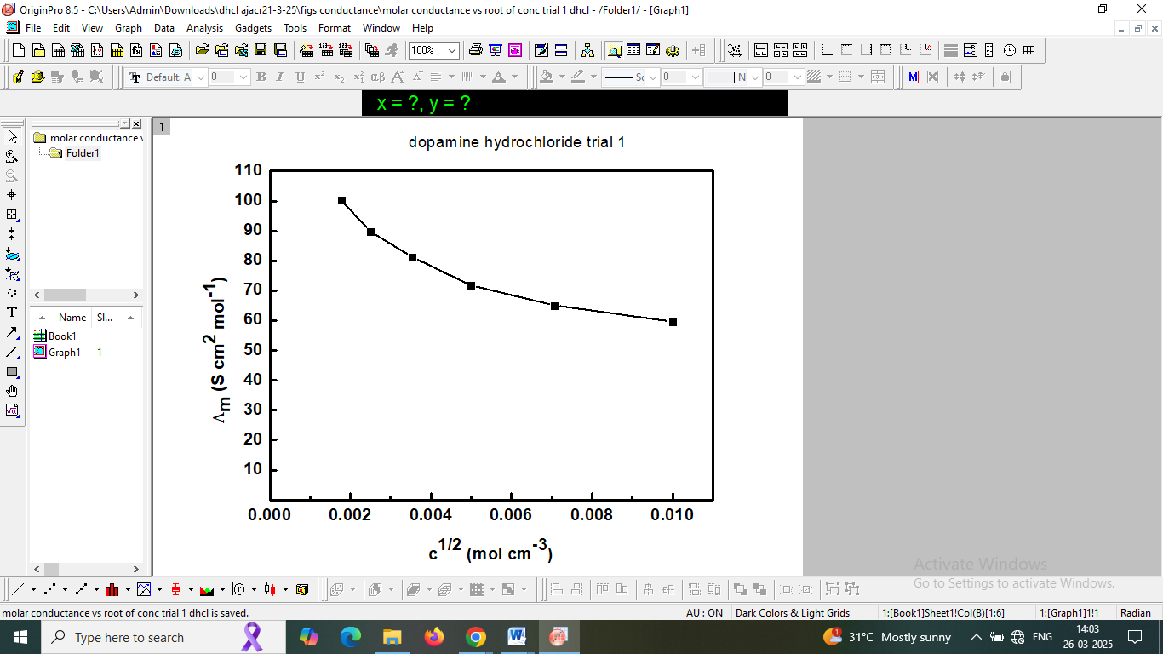

**Figure 1. Variation of molar conductance with dilution of dopamine hydrochloride.**

Figure 2 presents the relationship between the inverse molar conductivity (1/Λm) and the square root of dopamine hydrochloride concentration (√c). The observed nonlinear trend in this plot clearly demonstrates the characteristic behavior of a weak electrolyte (Samuel Glassstone, 2008). This curvature indicates that dopamine hydrochloride undergoes incomplete dissociation in solution, with the degree of dissociation increasing as concentration decreases - a feature of weak electrolytes that distinguishes them from strong electrolytes which typically show linear relationships in such plots (Samuel Glassstone, 2008).

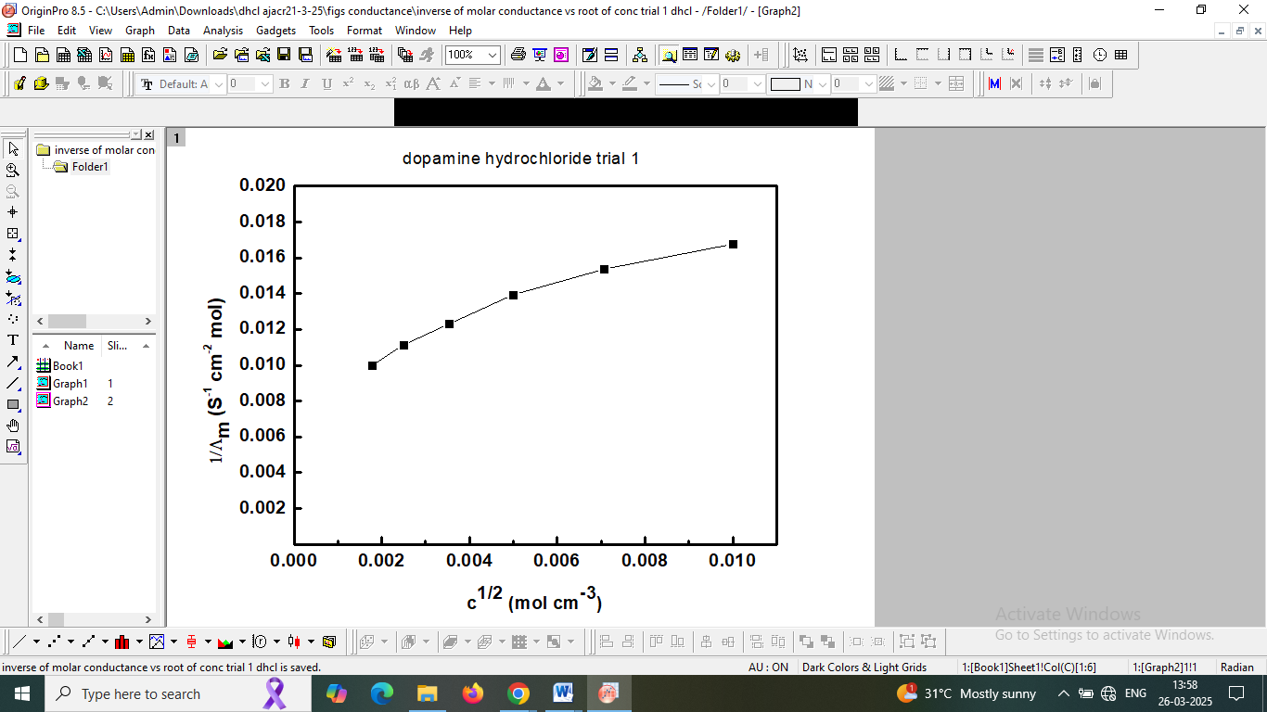

**Figure 2. Variation of inverse molar conductance with dilution of dopamine hydrochloride.**

Figure 3 displays the correlation between inverse molar conductivity (1/Λₘ) and specific conductivity (κ). The observed nonlinear progression of κ values demonstrates that Kohlrausch's law, which governs the behavior of strong electrolytes, does not apply to this system (Samuel Glassstone, 2008). This deviation from linearity provides further evidence that dopamine hydrochloride behaves as a weak electrolyte in solution, as its conductive properties show concentration-dependent characteristics distinct from fully dissociated electrolytes.

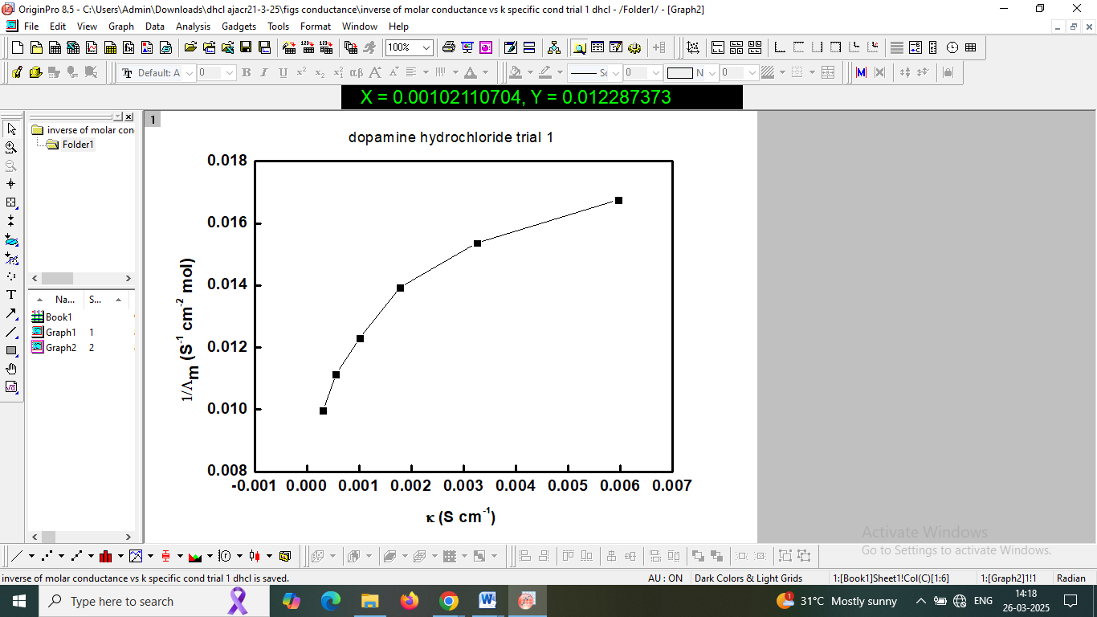

**Figure 3. Variation of inverse molar conductance with specific conductance of dopamine hydrochloride.**

In weak electrolyte solutions, the molar conductivity (Λₘ) exhibits a characteristic increase with decreasing concentration, asymptotically approaching its limiting value (Λₘ°) at infinite dilution. To determine this limiting conductivity, modified the Kohlrausch equation using power law analysis was used (Atkins, 2017; Hanibah *et al*., 2014). The fundamental relationship is expressed as: : Λm=κ/c where Λm = molar conductance, κ = specific conductance (Scm-1), c = concentration of dopamine hydrochloride solution (mol cm-3). This transforms into logarithmic form:

logκ = logΛm + logC.

At infinite dilution (c→0), where Λₘ→Λₘ°, the equation becomes Λm=Λm∘, so

logκ = logΛm∘ + logC (Hanibah *et al*., 2014).

Through linear regression analysis of experimental data, logκ =m⋅logC + b where m = slope (m) and b = intercept. Slope (m) is expected to approach unity for ideal weak electrolyte behavior and the intercept (b) directly relates to log Λₘ°, enabling determination of the limiting molar conductivity. This analysis method provides a robust approach for characterizing weak electrolyte systems while accounting for their incomplete dissociation behavior across concentration ranges (Hanibah *et al*., 2014; Hasnim *et al*., 2023).

The graphical representation in Figure 4 displays the logarithmic relationship between specific conductivity (log κ) and concentration (log C). In dilute solutions, this double logarithmic plot typically exhibits linear behavior. By extrapolating this linear region to the theoretical limit of infinite dilution (as log C approaches negative infinity), the y-intercept provides an estimate of the limiting molar conductivity (Λₘ°). This extrapolation method allows for determination of the electrolyte's maximum conductivity when completely dissociated at negligible concentration.

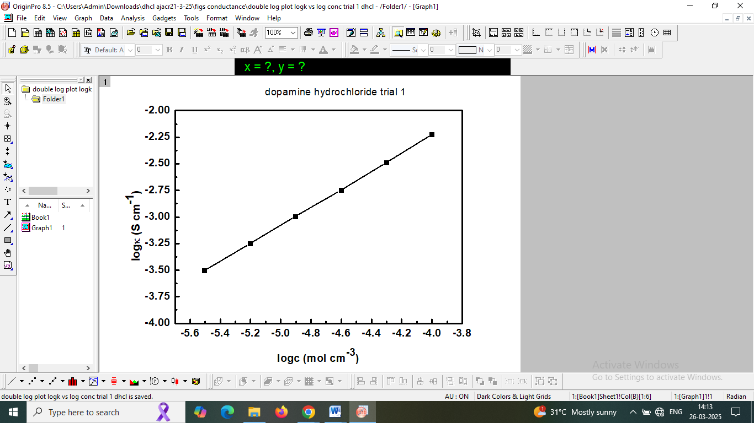

**Figure 4. Double log plot of specific conductance (κ) versus concentration of dopamine hydrochloride solution.**

Linear regression analysis of the experimental data yielded a slope of 0.85, which closely matches the theoretical expectation for weak electrolyte behavior. The calculated intercept value of 1.1162 corresponds to the reciprocal of the limiting molar conductivity (1/Λₘ°). Through this relationship, we determined the molar conductivity of dopamine hydrochloride at infinite dilution to be 14.55 Scm²mol⁻¹. This value represents the maximum conductivity achievable when the electrolyte is completely dissociated in an infinitely dilute solution.

The experimental evidence from this study establishes dopamine hydrochloride as a weak electrolyte in aqueous solutions based on hydrolysis behaviour and the conductivity analysis. These results contribute to our understanding of the compound's solution-phase properties, with potential applications in pharmaceutical formulation and biochemical research where its stability and reactivity are crucial considerations.

**CONCLUSION**

The experimental measurements yielded average equilibrium constants of i) hydrolysis constant (Kₕ) = 3.5677 × 10-6 and ii) dissociation constant (Kb) = 2.833 × 10-9. Conductivity studies revealed concentration-dependent behavior characteristic of weak electrolytes, with the limiting molar conductivity (Λ°ₘ) determined to be 14.55 S cm² mol⁻¹ at infinite dilution. These quantitative results provide fundamental thermodynamic and electrochemical characterization of dopamine hydrochloride in aqueous solutions.

**Declaration**

Author declares no conflict of interest

**USE OF AI:**

We have used (Deepseek) to rephrase the sentences to provide better meaning to the text.

**REFERENCES**

Atkins, P; Paula, J. De, Keeler J. (2017). Atkins’ Physical Chemistry, 11th edition., Oxford University Press.

Chemistry. 4th ed. Boston, New York: Houghton Mifflin Company.

Costa, K. M.; Schoenbaum Geoffrey. (2022). Dopamine, *Curr. Bio*. *32*:R807–R827. https://doi.org/10.1016/j.cub.2022.06.060

Glassstone S. An Introduction To Electrochemistry, Read Books Publications, 2008.

Hanibah H.; Ahmad, A.; Hassan, N. H. (2014). *Electrochimica Acta* 147:758-764. https://doi.org/10.1016/j.electacta.2014.09.156

Hanibah H.; Hassan, N. H; Ahmad, A. (2014). *Asian J. Chem.* *26*:4897–4900

Hashim, N. Z. N.; Hanibah, H.; Shamsudin I. J.; Syafiq, M.; Ithnin Z. (2023). *Malaysian J. Chem*. *25*(4):99-112. <https://doi.org/10.55373/mjchem.v25i4.99>

Laidler, K. J., Meiser, J. H. and Sanctuary, B. C. S. (2003) Solutions of Electrolytes. Physical

Latif, S.; Jahangeer, M.; Razia, D. M.; Ashiq, M.; Ghaffar, A.; Akram, M.; Allam, A. E.; Bouyahya, A.; Garipova, L.; Shariati, M. A.; Thiruvengadam, M.; Ansari, M. A. (2021). Dopamine in Parkinson's disease, *Clinica Chim. Acta*, *522*:114-126. https://doi.org/10.1016/j.cca.2021.08.009.

Vallone, D.; Picetti, R.; Borrelli E. (2000). Structure and function of dopamine receptors, *Neurosci. Biobehavioral Rev*. *24*:125-132. <https://doi.org/10.1016/s0149-7634(99)00063-9>.