***Original Research Article***

**GGE Biplot Analysis of Genotype x Environment Interaction and Yield Stability in African yam bean (*Sphenostylis stenocarpa*)**

**ABSTRACT**

Aims: To identify the genotype(s) most suited for the test environments in Nigeria and to understand the nature of genotype-by-environment interaction (GEI) effects on AYB production.

Study Design: Multi-environment trials combined with GGE biplot analysis to explore genetic interactions and determine the adaptability and stability of African yam bean accessions across diverse environments.

Place and Duration of study: The research was conducted over four environments, Umudike (rainforest) and Ibadan (derived savanna), during two consecutive years in 2020 (late season) and 2021 (early season).

Methodology: Eighty-six AYB accessions were evaluated using a randomized complete block design with three replications. Each accession was planted in a 3-meter-long ridge, with 1meter spacing between plants within the row. Rows were spaced 15 meters apart, with 1 meter spacing between plants within rows. Two seeds were initially planted per stand, later thinned to one plant, resulting in three plants per accession. Plants were staked with bamboo sticks three weeks after plantings. NPK fertilizer (15-15-15) was applied seven weeks after planting and data were taken on vegetative and reproductive characteristics.

Results: Combined analysis across environments revealed that genotypes and GEI significantly impacted AYB yield. The biplot polygon of “which-won-where” showed accessions TSs508, TSs518, TSs542, TSs544, TSs600, TSs598, TSs605, and TSs550 as winners. Accession TSs554 gave the highest yield in all test environments. Accessions TSs549, TSs555, TSs575, TSs604, and TSs563 were the most adaptable and the stable accessions were TSs591, TSs507, TSs517, and TSs 538. UMU 2021 is regarded as a superb environment in terms of discrimination and representativeness.

Conclusion: These accessions are suggested as parental lines in breeding programs for increasing grain and tuber yield in derived savanna or rainforest agroecological zones of Nigeria.

**Keywords:** African yam bean, genotype-by-environment interaction, GGE biplot, multi-environment trial, stability analysis

**INTRODUCTION**

African yam bean (*Sphenostylis stenocarpa*) (Hochst ex. A. Rich) Harms) is a highly nutritious legumes grown and eaten mostly by rural dwellers and poor peasant farmers in sub-Saharan Africa (1,2). Both underground tubers and seeds of AYB are eaten and are rich in amino acid (lysine and methionine) (3). AYB can grow over a wide range of climatic and soil conditions (4). It contributes to soil fertility improvement through atmospheric nitrogen fixation (5). The production of AYB is not improving as compared to other grain legumes. This could be ascribed to yield instability particularly in AYB producing areas, characterized by high inter annual yield variability (6) and environmental interaction among accessions. This emphasizes the need for selecting the high yield stable genotype resilient to the challenges of weather fluctuations.

Local landraces dominate production instead of agro-ecological or production-specific varieties with great variation in yield among landraces, especially when cultivated outside their niche (7). The capacity of a crop variety to thrive in a particular environment is determined by its adaptability and yield stability. Most traits are controlled by genotype-environment interactions (GEI) because different environments have different effects on various traits. Genotypes respond to the environment differently, their growth and adaptations contribute in determining their yield potential and identifying suitable genotypes for a specific environment.

Plant breeders analyze GEI to resolve issues controlling plant growth and development (1). Growing interest in GEI have led to the development of numerous statistical techniques for multi-environment trials (METs) (8,1). METs genotype-by-environment data are useful for identifying superior genotypes and assessing the test conditions (9). Biplot analysis displays results of the relationships of the genotypes and the environment in simple graphics. GGE concept explains the performance of genotype and their interaction with its environment within a two dimensional scattered plot based on the scores of the first two principal components (PC) axes (10). The two important factors which are also sources of variation in GGE biplot are G (genotype) and GE (Genotype x Environment). The genotype evaluation (mean vs stability), the discriminatory power vs representativeness test settings, and multi-environment analysis (such as the "which-won-where" pattern) are ideally suited for the GGE biplot (11, 12). Since the inception of the GGE biplot, many researchers have reported analysis using the application. (13) reported on the adaptability of African yam bean grain yield to four agroecologies in Nigeria using GGE biplot. GGE biplot analysis of Genotype x environment interaction and yield stability in Bambara groundnut was reported by (1). GGE biplot analysis of fluted pumpkin (*Telafaira occidentalis*) landraces evaluated for marketable leaf yield in southwest Nigeria was reported by (14). Other applications of GGE biplot have been reported on various crops such as Andean dry bean (15) and wheat (16). The goals of this study were to examine and quantify the magnitude of GEI effects on AYB yield, as well as to determine the adaptability of the 85 AYB accessions in the studied test environments in two agro-ecologies in Nigeria.

**MATERIALS AND METHOD**

The study was conducted in two agro-ecological zones: IITA, Ibadan (7.5°N, 3.9°E) which is a derived savannah, and Umudike (50 29’ N, 70 24’E), in the rainforest; and in 2020 during the late season and during the early season in 2021. The weather parameters prevailing during the experimental years for the study sites were recorded and are presented in Table 1.

Topsoil samples from experimental sites were analyzed for sand, clay, silt, pH, organic carbon (OC), total N, Organic matter, exchangeable Ca, Mg, K, available P, Na, Mn, Cu, Fe, Zn and particle size distribution (Table 2).

Eighty-five (85) accessions of AYB from IITA gene bank were used. The experimental sites were cleared, plowed and harrowed. The accessions were planted in three replicates and were laid out in a randomized complete block design (RCBD). The length of each plot was 3m, with 1m spacing between each plant and a row spacing of 1.5m between each plot. NPK fertilizer (15-15-15) was applied at the rate of 60 kg ha-1 by ring application method 7weeks after planting as recommended by (17). The plants were sprayed at two weeks’ interval with Terminate at the rate of 35-60ml in 20 litres of water every 2 weeks during flowering periods to control floral and pod pests. The experimental plots were kept weed free throughout the duration of the experiment. Plants were rain fed until the stop of rain, and then irrigation was applied once a week during dry season until harvest in 2020. The following traits were assessed: Days to plant maturity(DPM), Pod weight (PODWT), 100 seed weight (SEEDWT), days to 50% flowering (DFA), days to 100% flowering (DFB), days to first flowering (DFP), number of seeds per plant (NOSPP), number of leaves (NOLA) and number of branches (NOBB)

Data on yields were analyzed using an R statistical software. After the data had been standardized by log transformation, the yield data were subjected to analysis of variance (ANOVA). Each year at each location was treated as a distinct environment. The stability analysis in this work utilized the joint regression model developed by (18). The GGE biplot was constructed using the first two principal components (PC1 and PC2) derived using environment-centered yield data (19). GEA-R version 4.1 (20) was used to analyze GGE biplot and stability analysis. SVD of the first two principal components was used to fit the GGE biplot model (21).

**RESULTS AND DISCUSSION**

**Soil analysis:** The soil physio-chemical properties for the two locations are presented in Table 2. Higher amounts of nitrogen, organic carbon, calcium, magnesium, sodium, copper, iron, and zinc were recorded in Umudike compared to Ibadan in 2020, while Ibadan had a higher amount of sand, pH, and phosphorous in the same year. The soil pH was highly acidic in Umudike and neutral in IITA Ibadan 2020. The percentage of sand is higher than silt and clay in both locations. Sandy soil has a porous structure with large pores, allowing roots to grow while the clay allows for water absorption and retention which is very helpful when rainfall is insufficient. The performances and yield of crops have been shown to be influenced by soil and climatic conditions (1).

**Performance of Accessions in Different Environments:** Combined analysis of the two season environments (2020 late season) and 2021 (early season) at Ibadan, presented in Table 3 showed that for most of the measured traits, genotypic variation was highly significant (p<0.001) except for days to first flowering and days to 50% flowering. The environments also varied significantly (p<0.001) for all the traits measured, indicating the uniqueness of the environment. Genotype x Environment interaction was highly significant (p<0.001) for most of the traits except days to first flowering, days to 50% flowering, and Number of seed per plant (Table 3). For traits measured in Umudike (Table 4), genotypes also varied significantly (p<0.01) except for number of leaves and days to first flowering. The variation between the two seasons was also significant (p<0.01) for number of leaves, days of first flowering, and days to plant maturity and insignificant for other traits. Genotype x Environment interaction was highly significant (p<0.001) for only days to maturity and not significant for other measured traits (Table 4). Table 5 shows the result of the combined analysis across the two locations and seasons. Most traits including number of leaves, number of branches, number of seeds per plant, days to 100% flowering, days to plant maturity, pod weight, and 100 seed weight varied significantly (p<0.001) with genotype. All traits varied significantly (p<0.001) with environments showing the uniqueness of each environment (Table 5). Genotype x Environment interaction was significant (p<0.01) for most of the traits except number of seeds per plant, days to first flowering, days to 50% flowering, and pod weight (Table 5). This indicates that the accessions do not show consistent performance across the studied environments. The significant differences observed among the measured traits in both locations at different years can be linked to differences in climatic (Table 1) and edaphic factors (Table 2). The large variations and observed coefficient of variation (26%) in Table 5 demonstrate that the accessions used in this study contain variability that can improve a breeding program. This result is in line with the report of (1).

**Stability Analysis**

The stability of the accessions across the environments is presented in Table 6 and Figure 1. According to (18), a stable desirable genotype is one with high mean value, with regression coefficient (bi) =1 and deviation from regression (Sd2i) = 0. Following the reports of (22) and (1), genotypes having bi = 0 are not affected by environmental factors rather they are said to be stable, while those showing average responses possess bi = 1. Also, (23) reported that when a genotype performs the same way or at least not significantly different from before and after environmental changes, it is said to be stable. Based on these, 19 accessions (TSs 540, TSs 564, TSs 570, TSs 583, TSs 544, TSs 553, TSs 555, TSs 556, TSs 558, TSs 595, TSs 596, TSs 597, TSs 598, TSs 599, TSs 600, TSs 602, TSs 603 and TSs 606) were stable across the environments while accessions TSs 549, TSs 555, TSs 575, TSs 604, and TSs 563 were the best-adapting accessions. Coefficient of variation (CV) analysis showed 24 out of 86 accessions as highly productive and stable (Figure 1a).

**GGE Biplot Analysis:** The selection of superior genotypes for improved cultivar development can be severely constrained by a large GXE interaction for a quantitative feature like seed yield (23).GGE biplot analysis specifically reveals the performances of different accessions in each environment (24) and also explains the performance of genotypes and the interaction of the same with its environment within a two-dimensional scattered plot based on the scores of the first two principal components (PC) axes (24). In this study, from the biplot, 97.20% of the total variation was observed, of which 65.03% explained the first principal component (axis 1), while 31.17% explained the second principal component (axis 2). None of the environments are near the mean environment (Figure 2A) and representation of the accessions in the various environments (Figure 2B). In figures 2A and 2B, the vector red line which represented the environmental axis separated the accessions differently based on their performances. Accession performance in each environment is shown in figure 3. For the four environments, most accessions were clustered close to the average yield.

A crucial element of the GGE is the use of the polygon view of the "which-won-where" biplot, which aids in visualizing the interaction patterns between genotypes and environments to demonstrate the presence of cross-over GEI, massive environment differentiations, and particular adaptation (25). Accessions TSs508, TSs 518, TSs 542, TSs 544, TSS 600, TSs 598, TSs 605 and TSS 550 were situated at the corners of the polygon (Figure 3), indicating that these accessions were outstanding in terms of yield in those environments (11). Among these accessions, TSs 554 was the highest yielding in all test environments (Figure 4). Some accessions such as TSs528, TSs 593, TSs 581 and TSs 595 were located close to the center of the GGE biplot. This indicates that they showed a stable performance across the test sites (25,1).

Figure 5 indicates three environments: UMU 2020, UMU 2021 and IITA 2020 and IITA 2021 together forming the third environment. The comparison plot for environment and accessions is shown in Figure 5. Accessions and environments close to or at the center of concentric circle are said to be ideal. Therefore, in this study, as in figure 5A UMU 2021 (early season at Umudike) is the closet to being an ideal environment while TSS 536, TSS 573 are the ideal accessions as shown by their positions in figure 5B, followed by accession TSS 507, TSS 573 and TSS 580. Accession close to the ideal accession are said to be also good. All of the environments are positively correlated with one another in terms of the relationship between them, but UMU 2020 (Umudike late season) and UMU 2021 (Umudike early season) are more highly correlated with one another than any other environments (Figure 5c). UMU 2021 is chosen as the perfect test environment in this study because it has the longest vector and the smallest angle with an ideal environment, making it the most discriminating and representative of all test environments. This is in tandem with the thoughts of (26, 1).

Several studies have demonstrated the impact of GEI on a variety of legumes, including African yam bean (7), Bambara groundnut (1), and Soybean (26). The GEI has an impact on stability and adaptation because genotypes react to environments differently. The production efficiency of plant varieties is influenced by a variety of characteristics, including stability and adaptability (1). Genotype stability studies are important in classifying genotype adaptation and consistency in yield performance. Such studies will reduce efforts and save costs in engaging unpredictable field locations for farming and crop breeding purposes.

**CONCLUSION**

The study used performance data of 86 AYB genotypes at two locations, Umudike and Ibadan during the late season (in 2020) and early season (2021) utilizing a GGE biplot to determine the main effects of genotype (G), environment (E), and genotype x environment interaction (GEI) and identified specific accessions that were adapted to each environment. The stability analyses assisted in determining various genotypes that could be cultivated in each environment studied as well as a stable genotype that could be grown across the environments examined. UMU 2021 was chosen as the perfect test environment in this study because it has the longest vector and the smallest angle with an ideal environment, making it the most discriminating and representative of all test environments. The results can be used as a preliminary analysis for prospective breeding initiatives, but more research on this crop's adaptability and stability in more than two sites is required for the best outcomes and references.

**COMPETING INTERESTS DISCLAIMER**:

Authors have declared that they have no known competing financial interests OR non-financial interests OR personal relationships that could have appeared to influence the work reported in this paper.

**REFERENCES**

1. Olanrewaju, O.S., Oyatomi, O., Babalola, O.O. and Abberton, M. (2021). GGE Biplot Analysis of Genotype × Environment Interaction and Yield Stability in Bambara Groundnut. Agronomy. 11(9):1839. https://doi.org/10.3390/agronomy11091839

2. Usoroh, J., Eneobong, E.E., Okon, S. and Umoyen, A. (2019) Evaluation of the Genetic Diversity of African Yam Bean (*Sphenostylis stenocarpa* (Hoechst. ex. A Rich.) Harms.) Using Seed Protein Marker. Archives of Current Research International. 17 (4): 1-10. DOI: 10.9734/acri/2019/v17i430117

3. Uguru, M.I. and S.O. Madukaife. (2001) Studies on the variability in agronomic and nutritive characteristics of African yam bean (*Sphenostylis stenocarpa*) Hochst ex. A. Rich. Harms). Plant Product. Resources Journal, 6: 10-19.   **DOI:**[10.4236/as.2019.107066](https://doi.org/10.4236/as.2019.107066)

4. Malumba, P., Denis, B.M., Joseph, K.K., Doran, L., Danthine, S. and Bera, F. (2016) Structural and physicochemical characterization of *Sphenostylis stenocarpa* (Hochst. ex A. Rich.) Harms tuber starch. Food Chemistry 212:305–12. DOI: 10.1016/j.foodchem.2016.05.181

5. Assefa, F. and Kleiner D. (1997) Nodulation of African yam bean (*Sphenostylis stenocarpa*) by Bradyrhizobium sp. Isolated from *Erythrina brucei*. Biololgy and Fertility of Soils. 25:209–210. https://doi.org/10.1007/s003740050305

6. Sood, S., Kumar, N., Chandel, K.S. and Sharma, P. (2011). Determination of genetic variation for morphological and yield traits in bell pepper (*Capsicum annum var grossum*). Indian Journal Agricultural Science 81(7):590–4. https://epubs.icar.org.in/index.php/IJAgS/article/view/7359

7. Aremu, C.O., Ojuederie, O.B., Ayo-Vaughan, F., Dahunsi, O., Adekiya, A.O., Olayanju, A., Adebiyi, O.T., Sunday, I., Inegbedion, H. and Asaleye, A.J.; *et al*. (2019) Morphometric analysis and characterization of the nutritional quality in African yam bean accessions. Plant Physiology Reports. 24, 446–459. https://link.springer.com/article/10

8. Crossa, J. (1990). Statistical Analyses of Multilocation Trials. Advances in Agronomy 44: 55–85. <https://doi.org/10.1016/S0065-2113(08)60818-4>

9. Yan, W. and Kang, M.S. (2003) GGE Biplot Analysis: A Graphical Tool for Breeders, Geneticists and Agronomists; CRC: Boca Raton, FL, USA, 286pp. DOI**:**[10.4236/ajps.2017.88133](https://doi.org/10.4236/ajps.2017.88133)

10. Yan, W. (2002) Singular-value partitioning in biplot analysis of multi environment trial data. Agronomy Journal 94: 990–996. **DOI:** 10.12691/wjar-2-5-5

11. Yan, W., Kang, M.S., Ma, B., Woods, S. and Cornelius, P.L. (2007) GGE biplot vs. AMMI analysis of genotype-by-environment data. Crop Science 47: 643–653. Doi: 10.2135/cropsci2006.06.0374

12. Angelini, J., Faviere, G.S., Bortolotto, E.B., Arroyo, L., Valentini, G.H., Domingo, L. and Cervigni, G. (2019) Biplot pattern interaction analysis and statistical test for crossover and non-crossover genotype-by-environment interaction in peach. Scientia Horticulturae. 252: 298–309. doi: [10.1016/j.scienta.2019.03.024](https://doi.org/10.1016/j.scienta.2019.03.024)

13. Adewale, D., Ojo, D.R. and Abberton, M. (2017). GGE biplot application for adaptability of African yam bean grain yield to four agro-ecologies in Nigeria. African Crop Science Journal. 25. 333. 10.4314/acsj.v25i3.7.

14. Fayeun, L.S., Alake, G.C., and Akinlolu, A.O. (2018) GGE biplot analysis of fluted Pumpkin (*Telfairia occidentalis*) landraces evaluated for marketable leaf yield in Southwest Nigeria. Journal Saudi Society of Agricultural Science, 17, 416–423

15. Mndolwa, E., Msolla, S., Porch, T. and Miklas, P. (2019) GGE biplot analysis of yield stability for Andean dry bean accessions grown under different abiotic stress regimes in Tanzania. African Crop Science Journal 27: 413–425. DOI:[10.4314/acsj.v27i3.6](https://doi.org/10.4314/acsj.v27i3.6)

#### 16. Buenrostro-Rodríguez, J.F., Solís-Moya, E., Gámez-Vázquez, A.J., Raya-Pérez, J.C., Mandujano-Bueno, A., Cervantes-Ortiz, F. and Covarrubias-Prieto, J. (2019) Yield performance and GGE biplot analysis of Wheat genotypes under two irrigation treatments at El Bajío, Mexico. Chilean Journal Agricultural Research 79: 234–242. http://dx.doi.org/10.4067/S0718-58392019000200234

17. Togun, A.O. and Olatunde, A.O. (1998). Effect of soil applied fertilizer on the growth and yield of African yam bean (*Sphenostylis stenocarpa*). Nigerian Journal Science. 32:43–48. DOI: http://dx.doi.org/10.22159/ijags.2021v9i6.43171.

18. Eberhart, S.T. and Russell, W. (1966) Stability parameters for comparing varieties 1. Crop Science. 6: 36–40. http://dx.doi.org/10.2135/cropsci1966.0011183X000600010011x

19. Camacho, C. Coulouris, G. Avagyan, V. Ma, N. Papadopoulos, J. Bealer, K. and Madden, T.L. (2009) BLAST+: Architecture and applications. BMC Bioinformatics 10, 421. http://dx.doi.org/10.1186/1471-2105-10-421

20. Pacheco, A.; Vargas, M.; Alvarado, G.; Rodríguez, F.; Crossa, J.; Burgueño, J. (2015) GEA-R (Genotype × Environment Analysis with R for Windows) Version 4.0. CIMMYT Research Software, Mexico, 2015. Available online: https://hdl.handle.net/11529/10203 (accessed on 19 July 2021

21. Yan, W. (2001). ‘GGE biplot A windows application for graphical analysis of multi-environment trial data and other types of two-way data’. Agronomy Journal 93(5), 1111–1118. https://doi.org/10.2134/agronj2001.9351111x

22. Becker, H.C.; Léon, J. (1988) Stability analysis in plant breeding. Plant Breed. 1988, 101, 1–23. https://doi.org/10.1111/j.1439-0523.1988.tb00261.x

23. Sownya, H.H., M.Y. Kamatar, G. Shanthakumar, S.M. Brunda, T.V. Shadakshari, B.M. Showkath Babu and Sanjeev Singh Rajput. (2018) Stability Analysis of Maize Hybrids using Eberhart and Russel Model. Int. J. Curr. Microbiol. App. Sci. 7(02): 3336-3343. DOI:[10.20546/ijcmas.2018.702.399](http://dx.doi.org/10.20546/ijcmas.2018.702.399)

24. Sharma, S.P. Leskovar, D.I. Crosby, K.M. and Ibrahim, A. (2020) GGE biplot analysis of genotype-by-environment interactions for melon fruit yield and quality traits. Horticultural Science 1: 1–10. DOI:<https://doi.org/10.21273/HORTSCI14760-19>

25. Yan, W. and Tinker, N.A. (2006) Biplot analysis of multi-environment trial data: Principles and applications. Canadian Journal Plant Science 86: 623–645. http://dx.doi.org/10.4141/P05-169

26. Bhartiya, A., Aditya, J.P., Singh, K., Pushpendra, P., Purwar, J.P. and Agarwal, A. (2016) AMMI and GGE biplot analysis of multi environment yield trial of Soybean in North Western Himalayan state Uttarakhand of India. Legume Research International Journal 40: 306–312.  DOI:[10.18805/LR.V0IOF.3548](https://doi.org/10.18805/LR.V0IOF.3548)

**Table 1. Monthly mean meteorological data of the experimental sites during AYB growing season (average of 2019–2020 and 2020–2021 cropping season).**

|  |  |  |  |  |  |  |  |  |  |  |  |  |  |  |
| --- | --- | --- | --- | --- | --- | --- | --- | --- | --- | --- | --- | --- | --- | --- |
|  |  |  | **JAN** | **FEB** | **MAR** | **APR** | **MAY** | **JUN** | **JUL** | **AUG** | **SEPT** | **OCT** | **NOV** | **DEC** |
| IITA, IBADAN | 2019/2020 | AT (0C) | 27.3 | 29.0 | 29.3 | 28.8 | 28.0 | 26.3 | 25.3 | 25.2 | 25.2 | 26.2 | 26.9 | 27.4 |
|  |  | ARR(mm) | 0 | 0 | 76.5 | 60.5 | 115.7 | 178 | 140 | 11.1 | 25.5 | 210.8 | 40.0 | 0 |
|  |  | ARH (%) | 46.5 | 53.5 | 77 | 69.5 | 76 | 80.5 | 85 | 81 | 73 | 74.0 | 40.1 | 50 |
|  | 2020/20221 | AT (0C) | 28.5 | 29.2 | 28.8 | 28.5 | 27.8 | 26.1 | 25.5 | 25.5 | 25.8 | 26.9 | 27.2 | 27.6 |
|  |  | ARR(mm) | 0 | 0 | 54.3 | 77.5 | 74.1 | 163 | 159 | 282.6 | 251.6 | 211.1 | 42.3 | 0 |
|  |  | ARH (%) | 55.5 | 54 | 66.5 | 70 | 75.5 | 79.5 | 83 | 85 | 78 | 76.5 | 72.5 | 53 |
| UMUDIKE | 2019/2020 | AT (oC) | 30.2 | 29.2 | 24.4 | 33.5 | 27.0 | 27.0 | 26.3 | 31.2 | 26.5 | 21.5 | 27.6 | 28.4 |
|  |  | ARR(mm) | 0 | 0 | 126.1 | 117 | 271 | 341 | 483 | 92.4 | 434 | 185.4 | 200 | 0 |
|  |  | ARH (%) | 41 | 45.5 | 84.5 | 72.5 | 75.5 | 78.5 | 83.0 | 77.0 | 81.5 | 78.0 | 72.5 | 56.0 |
|  | 2020/2021 | AT (oC) | 29.0 | 25.5 | 26.0 | 28.0 | 16.0 | 26.5 | 27.5 | 16.0 | 26.5 | 27.5 | 28.0 | 28.5 |
|  |  | ARR(mm) | 0 | 0 | 36.3 | 75.5 | 47.9 | 272 | 301 | 557 | 344 | 328 | 99 | 0 |
|  |  | ARH(%) | 59.5 | 56.5 | 68.0 | 70.5 | 72.5 | 79.0 | 76.0 | 83.0 | 80.0 | 80.5 | 77.0 | 56.0 |

**Table 2.** Soil properties at the beginning of the experiment for individual locations

|  |  |  |
| --- | --- | --- |
| Properties | Umudike  2020 | Ibadan  2020 |
| Sand % | 72.0 | 79.33 |
| Silt % | 7.0 | 6.67 |
| Clay % | 21.0 | 14.00 |
| Ph | 4.2 | 6.59 |
| Phosphorus(mg/kg) | 11.25 | 11.27 |
| Nitrogen (cmol/kg) | 0.14 | 0.10 |
| Organic Carbon % | 0.62 | 0.44 |
| Calcium (cmol/kg) | 2.27 | 0.19 |
| Magnessium (cmol/kg) | 0.53 | 0.27 |
| Potassium (cmol/kg) | 0.01 | 0.22 |
| Sodium (cmol/kg) | 0.09 | 0.05 |
| Cu (ppm) | 1.46 | 0.20 |
| Iron (ppm) | 222.05 | 89.46 |
| Zinc (ppm) | 5.99 | 2.72 |
| Manganese (ppm) | 31.15 | 135.30 |

**Table 3: Mean squares from the combined ANOVA for traits recorded across two seasons (2020 and 2021).**

|  |  |  |  |  |  |  |  |  |  |
| --- | --- | --- | --- | --- | --- | --- | --- | --- | --- |
| **Source** | **DF** | **NOBB** | **NOSPP** | **DFP** | **DFA** | **DFB** | **DPM** | **PODWT** | **SEEDWTA** |
| Env (E) | 1 | 50.51*** | 676.17*** | 63619.77*** | 119893.24*** | 161443.42** | 188203.52*** | 396.51*** | 220.7* |
| Rep | 4 | 11.14*** | 17.08ns | 59.22ns | 120.98ns | 433.78* | 1218.14*** | 4.01ns | 113.11** |
| Gen (G) | 84 | 1.54*** | 18.54*** | 162.77ns | 116.48ns | 194.4** | 270.72*** | 5.82*** | 68.68*** |
| Gen*Env | 84 | 1.43** | 15.87*** | 172.6ns | 117.3ns | 155.86ns | 268.52*** | 5.02*** | 54.83*** |
| Error | 317 | 0.81 | 5.92 | 126.03 | 101.45 | 116.44 | 103.27 | 1.64 | 20.88 |
| CV (%) |  | 30.86 | 16.57 | 12.29 | 10.13 | 10.09 | 7.4 | 20.38 | 16.02 |

. *, **, *** Significant at p ≤ 0.01, p ≤ 0.001 and 0.0001 levels, respectively, ns = not significant. Gen, Genotype; Env, Environment (seasons); Rep, Replication; CV, Coefficient of Variation, NOBB, Number of primary branching; NOSPP, Number of seed per plant; DFP, Days to first flowering; DFA, Days to 50% flowering; DPM, Days to plant maturity, PODWT, Pod weight per plant; SEEDWT, 100 Seed weight

**Table 4: Mean squares from the combined ANOVA (Umudike) for traits recorded across two seasons (2020 and 2021).**

|  |  |  |  |  |  |  |  |  |  |  |
| --- | --- | --- | --- | --- | --- | --- | --- | --- | --- | --- |
| **Source** | **DF** | **NOLA** | **NOBB** | **NOSPP** | **DFP** | **DFA** | **DFB** | **DPM** | **PODWT** | **SEEDWTA** |
| Env (E) | 1 | 1079.88*** | 3.16ns | 26.76ns | 23256.40*** | 0.06ns | 0.21ns | 188203.52*** | 0.01ns | 48.16ns |
| Rep | 4 | 72.67ns | 9.76*** | 489.68ns | 952.91* | 134.39** | 662.7*** | 1218.14*** | 121.73* | 128.28** |
| Gen (G) | 85 | 94.18ns | 1.98*** | 392.02* | 308.52ns | 44.58* | 45.01* | 270.72*** | 48.04** | 51.26*** |
| Gen*Env | 85 | 14.79ns | 0.3ns | 35.84ns | 148.042ns | 1.08ns | 1.36ns | 268.52*** | 2.63ns | 4.97ns |
| Error | 336 | 67.18 | 0.95 | 257.71 | 236.73 | 28.18 | 30.03 | 103.27 | 28.4 | 25.06 |
| CV (%) |  | 37.47 | 30 | 60.43 | 19.62 | 5.52 | 5.21 | 7.4 | 72.6 | 36.48 |

. *, **, *** Significant at p ≤ 0.01, p ≤ 0.001 and 0.0001 levels, respectively, ns = not significant. Gen, Genotype; Env, Environment; Rep, Replication; CV, Coefficient of Variation, NOLA, Number of leaves per plant; NOBB, Number of primary branching; NOSPP, Number of seed per plant; DFP, Days to first flowering,; DFA, Days to 50% flowering; DPM, Days to plant maturity; PODWT, Pod weight per plant; SEEDWT, 100 Seed weight

**Table 5: Mean squares from the combined ANOVA for traits recorded across test environments**

|  |  |  |  |  |  |  |  |  |  |  |
| --- | --- | --- | --- | --- | --- | --- | --- | --- | --- | --- |
| **Source** | **DF** | **NOLA** | **NOBB** | **NOSPP** | **DFP** | **DFA** | **DFB** | **DPM** | **PODWT** | **SEEDWTA** |
| Env (E) | 3 | 23944.53*** | 57.91*** | 11636.27*** | 43901.38*** | 41175.2*** | 54293.16*** | 84332.95*** | 224.62*** | 17013.16*** |
| Rep | 8 | 55.26ns | 10.6*** | 248.77ns | 507.29* | 131.22ns | 554.29*** | 1010.73*** | 61.64*** | 121.05*** |
| Gen (G) | 84 | 96.91*** | 1.93*** | 205.91* | 203.79ns | 82.88ns | 121.7** | 1287.37*** | 23.57* | 64.39*** |
| Gen*Env | 252 | 60.51*** | 1.12* | 82.36ns | 194.3ns | 65.44ns | 91.84* | 726.26*** | 12.48 | 38.73*** |
| Error | 668 | 40.34 | 0.88 | 136.47 | 183.99 | 63.94 | 72.17 | 189.78 | 15.44 | 23.13 |
| CV (%) |  | 32.71 | 30.43 | 56.4 | 16.01 | 8.18 | 8.01 | 9.52 | 57.67 | 22.82 |

*, **, *** Significant at p ≤ 0.01, p ≤ 0.001 and 0.0001 levels, respectively, ns = not significant. Gen, Genotype; Env, (2 locations x 2 seasons); Rep, Replication; CV, Coefficient of Variation; NOLA, Number of leaves per plant; NOBB, Number of primary branching; NOSPP, Number of seed per plant; DFP, Days to first flowering; DFA, Days to 50% flowering, DPM, Days to plant maturity; PODWT, Pod weight per plant; SEEDWT, 100 Seed weight

|  |  |  |  |  |  |  |  |  |  |  |  |
| --- | --- | --- | --- | --- | --- | --- | --- | --- | --- | --- | --- |
| **GEN** | **Mean** | **Sd** | **CV(%)** | **Bi** | **S2di** | **GEN** | **Mean** | **Sd** | **CV(%)** | **Bi** | **S2di** |
| TSs507 | 22.18 | 4.19 | 18.90 | 0.41 | 0.76 | TSs562 | 21.42 | 10.13 | 47.30 | 1.13 | 10.53 |
| TSs508 | 22.17 | 9.37 | 42.26 | 1.04 | 9.83 | TSs563 | 22.3 | 8.22 | 36.88 | 0.98 | -7.59 |
| TSs509 | 26.51 | 8.63 | 32.55 | 0.94 | 9.89 | TSs564 | 23.11 | 9.33 | 40.39 | 1.09 | -1.88 |
| TSs511 | 22.93 | 13.81 | 60.26 | 1.56 | 19.85 | TSs566 | 21.58 | 9.87 | 45.72 | 1.11 | 7.81 |
| TSs512 | 22.12 | 12.89 | 58.30 | 1.50 | 2.23 | TSs567 | 17.45 | 4.28 | 24.55 | 0.50 | -7.06 |
| TSs513 | 22.64 | 12.60 | 55.66 | 1.48 | -2.79 | TSs569 | 22.65 | 6.69 | 29.52 | 0.72 | 3.97 |
| TSs514 | 23.43 | 14.51 | 61.90 | 1.69 | 5.94 | TSs570 | 22.62 | 8.93 | 39.49 | 1.06 | -6.86 |
| TSs515 | 24.11 | 10.35 | 42.93 | 1.16 | 10.91 | TSs571 | 19.46 | 8.91 | 45.81 | 1.04 | -3.04 |
| TSs517 | 19.58 | 6.327 | 32.31 | 0.40 | 35.67 | TSs572 | 20.94 | 9.46 | 45.17 | 1.12 | -5.99 |
| TSs518 | 20.92 | 4.53 | 21.67 | 0.54 | -7.65 | TSs573 | 20.80 | 7.62 | 36.60 | 0.90 | -7.00 |
| TSs519 | 23.15 | 7.15 | 30.91 | 0.84 | -5.00 | TSs574 | 19.22 | 6.75 | 35.10 | 0.78 | -6.82 |
| TSs520 | 12.28 | 13.14 | 107.11 | 0.53 | 222.16 | TSs575 | 17.72 | 7.46 | 42.12 | 0.85 | -0.94 |
| TSs521 | 22.23 | 6.31 | 28.38 | 0.65 | 7.36 | TSs576 | 15.6 | 12.98 | 83.21 | 1.50 | 5.86 |
| TSs523 | 22.73 | 5.44 | 23.94 | 0.59 | 0.22 | TSs577 | 20.17 | 11.86 | 58.82 | 1.35 | 9.23 |
| TSs525 | 20.48 | 8.64 | 42.16 | 1.00 | -2.21 | TSs578 | 20.64 | 4.25 | 20.57 | 0.50 | -7.53 |
| TSs527 | 21.09 | 11.25 | 53.35 | 1.33 | -4.42 | TSs580 | 19.65 | 7.65 | 38.91 | 0.90 | -5.79 |
| TSs528 | 19.36 | 5.95 | 30.74 | 0.70 | -6.32 | TSs581 | 20.40 | 8.02 | 39.29 | 0.92 | -0.46 |
| TSs529 | 19.70 | 7.20 | 36.53 | 0.83 | -2.23 | TSs582 | 20.07 | 8.12 | 40.48 | 0.95 | -5.48 |
| TSs531 | 21.60 | 8.61 | 39.83 | 1.01 | -5.03 | TSs583 | 23.27 | 7.73 | 33.20 | 0.91 | -6.81 |
| TSs532 | 12.40 | 14.27 | 115.0 | 0.65 | 253.81 | TSs584 | 19.63 | 9.59 | 48.82 | 1.13 | -6.41 |
| TSs534 | 28.11 | 6.66 | 23.70 | 0.73 | 1.66 | TSs587 | 19.76 | 7.56 | 38.28 | 0.89 | -6.68 |
| TSs535 | 20.48 | 10.23 | 49.99 | 1.22 | -7.38 | TSs588 | 19.70 | 6.80 | 34.51 | 0.80 | -5.73 |
| TSs536 | 20.04 | 10.43 | 52.08 | 1.23 | -4.10 | TSs589 | 20.17 | 4.02 | 19.93 | 0.48 | -7.67 |
| TSs537 | 21.86 | 5.72 | 26.17 | 0.61 | 1.31 | TSs590 | 19.55 | 9.60 | 49.06 | 1.14 | -7.43 |
| TSs538 | 13.92 | 9.57 | 68.73 | 0.28 | 120.73 | TSs591 | 24.03 | 3.98 | 16.56 | 0.37 | 1.89 |
| TSs540 | 24.41 | 5.02 | 20.56 | 0.59 | -7.26 | TSs592 | 19.60 | 5.64 | 28.78 | 0.65 | -5.16 |
| TSs542 | 18.33 | 8.97 | 48.90 | 1.05 | -3.04 | TSs593 | 18.65 | 7.92 | 42.45 | 0.92 | -3.02 |
| TSs544 | 23.67 | 6.45 | 27.24 | 0.72 | 0.25 | TSs594 | 20.38 | 7.49 | 36.74 | 0.89 | -7.53 |
| TSs546 | 21.94 | 11.90 | 54.21 | 1.41 | -7.49 | TSs595 | 21.04 | 10.48 | 49.80 | 1.24 | -7.0 |
| TSs547 | 22.28 | 6.88 | 30.87 | 0.77 | 1.09 | TSs596 | 21.79 | 8.94 | 41.04 | 1.06 | -7.58 |
| TSs548 | 20.9 | 14.23 | 68.08 | 1.68 | -4.81 | TSs597 | 23.96 | 11.13 | 46.45 | 1.32 | -7.63 |
| TSs549 | 22.78 | 10.22 | 44.84 | 1.16 | 6.91 | TSs598 | 21.16 | 9.14 | 43.19 | 1.06 | -1.88 |
| TSs550 | 22.28 | 14.59 | 65.50 | 1.66 | 18.07 | TSs599 | 23.27 | 7.65 | 32.88 | 0.91 | -7.58 |
| TSs552 | 19.10 | 10.17 | 53.24 | 1.21 | -7.45 | TSs600 | 24.48 | 8.24 | 33.68 | 0.96 | -3.70 |
| TSs553 | 21.40 | 10.10 | 47.25 | 1.18 | -1.79 | TSs601 | 19.64 | 10.39 | 52.92 | 1.22 | -4.75 |
| TSs554 | 18.73 | 7.18 | 38.35 | 0.71 | 16.00 | TSs602 | 21.89 | 10.42 | 47.58 | 1.23 | -2.61 |
| TSs555 | 22.45 | 10.16 | 45.27 | 1.20 | -5.02 | TSs603 | 21.39 | 11.00 | 51.41 | 1.31 | -7.20 |
| TSs556 | 22.53 | 10.33 | 45.87 | 1.20 | -0.60 | TSs604 | 19.13 | 9.45 | 49.43 | 1.01 | 18.68 |
| TSs557 | 20.18 | 11.39 | 56.43 | 1.33 | -0.47 | TSs605 | 19.92 | 11.45 | 57.48 | 1.34 | -0.31 |
| TSs558 | 23.90 | 9.58 | 40.08 | 1.12 | -2.84 | TSs606 | 24.12 | 9.05 | 37.51 | 1.05 | -2.48 |
| TSs560 | 20.14 | 8.76 | 43.47 | 1.03 | -4.11 | TSs607 | 20.51 | 10.97 | 53.48 | 1.29 | -4.30 |
| TSs561 | 20.75 | 9.57 | 46.12 | 1.14 | -7.25 | TSs608 | 22.26 | 12.27 | 55.11 | 1.46 | -7.45 |
|  |  |  |  |  |  |  |  |  |  |  |  |

**Table 6.** Mean and stability analysis for the accessions based on Eberhart and Russell method.

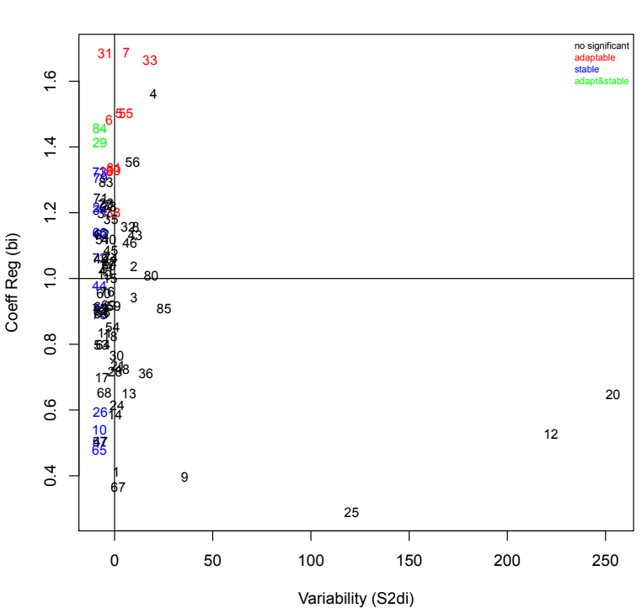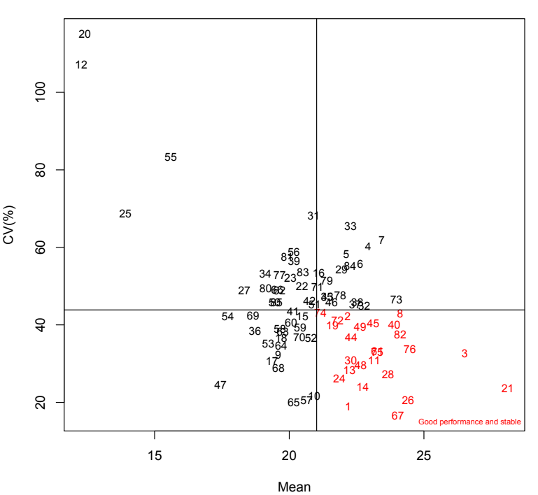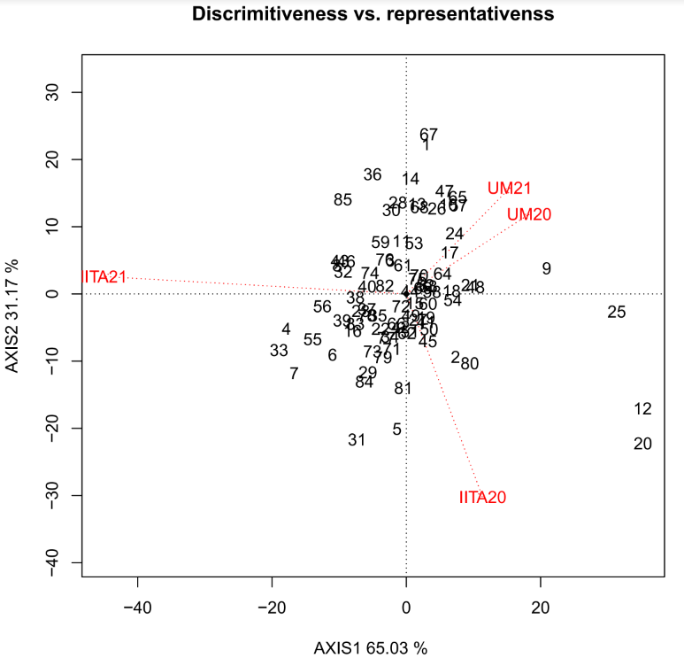

B

Figure 1. Stability analysis of the accessions with the environment. (**A**) CV vs (**B**) Mean biplot for seed yield.

Eberthart and Russell (bi, S2di) biplot for seed yield

A

B

Figure 2. (**A**) Biplot analysis result (**B**)Discriminativeness and representativeness of accessions with the environment

A

A

B

C

D

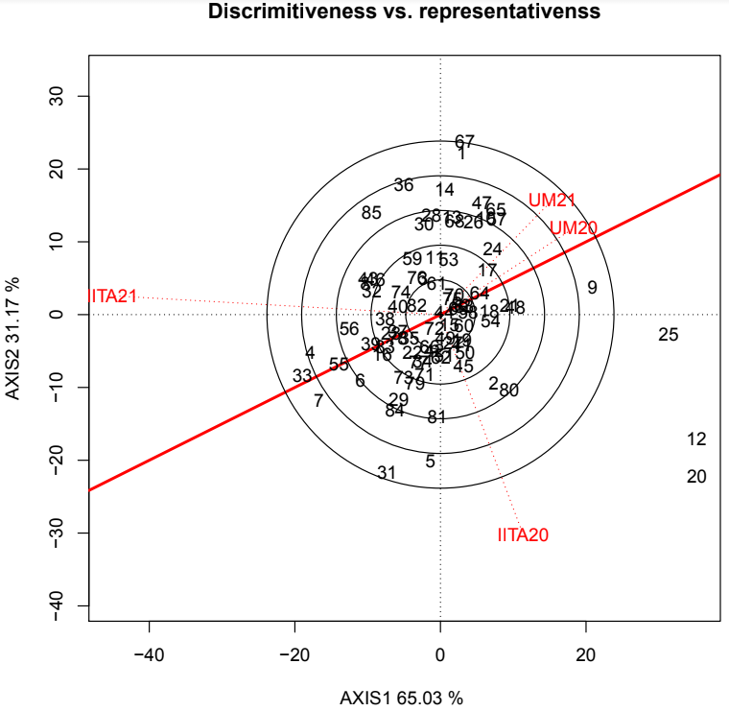

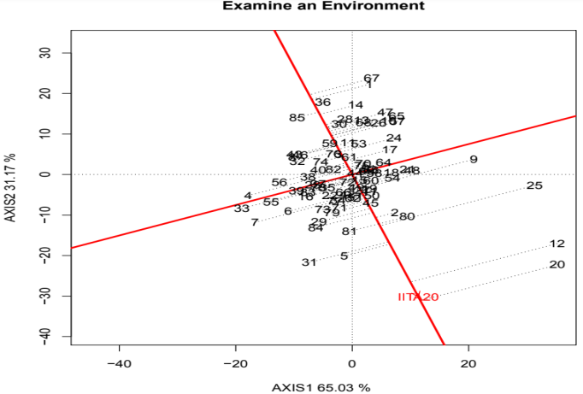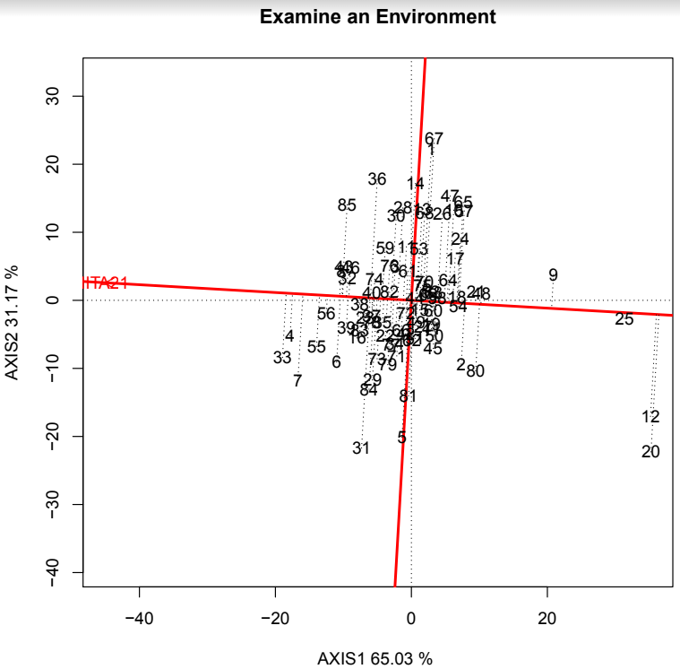

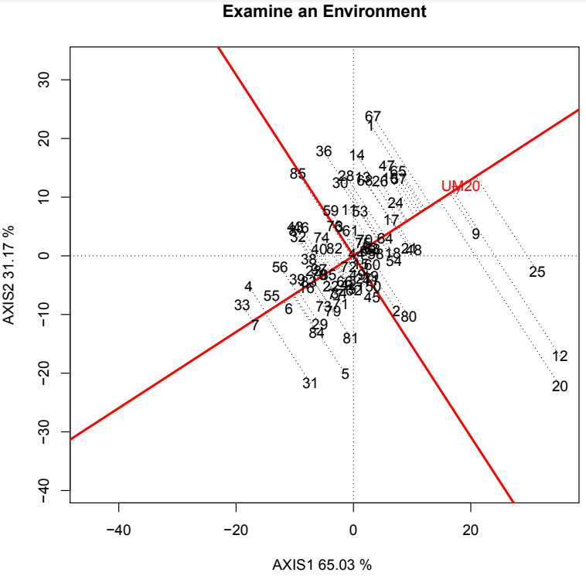

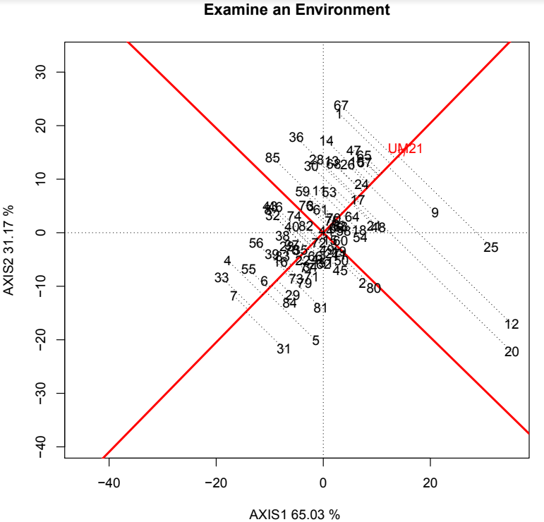

Figure 3. Evaluation of performances of the accessions in tested environment (A) IITA 2020 (B) IITA 2021 (C)UMU 2020 (D)UMU 2021

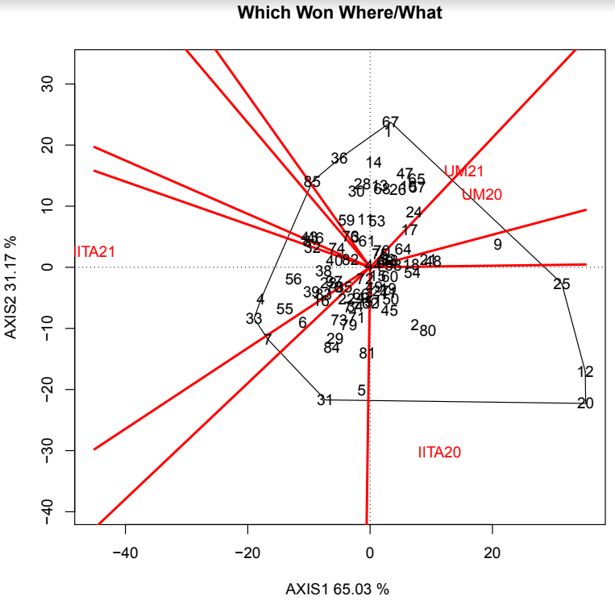

Figure 4. Which-won-where the analysis of the accessions. Identifying the best accession suitable for each environment

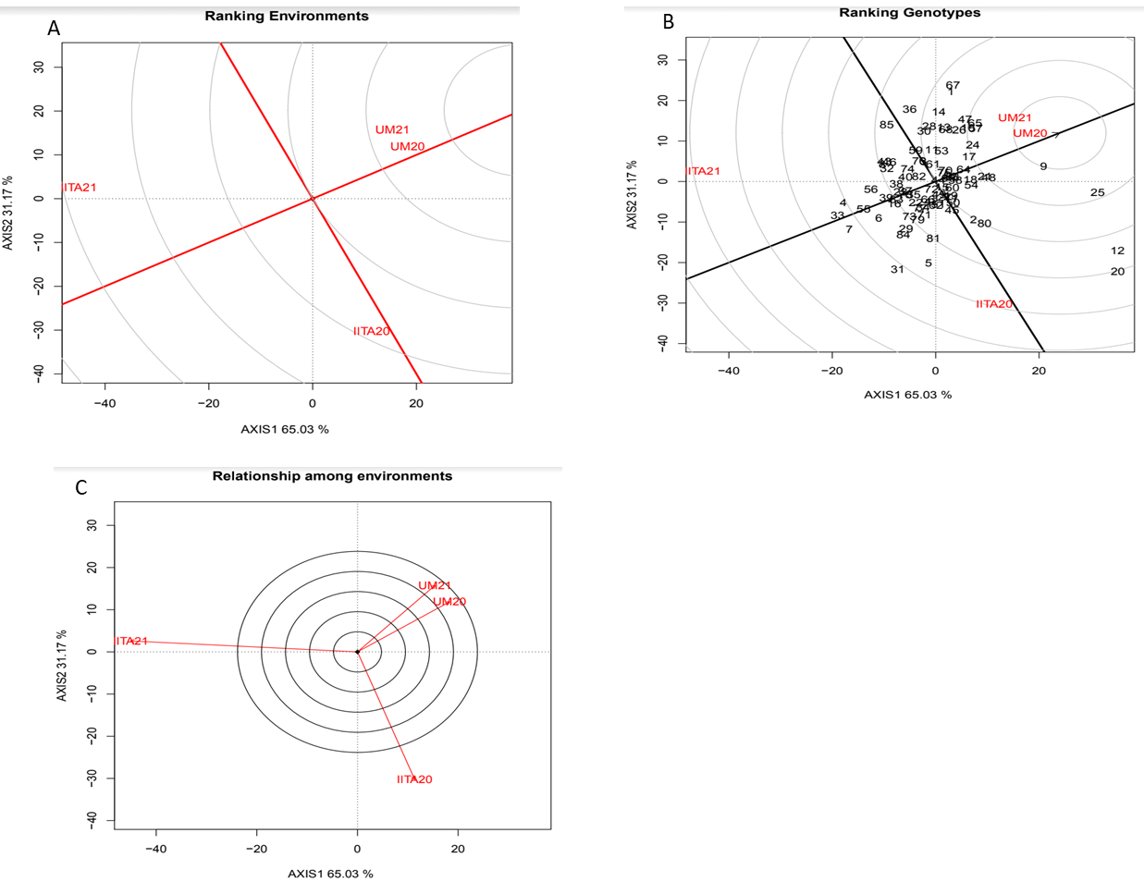

Figure 3.Evaluation of performances of the accessions in tested environment (A) IITA 2020 (B) IITA 2021 (C)UMU 2020 (D)UMU 2021

Figure 5. Ranking Environment based on both mean and stability relative to the ideal genotype. (A) Ranking environment with respect to an ideal environment (B). Ranking environment with respect to ideal genotype (C). Relationship among tested environment