**Design of a Flour Mill by Using SOLIDWORKS Software Based on Engineering Properties of Green Gram**

.

ABSTRACT

|  |
| --- |
| Green gram (mung bean) is among the most vital pulse crops in India, both nutritionally and economically. As the world’s largest producer of green gram, India contributes over 70% of the global production. To ensure the efficient processing of green gram in flour mills, it is essential to understand its physical properties, such as sphericity, bulk density, coefficient of friction, angle of repose, terminal velocity and moisture content. These properties impact various aspects of the milling process, machinery design and overall milling efficiency. In this investigation the physical properties of green gram were studied. As per the physical properties, a flour mill was designed in SOLIDWORKS software. The calculated average bulk density of green gram grains is 834.66 kg m-³ was reported. The calculated average sphericity for green gram grains was 0.84 reported. For green gram grains, the coefficient of friction was recorded as 0.43 on mild steel, 0.65 on galvanized iron, 0.59 on aluminium and 0.76 on belt material. The computed mean angle of repose for green gram was 34.73º. The average terminal velocity for green gram is 11.7 m s-1 was reported. The average moisture content of green gram grains reported as 23.33%. The average thousand grain weight for green gram is 49.33 g. |

*Keywords*: *SOLIDWORKS; Floor mill; Engineering properties; Green gram.*

1. INTRODUCTION

Green gram (mung bean) is one of the most vital pulse crops in India, both nutritionally and economically. As the world’s largest producer of green gram, India contributes over 70% of the global production. In the 2022-23 period, approximately 1.593 million hectares of land in India were dedicated to green gram cultivation, yielding about 3.74 million tonnes. The key producing states include Rajasthan, Maharashtra, Karnataka and Madhya Pradesh. Rajasthan leads the production, contributing nearly 45% of India’s total green gram output, followed by Maharashtra with 23.05%, Karnataka with 17.46% and Madhya Pradesh with 19%. Andhra Pradesh also plays an important role, dedicating 8.1% of its agricultural area to green gram cultivation during the 2023-24 rabi season, amounting to around 48,030 hectares. As stated by the Greengram Outlook report by Professor Jayashankar Telangana State Agricultural University, 2022-23.

Green grains well-known for its exceptional nutritional value as well as its environmental benefits. One of its most remarkable traits is its drought resistance, making it highly suitable for cultivation in semi-arid and drought-prone regions with limited water availability. This resilience significantly contributes to food security in regions where water resources are scarce. Furthermore, green grams are an important legume in sustainable agricultural systems due to their ability to fix nitrogen in the soil. This nitrogen fixation reduces the reliance on chemical fertilizers, thus improving soil health and promoting long-term agricultural sustainability. The crop’s short growing period, typically between 60 to 90 days, allows for multiple rotations with other crops, enhancing soil fertility and supporting crop diversification.

Nutritionally, green gram is a powerhouse, packed with plant-based protein, dietary fiber and essential vitamins such as folate and B-vitamins. It is also rich in minerals, including iron, magnesium and potassium, making it an essential dietary component, especially for vegetarian populations in India. Green gram is a key ingredient in various traditional dishes, including dal, soups, curries and snacks like mung bean sprouts and mung dal chilla. Its versatility in the kitchen ensures Its extensive application in various regions of India.

Economically, the extensive cultivation of green gram provides livelihoods for millions of farmers, especially in rural and semi-rural areas. The crop’s demand in both domestic and international markets further enhances its economic significance. India exports substantial quantities of green gram, along with its processed forms such as mung bean flour, to countries in Southeast Asia, the Middle East and Africa. These exports contribute significantly to India’s agricultural economy, cementing its role as a global leader in pulse production. The green gram industry supports not just farmers but also traders, processors, and manufacturers, generating employment opportunities and strengthening India’s position in international trade. To ensure the efficient processing of green gram in flour mills, it is essential to understand its physical properties, such as sphericity, bulk density, coefficient of friction, angle of repose, terminal velocity and moisture content. These properties impact various aspects of the milling process, machinery design and overall milling efficiency (Sawant *et al.,* 2009)

Sphericity is Importance in Milling: Sphericity measures how closely the shape of the green gram resembles a perfect sphere. Grains with higher sphericity tend to flow more smoothly through hoppers, conveyors and other processing equipment. This property is crucial for ensuring uniform grain movement during the milling process. A higher sphericity ensures consistent feeding into the mill, leading to uniform grinding and improved flour quality.

Bulk Density Importance in Milling: Bulk density refers to the mass of green gram per unit volume, including the spaces between the seeds. This property influences the design of storage systems, feeders and hoppers. It determines the appropriate capacity for material handling equipment, ensuring smooth grain transfer into milling machines. A higher bulk density means more material is processed per unit volume, which impacts milling efficiency and energy consumption. Bulk density also affects the design of storage units, ensuring optimal storage and processing.

Coefficient of Friction Importance in Milling: The coefficient of friction measures the resistance green gram grains encounter when sliding over surfaces. A high coefficient of friction can lead to blockages or uneven material flow, causing delays in the milling process. Conversely, a low coefficient of friction may lead to instability during handling. Understanding this property allows engineers to design smoother, more efficient surfaces for conveyors, chutes and hoppers, minimizing disruptions in the milling process.

Angle of Repose Importance in Milling: The angle of repose refers to the steepest angle at which a pile of green gram remains stable without sliding. This property is vital for designing storage systems and transfer mechanisms. A high angle of repose indicates that the green gram will not flow easily, which may require the use of vibrating feeders or screw conveyors to ensure smooth movement through the milling system. The angle of repose assists in predict how green gram behaves in storage units and during material transfer, allowing for more efficient milling equipment design.

Terminal Velocity Importance in Milling: Terminal velocity is the speed at which green gram seeds fall through the air under the influence of gravity. This property is especially important for air-classification systems used in mills to separate lighter particles, such as husk or dust, from the heavier green gram seeds. Understanding terminal velocity aids in designing efficient air separation systems that improve flour quality by ensuring the removal of unwanted particles. Proper airflow design enhances separation and ensures a cleaner, higher-quality product.

Moisture Content Importance in Milling: Moisture content is among the most critical factors in milling operations. High moisture content in green gram can cause clumping, clogging, or gumming of milling equipment, leading to reduced processing efficiency and potential damage. On the other hand, insufficient moisture content can make the seeds brittle, causing them to fracture during milling and resulting in uneven grinding. Maintaining the optimal moisture level is crucial for smooth and consistent grinding. This is especially important for designing drying or pre-conditioning systems that adjust the moisture levels before milling, ensuring high-quality flour production.

In conclusion, green gram is an essential crop in India, offering both significant nutritional value and economic importance. The crop is essential for ensuring food security, especially in semi-arid regions and supports sustainable farming practices by improving soil health through nitrogen fixation. Its short cultivation period permits crop rotation and diversification, further contributing to agricultural sustainability. With its widespread use in traditional dishes and growing export demand, green gram is an indispensable part of India's agricultural economy. Understanding its physical properties is vital for optimizing the milling process and ensuring efficient production of high-quality flour. By analyzing key properties such as sphericity, bulk density, coefficient of friction, angle of repose, terminal velocity and moisture content, we can improve the design of milling equipment and enhance the overall milling efficiency. With this knowledge, the green gram industry can continue to thrive, benefiting both farmers and consumers alike. The objectives of the investigation are

1. To Study the Engineer properties of green gram grains.

2. To design a flour mill model in SOLIDWORKS software based on engineering properties.

2. material and methods

All existing food processing equipment and machinery, developed through extensive research endeavors, primarily rely on physical properties of grains. This emphasis is crucial as the equipment must effectively operate in various conditions. For example, when designing food processing machinery, a close attention is paid concerning the physical attributes of grains, The chosen varieties for this study are the green gram variety LGG 630 newly developed at RARS, Lam.

When designing the food processing, conveying and cleaning unit for green gram grains involves measuring of engineering properties such as sphericity, coefficient of friction, angle of repose, terminal velocity, moisture content, bulk density and 1000 grain weight according to standard procedures, which are outlined in the following sections. Based on the engineering properties, designing a flour mill in SOLIDWORKS Software before fabrication allows for precise modeling, analysis and optimization of the machine’s components, ensuring efficiency and performance. It enables engineers to detect design flaws, optimize material usage and perform simulations for structural integrity and functionality. The present was mainly focusing on design of 3D modeling which helps in visualizing assembly, reducing errors during manufacturing and streamlining production by generating accurate technical drawing. This approach ultimately saves time, reduces costs and enhances the overall quality and reliability of the flour mill.

**2.1 Physical Properties of Green Gram Grains**

**2.1.1 Bulk density**

The bulk density of green gram grains was assessed with a measuring cylinder. Initially, a measuring cylinder with a capacity of 250 cc was selected and its weight (W1) was recorded. Next, the grains were filled into the cylinder up to the 250 cc mark and the cylinder was gently tapped to ensure settling. The weight of the grains and the cylinder (W2) was then noted. The weight of the grains (W) within the cylinder was determined by subtracting the weight of the empty cylinder (W1) from the weight of the cylinder with grains (W2). This process was repeated three times and an average value was calculated. The measurement of bulk density for green gram is illustrated in Figure 1. Subsequently, the bulk density was computed using the formula (1) provided by (Sawant *et al.,* 2009).

$$\text{Bulk density of grains }\left(\text{kg }{\text{m}}^{\text{-3}}\right)\text{ = }\frac{\text{W}}{\text{V}}\text{ …(1)}$$

Where,

W = Weight of the sample, kg

V = Volume of the cylinder, m3

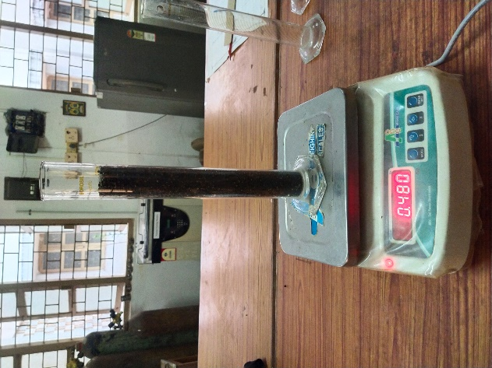

**Figure 1: Measurement of bulk density**

**2.1.2 Sphericity**

Size of the grains is an important parameter in designing the flour mill. The size of the grains is specified by its axial and lateral dimensions. Accordingly, the dimensions such as length (l), breadth (b) and thickness (t) were measured by using digital vernier callipers as shown in Figure 2, for a randomly selected sample of 20 grains and their average values were computed. Average value of the length (l), breadth (b) and thickness (t) are calculated by using the formula 2 given by (Siva Shankar and Pandiarajan, 2019). Sphericity is a property that shows the shape character of the grains relative to the sphere of the same volume. Sphericity is defined as the ratio of the diameter of the sphere having the same volume as that of particle and the diameter of the smallest circumscribing sphere or generally the largest diameter of the particle.

**Figure 2: Measurement of sphericity by digital vernier calliper**

$$\text{Sphericity }\left(\text{φ}\right)\text{ = }\frac{{\text{(l×b×t)}}^{\text{1/3}}}{\text{l}}\text{ …(2)}$$

Where,

φ = Sphericity

l = Average length of the grain, mm

b = Average breadth of the grain, mm

t = Average thickness of the grain, mm

**2.1.3 Coefficient of friction for grains**

The coefficient of friction plays a crucial role in determining the angle at which a consistent flow of grains from the hopper to the threshing cylinder can be achieved. This coefficient is assessed using the inclined plane method. For green gram grains, the coefficient of friction was measured across various surfaces including plywood, galvanized iron sheet, metal sheet and fiber sheet. To conduct the experiment, grains were placed in a circular box with a diameter of 6 cm and a height of 5.5 cm. Subsequently, the box was positioned on the surface to measure the coefficient of friction, after which the surface was gradually raised using a screw device, as depicted in Figure 3. The angle at which the box commenced sliding was recorded from the graduated scale on the apparatus. This procedure was repeated five times for each surface material. The coefficient of friction was then calculated as the tangent of the angle of inclination (α), as per equation 3 by (Dash *et al.,* 2022).

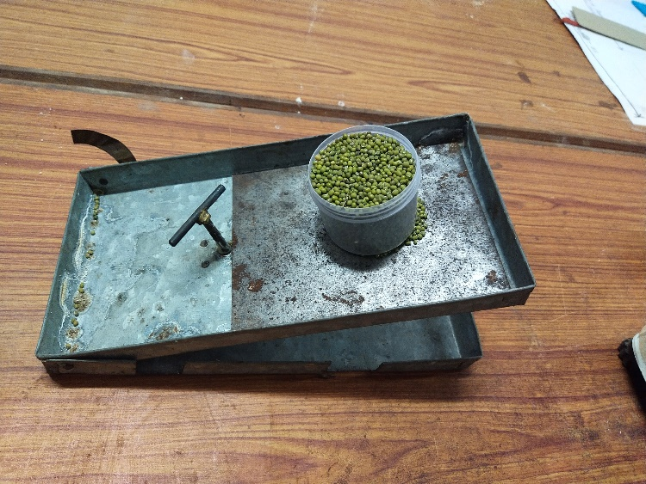

**Figure 3: Measurement of coefficient friction**

$$\text{Coefficient of friction, μ =}\text{tan}{\text{(α)}}\text{ …(3)}$$

Where

μ = Coefficient of friction

α = Angle of inclination, º

**2.1.4 Angle of repose**

Angle of repose is an important parameter helps in design of hopper of grain box. A circular plate was placed on the stand which is fitted inside the circular platform. The circular plate was surrounded by circular box and the box was placed on circular plate and then it was filled with grains to its full depth. After that circular box was removed, while removing a conical heap is formed on the surface of the plate as shown in Figure 4. Then the height of the cone formed and the diameter of the plate was measured by using a scale. The angle of repose given as angle between the base and the slope of the cone formed and is calculated by using the following equation 4 according to (Pandiselvam *et al.*, 2017).

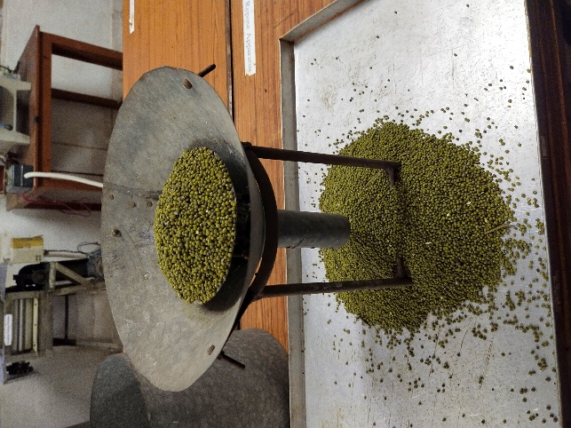

**Figure 4: Measurement of angle of repose for green gram**

$$\text{Angle of repose }\left(\text{θ}\right)\text{ = }{\text{tan}}^{\text{-1}}\left(\frac{\text{2h}}{\text{d}}\right)\text{ …(4)}$$

Where,

h = Height of the cone formed, cm

d = Diameter of the circular plate, cm

**2.1.5 Terminal velocity**

The terminal velocity of a particle can be described as the air velocity at which the particle remains suspended in a vertical pipe. Understanding terminal velocity is essential for determining the required winnowing velocity of a blower for separating chaff or waste materials from grains. The terminal velocity was determined using an air column. The terminal velocity was determined using a test stand illustrated in Figure 5. This setup comprises a vertical transparent glass tube, measuring 450 mm in length and 60 mm in diameter, utilized for suspending particles in an air stream. An electric motor-powered suction blower fan supplied the air. The test involved placing the sample on a mesh screen inside the vertical glass tube. The fan discharge was manually increased for each test run. During each run, a sample was dropped into the air stream from the top of the column and air was blown up the column to suspend the material in the air stream. The air velocity near the location of sample suspension was measured using a digital anemometer with a least count of 0.1 m s-1 and the data were recorded. The procedure was followed as given by (Nimkar and Chattopadhyay, 2001).

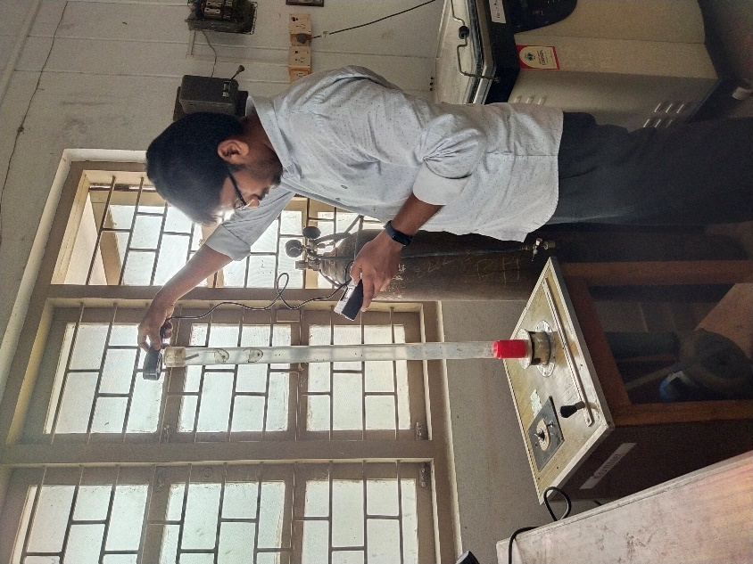

**Figure 5: Measurement of terminal velocity of green gram**

**2.1.6 Moisture content**

The moisture content of green gram was determined by following the procedure outlined in the ASAE standards, 2003. Crop samples were placed in a convection hot air oven at 103±2 °C for 24 hours. The weights of the crop samples were measured using an electronic balance (Model: HTR-220E, accuracy: ±0.001g). The weight of the empty box was recorded as We grams, the weight of the moisture box with the sample before placing it in the hot air oven was recorded as Ww grams and the weight of the moisture box with the sample after 24 hours in the oven was recorded as Wd grams. The weight loss of the samples was noted and the moisture content was calculated as a percentage. This procedure was repeated three times and the average moisture content was computed using Equation 5.

$$\text{Moisture content. \% }\left(\text{w.b}\right)\text{= }\frac{{\text{W}}_{\text{d}}\text{- }{\text{W}}_{\text{e}}}{{\text{W}}_{\text{w}}\text{ - }{\text{W}}_{\text{e}}}\text{ ×100 …(5)}$$

Where,

We = Weight of empty box, g

Ww = Moisture box with sample before drying, g

Wd = Moisture box with sample after drying, g

**2.1.7 1000 grain weight**

The weight of 1000 grain weight was determined using a precision electronic balance with an accuracy of 0.01 grams. To assess the accuracy of the 1000 grain weight, three randomly selected samples were weighed and the mean values were reported (Manoharan, 2018).

**2.2 Design of flour mill in SOLIDWORKS Software**

The flour mill is drawn and assembled in using SOLIDWORKS Software, the process flow chat as depicted in Figure 6. The engineering properties of green gram were utilized to support the design of the threshing unit. In the design process, part drawings were initially created for each component and then an isometric view of the flour mill was obtained by assembling all the part drawing components.

**Figure 6: Flow chat to design a flour mill in SOLIDWORKS Software**

**Figure 7: Designed flour mill in SOLIDWORKS Software**

Flour mills operate by grinding grains between two grooves, flat disks that rotate. The flour mill can be configured with either horizontal or vertical axes. One of the disks is fixed, while the other rotates and the material is fed between the plates to undergo crushing and shearing. The design of the grooves and corrugations on the disks determines the type of grinding operation. In flour mills, the material should be fed gradually, as excessive feeding reduces grinding efficiency and increases heat buildup. These mills are typically used for grinding whole or dehusked grains, though their application in spice grinding is limited. In the other case, both disks rotate in opposite directions at high speeds, which enhances their grinding capacity and makes them ideal for soft materials. These mills can operate at a broad range of speeds, which contributes to their versatility. The grind's fineness in these mills is determined by the plate type and the gap between the plates, which can be adjusted. To protect the mill from damage due to overloading or foreign materials in the feed, the plates are often spring-loaded. One of the main advantages of flour mills is their lower initial cost and relatively efficient power consumption.

3. results and discussion

The engineering properties such as sphericity, coefficient of friction, angle of repose, terminal velocity, moisture content, bulk density and 1000 grain weight of green gram was measured data were calculated as per the standard formulas and presented in the following subsections. After the calculation of engineering properties a design of flower mill was drawn in SOLIDWORKS Software with approximate dimensions.

**3.1 Physical Properties of Green gram**

**3.1.1 Bulk density**

**i. Calculation of Bulk density**

Empty weight of cylinder = 260 gm

Weight of cylinder with sample = 470 gm

Weight of sample = 470 – 260 gm = 210 gm = 0.210 kg =W

Volume of the cylinder = 250 ml = 0.00025 m3 = V

Similarly, bulk density was calculated for remaining samples.

**Table 1: Calculated values of bulk density**

|  |  |  |  |  |
| --- | --- | --- | --- | --- |
| **S. No.** | **Empty weight of cylinder, gm** | **Weight of cylinder with sample, gm** | **Weight of sample, gm** | **Bulk density, (kg m-3)** |
| 1. | 260 | 470 | 210 | 840 |
| 2. | 250 | 460 | 210 | 840 |
| 3. | 260 | 466 | 206 | 824 |
|  |  |  | Average | 834.66 |

Bulk density is an important parameter in the design of grain hoppers, storage boxes and flour mills. It was calculated using Equation 1, with the obtained values of green gram grains provided in Table 1. The average bulk density of green gram grain is 834.66 kg m-³. According to Manoharan (2018), the bulk density of green gram ranges from 626.56 to 984.29 kg m-3.

**3.1.2 Sphericity**

**Calculation of Sphericity**

Length of grain or major axis dimensions (l) = 4.43 mm

Width of grain or intermediate axis dimensions (w) = 3.08 mm

Thickness of grain or minor axis dimensions (t) = 3.06 mm

$$\text{Sphericity }\left(\text{φ}\right)\text{ = }\frac{{\text{(l × w × t)}}^{\text{1/3}}}{\text{l}}\text{ = }\frac{{\text{(4.43 × 3.08 × 3.06)}}^{\text{1/3}}}{\text{4.43}}\text{= 0.78 }$$

Similarly, sphericity was calculated for remaining samples.

**Table 2: Calculated values of sphericity**

|  |  |  |  |  |
| --- | --- | --- | --- | --- |
| **S. No.** | **Length, mm** | **Width, mm** | **Thickness, mm** | **Sphericity, φ** |
| 1. | 4.43 | 3.08 | 3.06 | 0.78 |
| 2. | 4.17 | 3.00 | 2.94 | 0.79 |
| 3. | 3.96 | 3.51 | 3.46 | 0.92 |
| 4. | 4.16 | 3.21 | 3.16 | 0.84 |
| 5. | 4.17 | 3.23 | 3.23 | 0.84 |
| 6. | 3.77 | 3.32 | 2.89 | 0.87 |
| 7. | 3.94 | 3.02 | 2.91 | 0.83 |
| 8. | 4.29 | 3.31 | 3.27 | 0.84 |
| 9. | 4.08 | 3.16 | 3.14 | 0.84 |
| 10. | 4.13 | 3.20 | 3.19 | 0.84 |
| Average | 4.11 | 3.204 | 3.125 | 0.84 |

Sphericity is an important parameter for selecting or designing grain hoppers and storage boxes. It was calculated using Equation 2 and the obtained values was given in Table 2**.** The length of green gram grains ranges from 3.77 to 4.43 mm, with an average length of 4.11 mm. The width varies between 3.00 and 3.51 mm, with an average width of 3.204 mm. The thickness ranges from 2.89 to 3.46 mm, with an average thickness of 3.125 mm. Sphericity of grain varies between 0.78 and 0.87, with an average sphericity of 0.84. Harerimana *et al.,* (2022) studied and reported the average sphericity of green gram grains to be in the range of 0.69 to 0.84.

**3.1.3 Coefficient of friction**

**Calculation**

For mild steel material,

Distance, x = 23 cm and Height, h = 10 cm

$$\text{α = }{\text{tan}}^{\text{-1}}\left(\frac{\text{h}}{\text{x}}\right)\text{= }{\text{tan}}^{\text{-1}}\left(\frac{\text{10}}{\text{23.0}}\right)\text{= 23.49°}$$

$$\text{μ = tan}\left(\text{α}\right)\text{ = tan }\left(\text{23.49}\right)\text{ = 0.43}$$

Similarly, it was calculated for all the materials.

**Table 3: Calculated values of coefficient of friction**

|  |  |  |  |  |  |
| --- | --- | --- | --- | --- | --- |
| **S. No.** | **Material** | **Distance, (x), cm** | **Height (h), cm** | **Angle (α)**  **(degree)** | **μ = tan(α)** |
| 1. | Mild steel | 23.0 | 10.0 | 23.49 | 0.43 |
| 2. | Galvanized iron | 19.0 | 12.5 | 33.34 | 0.65 |
| 3. | Aluminium | 20.0 | 12.0 | 30.96 | 0.59 |
| 4. | Fiber belt material | 17.0 | 13.0 | 37.40 | 0.76 |

The coefficient of friction is a critical factor in designing grain hoppers and flour mills to ensure the free flow of grains when they come into contact with the hopper. This coefficient varies based on material used for hopper. It was assessed by using Equation 3 for four distinct materials and is reported in Table 3. For green gram grains, the coefficients were recorded as 0.43 on mild steel, 0.65 on galvanized iron, 0.59 on aluminium and 0.76 on belt material. Manoharan (2018) studied the coefficient of friction, reporting values for green gram grains as 0.48 on mild steel and 0.82 on galvanized iron.

**3.1.4 Angle of repose**

**Calculation**

Diameter, d = 12.5 cm and Height, h = 4.4 cm

$$\text{θ = }{\text{tan}}^{\text{-1}}\left(\frac{\text{2h}}{\text{d}}\right)\text{= }{\text{tan}}^{\text{-1}}\left(\frac{\text{2×4.4}}{\text{12.5}}\right)\text{= 35.14°}$$

Similarly, it was calculated for remaining samples

**Table 4: Calculated values of angle of repose**

|  |  |  |  |
| --- | --- | --- | --- |
| **S. No.** | **Height (h), cm** | **Diameter (d), cm** | **Angle of repose, (θ)** |
| 1. | 4.4 | 12.5 | 35.14 |
| 2. | 4.3 | 12.5 | 34.53 |
| 3. | 4.3 | 12.5 | 34.53 |
|  |  | Average | 34.73 |

The angle of repose is an important parameter in designing grain hopper boxes and flour mills. It was calculated using Equation 4, with the values of green gram grains provided in Table 4. The average angle of repose for green gram is 34.73º, According to Dash *et al.,* (2022), it was ranges from 30.95º to 46.57º.

**3.1.5 Terminal velocity**

**Table 5: Measured values of terminal velocity**

|  |  |
| --- | --- |
| **S. No.** | **Terminal velocity, (m s-1)** |
| 1. | 11.6 |
| 2. | 11.5 |
| 3. | 12.0 |
|  | Average 11.7 |

Terminal velocity is a critical parameter for setting the blower fan speed to clean lighter particles such as chaff, husk and other foreign matter and also important for design of flour mills. It was measured using a digital anemometer and the values of green gram grains are provided in Table 5. The average terminal velocity for green gram grain is 11.7 m s-1. According to Nimkar and Chattopadhyay (2001), the terminal velocity of green gram ranges from 10.1 to 12.1 m s-1.

**3.1.6 Moisture content**

**Calculation of moisture content**

Empty box weight (We) = 20 g

Moisture box with sample before drying (Ww) = 70 – 20 = 50 g

Moisture box with sample after drying (Wd) = 32 – 20 = 12 g

$$\text{Moisture content. \% }\left(\text{w.b}\right)\text{ = }\frac{{\text{W}}_{\text{d}}}{{\text{W}}_{\text{w}}}\text{ × 100 = }\frac{\text{12}}{\text{50}}\text{ × 100 = 24 \%}$$

Similarly, the moisture content was calculated for all remaining samples.

**Table 6: Calculated values of moisture content**

|  |  |  |  |  |
| --- | --- | --- | --- | --- |
| **S. No.** | **Empty box weight (We), g** | **Moisture box with sample before drying (Ww), g** | **Moisture box with sample after drying (Wd), g** | **Moisture content, (%)** |
| 1. | 20 | 70 | 32 | 24 |
| 2. | 22 | 72 | 32 | 20 |
| 3. | 20 | 70 | 33 | 26 |
| Average | | | | 23.33 |

To determine the moisture content of green gram grains, three samples were selected and their moisture content was calculated using Equation 5. For green gram, the recorded moisture content values were 24, 20 and 26%, resulting in an average moisture content of 23.33%. Further details regarding the moisture calculation can be found in Table 6. According to Harerimana *et al.,* (2022), the average moisture content of green gram ranges from 11.1 to 28.2%.

**3.1.7 1000 grain weight**

The thousand grain weight of green gram grains is provided in Table 7.Variations in grain weight were observed due to differences in grain sizes. The average thousand-seed weight for green gram is 49.33 g. According to Manoharan (2018), the thousand grain weight for green gram ranges from 46 to 51 g.

**Table 7: Measured values of 1000 grain weight**

|  |  |
| --- | --- |
| **S. No.** | **1000 grain weight** |
| 1. | 50 |
| 2. | 48 |
| 3. | 50 |
|  | Average 49.33 |

4. Conclusion

The average bulk density of green gram grains is 834.66 kg m-³ was reported. The calculated average sphericity for green gram grains was 0.84 reported. For green gram grains, the coefficient of friction was recorded as 0.43 on mild steel, 0.65 on galvanized iron, 0.59 on aluminium and 0.76 on belt material. The calculated average angle of repose for green gram was 34.73º. The average terminal velocity for green gram is 11.7 m s-1 was reported. The average moisture content of green gram grains reported as 23.33%. The average thousand grain weight for green gram is 49.33 g. In conclusion, the physical properties of green gram, such as seed shape, density and moisture content play a pivotal role in determining the design of flour mills, particularly when modelled and simulated in SOLIDWORKS. Using SOLIDWORKS, these properties can be integrated into the design process, allowing for precise modelling. Furthermore, SOLIDWORKS facilitates the testing of various mill configurations, leading to a more tailored and efficient milling process for green gram. By incorporating the physical characteristics of green gram into the design process, manufacturers can reduce product waste, improve yield and achieve better operational performance. Future work may involve more detailed simulations considering additional factors such as wear and tear of milling parts and real-time feedback from the milling process, further enhancing the overall design and functionality of the flour mill.

**COMPETING INTERESTS**

The authors have declared no conflict of interests exist.

**COMPETING INTERESTS DISCLAIMER:**

Authors have declared that they have no known competing financial interests OR non-financial interests OR personal relationships that could have appeared to influence the work reported in this paper.

References

1. Sawant BP, Sawant SA and Munde PA. Effect of moisture content on selected physical properties of pulses. *International Journal of Agricultural Engineering.* 2009. 2(2):270-272.

2. Siva Shankar, V and Pandiarajan T. Engineering properties of black gram grain at various moisture content. *International Journal of Agriculture Sciences*. 2019. 11(10):8480-8484.

3. Dash BS, Swain SK, Behera D, Rayaguru K and Meshram M. Effect of moisture content on engineering properties of green gram for designing of agricultural equipment. *Asian Journal of Dairy and Food Research.* 2022. 41(1):47-55.

4. Pandiselvam R, Thirupathi V, Kothakota A and Kamalapreetha B. Important engineering properties of green gram (Vigna radiate). *Agricultural Engineering Today*. 2017. 41(4):30-36.

5. Nimkar PM and Chattopadhyay PK. PH-Postharvest Technology: some physical properties of green gram. *Journal of Agricultural Engineering Research*. 2001. 80(2):183-189.

6. Manoharan M. A comprehensive study on physical properties of black gram and green gram for developing a planter. 2018. *International Journal of Agricultural Science Research*. 8(6):71-74.

7. Harerimana L, Mani I, Parray RA and TV A.K. Effect of moisture content on engineering properties of Pusa-1431 variety of green gram. *The Pharma Innovation Journal*. 2022. 11(3):1269-1276.

8. ASAE. 2003. ASAE Standard S352-2FEB03 Moisture measurement. Unground grain and seeds. St Joseph Michigan.

9. Dash, B. S., Swain, S. K., Behera, D., Rayaguru, K., & Meshram, M. (2022). Effect of moisture content on engineering properties of green gram for designing of agricultural equipment. *Asian Journal of Dairy and Food Research*, *41*(1), 47-55.

10. Sivakumar, C., Chaudhry, M. M. A., Nadimi, M., Paliwal, J., & Courcelles, J. (2022). Characterization of roller and Ferkar-milled pulse flours using laser diffraction and scanning electron microscopy. *Powder Technology*, *409*, 117803.