**Original Research Article**

**Environmental Effects of Paddy Straw Burning: Farmer Satisfaction and Practices by Land Size in Punjab**

**Abstract**

Paddy straw burning in Punjab, India, a key rice-wheat region producing 20 million tons of straw annually, poses significant environmental challenges by releasing pollutants like particulate matter and CO₂, degrading air quality and soil health while contributing to climate change, with Punjab’s farmers–marginal (<1 ha), small (1–2 ha), semi-medium/medium (2–10 ha), and large (>10 ha), facing socioeconomic pressures driving burning, necessitating research into their satisfaction and practices to inform sustainable alternatives. This study surveyed 60 farmers across Fatehgarh Sahib and Rupnagar districts using face-to-face interviews to collect data on management practices. Results show 53.3% of farmers use incorporation, 28.3% burn straw, and 18.3% use baling. Marginal farmers favor burning, large farmers lean toward incorporation, and show higher awareness, while small and semi-medium/medium farmers vary. Machinery awareness is 80%, but adoption lags due to costs. The study reveals marginal farmers burn due to necessity and low awareness, while large farmers adopt sustainable methods, reflecting resource disparities, with small and semi-medium farmers showing mixed practices, highlighting the need for targeted interventions, subsidies for machinery access and comprehensive education, to reduce burning’s ecological toll and support Punjab’s shift toward sustainable straw management tailored to its diverse agrarian context.

**Keywords:** Paddy straw burning, farmer satisfaction, straw management, awareness

**1. Introduction**

Paddy straw burning in Punjab, India, a cornerstone of the Indo-Gangetic Plains’ rice-wheat system, producing 19–20 million tons of straw annually, poses severe environmental and agricultural challenges (Dutta et al., 2022). This practice releases pollutants like PM2.5, CO₂, and NOx, degrading air quality, contributing to climate change, and affecting soil health (Kumar et al., 2019a). During October-November, burning aligns with the tight rice-to-wheat transition, amplifying pollution that impacts Punjab and Delhi (Kaur et al., 2022). Socioeconomic pressures drive marginal, small, semi-medium/medium, and large farmers to burn straw, necessitating an understanding of their practices and satisfaction (Kumar et al., 2015). Burning depletes ecosystem services, costing northwest India dearly in soil fertility and air quality (Kumar et al., 2019a), while health risks rise with a noted increase in respiratory issues (Singh, 2018).

Punjab’s intensive agriculture generates vast straw volumes, overwhelming traditional uses like livestock feed (Lohan et al., 2017). Marginal and small farmers, constrained by time and resources, favor burning, while larger farmers explore alternatives (Lopes et al., 2023). Mechanized harvesting exacerbates stubble accumulation, making rapid disposal critical (Bhuvaneshwari et al., 2019). Sustainable options like incorporation and baling offer environmental gains, improving soil carbon and reducing emissions, but face adoption barriers (Bhattacharyya et al., 2021). In-situ management, such as Happy Seeder use, enhances resource efficiency, yet cost and awareness limit its reach among smaller landholders (Chaudhary et al., 2019). Biochar production from straw presents an ecological solution, cutting emissions and enriching soil, though infrastructure lags (Tokas et al., 2021; Aier et al., 2021).

Burning’s environmental toll includes 140–150 million tons of CO2-equivalent emissions annually, with Punjab as a major contributor (Launio et al., 2016). Soil properties suffer long-term degradation, losing organic matter and microbial diversity, while air pollution drives regional haze (Singh et al., 2022; Pradhan et al., 2024). Health studies link it to breathing woes, disproportionately affecting rural communities (Chopra & Bansal, 2022). Policy efforts, including subsidies and bans, struggle against farmer preferences for burning’s cost-effectiveness, especially among marginal holders (Bhuvaneshwari et al., 2019). Larger farmers (>10 ha), with better access to machinery, adopt alternatives, reflecting a land-size divide (Erbaugh et al., 2024).

**2. Materials and Methods**

**2.1 Study Area**

The survey was conducted in five villages of Fatehgarh Sahib and Rupnagar districts of Punjab, India. The region’s subtropical climate, with monsoon rains driving rice cultivation and irrigation supporting subsequent crops, sustains intensive farming. Predominantly, Jatt Sikh farmers engage in rice production here, generating significant quantities of paddy straw each season, which poses ongoing environmental management challenges.

**2.2 Data Collection**

Data were gathered through a comprehensive agricultural survey conducted across the specified villages. The survey aimed to capture comprehensive insights into paddy straw management practices and their perceived environmental implications within Punjab’s rice-centric farming communities. A structured questionnaire was administered via face-to-face talk, ensuring accurate and context-rich responses from farmers classified as marginal (<1 ha), small (1–2 ha), semi-medium/medium (2–10 ha), and large (>10 ha) based on landholdings.

**Table 1. Distribution of Farmers by Landholding Classification Across Villages**

|  |  |  |  |  |
| --- | --- | --- | --- | --- |
| **Village** | **Marginal (<1 ha)** | **Small (1–2 ha)** | **Semi-Medium/Medium (2–10 ha)** | **Large (>10 ha)** |
| Khant | 2 (17%) | 3 (25%) | 4 (33%) | 3 (25%) |
| Kajoli | 3 (25%) | 3 (25%) | 3 (25%) | 3 (25%) |
| Manpur | 2 (17%) | 4 (33%) | 4 (33%) | 2 (17%) |
| Kotli | 3 (25%) | 3 (25%) | 2 (17%) | 4 (33%) |
| Rauni Kalan/Khurd | 2 (17%) | 5 (42%) | 2 (17%) | 3 (24%) |

The questionnaire focused on straw management methods, perception of the easiest method, cost-effectiveness, and awareness of environmental and health impacts. Additional data included land size, farming experience, livestock ownership, and access to technology, providing a broader context for understanding management choices. Supplementary information on irrigation reliance, market access, and community dynamics enriched the dataset, offering a holistic backdrop to the farmers’ responses regarding paddy straw burning’s environmental effects.

**3. Results and Discussion**

**3.1 Farmer Profile**

The farmers surveyed represent a cross-section of Punjab’s agrarian community, ranging from 15 to 60 years, reflecting a blend of generational knowledge and newer entrants adapting to established practices. All farmers had access to mobile phones and internet connectivity, suggesting potential for digital outreach and information dissemination, though the adoption of advanced machinery varied widely across the sample. Livestock ownership was reported by 60%, influencing straw use for feed, while irrigation reliance, via canals and groundwater, underscored the intensive nature of their rice production, generating substantial straw residue annually.

**3.2 Environmental Effects of Paddy Straw Burning**

The survey focused on six key questions to explore the environmental effects of paddy straw burning, with responses analyzed through detailed comparative studies.

**3.2.1 Straw Management Methods:**

Incorporation (53.3%), prevalent among large (>10 ha) and semi-medium/medium (2–10 ha) farmers, aligns with sustainable practices that bolster soil organic matter and resource use efficiency, reducing emissions as emphasized by (Bhattacharyya et al., 2021; Chaudhary et al., 2019). Burning (28.3%), dominant among marginal farmers (<1 ha), persists due to its speed and low cost, intensifying air quality degradation with PM2.5 and CO emissions, a concern highlighted by (Lohan et al., 2017; Singh, 2018). Baling (18.3%), adopted by small (1–2 ha) and large farmers, offers an alternative for resource utilization, though infrastructural constraints limit its scalability (Yadav et al., 2022; Aier et al., 2021).

**Table 2. Straw Management Methods**

|  |  |  |
| --- | --- | --- |
| **Method** | **Count (%)** | **Land Size Insight** |
| Incorporation | 32 (53.3%) | Large (>10 ha) |
| Burning | 17 (28.3%) | Marginal (<1 ha) |
| Baling | 11 (18.3%) | Small (1–2 ha), Large (>10 ha) |

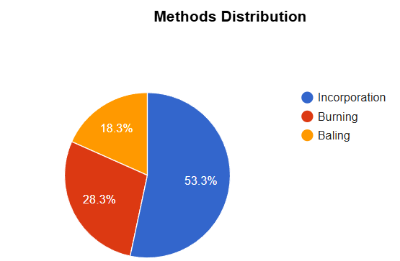

**Fig. 1. Proportion of Different Straw Management Methods**

**3.2.2 Perceived Easiest Straw Management Method:**

Perceived ease reveals 33.3% of marginal farmers favoring burning for its simplicity, exacerbating air pollution and health risks like respiratory ailments (Chopra & Bansal, 2022; Singh et al., 2022). Incorporation (30%), common among small farmers, balances practicality with soil health benefits (Jat et al., 2020), while cattle feed (20%), mulching (13.3%), and baling (3.4%) appeal to larger farmers, though equipment access remains a barrier (Kaur et al., 2021; Tokas et al., 2021). Cost-effectiveness perceptions show 30% of marginal farmers fully endorsing burning for its negligible upfront cost, 43% of small, semi-medium farmers partially agreeing due to mixed economic pressures, and 27% of large farmers disagreeing, favoring long-term gains from sustainable practices (Mishra et al., 2020; Gupta et al., 2023). Machinery awareness is high (80%), yet 20% of marginal farmers remain uninformed, reflecting adoption gaps tied to resource efficiency (Lohan et al., 2017; Lopes et al., 2023).

**Table 3. Perceived Easiest Straw Management Method**

|  |  |  |
| --- | --- | --- |
| **Method** | **Count (%)** | **Land Size Insight** |
| Burning | 20 (33.3%) | Marginal (<1 ha) |
| Incorporation | 18 (30%) | Small (1–2 ha) |
| Cattle feed | 12 (20%) | Large (>10 ha) |
| Mulching | 8 (13.3%) | Semi-Medium/Medium (2–10 ha) |
| Baling | 2 (3.4%) | Large (>10 ha) |

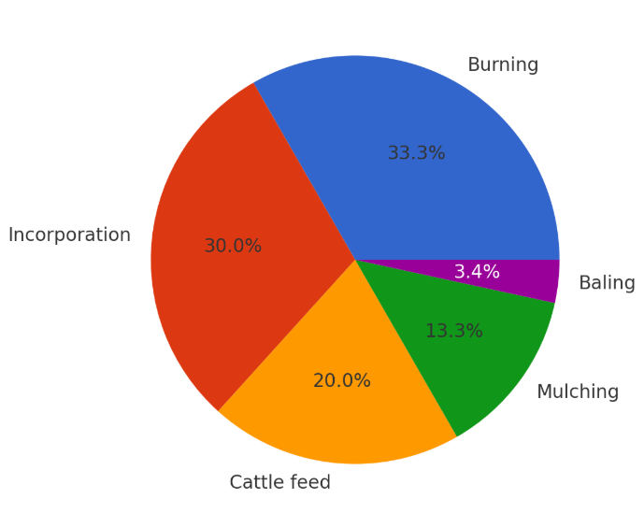

**Fig. 2. Percentage Breakdown of Easiest Straw Management Method**

**3.2.3 Awareness of Environmental and Health Impacts of Straw Burning:**

Awareness of burning’s multifaceted impacts remains alarmingly low, with only 23% of farmers, predominantly large, recognizing its detrimental effects on air quality, soil health, climate, and human health, while 77%, mainly marginal and small farmers, are unaware. This aligns with (Tripathi et al., 2019), who note that awareness campaigns in Punjab have limited reach among smaller landholders, often due to inadequate rural extension services and literacy barriers. Larger farmers, with better access to information via agricultural networks, acknowledge burning’s role in regional smog, contributing to Delhi’s haze (Dutta et al., 2022), and its health toll, with a 10–15% rise in respiratory hospital admissions during peak seasons (Kumar et al., 2015). The unaware majority underestimates climate impacts, such as 140–150 million tons of CO₂-equivalent emissions annually (Launio et al., 2016), and ecosystem losses, including biodiversity decline (Kumar et al., 2019b). Health risks, notably breathing problems, are well-documented (Chopra & Bansal, 2022), yet rural farmers rarely connect these to their practices, as (Erbaugh et al., 2024) suggest, due to a focus on immediate economic survival over long-term environmental costs.

**Table 4. Awareness of Environmental and Health Impacts of Straw Burning**

|  |  |  |  |
| --- | --- | --- | --- |
| **Response** | **Count (%)** | **Land Size Insight** | **Management Correlation** |
| Yes | 14 (23%) | Large (>10 ha) | Non-burning |
| No | 46 (77%) | Smaller (<5 ha) | Burning |

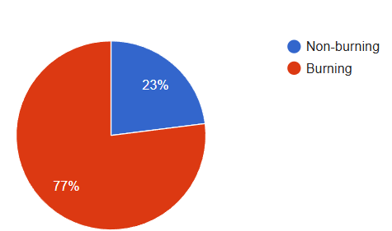

**Fig. 3. Distribution of Awareness of Environmental and Health Impacts of Straw Burning**

**3.2.4 Perception of Cost-Effectiveness of Straw Burning:**

Cost-effectiveness perceptions indicate 30% of marginal farmers endorsing burning, 43.3% of small, semi-medium farmers partially agreeing, and 26.7% of large farmers disagreeing, aligning with socioeconomic drivers and trade-offs (Mishra et al., 2020; Gupta et al., 2023). Soil fertility changes are noted by 17% of large farmers, with 83% unaware, underscoring burning’s subtle impact (Jain et al., 2022). Machinery awareness is 80%, yet 20% of marginal farmers remain uninformed, highlighting adoption barriers (Lohan et al., 2017; Lopes et al., 2023).

**Table 5. Perception of Cost-Effectiveness of Straw Burning**

|  |  |  |
| --- | --- | --- |
| **Response** | **Count (%)** | **Land Size Insight** |
| Yes | 18 (30%) | Marginal (<1 ha) |
| Partially | 26 (43.3%) | Smaller (<5 ha) |
| No | 16 (26.7%) | Large (>10 ha) |

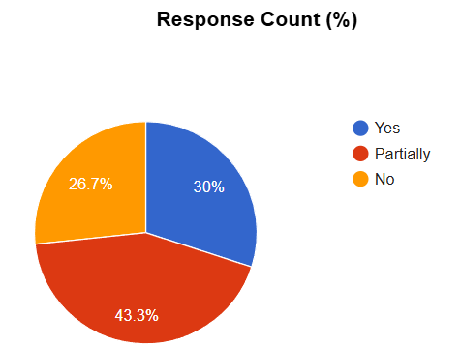

**Fig. 4. Percentage Breakdown of Perceived Cost-Effectiveness of Straw Burning**

**3.2.5 Observation of Soil Fertility Changes Due to Straw Burning:**

Only 17% of farmers, mainly large, observe soil fertility changes linked to burning, while 83% of marginal, small farmers report no noticeable impact, reflecting a critical awareness deficit. Burning depletes soil organic matter, nutrients like nitrogen and phosphorus, and microbial diversity, as detailed by (Kumar et al., 2019a; Pradhan et al., 2024), yet these gradual declines are subtle and often masked by short-term crop yields, leading smaller farmers to overlook them (Jain et al., 2022). Large farmers, transitioning to incorporation or mulching, notice improved soil structure and fertility over time (Bhattacharyya et al., 2021), corroborating (Chaudhary et al., 2019) findings on in-situ management. Marginal farmers’ lack of observation ties to their reliance on burning and limited exposure to soil science education (Lopes et al., 2023), missing ecosystem service losses like reduced water retention (Kumar et al., 2019b).

**Table 6. Observation of Soil Fertility Changes Due to Straw Burning**

|  |  |  |  |
| --- | --- | --- | --- |
| **Response** | **Count (%)** | **Land Size Insight** | **Awareness Correlation** |
| Yes | 10 (16.7%) | Large (>10 ha) | More aware |
| No | 50 (83.3%) | Marginal (< 1ha) | Less aware |

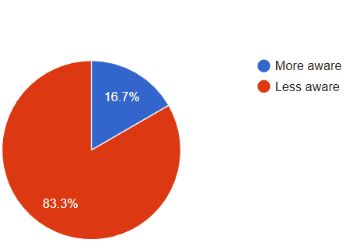

**Fig. 5. Farmer Observations of Soil Changes from Straw Burning**

**3.2.6 Awareness of Straw Management Machinery:**

Machinery awareness, at 80%, is notably high among large and semi-medium/medium farmers, reflecting effective dissemination of information about tools like the Happy Seeder through agricultural extension services, as documented by (Yadav et al., 2022). However, the 20% who remain unaware, primarily marginal, align with their higher burning rates, as economic and logistical barriers, such as equipment cost and availability, prevent them from translating awareness into action, a gap also identified by (Lohan et al., 2018). This discrepancy is evident in the low adoption of baling, despite widespread knowledge of machinery options, indicating that awareness alone is insufficient without financial and infrastructural support, a point reinforced by (Tripathi et al., 2019) in their analysis of policy interventions.

**Table 7. Awareness of Straw Management Machinery**

|  |  |  |
| --- | --- | --- |
| **Response** | **Count (%)** | **Land Size Insight** |
| Yes | 48 (80%) | Large (>10 ha) |
| No | 12 (20%) | Smaller (<5 ha) |

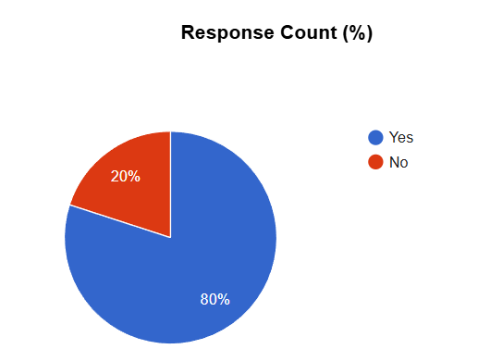

**Fig. 6. Distribution of Farmers' Awareness About Straw Management Equipment**

Burning’s broader environmental toll includes air quality degradation with seasonal smog (Dutta et al., 2022), climate change via greenhouse gas emissions (Launio et al., 2016), and health risks from respiratory issues (Singh et al., 2022). Ecosystem services erode as soil and biodiversity suffer (Kumar et al., 2019b), and resource efficiency lags with straw’s potential wasted (Bhuvaneshwari et al., 2019; Tokas et al., 2021). Marginal farmers burn out of necessity, amplifying these impacts, while large farmers adopt sustainable methods, mitigating them (Shyamsundar et al., 2019). Small and semi-medium farmers show mixed practices, balancing cost and environmental awareness (Singh et al., 2021). Targeted interventions, subsidies for machinery to address air, climate, and efficiency issues, and education to highlight soil, health, and ecosystem impacts- are essential, as (Dutta et al., 2022; Kumar et al., 2015) advocate, to shift Punjab toward sustainability.

**4. Conclusion**

This survey of Punjab farmers reveals that 28.3% burn straw, 53.3% use incorporation, and 18.3% employ baling, with 33% finding burning easiest and 30% deeming it cost-effective, yet only 23% recognize its environmental and health impacts. Marginal farmers predominantly burn, large farmers favor incorporation and note soil changes, while small and semi-medium/medium farmers show varied practices. Machinery awareness stands at 80%, but adoption is low due to resource constraints, with 77% unaware of burning’s impacts. Addressing this requires targeted education and financial support to shift marginal farmers from burning and enhance sustainability across Punjab’s farming landscape.

**5. Competing Interests**

Authors have declared that no competing interests exist.

**COMPETING INTERESTS DISCLAIMER:**

Authors have declared that they have no known competing financial interests OR non-financial interests OR personal relationships that could have appeared to influence the work reported in this paper.

**6. References**

1. Dutta, A., Patra, A., Hazra, K. K., Nath, C. P., Kumar, N., & Rakshit, A. (2022). A state of the art review in crop residue burning in India: Previous knowledge, present circumstances and future strategies. *Environmental Challenges*, 8, 100581.

<https://doi.org/10.1016/j.envc.2022.100581>

2. Kumar, A., Kushwaha, K. K., Singh, S., Shivay, Y. S., Meena, M. C., & Nain, L. (2019). Effect of paddy straw burning on soil microbial dynamics in sandy loam soil of Indo-Gangetic plains. *Environmental Technology & Innovation*, 16, 100469.

<https://doi.org/10.1016/j.eti.2019.100469>

3. Kaur, M., Malik, D. P., Malhi, G. S., Sardana, V., Bolan, N. S., Lal, R., et al. (2022). Rice residue management in the Indo-Gangetic Plains for climate and food security. A review. *Agronomy for Sustainable Development*, 42(5), 92. <https://doi.org/10.1007/s13593-022-00817-0>

4. Kumar, P., Kumar, S., & Joshi, L. (2015). Socioeconomic and environmental implications of agricultural residue burning: A case study of Punjab, India (1st ed.). Springer New Delhi.

<https://doi.org/10.1007/978-81-322-2014-5>

5. Kumar, S., Sharma, D. K., Singh, D. R., Biswas, H., Praveen, K. V., & Sharma, V. (2019). Estimating loss of ecosystem services due to paddy straw burning in North-west India. *International Journal of Agricultural Sustainability*, 17(2), 146–157.

<https://doi.org/10.1080/14735903.2019.1581474>

6. Singh, J. (2018). Paddy and wheat stubble blazing in Haryana and Punjab states of India: A menace for environmental health. *Environmental Quality Management*, 28(2), 47-53.

<https://doi.org/10.1002/tqem.21598>

7. Lohan, S. K., Jat, H., Yadav, A. K., Sidhu, H., Jat, M., Choudhary, M., Peter, J. K., & Sharma, P. (2017). Burning issues of paddy residue management in north-west states of India. *Renewable and Sustainable Energy Reviews*, 81, 693-706. <https://doi.org/10.1016/j.rser.2017.08.057>

8. Lopes, A. A., Tasneem, D., & Viriyavipart, A. (2023). Determinants of wheat residue burning: Evidence from India. *PLOS ONE*, 18(12), e0296059.

<https://doi.org/10.1371/journal.pone.0296059>

9. Bhuvaneshwari, S., Hettiarachchi, H., & Meegoda, J. N. (2019). Crop Residue Burning in India: Policy Challenges and Potential Solutions. *International Journal of Environmental Research and Public Health*, 16(5), 832. <https://doi.org/10.3390/ijerph16050832>

10. Bhattacharyya, P., Bisen, J., Bhaduri, D., et al. (2021). Turn the wheel from waste to wealth: Economic and environmental gain of sustainable rice straw management practices over field burning in reference to India. *Science of The Total Environment*, 775, 145896.

<https://doi.org/10.1016/j.scitotenv.2021.145896>

11. Chaudhary, A., Chhokar, R. S., Yadav, D. B., et al. (2019). In-situ paddy straw management practices for higher resource use efficiency and crop productivity in Indo-Gangetic Plains (IGP) of India. *Journal of Cereal Research*, 11(3), 172-198.

<http://doi.org/10.25174/2249-4065/2019/96323>

12. Tokas, D., Singh, S., Yadav, R., Kumar, P., Sharma, S., & Singh, A. N. (2021). Wheat-Paddy Straw Biochar: An Ecological Solution of Stubble Burning in the Agroecosystems of Punjab and Haryana Region, India, A Synthesis. *Applied Ecology and Environmental Sciences*, 9(6), 613-625. <http://dx.doi.org/10.12691/aees-9-6-6>

13. Aier, I., Sakhiya, A. K., Anand, A., Kaushal, P., & Vijay, V. K. (2021). Sustainable utilization of paddy straw in Punjab for biochar production: estimating the energy and emission potential. *International Energy Journal,* 21(3), 297-304.

14. Launio, C. C., Asis, C. A., Manalili, R. G., & Javier, E. F. (2016). Cost-effectiveness analysis of farmers' rice straw management practices considering CH4 and N2O emissions. *Journal of Environmental Management*, 183, 245-252. <https://doi.org/10.1016/j.jenvman.2016.08.015>

15. Singh, D., Dhiman, S. K., Kumar, V., et al. (2022). Crop Residue Burning and Its Relationship between Health, Agriculture Value Addition, and Regional Finance. *Atmosphere*, 13(9), 1405. <https://doi.org/10.3390/atmos13091405>

16. Pradhan, P., Sinha, A. K., & Pandit, T. K. (2024). The Effect of Stubble Burning and Residue Management on Soil Properties: A Review. *International Journal of Plant & Soil Science*, 36(6), 36-49. <https://doi.org/10.9734/ijpss/2024/v36i64604>

17. Chopra, Shruti & Bansal, Surbhi. (2022). Paddy Stubble Burning in Punjab: An Architect of Breathing Woes. *Indian Journal of Ecology*, 49, 1830-1836.

18. Erbaugh, J., Singh, G., Luo, Z., Koppa, G., Evans, J., & Shyamsundar, P. (2024). Farmer perspectives on crop residue burning and sociotechnical transition in Punjab, India. *Journal of Rural Studies*, 111, 103387. <https://doi.org/10.1016/j.jrurstud.2024.103387>