**Opinion Article**

**Overview of the current status of utilisation of solid waste resource calcium carbide slag**

**ABSTRACT:**

As a strong alkaline industrial waste generated in the process of acetylene production, calcium carbide slag has a huge annual output and prominent environmental risks. This paper systematically reviews the disposal and resource utilisation technology system of calcium carbide slag, reveals that its main component is calcium hydroxide (82%-90%) with silica-aluminium-iron impurities, and demonstrates the environmental urgency of industrial utilisation. By comparing the process characteristics of traditional physical disposal (reclamation pile, natural sedimentation) and chemical comprehensive utilisation (cement/lime/lightweight bricks), it is pointed out that landfill method has land encroachment and pollution potential, while the existing resource technology has significant limitations in terms of calcium carbide slag consumption (15%-50%), energy consumption control (calcination process up to 900-1000℃) and added value of the product. Focusing on the innovative path of calcium carbonate preparation from calcium carbide slag: breaking through the limitation of calcium hydroxide solubility, adopting ammonium chloride leaching-CO₂ carbonation recycling process to achieve the utilisation rate of calcium carbide slag to be increased to more than 80%, and the purity of the light calcium carbonate produced reaches 99.2%, whiteness > 93%, and its economic feasibility is verified by 50kt/a industrialised production line. Research shows that the leaching method reduces energy consumption by 15%-20% compared with the traditional calcination method, and the synergistic CO₂ capture can reduce emissions by 21kg CO₂/t of calcium carbide slag, which promotes the formation of a closed-loop resource chain of ‘calcium carbide slag-calcium carbonate’. The future needs to develop high value-added product development, intelligent purification process and cross-industry coupling technology to break through the bottleneck of industrialisation.

**KEY WORDS:** Tourmaline slag; Solid waste resource utilisation; Calcium hydroxide; Calcium carbonate; Ammonium chloride leaching; CO₂ carbonation; Recycling economy; Environmental governance

**Introduction**

Calcium carbide slag (CCS) is a solid waste from the hydrolysis of calcium carbide to obtain acetylene gas, with Ca(OH)2 as the main component. Carbide slag is a kind of waste residue with calcium hydroxide which is the main component after acetylene gas produced by hydrolysis of calcium carbide [20]. Generally, a large amount of carbide slag is produced in the process of using calcium carbide to produce acetylene, polyvinyl chloride, acetone, and other chemical products [21]. As a strong alkaline industrial waste generated in the process of acetylene production, calcium carbide slag has a huge annual output and prominent environmental risks.

# **1 Sources of calcium carbide slag**

The use of calcium carbide production of acetylene and downstream chemical products will discharge a large number of calcium carbide slag. The main component of calcium carbide slag (dry basis) is 82% to 90% of calcium hydroxide, but also contains silicon oxide, alumina, iron oxide, and a small amount of calcium carbonate, magnesium hydroxide, titanium dioxide, carbon residue and other impurities. Calcium carbide slag is strongly alkaline, aqueous solution pH 12.5, how to comprehensively utilise the calcium carbide slag, waste to treasure has been the whole industry is an imminent problem. At the same time, limestone resources, after all, is a non-renewable resources, with the state of calcium carbonate mining requirements are becoming more and more stringent, the three waste disposal, environmental protection requirements are getting higher and higher.

Calcium hydroxide is the main component of calcium hydroxide slag after hydrolysis of calcium carbide to obtain acetylene gas. Acetylene (C2H2) is one of the important raw materials for the basic organic synthesis industry, calcium carbide (CaC2) as a raw material, water (wet) production of acetylene process is simple and mature, 1t of calcium carbide and water can generate more than 300kg of acetylene gas, and at the same time generate 10t of solid content of about 12% of the industrial waste, commonly known as calcium carbide slag slurry. The use of calcium carbide slag can be used to replace limestone cement, production of quicklime used as raw materials for calcium carbide, the production of chemical products, the production of construction materials and for environmental management.

According to the production experience, each production of 1t PVC products consume 1.5-1.6t of calcium carbide, at the same time each t of calcium carbide produces 1.2t of calcium carbide slag (dry basis), calcium carbide slag moisture content according to 90%, then each production of 1t PVC products, discharged calcium carbide slag slurry of about 20t. It can be seen that the amount of calcium carbide slag slurry production is greatly exceeded by the output of PVC. Most PVC manufacturers will be calcium carbide slag slurry separation by gravity settlement, the supernatant recycling; calcium carbide slag by further dehydration, its moisture content is still up to 40% -50%, was a paste, easy to leakage in transit to pollute the road, the long-term accumulation of not only take up a large amount of land, but also on the land has a serious erosive effect. To solve the problem fundamentally, only to seek breakthroughs in technology, seeking new treatment processes, comprehensive utilisation, turning harm into benefit, turning waste into treasure.

The calcium carbide slurry is a grey-brown turbid liquid. After standing, it is divided into three parts, the clarified liquid, the solid sediment layer and the intermediate colloidal transition layer. Proportion of the three with the rest of the time and environmental conditions are reversible transformation. Solid sediment is what we often call calcium carbide slag.

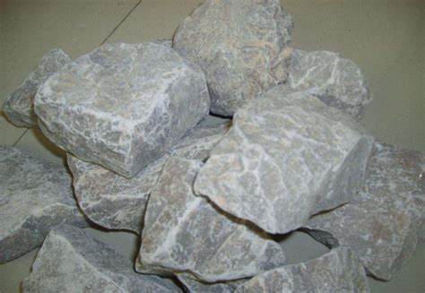 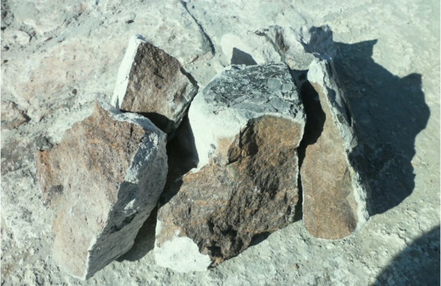

**Fig 1-Calcium carbide chunks**

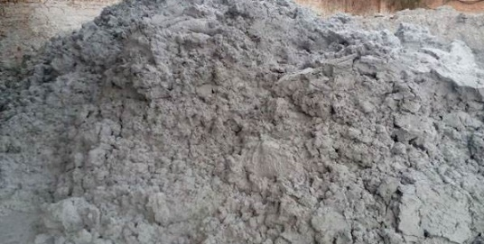 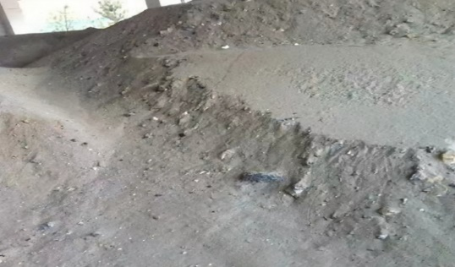

**Fig 2-Calcium carbide**

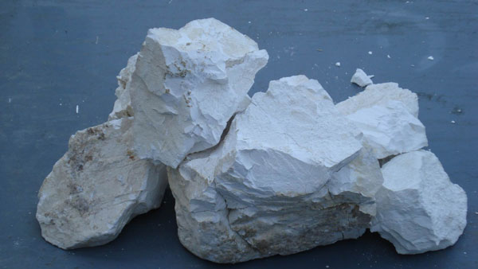

**Fig 3- Calcium carbide briquettes**

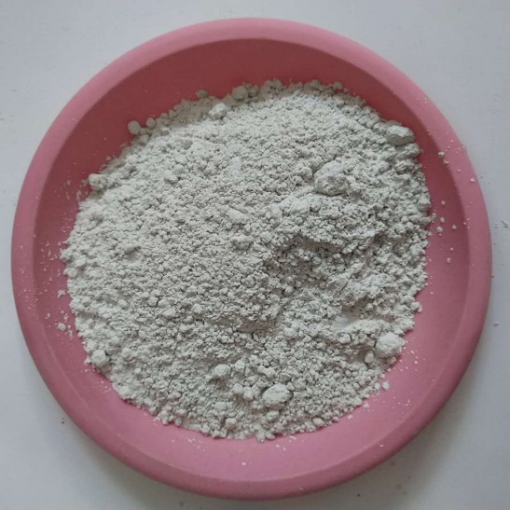

**Fig 4- Calcium carbide slag powder**

# **2 Physical handling**

## **2.1 Reclamation, ditch filling in regular piles**

Some of the construction in the coastal or mountainous areas of the factory, has been the calcium carbide slag directly discharged into the sea ponds or valleys, reclamation ditch regular piles, almost no seepage control treatment. This method covers a large area and causes serious pollution.

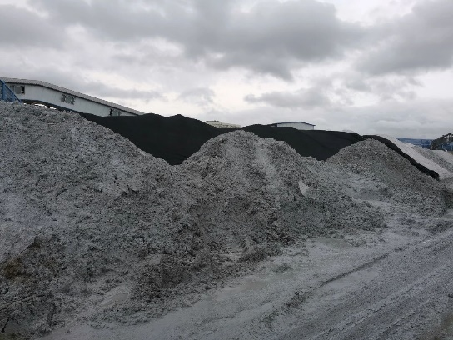 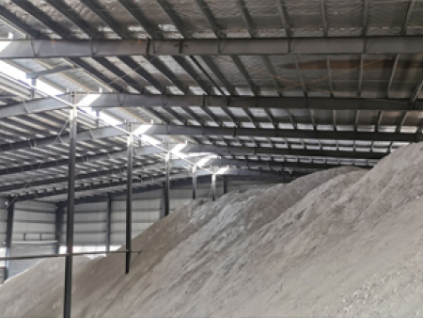

**Fig 5-Stacking diagram**

## **2.2 Sold after natural settlement**

Most plants use the natural sedimentation method. The calcium carbide slurry will be discharged into the sedimentation tank or low concave open space, natural evaporation to be slurry precipitation, and then manually or with a forklift, grapple excavated out of the external sale.

The treatment effect of natural sedimentation method is unstable and affected by environmental and meteorological conditions. Especially in the south, rainfall, evaporation is small, high water content of precipitation in the rainy season, generally in the 50% to 60% is thick slurry. It is simply impossible to excavate and utilise it.

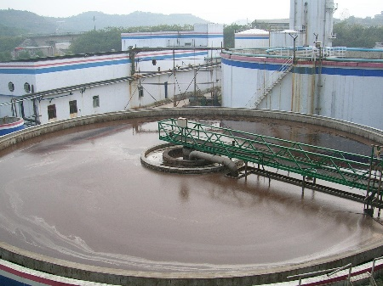 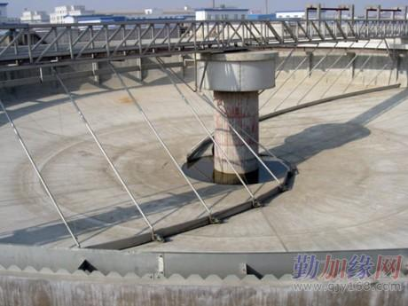

**Fig 6-Sedimentation tank**

# **3. Comprehensive utilisation**

## **3.1** **Substitution of limestone for cement**

Calcium carbide slag cement in the country has many mature enterprises, such as: Jilin Chemical Plant, Tianjin Chemical Plant, Guizhou Organic Chemical Plant, Shanxi Province Chemical Plant, etc., some in the 70's on the completion of the industrial scale device, proprietary a cement production line to digest calcium carbide slag. For example, JICC uses a concentration pool to concentrate the concentration of calcium carbide slag slurry from 5-8 per cent to 35 per cent, sand pumped into the trough, after part of the supernatant and sandstone, clay slurry formulated into raw cement, and then sent to the rotary kiln calcination of cement.

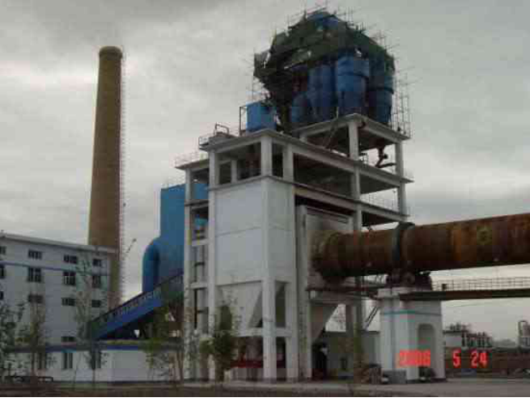

**Fig 7-End of kiln (dry hollow kiln) for cement production line from calcium carbide slag**

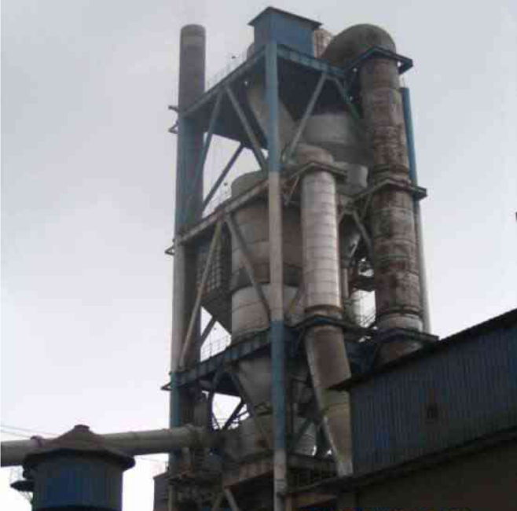

**Fig 8-Kiln end of cement clinker production line from calcium carbide slag (wet grinding and dry firing)**

## **3.2 Production of quicklime as raw material for calcium carbide**

Calcium carbide production lime process: after dehydration to get 60% solids content of calcium carbide slag, conveyed by screw conveyor, in the granulator length of three-quarters of the uniform distribution to the granulator, granulation made of 5 ~ 20mm size ranging from the garden ball, and then through the air drying furnace (350 ° C) drying, the rotary furnace (900 ~ 1,000 ° C) calcination. The drying of materials in the drying furnace is to use the hot exhaust gas from the rotary furnace to dry. The calcined recycled lime flows into the unloading hopper and is loaded and transported to the calcium carbide plant as raw material for calcium carbide.

The technical route of this method is feasible, as an exploration of the production of lime, should be the best method of governance, this is because: First, the production of lime less than one-tenth of the investment in the production of cement; Second, lime is the raw material for calcium carbide production, there is no question of finding another market to calcium as a carrier to achieve calcium carbide slag - lime - calcium carbide - calcium carbide slag such a closed loop; Third, reduce the constraints on their own factors, calcium carbide method PVC The scale can be further expanded to improve competitiveness, but also to protect the limestone ore source, the new calcium carbide waste slag lime produced by the economic and social benefits are far from other methods of governance.

However, energy consumption, recycled lime heavy as raw materials for calcium carbide can only be mixed into 20% of the raw materials for calcium carbide, should not be too much, because the recycled lime containing sulfur, phosphorus impurities, will affect the quality of calcium carbide.

## **3.3 Production of lightweight bricks**

Shandong Cement Products Factory has successfully developed the use of calcium carbide waste slag production of lightweight cinder blocks, the quality of its products meet the quality standards of similar products.

This brick to concentrate the waste calcium carbide waste slag (water content of 39.6%) as the main raw material, mixed with a small amount of cement, and after crushing cinder (particle size <20mm), crushed stone material according to the calcium carbide waste slag: cement: crushed stone: cinder = 3.2:1.1:3.2:2.5 ratio of mixing, by the block moulding machine pressurised molding, natural maintenance for 28 days or so, can be sold at the factory.

Lightweight calcium carbide - cinder brick strength can reach the strength of ordinary red brick, in line with the national standard of small hollow block, investment, low cost, light weight products, can be produced at room temperature, normal pressure maintenance, energy saving, its cost is 60% of the ordinary clay bricks, is 50% of the concrete block. The use of calcium carbide slag production of lightweight bricks are widely used, both for the comprehensive use of calcium carbide slag, improve economic efficiency, waste into treasure, but also to protect the environment, it is a good product to kill two birds with one stone.

However, in the production process of lightweight cinder blocks, calcium slag as calcium raw materials to join, the amount of its addition is limited, generally no more than 15% to 35%, for the large amount of slag enterprises, it is difficult to digest completely, and cinder bricks of the market outlets are not good, but also restricts the development of the product.

# **4 Production of calcium carbonate from calcium carbide slag solid waste resources**

## **4.1 Basic method and recycling process for calcium carbonate preparation from calcium carbide slag**

To prepare calcium carbonate from calcium carbide slag, the slag is first treated to obtain Ca(OH)2 suspension or soluble calcium ion solution, and then carbonised to obtain calcium carbonate. Calcium carbonate products with high purity and whiteness, and different structures and crystal types are produced through controlled processes to meet diversified application requirements.

## **4.2 Extraction method of calcium from calcium carbide slag**

There are two methods of obtaining calcium resources from calcium carbide slag: one is to calcine directly and then add water to digest to get a certain concentration of calcium hydroxide solution, and the other is to leach without calcination to get a solution of soluble calcium ions by leaching agent. The leaching agent is commonly used as hydrochloric acid or ammonium chloride solution, and there are also studies that choose glycine and fatty acids as leaching agents. There are also extraction methods that use a combination of the two ways, that is, first after high-temperature calcination, and then leaching agent leaching.

The two types of methods have their advantages and disadvantages, high temperature calcination method is simple, but high energy consumption, can not effectively remove Mg, Si, Al, Fe and other oxide impurities, affecting the whiteness of calcium carbonate products; digestion of the suspension obtained by the activity of the crystalline stability of the product and the purity of the impact. Solution leaching method can be used to remove impurities by controlling the pH of the solution and obtain high-purity products, which has a wide range of application prospects. Among them, the purity and whiteness of the products obtained by hydrochloric acid treatment method can reach the national standard, but the leaching agent can not be recycled; Ammonium chloride solution to extract calcium ions can achieve the recycling of ammonium chloride; Glycine calcium extraction method adopts glycine aqueous solution to extract calcium hydroxide from calcium carbide slag to become soluble glycine calcium salts; The use of fatty acids as an extraction agent, the generated calcium carbonate surface is coated with a layer of fatty acids, the carboxyl group can be combined with the calcium carbonate surface of Ca2+ and the carboxyl group can be used for the extraction of calcium carbonate. The carboxyl group can react with Ca2+ on the surface of calcium carbonate to form (Ca2+)-(-OOC) chemical bond, which is adsorbed on the surface of calcium carbonate, so that there is no adhesion and agglomeration between calcium carbonate, and the dispersion effect is good. The extraction process mainly examines the calcium ion extraction rate or calcium slag utilisation rate, the concentration and dosage of leaching agent have a direct impact on it, there are studies on the direct dissolution of calcium hydroxide solution obtained by dissolving calcium hydroxide slag with water, due to the solubility of calcium hydroxide is small, the water-soluble method of extracting calcium ions from calcium slag has a low utilisation rate, which is not conducive to promotion.

## **4.3 Carbonisation method**

Carbonation methods commonly used are CO2 carbonation and carbonate carbonation, CO2 carbonation is a common carbonation method used in the industry, carbonate carbonation is essentially a complex decomposition reaction, the carbonate used includes ammonium carbonate or ammonium bicarbonate, sodium carbonate and so on.

## **4.5 Preparation of light calcium carbonate from calcium carbide slag**

Calcium carbonate can be divided into heavy calcium carbonate and light calcium carbonate according to the preparation method and different quality. Light calcium carbonate, i.e. precipitated calcium carbonate, is different from the heavy calcium carbonate obtained by grinding, with finer particle size, higher purity and wider application fields. Taking calcium carbide slag as raw material, light calcium carbonate is prepared by ammonium chloride leaching and CO2 gas-liquid intermittent carbonation. A face-centred cubic type of light calcium carbonate was produced by directly dissolving calcium carbide slag in water, with Na2CO3 as the carbonation agent, and by adding the surfactant polyethylene glycol to produce light calcium carbonate. As mentioned before, due to the small solubility of calcium hydroxide, the water-soluble method of extracting calcium ions has a low utilisation rate of calcium carbide slag, which is not conducive to industrial production. Industrial production not only requires products with high quality, but also hopes that calcium carbide slag has a high utilisation rate.

At present, the use of ammonium chloride leaching, CO2 carbonation process, calcium carbonate light calcium carbide preparation of calcium carbide slag has achieved industrial production, Zhuzhou Chemical Industry Group and Hunan University of Technology has been built in cooperation with the production line of 50kt / a high-purity calcium carbonate light.

# **5 Conclusion**

Through the comprehensive analysis and discussion of the disposal and use of calcium carbide slag, it is not difficult to see that the disposal of calcium carbide slag reclamation, ditch filling and regular stacking and natural settlement of the sale; calcium carbide slag use instead of limestone cement, production of quicklime used as raw materials for calcium carbide and the production of construction materials. Although the use of calcium carbide slag many ways, but each has its own advantages and disadvantages, each method of treatment are not satisfactory.

From the actual situation of many domestic manufacturers, most of the natural sedimentation method, the calcium carbide slurry by gravity sedimentation separation, mechanical dewatering, liquid recycling; calcium carbide slag transported by car to the low-lying valleys or the seashore, reclaiming ditches and reclaiming the sea. As the calcium carbide slag and leachate are strongly alkaline, they contain sulfide, phosphide and other toxic and hazardous substances. According to the national standard ‘Hazardous Waste Identification Standard’ (GB5085-1996), calcium carbide slag should be Class II general industrial solid waste; according to the standard ‘Chemical Waste Landfill Design Provisions’ (HG20504-92), Class II general industrial solid waste (material) slag, should be taken to impermeable measures and disposed of in landfills.

If the effective use of calcium carbide slag, not only can bring good economic, environmental and social benefits, but also to achieve waste into treasure. But to really make comprehensive utilisation still need to do a lot of research and development work.

Calcium carbonate products prepared from calcium carbide slag show a trend of low value-added applications to the development of high value-added applications, while having obvious economic and environmental benefits. Calcium extraction during calcium carbonate preparation from calcium carbide slag is mainly calcined and digested and leached in solution, of which the leaching method can obtain high-purity products and realise the efficient use of calcium carbide slag. Ammonium chloride leaching carbonation process realises the reuse and recycling principle of circular economy. Therefore, under the current situation of chemical industry development, ammonium chloride leaching carbonisation has a large application potential, and should be further combined with CO2 absorption to comprehensively utilise the waste slag and waste gas. In the context of green chemical industry development with severe environmental protection situation, emphasis on waste resourcing and development of circular economy, it is of great significance to utilise calcium carbonate prepared from calcium carbide slag resourcefully to improve its utilisation rate and added value.

# **References:**

[1] Wang Changjun. Comprehensive utilisation of calcium carbide slag for cement production[J]. China Chlor-alkali,1999(06):39-41.

[2] Yu Jianfang. Development and comprehensive use of calcium carbide slag effective way to broaden the seminar[J]. China Chlor-alkali,2000(10):31-32.

[3] Zhang Binghui. Comprehensive Utilisation Project of Tianjin Chemical Plant Waste Slag[J]. Chlor-alkali Industry,2001(02):30-32.

[4] HUANG Cunhan, DENG Yinsheng, XING Xueling, LU Jing. Discussion on the comprehensive utilisation of calcium carbide slag[J]. Journal of Jiaozuo Institute of Technology (Natural Science Edition),2004(02):143-146.

[5] Yan Kun, Zhou Kanggen. Progress of comprehensive utilisation of calcium carbide slag[J]. Journal of Environmental Science,2008(S1):103-106.

[6] GUO Junwen, WANG Junzhong, SUN Weiyan. Study on the preparation of lightweight calcium carbonate using calcium carbide slag and sodium carbonate[J]. Synthetic Materials Aging and Application,2015,44(03):85-88.DOI:10.16584/j.cnki.issn1671-5381.2015.03.005.

[7] Feng Dongmei, Liu Yuan, Tang Shengliang, Cai Yuliang, Ye Xuchu. Optimisation of cyclic process conditions for the preparation of lightweight calcium carbonate from calcium carbide slag[J]. Modern Chemical Industry,2014,34(05):117-121.DOI:10.16606/j.cnki.issn0253-4320.2014.05.009.

[8] Tian FY, Mou HJ, Gu WR. Study on the preparation of lightweight calcium carbonate from calcium carbide slag by two-step method[J]. Modern Chemical Industry,2013,33(04):95-99.DOI:10.16606/j.cnki.issn0253-4320.2013.04.019.

[9] Liu RJ, Li R, Hu YQ, Zhao H, Zhao FY, Hu QF. Production of calcium carbonate from calcium carbide slag and flue gas[J]. Inorganic Salt Industry,2013,45(02):50-52.

[10] Shu Junjie. Study on the preparation of lightweight calcium carbonate from calcium carbide slag[J]. Guangdong Chemical Industry,2012,39(14):60-62.

[11] LIU Fei, ZHU Bo, LI Jing, CAO Jianxin, ZENG Lingke. Effect of modification process on the activity of calcium carbide slag emulsion[J]. Chemical Progress,2010,29(01):34-38.DOI:10.16085/j.issn.1000-6613.2010.01.033.

[12] HOU Qinglin, LIU Qilong, DUAN Liyan. Recycling technology of industrial waste in Zhuzhou Qingshuitang area[J]. Chemical Progress,2009,28(02):349-353.

[13] YUAN Ke, YIN Yingwu, XIE Zengyong, ZHU Zhaowei, ZHA Zhengjiong. A new process for the preparation of spherical calcium carbonate from calcium carbide slag[J]. Silicate Bulletin,2008(03):597-600+614.DOI:10.16552/j.cnki.issn1001-1625.2008.03.018.

[14] Wei Yunhuan. Application of calcium carbide slag in acidic wastewater treatment[J]. Progress of Chemical Industry,2003(04):410-412.

[15]ZHOU M, DONG W L, QIAN X. A method of preparation of light calcium carbonate with carbide slag: 102992373 B [P]. 2015-01-28.

[16]LI D X, WANG H C, WU J G. Research of using calcium carbide slag and simulation flue gas to produce nano calcium carbonate [J]. China Chlor-Alkali, 2011(7):44-45

[17] LIU C T, LI Y J, SUN R Y, et al. Cyclic CO2 capture of carbide slag modified by pyroligneous acid in calcium looping cycles[J]. Asia-Pacific Journal of Chemical Engineering, 2014, 9(5):678-685.

[18]SUN J, LIU W Q, HU Y C, et al. Enhanced performance of extruded-spheronized carbide slag pellets for high temperature CO2 capture[J]. Chemical Engineering Journal, 2016, 285:293-303.

[19]SAID A, MATTILIA H P, JARVINEN M, et al. Production of precipitated calcium carbonate (PCC) from steelmaking slag for fixation of CO2[J]. Applied Energy, 2013, 112:765-771.

[20] Liu, S., Rong, P., Zhang, C., Lu, J. X., Guan, X., Shi, C., & Zhu, J. (2023). Preparation and carbonation hardening of low calcium CO2 sequestration materials from waste concrete powder and calcium carbide slag. *Cement and Concrete Composites*, *141*, 105151.

[21] Wang, H., Xu, W., Sharif, M., Cheng, G., & Zhang, Z. (2022). Resource utilization of solid waste carbide slag: a brief review of application technologies in various scenes. *Waste Disposal & Sustainable Energy*, *4*(1), 1-16.