*Original Research Article*

# The effect of freeze drying on the nano and micro structures of sugars

.

ABSTRACT

|  |
| --- |
| **Aims:** Crystallization during freeze-drying (FD) play essential role for creating high-quality sugar products and optimizing production processes in the sugar and pharmaceutical industry. The primary objective of this study is to examine the impact of the FD process on the nanoscopic nucleation stage of monosaccharides (glucose, galactose and fructose) and disaccharides (sucrose and lactose) during the crystallisation process.  **Study design:** Experimental and employs software for modelling.  **Place and Duration of Study:** Department of Food Engineering ( METU) and Department of Physics Engineering (Hacettepe University), National Synchrotron Radiation Research Center, between 2022 and 2024.  **Methodology:** The 3D nanoscopic structures of the sugars were established by SAXS-WAXS (Small and Wide-Angle X-ray scattering) methods for the first time. Attenuated Total Reflectance Fourier Transform Infrared spectroscopy (ATR-FTIR) was used to examine the molecular structural changes and behavior of water molecules surrounding of sugar molecules.  **Results:** Crystallographic unit cells, lattices of the nano-nucleation and nano morphologies were determined. The uniform distribution and well-defined compact morphology were found for FD-lactose. Marked spectral differences in ATR-FTIR spectra between FD and control samples of glucose and sucrose were observed.  **Conclusion:** The findings of the study suggest that the freeze-drying process may potentially result in an enhancement of the molecular and nanoscopic stability of sugars. |

*Keywords: Sugar; Freeze-drying; Crystalline structures; SAXS; WAXS, ATR-FTIR*

1. INTRODUCTION

Freeze-drying (FD) is a technique used for removal of the solvent without crystallization of the solute for amorphous solids, which is widely used in food/pharmaceutical manufacturing processes [1-3]. **Freeze-dried foods** provide a number of advantages over fresh foods. In many processes, the sugar crystallinity is critical to the acceptance of the final product [4-6].

Glucose, fructose, galactose, sucrose and lactose are common sugars (Fig. 1), which are found in dairy products such as fruits, vegetables or processed foods.

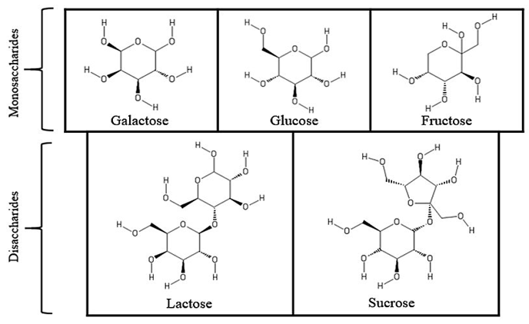

**Fig.1. The chemical structure of monosaccharides and disaccharides.**

Glucose, fructose and lactose were used for the growth medium to examine the heat tolerance and survival during storage of FD foods [8-11]. There are also multiple possible mechanisms in FD process such as the water replacement and glass transition [12].

One of the main challenges in industrial manufacturing of crystallized products is the control of crystal properties of sugars. The crystal structures of fructose and sucrose and polycrystalline structures of all other sugars are known [13,14]. Sugars used in this study have the tendency to develop clusters due to their high water-retaining abilities, coming from their hydroxyl groups [14-16].

It was expected and predicted that the electron densities, the sizes and morphologies of the crystallites/nano formations and their distributions would change after FD process. The most important process of the sugar crystallization is nano-nucleation and the nanoscale crystallite (aggregation sizes, morphologies and distributions).

SAXS and WAXS methods are X-ray based metrology that has been recently attempted in the food industry to determine the size, electron density and morphology of nanoparticles as well as for the investigation of different phases in multiple component systems such as milk [17- 19 ]. SAXS structural characterization can reveal a more complete structural information (size, shape, conformation distribution and inner/interface properties) of the nano formations in liquid, gel and solid forms.

ATR-FTIR spectroscopy is noninvasive and rapid tool for structural characterization of molecules. Mid IR spectroscopy is the very sensitivetool for probin*g* hydrogen bonds [20].

This paper presents nano and micro structural characterization of FD-sugars (glucose, fructose, galactose, sucrose and lactose) using SAXS-WAXS and ATR-FTIR spectroscopy techniques, respectively*.*

2. material and methods

# 2.1. Materials

Commercial crystal sucrose (*beet sugar*) and lactose were purchased from a local market with the brand name Altın Küp (Turkey) and LAB M (United Kingdom), respectively. D(+)-glucose monohydrate (*grape sugar*), referred as Glucose-1, and anhydrous D(+)-glucose, referred as Glucose-2, were both purchased from Merck KGaA (Darmstadt, Germany). To make a systematic comparison with other sugars, glucose defined as Glucose-1 is used in this study.

**2.2. Sample preparation**

To obtain amorphous sugars, lactose (*disaccharide milk sugar*), galactose (*monosaccharide milk sugar*) fructose (*fruit sugar*), glucose, and sucrose were freeze-dried following dilution. Freeze drying of glucose, galactose, sucrose (50% w/v), and lactose (10% w/v) were carried out using a vacuum freeze dryer (LGJ‐10, Beijing Songyuan Humxing Tech. Co. Ltd., Beijing, China) for 48 hours. The hygroscopic fructose sample (gel form) could not be dried effectively due to the limitations of the equipment used.

# 2.3. Microscopic imaging

A conventional microscope was used to visualize structures of the control and FD sugar samples immediately after preparation.

# 2.4. SAXS and WAXS measurements

Two-dimensional (2D) experimental scattering profiles were obtained at the 23A SAXS beamline of NSRRC (National Synchrotron Radiation and Research Center), Taiwan. Monochromatic X-rays with 10 keV energy were used in measurements (ref). Sample detector distance was determined as 4555.4 mm. The 2D scattering images were recorded with a Dectris Pilatus 1MF 2D pixel detector for SAXS and a Hamamatsu C10158 DK flat panel detector for WAXS. Multi-mode measurements were performed for both SAXS and WAXS analyzes. The sample permeability coefficient was 66.03 % and the permeability of the empty sample chamber was 88.32 %.

The 1D scattering intensity profiles I (q) were reduced from the 2D patterns according to the scattering vector q = 4πλ-1sinθ where λ is the wavelength of X-ray and 2θ is the scattering angle. Since this measurement contains reciprocal space information, Fourier Transforms of the scattered intensities and the amplitudes must be performed for passing mathematically to real space. The radius of gyration (RG) and maximum dimensions were calculated using Igor Pro software [21]. SAXS 3D *ab-initio* morphologies were performed using the program DAMMIN [22].

RG2  is the average electron density weighted squared distance of the scatters from the object’ center [23, 24], may be defined as follows:

RG2 (1)

where r is radial distance and P(r) is pair-distribution function P(r), which is a histogram of all inter-electron distances in the scattering particle.

Scattering intensity (Equation 2) can be obtained by employing the Guinier approximation (q→0) and the scattering data in the Guinier region

I(q)= I(0) exp $\left[\frac{{ R_{G}^{2} q}^{2}}{3}\right]$ (2)

The region of about q= 0.005 to 0.05 Å-1 is known as the middle q region or Fourier Region. The scattering data of this order gives information about the shape, distribution and maximum size of the electron densities. The Igor Pro software modeled the scattering data of all sugar samples. Poly Core model [25] fitted to the data in different parameter values and different data ranges for both control group and FD group of sugar samples.

**2.5. ATR-FTIR spectra**

ATR-FTIR spectroscopy (Perkin Elmer Spectrum One with PIKE Gladi ATR accessory) is performed at room temperature in the range between 4000–450 cm–1. The samples were ground in an agate mortar. The spectra were collected as a result of 32 running scans at a resolution of 4 cm−1. Three individual spectra were recorded for each sample.

3. results and discussion

# 3.1. Microscopic imaging

At both macroscopic and microscopic length scales, different structural features of the studied sugars were observed. (Fig. 2).

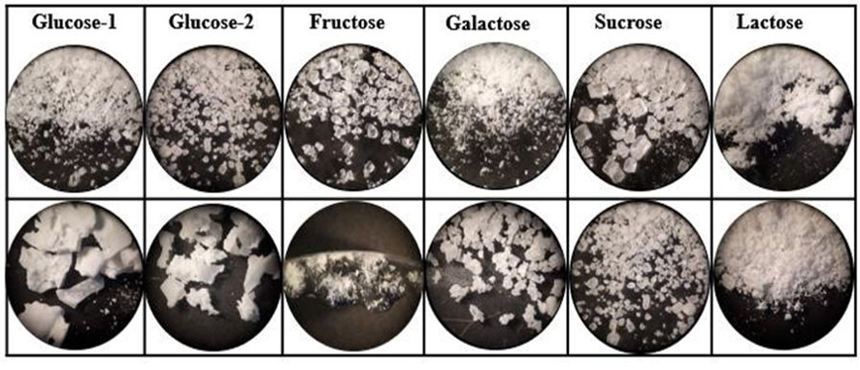

**Fig. 2. Light microscopy images (10x) of sugar samples. Control (top) and the FD forms (bottom).**

**3.2. SAXS and WAXS analyses**.

Fig. 3 represents 2D scattering profiles related to SAXS and WAXS measurements. The nano structural parameters such as RG and maximum length scale (maximum range in the pair distance distributions (PDDs) of control and FD groups of studied sugars are listed in Table 1.

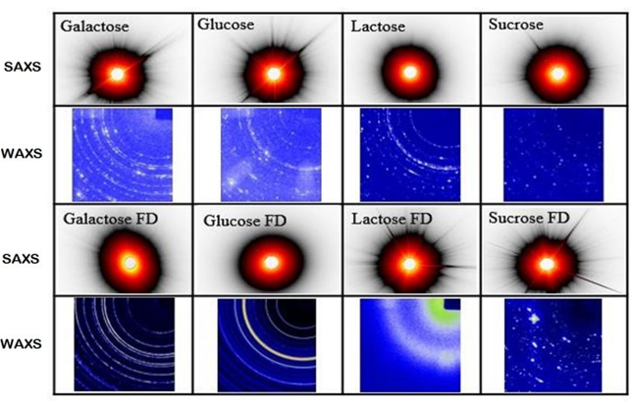

**Fig. 3. SAXS and WAXS images of control (top rows) and FD sugars by ALBULA software. (The 2D images taken with the Pilatus 1MF SAXS detector and the WAXS Hamamatsu flat panel detector).**

**Table 1. Calculated gyration radii values and maximum size of sugar nano aggregations**

|  |  |  |  |  |
| --- | --- | --- | --- | --- |
| **Sugars** | **Control RG (nm)** | **Maximum Size (nm)** | **Freeze-dried (FD)**  **RG (nm)** | **Maximum Size (nm)** |
| **Glucose** | 28.3 ± 0.5 | 95.5 | 59.7 ± 3.4 | 211.6 |
| **Sucrose** | 33.4 ± 0.6 | 120.3 | 53.8 ± 3.8 | 180.9 |
| **Galactose** | 39.7 ± 0.4 | 128.7 | 54.5 ± 1.0 | 183.5 |
| **Lactose** | 42.5 ± 2.3 | 165.5 | 64.9 ± 3.1 | 218.3 |

For monodispersed nano systems, during the coupling of two nano particles by touching, they behave as a new collective aggregation. The maximum size of this collective aggregation may be indicated by addition of diameters of the particles.

## **3.3. 3D modelling of the nano aggregations**

Unlike other sugars, fructose control sample was analyzed by interpolation of the observed peaks in the large q region (Fig. 4) and the nanocrystalline structure was determined as cubic phase by indexing q1, q2, q3 and q4 peaks with the ratio of q/q0 [26 ].

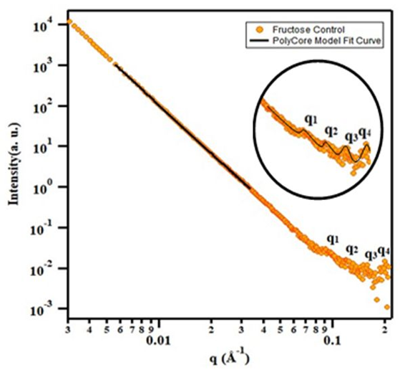

**Fig. 4. SAXS profile and fitting curve for fructose (control) with Poly Core model**

SAXS profiles and the fitting curves of control and FD sugar samples except fructose are presented in Fig 5A and 5B, respectively. A poly-core model well fit the scattering data of all sugar samples. There is a distinct tendency to form nano crystals in control monosaccharide groups for glucose and galactose (Fig. 5A).

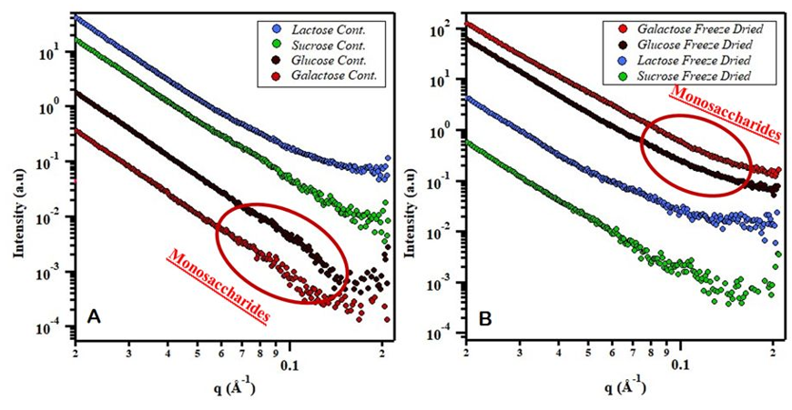

**Fig. 5. SAXS profiles of control sugar groups (A) and FD sugar groups (B).**

The prominent change of nano crystalline structure and increase amorphous fractions in FD samples of monosaccharides were found (Fig. 5B). The more intense scattering data in small *q* range and the disappearing peak in Fig. 5B can be considered to the crystal alignment dispersed by dilution and drying [27].

In contrast, the crystalline formations in disaccharides due to FD can be seen in high *q* range in Fig. 5B. The central torsion angle of C-C-O-C may be effective on more planar and crystalline arrangement in FD samples. The known and expected irregular shaped crystal nucleation and clumped arrangements of lactose structure can transform to the more stable structure in FD-lactose which is more preferable during the interaction with other food constituents in food technology [7,13,28 ].

The 3D *ab-initio* (DAMMIN) morphologies of the nanoparticles in samples and pair distance distribution function patterns are presented in Figures. 6 and 7, respectively.

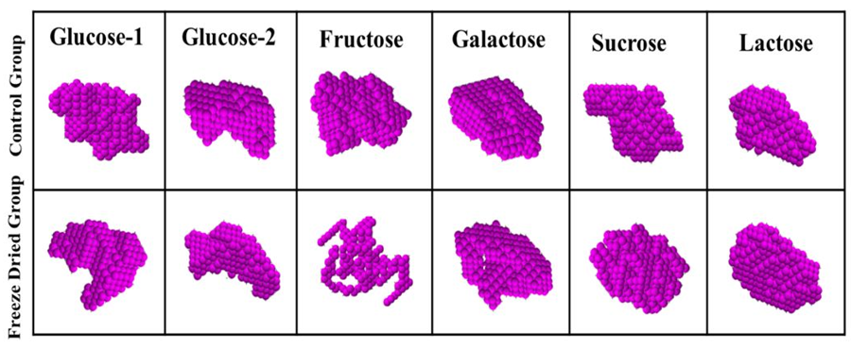

**Fig. 6. Control and FD groups for all studied sugar samples modelled by 3D DAMMIN.**

Fructose has more clustered structure then the other sugars [29] . The crystallization behavior of fructose samples was different from expectation after the FD process and it is still the dense gel phase. As can be seen from Fig. 7, control fructose has the largest nanoparticles and globular (volume like) structure and clustering is minimal.

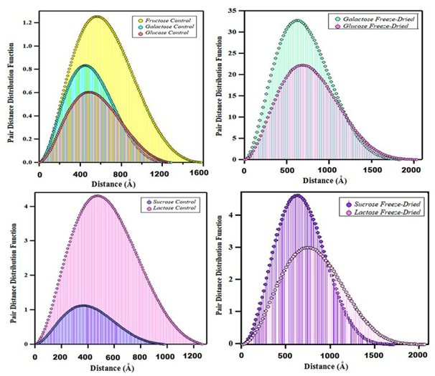

**Fig. 7. Pair Distance Distribution Function histograms for studied sugars. Control (left) and FD (right) groups. The biggest range in horizontal axis (D) indicates maximum size of the big globules and maximum distance between small nano aggregations.**

The aggregation and globular size of sugars increases in FD-sugars except fructose (Table 1). As it is known, when white crystal sugars are stored in silos after processing and drying, the caking problem arises. In order to solve this frequently encountered problem, rational research should be carried out with the aim of examining the structure (size: radius of gyration -surface area: indented morphologies) and dehumidification states of sugar nano-crystallites. Roge et al. examined this relationship in 2000 [30]. In this study mentioned, the water content of sucrose crystals of different sizes was investigated and an attempt was made to establish a relationship between particle size and moisture retention in order to solve the caking problem.

The conclusion reached in this study is that it would be better not to have small sized crystallites in the structure to prevent caking. In other words, when the dimensions of globular structures increase after FD, this is a desired situation in terms of not retaining moisture. As can be seen from the 2D-WAXS profiles (Fig. 3), the spot-shaped diffraction peaks (which were observed in WAXS profiles of control groups) turn into continuous ring-shaped diffraction peaks after FD process.

FD can reduce crystallinity in foods, to keep better the original food textures after defrozen. The crystalline structure (inside of the nano aggregations) reaches a less crystalline form with the FD as seen in Fig.3 WAXS patterns (including diffraction rings). In general scope, the molecular crystalline aggregations were observed for all control and FD sugars except lactose-FD. We found that lactose-FD particles have a more globular shape, which might be advantageous in creating extreme functionality. 1D-WAXS profiles are shown for comparative purposes (Figure S1). The reduced crystalline features shown in the 1D profile and 2D -WAXS pattern for the FD lactose, with respect to that of the lactose and other samples, may explain the presence of stereoisomers in the structure of lactose. As it is known, lactose has two stereoisomers (α-lactose and β-lactose) based on mutarotation of the glucose part (the disaccharide consisting of glucose and galactose) [31,32]. The α/β-lactose co-crystals were identified in XRD analysis on lactose [16,33,34].

The more broadened crystalline peaks including the fingerprints of the mentioned stereoisomers revealed from the WAXS result, clearly shown the FD processing effect on reducing the crystallization tendency of lactose. In contrast, FD-glucose samples (Glucose-1 and Glucose-2) preserved their initial form of D-glucose. The crystalline structures of Glucose-1 and Glucose-2 are almost identical, while the control samples of them are different. In the galactose, the intensity of some low peaks increased but the indices of the peaks (dependently unit cell parameters) did not changed. Therefore, it can be said that the number and size of existing crystallites increased in galactose-FD, as supported by the best-enhanced SAXS intensities (Fig. 5) of galactose-FD.

Structural models were performed using SAXS/WAXS data (Fig.8) The overall size (Rg) develops with FD in all samples. The increase in RG values ​​indicates the size growth of nano-aggregates.

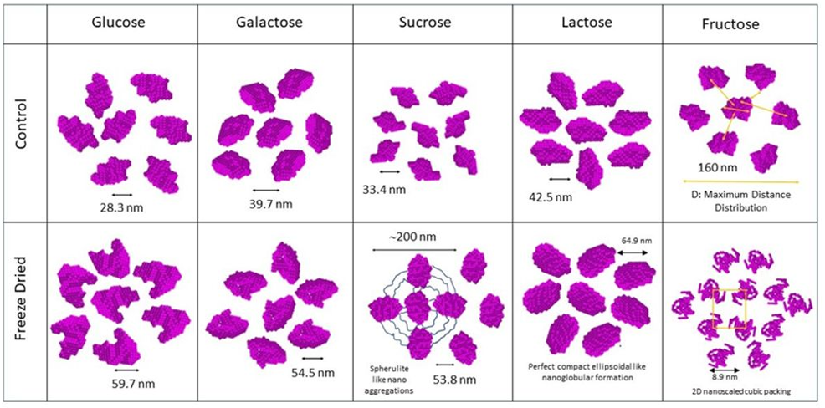

**Fig. 8. Ordering and clustering of nano aggregates for sugars.**

The fact that the X-ray powder rings in the WAXS profile (Fig.3) became more isotropic and less powder rings than those in the control groups also qualitatively supports the information that the crystallinity of sugars can be reduced by FD processing effectively. In addition, the generally much reduced diffraction spots and maximum distance values ​​to large values ​​in PDDs graphs also (Fig.7), suggest that sugar aggreagte more with less crystallization as expected.

The molecular-scale crystallinity increase in glucose is better than in galactose, as supported by sharper and more distinct circular lines in the WAXS profile. In the lactose structure, nanoscopic crystallinity develops with the effect of FD. The widening of the diffraction rings in the WAXS profile and the prominence of the rings at small angle values indicate this. The decrease in the area under the PDDs graph is also an indication that the crystallite size increased but the number of scattering nano-formations (crystallite) decreased.

The most interesting one among the examined samples is the sucrose structure. In this example, spherulite-like nanostructures and nanonucleation appear with the FD effect. The presence of cruciform diffraction traces in the WAXS profile (Fig.3) supports this finding.

In addition, approximately 3-fold increase in the area under the PDDs graph compared to the control group, as alsos revealed from consistent increase in other structural parameters (the projection of the peak peak value and the maximum distance value).

**3.3. ATR-FTIR spectral analysis**

**3.3.1. ATR-FTIR spectra of control sugars**

Average ATR -FTIR spectra of control samples for glucose, galactose, lactose and sucrose are shown in Figure S2 and observed wavenumbers (cm-1) and assignment of the observed fundamental bands are given in Table S1.

The observed bands in all spectra in the 3600 and 2800 cm-1 region were due to the stretching vibrations of -OH, and -CH groups. The fingerprint region, which covers the range of approximately 1500 to 800 cm-1, is complex showing a series of sharp overlapping absorption bands arising from CO stretching, CC stretching, and COH bending vibrations (Coates, 2000). The hydroxyl (-OH) groups in sugars can participate in chemical reactions to link molecules together, and their tendency to form hydrogen bonds increases solubility which is very important in biochemistry [35- 37]. In principal, the position of the O-H stretching vibration band represents the state of hydrogen bonds associated with sugar molecules, including their strength and degree of formation.

There is a broad, strong O-H stretching envelope in the ATR-FTIR spectrum of glucose with three bands at 3404, 3302 and 3254 cm-1 indicating that there are different alcohol groups in molecule. The band at 3404 cm-1 from the secondary alcohols present, and the others from the primary alcohol present. The broadened feature of the O–H stretching mode indicates very strong intermolecular hydrogen bonds between sugar molecules.

There is only one hydrogen attached to a carbon in glucose (saturated) therefore C-H stretching vibration will be observed below 3000 cm-1 [38]. The saturated ethers in ring have a C-O stretching band from 1140 to 1070 cm-1, secondary alcohols have one from 1150 to 1075 cm-1, and in primary alcohols this band appears between 1075 and 1000 cm-1, making for a potentially complex C-O stretching region.

The main difference between glucose and galactose is the position of each hydroxyl group in the 4th carbon.  Clear differences in in the ATR-FTIR spectra were identified for these molecules. No band observed in the 850-950 cm-1 region for galactose, and the intensity of the bands in the finger print region are opposite compared to glucose. The band at 915 cm -1 of glucose disappears and new bands appears in the spectrum of galactose.

Sucrose consists of a glucose ring attached via a saturated ether linkage to a five-membered fructose ring. There are multiple and more O-H and C-O stretching bands in the ATR-FTIR spectrum of sucrose than in the spectrum of glucose.

Two absorption bands at 3326 and 3383 cm−1, and one isolated sharp band at 3561 cm−1 were observed in the region of OH-stretching. It is suggested that the band at 3561 cm−1  arises from weakly bonded O-H⋯O system [39]. The band at 1640 cm−1 which arise from OH-bending (in plane) mode of sucrose.

The observed band at 3522 cm-1 for lactose related to the O–H stretching while the band at 1648 cm−1 is related to the distortion of the OH groups in water molecule [40]. This observation confirmed that lactose sample is not anhydrous.

**3.3.2. The spectral differences between control and FD samples**

The ATR-FTIR spectra of control samples were compared with the corresponding spectra of the related FD samples The O-H, C-O and C-C stretching vibrations could be used to monitor changes in the physical state of sugar samples. There are no marked differences in finger print region of control galactose and lactose and those of FD samples (Fig. S3). One of the regions of a particular interest is between in the 3600-3000 cm-1 region, which depicts behavior of water molecules. The amount of water molecules decreasing in freeze*-*dried lactose compared with control sample.

The most clearly visible changes are marked for O-H stretching of glucose (Fig. 9A) and sucrose (Fig 9B). The band at 3404 cm-1 of weak hydrogen bonded O-H groups and the other O-H stretching bands are disappeared and one strong broad band at 3238 cm-1 was observed in the spectrum of glucose-FD compared with control sample ( Fig. 9A ).

The shift of the O-H stretching band to a lower wavenumber are often attributed to the strengtheningof the hydrogen bonding interaction [41]. Additional intramolecular hydrogen bonds can stabilize structure.

The 1200-700 cm−1 region, which is dominated by C-O, C-C stretching and C-O-H deformation vibrations is sensitive to the physical (amorphous/crystalline, glassy/rubbery) state of the sugars [39, 40-43].

The clear change in the shape and wavenumber of the C-O stretching band was observed for freeze*-*dried glucose/sucrose samples compare with those of control samples (Fig. 9). ATR-FTIR spectrum of control glucose shows two bands at 1020 cm-1 and 994 cm-1, however a single and relatively broad band at 1007 cm-1 and the new band at 513 cm-1 appears in glucose-FD. The new band at 581 cm-1 appears in the sucrose-FD and the changes were observed in the 1100-950 cm−1 indicating that these bands was influenced by hydrogen bonding. These results reveals that the recrystallization of sucrose and glucose.

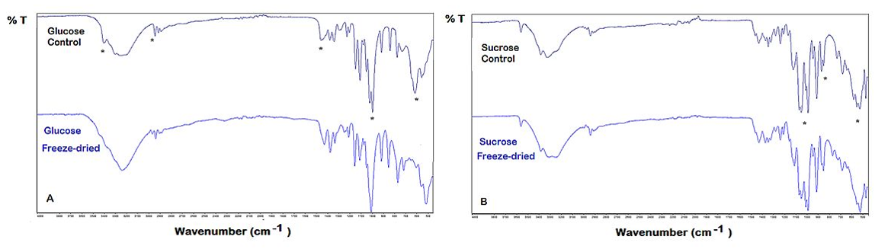

**Fig. 9. Comparison of average ATR-FTIR spectra in the range4000 cm-1 - 450 cm-1 for control and frieze dried glucose (A) and sucrose (B). Asterisks show the most differences in spectral bands in spectra.**

4. Conclusion

The FD method has the advantage of preventing stability disturbances, both physical and chemical, that occur when sugar nanoparticles are exposed to moisture during long-term storage. The effect of the FD process could be successfully monitored by nanoscale SAXS analysis, a very important and widely used technique to obtain the desired particle size and properties. It was found that the FD was responsible for the formation of large aggregation sizes in nano-nucleation for all samples. The increase in large aggregation structure with less crystallinity may improve the ability to retain less moisture and water, which may provide an alternative solution to the problem of sugar caking. Larger sizes may also be good for different applications, as water retention and hygroscopicity, as well as binding properties, have been altered to affect the long-term stability of the colloidal nanoparticles. The fructose sample remained in the non-dried gel phase after the FD process. Nanocrystalline cubic packing appeared in the fructose FD sample. The reason for this nanocrystalline cubic phase may be due to the presence of a chiral centre in the molecular structure of fructose. The structures formed much larger clusters and the nanostructures were arranged in tighter packages in the glucose samples. The fact that the samples in the monosaccharide group consist of a hexagonal ring causes a decrease in crystallinity at the molecular level with the effect of FD. The bonding of the OH and C-OH groups in the fructose structure from the same C atom to the hexadecimal ring creates a chiral centre at this C atom position. This chiral centre causes the formation of different nanocrystalline arrangements with cubic symmetry. As the samples belonging to the disaccharide group are molecularly composed of two main groups, a different development of nanoformations is expected. In line with this expectation, more compact (close to spherical and ellipsoidal) nanocrystalline morphologies were determined in lactose and sucrose structures under the effect of FD.

The ATR-FTIR spectra of control galactose and lactose did not differ from those of the FD samples. The differences at the microscopic level were more pronounced for glucose and sucrose due to hydrogen bonding after frieze drying. Combining FTIR and SAXS-WAXS methods for average structural finding over a wide range of length scales show a complementary approach to conventional structural studies in these food systems.

References

1. Abdelwahed, W., Degobert, G., Stainmesse, S., and Fessi, H.. (2006). Freeze-drying of nanoparticles: Formulation, process and storage considerations. Adv. Drug Deliv. Rev. 58 1688–1713.
2. Tonnis W F, Mensink MA, de Jager A, van der Voort Maarschalk, K., Frijlink, HW, Hinrichs W L. (2015). Size and molecular flexibility of sugars determine the storage stability of freeze-dried proteins. Mol Pharm. 12: 684-94.
3. Garcia-Amezquita, LE, Welti‐Chanes, J., Vergara-Balderas, FT, Bermúdez-Aguirre, D. (2016). Freeze-drying: The Basic Process, Editor(s): Benjamin Caballero, Paul M. Finglas, Fidel ToldrÃ¡,Encyclopedia of Food and Health,Academic Press, 104-109
4. Lai, H. M., Schmidt. S.J. (1990) Lactose crystallization in skim milk powder observed by hydrodynamic equilibria, scanning electron microscopy and 2H nuclear magnetic resonance. J. Food Sci. 55 994–999.
5. Martinez, E., Hough, G., Contarini, A. (1990). Sandiness prevention in dulce de leche by seeding with lactose microcrystals. J. Dairy Sci. 73:612–616.
6. Fonte, P., Soares, S., Sousa, F., Costa, A., Seabra, V., Reis, S., Sarmento, B (2014). Stability study perspective of the effect of freeze-drying using cryoprotectants on the structure of insulin loaded into PLGA nanoparticles. Biomacromolecules, 153753–3765.
7. Wijayasinghe, R., Bogahawaththa, D., Chandrapala, J. and Vasiljevic, T. (2020) Crystallization behavior and crystal properties of lactose as affected by lactic, citric, or phosphoric acid J. Dairy Sci. 10311050–11061.
8. Carvalho S., Silva J., Ho P., Teixeira P., Malcata F.X., Gibbs P. (2004) Effects of various sugars added to growth and drying media upon thermotolerance and survival throughout storage of freeze-dried lactobacillus delbrueckii ssp. Bulgaricus, Biotechnol Prog. 20 248-254.
9. Cui S., Hu M., Sun Y., Mao B., Zhang Q, Zhao J., Tang X., Zhang H. (2023)Effect of Trehalose and Lactose Treatments on the Freeze-Drying Resistance of Lactic Acid Bacteria in High-Density Culture, Microorganisms 11 48.
10. Segawa, S., Nakakita, Y., Takata, Y., Wakita, Y., Takafurni, K.A., Hirotaka, K.A., Wataria, J., Yasui, H., (2008) Effect of oral administration of heat-killed Lactobacillus brevis SBC8803 on total and ovalbumin-specific immunoglobulin E production through the improvement of Th1/Th2 balance. Int. J. Food Microbiol., 121 1–10.
11. Liu, Y., Fatheree, N.Y., Mangalat, N., Rhoads, J.M., (2010). Human-derived probiotic Lactobacillus reuteri strains differentially reduce intestinal inflammation. Am. J. Physiol. Gastrointest. Liver Physiol. 299, G1087–G1096.
12. Santivarangkna, C., Wenning, M., Foerst, P., Kulozik, U., (2007) Damage of cell envelope of Lactobacillus helveticus during vacuum drying. J. Appl. Microbiol. 102 748–756
13. Pérez, S. (1995) The structure of sucrose in the crystal and in solution. In: Mathlouthi, M., Reiser, P. (eds) Sucrose. Springer, Boston, MA..
14. Hurtta, M., Pitkänen, I., Knuutinen, J. (2004) Melting behaviour of D-sucrose, D-glucose and D-fructose. Carbohydrate Research, 3392267–2273.
15. Mathlouthi, M.. (1981) X-ray diffraction study of the molecular association in aqueous solutions of d-fructose, d-glucose, and sucrose. Carbohydrate Research, 91113–123.
16. Haque, M. K., Roos, Y. H. 2005) Crystallization and X-ray diffraction of spray-dried and freeze-dried amorphous lactose. Carbohydrate Research, 340(293-301.
17. Kent, B., Garvey, C. J., Lenné, T., Porcar, L., Garamus, V. M., Bryant, G. (2010) Measurement of glucose exclusion from the fully hydrated DOPE inverse hexagonal phase. Soft Matter, 61197–1202.
18. Londoño, O.M., Tancredi, P., Rivas, P., Muraca, D., Socolovsky, L.M., Knobel, M. (2018). Small-Angle X-Ray Scattering to Analyze the Morphological Properties of Nanoparticulated Systems. In: Sharma, S. (eds) Handbook of Materials Characterization. Springer, Cham.
19. Heiden-Hecht, T., Wu, B., Appavou, M-S., Förster S., Frielinghaus H., Holderer, O. (2023) Multiscale Structural Insight into Dairy Products and Plant-Based Alternatives by Scattering and Imaging Techniques, Foods, 12 2021.
20. Max J.J., Chapados C. (2007) Glucose and Fructose Hydrates in Aqueous Solution by IR Spectroscopy J. Phys. Chem. A, 111, 14 2679–2689.
21. Ilavsky, J., Jemian, P. R. (2009) Irena: Tool suite for modeling and analysis of small-angle scattering. Journal of Applied Crystallography, 42347–353.
22. Svergun, D. I. (1999),Restoring low resolution structure of biological macromolecules from solution scattering using simulated annealing. Biophysical Journal, 76 2879–2886.
23. Guinier, A. (1939) La diffraction des rayons X aux trés petits angles: application a l’étude de phénomènes ultramicroscopiques. Annales de Physique, 11161–237.
24. Wignall, G. D., Lin, J. S. Spooner, S. (1990)Reduction of parasitic scattering in small-angle X-ray scattering by a three-pinhole collimating systemJ. Appl. Cryst. 23 241–245.
25. Bartlett, P., & Ottewill, R. H. (1992). A neutron scattering study of the structure of a bimodal colloidal crystal. J. Chem. Phys. 96, 3306–3318.
26. Matsuoka, H., Kakigami, K., Ise, N. (1991)Ultra-Small-Angle X-Ray Scattering. The Rigaku Journal
27. Grunin, L., Oztop, M. H., Guner, S., Baltaci, S. F. (2019 )Exploring the crystallinity of different powder sugars through solid echo and magic sandwich echo sequences. Magnetic Resonance in Chemistry, 607-615.
28. Gänzle, M. G., G. Haase, and P. Jelen. (2008) Lactose: Crystallization, hydrolysis and value-added derivatives. Int. Dairy J. 18 685-694.
29. Pandey, N. K., Ghosh, S., Dasgupta, S.. (2013) Fructose restrains fibrillogenesis in human serum albumin. International J. Biological Macromol., 61424–432.
30. Rogé, B., Mathlouthi, M. (2000) Caking of sucrose crystals : effect of moisture and grain size Zuckerindustrie. Sugar industry, 125 336-340.
31. Agrawal, S., Paterson, T., Jones, J., McLeod, J., Bronlund, J.. (2015) A mathematical model based parametric sensitivity analysis of an evaporative crystallizer for lactose monohydrate. Food Bioprod. Process. 97 1-11.
32. Ramesh, P., Kritikos, A., Tsilomelekis, G., (2018) Effect of metal chlorides on glucose mutarotation and possible implications on humin formation. React. Chem. Eng. 4 273–277.
33. Barham, A.S., Hodnett, B.K.. (2005) In situ x-ray diffraction study of the crystallization of spray-dried lactose. Cryst. Growth Des., 1965-1970.
34. Lara-Mota, E.E., Nicolás–Vázquez, M.I., López-Martínez, L.A., Espinosa-Solis, V., Cruz-Alcantar, P., Toxqui-Teran, A., Saavedra-Leos, M.Z.(2020) . Phenomenological study of the synthesis of pure anhydrous β-lactose in alcoholic solution. Food Chem. 340, 128054.
35. Hérault, D., Rodembusch, F., Campo, L., Gingras, M., Cerveau, G., Corriu, R. J. P. (2010) Valorization of by-products of the sugar industry: New nanostructured hybrid materials containing sugar derived structures. Comptes Rendus Chimie, 13566–574.
36. Le Ray, A. M., Gautier, H., Bouler, J. M., Weiss, P., Merle, C. (2010) A new technological procedure using sucrose as porogen compound to manufacture porous biphasic calcium phosphate ceramics of appropriate micro- and macrostructure. Ceram. Int. 36 93–101.
37. Russo, L., Landi, E., Tampieri, A., Natalello, A., Doglia, S. M., Gabrielli, L., Cipolla, L., Nicotra, F. (2011) Sugar-decorated hydroxyapatite: An inorganic material bioactivated with carbohydrates. Carbohydr. Res., 346 1564–1568.
38. Smith B.C. (2017 )An IR Spectral Interpretation Potpourri: Carbohydrates and Alkynes Spectroscopy, 32 18–24.
39. Kacuráková M, Mathlouthi M. (1996) FTIR and laser-Raman spectra of oligosaccharides in water: characterization of the glycosidic bond. Carbohydr Res.284145-157.
40. Wolkers, W. F., Oliver, A. E., Tablin, F., Crowe, J. H..A (2004) Fourier-transform infrared spectroscopy study of sugar glasses, Carbohydrate Research, 339 1077-1085.
41. Kirk, J. H., Dann, S. E., Blatchford, C. G. ( 2007) Lactose: A definitive guide to polymorph determination, Int. J. Pharm. 334 103–114.
42. Meyers R.A., J Coates (2000) Interpretation of infrared spectra, a practical approach, (Ed.), Encyclopedia of Analytical Chemistry, John Wiley & Sons Ltd, Chichester pp. 10815-108377.
43. Ottenhof M-A., MacNaughtan, W., Farhat, I. A. (2003) FTIR study of state and phase transitions of low moisture sucrose and lactose, Carbohydr. Res., 338 2195-2202

**Supplementary (Figures and Table)**

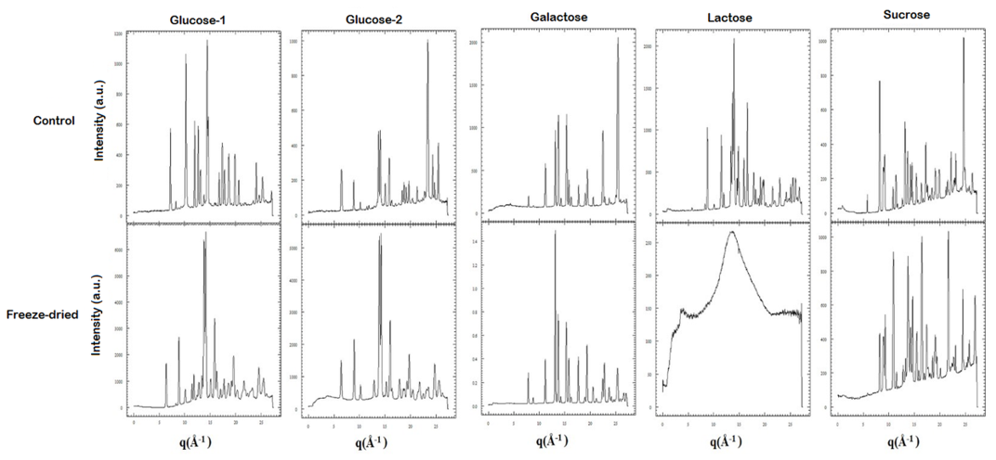

**Fig. S1. 1D-WAXS patterns of control and FD sugars**

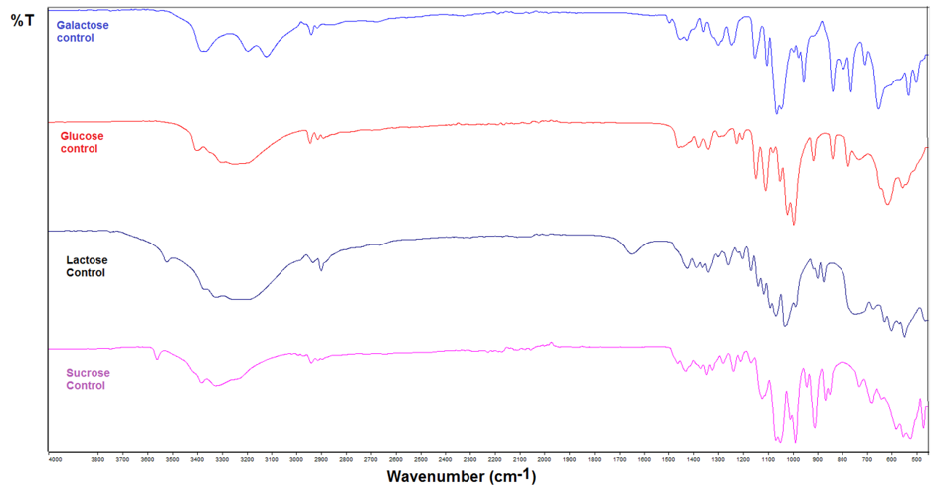

**Fig. S2 Average ATR -FTIR spectra of control samples in the range 4000 cm-1 - 450 cm-1 glucose, galactose, lactose and sucrose**

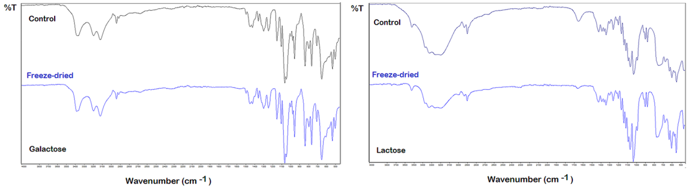

**Fig. S3.** **ATR-FTIR spectra in the range 4000 cm-1 - 450 cm-1 of control galactose and lactose and those of freeze - dried samples.**

**Supplementary Table (Table S1)**

|  |  |  |  |  |  |  |  |  |
| --- | --- | --- | --- | --- | --- | --- | --- | --- |
| **Table S1 Observed infrared band wavenumbers( cm-1) and the tentative assignments for control (C) and freeze-dried (FD) sugar samples\*** | | | | | | | | |
| **Assignments** | **Glucose**  **C** | **Glucose**  **FD** | **Galactose**  **C** | **Galactose**  **FD** | **Sucrose**  **C** | **Sucrose**  **FD** | **Lactose**  **C** | **Lactose**  **FD** |
| Weak hydrogen bonded ν(O-H) | 3404 |  | 3383 | 3384 | 3561 |  | 3522 | 3524 |
| ν(O-H) |  |  | 3366 | 3366 | 3383 | 3382 |  |  |
| ν(O-H) | 3304 |  |  |  | 3326 | 3309 | 3324 | 3330 |
| ν(O-H) | 3254 | 3238 | 3196 | 3197 |  | 3250 | 3198 | 3197 |
|  |  |  | 3121 | 3121 |  |  |  |  |
| ν(CH2) |  |  |  |  | 2991 | 2995 |  | 2994 |
| ν(CH2) |  | 2968 |  |  | 2970 |  |  |  |
| ν(CH2) | 2944 | 2938 | 2940 | 2940 | 2939 | 2938 | 2932 | 2934 |
| ν(CH2) | 2913 | 2903 | 2915 | 2915 | 2913 | 2910 | 2899 | 2900 |
| ν(C-H) | 2890 | 2884 | 2864 | 2844 |  |  |  |  |
| δ(OH) |  |  |  |  |  |  | 1648 | 1657 |
|  |  |  | 1565 | 1563 |  |  |  | 1541 |
|  |  |  | 1494 | 1495 |  |  |  |  |
| δ(CH2)+ δ(OH) | 1457 |  | 1450 | 1450 | 1460 | 1459 |  |  |
| δ(OC)+ δ(CH) | 1442 | 1426 | 1423 | 1423 | 1428 | 1427 | 1422 | 1424 |
|  |  |  |  |  |  |  | 1385 | 1387 |
| δ(CO)+δ(OCH) | 1377 | 1374 | 1358 | 1358 | 1369 | 1370 | 1361 | 1362 |
| δ(CH) +δ(COH) | 1338 | 1332 |  |  | 1345 | 1345 |  |  |
|  |  |  |  |  | 1322 | 1324 | 1339 | 1340 |
| δ(CH) +δ(COH) | 1294 |  | 1298 | 1298 | 1279 | 1278 | 1299 | 1299 |
| δ(CH2)+ ν (C-C) | 1224 | 1248 | 1245 | 1245 | 1237 | 1237 | 1258 | 1259 |
| δ(OCC) +ν (C-O) | 1202 | 1208 |  |  | 1208 | 1208 | 1219 | 1220 |
| ν (C-O) Glycosidic |  |  |  |  |  |  | 1201 | 1201 |
| ν (C-O)+ ν (C-C) | 1147 | 1154 | 1151 | 1151 | 1166 | 1156 | 1167 | 1167 |
| ν (C-O) Glycosidic |  |  |  |  |  |  | 1138 | 1140 |
| δ (C-OH) +ν (C-O) | 1108 | 1110 | 1103 | 1103 | 1121 | 1110 | 1115 | 1116 |
| ν (C-O) Glycosidic |  |  |  |  |  |  | 1090 | 1091 |
| δ (C-OH ) | 1079 | 1071 | 1063 | 1063 | 1066 | 1067 | 1066 | 1068 |
| **Table S1 (Continue)** | | | | | | | | |
| **Assignments** | **Glucose**  **C** | **Glucose**  **FD** | **Galactose**  **C** | **Galactose**  **FD** | **Sucrose**  **C** | **Sucrose**  **FD** | **Lactose**  **C** | **Lactose**  **FD** |
| ν (C-O) | 1020 | 1007 |  |  | 1008 | 1008 |  |  |
| ν (C-O)+ ν (C-C) | 994 |  | 994 | 995 | 988 | 988 | 987 | 988 |
| ν (C-O)+ δ (C-OH |  |  | 975 | 974 |  |  |  |  |
| δ(C-OH)+ ν (C-C) |  |  | 954 | 954 | 942 | 942 |  |  |
| ν (C-OH)+  ν (C-C) | 915 | 915 |  |  | 909 | 911 | 915 | 915 |
| ν (C-O-C) |  |  |  |  |  |  | 898 | 899 |
| δ(CH2)+ δ(CCO) |  |  |  |  | 867 | 865 | 874 | 875 |
| δ(CH2)+ δ(OCH) | 838 | 852 | 837 | 837 | 849 | 850 |  |  |
|  |  |  | 794 | 794 |  |  |  |  |
| δ(CH2) | 774 | 768 | 763 | 764 |  | 768 | 745 | 772 |
| δ(CH2) | 730 | 715 |  |  | 729 |  |  |  |
|  |  |  | 706 | 707 |  | 718 | 672 | 678 |
| δ (C-C-O) |  |  | 651 | 652 | 678 | 681 |  |  |
| δ (C-C-O) |  | 649 |  |  | 640 | 639 | 628 | 630 |
| δ (C-C- C) | 615 | 602 |  | 602 |  |  | 600 | 603 |
|  |  |  |  |  | 581 |  | 569 | 570 |
| δ (O-C-O) | 555 | 559 |  |  | 552 | 551 | 547 | 550 |
|  | 540 |  | 531 | 532 |  |  |  |  |
| τ (C-O) |  | 513 | 500 | 501 | 523 | 521 |  |  |
| C-C-O / Glycosidic |  |  |  |  |  | 469 | 464 |  |

*Vibrational modes: ν, stretching; δ, deformation τ torsion