**Review Article**

**Genetic Resources of Livestock and Poultry in Uttarakhand State of India: A Comprehensive Review**

**ABSTRACT**

Uttarakhand, a northwestern Himalayan state in India, is home to diverse livestock and poultry breeds adapted to its unique agro-climatic conditions. With its rugged terrain and varied ecosystems, the state offers a rich repository of indigenous animal genetic resources. Among these are native cattle like the Badri, goats such as Pantja and Chaugarkha, sheep like Muzzafarnagri, and poultry breeds including Uttara fowl. These animals, well-suited to the challenges of high-altitude living, play a vital role in sustaining rural livelihoods through dairy, meat, wool, egg and manure production. Despite a decline in indigenous livestock populations, grading-up and crossbreeding programmes have instrumental in increasing the production potential of the existing livestock. Notably, while the cattle and buffalo populations have declined, the goat and poultry populations have increased significantly, driven by growing market demands. The review also highlights the critical conservation efforts in the region, including breeding programmes aimed at preserving the genetic diversity of these local breeds. Significant initiatives such as those by the Uttarakhand Livestock Development Board, the Himmotthan Society, and the Department of Animal Genetics & Breeding at Govind Ballabh Pant University of Agriculture and Technology, Pantnagar focus on improving livestock productivity through selective breeding, artificial insemination and advanced reproductive technologies. Furthermore, these efforts aim to integrate modern agricultural practices with the preservation of traditional livestock systems. Genetic characterization of breeds like the Badri cattle, Uttara fowl, and Pantja and Chaugarkha goat breeds has been instrumental in their registration and conservation. The review underscores the importance of maintaining these indigenous genetic resources to ensure the sustainability of the region's agriculture, provide economic stability to farmers, and contribute to India's broader agricultural biodiversity.

***Keywords:*** *Conservation, Livestock, Poultry, Uttarakhand*

1. **Introduction**

India is rich repository of livestock species viz. cattle, buffalo, sheep, goat, pig and various domesticated poultry species. The Indian subcontinent has been a cradle for the earliest domestication of several farm species. During the Indus Civilization, cattle husbandry was a primary occupation, playing a crucial role in both the nutritional and economic aspects of their society [1]. Uttarakhand, a northwestern Himalayan state of India, is known for its rich biodiversity and diverse agro-climatic conditions, which support a variety of indigenous animal genetic resources. The state, characterized by its mountainous terrains, rivers, and forested landscapes, is home to several native livestock and poultry breeds that have adapted to the challenging environmental conditions over centuries.

India is home to approximately 536.82 million livestock and 851.12 million poultry [2]. According to the 20th Livestock Census (2019), the total livestock population in the Uttarakhand state, including poultry, stands at 96.78 lakhs. Uttarakhand's livestock population, in comparison to the national figures, comprises 0.96% cattle, 0.79% buffaloes, 0.38% sheep, 0.92% goats, 0.20% pigs, and 0.59% poultry. Notably, while the overall cattle population has declined, there has been a marked rise in crossbred cattle, accompanied by a decrease in indigenous cattle numbers. This shift indicates the direct impact of ongoing Breed Improvement Programmes leading to increase production potential existing livestock resource. Additionally, both buffalo and sheep populations have witnessed a decline, whereas goat numbers have increased significantly. A particularly notable trend is the sharp rise in poultry population, most likely driven by the growing demand for poultry meat and eggs [3].

As of now, India has a total of 230 registered indigenous breeds of livestock and poultry. This includes 53 indigenous cattle breeds plus on synthetic cattle breed (Frieswal), 21 buffalo breeds, 41 goat breeds, 46 sheep breeds, 8 horse and pony breeds, 9 camel breeds, 15 pig breeds, 4 donkey breeds, 5 dog breeds and 2 yak breeds in the livestock category. In the poultry category, there are 20 chicken breeds, 1 geese breed, and 4 duck breeds. Among the 230 recognized breeds in India, Uttarakhand is home to one registered breed each of cattle, sheep, and chicken, along with two recognized goat breeds [4].

Therefore, this review explores the genetic resources of Uttarakhand, focusing on their importance, conservation efforts and potential role in advancing modern agriculture and livestock enhancement programs.

1. **Genetic Resource of Cattle**

Uttarakhand, a Himalayan state in northern India, is home to diverse cattle genetic resources uniquely adapted to its varied agro-climatic conditions. The indigenous Badri cattle, the only registered breed from the region, thrive in the hilly terrain due to their resilience, disease resistance, and ability to sustain on forest-based fodder [17,18]. Additionally, crossbreeding programmes have introduced high-yielding dairy breeds such as Jersey and Holstein Friesian in the hilly terrains and plains, respectively, to enhance milk production. These genetic resources play a vital role in the livelihoods of rural farmers, contributing to dairy farming, draught power, and sustainable agriculture in the region. Conservation and selective breeding efforts continue to improve productivity while maintaining the adaptability of local breeds.

**2.1 Badri**

The breeding tract of Badri cattle in Uttarakhand state is Chamoli, Uttarkashi, Rudraprayag, Tehri Garhwal, Pauri Garhwal, Champawat, Pithoragarh, Bageshwar, Almora and Nainital. The Badri cattle, also known locally as *Pahadi*, is an indigenous breed found in the hilly regions of Uttarakhand. These cattle are primarily reared for milk production, draught power, and manure, making them an integral part of the traditional farming system in the region. They thrive at altitudes ranging from 1,200 to 2,200 meters above sea level, with daily sunshine exposure varying between 6 to 10 hours. The major crops cultivated in their breeding tract include wheat, maize, rice, bajra, barley etc. Badri cattle are well adapted to the challenging hilly terrain and climatic conditions of Uttarakhand. Their balanced gait enables efficient movement on steep slopes, making them ideal for agricultural activities in mountainous areas. The management system for these cattle follows a semi-intensive approach. Adult animals primarily rely on grazing and fodder, with feeding practices involving stall-feeding in the morning and evening, while grazing occurs from late morning until early evening. They are typically housed under the dwelling-house or in separate cowsheds during the night. Fodder mainly consists of crop residues/by-product and grasses collected from hillsides, often carried by women, reflecting the deep integration of Badri cattle in the rural agrarian lifestyle [19,20]. Their resilience and adaptability make them an invaluable genetic resource for sustainable livestock farming in Uttarakhand.

Badri cattle exhibit a diverse coat colour, predominantly black, red, or grey. Their horns are curved upward and inward, measuring approximately 10–22 cm in males and 15–25 cm in females. These cattle are small-sized, active, and sure-footed, making them well-suited for the rugged terrain of Uttarakhand. They possess a straight forehead with a prominent poll, a medium to large hump, and a small udder that is neatly tucked-up with the body. In terms of body measurements, the average height is 110.5 cm in males and 108.0 cm in females, while the average body length is 115.2 cm in males and 116.3 cm in females. The heart girth is 145.2 cm in males and 140.5 cm in females, reflecting their compact and well-proportioned build. The average body weight of Badri cattle is 257.00 kg for males and 231.00 kg for females, with an average birth weight of 17.20 kg for males and 16.20 kg for females. These physical characteristics highlight the breed's adaptability to the hilly terrain and climatic conditions, making them an essential livestock resource for the region. The average litter size born, age at first parturition, parturition interval, milk yield per lactation and milk fat are 1.00, 49.00 months, 13.40 months, 632.00 kg and 4%, respectively [5].

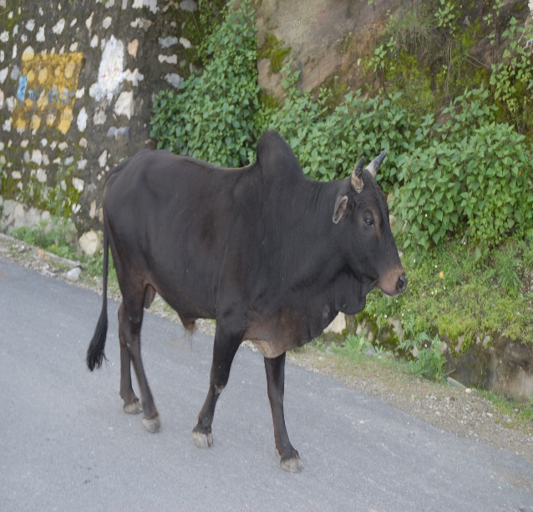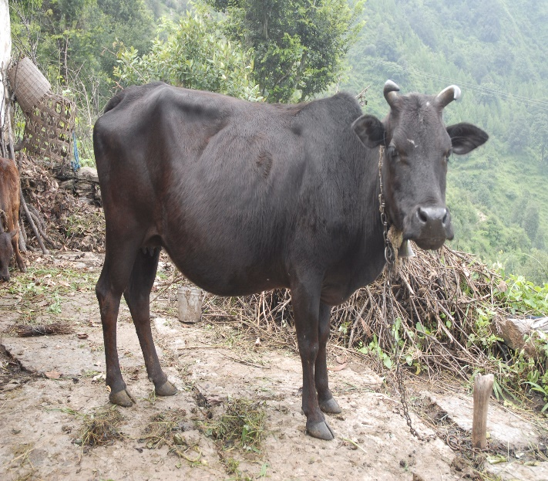

**Fig 1. Badri cattle (Male) Fig 2. Badri cattle (Female)**

**(Source: ICAR-NBAGR, Karnal)**

1. **Genetic Resource of Goat**

The state hosts around 13,71,000 goats. The state's goat genetic resources primarily consist of non-descript lesser-known indigenous goats, well adapted to harsh climatic conditions, rugged terrains and limited fodder availability. These goats are reared mainly for meat, milk and fibre, contributing significantly to food security and income generation for landless, small and marginal farmers. Efforts are being made to improve their productivity through selective breeding, scientific management practices and conservation programmes, ensuring sustainable goat farming in the region.

**3.1 Pantja**

Pantja is a registered goat breed native to the Tarai region of Uttarakhand, primarily reared for meat production by local farmers. These goats are known for their morphological resemblance to deer and are well adapted to the hot and humid climate of the Tarai region in Uttarakhand and the neighbouring districts of Uttar Pradesh [6]. The Pantja goat is a dual-purpose breed valued for both chevon and milk production. Farmers particularly appreciate the quality of Pantja chevon, leading to the practice of castrating bucklings at an early age of 7 to 10 days. The management system followed for Pantja goats is primarily extensive, with the animals being stationary rather than migratory. Adult goats rely on grazing and fodder for their nutritional needs. These goats are predominantly reared by landless, small, and marginal farmers, with an average flock size of 7.2 animals.

The Pantja goat exhibits a fawn to brown coat colour, which gradually lightens on the ventral side. It possesses small horns, typically less than 15 cm in length, with a triangular shape that is twisted, slightly directed upwards and backwards, and ends in a pointed tip. A distinctive white streak is present on either side of the face, and the head has a slightly convex profile. The breed is also characterized by its pendulous ears. In terms of body measurements, the average height is 63.57 cm in males and 59.63 cm in females, while the average body length is 56.24 cm and 54.21 cm, respectively. The heart girth averages 65.81 cm in males and 63.65 cm in females. The adult body weight is approximately 22.91 kg for males and 18.81 kg for females, with an average birth weight of 1.96 kg in males and 1.85 kg in females. The Pantja goat is an early-maturing and highly prolific breed, with a twinning rate exceeding 65%. It is favoured by farmers for its meat, milk, and reproductive efficiency. The breed has an average litter size of 2.0 kids per kidding. The age at first parturition is approximately 14.17 months, with a parturition interval of around 9.35 months. In terms of milk production, the average milk yield per lactation is 127.0 kg, with a milk fat percentage of 3.87%. Additionally, the breed exhibits a dressing percentage of 56.0%, further enhancing its economic value for meat production [7].

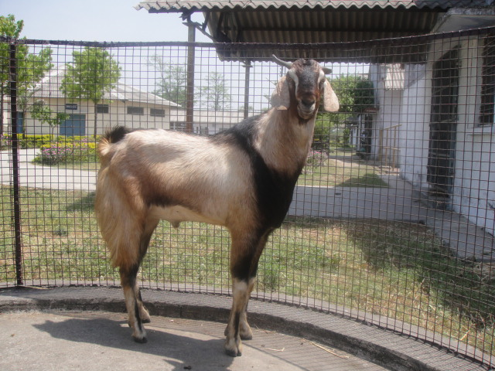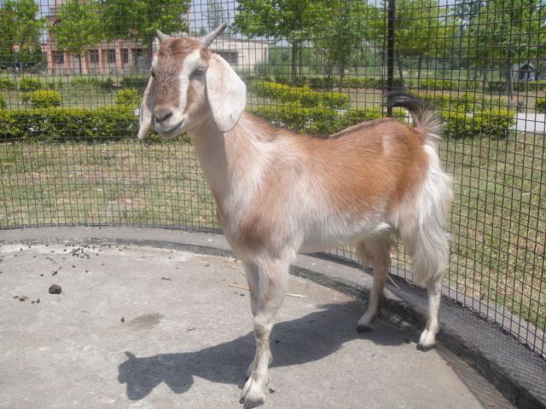

**Fig 3. Pantja Goat (Male) Fig 4. Pantja Goat (Female)**

**(Source: ICAR-NBAGR, Karnal)**

**3.2 Chaugarkha**

The Chaugarkha, also known as the Kumaoni goat, is primarily found in the Almora, Pithoragarh, Nainital, Champawatand Bageshwar districts of Uttarakhand. This breed is mainly raised for mutton production. The average adult body weight is approximately 27 kg for males and 24 kg for females [8].

Chaugarkha goats are small in size and reared for meat purpose. The coat colour of this bred varies from black, Fawn to white. The ear length, height at withers, body length, heart girth, tail length, and horn length of Chaugarkha goats at full mouth age were 13.95 cm, 56.92 cm, 55.12 cm, 65.23, 10.81 cm, and 7.72 cm, respectively, in females and 14.91 cm, 62.95 cm, 57.12 cm, 70.21 cm, 12.73 and 13.27 cm, respectively, in males. The adult body weight of Chaugarkha goats at six teeth was 25.60 kg in males and 22.40 kg in females. They kid twice a year with one or two kids. Meat of this breed is coarse and devoid of fat. The udder is small with well set with small pointed teats. The she goats do not yield any appreciable quantity of milk except for nourishing the kids.

|  |  |  |
| --- | --- | --- |
|  |  | DSC00584 |
|  |  |  |
|  |  |  |
|  |  |  |
|  |  |  |
|  |  |  |
|  |  | DSCN4657 |
| **Fig 5. Chaugarkha Females** |  | **Fig 6. Chaugarkha Males** |

1. **Genetic Resource of Sheep**

The state's sheep population primarily includes Muzzafarnagri breed, which is well adapted to the local conditions and migratory grazing systems. These indigenous breeds are reared mainly for wool, meat, and manure, contributing significantly to the rural economy. The lesser-known black sheep of Garhwal, known for their medium-quality dense fleece, are also prevalent in the region. Conservation and genetic improvement efforts are being undertaken to enhance wool quality, productivity and overall sustainability of sheep farming in Uttarakhand.

**4.1 Muzzafarnagri**

The breed is managed under an extensive system, with stationary mobility and a grazing-based feeding regimen. It is primarily white in colour, with occasional patches of brown or black, while the ears and face may also exhibit black markings. Both males and females are polled. Morphologically, the breed has a slightly convex face, long and drooping ears, and a coarse, open fleece that is predominantly white. The belly and legs are devoid of wool.

In terms of body measurements, the average height is 80.68 cm in males and 73.59 cm in females, while body length averages 80.32 cm and 73.53 cm, respectively. The heart girth measures approximately 84.32 cm in males and 78.51 cm in females. The adult body weight is around 50.21 kg in males and 39.61 kg in females, with an average birth weight of 3.01 kg in males and 3.0 kg in females.Regarding reproductive performance, the breed typically produces a single lamb per birth. The age at first parturition ranges from 16 to 18 months, with a parturition interval of 6 to 8 months. The fleece yield varies between 0.6 and 1.0 kg per year, with an average staple length of 3.72 cm and a fibre diameter of 45.17 microns. The breed exhibits a dressing percentage of 50.4%. Notably, it is recognized as one of the heaviest and largest sheep breeds in India [9].

|  |  |
| --- | --- |
|  |  |

**Fig 7. Muzzafarnagri Sheep (Male) Fig 8. Muzzafarnagri Sheep (Female)**

**(Source: ICAR-NBAGR, Karnal)**

1. **Genetic Resource of Poultry**

The poultry population stands at approximately 50,18,000. Various species, including chickens, ducks, guinea fowl and quail, contribute significantly to the human food chain and family income. These species exhibit large genetic variation, which needs to be explored for improvement and conservation. Differences in body size, conformation, and colour patterns among these birds should be thoroughly described and evaluated using both phenotypic traits and DNA profiles. Additionally, these populations should be studied for unique traits related to disease resistance and their ability to survive under harsh climatic conditions.

**5.1 Uttara Fowl**

Uttara fowls are predominantly reared under the backyard system in the Kumaon division of Uttarakhand. This breed holds significant local importance, providing both nutritional and economic security to the farming communities [10]. Similarly, Uttara fowl is well adapted to the cold winter stress and thrives under challenging conditions, including poor housing, inadequate management, and limited feeding resources. The breed is characterized by its predominantly black plumage, a distinct crest or crown-like structure on the head, and feathery shanks. Uttara fowl is widely reared under traditional systems by marginal farmers, tribal communities, and other rural populations in the hilly regions of Uttarakhand [11].

The Uttara fowl is characterized by its compact body, alert nature, and strong adaptability. The breed exhibits normal plumage with a solid black coloration, a single comb, white skin, and yellow shanks. A distinct feature observed in approximately 18% of birds is the presence of feathered shanks and a bunch of feathers forming a crown-like structure on the head.In terms of growth, the average birth weight is 33.19 g in males and 33.04 g in females, with adult weights averaging 1.296 kg and 1.129 kg, respectively. The breed reaches its first egg-laying stage at around 5.5 months, with a range of 5.4 to 5.8 months. The clutch size varies from 3 to 6 days, averaging 5 days. Annual egg production ranges from 125 to 160 eggs, with an average egg weight of 51.33 g. The breed demonstrates a fertility rate between 71% and 86%, with an average of 81.36%, while the hatching percentage ranges from 59% to 71%, averaging 60.12%. The dressing percentage varies between 70% and 78%, with an average of 76%. Uttara fowl is known for its unique traits such as high alertness, noisiness, strong fighting ability, and attractive plumage. The breed’s lighter body structure and strong wings enhance its ability to escape predators by running swiftly or flying to safety. Notably, Uttara fowl produces more noise compared to commercial poultry breeds, making it a distinctive choice for backyard farming. Additionally, its meat is well regarded for its taste, further contributing to its popularity among rural and marginal farmers [12].

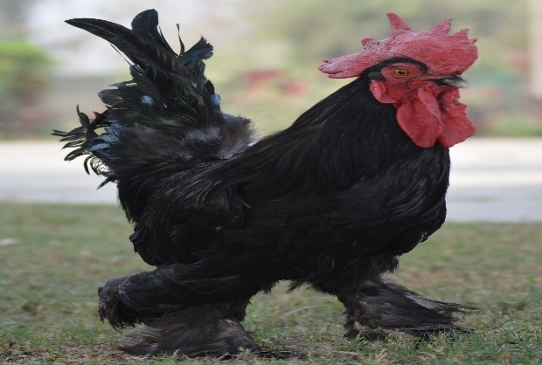 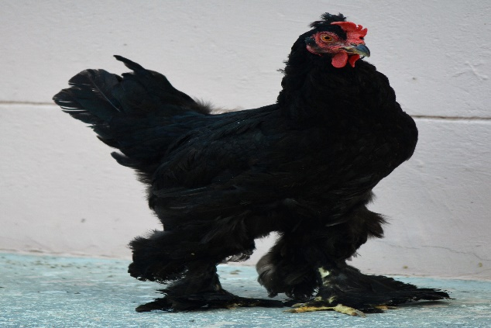

**Fig 9. Uttara Fowl (Male) Fig 10. Uttara Fowl (Female)**

**(Source: ICAR-NBAGR, Karnal)**

1. **Conservation and Genetic Enhancement Initiatives**

**6.1 Badri Cattle Conservation and Genetic Enhancement**

Recognizing the importance of preserving and enhancing its indigenous animal genetic resources, Uttarakhand has undertaken several initiatives. The Animal Breeding Farm in Nariyalgaon, Champawat, established in 2012, focuses on the conservation and propagation of the Badri cow. Starting with 50 cows, the farm has expanded its population to over 300, emphasizing the significance of this breed in the state's livestock diversity [13].

To further boost the productivity of the Badri cow, the state government has proposed the use of advanced reproductive technologies, such as Multiple Ovulation Embryo Transfer (MOET) and in vitro fertilization (IVF). These methods aim to enhance milk yield and ensure the proliferation of high-genetic-stock cattle. The project, with an estimated cost of ₹50 crore, reflects the state's commitment to improving the livelihoods of mountain farmers through sustainable livestock development [14].

**6.2 Breed Improvement Initiatives by Himmotthan Society**

The Himmotthan Society has been actively involved in enhancing livestock productivity in Uttarakhand's mid and higher Himalayan regions. Their initiatives include:

**Large Ruminants (Cattle and Buffaloes):** To address low milk yields, Himmotthan, in partnership with the Uttarakhand Livestock Development Board (ULDB) and the International Livestock Research Institute (ILRI), has performed approximately 28,500 artificial inseminations, resulting in 12,929 improved progenies as of December 2020. Preferred breeds among the community include Red Sindhi and Jersey for cattle, and Murrah for buffaloes.

**Small Ruminants (Goats):** Recognizing the non-descript nature and low productivity of local goats, Himmotthan promotes semi-stall feeding practices, construction of goat sheds, introduction of improved feed, and selective breeding to avoid inbreeding. These efforts aim to make goat rearing economically viable for rural communities.

**Backyard Poultry:** To boost local poultry production, Himmotthan has established hatchery units in project clusters to reduce the cost of day-old chicks and promote the production of local birds [15].

**6.3 Academic and Research Contributions**

The Department of Animal Genetics & Breeding at Govind Ballabh Pant University, Pantnagar has been instrumental in characterizing and conserving Uttarakhand's livestock genetic resources. Their achievements include:

**Characterization of Badri Cattle and Tarai Buffaloes:** The department has conducted studies to understand the unique traits of these indigenous breeds, aiding in their conservation and improvement efforts.

**Characterization and Registration of Uttara Fowl:** In collaboration with the Department of Livestock Production Management, the university has worked on identifying and registering this local poultry breed, ensuring its preservation and recognition.

**Characterization and Registration of Pantja and Chaugarkha goats:** The department of Livestock Production and Management of Govind Ballabh Pant University of Agriculture and Technology, Pantnagar has got registered Pantja goat in the year 2014 as a distinct goat breed of the country. Similarly, the department of Animal Genetics and Breeding along with other institutions got registered Chaugarkha goat breed in the year 2025.

**Establishment of Elite Guinea Fowl Flocks:** The department has developed elite flocks of guinea fowls suitable for semi-intensive systems, aiming to provide economic upliftment opportunities for rural women in Uttarakhand [16].

These concerted efforts by various organizations and institutions underscore Uttarakhand's commitment to conserving and enhancing the genetic resources of its livestock and poultry, thereby supporting sustainable livelihoods and preserving biodiversity in the region.

**Conclusion**

Uttarakhand’s indigenous livestock and poultry breeds are important genetic resource for sustaining rural economies and agricultural systems. Conservation and genetic enhancement efforts are crucial in preserving these genetic resources, improving productivity and ensuring food security. The state's focus on breed improvement, including the use of modern technologies, promises a bright future for these breeds. Continued collaboration between government bodies, research institutions and local communities is vital for the success of these initiatives.

**Table 1. SPECIESWISE LIVESTOCK POPULATION (2019)**

|  |  |  |  |
| --- | --- | --- | --- |
| **S.NO.** | **Category** | **India’s Population (million)** | **Uttarakhand’s Population (lacs)** |
| 1 | Cattle | 193.46 | 18.52 |
| 2 | Buffalo | 109.85 | 8.66 |
| 3 | Sheep | 74.26 | 2.84 |
| 4 | Goat | 148.88 | 13.71 |
| 5 | Equines (Horse/Pony/Mule/Donkey) | 0.54 | 0.34 |
| 6 | Pig | 9.06 | 0.17 |
| 7 | Others (Yak/Dog/Rabbit) | 10.04 | 2.36 |
| 8 | Poultry | 851.81 | 50.18 |

**(Source: 20th Livestock Census of Uttarakhand)**

**Fig 11. Livestock and Poultry Population in India as per 20th Livestock Census**

**Fig 12. Livestock and Poultry Population in Uttarakhand as per 20th Livestock Census**

**Table 2. Registration number of livestock and poultry breeds of Uttarakhand**

|  |  |  |  |  |
| --- | --- | --- | --- | --- |
| **Sr.No.** | **Breed** | **Home Tract** | **Utility** | **Accession Number** |
| 1 | Badri | Uttarakhand | Milk and Draught | INDIA_CATTLE_2400_BADRI_03040 |
| 2 | Pantja | Uttarakhand | Milk and Meat | INDIA_GOAT_2420_PANTJA_06024 |
| 3 | Chaugarkha | Uttarakhand | Meat | INDIA_GOAT_2400_CHAUGARKHA_06040 |
| 4 | Muzzafarnagri | Uttar Pradesh &Uttrakhand | Meat | INDIA_SHEEP_2024_MUZZAFARNAGRI_14014 |
| 5 | Uttara | Uttarakhand | Egg and Meat | INDIA_CHICKEN_2400_ UTTARA_12019 |

The above breeds of livestock and poultry have been registered by National Bureau of Animal Genetics and Breeding (NBAGR), Karnal, India.

**COMPETING INTERESTS DISCLAIMER:**

Authors have declared that they have no known competing financial interests OR non-financial interests OR personal relationships that could have appeared to influence the work reported in this paper.

**References**

1. Mishra BP, Niranjan SK. Animal Genetic Resources (AnGR) Diversity in India. Indian Journal of Plant Genetic Resources. 2022 Sep 25;35(03):223-8.
2. Department of Animal Husbandry & Dairying. 20th Livestock Census. All India Report. Ministry of Fisheries, Animal Husbandry & Dairying, Government of India. 2019.
3. Department of Animal Husbandry, Government of Uttarakhand. 20th Livestock Census Report, Uttarakhand. 2019.
4. ICAR-NBAGR. National Bureau of Animal Genetic Resources, Karnal (Haryana). 2025.
5. ICAR-NBAGR. Badri cattle. National Bureau of Animal Genetic Resources, Karnal (Haryana). 2016.
6. Khadda BS, Singh B, Singh DV, Singh SK, Singh CB, Singh JL, Palod J. Growth performance of Pantja goats under field conditions in their home tract. Indian Journal of Animal Research. 2019;53(2):264-9.
7. ICAR-NBAGR. Pantja Goat. National Bureau of Animal Genetic Resources, Karnal (Haryana). 2014.
8. ICAR-NBAGR. Chaugrakha Goat. National Bureau of Animal Genetic Resources, Karnal (Haryana). 2025.
9. ICAR-NBAGR. Muzaffarnagri sheep. National Bureau of Animal Genetic Resources, Karnal (Haryana). 1995.
10. Jaiswal S, Singh I, Mahanta D, Sathapathy S, Mrigesh M, Pandit K, Selvan ST. Gross and morphometrical studies on the heart of Uttara fowl. Journal of Entomology and Zoology Studies. 2017;5(6):2313-8.
11. Ansari VA, Kumar A, Dar AH, Singh B, Kumar S, Singh SK. Growth and mortality patterns in uttarafowl. Journal of Animal Research. 2018 Jun 1;8(3):429-34.
12. ICAR-NBAGR. Uttara fowl. National Bureau of Animal Genetic Resources, Karnal (Haryana). 2018.
13. <https://www.uldb.org/animal-breeding-farm-nariyalgaon.php>
14. <https://www.thehindu.com/news/national/other-states/uttarakhand-plans-genetic-enhancement-of-its-indigenous-badri-cow/article66247599.ece>
15. Himmotthan Society. (n.d.). *Breed improvement initiatives*. Himmotthan Society. Retrieved from <https://www.himmotthan.org/livestock/BreedImprovement.aspx>
16. Govind Ballabh Pant University of Agriculture and Technology. (n.d.). *Department of Animal Genetics & Breeding*. Retrieved from <https://www.gbpuat.ac.in/colleges/COV/D2/about.html>
17. Blackburn, H. D. (2006). The national animal germplasm program: challenges and opportunities for poultry genetic resources. *Poultry science*, *85*(2), 210-215.
18. Yuying, Y. A. N. G., Shanshan, H. E., & Yubin, W. A. N. G. (2024). Current Situation, Dilemma and Way out of the Protection of Livestock and Poultry Genetic Resources in China. *Journal of Agriculture*, *14*(8), 44.
19. Xie, X., Shi, L., Zhong, Z., Wang, Z., Pan, D., Hou, G., & Xiao, Q. (2024). Danzhou chicken: a unique genetic resource revealed by genome-wide resequencing data. *Poultry Science*, *103*(8), 103960.
20. Xiao-fang, W. U., & Hui, Y. A. N. G. (2024). Research on high-quality development path of livestock and poultry breeding industry in perspective of Chinese-style modernization. *Feed Research*, *47*(2).