**Necrotizing Sialometaplasia Associated with Orthodontic Appliance: A Case Report**

**Abstract**

Necrotizing Sialometaplasia (NS) is a rare, self-limiting inflammatory condition primarily affecting the minor salivary glands of the palate, accounting for less than 1% of salivary gland diseases. It typically manifests in men around the age of 40, though its exact etiology remains unclear. Trauma-induced ischemia and chemical irritation, particularly from gastric acid reflux, have been suggested as potential contributing factors. This study presents a case of NS in a 17-year-old female following the placement of a palatal breaker appliance, exploring its possible association with mechanical trauma and comparing it with existing literature.

Keywords: Necrotizing sialometaplasia, Salivary glands, Palate, Inflammation, Orthodontics.

**1 Introduction**

Necrotizing Sialometaplasia (NS) consists of an uncommon benign inflammatory process affecting the salivary glands. Despite clinically and histologically mimicking a malignant condition, it is self-limiting, with spontaneous regression occurring within approximately one to ten weeks, and it does not present recurrences (NEVILLE et al., 2009; HENRICH & SILVA, 2009; RAVN et al., 2009; REBELLATO JÚNIOR, 2003).

NS was first described by Abrams et al. (1973) as a necrotizing inflammatory reaction involving the minor salivary glands of the hard palate. In 1992, the World Health Organization (WHO) classified NS as a tumoral lesion of the salivary glands (KRISHNA et al., 2011; REBELLATO JÚNIOR, 2003). However, in the latest WHO classification of head and neck tumors in 2005, this lesion was no longer considered a tumor. Therefore, it is well established that NS is a reactive inflammatory process.

The etiology remains undefined, but it appears to be associated with reduced oxygenation of the salivary glands due to ischemia of adjacent blood vessels. It accounts for approximately 1% of salivary gland lesions and less than 1% of biopsied oral lesions (MOREIRA et al., 2022). The most commonly affected site is the minor salivary glands of the hard palate. Additionally, any region containing salivary tissue can be affected, but the vast majority of cases reported in the literature involve the palate.

NS shows a predilection for the male gender and the fourth decade of life, although it can affect individuals of any age group (NEVILLE et al., 2009). Clinically, the lesion begins as a non-ulcerated swelling, often associated with paresthesia and pain. It progresses into a deep ulcer of varying size, irregular shape, with elevated and well-defined borders, and may present unilaterally or bilaterally. Typically, when the lesion ulcerates, pain subsides (FEMOPASE et al., 2004; NEVILLE et al., 2009). An unusual case in the literature describes NS manifesting as a cystic lesion in the floor of the mouth (LIMA et al., 2002).

Histopathologically, NS frequently exhibits areas of acinar necrosis, squamous metaplasia of salivary ducts, and preservation of the lobular architecture, which may include an inflammatory infiltrate with mucin release. Although squamous metaplasia is common in most cases, NS differs from malignant lesions due to its milder cytological appearance and its lack of disruption of lobular architecture (FEMOPASE et al., 2004; MADALA et al., 2011; NEVILLE et al., 2009; MOREIRA et al., 2022).

A biopsy is essential to rule out malignancy, preventing unnecessary treatments, as the clinical aspects can be very concerning for patients. Moreover, histopathological examination excludes other malignant diagnostic hypotheses with similar characteristics, such as mucoepidermoid carcinoma, squamous cell carcinoma, and adenoid cystic carcinoma (FEMOPASE et al., 2004; NEVILLE et al., 2009; ABDALLA-ASLAN et al., 2020).

The aim of this study is to report a case of NS associated with a palatal expander and to seek correlations with other cases in the literature.

**2 Case Report**

A 17-year-old female patient, melanoderma, visited the Stomatology Clinic at the Department of Dentistry, Federal University of the Jequitinhonha and Mucuri Valleys (UFVJM), in Brazil, presenting with a chief complaint of pain in the palate following the installation of a palatal expander.

During the investigation of the lesion's etiology, the patient's mother reported that she had undergone orthodontic treatment, including the placement of a palatal expander. However, 15 days after the device was placed, the patient experienced exacerbated pain and returned to the orthodontist requesting its removal. After removal, a lesion was observed on the hard palate, and the patient was referred to the Stomatology Clinic at UFVJM.

The patient was in good systemic health with no history of illnesses and had a satisfactory extraoral appearance upon examination. During the intraoral examination, an ulcerated lesion with elevated borders, an irregular surface, and an irregular shape was identified on the right side of the hard palate, measuring 2 cm x 1 cm in diameter.

The clinical and radiographic characteristics of the lesion, combined with the absence of risk factors for malignancy and the history of palatal expander use, ruled out a malignant diagnosis. The primary diagnostic hypotheses considered were Necrotizing Sialometaplasia (NS) and Eosinophilic Ulcer (Figures 1, 2, and 3).

Figure 1. Palatal expander-type orthodontic appliance used by the patient.

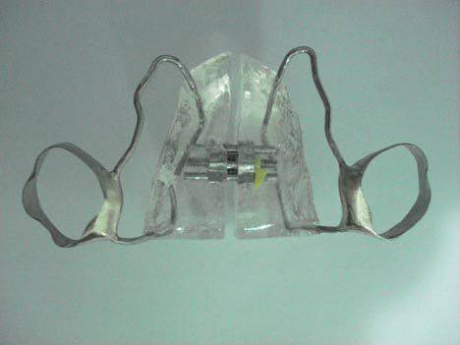

Figure 3. Radiographic examination of the palate.

Figure 2. Intraoral examination of the palate.

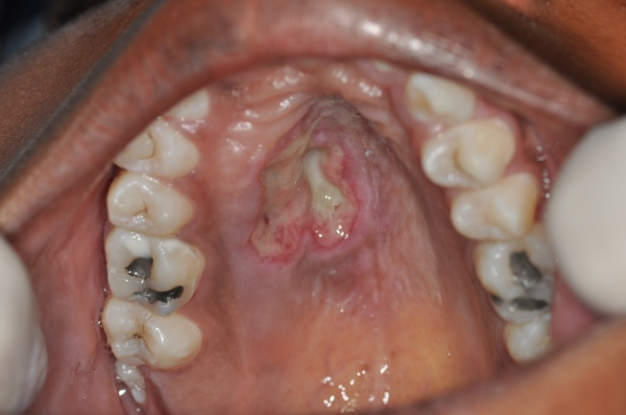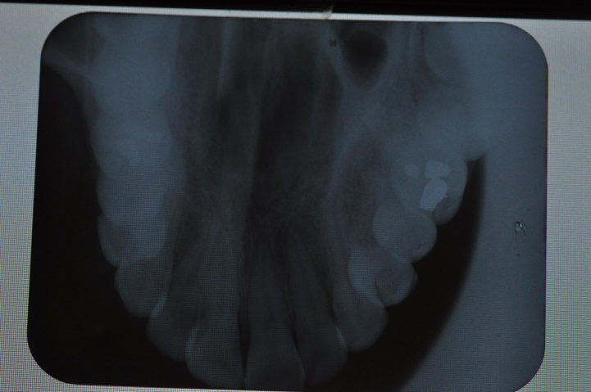

The proposed approach was an incisional biopsy to confirm the diagnosis of the lesion. The removed fragment was fixed in 10% formalin and sent to the Pathology Laboratory at UFVJM. Paracetamol 500 mg was prescribed every 4 hours for two days, along with chlorhexidine digluconate 0.12% mouth rinses (15 mL), twice a day for 7 days (Figures 4 and 5).

Figure 5. Fragment removed during the biopsy.

Figure 4. Incisional biopsy.

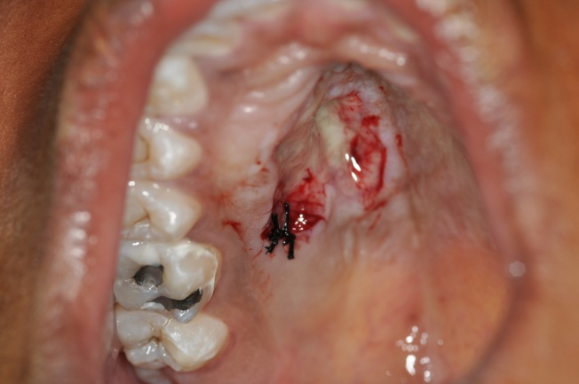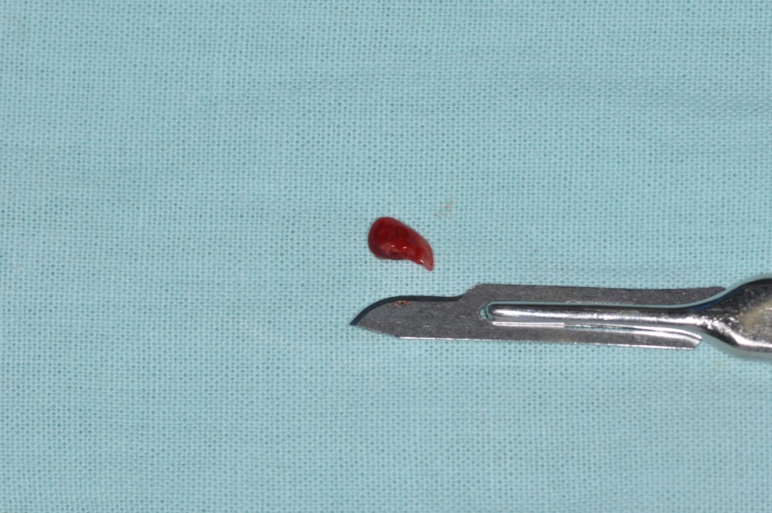

The slides were prepared using the hematoxylin-eosin (HE) staining technique, and the histopathological analysis revealed epithelial hyperplasia, inflammatory infiltrate, salivary duct metaplasia, and acinar necrosis, consistent with NS (Figures 6 and 7).

Figure 6. Histopathological examination revealing areas of squamous metaplasia and necrosis.

Figure 7. Histopathological examination revealing areas of ductal metaplasia and inflammatory infiltrate (macrophages and lymphocytes).

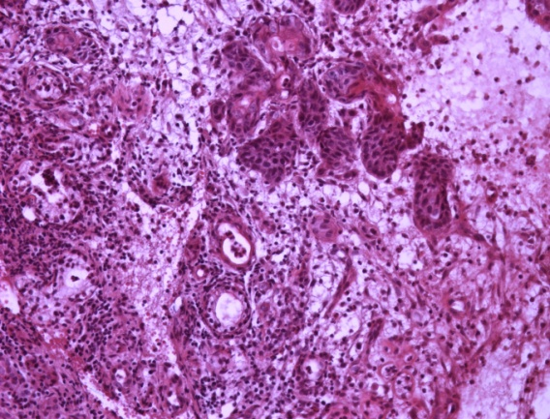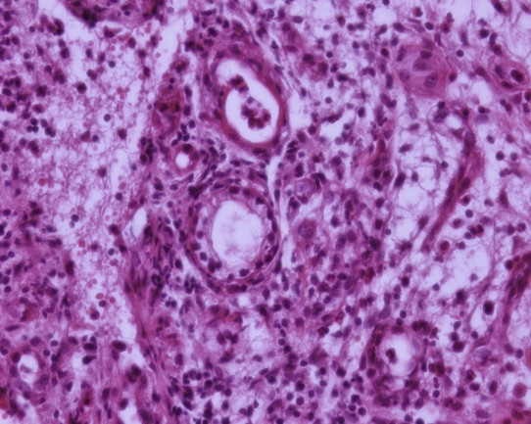

One week after the biopsy, the patient returned to the Stomatology Clinic for suture removal and lesion reassessment. She reported no pain, and significant regression of the lesion was observed. The patient was placed under follow-up, and after eight months of monitoring, complete regression of the lesion was noted (Figures 8, 9, 10, and 11).

Figure 9. 15 days after the biopsy.

Figure 8. One week after the biopsy.

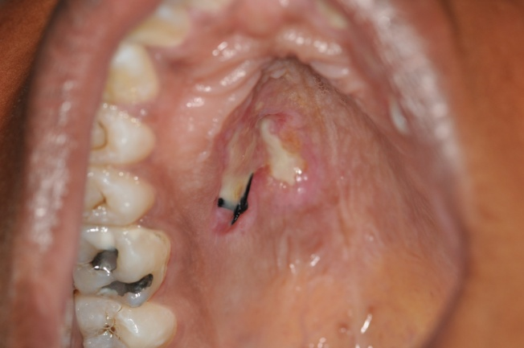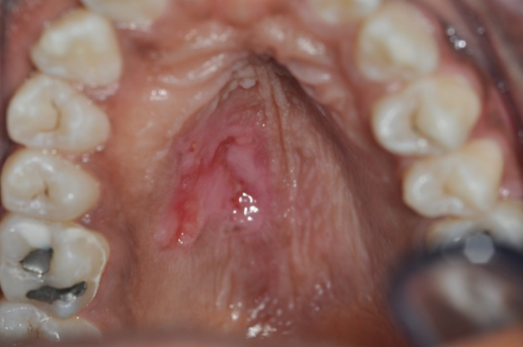

Figure 11. 8 months after the biopsy.

Figure 10. 3 months after the biopsy.

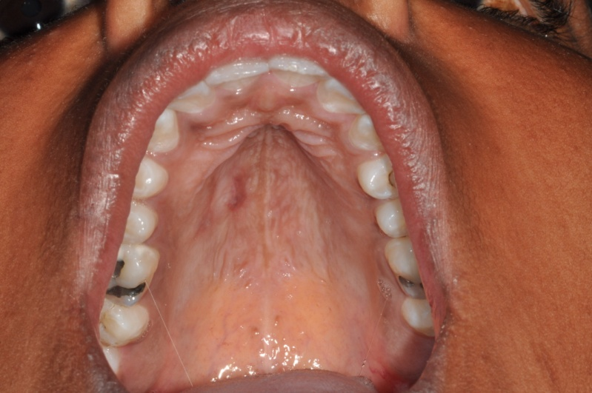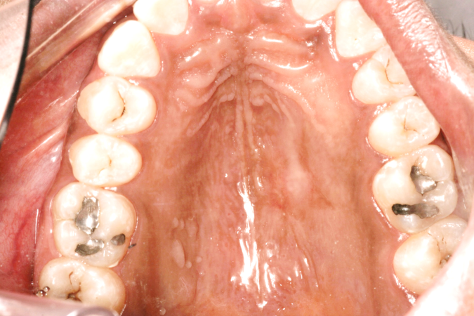

**3 Discussion**

Necrotizing sialometaplasia (NS) is an uncommon pathology with no proven etiology. However, most case reports in the literature associate the lesion's development with reduced oxygenation of the affected tissue. The most commonly affected site is the minor salivary glands of the hard palate, likely because this region consists of thin and poorly vascularized tissue, making it more susceptible to cellular necrosis compared to other affected areas (Consolaro et al., 2009; Neville et al., 2009).

A detailed medical history often allows identification of the etiological factor associated with lesion development. In the present case report, since there were no other risk factors (such as smoking or prior surgeries) and the lesion coincided with the installation of a palatal expander, other causal factors were ruled out, excluding possible malignancy. The only differential diagnosis besides NS was eosinophilic ulcer, another benign, uncommon, self-limiting ulcerated lesion with raised borders. However, it primarily affects the tongue. Histopathological examination differentiates eosinophilic ulcer from NS by the presence of an inflammatory infiltrate rich in eosinophils and the absence of cellular metaplasia (Câmara et al., 2014).

Regarding NS associated with orthodontic appliances, Consolaro et al. (2009) emphasize the importance of understanding the type of palate in each patient and the trajectory of the palatine arteries when planning palatal expansion with dentomucosal-supported appliances. Since NS is occasionally observed in orthodontic practice, it can be considered iatrogenic. A review of the literature found only two cases of NS associated with a palatal expander; however, the authors did not perform biopsies to establish a histopathological diagnosis (Consolaro et al., 2009). Thus, the present case is the first histopathologically confirmed report of NS associated with a palatal expander.

Although the etiology of NS is unproven, several predisposing factors have been suggested, including traumatic lesions, ill-fitting prostheses, anesthetic injections with vasoconstrictors, upper respiratory tract infections, adjacent tumors, ingestion of hard foods, prior surgeries, and other factors that may compress the arteries supplying the affected area (Neville et al., 2009). In a case reported by Uppal & Baliga (2014), NS may have been caused by reduced oxygenation of the palate, either due to smoking or the injection of a vasoconstrictor-containing anesthetic during tooth extraction. Interestingly, a case of NS was also described in a patient with anorexia who experienced acute palatal pain after chewing ice. The authors suggested that NS in this case may have been related to anorexia or vascular compression from ice application (Gilowsky et al., 2014). This can be explained by the fact that intraoral pH is reduced in patients with eating disorders, disrupting oral microbiota and contributing to chemical, physical, and biological risk factors. Additionally, ice chewing results in blood vessel constriction, reinforcing the ischemic etiology of NS (Gilowsky et al., 2014). Recent studies also associate lesion development with chemical irritation from stomach acid, as described by Janner et al. (2014) in a case of NS in a smoking patient with acute-phase bulimia. In this case, the predisposing factor was thought to be either local blood supply impairment or irritation weakening mucosal defense mechanisms. The traumatic event, therefore, was chemical in nature and exacerbated by irritants such as smoking and induced vomiting.

Consolaro et al. (2009) described symptoms of NS, including pain, fever, burning sensation, and paresthesia, though these may not always be present simultaneously. In the present case, the patient only reported pain and burning while eating. The sudden onset and aggressive nature of the lesion may cause anxiety, as patients may fear a possible cancer diagnosis. Clinicians may also suspect malignancy based on the anamnesis and clinical examination. It is important to ask the patient about pain, as malignant lesions are typically painless, although NS can also be painless in its ulcerated form (Uppal & Baliga, 2014).

Differential diagnoses of NS include malignant lesions, particularly when the patient has risk factors such as smoking and alcohol consumption. Additionally, Daniell et al. (2006) noted that, clinically, NS resembles endophytic squamous cell carcinoma (SCC) due to its ulcerated lesion with raised borders and necrotic areas. Uppal & Baliga (2014) reported a case of NS mimicking oral cancer, with a palatal ulcer similar to the present case. However, in that case, the patient was male, over 60 years old, and had tobacco and alcohol use history. Despite this, the lesion regressed spontaneously, and histopathological examination confirmed NS, as observed in the present case.

Another differential diagnosis for NS mentioned in the literature is mucoepidermoid carcinoma (MEC), as it affects tissues containing salivary glands and may present as a superficial ulceration with paresthesia (Santos et al., 2012; Tinoco et al., 2009).

NS typically begins as a swelling that rapidly and aggressively leads to epithelial tissue necrosis, which detaches and forms an ulcer. This aligns with the present case, where the ulcer developed within 15 days. The lesion size varies widely, ranging from less than 1 cm to 5 cm in diameter (Neville et al., 2009). In this case, the ulcer measured 2 cm in diameter. According to Neville et al. (2009), underlying palatal bone destruction is rare in NS, with no radiographic alterations observed, which was also noted in the present case.

Histopathologically, diagnosing NS may be challenging for less experienced pathologists, as acinar cells exhibit a high degree of differentiation, potentially leading to a misdiagnosis of malignancy. What confirms NS and rules out malignancy is the preservation of the lobular architecture of the affected glands, as well as the mild cytological appearance of squamous proliferation. The lesion also presents an inflammatory infiltrate, mainly consisting of macrophages and lymphocytes, with possible mucin release (Neville et al., 2009). Therefore, a biopsy is essential to confirm the diagnosis.

NS is a self-limiting pathology that resolves spontaneously without causing tissue sequelae, with excellent healing outcomes (Consolaro et al., 2009). This was confirmed in the present case, as the lesion completely regressed without treatment and left no scarring.

Studies have shown that NS regression time ranges from one to ten weeks (Neville et al., 2009; Henrich & Silva, 2009; Ravn et al., 2009; Rebellato Júnior, 2003). However, in this case, the ulcer regressed within two to twelve weeks, with only an erythematous area remaining, which disappeared after eight months.

NS does not require lesion-specific treatment, as it resolves spontaneously within a few weeks. However, palliative treatment with analgesics and anti-inflammatory medications is recommended for symptom relief, and antibiotics may be used to prevent opportunistic infections (Consolaro et al., 2009). In this case, only an analgesic and oral antiseptic were prescribed postoperatively.

Despite being rare, NS should be considered in the differential diagnosis of ulcerative lesions on the palate. A thorough clinical examination and biopsy are essential for accurate diagnosis and proper management.

**4 Conclusion**

The clinical and histopathological diagnosis of SN is challenging due to its rarity and its similarities to malignant lesions. Therefore, a biopsy should be performed before any treatment. Once the diagnosis is confirmed, the only approach is follow-up.

SN can be induced by the pressure of the palatal expander and should be considered during orthodontic planning.

**COMPETING INTERESTS DISCLAIMER:**

Authors have declared that they have no known competing financial interests OR non-financial interests OR personal relationships that could have appeared to influence the work reported in this paper.

**REFERENCES**

**Abdalla-Aslan R, Frid H, Totri A, Akrish S, Merhav G, Rachmiel A. Necrotizing sialometaplasia of the palate in a young bodybuilder with anabolic androgenic steroids abuse. Quintessence Int. 2020;51(6):496-501. doi:10.3290/j.qi.a44146**

**ABRAMS, A. M.; MELROSE, R. J.; HOWELL, F. V. Necrotizing sialometaplasia: a disease simulating malignancy. Cancer, vol. 32, no. 1, p. 130-35, 1973.**

**CÂMARA, P. R. et al. Eosinophilic ulcer: report of two clinical cases. XXI Jornada Mineira de Estomatologia, Universidade Vale do Rio Verde, August 2014. Oral presentation of a clinical case.**

**CONSOLARO, A. et al. Necrotic lesions in palatal disjunction: explanation and prevention. Dental Press Orthodontics and Facial Orthopedics Journal, v. 14, n. 5, p. 20-26, 2009.**

**DANIELL, F. I. et al. Squamous cell carcinoma in the lower alveolar ridge: diagnosis and supportive dental treatment. Brazilian Journal of Pathology and Laboratory Medicine – On-line version, v. 42, n. 4, 2006.**

**FEMOPASE, F. L. et al. Necrotizing sialometaplasia: Presentation of five clinical cases. Oral Medicine and Pathology, v. 9, p. 304-8, 2004.**

**GILOWSKI, L. et al. Necrotizing sialometaplasia of the palatal mucosa inpatient with history of anorexia: Review and case report. American Journal of Otolaryngology – Head and Neck Medicine and Surgery, v. 35, p. 400-401, 2014.**

**HENRICH, D.; SILVA, J. T. Non-neoplastic salivary gland lesions: analysis of cases evaluated by the histopathological diagnosis service of oral lesions at UNIVALI. Itajaí: Universidade do Vale do Itajaí, 2009. 32 p. Final Course Work, Dentistry Course, Center of Health Sciences, Universidade do Vale do Itajaí, Itajaí, 2009.**

**JANNER, S. F. M. et al. Bilateral necrotizing sialometaplasia of the hard palate in a patient with bulimia: A case report and review of the literature. Quintessence International, vol. 45, no. 5, p. 431-37, 2014.**

**KRISHNA, R.; BK, R. Necrotizing sialometaplasia of palate: a case report. Imaging Sci. Dent., v. 41, no. 1, p. 35-8, 2011.**

**LIMA, M. A. et al. Cystic form of necrotizing sialometaplasia in the sublingual salivary gland. Brazilian Journal of Otorhinolaryngology, v. 68, no. 2, 276-9, 2002.**

**MADALA, J. et al. Necrotizingsialometaplasia: the diagnosisdilemma. OHDM, vol. 13, no. 3, 687-89, 2014.**

**Medeiros MRS, Barros CCDS, Miguel MCDC, da Silveira ÉJD, de Oliveira PT. Necrotizing sialometaplasia: A report of two cases and review of the literature. Stomatology. 2022;24(2):56-60.**

**NEVILLE, B.W.; DAMM, D.D.; ALLEN, C.M.; BOUQUOT, J.E. Oral and Maxillofacial Pathology. Trad.3rd Ed., Rio de Janeiro: Elsevier, 2009, 972p.**

**RAVN, R. et al. Adenosquamous carcinoma of the larynx associated with necrotizing sialometaplasia: A diagnostic challenge. AurisNasusLarynx, v. 36, p. 721-24, 2009.**

**REBELLATO JUNIOR, V. Microscopic analysis of necrotizing sialometaplasia and presentation of a hypothesis about its etiopathogenic relationships, especially with palatal expansion devices. Bauru: University of São Paulo, 2003. 134 p. Master's Dissertation, Postgraduate Course, Bauru School of Dentistry, University of São Paulo, Bauru, 2003.**

**SANTOS, T. et al. Mucoepidermoid carcinoma of the palate, case report. Rev. Port. Stomatol. Med. Dent. Cir. Maxilofac., v. 53, p. 29-33, 2012.**

**TINOCO, P. et al. Mucoepidermoid carcinoma of minor salivary glands.Arq. Int. Otorhinolaryngol., v.15, n.1, p. 99-101, 2011.**

**UPPAL, N.; BALIGA, M. Necrotizing sialometaplasia: A rare lesion that mimics oral cancer clinically and histopathologically. OtolaryngologiaPolska, v. 68, p. 154-56, 2014.**