**Evaluation of Profitability in Chinese Snack Food Enterprises: A DuPont Empirical Analysis**

**ABSTRACT**

With the improvement in Chinese residents' consumption capacity and the leisure food market's scale surpassing one trillion yuan, the industry has shown rapid growth. However, domestic companies still face challenges in areas such as brand influence, technological research and development, and management experience. This paper takes Three Squirrels, Bestore, and YanJin Shop as research subjects and systematically evaluates the differences in profitability and their driving factors from 2019 to 2023 using the DuPont analysis method. The net return on equity (ROE) is decomposed into net profit margin, total asset turnover, and equity multiplier. The study finds that YanJin Shop, by optimizing cost control and adopting a differentiated product strategy, increased its ROE from 17.93% in 2019 to 39.34% in 2023, demonstrating strong profit potential. Bestore, due to intensified market competition and cost pressures, saw its ROE decrease continuously from 27.02% to 7.32%, highlighting the sustainability risks of its profit model. Three Squirrels' ROE exhibited cyclical fluctuations, with a decline in asset turnover efficiency and tighter financial leverage causing its ROE to drop sharply to 5.61% in 2022. However, its capital structure stability improved. Further analysis indicates that the differences in corporate profitability stem from variations in market positioning, asset operation efficiency, and financial leverage strategies. Based on this, this paper suggests constructing a differentiated product structure, expanding diverse consumption scenarios, strengthening multi-channel synergies, and innovating marketing strategies to help companies balance financial risks and growth needs, thereby enhancing industry competitiveness. This study provides theoretical and empirical evidence for leisure food companies to optimize their profit models and achieve sustainable development.

***Keywords:*** Snack Foods; DuPont Analysis; Profitability; Chain Substitution Method; Enterprise Evaluation

**1 Introduction**

With the steady improvement of China's economic level and the rapid development of the tourism industry, residents' purchasing power has significantly increased, leading to a continuous growth in demand for snack foods. Snack foods, characterized by their convenience, speed, and delicious taste, have gradually become an essential part of daily consumption. From nuts and puffed foods to baked pastries and functional snacks, the variety of products on the market has been expanding, catering to the personalized needs of different consumers. According to China Casual Snacks Market Report, the annual demand of China's casual food market has exceeded one trillion yuan in recent years, and the market size is growing in geometric progression. The average annual growth rate of the consumer market has reached approximately 25%, demonstrating strong growth potential. Although China's snack food industry has developed rapidly, with many market participants, domestic enterprises still lag behind international brands in terms of brand influence, technological research and development, and management experience. The industry as a whole has a relatively short history and weaker competitive strength, with homogeneous competition among enterprises being a common phenomenon. With the rise of trends toward healthier, functional, and personalized consumption, market potential has been further stimulated. If domestic enterprises can seize this strategic opportunity by deeply understanding market demand, optimizing product structures, and enhancing operational efficiency, they are likely to achieve rapid development and breakthrough progress.

The profit model is not only the key to gaining a competitive advantage but also the foundation for a company's survival and development. (Delmar et al., 2013) argued that a company's profitability serves as the driving force for continuous growth, while sustained growth, in turn, enhances its profitability. (Ball et al., 2015) found that profitability can be analyzed through business operations, investment, and financing, and that these factors can be used to predict a company's future profitability. (Kim, 2016) applied the DuPont analysis method to measure the ratio of ROE to ROA and presented its cyclical variations in tabular form. The study found that profitability can be comprehensively analyzed using ROE and ROI indicators, as this method considers the impact of operational investment and financial leverage on profitability. (Wu et al., 2021) found that a company's profitability has a positive impact on corporate social responsibility, and the extent to which a company fulfills its social responsibilities can, to some extent, reflect its profitability.

Currently, Chinese scholars primarily focus on two main directions in the study of corporate profitability analysis: On the one hand, research based on factor analysis and hierarchical analysis methods. For instance, (Zhu, 2021) evaluated the profitability of Company D using factor analysis, while (Shao, 2023) applied the same method to study the profitability of logistics enterprises. In contrast, (Chen, 2019) and other scholars employed hierarchical analysis to assess the profitability of internet-listed companies operating under an asset-light model and shared bicycle enterprises. On the other hand, research based on the DuPont analysis method is also widely conducted. (Gao, 2020) proposed incorporating targeted financial indicators into the DuPont analysis framework to evaluate corporate development capabilities. Additionally, the inclusion of cash flow indicators enhances the dynamism of financial analysis, thereby improving its comprehensiveness and scientific rigor. (Wang, 2020) further suggested incorporating the sustainable growth rate and cash flow indicators into the analytical framework to enhance the rationality and systematic nature of financial analysis. These studies provide a theoretical foundation and methodological support for the multidimensional evaluation of corporate profitability, highlighting the advantages and characteristics of different analytical approaches in practical applications.

Based on this, this study selects Three Squirrels, Bestore, and YanJin Shop as research subjects and systematically analyzes the components of their profit models from 2019 to 2023. The study utilizes financial data and relevant business information, combined with the DuPont analysis method, to compare the profitability of the three companies by examining key indicators such as return on equity (ROE), profit margin (PM), asset turnover ratio (ATO), and equity multiplier (EM). Additionally, by considering the current state and development trends of the snack food industry, this study explores the strengths and weaknesses of these enterprises in market competition, providing insights for industry development.

**2 Research Foundation**

**2.1 Research methodology**

DuPont Analysis is a comprehensive financial analysis tool that was first introduced by DuPont Corporation in the early 20th century.(Hu et al., 2024) This method systematically breaks down a company's financial performance, helping analysts gain a deeper understanding of the interrelationships between profitability, operational efficiency, and financial leverage. As a result, it provides a more comprehensive assessment of financial health for company management, investors, and other stakeholders. DuPont Analysis does not focus solely on a single financial ratio; instead, it integrates multiple financial indicators to reveal a more detailed picture of financial performance. Specifically, DuPont Analysis deconstructs Return on Equity (ROE), allowing management to clearly identify how various factors influence a company’s overall profitability. ROE is a key indicator of shareholder investment returns, making it highly significant for investors and shareholders. DuPont Analysis breaks ROE down into three main components: net profit margin, total asset turnover, and the equity multiplier. These components represent a company's profitability, asset utilization efficiency, and the leverage effect of its capital structure, respectively. By deconstructing ROE in this way, DuPont Analysis not only helps analysts assess a company’s financial condition but also provides guidance on improving performance in each aspect to enhance overall financial performance. The formula for DuPont Analysis is as follows:

（1）Core Formula:

The core of DuPont analysis is the Return on Equity (ROE) decomposition formula:

$$\begin{aligned}ROE=\text{Net Profit Margin}×\text{Total Asset Turnover}×\text{Equity Multiplier}\#（1）\end{aligned}$$

（2）Net Profit Margin

Reflects the company's ability to generate profit from its sales activities, representing profitability:

$$\begin{aligned}\text{Net Profit Margin}=\frac{NetProfit}{\text{Sales Revenue}}\#（2）\end{aligned}$$

（3）Total Asset Turnover

Measures the efficiency of asset use, indicating how much sales revenue is generated from each unit of assets:

$$\begin{aligned}\text{Total Asset Turnover}=\frac{\text{Sales Revenue}}{\text{Total Assets}}\#（3）\end{aligned}$$

1. Equity Multiplier

Reflects the financial leverage of the company, showing the magnifying effect of assets on equity:

$$\begin{aligned}\text{Equity Multiplier}=\frac{\text{Total Assets}}{\text{Owner's Equity}}\#（4）\end{aligned}$$

The framework of DuPont Analysis can be summarized in the following aspects. the core of the DuPont Analysis system is Return on Equity (ROE), which serves as the most comprehensive financial analysis indicator. Operating net profit margin is one of the key indicators of a company’s profitability, referring to the ratio of net profit to operating revenue, which directly reflects how much net profit can be generated from each unit of operating revenue. Generally, the higher the operating net profit margin, the stronger the company’s profitability, indicating superior cost control and business model; conversely, it suggests that the company may face higher costs, sales strategy adjustments, or market competition pressures during its operations. Total asset turnover is an important indicator for measuring the relationship between a company’s asset investment scale and sales level, typically referring to the ratio of net sales revenue to average total assets over a certain period. In short, this indicator reflects the turnover of a company’s total assets, i.e., the efficiency with which the company utilizes its total assets for business activities. Generally, the higher the total asset turnover, the higher the company’s asset utilization efficiency and the faster the capital turnover. This means that the company can more effectively use existing assets for production and operations, thereby creating greater value. Therefore, this indicator holds significant reference value in corporate operations management. The equity multiplier, also known as the capital multiplier or equity-to-total-assets ratio, is the ratio between a company’s total assets and total shareholders' equity. This indicator is used to measure the proportion of a company’s total assets that is financed by shareholders' equity, while also reflecting the degree to which the company’s assets depend on equity. In other words, the equity multiplier represents how many times the company’s total assets are relative to its equity, reflecting the company’s financial leverage effect. Typically, the larger the equity multiplier, the lower the proportion of shareholders’ equity in total assets, and the higher the debt level. This means the company uses less equity to support a larger operational scale, demonstrating significant financial leverage. Moderate financial leverage can help a company expand its scale and improve profitability, but excessive leverage can lead to greater financial risk and increased debt repayment pressure. Therefore, when formulating capital structure and financing strategies, a company must strike a balance between returns and risks. The financial indicator relationships in DuPont Analysis are illustrated in Figure 1.

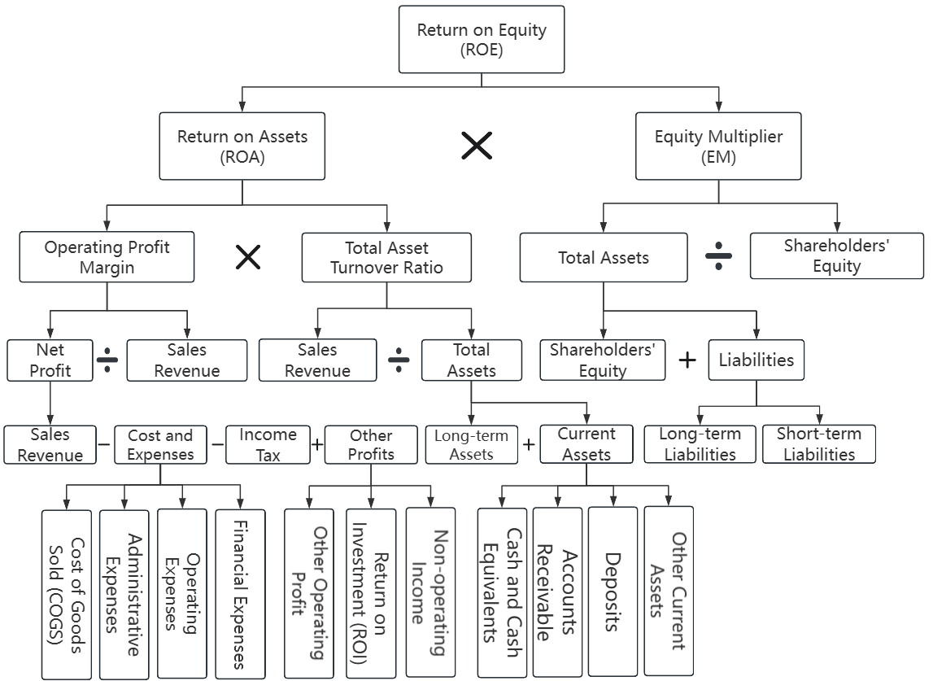

**Fig.1. DuPont Financial Analysis Chart**

Source: Compiled by authors

**2.2.Research Data**

This study selects Three Squirrels, Bestore, and YanJin Shop as research subjects, aiming to conduct an in-depth analysis of their operational performance and profit models. These three companies have held significant market shares and brand influence in the snack industry in recent years, making them highly representative and valuable for research. To ensure objectivity and accuracy, this research relies on data from the annual reports of these companies, sourced from the Oriental Wealth website. These reports provide comprehensive insights into financial data, operational status, and market strategies, making them authoritative and highly valuable as references. The study covers the period from 2019 to 2023, a timeframe that includes industry fluctuations and corporate strategic adjustments. This comprehensive perspective helps reveal the evolution and development of corporate profit models.

**3 Research Analysis**

**3.1 Overall Analysis**

The Return on Equity (ROE) of Three Squirrels remained relatively stable from 2019 to 2021 (15.88%, 15.1%, and 18.88%, respectively). However, it experienced a sharp decline to 5.61% in 2022, followed by a slight recovery to 9.05% in 2023, indicating periodic fluctuations in profitability. The ROE of Bestore exhibited a continuous downward trend, declining from 27.02% in 2019 to 7.32% in 2023, suggesting a gradual weakening of profitability, possibly due to market competition and cost pressures. The ROE of YanJin Shop exhibited significant fluctuations. It stood at 17.93% in 2019, surged to 29.44% in 2020, then declined to 17.65% in 2021. However, it rebounded sharply to 29.72% in 2022 and further increased to 39.34% in 2023, demonstrating strong profitability and growth potential. These differences reflect variations in market positioning, operational strategies, and cost control among these companies. The specific details are presented in Table 1.

**Table 1. Comparison of Return on Equity (ROE) Indicators Among Industry Peers**

|  |  |  |  |  |  |
| --- | --- | --- | --- | --- | --- |
|  | 2019 | 2020 | 2021 | 2022 | 2023 |
| Three Squirrels | 15.88 | 15.1 | 18.88 | 5.61 | 9.05 |
| Bestore | 27.02 | 19.39 | 13.34 | 14.66 | 7.32 |
| YanJin Shop | 17.93 | 29.44 | 17.65 | 29.72 | 39.34 |

Source: Compiled by authors

**3.2 Three Squirrels**

As shown in Figure 2, from 2019 to 2023, Three Squirrels' operating net profit margin, total asset turnover, and equity multiplier exhibited certain fluctuations, reflecting changes in the company’s profitability, asset utilization efficiency, and capital structure management. Specifically, Three Squirrels' operating net profit margin increased from 2.35% in 2019 to 4.21% in 2024, and then decreased to 3.09% in 2023. This change reflects the profitability fluctuations Three Squirrels has faced in recent years, with the significant decline in operating net profit margin likely linked to increased market competition, rising raw material costs, and adjustments in the company's sales strategy. Specifically, the significant reduction in operating costs was offset by the increase in sales expenses, leading to only a minor change in total costs. However, due to the intensifying industry competition, Three Squirrels' operating revenue experienced a slight decline, particularly in its online channels, where customer acquisition costs rose sharply. The steady changes in revenue were partially attributed to the increase in non-operating income and investment returns, indicating that the company is compensating for the decline in its core business through non-core operations, which further exposes Three Squirrels’ growth bottleneck amid changes in the market environment. This bottleneck reflects that, under the dual pressures of increased competition and rising costs, the company’s adjustments to its business model have not yet resulted in significant breakthroughs(Wan et al., 2015).

Total asset turnover is an important indicator for measuring the efficiency of a company's asset utilization. Three Squirrels' total asset turnover was 2.56 times in 2019, and it declined year by year, reaching 1.41 times in 2023. The continued decline in total asset turnover indicates that the company is facing certain challenges in improving asset utilization efficiency. This decline may be related to the expansion of asset scale, but the growth in sales revenue has not kept pace, resulting in a decrease in asset utilization efficiency. Additionally, the decrease in accounts receivable turnover may be another reason for the decline in total asset turnover. As the company’s sales scale expands, especially with the increase in online business, the difficulty of managing accounts receivable has increased. Loosening credit sales policies may result in delays in collecting receivables, thus affecting the performance of total asset turnover. Return on assets (ROA) is directly influenced by both total asset turnover and operating net profit margin. In the above analysis, difficulties in inventory turnover have worsened the turnover speed of total assets, and the decline in inventory turnover further exacerbates Three Squirrels' brand reputation issues, while also increasing customer acquisition costs, which further impacts the company's profitability.

In terms of capital structure, Three Squirrels' equity multiplier decreased from 2.64 in 2019 to 2.1 in 2023, reflecting a gradual tightening of financial leverage and the stabilization of its capital structure. The decrease in the equity multiplier indicates that Three Squirrels has reduced its reliance on external debt, thereby lowering the risks associated with financial leverage. This change may be a result of the company realizing, after experiencing a more complex market environment, the financial risks and debt repayment pressures associated with excessive reliance on leverage. Therefore, the company has gradually adjusted its capital structure to enhance financial stability. However, although a lower equity multiplier has alleviated financial risks, it may also, to some extent, limit the company's expansion speed(Yang and Zhang, 2020). Reduced external debt financing may place pressure on the company's ability to acquire capital, especially in situations requiring rapid expansion. Finding a balance between stability and growth will be crucial for the company's future development.

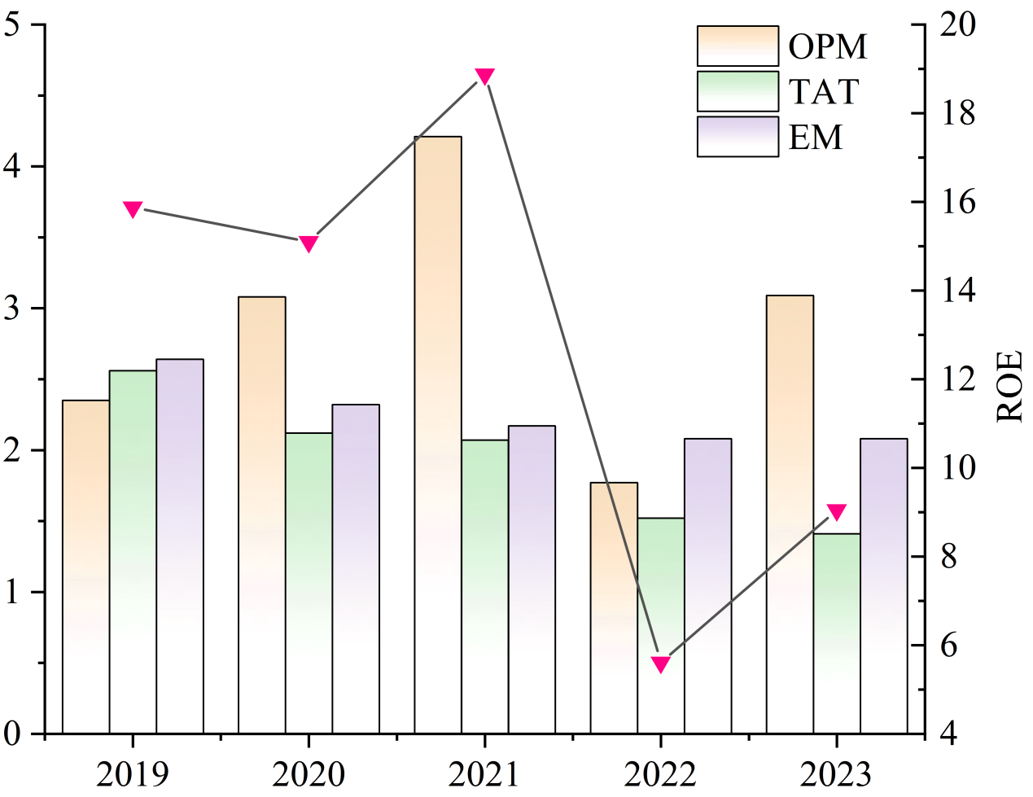

**Fig.2. Key Financial Indicators of Three Squirrels**

Source: Compiled by authors

**3.3 Bestore**

As shown in Figure 3, from 2019 to 2023, the operating net profit margin, total asset turnover, and equity multiplier of Bestore all showed a downward trend. Among these, the decrease in the equity multiplier was relatively small, while the declines in operating net profit margin and total asset turnover were more significant. Due to the combined effects of these three indicators, Bestore's return on equity (ROE) showed an overall downward trend during this period. Particularly in 2023, the ROE decreased by as much as 50% compared to 2022, mainly due to the decline in operating income and net profit. This change may be related to Bestore's adjustment of its business strategy in 2023. The company implemented a "high quality at affordable prices" pricing strategy, reducing the prices of over 300 products. While this helped improve market competitiveness, it also somewhat suppressed the growth of operating income. Additionally, from 2019 to 2023, the changes in Bestore's equity multiplier were minimal, indicating that its capital structure remained stable and it maintained a relatively good development momentum.

In terms of operating net profit margin, as shown in Figure 3, Bestore's operating net profit margin exhibited a continuous downward trend from 2019 to 2021, rebounded in 2022, but declined again in 2023. This indicates that the company's profitability has fluctuated in recent years and is generally on a downward trajectory. In contrast, Salted Fish Shop's operating net profit margin has shown a fluctuating upward trend over the past five years, indicating its stability and growth potential in terms of profitability. The further decline in Bestore's operating net profit margin in 2023 was mainly due to the reduction in operating income and the decline in net profit. Further analysis reveals that in 2023, Bestore implemented a large-scale price reduction strategy centered on the concept of "high quality at affordable prices," lowering the prices of over 300 products. This strategy has, to some extent, enhanced market competitiveness, attracted more consumers, and may have driven sales growth. However, the price reduction directly led to a decline in gross margin, thereby adversely affecting the company's overall profitability. While price reductions may stimulate short-term sales growth, without proper cost control and efficient operational management, the compression of profit margins will further exacerbate the decline in the company's profitability(Rahmandad, 2012). In addition, Bestore's operating costs are relatively high, further squeezing its profit margins, resulting in a greater impact on net profit and operating net profit margin. From a long-term development perspective, Bestore still has considerable room for improvement in optimizing supply chain management, implementing lean production models, and strengthening refined operational cost control. By further reducing procurement and production costs, improving operational efficiency, and enhancing the precision of marketing strategies, the company may improve profitability and strengthen market competitiveness. At the same time, a reasonable pricing strategy should align with brand value and market positioning to ensure a balance between profit and market share, thus promoting the company's sustainable growth(Sharma et al., 2010).

In terms of total asset turnover, as shown in Figure 3, Bestore’s total asset turnover rate continued to decline from 2019 to 2023, reaching its lowest value of 1.52 in 2023, whereas its industry peer, Salted Fish Shop, exhibited a continuously rising trend in total asset turnover. This comparison indicates that Bestore’s asset management capabilities and asset utilization efficiency are declining, suggesting that the company may be facing challenges in resource management and operational efficiency. The decline in total asset turnover may imply that the company has room for improvement in enhancing asset utilization efficiency, optimizing production and operational processes, and improving cash flow turnover. Further analysis reveals that one key factor affecting Bestore’s total asset turnover is the accounts receivable turnover rate. From 2019 to 2023, Bestore’s accounts receivable turnover rate showed an overall downward trend. This may indicate inefficiencies in the company’s collection process, longer customer payment cycles, or a relatively lenient credit sales policy, leading to a significant amount of capital being tied up in accounts receivable and not promptly converted into cash for reinvestment or operational use. This not only increases the company’s risk of bad debts but also, to some extent, limits its ability to use these funds for business expansion or operational improvements. From a long-term development perspective, Bestore needs to optimize asset management and improve capital turnover efficiency.

In terms of the equity multiplier, as shown in Figure 3, Bestore's equity multiplier reached its highest point in 2019, remained relatively stable with minor fluctuations from 2020 to 2022, and then declined to its lowest level in 2023, aligning with the values of two other companies in the same industry. This trend indicates that as a leading company in the snack food industry, Bestore has demonstrated a high level of foresight and financial stability in its financial management. In recent years, the company has deliberately controlled its financial leverage by reducing its asset-liability ratio to optimize its capital structure, a strategy that is directly reflected in the decline of its equity multiplier. From a financial management perspective, the decline in the equity multiplier indicates that the company is relying more on its own capital rather than external debt to support operations and expansion, thereby reducing the potential risks associated with financial leverage to some extent. While a lower equity multiplier may indicate reduced reliance on external financing, it may also constrain the company's expansion pace. Therefore, in managing its capital structure in the future, Bestore needs to balance stability and growth. It should maintain a reasonable level of financial leverage to mitigate financial risks while effectively utilizing appropriate external financing to enhance capital efficiency and drive sustainable development(Ng, 2018).

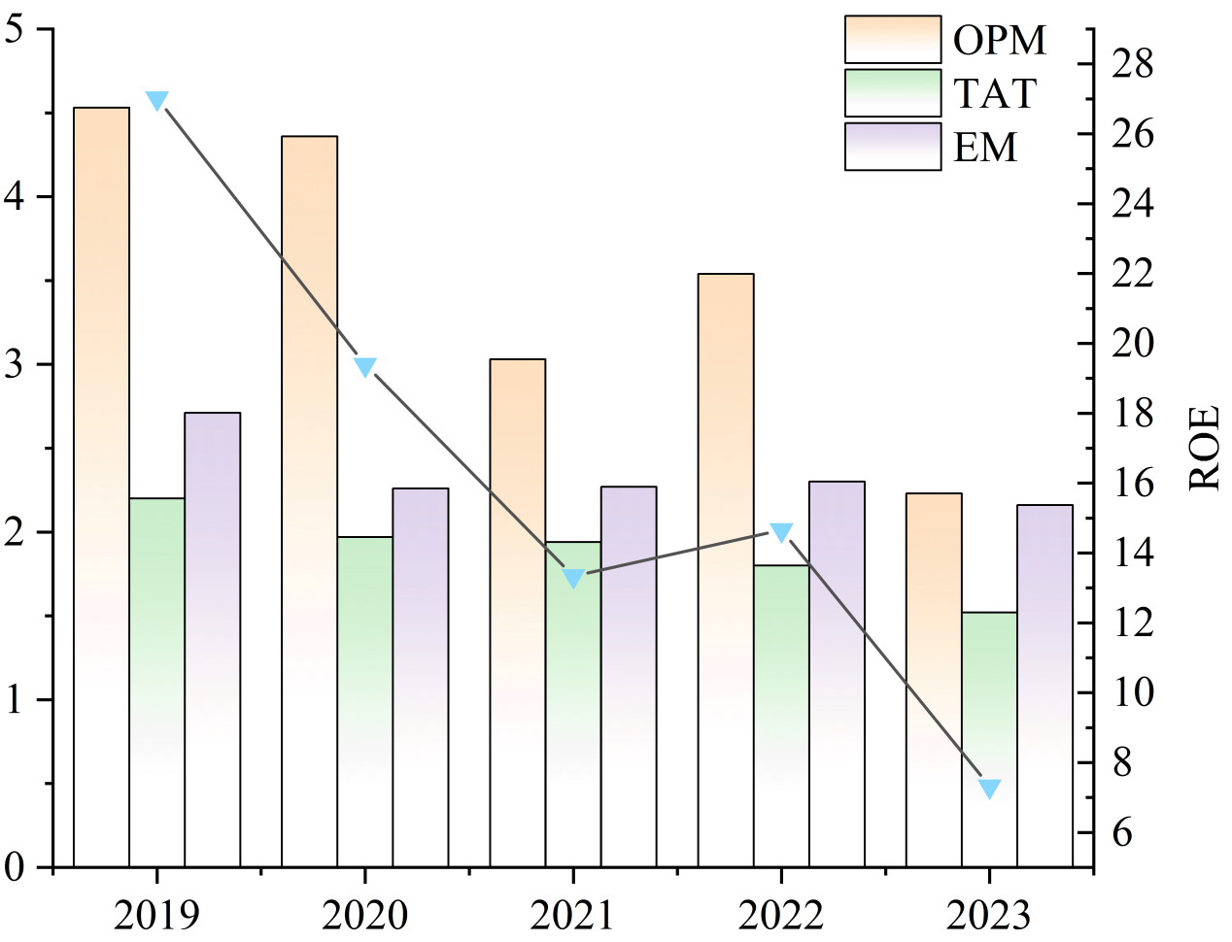

**Fig.3. Key Financial Indicators of Bestore**

Source: Compiled by authors

**3.4 YanJin Shop**

As shown in Figure 4, from 2019 to 2023, Yanjin Shop's operating net profit margin, total asset turnover ratio, and equity multiplier exhibited a steady upward trend, reflecting the company's positive performance in profitability, asset utilization efficiency, and capital structure optimization. Specifically, Yanjin Shop's operating net profit margin increased from 9.2% in 2019 to 12.47% in 2023. This growth trend indicates that Yanjin Shop has effectively enhanced its profitability over the past few years, particularly achieving significant success in cost control and profit model optimization. In particular, regarding sales strategy and product pricing, Yanjin Shop has effectively responded to industry competition pressure through precise market positioning and a differentiated product strategy, thereby improving its operating net profit margin.

In terms of total asset turnover, Yanjin Shop's ratio gradually increased from 0.99 in 2019 to 1.55 in 2023, demonstrating the company's active efforts to enhance asset utilization efficiency. The continuous increase in total asset turnover reflects Yanjin Shop’s gradual improvement in asset utilization efficiency through measures such as optimizing supply chain management, accelerating inventory turnover, and strengthening accounts receivable management. In particular, the optimization of its supply chain management has enabled Yanjin Shop to better respond to market demand fluctuations, effectively reduce inventory backlog, and further improve capital utilization efficiency.

In terms of capital structure, Yanjin Shop's equity multiplier increased from 1.98 in 2019 to 2.04 in 2023, indicating a growing reliance on external debt in its capital structure management. By leveraging financial leverage, Yanjin Shop has been able to expand its business scale and enhance profitability. However, as the equity multiplier rises, the company also faces greater financial risks, particularly in an environment of increasing market uncertainty. In the future, Yanjin Shop must strike a balance between leveraging financial debt and managing financial risk to ensure that expansion does not come at the cost of financial stability.

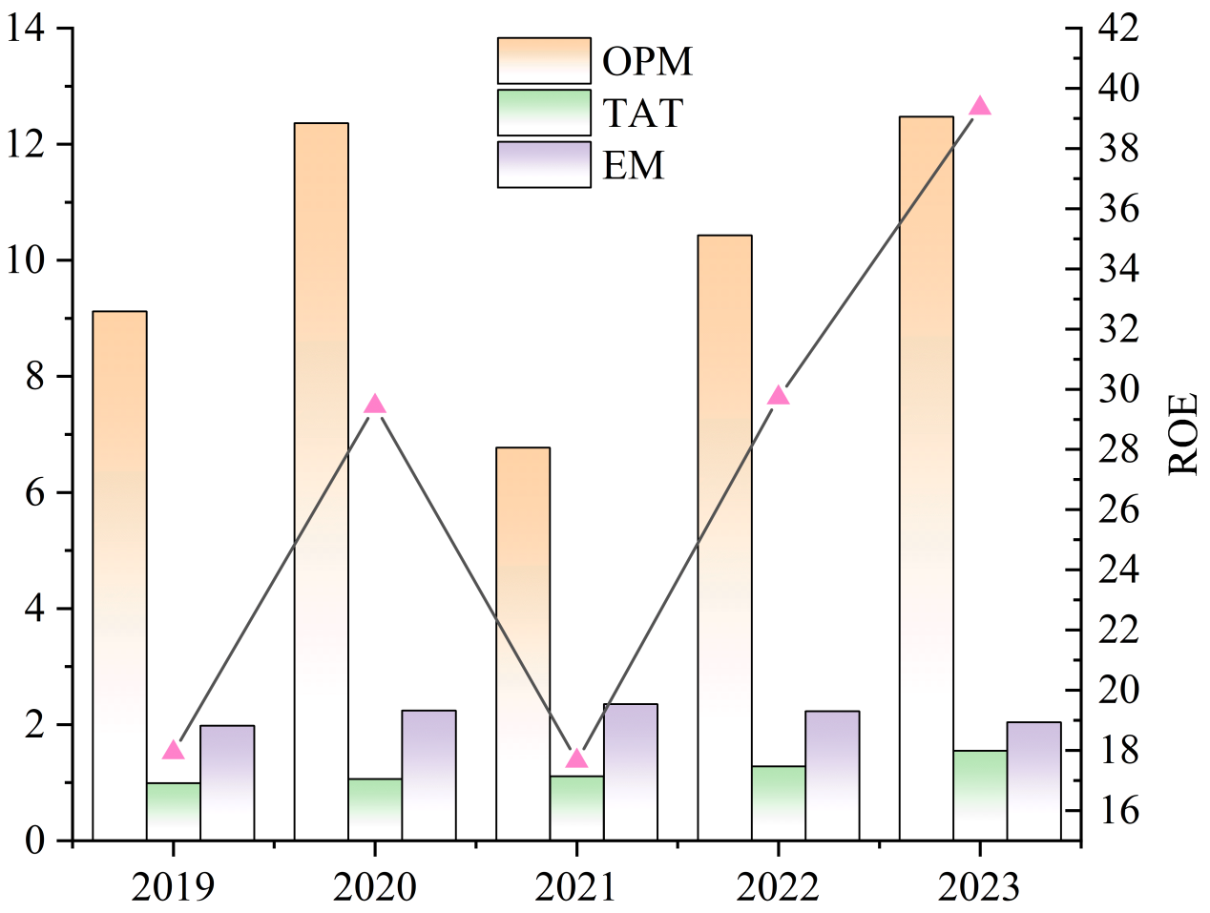

**Fig.4. Key Financial Indicators of YanJin Shop**

Source: Compiled by authors

**Analysis of Yanjin Shop’s Target Consumer Segments.** Yanjin Shop's primary target consumer segments consist of children and young adults, with different snack food production lines and marketing channels catering to distinct demographic groups. Specifically, the traditional specialty savory snack production line primarily targets young adults, whereas the leisure baking pastry production line is aimed at children, thereby expanding the scope of its target consumers. Previously, Yanjin Shop primarily adopted a supermarket-based sales model and maintained long-term cooperation with major retail chains, making frequent supermarket shoppers its key profit-generating customer base. **Analysis of Yanjin Shop’s Revenue Sources.** Yanjin Shop primarily relies on a supermarket-based sales model, maintaining long-term and stable cooperation with major domestic retail chains such as Yonghui Superstores, Carrefour, and Rainbow Department Store. The company supplies products to these retail giants and establishes dedicated display shelves within supermarkets to generate revenue through wholesale and retail sales. However, as the expansion potential of the supermarket model has become increasingly limited, Yanjin Shop is actively accelerating its transition toward an omnichannel sales approach that integrates both online and offline platforms. **Analysis of Yanjin Shop’s Profit Drivers.** Yanjin Shop's primary profit drivers are derived from three major production lines: the first focuses on traditional specialty savory snacks, the second on leisure baking pastries, and the third on spicy marinated snack products. Among these, traditional savory snacks, leisure pastries, and spicy marinated snacks constitute the core sources of the company's revenue. Furthermore, Yanjin Shop has capitalized on the rising popularity of fish tofu products by launching its sub-brand “31° Fresh,” specializing in the research, development, and production of deep-sea snack products, thereby further enhancing its revenue stream.

**4 Conclusions and Implications**

**4.1** **Conclusions**

This study systematically analyzes the profitability of three Chinese snack food companies—Three Squirrels, Bestore, and YanJin Shop—using the DuPont analysis method. By deconstructing the return on equity (ROE) and its influencing factors from 2019 to 2023, the study finds that different business models, market positioning, and operational strategies directly impact financial performance. First, YanJin Shop achieved significant ROE growth over five years, increasing from 17.93% in 2019 to 39.34% in 2023, driven by excellent cost control and a differentiated product strategy. The improvement in profitability is primarily attributed to optimized supply chain management, enhanced asset utilization efficiency, and precise market positioning. The company has demonstrated strong profit potential in the snack food industry and continues to expand its market share. Second, Bestore’s ROE showed a continuous decline, dropping from 27.02% in 2019 to 7.32% in 2023. The analysis indicates that the decline in profitability was mainly due to intensified market competition, rising sales costs, and sustainability risks associated with its profit model. Although the company adopted pricing adjustments to attract consumers, the decline in gross profit margin further squeezed profit margins. Additionally, the decline in total asset turnover suggests that the company needs to improve asset utilization efficiency and cash flow recovery speed. Three Squirrels' ROE was significantly affected by cyclical market fluctuations, dropping to 5.61% in 2022 before rebounding to 9.05% in 2023. The volatility in profitability was mainly due to a decline in asset turnover efficiency and adjustments in financial leverage. Although the company has strengthened capital structure management and reduced financial leverage risks in recent years, intensified market competition and rising operating costs continue to challenge its profitability.

Overall, the differences in profitability among the three companies stem from variations in market positioning, asset operation efficiency, and financial leverage strategies. The findings of this study suggest that key factors for enhancing profitability include optimizing cost management, strengthening product differentiation, improving asset utilization efficiency, and appropriately allocating financial leverage. In the future, snack food companies should adjust their business strategies based on market trends, leverage new retail models to enhance brand competitiveness, and seek sustainable development paths in an increasingly competitive environment.

**4.2 Implications**

**(1) Constructing a Differentiated Product Structure Based on the New Retail Business Model**

Analyzing the profit models of Bestore and Yanjin Shop clearly reveals that the new retail business model demonstrates significant vitality and innovation potential in today's market environment. Online sales channels have become a crucial marketing avenue in the snack food industry. As a comprehensive omnichannel strategy, the new retail model not only focuses on the development of online platforms but also emphasizes the meticulous planning and optimization of offline store layouts. This model achieves a seamless integration of online and offline channels, offering consumers a more convenient and personalized shopping experience. Against this backdrop, snack food enterprises should continuously refine their marketing strategies, deeply analyze consumer demand patterns in the digital age, and develop a differentiated product portfolio tailored to diverse consumer segments. Through precise market segmentation, enterprises can offer products that cater to various age groups and consumption levels while implementing personalized innovations in product design and service models(Padual et al., 2024). This approach strengthens consumer engagement and loyalty. Establishing a differentiated product structure not only enables enterprises to stand out in a highly competitive market but also enhances their operational efficiency and overall market competitiveness. Furthermore, snack food enterprises should actively promote an omnichannel sales model that integrates online and offline platforms. By leveraging data-driven precision marketing and optimized supply chain management, companies can enhance customer satisfaction and shopping experiences. This model allows businesses to effectively respond to market demand fluctuations, improve resource allocation efficiency, and drive sustainable growth and long-term competitiveness(Hsieh and Chou, 2018). Therefore, constructing a differentiated product structure within the framework of the new retail business model is not only a key strategy for improving business performance but also serves as a critical foundation for securing long-term competitive advantages in an increasingly competitive market.

1. **Constructing Diversified Consumption Scenarios Based on Differences in Profit Target Demands**

Different enterprises adopt differentiated market engagement strategies based on the specific demand characteristics of their profit targets, thereby optimizing resource allocation and facilitating market expansion. Bestore precisely targets young consumers who frequently shop online, attracting its target audience through online campaigns and digital marketing strategies while leveraging social media platforms and e-commerce channels for product promotion. In contrast, Yanjin Shop focuses on a broader consumer group that primarily engages in offline shopping. Its marketing efforts are predominantly offline, aiming to enhance in-store consumer experiences and expand the target audience across different age groups. Both marketing models have achieved remarkable success within their respective profit frameworks. The key reason lies in their ability to construct consumption scenarios that closely align with consumer needs and expectations, thereby effectively meeting actual consumer demands in specific purchasing environments. Therefore, snack food enterprises should actively explore and develop diversified consumption scenarios to better cater to the varied needs of different consumer segments. By designing rich and engaging consumption scenarios, enterprises can offer consumers a personalized and immersive shopping experience, thereby strengthening brand competitiveness and customer loyalty. Specifically, enterprises should integrate online platforms such as WeChat Mini Programs and shopping apps with offline channels such as community stores and regional flagship stores to achieve a seamless online-offline synergy that meets consumer needs across various consumption scenarios. Additionally, enterprises can conduct in-depth analyses of consumer shopping behaviors and preferences to offer customized products and services tailored to different consumer groups, ultimately enhancing overall customer satisfaction and brand loyalty(Theodorakopoulos and Theodoropoulou, 2024). As the market environment continues to evolve, enterprises must consistently innovate their consumption scenarios and adapt their marketing strategies flexibly to develop a more diversified market structure, thereby driving sustained business growth and expanding market share.

1. **Strengthening the Collaborative Effect of Multiple Stakeholders in Marketing Channel Construction**

Snack food enterprises should focus on strengthening the collaborative involvement of multiple stakeholders and constructing an effective marketing channel system aimed at achieving balanced development of both online and offline channels. First, in terms of physical store layout, enterprises should consider the ready-to-eat nature of snack foods, combining sensory experiences such as touch, vision, smell, and taste to optimize the in-store experience from multiple dimensions. This ensures that consumers receive a distinct, real-world shopping experience when visiting the store, motivating immediate consumption. Through this approach, enterprises can enhance consumers' immersion in the shopping experience, thereby increasing their purchase conversion rate. Secondly, enterprises should actively explore and promote the implementation of the innovative “community + delivery” sales model(Kantamaturapoj et al., 2022). In this model, enterprises can establish offline stores in communities and create convenient online shopping channels through online platforms, allowing consumers to place orders online directly at community stores for nearby delivery. This model not only utilizes community stores as inventory management centers to improve product turnover efficiency but also leverages the advantages of new media and social e-commerce, enabling enterprises to respond quickly to market demand and improve inventory turnover. Through diversified channel construction and effective resource integration, snack food enterprises can achieve the organic integration of online and offline businesses, enhancing consumer convenience and overall shopping experience, thereby standing out in a highly competitive market environment. At the same time, the construction of these collaborative marketing channels helps enterprises accelerate product circulation, improve operational efficiency, and thereby promote sustainable development.

**(4) Expanding Revenue Sources Using Modern Marketing Strategies**

One of the core strategies for enhancing a company’s profitability is to expand revenue sources. By adopting a multi-channel revenue model, the company can maintain a stable overall revenue level even if a specific income channel faces issues. In addition to traditional sales services, snack food enterprises should actively develop and offer derivative products and services. For instance, companies could develop merchandise based on the mascots and packaging designs of snack foods and offer these items as giveaways or promotional tools in marketing activities. This can attract consumer attention, especially during new product launches, where such derivatives can help drive more traffic and achieve more efficient marketing results. Moreover, with the rapid development of internet e-commerce, snack food enterprises should precisely grasp this trend and optimize their business layout on major e-commerce platforms. By expanding online marketing channels, they can further increase their revenue sources. Leveraging the traffic advantage of e-commerce platforms, enterprises can reach a broader consumer base, enhance brand exposure, and use platform data analytics to fine-tune marketing strategies, thereby maximizing revenue potential. By comprehensively utilizing modern marketing approaches, enterprises can not only diversify their revenue sources but also enhance market competitiveness and brand influence, leading to sustainable profit growth(Tang et al., 2024).

**DISCLAIMER (ARTIFICIAL INTELLIGENCE)**

The author(s)declare that only generative Al tools (e.g., GPT) were used for translation purposes. No generative Al technologies were employed in the writing or editing of the other content in this manuscript.

**COMPETING INTERESTS**

Authors have declared that no competing interests exist.

**COMPETING INTERESTS DISCLAIMER**

Authors have declared that they have no known competing financial interests OR non-financial interests OR personal relationships that could have appeared to influence the work reported in this paper.

**REFERENCES**

Ball, R., Gerakos, J., Linnainmaa, J.T., Nikolaev, V.V., 2015. Deflating profitability. Journal of Financial Economics 117, 225–248. https://doi.org/10.1016/j.jfineco.2015.02.004

Chen X., 2019. Profitability Analysis of Internet-Listed Companies under the Asset-Light Model. Communication of Finance and Accounting 58–62. https://doi.org/10.16144/j.cnki.issn1002-8072.2019.17.013

Delmar, F., McKelvie, A., Wennberg, K., 2013. Untangling the relationships among growth, profitability and survival in new firms. Technovation, Technology Entrepreneurship: A Special Issue in Memory of Bruce A. Kirchhoff 33, 276–291. https://doi.org/10.1016/j.technovation.2013.02.003

Gao Y., 2020. Improvements and Developments in the DuPont Financial Analysis System. China Circulation Economy 189–190. https://doi.org/10.16834/j.cnki.issn1009-5292.2020.01.091

Hsieh, Y.-H., Chou, Y.-H., 2018. Modeling the impact of service innovation for small and medium enterprises: A system dynamics approach. Simulation Modelling Practice and Theory 82, 84–102. https://doi.org/10.1016/j.simpat.2017.12.004

Hu, Y., Hassan, A., Atif, S., 2024. Examining the interplay between CEPSA’s ESG performance and financial performance: An overview of the energy sector transformation. Sustainability 16, 2772. https://doi.org/10.3390/su16072772

Kantamaturapoj, K., McGreevy, S.R., Thongplew, N., Akitsu, M., Vervoort, J., Mangnus, A., Ota, K., Rupprecht, C.D.D., Tamura, N., Spiegelberg, M., Kobayashi, M., Pongkijvorasin, S., Wibulpolprasert, S., 2022. Constructing practice-oriented futures for sustainable urban food policy in bangkok. Futures 139, 102949. https://doi.org/10.1016/j.futures.2022.102949

Kim, H.-S., 2016. A study of financial performance using DuPont analysis in food distribution market. Culinary science and hospitality research 22, 52–60.

Ng, A.W., 2018. From sustainability accounting to a green financing system: Institutional legitimacy and market heterogeneity in a global financial centre. Journal of Cleaner Production 195, 585–592. https://doi.org/10.1016/j.jclepro.2018.05.250

Padual, S.R.M., Ong, A.K.S., German, J.D., Gumasing, Ma.J.J., 2024. The need for individualization: An open innovation perspective on the case for customized products. Acta Psychologica 249, 104473. https://doi.org/10.1016/j.actpsy.2024.104473

Rahmandad, H., 2012. Impact of growth opportunities and competition on firm-level capability development trade-offs. Organization Science 23, 138–154. https://doi.org/10.1287/orsc.1100.0628

Shao K., 2023. Evaluation of Profitability of Listed Logistics Companies Based on Factor Analysis. Logistics Technology 42, 46–49.

Sharma, A., Iyer, G.R., Mehrotra, A., Krishnan, R., 2010. Sustainability and business-to-business marketing: A framework and implications. Industrial Marketing Management 39, 330–341. https://doi.org/10.1016/j.indmarman.2008.11.005

Tang, H., Liu, X., Li, M., 2024. Research on the influencing factors of Chinese agricultural brand competitiveness based on DEMATEL-ISM. Sci Rep 14, 11363. https://doi.org/10.1038/s41598-024-62068-1

Theodorakopoulos, L., Theodoropoulou, A., 2024. Leveraging big data analytics for understanding consumer behavior in digital marketing: A systematic review. Human Behavior and Emerging Technologies 2024, 3641502. https://doi.org/10.1155/2024/3641502

Wan, F., Williamson, P.J., Yin, E., 2015. Antecedents and implications of disruptive innovation: Evidence from China. Technovation, Opportunity Recognition and Creation 39–40, 94–104. https://doi.org/10.1016/j.technovation.2014.05.012

Wang G., 2020. Research on the Improved DuPont Financial Analysis System. Money Chian 141–142.

Wu, X., Dluhošová, D., Zmeškal, Z., 2021. Corporate social responsibility and profitability: The moderating role of firm type in Chinese appliance listed companies. Energies 14, 227. https://doi.org/10.3390/en14010227

Yang, L., Zhang, Y., 2020. Digital financial inclusion and sustainable growth of small and micro enterprises—evidence based on China’s new third board market listed companies. Sustainability 12, 3733. https://doi.org/10.3390/su12093733

Zhu Y., 2021. Research on Profitability Evaluation of D Company (Dissertation for the Professional Master Degree). Northeast Agricultural University. https://doi.org/10.27010/d.cnki.gdbnu.2020.000548