Original Research Article

Gender Disparity in Formal Financial Services Utilization in Afghanistan

.
ABSTRACT

Aim: Financial inclusion refers to the availability and use of financial services to individuals and businesses at an affordable cost, without discrimination to any group. This study examines gender disparity in the utilization of formal financial services in Afghanistan, a country where financial exclusion remains a critical issue.
Design/methodology/approach: This study is quantitative in nature, using data from the Global Findex data (2011-2021) from the World Bank. The study employs a descriptive summary to provide an overview of the data. The Kruskal-Wallis test and Dunn’s post-hoc test are then applied to test the hypothesis considered under this study. Additionally, the study presents key barriers to financial inclusion in Afghanistan using Global Findex 2021 data, analyzed descriptively through graphical representation.
Research Findings: The findings reveal significant disparities in account ownership, debit card usage, digital payment adoption, and savings, with males consistently demonstrating higher usage across these services. No disparity was observed for borrowings and mobile money, and low usage levels were exhibited for both men and women. Additionally, barriers to financial inclusion in Afghanistan, such as insufficient funds, distance, trust, documentation, and cost, limit access to formal financial services.
Theoretical Contribution/Originality: Despite the importance of financial inclusion and gender disparity, Afghanistan remains largely understudied. While numerous studies have examined gender gaps in financial access using the Global Findex database across various countries, research specific to Afghanistan is scarce. This study fills that gap by providing empirical evidence of gender disparities, highlighting the need for targeted interventions.

Keywords: Gender Gap, Financial Inclusion, Barriers to Financial Inclusion, Afghanistan

1. INTRODUCTION

Financial inclusion refers to the availability, accessibility, and usage of financial services for individuals and businesses. It is also considered to be a key factor for economic development. This enables individuals to save, borrow, invest, and transact, which is important for improving the livelihoods of individuals and communities (Ozili, 2020; Demirgüç-Kunt et al., 2022). Financial inclusion is particularly important in reducing poverty and economic development, playing a key role in achieving sustainable development goals (SDGs) (Beck et al., 2007; Nsiah et al., 2021; Ozili et al., 2022). For instance, Ma’ruf & Aryani (2019) find that financial inclusion significantly contributes to achieving SDGs, specifically poverty alleviation. Digital financial services emerged as an important driver of financial inclusion, specifically for developing countries in Africa and Asia (Khera et al., 2022). As Ozili ( 2018) states, digitalization helps accelerate financial inclusion in developing countries. Moreover, Kouladoum et al. (2022) find that the digital financial services significantly improve the rate of financial inclusion.

Financial inclusion helps in reducing gender disparity and empowers women to save, invest, and transact through access to financial services. Women who are included in access to financial services are more active economically and contribute towards entrepreneurship and development (Bhatia & Singh, 2019; Goel & Madan, 2019; Aziz et al., 2022). Financial development has a positive effect on women's empowerment, while gender discrimination, despite financial development, has a negative impact on women's empowerment (Arshad, 2023).
The Global Findex 2021 reveals that 1.4 billion adults still remain unbanked, with women and those from poor, rural households disproportionately affected. Despite progress, a significant gender gap in account ownership persists, though mobile money shows promise in narrowing this divide (Demirgüç-Kunt et al., 2022). In many countries, particularly in developing nations, significant disparities exist in access to financial services. Among the most notable disparities is gender inequality, with women often facing greater challenges in accessing and utilizing formal financial services compared to men (Kara et al., 2021; Tay et al., 2022).
Despite growing research on financial inclusion, Afghanistan remains largely absent from discussions on gender disparities in formal financial services. Most studies in South Asia, including Afghanistan, have primarily focused on account ownership, offering only a partial understanding of financial inclusion. Unlike previous research, this study examines gender disparities across multiple dimensions, including credit card ownership, debit card ownership, mobile money usage, savings at financial institutions, borrowing from financial institutions, and digital payments, using data from the Global Findex database across the years 2011, 2014, 2017, and 2021. Additionally, the study presents key barriers to financial inclusion in Afghanistan using Global Findex data 2021, analyzed descriptively. The findings offer insights that can inform targeted financial inclusion policies.
The paper is structured as follows: First, the literature review will provide an overview of financial inclusion and gender disparity in formal financial services utilization. The methodology section discussed the study design and operationalization, followed by the findings section, which presents all the statistical results. This is followed by a discussion section and ends with a conclusion and recommendations for addressing gender disparities in financial inclusion and suggestions for future research.
2. LITERATURE REVIEW
2.1 Financial inclusion:
Financial inclusion ensures all individuals and businesses have access to financial services, specifically vulnerable groups who are excluded from using financial services (Beck et al., 2007; Lyons & Kass-Hanna, 2019; Demirgüç-Kunt et al., 2022). Financial inclusion plays a pivotal role in fostering economic growth and poverty reduction, aligning with the global efforts to achieve the United Nations' Sustainable Development Goals (SDGs), particularly Goal 1 (No Poverty), Goal 8 (Decent Work and Economic Growth), and Goal 10 (Reduced Inequality) (Sarma & Pais, 2011; Tay et al., 2022; Ozili, 2022). Erlando et al. (2020) study the impact of financial inclusion on economic growth in Indonesia using a bivariate causality model and find that FI significantly contributes to economic growth, poverty reduction, and income inequality. Similarly, Daud (2023) finds that financial inclusion and digital technology are positively correlated with economic growth.
A large body of literature highlights that financial inclusion contributes to economic resilience by enabling individuals and businesses to better manage risks, increase investment opportunities, and improve their standard of living (Belayeth Hussain et al., 2019; Ajide, 2020; Hussain et al., 2021). For instance, Sakyi-Nyarko et al. (2022) reveal that financial inclusion significantly enhances household financial resilience, with savings and formal account ownership yielding stronger effects compared to mobile money. Urrea & Maldonado (2011) demonstrate that access to savings and credit, both formal and informal, significantly mitigates household vulnerability to income shocks. Similarly, financial inclusion enhances entrepreneurship by enabling access to capital and insurance, which are essential for starting and growing businesses (Goel & Madan, 2019; Wellalage et al., 2021).
Hasan et al. (2023), using the Global Findex database, reveal that women entrepreneurs with greater digital financial literacy are more likely to use formal banking. Furthermore, digital financial services have revolutionized access, particularly in remote areas, by overcoming geographical and infrastructure barriers (Tay et al., 2022). Kamara & Yu (2024) highlight that FinTech enhances financial inclusion by improving demographic access but negatively impacts geographic reach and usage. A number of studies reveal that financial inclusion significantly reduces income inequality and improves household income (Kim, 2015; Zhang & Posso, 2017; Kling et al., 2020; Adera & Abdisa, 2023).
However, despite progress in some regions, a large segment of the global population remains excluded from formal financial services. According to Global Findex (2021), 1.4 billion adults still remain unbanked, with the vast majority living in developing countries (Demirgüç-Kunt et al., 2022). While extensive research explores the impact of financial inclusion on economic growth, poverty reduction and resilience, Afghanistan remains largely absent from these discussions. Most studies focus on regions with more developed financial infrastructures, while Afghanistan faces unique challenges have not been investigated.
2.2 Barriers to financial inclusion
Despite the critical importance of financial inclusion, various barriers hinder its progress. Access to financial services is often limited by lack of education or financial literacy (Lusardi & Mitchell, 2011; Ambarkhane et al., 2022). Kara et al. (2021) reveal that access to credit is positively influenced by higher education and financial literacy, while demographic and socio-economic factors, such as lower income, minority status, gender, and disability, significantly hinder access, leading marginalized groups to rely on high-cost fringe finance providers. Similarly, Saluja (2023) in a systematic review revealed that women’s financial inclusion is hindered by barriers such as patriarchal norms, psychological constraints, low income, limited financial literacy, restricted accessibility, and ethnic disparities, while interventions including government initiatives, microfinance, formal savings, asset transfers, self-help groups, and digital solutions have shown potential to address these challenges.
Demirgüç-Kunt & Klapper (2012a) using the Global Findex database, reveal that limited access to formal financial institutions, reliance on informal methods, and insufficient support for high-growth enterprises highlight significant barriers to financial inclusion. Studies show that in many developing countries, cultural norms, religious beliefs, and gender biases restrict financial inclusion (Demirguc-Kunt et al., 2014; Lu et al., 2021; Kulkarni & Ghosh, 2021; Aslan, 2022). Anyangwe et al. (2022) find that cultural dimensions, such as power distance, masculinity, and uncertainty avoidance, act as barriers to financial inclusion, while individualism, long-term orientation, and indulgence positively influence formal account ownership and usage. Additionally, Demirgüç-Kunt et al. (2013) find that Gender disparities in financial inclusion are influenced by legal restrictions, discriminatory norms, and socio-cultural factors, with women in restrictive environments significantly less likely to own accounts or access savings and credit services.
Studies highlight that high cost, regulatory requirements (e.g., KYC), and distance significantly impact financial inclusion and hinder financial services usage (Allen et al., 2016; Aslan, 2022; Saluja et al., 2023). Sanderson et al. (2018) demonstrate that barriers to financial inclusion include documentation requirements and the distance to financial access points, while age, education, financial literacy, income, and internet connectivity are key enablers. Ghosh (2020) state that distance is a major barrier to using bank accounts, with both travel time and physical distance reducing financial inclusion. Demirgüç-Kunt & Klapper (2012b) reveal that barriers such as high costs, physical distance, and lack of documentation significantly limit account usage. In the same way, Ayyagari & Beck (2015) highlight that financial inclusion in developing Asia is low, with fewer than 27% of adults having a formal bank account and only 33% of enterprises having access to credit or loans. Despite superior banking sector depth in the region, significant barriers such as cost, geographic access, and lack of identification hinder broader financial inclusion. Similarly, Fungáčová & Weill (2015) reveal that lower income and education are associated with less use of formal accounts and savings. Additionally, a large body of literature highlights that higher income is positively related to the usage of financial services and financial inclusion, or vice versa (Demirgüç-Kunt & Klapper, 2012a; Park & Mercado, 2015; Sanderson et al., 2018). A study conducted by the Consultative Group to Assist the Poor (CGAP) in 2024, based on field research in late 2023, finds that Afghanistan’s financial sector has become increasingly reliant on the informal hawala system due to banking sector instability, with hawaladars (dealers) serving as the primary financial service providers by facilitating money transfers, savings, and informal lending despite regulatory challenges (Cook et al., 2024).
While global literature extensively discusses barriers to financial inclusion, there is limited research on how these challenges manifest in Afghanistan’s socio-economic and institutional environment. Unlike any other developing countries, Afghanistan’s financial sector is affected by years of war, conflicts, and weak regulatory measures. This study presents the barriers to financial inclusion in Afghanistan using the Global Findex database 2021 for Afghanistan.
2.3 Gender disparity in financial inclusion
Globally, women are disproportionately excluded from financial systems, reflecting broader gender inequalities. According to Global Findex 2021, the gender gap in developing economies has fallen from 9% to 6% (Demirgüç-Kunt et al., 2022). Women face more barriers in access to credit compared to men (Sandhu et al., 2012; Mascia & Rossi, 2017). Social and cultural norms restricting women's mobility, decision-making power, and access to education are major contributors to this disparity (Demirgüç-Kunt et al., 2013). Similarly, Pahlevan Sharif et al. (2013) highlight that education is a key in reducing the gender gap in financial inclusion. In addition, Ndoya & Tsala (2021) reveal that income is the largest contributor to the gender gap in access to financial products and services, while education is the primary driver of the gap in their usage. Esmaeilpour Moghadam & Karami (2023) confirm that education reduces the gender gap in financial inclusion; however, this effect is insignificant in countries with high levels of gender discrimination.
Roy & Patro (2022) in a structured systematic literature review of 75 peer-reviewed articles (2000–2021) revealed that gendered financial inclusion is primarily influenced by demand-side factors, alongside socio-economic and cultural barriers. Studies highlight that digital financial services and fitech helps reducing gender gap (Esmaeilpour Moghadam & Karami, 2023; Mabrouk et al., 2023; Yeyouomo et al., 2023). For instance, Yeyouomo et al. (2023) in a study Sub-Saharan Africa reveal that fintech help reduce the gender gap in access to and use of financial services. In contrast, Johnen & Mußhoff (2023) find that formal digital credit has unexpectedly widened the gender gap in financial inclusion, primarily due to socio-economic disparities and uniform contract terms. Bala & Singhal (2018) also confirm this and state that this is primarily driven by exclusion from basic technological skills, social norms, and financial constraints. Ashoer et al. (2024) find that men are more likely than women to benefit from mobile fintech services. The digital gender divide limits women's access to ICTs, skills, and leadership, potentially worsening gender inequalities (Kuroda et al., 2019). Fowowe (2025) further find that financial inclusion significantly enhances agricultural productivity in Mali, while gender gaps persist, with women's productivity notably lower than men's.
A number of studies used the Global Findex database to measure the gender gap in FI. For instance, Ghosh and Chaudhury (2019) used the Global Findex 2017 and Fairlie’s decomposition method to analyse India’s gender gap in financial inclusion. Employment status and education are key contributors, explaining most gaps in account ownership and savings, while structural barriers persist in borrowing. Similarly, Antonijević et al. (2022) analysed gender disparities in FI across 144 countries using the Global Findex Database 2017. Employing the Wilcoxon Signed-Ranks test due to non-normality of the data, it found significant gaps favouring men in account ownership, saving, borrowing, credit card use, and digital financial activities, with the largest differences in digital payments and account ownership. Additionally, Özşuca (2019) analysed the gender gap in FI across 14 MENA countries using the 2017 Global Findex Database and the Fairlie decomposition method. The findings revealed significant gaps favouring men in account ownership, formal saving, and borrowing, with employment as the largest contributing factor, followed by tertiary education and income level. Haq & Abbas (2024) using the Global Findex 2021 data for Pakistan, finds that a significant gender gap persists in digital financial inclusion, with women facing greater financial concerns than men, particularly related to old age, education fees, and utility payments.
Pahlevan Sharif et al. (2013) found a gender gap in bank account ownership in low-income economies, but no gap in formal savings or credit access. Education reduced the gender gap in account ownership and informal savings but had no impact on formal savings or borrowing. Aziz et al. (2022) explores gender disparities in financial inclusion in South Asia, finding that women are less likely to use financial services, especially in countries with religious restrictions. However, countries promoting gender equality through legislation show higher financial activity among women. Mani (2016) finds that Afghanistan and Pakistan have the lowest financial inclusion levels in South Asia, while Sri Lanka has the highest. A significant gender gap persists, with women in Afghanistan and Pakistan facing greater exclusion due to socio-cultural barriers and limited financial literacy. Aslan (2022) also confirm the findings of Mani (2016) that financial inclusion remains low among youth and women in South Asia, with Afghanistan and Pakistan having the lowest inclusion rates and a significant gender gap​.
Gender disparities in financial inclusion have been widely studied across various regions, yet research on Afghanistan remains limited. Existing studies on South Asian countries, including Afghanistan, have primarily focused on account ownership, providing only a partial understanding of financial inclusion. Unlike previous research, this study examines gender disparities across multiple dimensions, including account ownership, credit card ownership, debit card ownership, mobile money usage, savings at financial institutions, borrowing from financial institutions and digital payments.
The following hypothesises have been formulated based on our literature discussion:
- H₁: There is a significant gender difference in account ownership among Afghan adults.
- H₂: There is a significant gender difference in borrowing from financial institutions among Afghan adults.
- H₃: There is a significant gender difference in credit card ownership among Afghan adults.
- H₄: There is a significant gender difference in debit card ownership among Afghan adults.
- H₅: There is a significant gender difference in digital payment usage among Afghan adults.
- H₆: There is a significant gender difference in mobile money usage among Afghan adults.
- H₇: There is a significant gender difference in savings at financial institutions among Afghan adults.
Furthermore, we present the barriers to financial inclusion in Afghanistan based on Global Findex (2021) data at the end.
3. methodology

This study investigates gender differences in the usage of formal financial services in Afghanistan, using data derived from the Global Findex Database across the years 2011, 2014, 2017, and 2021. The analysis focused on several key financial services, including account ownership, credit card ownership, debit card ownership, mobile money usage, savings at financial institutions, borrowing from financial institutions, and digital payments. Additionally, the study presents barriers to financial inclusion using data from the most recent 2021 Global Findex dataset for Afghanistan, as barrier-related data was only available for this year
3.1 Data:
The dataset used in this study was obtained from the Global Findex Database, which provides comprehensive information on the use of financial services by individuals in various countries. This dataset includes information on financial service usage disaggregated by gender and year.

Initially, the data was in a wide format, with separate columns for each financial service variable (e.g., Account_Female, Account_Male). The data was converted into a long format using the pivot_longer() function in R. This transformation allowed for a more manageable structure, where each record represented a single observation for a financial service variable, with corresponding gender and year information. This long format data enabled the analysis of gender differences across all years combined, rather than performing separate analyses for each year. For barriers to financial inclusion, only the 2021 dataset was presented, as barrier-related data was not available for previous years.
3.2 Operationalization:
Given that the data for many variables did not follow a normal distribution, the Kruskal-Wallis test was chosen to compare the usage of financial services between males and females. The Kruskal-Wallis test is a non-parametric method that does not assume normality and is ideal for comparing independent groups, such as gender in this case. This test is appropriate for comparing more than two independent groups when the data is not normally distributed (Conover, 1999; Ostertagova et al., 2014; Cleophas & Zwinderman, 2016).
When the Kruskal-Wallis test indicated significant differences for most of the variables, a Dunn’s post-hoc test was performed for significant variables to determine which specific groups (male or female) differed significantly within those financial services (Dunn, 1964). Since the Kruskal-Wallis test only detects the presence of differences but does not specify which groups differ, Dunn’s test with Bonferroni correction was applied to adjust for multiple comparisons (Dinno, 2015).
The study also examines the barriers to FI in Afghanistan using Global Findex 2021 data. Since data on barriers is available only for 2021, a bar chart representation was used to visually illustrate the major barriers reported by individuals in Afghanistan. No statistical analysis was conducted on this dataset. It serves as a descriptive component of the study to provide additional insights into why financial exclusion persists in the country.
3.3 Ethical Considerations
As the data used in this study was secondary data derived from the publicly available Global Findex Database, no personal or sensitive information was used. Therefore, ethical approval was not required for this analysis.
4. results

4.1 Summary Data

Table 1: Descriptive Summary of Financial Services Utilization by Gender (2011-2021)
Year | Gender | Account Ownership (%) | Credit Card (%) | Debit Card (%) | Mobile Money (%) | Saved in Institution (%) | Borrowed from Institution (%) | Digital Payment (%)
2011 | Male | 15 | 1 | 8 | NA | 5 | 10 | NA
 | Female | 3 | 1 | 1 | NA | 1 | 5 | NA
Gap |  | 12 | 0 | 7 | NA | 4 | 5 | NA
2014 | Male | 16 | 2 | 3 | 0 | 6 | 8 | 10
 | Female | 4 | 0 | 0 | 0 | 1 | 1 | 1
Gap |  | 12 | 2 | 3 | 0 | 5 | 7 | 9
2017 | Male | 23 | 2 | 4 | 1 | 6 | 4 | 17
 | Female | 7 | 0 | 1 | 1 | 1 | 3 | 4
Gap |  | 16 | 2 | 3 | 0 | 5 | 1 | 13
2021 | Male | 15 | 0 | 5 | 0 | 3 | 3 | 12
 | Female | 5 | 0 | 0 | 0 | 0 | 1 | 4
Gap |  | 10 | 0 | 5 | 0 | 3 | 2 | 8
Source: Authors’ calculation based on the Global Findex database
Table 1 provides detailed data on the usage of various financial services by males and females, while Figure 1 visualizes these disparities. Account ownership shows the largest and most consistent gap, peaking at 16 percentage points in 2017 before narrowing to 10 percentage points in 2021. Similarly, digital payment usage exhibits significant disparities, with the gap ranging from 8 to 13 percentage points over the years. While credit card usage remained negligible for both genders, debit card usage showed a minor improvement among males, maintaining a gap of 3 to 7 percentage points. Savings and borrowing from formal institutions showed a steady but smaller gap, typically between 3 and 5 percentage points. Mobile money adoption, introduced in 2017, was minimal and exhibited no gender gap. Figure 1 visually reinforces these findings by illustrating the persistent gender gaps in financial service utilization across all categories, emphasizing the areas where disparities remain most pronounced.
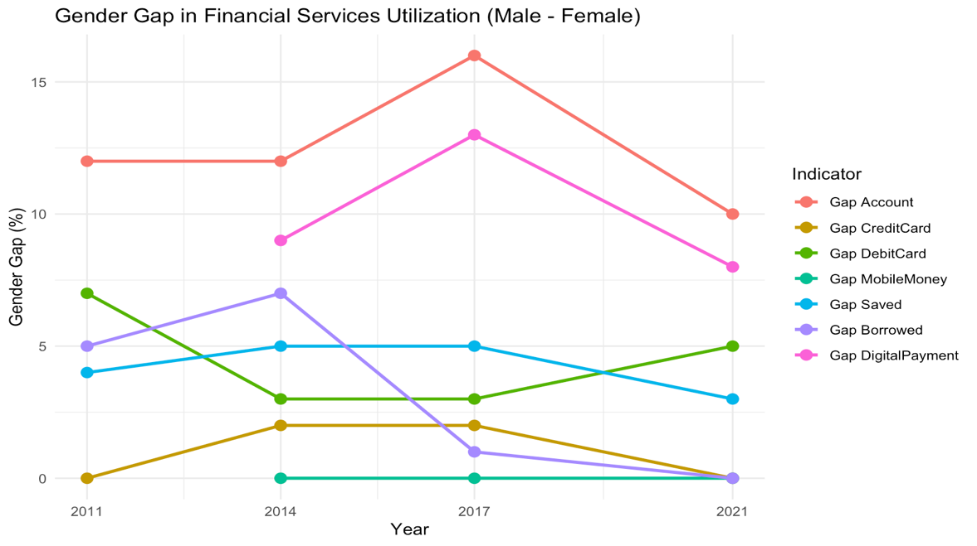
Figure 1: Gender Gap in utilization of financial services (2011-2021)
Source: Author’s calculation based on the Global Findex database
Figure 2 presents the mean utilization of financial services by males and females, calculated as the average usage levels across the years 2011, 2014, 2017, and 2021. This approach provides a consolidated view of gender disparities in financial service utilization over time, rather than focusing on individual-year fluctuations, which are already detailed in Figure 1. Males consistently demonstrate higher mean values across all categories, with the most significant disparities observed in account ownership and digital payments. Savings and borrowing from formal institutions also show higher average usage among males. Credit card and mobile money usage remain negligible for both genders, with little variation. This figure summarizes the overall trends, highlighting the persistent gender gaps across financial services despite minimal improvements in some areas over the years.
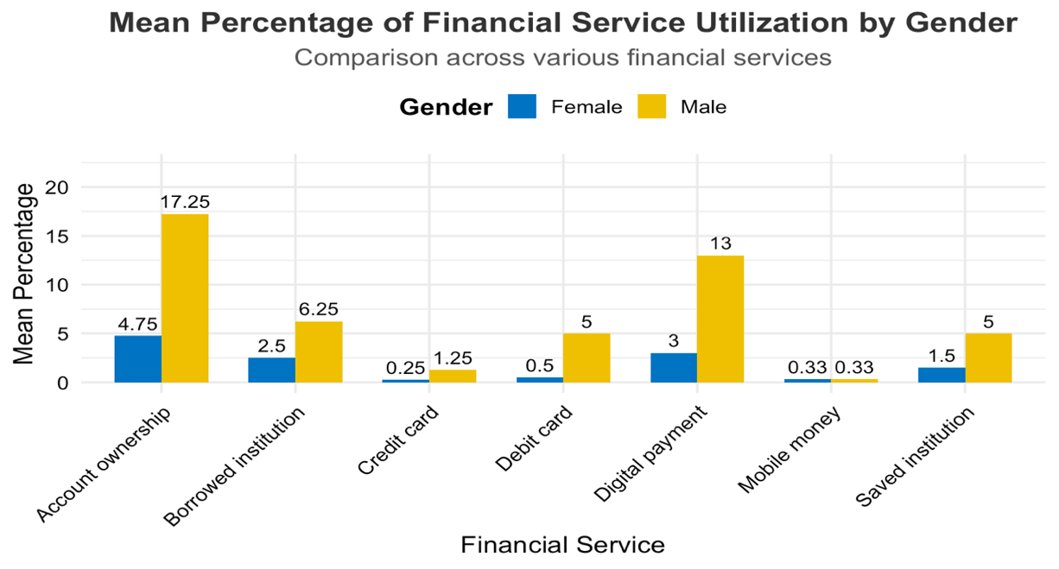
Figure 2: Mean percentage of financial services utilization by gender
Source: Author’s calculation based on the Global Findex database

4.2 Hypothesis testing
Table 2 shows the Kruskal-Wallis test was conducted to assess gender differences in the usage of various formal financial services. The results showed significant gender differences in account ownership, debit card ownership, digital payment usage, and savings at financial institutions, with p-values below 0.05. These findings suggest that gender plays a role in determining access to and usage of these financial services in Afghanistan. However, for borrowing from financial institutions, credit card ownership, and mobile money usage, the Kruskal-Wallis test did not show significant results, with p-values greater than 0.05. This non-significance can likely be attributed to the low usage or near-zero usage of these services for both male and female, which restricts the ability to detect any meaningful differences. As a result, we cannot make a clear indication of gender equality or gender disparity in these services based on the available data.
Table 2: Results of the Kruskal-Wallis Test
Variable | Kruskal-Wallis Statistic | p-value | Hypothesis
Account | 5.40 | 0.02 | Accepted (H1)
Borrowed | 2.58 | 0.1 | Rejected (H2)
Credit Card | 2.43 | 0.1 | Rejected (H3)
Debit Card | 5.46 | 0.01 | Accepted (H4)
Digital Payment | 3.97 | 0.04 | Accepted (H5)
Mobile Money | 0.00 | 1.00 | Rejected (H6)
Saved | 5.67 | 0.01 | Accepted (H7)
Source: Author’s calculation based on the Global Findex database
Given the significant results from the Kruskal-Wallis test, we proceeded with Dunn’s post-hoc test (see Table 3) to explore the specific nature of gender differences. The Dunn’s test confirmed significant gender differences in account ownership, with men being significantly more likely to own an account than women (Z = -2.323, p = 0.01). Similarly, men were found to have significantly higher rates of debit card ownership compared to women (Z = -2.337, p = 0.01). Regarding digital payment usage, men were also found to use digital payments significantly more than women (Z = -1.993, p = 0.02). Lastly, men were more likely to save at financial institutions than women (Z = -2.381, p = 0.01), further reinforcing the findings from the Kruskal-Wallis test.
Table 3: Results of Dunn’s Post-Hoc Test
Variable | Comparison | Z-score | Unadjusted p-value | Bonferroni Adjusted p-value
Account | Female - Male | -2.323 | 0.01* | 0.01
Debit Card | Female - Male | -2.337 | 0.01* | 0.01
Digital Payment | Female - Male | -1.993 | 0.02* | 0.02
Saved | Female - Male | -2.381 | 0.01* | 0.01
Source: Author’s calculation based on the Global Findex database
Note: Dunn’s post-hoc tests were only performed for variables with significant results in Kruskal-Wallis test (p < 0.05).
4.3 Findings on Barriers to Financial Inclusion in Afghanistan:
The utilization of financial services in Afghanistan has remained consistently low over the years, as highlighted in the earlier analysis of gender disparities. Across various financial services, such as account ownership, savings, and digital payments, usage levels were notably limited for both males and females, with females consistently lagging behind. The persistent gender gap observed in financial services utilization can be closely linked to several structural and cultural barriers prevalent in the country.
Figure 3 shows the primary barrier to having a bank account in 2021 was insufficient funds, reflecting widespread poverty and economic constraints that impact both genders but often disproportionately affect women. Additionally, logistical challenges, such as the distance to financial institutions, and a lack of trust in financial systems further discourage usage. Procedural barriers, including the lack of necessary documentation and the high cost of financial services, exacerbate exclusion, making formal financial systems inaccessible to many, particularly women. Cultural and social factors also play a significant role, with religious considerations and reliance on family-held accounts limiting individual financial participation, especially for females. These barriers collectively explain the low usage of financial services and the persistent gender gap, underscoring the need for targeted interventions to address these challenges and promote equitable financial inclusion.
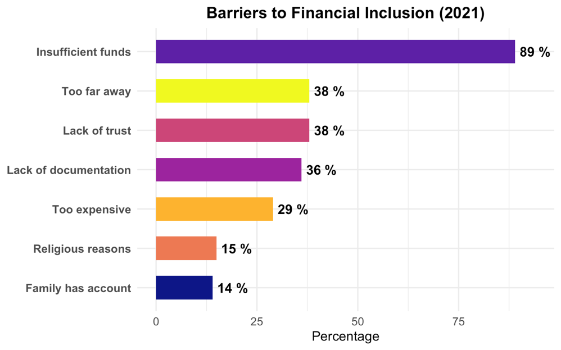
Figure 3: Barriers to FI in Afghanistan (2021)
Source: Author’s compilation based on Global Findex database
5. DISCUSSION:
The descriptive summary reveals persistent gaps in financial service usage, with males consistently demonstrating higher engagement across almost all categories. While account ownership and digital payment usage exhibited the most substantial disparities, other services like savings and debit card usage also showed notable gender differences. The negligible usage of credit cards and mobile money for both genders indicates limited penetration of these services in the country, reflecting broader infrastructural and accessibility challenges. This finding is aligned with Demirgüç-Kunt et al. (2022) which state financial inclusion is too low in developing countries, and Mani (2016) finds that financial inclusion in South Asia remains low, with gender disparities persisting despite growing mobile banking adoption. Among the unbanked population, women are excluded at a higher rate (Kara et al., 2021; Tay et al., 2022).
The statistical analyses further underscored these disparities. The Kruskal-Wallis test identified significant gender differences in account ownership, debit card usage, digital payment adoption, and savings at financial institutions; this aligns with the finding of Ghosh & Chaudhury (2019) and Antonijević et al. (2022), as they found a significant gender gap in access and usage of financial services across the globe using the Global Findex database 2017. For instance, Pahlevan Sharif et al. (2013) analyzed the gender gap in financial inclusion in low-income economies and found significant differences with men using at a higher rate. Similarly, Aziz et al. (2022) found that women are less likely to use financial services, especially in countries with religious restrictions. However, in contrast to previous studies, no significant differences were detected for borrowing, credit card usage, and mobile money, likely due to the near-zero usage of these services across both genders. This aligns with the findings of Pahlevan Sharif et al. (2013) that find no gap in formal savings and credit. This highlights the need to approach low-usage services with caution when drawing conclusions about gender equality, as the lack of significance may reflect minimal adoption rather than true parity. Dunn’s post-hoc tests provided further clarity, confirming significant gender differences in the services identified as significant in the Kruskal-Wallis test, with men consistently exhibiting higher usage rates, aligning with previous studies on the gender gap in financial inclusion (Antonijević et al., 2022; Demirgüç-Kunt et al., 2013; Mani, 2016; Ghosh & Chaudhury, 2019; Kuroda et al., 2019; Aziz et al., 2022; Demirgüç-Kunt et al., 2022; Roy & Patro, 2022).
The barriers to financial inclusion, as illustrated in this study, provide valuable context for understanding these findings. Insufficient funds emerged as the most significant constraint, highlighting the economic challenges that restrict access to financial services for a substantial portion of the population, aligning with the findings of Kara et al. (2021) and Saluja et al. (2023), which state lack of income as a major barrier to FI. Fungáčová & Weill (2015) find that lack of income and education are associated with less use of formal accounts and savings. Additional barriers, such as distance, procedural requirements, and cultural norms, exacerbate exclusion, particularly for women, aligning with the findings of Anyangwe et al. (2022), Demirgüç-Kunt et al. (2013), Allen et al. (2016), and Saluja et al. (2023). For instance, Anyangwe et al. (2022) highlight that cultural factors like power distance and masculinity hinder financial inclusion, while individualism and long-term orientation promote formal account usage. Mani (2018) finds that a significant gender gap persists in South Asian countries, with women in Afghanistan and Pakistan facing greater exclusion due to socio-cultural barriers and limited financial literacy​. Similarly, Demirgüç-Kunt et al. (2013) find that legal restrictions, discriminatory norms, and socio-cultural factors significantly limit women's access to financial services. Moreover, Sanderson et al. (2018) identify documentation requirements and distance to financial access points as key barriers to financial inclusion, and Ayyagari & Beck (2015) report that financial inclusion in developing Asia remains low, with under 27% of adults having bank accounts and only 33% of enterprises accessing credit.
6. Conclusion

This study examined gender disparities in financial services utilization in Afghanistan using the Global Findex database. The findings reveal significant gender differences in account ownership, debit card usage, digital payments, and savings at financial institutions, while borrowing, credit card ownership and mobile money usage showed no significant disparities, likely due to their minimal adoption among both genders. Structural and socio-cultural barriers, including lack of funds, limited financial access, and procedural challenges, contribute to the persistent gender gap. These results underscore the need for targeted policies to promote financial inclusion and reduce gender-based financial inequalities in Afghanistan.
Policymakers should prioritize targeted interventions to address gender disparities in financial service usage. Initiatives such as gender-responsive financial products, financial literacy programs and streamlined account-opening processes can help bridge the gap. Efforts should also aim to reduce cultural and procedural barriers that disproportionately affect women, ensuring equitable access to financial services.
This study does not explore regional or urban-rural disparities, which may reveal even greater gender gaps in financial inclusion. Future research should focus on these dimensions to provide a more nuanced understanding of financial exclusion across Afghanistan. Additionally qualitative studies could investigate socio-cultural factors in greater depth, complementing quantitative findings. It is also important to note that these barriers are only described as contextual background and are not analyzed statistically in this study. Future research could further investigate these barriers through qualitative methods or surveys to understand their impact on financial exclusion.
Data Availability:
The data is publicly available from the Global Findex database, World Bank.
AI Disclaimer
The authors declare that generative AI technologies were utilized during the writing and editing of this manuscript. The details of AI usage are as follows:
- Technology Used: ChatGPT (GPT-4), developed by OpenAI.
- Purpose of Use: AI assistance was employed to enhance formatting, improve readability, and refine clarity.
- Scope of AI Assistance: The AI was used for grammar correction, text refinement, and formatting improvements.
The final manuscript has been thoroughly reviewed and edited by the authors. The authors take full responsibility for its content, accuracy, and interpretation, ensuring that the work remains their original contribution.
References

Adera, A., & Abdisa, L. T. (2023). Financial inclusion and women’s economic empowerment: Evidence from Ethiopia. Cogent Economics & Finance, 11(2). https://doi.org/10.1080/23322039.2023.2244864.
Ajide, F. M. (2020). Financial inclusion in Africa: does it promote entrepreneurship? Journal of Financial Economic Policy, 12(4), 687-706. https://doi.org/10.1108/JFEP-08-2019-0159.
Allen, F., Demirguc-Kunt, A., Klapper, L., & Peria, M. S. (2016). The foundations of financial inclusion: Understanding ownership and use of formal accounts. Journal of financial Intermediation, 27, 1-30. https://doi.org/10.1016/j.jfi.2015.12.003.
Ambarkhane, D., Singh, A. S., Venkataramani, B., & Marak, Z. (2022). Overcoming barriers to financial inclusion: empirical evidence from India. International Journal of Social Economics, 49(9), 1302-1323. https://doi.org/10.1108/IJSE-04-2020-0254.
Antonijević, M., Ljumović, I., & Ivanović, Đ. (2022). Is there a gender gap in financial inclusion worldwide? Journal of Women's Entrepreneurship and Education, (1-2), 79-96. DOI: 10.28934/jwee22.12.
Anyangwe, T., Vanroose, A., & Fanta, A. (2022). Determinants of financial inclusion: does culture matter? Cogent Economics & Finance, 10(1). https://doi.org/10.1080/23322039.2022.2073656.
Arshad, A. (2023). Nexus between financial inclusion and women empowerment: evidence from developing countries. Gender in Management: An International Journal, 38(4), 561-580. https://doi.org/10.1108/GM-04-2022-0125.
Ashoer, M., Jebarajakirthy, C., Lim, X. J., Mas' ud, M., & Sahabuddin, Z. A. (2024). Mobile fintech, digital financial inclusion, and gender gap at the bottom of the pyramid: An extension of mobile technology acceptance model. Procedia Computer Science, 234, 1253-1260. https://doi.org/10.1016/j.procs.2024.03.122.
Aslan, G. (2022). Enhancing youth and women’s financial inclusion in South Asia. Cogent Economics & Finance, 10(1). https://doi.org/10.1080/23322039.2022.2136237.
Ayyagari, M., & Beck, T. (2015). Financial inclusion in Asia: An overview. Asian Development Bank Economics Working Paper Series, (449). http://dx.doi.org/10.2139/ssrn.2707540.
Aziz, F., Sheikh, S. M., & Shah, I. H. (2022). Financial inclusion for women empowerment in South Asian countries. Journal of Financial Regulation and Compliance, 30(4), 489-502. https://doi.org/10.1108/JFRC-11-2021-0092.
Bala, S., & Singhal, P. (2018). Gender digital divide in India: a case of inter-regional analysis of Uttar Pradesh. Journal of Information, Communication and Ethics in Society, 16(2), 173-192. https://doi.org/10.1108/JICES-07-2017-0046.
Beck, T., Demirgüç-Kunt, A., & Levine, R. (2007). Finance, inequality and the poor. Journal of economic growth, 12, 27-49. https://doi.org/10.1007/s10887-007-9010-6.
Belayeth Hussain, A. H., Endut, N., Das, S., Chowdhury, M. T., Haque, N., Sultana, S., & Ahmed, K. J. (2019). Does financial inclusion increase financial resilience? Evidence from Bangladesh. Development in Practice, 29(6), 798–807. https://doi.org/10.1080/09614524.2019.1607256.
Bhatia, S., & Singh, S. (2019). Empowering women through financial inclusion: a study of urban slum. Vikalpa, 44(4), 182-197. https://doi.org/10.1177/0256090919897809.
Cleophas, T., & Zwinderman, A. (2016). Non-parametric Tests for Three or More Samples (Friedman and Kruskal-Wallis). Clinical data analysis on a pocket calculator: understanding the scientific methods of statistical reasoning and hypothesis testing, 193-197. https://doi.org/10.1007/978-3-319-27104-0_34.
Conover, W. J. (1999). Practical nonparametric statistics (Vol. 350). john wiley & sons.
Cook, W., Lennox, D., & Hakimzay, H. (2024). Trust in Transition: Afghanistan’s Hawala System in Crisis and Recovery.CGAP/World Bank. Retrieved from https://www.cgap.org/research/publication/trust-in-transition-afghanistans-hawala-system-in-crisis-and-recovery.
Daud, S. N. (2023). Financial inclusion, economic growth and the role of digital technology. Finance Research Letters, 53, 103602. https://doi.org/10.1016/j.frl.2022.103602.
Demirgüç-Kunt, A., & Klapper, L. F. (2012a). Financial inclusion in Africa: an overview. World Bank policy research working paper, (6088). Available at SSRN: https://ssrn.com/abstract=2084599.
Demirgüç-Kunt, A., & Klapper, L. F. (2012b). Measuring financial inclusion: The global findex database. World bank policy research working paper, (6025). https://ssrn.com/abstract=2043012.
Demirgüç-Kunt, A., Klapper, L. F., & Singer, D. (2013). Financial inclusion and legal discrimination against women: evidence from developing countries. World Bank Policy Research Working Paper, (6416). Available at SSRN: https://ssrn.com/abstract=2254240.
Demirguc-Kunt, A., Klapper, L., & Randall, D. (2014). Islamic finance and financial inclusion: measuring use of and demand for formal financial services among Muslim adults. Review of Middle East Economics and Finance, 10(2), 177-218. https://ssrn.com/abstract=2341370.
Demirgüç-Kunt, A., Klapper, L., Singer, D., & Ansar, S. (2022). The Global Findex Database 2021: Financial inclusion, digital payments, and resilience in the age of COVID-19. World Bank Publications.
Dinno, A. (2015). Nonparametric pairwise multiple comparisons in independent groups using Dunn's test. The Stata Journal, 15(1), 292-300. https://doi.org/10.1177/1536867X1501500117.
Dunn, O. J. (1964). Multiple comparisons using rank sums. Technometrics, 6(3), 241-252. https://doi.org/10.1080/00401706.1964.10490181.
Erlando, A., Riyanto, F. D., & Masakazu, S. (2020). Financial inclusion, economic growth, and poverty alleviation: evidence from eastern Indonesia. Heliyon, 6(10).
Esmaeilpour Moghadam, H., & Karami, A. (2023). Financial inclusion through FinTech and women's financial empowerment. International Journal of Social Economics, 50(8), 1038-1059. https://doi.org/10.1108/IJSE-04-2022-0246
Fowowe, B. (2025). Financial inclusion, gender gaps and agricultural productivity in Mali. Review of Development Economics, 29(1), 3-42. https://doi.org/10.1111/rode.13034
Fungáčová, Z., & Weill, L. (2015). Understanding financial inclusion in China. China Economic Review, 34, 196-206. https://doi.org/10.1016/j.chieco.2014.12.004.
Ghosh, C., & Chaudhury, R. H. (2019). Gender gap in case of financial inclusion: An empirical analysis in Indian context. Economics Bulletin, 39(4), 2615-2630.
Ghosh, S. (2020). Financial Inclusion in India: Does Distance Matter? South Asia Economic Journal, 21(2), 216-238. https://doi.org/10.1177/1391561420961649.
Goel, N., & Madan, P. (2019). Benchmarking financial inclusion for women entrepreneurship–a study of Uttarakhand state of India. Benchmarking: An International Journal, 26(1), 160-175. https://doi.org/10.1108/BIJ-01-2018-0023.
Haq, W., & Abbas, F. (2024). Digital Financial Inclusion of Women in Pakistan: Evidence from Global Findex Database. In The Economics of Financial Inclusion (pp. 35-50). Routledge.
Hasan, R., Ashfaq, M., Parveen, T., & Gunardi, A. (2023). Financial inclusion–does digital financial literacy matter for women entrepreneurs? International Journal of Social Economics, 50(8), 1085-1104. https://doi.org/10.1108/IJSE-04-2022-0277.
Hussain, A. B., Islam, M., Ahmed, K. J., Haq, S. M., & Islam, M. N. (2021). Financial inclusion, financial resilience, and climate change resilience. In J. Luetz, & D. (. Ayal, Handbook of Climate Change Management: Research, Leadership, Transformation (pp. (pp. 2085-2107). https://doi.org/10.1007/978-3-030-57281-5_19. Springer, Cham.
Johnen, C., & Mußhoff, O. (2023). Digital credit and the gender gap in financial inclusion: Empirical evidence from Kenya. Journal of International Development, 35(2), 272-295. https://doi.org/10.1002/jid.3687.
Kamara, A. K., & Yu, B. (2024). The Impact of FinTech Adoption on Traditional Financial Inclusion in Sub-Saharan Africa. Risks, 12(7), 115. https://doi.org/10.3390/risks12070115.
Kara, A., Zhou, H., & Zhou, Y. (2021). Achieving the United Nations' sustainable development goals through financial inclusion: A systematic literature review of access to finance across the globe. International Review of Financial Analysis, 77, 101833. https://doi.org/10.1016/j.irfa.2021.101833.
Khera, P., Ng, S., Ogawa, S., & Sahay, R. (2022). Measuring digital financial inclusion in emerging market and developing economies: A new index. Asian Economic Policy Review, 17(2), 213-230. https://doi.org/10.1111/aepr.12377.
Kim, J. H. (2015). A Study on the Effect of Financial Inclusion on the Relationship Between Income Inequality and Economic Growth. Emerging Markets Finance and Trade, 52(2), 498–512. https://doi.org/10.1080/1540496X.2016.1110467.
Kling, G., Pesqué-Cela, V., Tian, L., & Luo, D. (2020). A theory of financial inclusion and income inequality. The European Journal of Finance, 28(1), 137–157. https://doi.org/10.1080/1351847X.2020.1792960.
Kouladoum, J. C., Wirajing, M. A., & Nchofoung, T. N. (2022). Digital technologies and financial inclusion in Sub-Saharan Africa. Telecommunications Policy, 46(9), 102387. https://doi.org/10.1016/j.telpol.2022.102387.
Kulkarni, L., & Ghosh, A. (2021). Gender disparity in the digitalization of financial services: challenges and promises for women’s financial inclusion in India. Gender, Technology and Development, 25(2), 233–250. https://doi.org/10.1080/09718524.2021.1911022.
Kuroda, R., Lopez, M. S., & Settecase, M. (2019). The digital gender gap. W20 Japan, EY-GSMA.
Lu, W., Niu, G., & Zhou, Y. (2021). Individualism and financial inclusion. Journal of Economic Behavior & Organization, 183, 268-288. https://doi.org/10.1016/j.jebo.2021.01.008.
Lusardi, A., & Mitchell, O. S. (2011). Financial literacy around the world: an overview. Journal of pension economics & finance, 10(4), 497-508. https://doi.org/10.1017/S1474747211000448.
Lyons, A. C., & Kass-Hanna, J. (2019). Financial Inclusion, Financial Literacy and Economically Vulnerable Populations in the Middle East and North Africa. Emerging Markets Finance and Trade, 57(9), 2699–2738. https://doi.org/10.1080/1540496X.2019.1598370.
Ma’ruf, A., & Aryani, F. (2019). Financial inclusion and achievements of sustainable development goals (SDGs) in ASEAN. J. Bus. Econ. Review, 4(4), 147-155. https://ssrn.com/abstract=3528373.
Mabrouk, F. B., Elhaj, M., Binsuwadan, J., & Alofaysan, H. (2023). Empowering Women through Digital Financial Inclusion: Comparative Study before and after COVID-19. Sustainability, 15(12), 9154. https://doi.org/10.3390/su15129154.
Mani, M. (2016). Financial Inclusion in South Asia—Relative Standing, Challenges and Initiatives. South Asian Survey, 23(2), 158-179. https://doi.org/10.1177/0971523118783353.
Mascia, D. V., & Rossi, S. P. (2017). Is there a gender effect on the cost of bank financing? Journal of Financial Stability, 31, 136-153. https://doi.org/10.1016/j.jfs.2017.07.002
Ndoya, H. H., & Tsala, C. O. (2021). What drive gender gap in financial inclusion? Evidence from Cameroon. African Development Review, 33(4), 674-687. https://doi.org/10.1111/1467-8268.12608.
Nsiah, A. Y., Yusif, H., Tweneboah, G., Agyei, K., & Baidoo, S. T. (2021). The effect of financial inclusion on poverty reduction in Sub-Sahara Africa: Does threshold matter? Cogent Social Sciences, 7(1). https://doi.org/10.1080/23311886.2021.1903138.
Ostertagova, E., Ostertag, O., & Kováč, J. (2014). Methodology and application of the Kruskal-Wallis test. Applied mechanics and materials, 611, 115-120. https://doi.org/10.4028/www.scientific.net/AMM.611.115.
Ozili, P. K. (2018). Impact of digital finance on financial inclusion and stability. Borsa istanbul review, 18(4), 329-340. https://doi.org/10.1016/j.bir.2017.12.003.
Ozili, P. K. (2020). Financial inclusion research around the world: A review. Forum for Social Economics, 50(4), 457–479. https://doi.org/10.1080/07360932.2020.1715238.
Ozili, P. K. (2022). Financial inclusion and sustainable development: an empirical association. Journal of Money and Business, 2(2), 186-198. https://doi.org/10.1108/JMB-03-2022-0019.
Özşuca, E. A. (2019). Gender gap in financial inclusion: Evidence from MENA. Economics and Business Letters, 8(4), 199-208. https://doi.org/10.17811/ebl.8.4.2019.199-208.
Pahlevan Sharif, S., Naghavi, N., Waheed, H., & Ehigiamusoe, K. U. (2013). The role of education in filling the gender gap in financial inclusion in low-income economies. International Journal of Emerging Markets, 18(12), 5755-5777. https://doi.org/10.1108/IJOEM-07-2021-0991.
Park, C. Y., & Mercado, R. (2015). Financial inclusion, poverty, and income inequality in developing Asia. Asian Development Bank Economics Working Paper Series, (426). http://dx.doi.org/10.2139/ssrn.2558936.
Roy, P., & Patro, B. (2022). Financial inclusion of women and gender gap in access to finance: A systematic literature review. Vision, 26(3), 282-299. https://doi.org/10.1177/09722629221104205.
Sakyi-Nyarko, C., Ahmad, A. H., & Green, C. J. (2022). The gender-differential effect of financial inclusion on household financial resilience. The Journal of Development Studies, 58(4), 692-712. https://doi.org/10.1080/00220388.2021.2013467.
Saluja, O. B., Singh, P., & Kumar, H. (2023). Barriers and interventions on the way to empower women through financial inclusion: a 2 decades systematic review (2000–2020). Humanities and Social Sciences Communications, 10(1), 1-14. https://doi.org/10.1057/s41599-023-01640-y.
Sanderson, A., Mutandwa, L., & Le Roux, P. (2018). A review of determinants of financial inclusion. International Journal of Economics and Financial Issues, 8(3), 1.
Sandhu, N., Hussain, J., & Matlay, H. (2012). Barriers to finance experienced by female owner/managers of marginal farms in India. Journal of Small Business and Enterprise Development, 19(4), 640-655. https://doi.org/10.1108/14626001211277442.
Sarma, M., & Pais, J. (2011). Financial inclusion and development. Journal of international development, 23(5), 613-628. https://doi.org/10.1002/jid.1698.
Tay, L. Y., Tai, H. T., & Tan, G. S. (2022). Digital financial inclusion: A gateway to sustainable development. Heliyon, 8(6).
Urrea, M. A., & Maldonado, J. H. (2011). Vulnerability and risk management: the importance of financial inclusion for beneficiaries of conditional transfers in Colombia. Canadian Journal of Development Studies / Revue Canadienne d’études Du Développement, 32(4), 381–398. https://doi.org/10.1080/02255189.2011.647442.
Wellalage, N. H., Hunjra, A. I., Manita, R., & Locke, S. M. (2021). Information communication technology and financial inclusion of innovative entrepreneurs. Technological Forecasting and Social Change, 163, 120416. https://doi.org/10.1016/j.techfore.2020.120416.
Yeyouomo, A. K., Asongu, S. A., & Agyemang-Mintah, P. (2023). Fintechs and the financial inclusion gender gap in Sub-Saharan African countries. Women's Studies International Forum. Pergamon, Vol. 97, p. 102695. https://doi.org/10.1016/j.wsif.2023.102695.
Zhang, Q., & Posso, A. (2017). Thinking Inside the Box: A Closer Look at Financial Inclusion and Household Income. The Journal of Development Studies, 55(7), 1616–1631. https://doi.org/10.1080/00220388.2017.1380798.

