**A COMPARATIVE STUDY ON HELMINTH CONTAMINATION IN MARKET AND STREET FAIR VEGETABLES: PUBLIC HEALTH IMPLICATIONS**

.

**ABSTRACT**

|  |
| --- |
| **Introduction:** The contamination of food by intestinal helminths poses a significant public health challenge, especially in regions where sanitary conditions are poor. This study addresses the prevalence of parasites in leafy vegetables sold in markets and street fairs.  **Objective:** To analyze and compare the prevalence of intestinal helminths in leafy vegetable samples collected from street fairs and supermarkets in Bahia.  **Methodology:** Ten samples of leafy vegetables were collected from different points of sale, stored in sterile bags, and transported for laboratory analysis. The samples were washed with sterile distilled water, and the resulting sediment was microscopically examined after the addition of Lugol's solution. A brief mention of the statistical methods used to compare the prevalence between the locations, such as chi-square tests or descriptive analysis, could strengthen the methodology and provide additional clarity.  **Results and Discussion:** In the market, Entamoeba sp. was the most prevalent species, accounting for 41.25% of occurrences, while in the street fair, Taenia sp. predominated, representing 43.75% of the samples. The comparison revealed significant variations between the locations, reflecting possible differences in hygiene and handling practices. Including the specific number of samples analyzed in this section (10 samples) helps improve the transparency and reliability of the findings.  **Conclusion:** The prevalence of different helminths in both locations highlights the importance of targeted sanitary interventions to improve food safety and reduce the risk of parasitic infection. Additionally, future studies should aim to use larger sample sizes and incorporate advanced statistical methods to validate and expand on these findings. Explicitly stating the statistical tools used for comparison can further substantiate the results and guide interventions more effectively. |

*Keywords: Helminths, Food contamination, Food safety, Public health.*

**1. INTRODUCTION**

Food contamination by pathogens, including intestinal parasites, poses a significant challenge to global public health. This directly impacts food safety and population well-being, especially in regions where fresh foods are consumed without proper supply chains. The presence of parasites in vegetables, such as leafy greens, can be linked to harmful agricultural practices and the use of contaminated water, which increases the risk of infection [1]. Intestinal parasitic infections, like those caused by helminths, are common in areas with poor sanitary infrastructure, affecting millions of people, particularly in tropical and subtropical regions where the incidence is higher [2].

Helminths, such as Ascaris lumbricoides, Trichuris trichiura, and hookworms, are examples of parasites that can be found in contaminated food. These parasites are primarily transmitted through the ingestion of eggs present in improperly washed food or food exposed to compromised sanitary conditions [3]. Fecal-oral transmission, associated with inadequate hygiene, is a common route of infection, highlighting the importance of strict hygiene practices in food production and handling [4]. In this context, epidemiological studies reveal that the consumption of raw food increases the risk of intestinal parasitic transmission, posing a global public health concern [5].

Contamination of fresh foods, especially leafy vegetables, is a persistent issue due to frequent handling and exposure during sales in markets and fairs. Contaminated water and soil are potential sources of parasites, contributing to infection in locations where hygiene measures are insufficient [6]. Additionally, the lack of sanitation practices increases the prevalence of helminths in agricultural products, potentially leading to outbreaks of parasitic diseases in vulnerable communities [7]. The implementation of monitoring programs and effective hygiene procedures can mitigate these risks and improve food safety [6].

The relationship between the presence of parasites in food and the epidemiology of infections is complex and underscores the need for an integrated approach to control and prevention. Studies indicate that monitoring practices, combined with sanitary interventions, are essential to reduce the parasitic load in food and prevent outbreaks [3]. Helminth infections can range from mild symptoms, such as abdominal discomfort, to severe complications, depending on the parasite involved and the host's health status [8]. Assessing the contamination of food sold in environments such as markets and supermarkets is therefore crucial for developing effective public health policies [9].

This study aims to analyze samples of leafy vegetables sold at open markets and supermarkets in Bahia to identify contamination by intestinal helminths. The central question guiding this investigation is: what is the degree of contamination by intestinal helminths in leafy vegetables sold in these locations? The relevance of this research lies in the need to assess food safety and support mitigation strategies to protect public health. Evaluating the extent of this contamination can promote better sanitation practices and contribute to food safety and public health at a regional level.

**2. material and methods**

For the analysis of intestinal helminth contamination in leafy vegetables sold at open markets and supermarkets in the state of Bahia, a study was conducted following a rigorous collection and laboratory analysis protocol. Specifically, 20 samples of traditionally grown lettuce (non-hydroponic) (Lactuca sativa) were collected, with 10 from supermarkets and 10 from open markets, representing exclusively this type of leafy vegetable to ensure homogeneity in the analysis.

The samples were obtained from three supermarkets located in different cities: Conceição do Jacuípe-BA, Cachoeira-BA, and Feira de Santana-BA, with three samples collected from each supermarket. For the open markets, samples were collected from two different locations: one open market in Baixa Grande-BA and another in Povoado do Beça-BA, with five samples from each market. At each collection site, vendors were randomly selected, and each vendor contributed one sample, totaling the 20 samples analyzed. The lettuces were placed in sterile bags to ensure integrity and prevent contamination during transport to the laboratory. Each head of lettuce was weighed, with an average weight of approximately 250 grams per unit.

In the laboratory, the samples remained in their original collection bags to maintain sterility. At the supermarkets, no details were provided about the storage conditions or the production methods of the lettuce. However, at the open markets, vendors reported that the lettuces were irrigated with treated and piped water supplied by the local water company, a factor that could influence the level of contamination (table 1).

The samples were then subjected to careful washing with sterile distilled water, still within the collection bags. The wash water was transferred to a conical-bottomed beaker, ideal for particle sedimentation. After 24 hours, the sediment accumulated at the bottom of the beaker was used for microscopic analysis. An aliquot of the sediment was taken with a sterile Pasteur pipette and transferred to a glass slide. To enhance the visualization of parasitic structures, a drop of Lugol's solution was added to the aliquot, followed by the placement of a coverslip.

Microscopic analysis was performed using a final magnification of 1000x, allowing for the specific identification of eggs, larvae, and other parasitic structures. The analysis was conducted by an experienced microscopist, with validation through comparison with a parasitological atlas, ensuring accuracy in the identification of parasites. The findings were documented with photographs, which enabled subsequent identification and additional verification.

This methodology also acknowledges its limitations, such as the use of Lugol's solution, which may be less sensitive for some types of helminth eggs. This aspect was included in the discussion, along with the suggestion of more sensitive alternative methods for future research.

Tabel 1: Data from the collection site regarding general aspects and water usage.

|  |  |  |
| --- | --- | --- |
|  | **Production Origin** | **Site Conditions** |
| **Market** | Agricultura familiar | Limpo, organizado, bem iluminado, refrigerado |
| **Open Market** | Horta de propriedade rural | Ambiente sujo, alfaces expostas |

**3. results and discussion**

Market Samples

Table 2: Total helminth specimens from market samples.

|  |  |  |  |
| --- | --- | --- | --- |
| **Identification** | **Total** | **Average** | **Percentage** |
| Entamoeba sp. | 33 | 6.6 | 41.25 |
| Ascaris lumbricoides | 12 | 2.4 | 15.0 |
| Schistossoma mansoni | 3 | 0.6 | 3.75 |
| Stroguloids stercoralis | 1 | 0.2 | 1.25 |
| Taenia sp. | 10 | 2.0 | 12.5 |
| Ancilostomídeos | 5 | 1.0 | 6.25 |
| Echinococcus granulosus | 1 | 0.2 | 1.25 |
| Enterobius vermicularis | 7 | 1.4 | 8.75 |
| Fascíola hepática | 8 | 1.6 | 10.0 |

An analysis of the market samples (Table 2) revealed that Entamoeba sp. was the most prevalent species, with a total of 33 occurrences, an average of 6.6 per sample, and representing 41.25% of the total. Following this, Ascaris lumbricoides showed 12 occurrences, averaging 2.4 per sample and accounting for 15% of the total. Taenia sp. had 10 occurrences, an average of 2 per sample, representing 12.5% of the total.

Other species, such as Schistosoma mansoni and Strongyloides stercoralis, had fewer occurrences, with 3 and 1 occurrence, respectively, corresponding to 3.75% and 1.25% of the total. This distribution (Graph 1) highlights that, although some helminth species are found more frequently in market samples, others appear more sporadically. These data are essential for understanding the prevalence and distribution of infestations in the tested samples.

Graph 1: Distribution of helminth specimens in market samples.

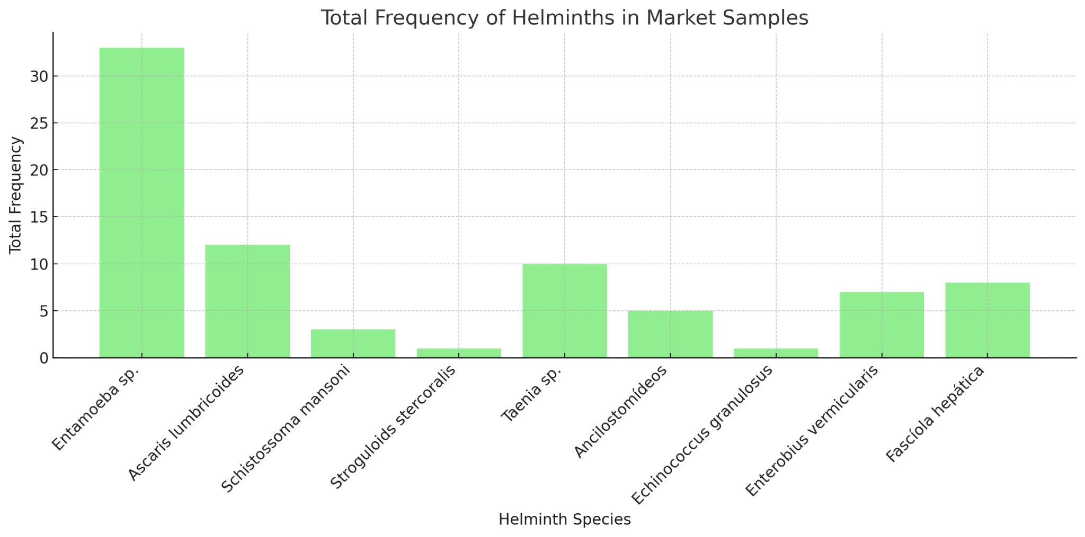

Table 3: Total helminth specimens from open market samples.

|  |  |  |  |
| --- | --- | --- | --- |
| **Identification** | **Total** | **Average** | **Percentage** |
| Taenia sp. | 14 | 2.8 | 43.75 |
| Entamoeba sp. | 12 | 2.4 | 37.5 |
| Ascaris lumbricoides | 2 | 0.4 | 6.25 |
| Enterobius vermicularis | 2 | 0.4 | 6.25 |
| Trichuris trichura | 1 | 0.2 | 3.125 |
| Fasciola hepatica | 1 | 0.2 | 3.125 |

Table 3 provides detailed information about helminth species found in samples collected from the open market. Each row indicates a helminth species, showing the total number of occurrences, the average per sample, and the percentage of the total number of occurrences of all species combined.

Taenia sp. was the most prevalent species, with a total of 14 occurrences, resulting in an average of 2.8 per sample and a significant percentage of the total. Following this, Entamoeba sp. had 12 total occurrences, averaging 2.4 per sample, also showing relevant presence. Conversely, Ascaris lumbricoides and Enterobius vermicularis appeared with lower frequency, each having 2 occurrences and an average of 0.4 per sample, indicating lower prevalence. Trichuris trichiura and Fasciola hepatica were observed only once each, resulting in an average of 0.2 per sample and contributing the lowest percentages of the total.

These data provide a clear understanding of the distribution (Graph 2) of different helminth species in the tested samples, highlighting the most and least frequent species, which can be useful for evaluating contamination patterns and guiding public health measures.

Graph 2: Distribution of helminth specimens in open market samples.

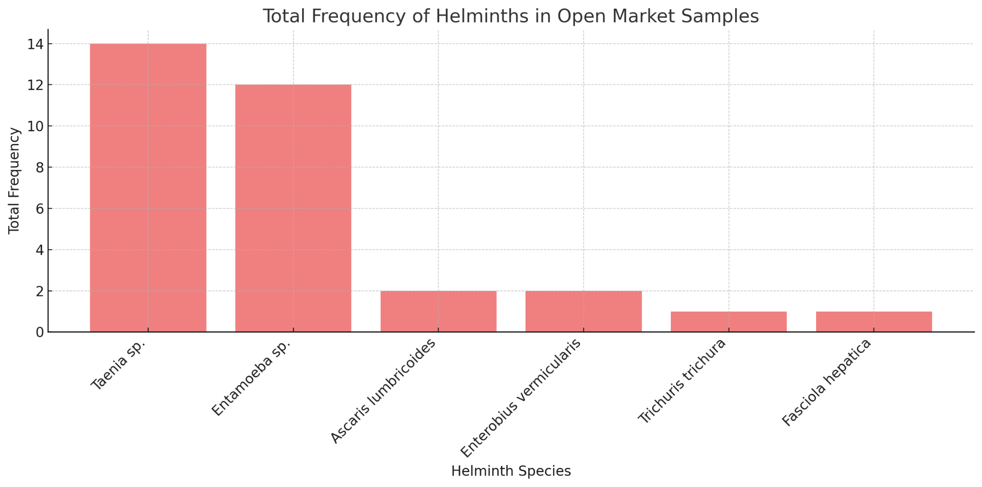

Graph 3 shows a comparison of the total frequency of helminths found in market and open market samples, with blue bars representing market frequencies and green bars representing open market frequencies. The distribution of each species is shown side-by-side, facilitating visualization of differences in prevalence between the two locations.

It is noted that Entamoeba sp. had a high total frequency in the market, but its presence was lower in the open market. Conversely, Taenia sp. was predominant in both locations, with a higher frequency in the open market compared to the market. Species like Ascaris lumbricoides and Enterobius vermicularis had low frequencies in both environments but were present.

It is noteworthy that Schistosoma mansoni appeared in market samples but was not found in open market samples. On the other hand, Trichuris trichiura and Fasciola hepatica showed low frequencies in the open market and minimal or no representation in market samples.

This visual analysis highlights variations in helminth prevalence between the two locations, showing that while some species are common in both, others appear exclusively or in greater quantities in only one environment. These data may reflect differences in contamination factors and occurrence conditions between the market and open market settings.

Graph 3: Comparative analysis between collection locations.

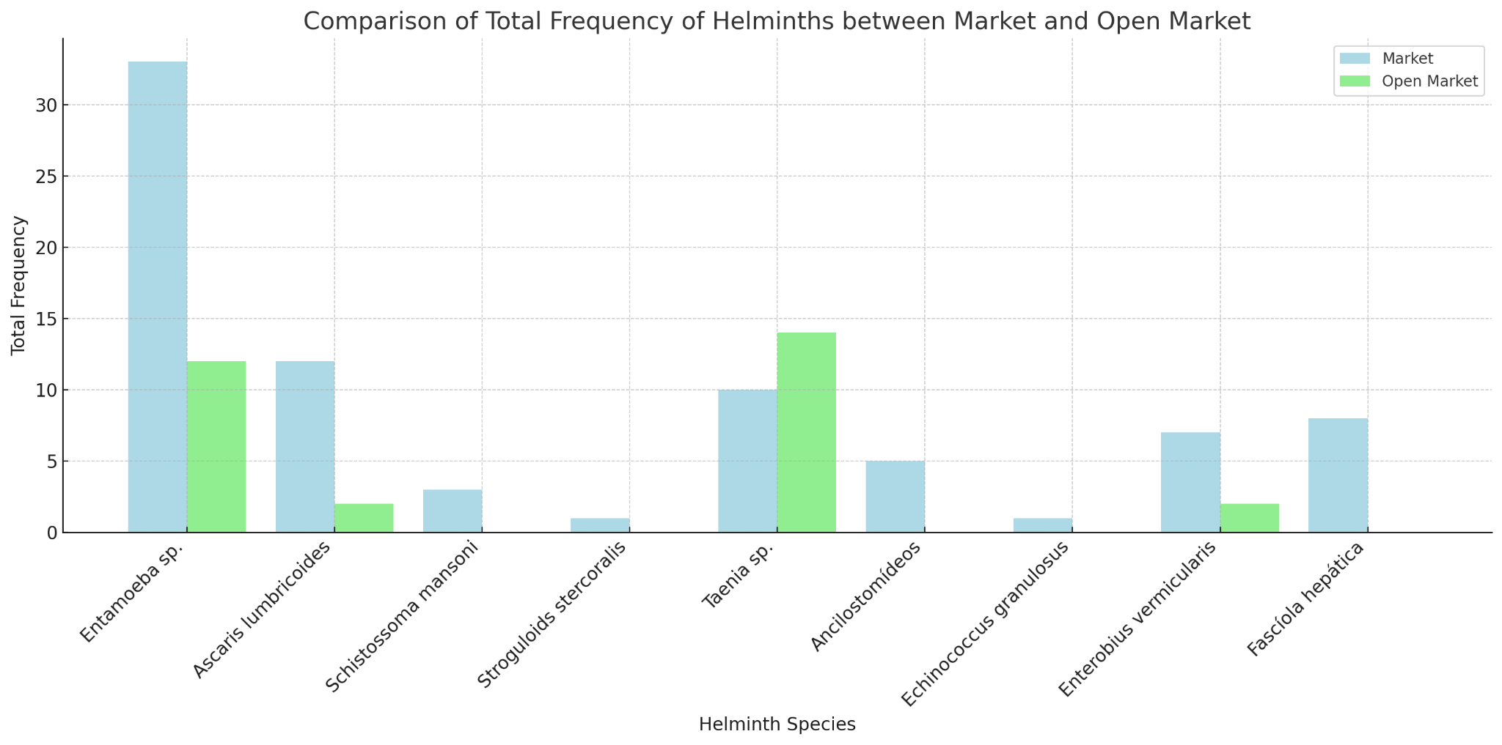

The analysis of helminth samples collected from different locations, such as markets and open markets, shows significant variations in the prevalence of identified species. In the market, Entamoeba sp. stands out as the most prevalent species, with 33 occurrences representing 41.25% of the total and an average of 6.6 per sample. This high frequency may indicate food handling conditions and water contamination sources that favor the spread of this parasite. Other species, such as Ascaris lumbricoides, had lower prevalence, with 12 occurrences [13], and Taenia sp. showed 10 occurrences [14], suggesting distinct contamination patterns [15].

In open market samples, the situation changes. Taenia sp. was the most prevalent species, totaling 14 occurrences and representing 43.75% of the total. Entamoeba sp. followed, with 12 occurrences, corresponding to 37.5%. Meanwhile, Ascaris lumbricoides and Enterobius vermicularis appeared with only 2 occurrences each, indicating lower incidence. Other species, such as Trichuris trichiura and Fasciola hepatica, were observed only once, reflecting minimal representation in the tested samples [16]. This pattern can be associated with seasonal environmental conditions and specific sanitary practices at each location, as highlighted in the study by Bouchaala et al. (2024). For instance, during summer, higher temperatures and humidity promote microbial growth, including the persistence of helminth eggs in similar environments, such as sewage sludge drying beds, observed in the study conducted in Algeria. Despite techniques like air-drying significantly reducing microbial loads, pathogens such as Clostridium and helminth eggs continue to be detected at considerable levels ( Bouchaala et al., 2024).

Comparing the two locations shows that while Entamoeba sp. was highly prevalent in the market, it had a lower presence in the open market. Conversely, Taenia sp. maintained high frequency in both, being more predominant in the open market. This difference may be attributed to specific environmental and sanitary factors of each location, such as food handling practices and access to clean water. Additionally, the absence of Schistosoma mansoni in the open market and the presence of other helminth species, such as Trichuris trichiura, emphasize differences in contamination conditions between the analyzed environments [17]. The study by Bouchaala et al. (2024) further complements this analysis by emphasizing that climatic factors, such as higher temperatures, contribute to the proliferation of pathogenic microorganisms and helminths during warmer periods (Bouchaala et al., 2024).

These observations have direct public health implications, as the prevalence of different helminth species in distinct locations reflects the need for targeted interventions. For example, the high incidence of Entamoeba sp. in the market suggests the importance of policies that strengthen water safety and food handling hygiene. Conversely, the predominance of Taenia sp. in the open market may indicate the need for stricter control practices for animal-derived food and educational programs on personal and sanitary hygiene for vendors and consumers [18].

**Statistical Analysis**

Table 4: Comparative Statistical Analysis Between Collection Locations (Market and Open Market)

|  |  |  |
| --- | --- | --- |
| **Metric** | **Market** | **Open market** |
| ***Count*** | 11.0 | 11.0 |
| ***Mean*** | 7,2 | 2,9 |
| ***Std Dev*** | 9,4 | 5 |
| ***Min*** | 0.0 | 0.0 |
| ***25th Percentile*** | 1.0 | 0.0 |
| ***Median*** | 5.0 | 1.0 |
| ***75th Percentile*** | 9.0 | 2.0 |
| ***Max*** | 33.0 | 14.0 |

Table 5: Statistical Tests

|  |  |
| --- | --- |
| **Test** | **p-Value** |
| Chi-Squared Test | 0.0069 |
| T-Test | 0.1981 |
| Mann-Whitney Test | 0.1499 |

The data presented in Table 4 reveal important insights into the occurrences of parasites in the two analyzed settings: the market and the open-air fair. In the market, the mean occurrence was 7.27 ± 9.49, with values ranging from 0 to 33, indicating a higher prevalence and greater dispersion of occurrences. In contrast, at the open-air fair, the mean occurrence was lower (2.91 ± 5.07), with a range of 0 to 14. These results suggest that the market may present more favorable conditions for the occurrence of parasites, or that the sampling conducted in this environment captured a greater diversity of situations. Percentiles show that in both settings, most occurrences are concentrated at low values (25th percentile at 1 in the market and 0 in the fair), but the higher values recorded in the market significantly raise its mean and standard deviation.

In Table 5, the results of the Chi-Square test indicate a significant difference in the proportions of parasite occurrences between the two settings (p=0.0069). This finding suggests that the distribution of parasites is not homogeneous, with certain parasites predominating in each setting. On the other hand, tests focused on means, such as the t-test (p=0.1981) and the Mann-Whitney test (p=0.1499), did not identify significant differences between the overall means of occurrences. These results suggest that although there are specific differences in the proportions of parasites, the overall means do not show sufficient variation to be statistically distinct.

The combined interpretation of these results highlights the need to consider differences in parasite distribution as a critical factor in understanding the specific risks associated with each setting. The significant difference in proportions may reflect environmental factors, management practices, or differing sanitary conditions between the market and the fair. Conversely, the absence of differences in means suggests that, despite certain species dominating in each setting, the overall infestation levels are not sufficiently distinct to significantly alter the total mean. This finding reinforces the importance of specific analyses to identify distribution patterns, rather than relying solely on global metrics such as the mean. Additionally, the need to increase the sample size is emphasized, as the small number of observations may limit the ability to detect more subtle differences.

These findings are fundamental to informing parasite control strategies in different contexts, considering both the prevalence of specific parasites and variations in distribution between the analyzed settings. Future studies could expand the sample scope and investigate environmental and behavioral factors influencing these differences.

**4. Conclusion**

It is concluded that a detailed understanding of the distribution of helminths in different locations is essential for formulating effective intervention strategies. The visual and comparative analysis of occurrences reinforces the importance of continuous monitoring and health education programs to mitigate the risks of parasitic infestations. Improvements in sanitary infrastructure and the quality control of food and water should be prioritized to reduce parasite prevalence and protect public health

**Disclaimer (Artificial intelligence)**

Option 2:

Author(s) hereby declare that generative AI technologies such as Large Language Models, etc. have been used during the writing or editing of manuscripts. This explanation will include the name, version, model, and source of the generative AI technology and as well as all input prompts provided to the generative AI technology

Details of the AI usage are given below:

1. Technology Used: OpenAI's GPT-4, version 4.0, model from OpenAI

* Source: OpenAI API platform
* Purpose of Use: Used for generating suggestions, improving clarity, and refining the language in the manuscript, as well as assisting with the synthesis of information and structuring sections of the text.

2. Additional Context: The AI was employed solely for enhancing the manuscript's content. No AI-generated content was included without review, and all outputs from the AI were verified and modified by the authors before inclusion in the manuscript.

**References**

1. Adhikari, S., Hunter, E., Van De Vossenberg, J., & Thomas, J. (2023). A review of latrine front characteristics associated with the risk of microbial infection; reveals a lack of pathogen density data. International Journal of Hygiene and Environmental Health, 254, 100234.

2. Girma, A., & Genet, A. (2024). Prevalence and factors associated with intestinal parasitic infections among preschool children in Ethiopia: A systematic review and meta-analysis. Epidemiology and Parasite Control, 26, 100345.

3. Holland, CV (2023). A walk on the wild side: A review of the epidemiology of Toxocara canis and Toxocara cati in wild hosts. Parasitology: Parasites and Wildlife, 22, 216–228.

4. Mahapatra, S., Ali, M. H., Samal, K., & Moulick, S. (2022). Diagnostic and treatment technologies for detection and removal of helminths in wastewater and sludge. Energy Nexus, 8, 100101.

5. Mota, J. D. O., Boué, G., Prévost, H., Maillet, A., Jaffres, E., Maignien, T., Arnich, N., Sanaa, M., & Federighi, M. (2021). Environmental monitoring program to support microbiological food safety and quality in food industries: a review of research scope and guidelines. Journal of Food Safety and Microbiology, 130, 100789.

6. Nguyen, T. H., Dorny, P., Nguyen, T. T. G., & Dermaauw, V. (2021). Helminth infections in fish in Vietnam: a systematic review. International Journal of Parasitology: Parasites and Wildlife, 13–32, 100456.

7. Tinkler, H. S. (2020). Preventative chemotherapy and anthelmintic resistance of soil-transmitted helminths – Can we learn nothing from veterinary medicine? One Health, 9, 100567.

8. Trevisan, C., Torgerson, P. R., & Robertson, L. J. (2019). Foodborne parasites in Europe: current situation and future trends. Trends in Parasitology, 35(9), 695–710.

9. Che-Kamaruddin, N., et al. (2024). Prevalence and risk factors of fasciolosis in a cattle population on farms in Taiping, Malaysia. Veterinary Parasitology: Regional Studies and Reports, 49, 100998.

10. Foster, T., et al. (2021). Modeling faecal pathogen flows and health risks in urban Bangladesh: Implications for sanitation decision-making. International Journal of Hygiene and Environmental Health, 233, 113669.

11. Lappan, R., et al. (2021). Monitoring diverse enteric pathogens in environmental and host reservoirs with TaqMan array cards and standard qPCR: a methodological comparison study. The Lancet Planetary Health, 5, e297–e308.

12. Mahdavi, F., et al. (2024). Design and evaluation of loop-mediated isothermal amplification for rapid detection of Enterocytozoon bieneusi. Food and Waterborne Parasitology, 35, e00225.

13. Mationg, M. L. S., et al. (2022). “The Magic Glasses Philippines”: a randomized controlled cluster of a health education package for the prevention of intestinal worm infections in school-aged children. The Lancet Regional Health - Western Pacific, 18, 100312.

14. McIntyre, K. M., et al. (2024). Understanding the interests of academics from diverse disciplines to identify prospective focus for a UK-based transdisciplinary network involving farm-to-fork stakeholders on antimicrobial resistance in agricultural systems: An online survey. Uma Saúde, 19, 100884.

15. Mukutmoni, M., et al. (2023). Perceptions and practices of urban slum-dwelling women concerning soil-transmitted helminths infections in Bangladesh: A cross-sectional study. Epidemiology and Parasite Control, 21, e00291.

16. Pawestri, A. R., et al. (2021). Seasonal prevalence, risk factors, and One Health intervention for prevention of intestinal parasitic infection in underprivileged communities on the Thai-Myanmar border. International Journal of Infectious Diseases, 105, 152–160.

17. Razafiarimanga, Z. N., et al. (2022). Risk factors for intestinal parasite harbors in an informal suburb on the west coast of Madagascar. Epidemiology and Parasite Control, 19, e00267.

1. Bouchaala L, Grara N, Charchar N, et al. Microbiological Characterization and Pathogen Control in Drying Bed-Processed Sewage Sludge. *Water*. 2024;16(22):3276.