Effect of Defected Ground Structures on Microstrip Patch Antenna Performance for ISM Band Applications

ABSTRACT
Recent years have seen a rise in the use of microstrip patch antennas (MPAs) due to their superior radiation properties, affordability, lightweight design, ease of feeding, and ease of manufacturing and analysis. This study investigates how the addition of Defected Ground Structures (DGS) affects the performance of microstrip patch antennas designed for Industrial, Scientific, and Medical (ISM) band applications. Antennas are developed using an inexpensive FR-4 substrate that has a thickness of 1.6 mm and a dielectric constant of 4.4. Using HFSS software, the antennas are studied and simulated at the ISM Band operating frequency i.e. 2.4 GHz and 5.8 GHz. The design was verified by manufacturing and experimental testing with a Vector Network Analyser (VNA).

Keywords: Defected Ground Structure (DGS), Microstrip Patch Antenna, ISM Band, FR-4, Vector Network Analyser (VNA).
- INTRODUCTION
With the continuous evolution of the industry in the ISM radio band, there is a growing demand for small, efficient, and high-performance antennas that have become essential components of wireless communication system. Microstrip patch antenna one of the most preferred antennas due to its requirement of low profile, ease of fabrication, compatibility with integrated circuit [1]-[5]. Conventional microstrip patch antennas also have the drawback of narrow bandwidth, low gain, and surface wave loss [6]-[8].
Different techniques have been proposed to combat these problems, among which is the application of Defected Ground Structures (DGS) [9]. DGS, specifically, is the intentional inclusion of defects or patterning on the ground plane of a microstrip antenna that changes the current distribution and associated electromagnetic fields that can improve antenna performance [10], [11]. DGS is conceptually derived from Electromagnetic Band Gap (EBG) structures and Photonic Band Gap (PBG) structures, but it provides a simpler design and easier implementation [12]. Such methods have demonstrated enhancement in parameters like gain, bandwidth, and radiation efficiency [13], [14].
DGS has been shown in some recent studies to significantly improve different antenna parameters. Specifically, DGS have applied in suppression of high-order harmonics, the mutual coupling reduction in antenna arrays and the impedance matching [15]-[17]. In the context of ISM band applications, DGS has been successfully employed to enhance bandwidth and gain [18].
DGS is proved to enhance antenna performance in literature [19], [20]. A microstrip patch antenna with U-shaped DGS obtained substantial enhancement in bandwidth and return loss [21]. A circular microstrip patch antenna was also miniaturized utilizing a novel DGS design that operated at 2.45 GHz that demonstrated improved performance for ISM band applications [22], [23].
In this study, we are going to introduce and investigate a microstrip patch antenna with inset feed considering DGS and without DGS to observe the effect of DGS on antenna characteristics in ISM band application. The parameters studied include reflection coefficient, VSWR, impendence matching and gain.

- ANTENNA DESIGN AND SIMULATION
2.1 MATHEMATICAL DESIGNING
The equations for patch width, substrate height, effective dielectric, patch length are given by the following: equation The proposed antenna's dimensions are designed using the following equations:
Patch width (𝑊)
$W=\frac{c}{2f_{r}\sqrt{(ε_{r}-1})/2}$ (1)
Where, 𝑐 = light speed in vacuum
f_{r} = resonant frequency
Substrate height (ℎ)
$\frac{w}{h}$ >1. (2)
Effective dielectric constant (ε_{reff})
$ε_{reff }=\frac{ε_{r}+1}{2} + \frac{ε_{r }- 1}{2} {[1+12\frac{h}{w}]}^{-1/2}$ (3)
Patch length (𝐿)
$L_{eff}=\frac{c}{2f_{r}\sqrt{ε_{reff}}}$ (4)
$ΔL=0.412h\frac{\left(ε_{reff}+0.3\right)\left(\frac{w}{h}+0.264\right)}{\left(ε_{reff}-0.258\right)\left(\frac{w}{h}+0.8\right)}$ (5)
Ground plane dimensions are
𝐿_{𝑔} = 𝐿 + 6ℎ (6)
𝑊_{𝑔} = 𝑊 + 6ℎ (7)

2.2 ANTENNA WITHOUT DGS
The first design is a rectangular microstrip patch antenna with an inset feed. The antenna is designed to operate at the ISM band frequency of 2.4 GHz. The substrate used is FR4 with ε_{r}=4.4, tanδ=0.02, and substrate thickness of 1.6 mm. The patch and inset feed dimensions are optimized for the desired resonant frequency. Fig.1 and Fig. 2 shows the radiating patch and ground plane without DGS.
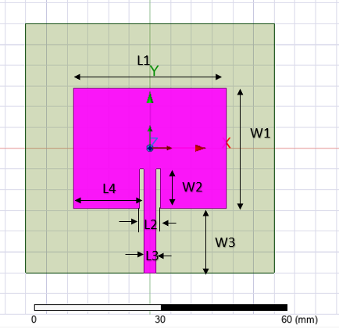
Fig.1: Proposed antenna patch design without DGS
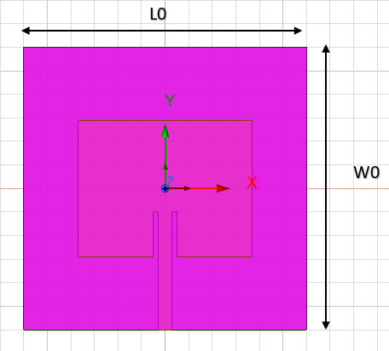
Fig.2: Proposed antenna (Antenna 01) ground plane without DGS
2.3 ANTENNAS WITH DGS
To study the effect of DGS, the effect of DGS is achieved by using variation in the ground plane which comprises five design steps. Fig. 4 displays the evolution process for designing five antennas (Antenna 01 to 05), all having the same patch size. Rectangular slots are incorporated in the ground plane directly beneath the patch of multiple antennas. The slot dimensions and position are selected to improve the antenna parameters without affecting the fundamental mode of operation. Fig. 3 shows the radiating patch. All antennas’ configurations are simulated using High Frequency Structure Simulator (HFSS). The simulations are carried out to study parameters like S11, VSWR, radiation pattern, and gain.

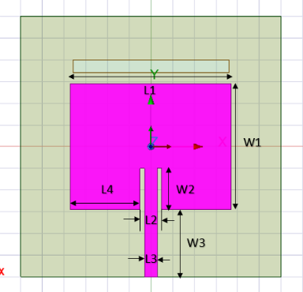

Fig.3: Proposed antenna patch design with DGS
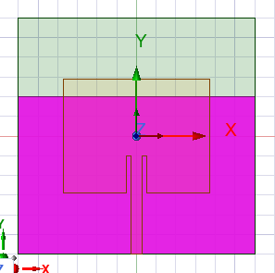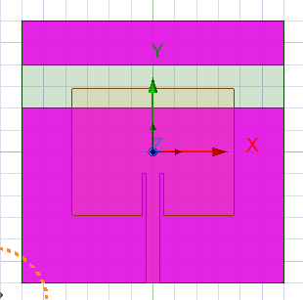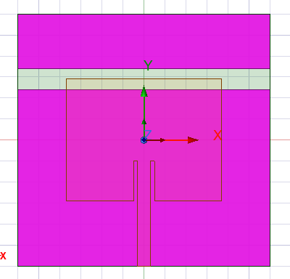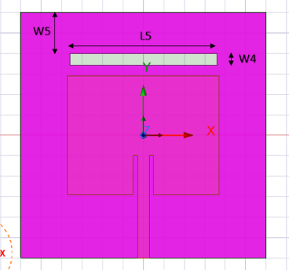
W11
W10
W9
W8
W8
W6
W7
W6
- Antenna 02 (b) Antenna 03 (c) Antenna 04 (d) Antenna 05
Fig.4: Proposed evolution design procedure for the variations in the ground plane with DGS from Antenna 02-05
The dimensions of proposed antenna design as shown in Table 1.
Dimensions | Value (mm)
Width W0 | 60
Width W1 | 29
Width W2 | 9.5
Width W3 | 15.5
Width W4 | 3
Width W5 | 10
Width W6 | 40
Width W7 | 20
Width W8 | 10
Width W9 | 42
Width W10 | 5
Width W11 | 13
Length L0 | 60
Length L1 | 37
Length L2 | 5
Length L3 | 3
Length L4 | 16
Length L5 | 36

Table 1. Proposed antennas (Antenna 01 to Antenna 05) specifications along with their dimensions with DGS
2.4 SIMULATION SETUP
Antenna configurations were simulated using the High Frequency Structural Simulator (HFSS) to obtain parameters such as reflection coefficients S11, VSWR, impedance matching, and gain.
- RESULTS AND DISCUSSION
  - REFLECTION COEFFICIENT AND VSWR
Fig. 5 shows their HFSS simulated return loss (S11) results. The next sections describe and investigate in detail the design procedure for these antennas as well their simulation S11 results.

Fig. 5. Simulated return loss for the five designed antennas.

The simulated reflection coefficient S11 for the antenna 01 (Shown in Fig. 6(a)) without DGS (Antenna 01) stands at -21.35 dB at the operating frequency of 2.4 GHz, indicating good impedance matching at the desired frequency. However, other resonances are also being characterized at 3.8 GHz and 4.5 GHz with S11 values of -28.45 dB and -11.72 dB, respectively. The simulated reflection coefficient of the proposed antennas without DGS to DGS (Antenna 01 to 05) are shown in Fig. 6.
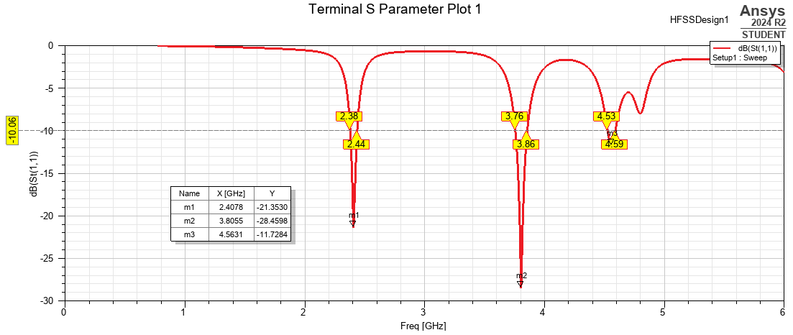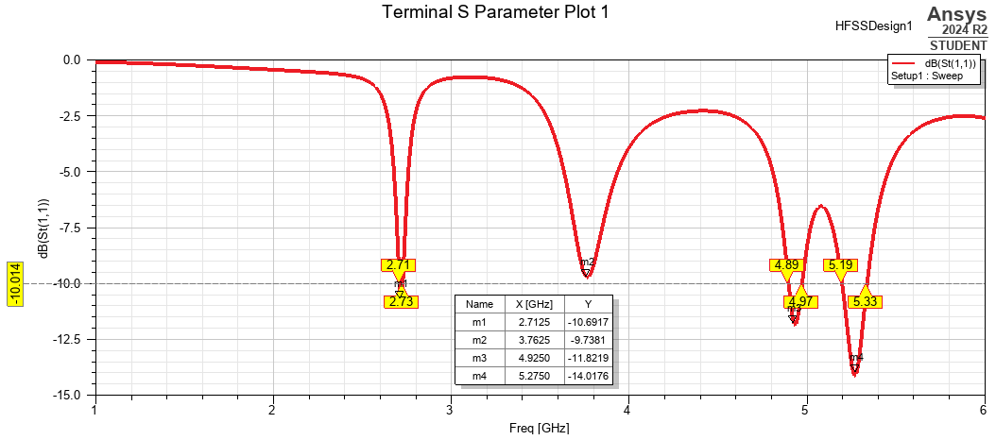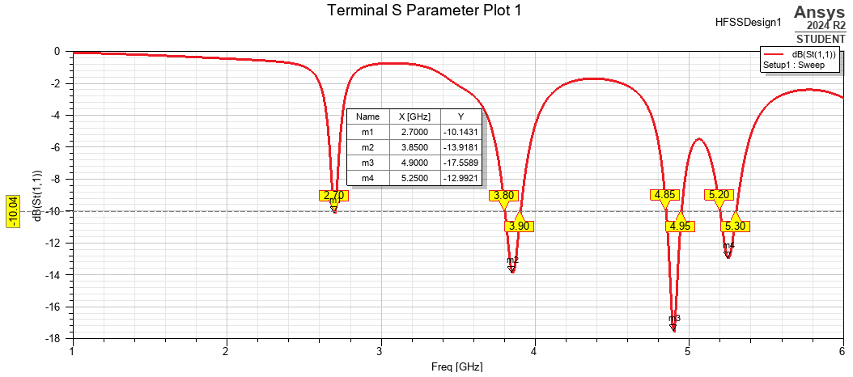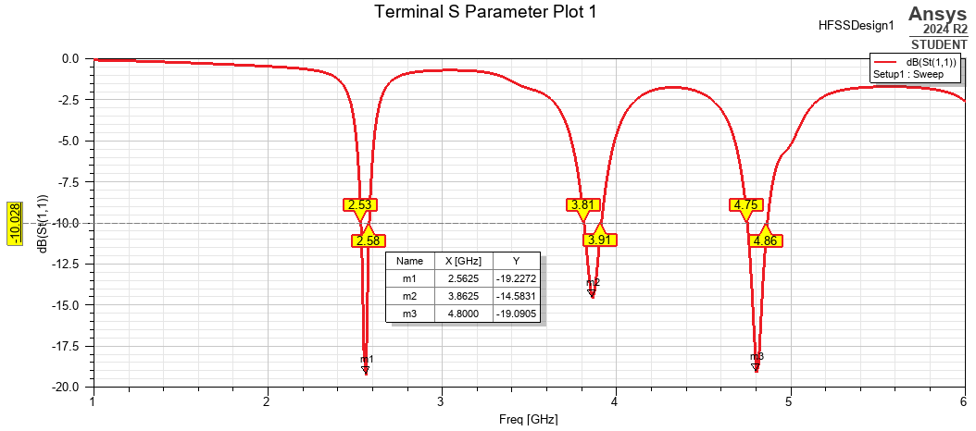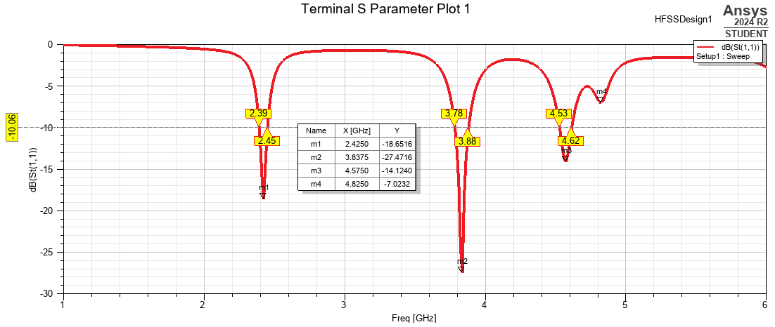
- (b) (c) (d) (e)
Fig. 6: S₁₁ Parameter of simulated rectangular patch antenna without DGS to DGS (Antenna 01 to 05).
Since the Antenna 05 DGS is introduced, the reflection coefficient at 2.4 GHz is changed to -18 dB; the additional resonances are, respectively, shifted to 3.83 GHz (-27.47 dB) and 4.57 GHz (-14.12 dB). The VSWR value for all configurations remains less than 2 over the resonant frequencies, hence indicating good impedance matching. The simulated reflection coefficient of the proposed antenna with DGS is shown in Fig. 5(e).
3.2 IMPEDANCE MATCHING
Smith Chart analysis shows that the DGS antenna has a better impedance matching at the resonance frequency than the antenna without DGS. The DGS introduces additional inductance and capacitance that help in better matching the antenna impedance to the feed line. Fig. 7(a) to Fig. 7(e) shows the simulated Smith chart of Antenna 01 to Antenna 05 for the rectangular patch antenna without DGS to with DGS, respectively.
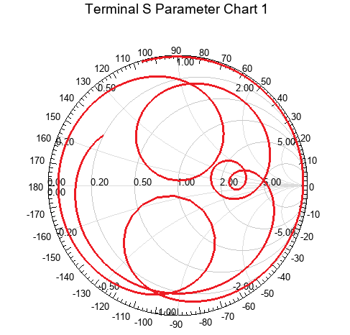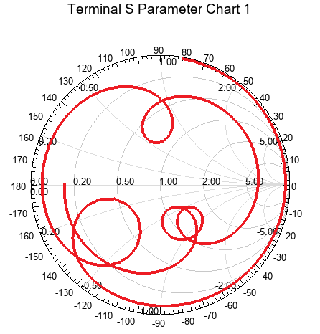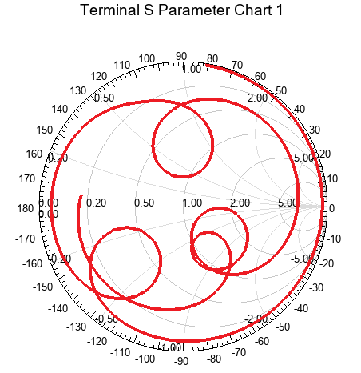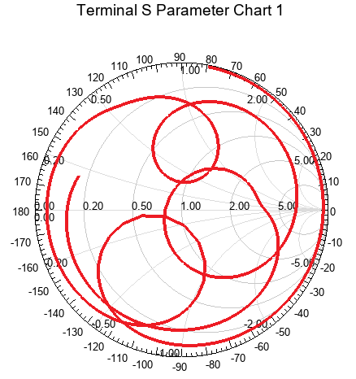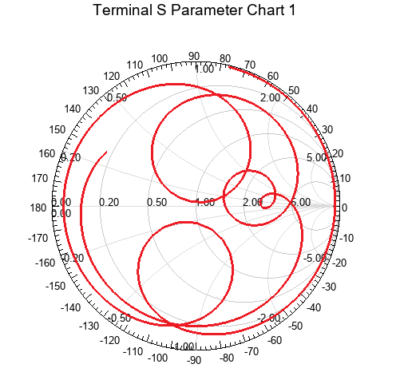
- (b) (c) (d) (e)
Fig. 7: Simulated Smith Chart of rectangular patch antenna without DGS to DGS (Antenna 01 to Antenna 05).

3.3 GAIN
The presence of the DGS leads to an enhancement in antenna gain against the case of no DGS, which can essentially be attributed to surface-wave suppression as well as modification of the current distribution on the ground plane for better radiation. Simulated gain of rectangular patch antennas is shown in Fig. 8, which is without DGS, and Fig. 9, which has DGS.
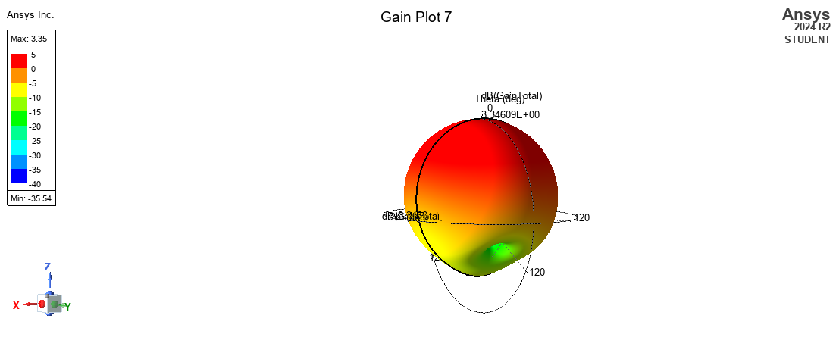
Fig. 8: Gain of simulated rectangular patch antenna without DGS (Antenna 01).
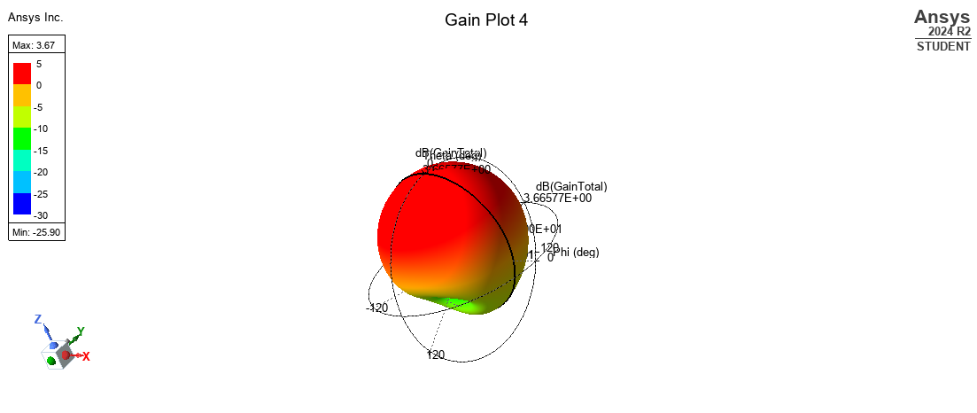
Fig. 9: Simulated Gain of rectangular patch antenna with DGS (Antenna 05).
3.4 FABRICATION AND MEASUREMENT
The antenna along with optimized DGS is fabricated shown in Figures 10 and 11 front view and back view on an FR4 substrate. The measured reflection coefficients were -19.67 dB at 2.37 GHz, -14.58 dB at 3.75 GHz, -16 dB at 4.4 GHz, and -13.55 dB at 4.77 GHz. The measured ranges of VSWR were between 1 and 1.5 in the resonant range. Figures 12, 13, and 14 display the fabricated reflection coefficients, VSWR, and Smith Chart of the proposed antenna with DGS.
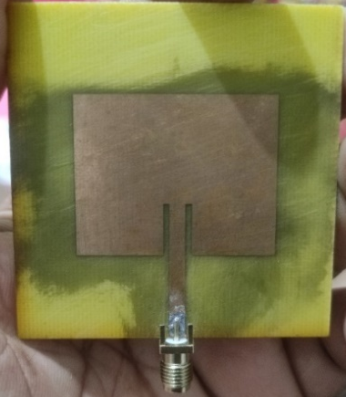
Fig. 10: Front view of the antenna along with optimized DGS
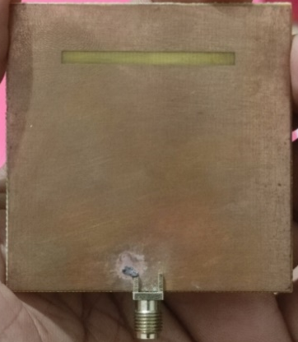
Fig. 11: Back view of the antenna along with optimized DGS

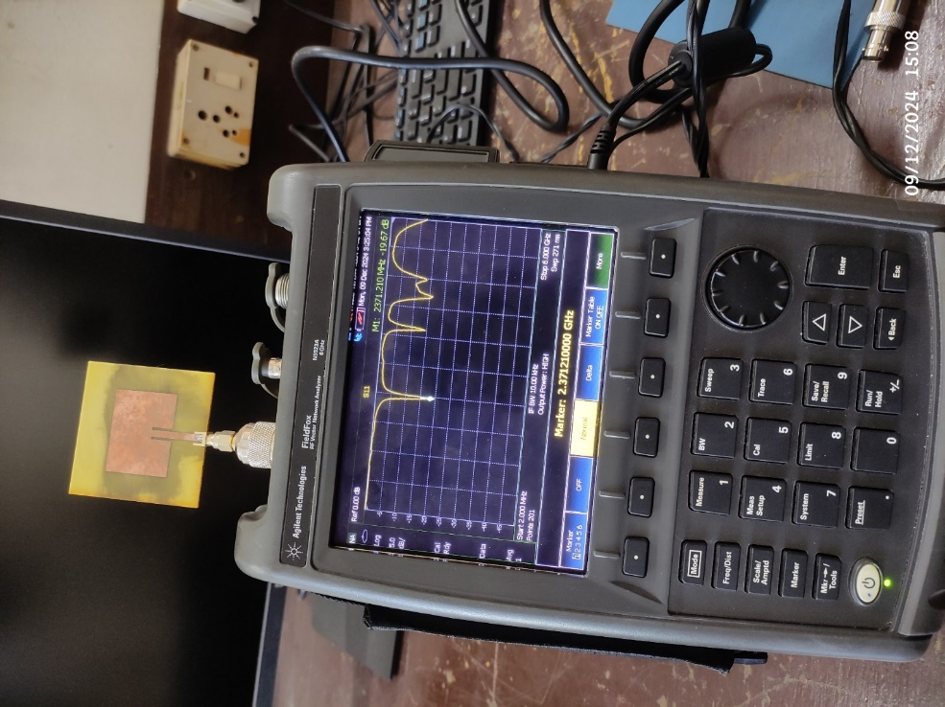
Fig. 12: S₁₁ Parameter of fabricated rectangular patch antenna with DGS.
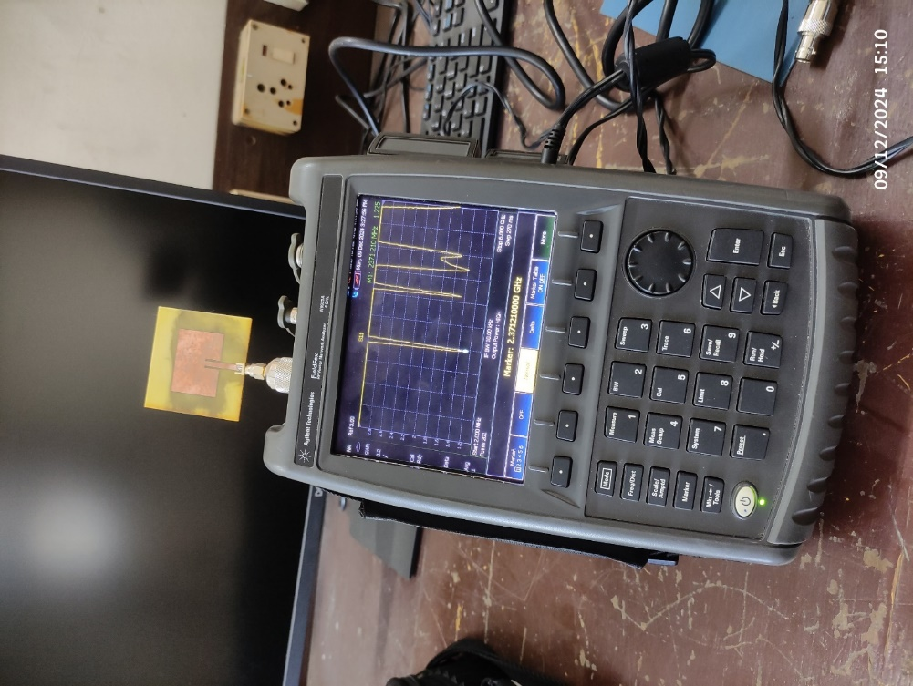
Fig. 13: VSWR of fabricated rectangular patch antenna with DGS.
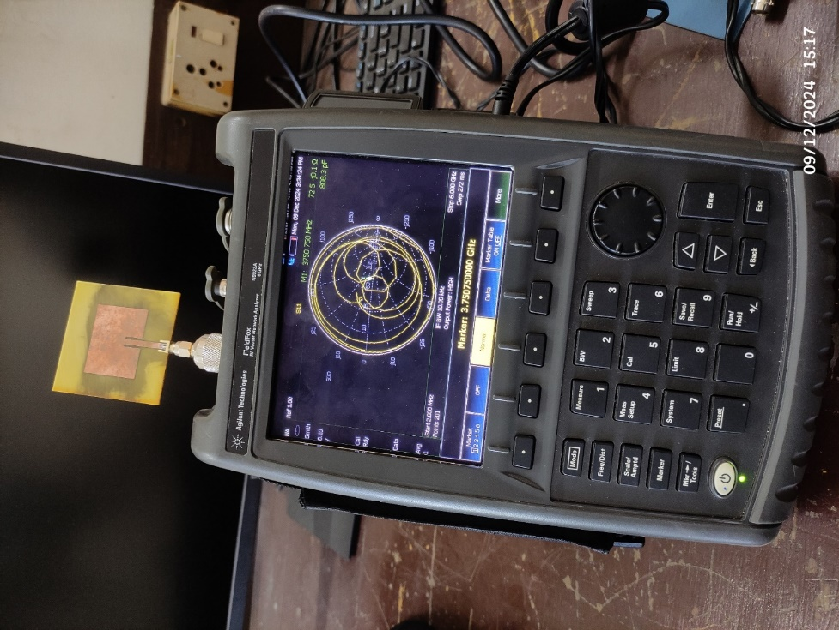
Fig. 14: Smith Chart of fabricated rectangular patch antenna with DGS.
- CONCLUSION
This paper studies the benefits of Defected Ground Structures (DGS) in microstrip patch antennas for the ISM band application. The strategic introduction of the ground plane led to significant improvements in gain, bandwidth, and impedance matching. The DGS modified antenna's reflection coefficient was -19.67 dB at 2.37 GHz, while the VSWR was between 1 and 1.5 for all resonated ranges of the antenna. Improved gain was attributed to reduced surface wave interference, and the improved impedance characteristics were confirmed by the Smith chart analysis. This suggests that microstrip patch antennas can be DGS integrated while still being dependable and efficient and thus suitable for modern wireless communication systems.

COMPETING INTERESTS DISCLAIMER:
Authors have declared that they have no known competing financial interests OR non-financial interests OR personal relationships that could have appeared to influence the work reported in this paper.

REFERENCES
- M. S. Yahya, S. Soeung, S. K. A. Rahim, U. Musa, S. S. B. Hashwan, Z. Yunusa, and S. A. Hamzah, "LoRa microstrip patch antenna: A comprehensive review," Alexandria Engineering Journal, vol. 103, pp. 197–221, 2024, doi: 10.1016/j.aej.2024.06.017.
- U. Raithatha and S. S. Kashyap, "Microstrip patch antenna for ISM band applications," International Journal of Emerging Technology and Advanced Engineering, vol. 5, no. 5, pp. 233-234, 2015.
- Y. Hong, J. Tak, J. Baek, B. Myeong, and J. Choi, "Design of a Multiband Antenna for LTE/GSM/UMTS Band Operation," International Journal of Antennas and Propagation, vol. 2014, pp. 1187–1190, 2014.
- Q. Li, A. P. Feresidis, M. Mavridou, and P. S. Hall, "Miniaturized Double-Layer EBG Structures for Broadband Mutual Coupling Reduction Between UWB Monopoles," IEEE Transactions on Antennas and Propagation, vol. 63, no. 3, pp. 1168–1171, Mar. 2015.
- B. S. G. J. Selvakumar, S. S. Ravi, S. Soman, and S. Damodaran, "A dual band square patch antenna with slots and notches," in AIP Conference Proceedings, vol. 3175, no. 1, Mar. 2025, AIP Publishing.
- K. F. Lee and K. F. Tong, "Microstrip patch antennas—basic characteristics and some recent advances," Proceedings of the IEEE, vol. 100, no. 7, pp. 2169–2180, 2012.
- S. Lamultree, N. Somsanook, W. Narkkoht, and C. Phongcharoenpanich, "A dual-band rectangular shape incorporated into circular patch antenna for 2.4/5 GHz wireless local area network applications," TELKOMNIKA (Telecommunication Computing Electronics and Control), vol. 23, no. 1, pp. 22-31, 2025.
- A. M. M. A. Allam and A. M. G. Hemdan, "Novel DGS Shape for Mutual Coupling Reduction," in GeMiC 2016, Bochum, Germany, Mar. 2016.
- S. Goswami and D. Karia, "Design and Analysis of a Multi-band Flower Shaped Patch Antenna for WLAN/WiMAX/ISM Band Applications," Wireless Personal Communications, vol. 115, no. 2, pp. 1235–1248, 2020.
- M. K. Khandelwal, B. K. Kanaujia, and S. Kumar, "Defected ground structure: fundamentals, analysis, and applications in modern wireless trends," International Journal of Antennas and Propagation, vol. 2017, no. 1, p. 2018527, 2017.
- M. Sharma, "Design of Multiband Circularly/Linearly Polarized Antenna for Multiple Wireless Applications," International Journal of Microwave and Wireless Technologies, vol. 11, no. 9, pp. 967–974, 2019.
- A. Y. Ashyap et al., "An overview of electromagnetic band-gap integrated wearable antennas," IEEE Access, vol. 8, pp. 7641-7658, 2020.
- D. El Nabaoui, et al., "Multiband Planar Inverted F Antenna (PIFA) for ISM, WLAN, and WiMAX Applications," in Proceedings of the Third International Conference on Computing and Wireless Communication Systems (ICCWCS), 2019.
- P. Nayak, S. Verma, and A. Kumar, "Compact Tri-Band Planar Antenna for Wireless Applications," arXiv preprint arXiv:2106.12884, 2021.
- J. D. Zhang, L. Zhu, Q. S. Wu, N. W. Liu, and W. Wu, "A compact microstrip-fed patch antenna with enhanced bandwidth and harmonic suppression," IEEE Transactions on Antennas and Propagation, vol. 64, no. 12, pp. 5030-5037, Dec. 2016.
- A. Arora and N. Kumar, "To reduce mutual coupling in microstrip patch antenna arrays elements using electromagnetic band gap structures for X-band," 2017 International Conference on Nextgen Electronic Technologies: Silicon to Software (ICNETS2), Chennai, India, Mar. 2017, pp. 228-230, doi: 10.1109/ICNETS2.2017.8067946.
- J. Acharjee, A. K. Singh, K. Mandal, and S. K. Mandal, "Defected ground structure toward cross polarization reduction of microstrip patch antenna with improved impedance matching," Radioengineering, vol. 28, no. 1, pp. 33-38, 2019.
- S. Ullah, C. Ruan, M. S. Sadiq, T. U. Haq, A. K. Fahad, and W. He, "Super wide band, defected ground structure (DGS), and stepped meander line antenna for WLAN/ISM/WiMAX/UWB and other wireless communication applications," Sensors, vol. 20, no. 6, p. 1735, 2020.
- S. K. Sharma and P. Thakur, "High-Performance Fractal Antenna for Multiband IoT Applications," IEEE Transactions on Antennas and Propagation, vol. 68, no. 12, pp. 8158–8162, 2020.
- R. Jain, P. Kanaujia, and D. Gangwar, "Compact Ultra-Wideband Antenna with Multiband Characteristics for Modern Wireless Devices," IET Microwaves, Antennas & Propagation, vol. 13, no. 4, pp. 425–432, 2019.
- C. Wang, L. Wei, and T. Huang, "Miniaturized Multiband Antenna Using Metamaterial-Based Structures for Wireless Applications," Progress in Electromagnetics Research C, vol. 105, pp. 59–69, 2020.
- X. Liu and Y. Zhang, "A Novel Quad-Band Antenna for WLAN and WiMAX Applications," IEEE Antennas and Wireless Propagation Letters, vol. 18, no. 4, pp. 724–728, 2021.
- R. Verma, et al., "Miniaturized Slot Antenna with Wideband Characteristics for IoT Applications," Progress in Electromagnetics Research B, vol. 92, pp. 153–170, 202
- C. A. Balanis, Antenna theory: analysis and design, John Wiley & Sons, 2005.

