**Analysis of the microbiological quality of drinking water from some wells and boreholes in the city of Mongo, Chad**

**Abstract**: Water is an essential mineral compound that plays an important role in life, health, and human dignity. Due to the absence of the Chadian Water Society (STE) networks in certain neighbourhoods, households are forced to source water from other places, such as wells and boreholes. The aim of this study is to assess the microbiological quality of well and borehole water consumed in the city of Mongo. **Methodology:** To carry out this study, a randomized selection of forty-three (43) water points, including sixteen (16) wells and twenty-seven (27) boreholes, was made, and samples were collected. These samples were transported to the National Water Laboratory (LNE) for the analysis of several microbiological parameters, namely *Escherichia coli*, Total coliforms, Fecal coliforms, Fecal enterococci, *Salmonella spp*, and Total aerobic flora. The technique used for this analysis is spread plating and membrane filtration. **Result:** The average values obtained for borehole water are 0.187*10⁴ CFU/100 ml for Total coliforms, 0.646*10³ CFU/100 ml for Fecal coliforms, 1.77*10³ CFU/100 ml for *Escherichia coli*, 50 CFU/100 ml for Fecal enterococci, 11.11 CFU/100 ml for *Salmonella spp*, and 1.1888*10⁴ CFU/100 ml for Total aerobic flora. Regarding well water, the average values obtained are 2.081*10³ CFU/100 ml for Total coliforms, 0.412*10³ CFU/100 ml for Fecal coliforms, 0.7*10³ CFU/100 ml for *Escherichia coli*, 169 CFU/100 ml for Fecal enterococci, 1.4983*10⁴ CFU/100 ml for *Salmonella spp*, and 6.25 CFU/100 ml for Total aerobic flora. **Conclusion**: Microbiological analyses showed a high bacterial density in most samples, making them unfit for human consumption when compared to the WHO drinking water standards. Therefore, appropriate intervention strategies must be implemented to address these issues.

**Keywords**: Microbiological Quality, Water, Boreholes, Wells, Mongo-Chad

1. **INTRODUCTION**

Water is a mineral compound that plays an essential role in life, health, and human dignity **(1-5).** “ Water performs a number of functions for the body. It serves as a body transport system; acts as a lubricant; regulates body temperature; etc. In fact; more than 2/3 of the human body is made of water. Safe access to safe drinking water for urban and rural populations in developing countries remains a challenge for sustainable development ” [29,30]. The quality of drinking water is assessed by its physico-chemical and bacteriological properties ( **6-10** ).

“ The United Nations General Assembly expressed serious concern in 2018 that nearly 900 million people worldwide do not have access to clean water. Microbiological contamination of drinking water can be the cause of transposing. The microbiological contamination of drinking water can be the cause of transmission of diseases such as diarrhoea, cholera, dysentery, typhoid and polio, and is estimated to cause 505,000 deaths each year from diarrhoeal diseases ” **(12**).

“ In Chad, access to clean drinking water and a healthy environment remains a luxury for the population, despite the good intentions and commitments made by the Chadian government to address this issue through the 2003 water master plan. According to the WHO, in 2017 only 14% of the Chadian population had access to basic sanitation facilities, which contributes to the spread of waterborne diseases ” **(13,31)**. Furthermore, open defecation is common in many regions of the country, which exacerbates health and environmental risks.

“ The Guera region, with Mongo as its capital, is among those most affected by water shortages and the practice of open defecation. As an example, the management of the drinking water supply system in the town of Mongo was officially transferred to the Chadian Water Company (STE) on July 23, 2020. With a capacity of 100 m3, the water tower, installed in 1987 for a population of 15,000 inhabitants, is no longer sufficient to meet the water supply needs of a population now estimated at over 73,000 inhabitants, according to the mayor, putting additional pressure on the available water resources. Furthermore, in the absence of Chadian Water Company (STE) networks in some neighborhoods, households are forced to obtain water from other sources, such as wells, and boreholes, and by purchasing water from the STE at public standpipes and/or from street vendors. Other types of water, such as rainwater and water from streams ” [13]. The objective of this study is to assess the microbiological quality of well and borehole water consumed in the city of Mongo, chad.

**2. MATERIALS AND METHODS**

**2.1 Framework of study**

The city of Mongo, the capital of Guera Province, is located between the parallels 1209.5’ and 12o12.5’ Nord latitude and the meridians 18o40’ to 18o44’ east longitude (fig.1). it is 520 km by road from the capital N’djamena (**14**).

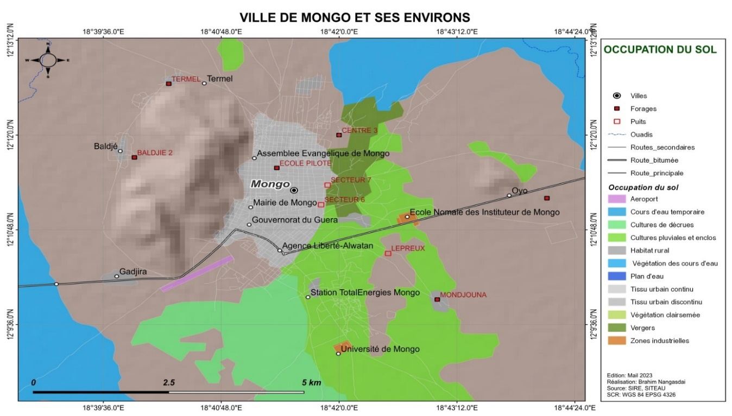

**Figure 1: Map of the city of Mongo (LNE, 2024)**

**2.2 Identification of Water Points, Sampling, and Sample** **Conditioning**

The operational method used is that adopted by Rodier et al., (**15**). A total of forty-three (43) samples were collected, including sixteen (16) well water samples and twenty-seven (27) borehole water samples. The samples were collected in sterile 500 ml glass bottles at each site. The collected samples were immediately sealed, labelled, and placed in a cooler with ice packs at a temperature of 4°C and transported to the National Water Laboratory in N'Djamena for microbiological analysis. Six (6) microbiological parameters were investigated and counted in this study: Total coliforms, faecal coliforms, Escherichia coli, faecal enterococci, Salmonella spp., and total aerobic flora.

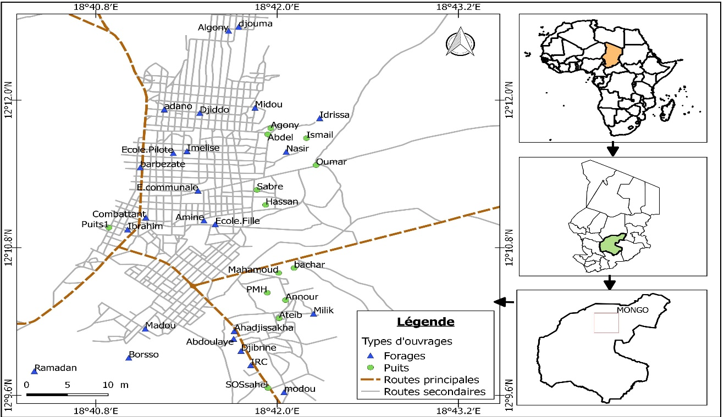

**Figure 2 :** Map of the sampling points location **(LNE, 2025)**

**2.3 Microbiological Analysis**

The membrane filtration method was used to determine the bacteria indicating faecal pollution. Identification was performed by spreading for some samples and by filtering at least 2 ml of water onto a cellulose membrane with uniformly sized pores of 0.45 μm in diameter. Table 1 summarizes the techniques used, the culture media, the incubation time, and the temperature for each microorganism.

**Table 1 : Method of search and identification of the** Microorganismes **sought**

|  |  |  |
| --- | --- | --- |
| microbial analysis | Culture medium | Incubation time and temperature |
| Total coliforms | Chromocult agar | 24h - 36±1°C |
| Fecal coliforms | Chromocult agar | 24h - 44±1°C |
| *Escherichia Coli* | Chromocult agar | 24h - 36±1°C |
| Fecal Enterococci | Slanetz Bartley Agar | 48h - 36±1°C |
| Total aerobic flora *Salmonella SPP* | PCA  SS | 24 - 48H - 36±1°C  24 - 48H - 36±1°C |

**2.4 Data analysis**

Microsoft Excel 2016 software was used to perform statistical analyses of the data. Microbiological analyses were performed in triplicate. The results are presented as an average.

**3. Results and discussion**

**3.1 Average loads of pathogenic Microorganisms** **in well and borehole water**

**Table 2** : Average loads and extreme values ​​of the desired microbes (CFU/100 mL)

|  |  |  |  |  |  |  |  |
| --- | --- | --- | --- | --- | --- | --- | --- |
| Researched microbes | Drilling water | | | Borehole water | | | WHO Guidelines (2017) |
|  | Min. | Min. | Min. | Min. | Max. | Avg. |
| Total coliforms | 400 | 0.9 104 | 0.187 104 | 0 | 1.03104 | 2.081 103 | 00 UFC/ 100 ml |
| Fecal coliforms | 270 | 2.6 103 | 0.646 103 | 0 | 0.1 104 | 0.412 103 | 00 UFC/ 100 ml |
| *Escherichia coli* | 0 | 0.98103 | 1.77 103 | 0 | 1.02103 | 0.7 103 | 00 UFC/ 100 ml |
| Fecal enterococci | 0 | 570 | 50 | 0 | 1.7 103 | 169 | 00 UFC/ 100 ml |
| Total aerobic flora *Salmonelles spp* | 195  0 | 1.98104  50 | 1.1888 104  11.11 | 192  0 | 1.97104  50 | 1.4983 104  6.25 | --  00 UFC/ 100 ml |

**Avg.: Average. Min : Minimum Max. : Maximum**

The results of the germ counting (Table 2) revealed an average load of 0.187*10⁴ and 2.081*103 CFU/100 ml for total coliforms in respectively borehole and well water, with extreme values ranging between 400 and 0.6*10⁴ CFU/100 ml for well water and between 0 and 1.03*10⁴ CFU/100 ml for borehole water.

For fecal coliforms, the extreme values obtained range from 270 to 2.6*103 CFU/100 ml, with an average load of 0.646*103 CFU/100 ml for borehole water and from 0 to 1.04*103 CFU/100 ml with an average of 0.412*103 CFU/100 ml for well water, considering the tolerance threshold set by the WHO.

Regarding Escherichia coli, the extreme values of the loads obtained range from 0 to 0.7*103 CFU/100 ml, with an average load of 1.02*103 CFU/100 ml for well water, and from 0 to 0.98*103 CFU/100 ml with an average of 1.77*103 CFU/100 ml for borehole water.

Faecal enterococci are present with an average load of 169 CFU/100 ml for well water and 50 CFU/100 ml for borehole water, corresponding to values ranging from 0 to 1.7*103 CFU/100 ml for well water and between 0 to 570 CFU/100 ml for borehole water.

The extreme values of the total aerobic flora loads obtained were 195 and 1.98*103 CFU/100 ml for borehole water, and 192 and 1.97*10⁴ CFU/100 ml for well water. The average loads were 1.1888*10⁴ CFU/100 ml for well water and 1.4983*10⁴ CFU/100 ml for borehole water. The extreme values of the loads obtained for Salmonella spp. were 0 and 50 CFU/100 ml for both boreholes and wells, with an average load of 11.11 CFU/100 ml for borehole water and 6.25 CFU/100 ml for well water.

**3.2 E. coli Contamination of Well and Borehole Water**

**Figure 3 :** Compliance rates of well and borehole water with respect to *E. Coli*

The compliance rate of well and borehole waters for *Escherichia coli* generally gives us 74, 42% of samples are compliant and 25.58% of samples are non-compliant. Well water yielded the most conformal samples with 80% and boreholes 71.43%.

**3.2 Contamination of wells and boreholes water by total coliforms**

**Figure 4 :** Compliance rate of well and borehole water relative to total coliforms **Count**

The study areas are given in general :

* 90,7 % of the samples are non-compliant;
* 9,3 % of samples are compliant;
* 80% of well water is non-compliant. For borehole water, 80.56% of the samples do not comply with the WHO standard.

**3.3 Contamination of well and borehole water by faecal coliforms**

**Figure 5** : Compliance rate of well and borehole water with faecal coliforms

Faecal coliform counts in well and borehole waters are shown in Figure 5 above. Of all the samples taken, only 11.63% meet the WHO standard. Only 20% and 7.14% of the well and drilling water samples respectively comply with the standard.

**3.4 Contamination of well and borehole water by faecal enterococci**

**Figure 6**: Compliance rate of well and borehole water against faecal Enterococci

Figure 6 shows the levels of contamination of well and borehole water by faecal enterococci. 80% of well water samples are compliant for 20% of non-compliant samples. For borehole water, only 14, 29% of the samples were non-compliant with the WHO standard.

**3.5 Contamination of well and borehole water by *Salmonella spp***

**Figure 7**: Compliance rate of well and borehole water against *Salmonella spp*

The count of *Salmonella SPP* in the samples gave a non-conformity rate of 20.93% overall. The non-compliance rate for wells and boreholes was respectively 20% and 21.43% and about 80% of the samples did not contain *Salmonella SPP*.

**3.6 Contamination of well and borehole water by** **aerobic flora**

**Figure 8** : Compliance rate of well and borehole waters with respect to total aerobic flora

Figure 8 shows the levels of contamination of well and borehole water by total aerobic flora. 100% of the samples from all well structures such as drilling are not in accordance with WHO standards.

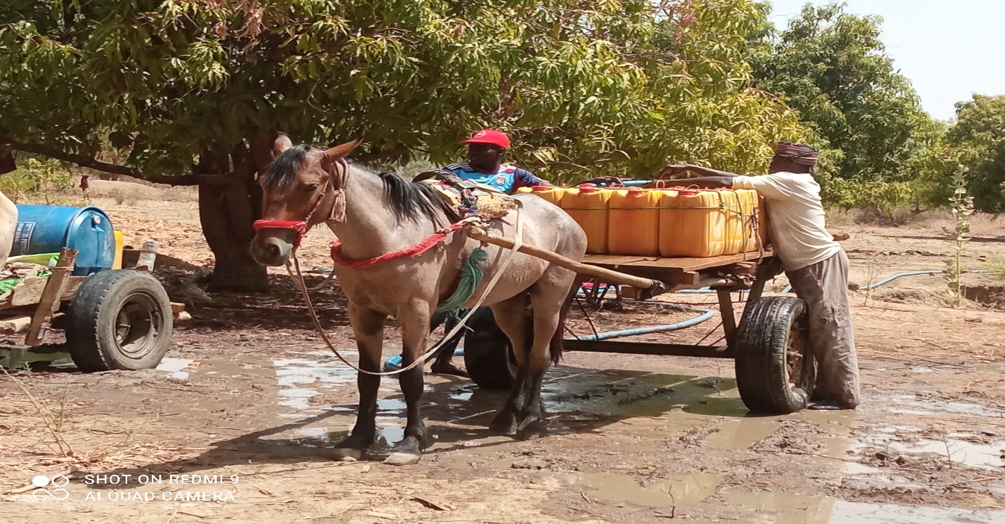 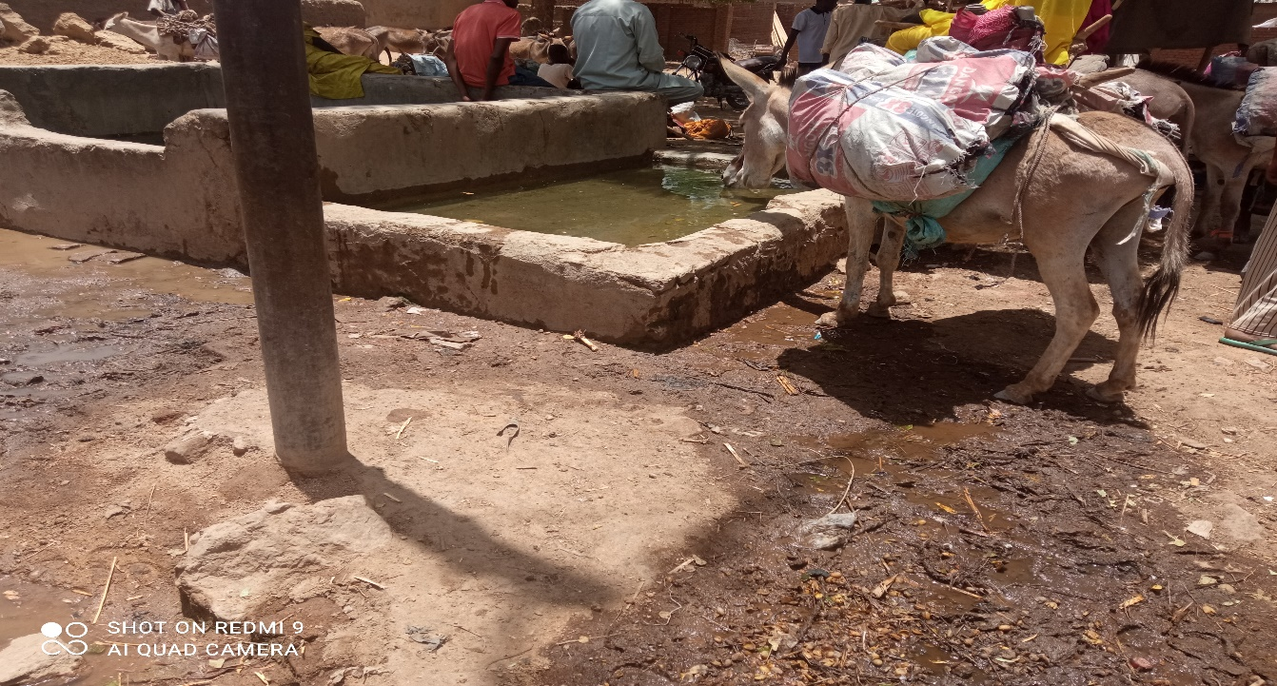

**Figure 9:** water point with the presence of animals

The results of the microbiological analyses showed that all the samples of well and borehole water studied had a high contamination rate of Escherichia Coli, Salmonella-Shigella, Total Coliforms, Fecal Coliforms, Enterococci, and total aerobic flora. However, the highest bacterial loads were observed for Total Coliforms, Fecal Coliforms, and Total Aerobic Flora, with 96.43% for boreholes and 80% for wells, 92.86% for boreholes and 80%, followed by 100% non-compliance. Our results are consistent with those of Louzayadio Mvouezolo et al. (2021) (**16**), Louzayadio Mvouezolo (2019) (**17**) on groundwater in the Kombé neighbourhood (Togo), and Zvidzai et al. (2007) in Zimbabwe (**18**), who found high contamination of well water by fecal microbes compared to borehole water. Coumare et al. (2018) on the bacteriological quality of drinking water (boreholes and wells) in three districts of the Koulikoro region in Mali (**19**) found results similar to this study, with 5.3% non-compliance for borehole water and 94.7% non-compliance for well water. For total coliforms, the proportion of compliant samples reported by Soncy et al. (2015) (63%) (**20**) and Benaissa (**21**).

Thus, globally, taking into account the three types of microbes, the overall compliance rate obtained during this study was higher than that found in the well water in Togo (Fambi et al., 2021) (**22**). Indeed, these authors reported faecal-origin bacterial contamination in the majority of the well waters they studied (over 75%), especially for total coliforms, indicating a lack of hygiene around these wells. The wells showed a non-compliance rate of 20% for *E. coli*, faecal Enterococci, and *Salmonella SPP*, while the boreholes showed a non-compliance rate of 28.57% for E. coli, 14% for Enterococci, and 100% for total aerobic flora. Our results are similar to those of A. Abengourou in Côte d'Ivoire, where Aka et al. (2013) (**23**).found *Escherichia coli* strains in 28% of the analyzed well water samples, but lower than those of Sokegbe et al., who showed a non-compliance rate of 66.67% for wells due to the presence of Escherichia coli, and their absence in borehole waters (**24**). Similarly, Soncy et al. (2015) reported a non-compliance rate of 70.08% in well water samples analyzed in Lomé (Togo) (**25**). The poor quality of these waters can be explained not only by the lack of sanitation but also by the unhealthy environment due to the lack of hygiene around these water sources (Nanfack et al., 2013) (**26**).

The presence of a high bacterial density in these waters could be explained by the fact that not all wells respect the required distance of more than 15 meters between the well and the nearest latrine, as well as the absence of casing, which significantly increases the risks of water point contamination. Disinfection is necessary before any use. It is therefore important to monitor factors that may contribute to this contamination because the presence of coliforms, *Escherichia coli, Salmonella spp*, and other coliforms in drinking water indicates faecal contamination and non-potability of the water, regardless of the number of microbes, even one (1) in 100 ml of sampled water (Balloy M et al., 2019) (**27**).. Consumption of this water exposes the local population to numerous waterborne diseases such as typhoid, dysentery, and diarrhoea, as these waters contain high levels of *Escherichia coli* and coliforms (WHO, 2011) (**28**).

**5. CONCLUSION**

This study assessed the microbiological quality of well and borehole water consumed in the city of Mongo (Chad). Most of the samples contained total coliforms, faecal coliforms, faecal enterococci, Salmonella spp., and Escherichia coli. The contamination of these waters by fecal-origin bacteria poses a major risk of gastroenteritis for consumers. The main causes are the lack of sanitation and poor hygiene practices around these water sources. These waters must be treated, and the environments of water points should be improved to limit contamination and reduce the incidence of waterborne diseases.

**Disclaimer (Artificial intelligence)**

Option 1:

Author(s) hereby declare that NO generative AI technologies such as Large Language Models (ChatGPT, COPILOT, etc.) and text-to-image generators have been used during the writing or editing of this manuscript.

Option 2:

Author(s) hereby declare that generative AI technologies such as Large Language Models, etc. have been used during the writing or editing of manuscripts. This explanation will include the name, version, model, and source of the generative AI technology and as well as all input prompts provided to the generative AI technology

Details of the AI usage are given below:

1.

2.

3.

**REFERENCE**

1. Niambele D, Diarra O, Bagayoko M.W, Samake S, Samake F, Babana, A.H.; (2020) Evaluation of the Bacteriological Quality of the Drilling Water Analyzed at the National Health Laboratory during the First Half of 2019; International Journal of Science and Research (IJSR) ISSN: 2319-7064, 392- 395.
2. Who (2011) Water Quality and Waterborne disease in the Niger River Inland Delta, Mali: A study of local knowledge and response, Health and Place, vol.2, 2011, PP
3. Adetunde, L.A., et Glover, R.L.K. (2011) Evaluation of bacteriological quality of drinking water used by selected secondary schools in Navrongo in Kassena- Nankana district ofupper east region of Ghana. Prime J. Microbiol. Res. 1, 47–51.
4. WHO and UNICEF (2018) Progress on sanitation and drinking water; Report. 98 p.
5. Diallo T. (2017) Bacteriogical quality of drinking water; Doctoral thesis in Pharmacy, Faculty of Medecine of pharmacy and Odontostomatology, University of Bamako, 32P.
6. Adesakin A. T, Oyewale T. A, Bayero U, Mohammed A. N, Aduwo I. A, Zubeidat P.A, Dalhata N. A, Balkisu I. B. (2020) Assessment of bacteriological quality and physico-chemical parameters of domestic water sources in Samaru community, Zaria, Northwest Nigeria, Elsevier, Heliyon (6) e04773, 13 p
7. Sila,O.N. (2019) Physico-chemical and bacteriological quality of water sources in rural 11 settings, a case study of Kenya, Africa; Elsevier, Scientific African (2) e0 0 018, 13 p.
8. Esharegoma, O.S., Awujo, N.C., Jonathan, I., Nkonye-Asua, I.P., (2018) Microbiological and physicochemical analysis of Orogodo River, agbor, delta state, Nigeria. International Journal of Ecological Science and Environmental Engineering 5 (2), 34–42.
9. Bello, O.O, Osho, A., Bankole, S.A., Bello, T.K., (2013) Bacteriological and physicochemical analyzes of borehole and well water sources in ijebu-ode, southwestern Nigeria. Journal of Pharmaceutical and Biological Research 8 (2), 18– 25.
10. Okoli, E.N., (2012) Evaluation of the bacteriological and physicochemical quality of water supplies in Nsukka, Southeast, Nigeria. Afr. J. Biotechnol. 11(48), 10868–10873. Sila,O.N. (2019) Physico-chemical and bacteriological quality of water sources in rural 11 settings, a case study of Kenya, Africa; Elsevier, Scientific African (2) e0 0 018, 13 p.
11. WHO and UNICEF (2018) Progress on sanitation and drinking water; Report. 98p.
12. **OMS, 2022. https://www.who.int/fr/news-room/fact-sheets/detail/drinking-water**
13. World Health Organization (WHO). 2017. Guidelines for drinking-water quality, 4th edition including the first addendum, Geneva, 564p
14. . INSEED, 2009. Map of Chad, administrative division and communication routes at a scale of 1/7,000,000.
15. . Rodier J., Legube B., Merlet N. Water analysis, 9th edition, Ed. Dunod, 2009, 1579p.
16. Louzayadio Mvouezolo R.F., Ayessou N., Nkounkou Loumpangou C., Tchoumou M., Mar Diop C.G. and Ouamba J-M., 2021. Vulnerability to Microbiological Pollution of Tap Water and Groundwater Consumed in the Southern Zone of the City of Brazzaville (Republic of the Congo). International Journal of Environmental Monitoring and Analysis, 9(5), 152-161
17. **Louzayadio Mvouezolo** Chouti, W. K., 2007. Evaluation de la qualité des eaux de puits couverts munis de pompe dans la commune de Porto-Novo (Mémoire de Master). Repéré à <https://www.memoireonline.com///10/10/3944/Evaluation-de-laqualite-des-eaux-des-puits-couverts-munis-de-pompe-dans-lacommune-de-Porto-Novo.html>. doi:10.11648/j.ijema.20210905.16
18. **Zvidzai et al.** **(2007**) Zvidzai C, Mukutirwa T, Mundembe R, Sithole-Niang I. 2007. Microbial community analysis of drinking water sources from rural areas of Zimbabwe. African Journal of Microbiology Research, 1(6): 100-103.
19. Coumare K, Diallo T, Siby L, Haidara A, Traore M, Coulibaly M, Sangare D, Traore IT, Tangara D, Coulibaly SM, Koumare BY. 2018. The bacteriological quality of drinking water (boreholes and wells) in three circles of the Koulikoro region. Mali Rev. Mali Infect. Microbiol., 11: 25- 32.
20. . Soncy K, Djeri B, Anani K, Eklou-Lawson M, Adjrah Y, Karou DS, Ameyapoh Y, De Souza C. 2015. Assessment of the bacteriological quality of well and borehole water in Lomé, Togo. J. Appl. Biosci., 91: 8464-8469. DOI: <http://dx.doi.org/10.4314/jab.v91i1.6>
21. Benaissa C, Bouhmadi B, Rossi A. 2023. An assessment of the physicochemical, bacteriological quality of groundwater and the water quality index (WQI) used GIS in Ghis Nekor, Northern Morocco. Scientific African, 20: e01623. DOI: https://doi.org/10.1016/j.sciaf.2023.e016 23
22. . Pazou, E. Y. A., Azocli, D., Hinson, A. V., Assogba, B., Avoce, H., & Hozanhekpon, E. 2018. Study of the quality of water consumed in the commune of Adjohoun in Benin. International Journal of Biological and Chemical Sciences 12(4): 1920 1930.
23. Aka N., Bamba S., Soro G. and Soro N., 2013. Hydrochemical and microbiological study of Alterite layers in a humid tropical climate: Case of the Department of Abengourou (South-East of Côte d’Ivoire). Larhyss, ISSN 1112-3680, No. 16, December 2013, pp. 31-52
24. . O. Y. SOKEGBE et al. Ognansan Y. SOKEGBE, Bouraïma DJERI, Essozimna KOGNO*, Messanh KANGNIDOSSOU, Raouf T. MENSAH, Kouassi SONCY and Yao. 2017. Health risks related to drinking water sources in district No. 2 of Lomé-commune: case of the Adakpamé district. Int. J. Biol. Chem. Sci. 11(5): 2341-2351. DOI: https://dx.doi.org/10.4314/ijbcs.v11i5.31
25. . Soncy K, Djeri B, Anani K, Eklou-Lawson M, Adjrah Y, Karou DS, Ameyapoh Y, De Souza C. 2015. Assessment of the bacteriological quality of well and borehole water in Lomé, Togo. J. Appl. Biosci., 91: 8464-8469. DOI: http://dx.doi.org/10.4314/jab.v91i1.6
26. . Nanfack et al., 2013. Nanfack NAC, Fonteh FA, Payne VK, Katte B, Fogoh JM. 2014. Unconventional water: a risk or a solution to water problems for the poor. Larhyss Journal, 17: 47- 64.
27. . Balloy Mwanza P, Katond JP, Hanocq P. 2019. Evaluation of the physicochemical and bacteriological quality of well water in the spontaneous neighborhood of Luwowoshi (DR Congo). Tropicultura, 37(2): 1-15. DOI: 10.25518/2295- 8010.627
28. World Health Organization (WHO). 2011. Guidelines for drinkingwater quality. Fourth edition. Geneva, Switzerland, 564 p
29. Nishan, K. F., Yeasmin, N., Devi, U. R., Akter, S., Bakar, M. A., & Haque, M. M. (2020). Physiochemical and Microbiological Analysis of Drinking Water in Chattogram City, Bangladesh. Asian Journal of Advanced Research and Reports, 12(2), 42–50. <https://doi.org/10.9734/ajarr/2020/v12i230286>
30. Dianou, D., Savadogo, B., Zongo, D., Zougouri, T., Poda, J. N., Bado, H., & Rosillon, F. (2011). Surface Waters Quality of the Sourou Valley: The Case of Mouhoun, Sourou, Debe and Gana Rivers in Burkina Faso. *International Journal of Biological and Chemical Sciences*, *5*(4), 1571-1589.
31. Kanika, M. A., Soudy, I. D., Nazal, A. M., Adam, O. Y., & Allamine, Y. M. (2024). Assessment of the Microbiological Quality of Drinking Water from Some Wells and Boreholes in the City of Abeche (Chad). Food and Nutrition Sciences, 15(12), 1253-1263.