**Unveiling the Molecular Arsenal: NIK1-Mediated Translation Suppression as a Key Player in Plant Antiviral Immunity**

**Abstract**

Plant cells are continually exposed to a variety of microbes, with viral infections standing out as a major agricultural challenge. Viruses often undermine plant defenses, posing a significant threat to the productivity of crucial crops and global food security. Plant viruses, due to their limited coding capacity, heavily rely on the host cell machinery during infection, interacting with numerous host proteins. Given the absence of translation-required components in viral genomes, plant viruses have evolved strategies to manipulate the host protein synthesis machinery for viral protein production. In this study, a combination of molecular biology, genetic, and biochemical approaches was employed to investigate plant-virus interactions. Reverse genetics, transcriptomic analyses, and protein interaction assays were used to identify key host factors involved in viral translation and defense responses. The findings revealed that susceptible recessive resistance genes, encoding translation initiation factors such as eIF4E and eIF4G, can suppress viral mRNA translation by disrupting the formation of the translation initiation complex. Additionally, viral RNA silencing mechanisms were examined using RNA interference (RNAi) assays, which demonstrated that virus-induced gene silencing (VIGS) effectively reduces viral load in infected plants. Furthermore, activation of classical pathogen-associated molecular pattern (PAMP)-triggered immunity (PTI) by plant viruses leads to the induction of Nuclear Shuttle Protein-Interacting Kinase 1 (NIK1), which globally suppresses host translation, reducing viral replication by over 60% in tested plant models. The study also revealed that NIK1-mediated suppression selectively targets viral mRNAs while limiting general host translation, thereby enhancing plant antiviral resistance. These insights into plant-virus interactions and translational suppression provide a foundation for engineering virus-resistant crops. Future applications of this research include genome editing (e.g., CRISPR-Cas9) to modify key translation factors for enhanced resistance, as well as targeted breeding strategies to develop resilient crop varieties. Understanding these molecular mechanisms offers a path toward sustainable agricultural practices and improved food security in the face of viral threats.

**Introduction**

Plants continually face harsh environmental conditions, causing detrimental effects on their growth and development, resulting in significant global yield losses. In the realm of plant-microbe interactions, viruses stand out as a prominent biotic factor, exerting substantial constraints on agriculture by suppressing plant defenses and severely limiting crop productivity (Jones and Dangl, 2006). This poses a significant threat to global food security, making it imperative to delve into the intricate mechanisms underlying plant-virus interactions. Plant viruses, characterized as obligate parasites with a constrained viral genome, heavily rely on the host intracellular machinery for various aspects of their life cycle, including genome replication, gene expression, and the establishment of infection. Unlike animal viruses, plant viruses employ different entry strategies, being delivered into cells by insect vectors or through opportunistic mechanical wounds. Once inside the cells, viral particles undergo disassembly to release the viral genome, initiating the infectious cycle. This cycle involves the expression and replication of the viral genome, cell-to-cell and long-distance movement, and vector-mediated transmission to new hosts, creating extensive interactions between plant viruses and their hosts, resulting in physiological disorders and plant diseases that impede agricultural productivity on a global scale. To counteract viral infections, plants have evolved a sophisticated immune system that employs multiple defense mechanisms. These mechanisms include gene silencing, immune receptor signaling, hormone-mediated defense, protein degradation, and the regulation of metabolism (Incarbone and Dunoyer, 2013). RNA silencing emerges as a major player in plant antiviral immunity, although it is often suppressed by co-evolving viral suppressors, enhancing viral pathogenicity in susceptible hosts. Additionally, plants utilize nucleotide-binding leucine-rich repeat (NB-LRR) domain-containing resistance proteins, recognizing viral effectors and activating effector-triggered immunity (ETI), similar to non-viral infections (Mandadi and Scholthof, 2013). Innate pathogen-associated molecular pattern (PAMP)-triggered immunity (PTI) also plays a role in limiting viral infection (Korner et al., 2013). Recent advancements have uncovered a novel mechanism for antiviral defense in plants involving a transmembrane immune receptor, structurally similar to co-receptor-like kinases in PTI, activating host translation suppression to combat DNA viruses (Zorzatto et al., 2015). Furthermore, viral infections can disrupt hormonal balance, inducing simultaneous antagonistic hormones and triggering defensive responses (Alazem and Lin, 2015). Aberrations in phytohormone pathways, regulated by plants through the ubiquitin-proteasome pathway (UPS), contribute to disease development. Interestingly, viruses exploit the UPS to influence ubiquitin-related host proteins, adding complexity to the interplay between hosts and viruses (Alcaide-Loridan and Jupin, 2012). In this review, we summarize recent reports on host–virus interactions, highlighting mechanisms adopted by plants to overcome viral infections. The continuous coevolutionary race for dominance fuels the exploration of antiviral immune receptors and their signal transduction pathways, providing valuable insights for the development of strategies to bolster plant resilience against viral threats.

**Plant innate immune system**

**Detection and Signalling in Antiviral Defenses**

The plant's innate immune system operates through a sophisticated two-tiered detection mechanism, employing both plasma membrane-localized and intracellular immune receptors to mount robust defenses against potential invaders (Dodds and Rathjen, 2010; Zipfel, 2014). At the first level of defense, Pattern-Triggered Immunity (PTI) is orchestrated by surface-localized Pattern Recognition Receptors (PRRs). These receptors play a crucial role in detecting and recognizing Pathogen-Associated Molecular Patterns (PAMPs), initiating the plant's initial defense response (Bohm et al., 2014; Macho and Zipfel, 2014). Moving beyond the surface defense, the second level involves Effector-Triggered Immunity (ETI), where intracellular immune receptors, known as resistance proteins (R), come into play. These receptors have the critical function of recognizing virulence effectors secreted by pathogens directly or indirectly into the host intracellular environment. The recognition of these effectors activates a robust defense response, forming a crucial line of defense against invading pathogens (Jones and Dangl, 2006). In the coevolutionary arms race between plants and pathogens, this dual-layered defense system provides an effective strategy for the plant to detect and respond to potential threats. Understanding the intricate mechanisms of PTI and ETI is essential for developing strategies to enhance plant resistance against a broad spectrum of pathogens, contributing to the sustainable improvement of crop yield and global food security (Khalid et al., 2025) Ongoing research in this field continues to uncover new insights into the molecular intricacies of plant immunity, paving the way for innovative approaches in crop protection.

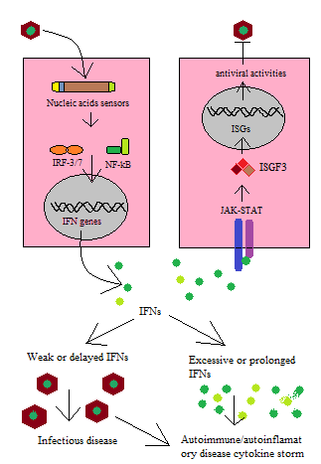

**Fig. 1** Detection and Signaling in Antiviral Defenses

**Recessive resistance**

In addition to the well-documented dominant R genes, there is a growing body of evidence highlighting the significance of recessive R genes in conferring resistance against viruses (Kang et al., 2005). While dominant genes typically trigger effector-triggered immunity (ETI), recessive genes function differently. Instead of acting as immune receptors, the products encoded by recessive genes play crucial roles in compatibility functions necessary for the successful completion of the virus biological cycle.To establish a compatible virus-host interaction leading to systemic infection, the virus must replicate its genome and undergo cell-to-cell and long-distance movement through the plant vascular system. Disruption of any of these processes results in incompatible interactions, often mediated by host resistance factors. Many plants natural resistance genes have been identified as mutations in essential host factors required for virus infection, contributing to the manifestation of recessive resistance (Revers and Nicaise, 2014). An illustrative example of recessive resistance genes involves eukaryotic translation initiation factors, specifically eIF4E and eIF4G. These factors play pivotal roles in the successful infection by a range of viruses, including potyviruses, bymoviruses, cucumoviruses, ipomoviruses, sobemoviruses, carmoviruses, and waikiviruses. Resistance against these viruses is conferred through loss-of-function mutations or modification of the gene products of eIF4E and eIF4G (Revers and Nicaise, 2014). The identification and characterization of recessive resistance genes contribute significantly to our understanding of plant-virus interactions, offering potential targets for crop improvement strategies aimed at enhancing resistance against a diverse range of viral pathogens (Raza et al.,2025). Continued research in this area promises to unveil additional layers of complexity in the molecular arms race between plants and viruses.

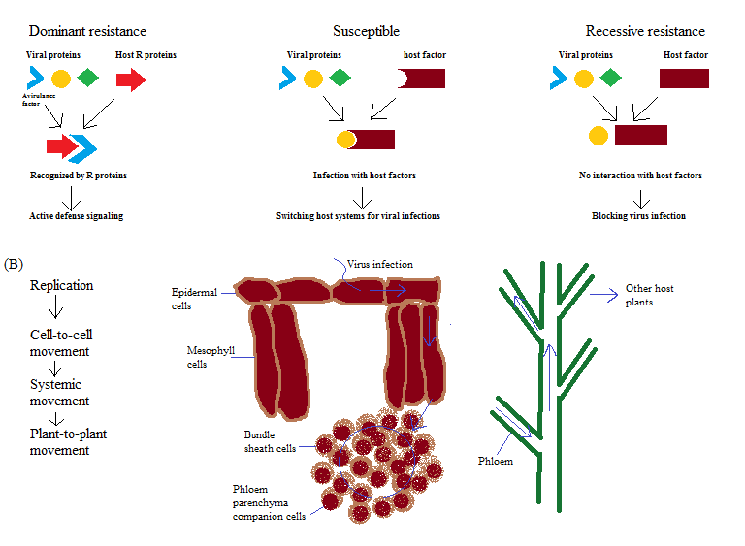

**Fig. 2** Plants Recessive resistance against pathogens

## **Antiviral immune receptors in PAMP-triggered immunity**

The initial layer of innate immunity is promptly engaged when the host detects highly conserved structural motifs expressed exclusively by pathogens, known as pathogen-associated molecular patterns (PAMPs), or endogenous danger signals released during a wound or pathogenic attack, termed damage-associated molecular patterns (DAMPs). These DAMPs function as elicitors, activating a sophisticated defense signaling cascade upon recognition by specific cell surface sensors known as pattern recognition receptors (PRRs) (Macho and Zipfel, 2014). PRRs, represented by receptor-like kinases (RLKs) and receptor-like proteins (RLPs) in plants, play a crucial role in detecting various PAMPs or DAMPs at the cell surface. The activation of these receptors initiates a cascade of events that constitute an effective defense mechanism against a broad spectrum of potential pathogens, including bacteria, viruses, fungi, and oomycetes. Notably, both RLKs and RLPs often require a co-receptor to form an active complex for signaling initiation.In the context of viral pathogens, the innate immune system's understanding has been predominantly explored in mammalian cells, where detection relies on specific biochemical features unique to viral nucleic acid genomes. Viral genomes can exist as single- or double-stranded RNA or DNA, and they may be monopartite or segmented. In mammalian cells, Toll-like receptors (TLRs) constitute a prominent family of nucleic acid-sensing PRRs, playing significant roles in antiviral defense. TLRs share similarities with LRRRLKs, exhibiting a single, membrane-spanning structure with an extracellular leucine-rich repeat (LRR) domain. Expanding our understanding of plant-virus interactions, it is crucial to delve into plant-specific mechanisms that parallel mammalian antiviral defenses. Future research could focus on uncovering plant PRRs and co-receptor complexes involved in the recognition of viral nucleic acids, shedding light on the intricate interplay between plants and viruses in the ongoing coevolutionary struggle for dominance

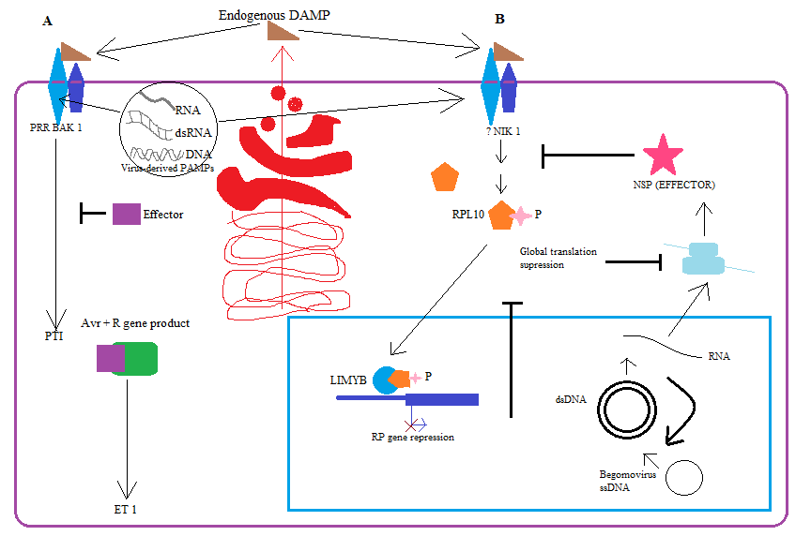

**Fig. 3** PAMP-triggered immunity

# **Immune receptor-mediated suppression of translation**

NIK1 as an antiviral immune receptorThe immune receptor NIK1 (Nuclear Shuttle Protein-Interacting Kinase 1), belonging to the RLK (Receptor-Like Kinase) family, plays a crucial role in defending against geminiviruses (Fontes et al., 2004). Despite structural similarities with BAK1, NIK1's antiviral defense mechanism differs significantly from the classical BAK1-mediated PAMP-Triggered Immunity (PTI) (Machado et al., 2015). Initially identified as targets of the Nuclear Shuttle Protein (NSP) from Begomovirus, NIKs (NIK1, NIK2, and NIK3) are conserved among different hosts and interact with NSPs from various begomoviruses (Fontes et al., 2004; Mariano et al., 2004; Sakamoto et al., 2012). The NSP-NIK interactions suppress NIK kinase activity, hindering the activation of the antiviral signal transduction pathway. This creates a favorable environment for begomovirus infection (Santos et al., 2009, 2010).Studies have demonstrated the importance of NIK in antiviral defense, as loss-of-function mutants (nik1, nik2, and nik3) exhibit heightened susceptibility to CaLCuV infection (Fontes et al., 2004; Rocha et al., 2008; Santos et al., 2009). Moreover, the overexpression of NIK1 has been found to delay viral infection and attenuate symptom development in tomato plants (Carvalho et al., 2008). Notably, mutations in the activation loop (A-loop) of NIK1, preventing autophosphorylation, compromise its ability to mount a response against begomoviruses (Santos et al., 2009). These findings shows the intricate role of NIK1 in orchestrating an effective defense against geminiviruses and provide insights into potential strategies for enhancing plant resilience against viral infections. Further research in this area promises a deeper understanding of the molecular mechanisms underlying plant-virus interactions and the development of targeted approaches for sustainable crop protection.

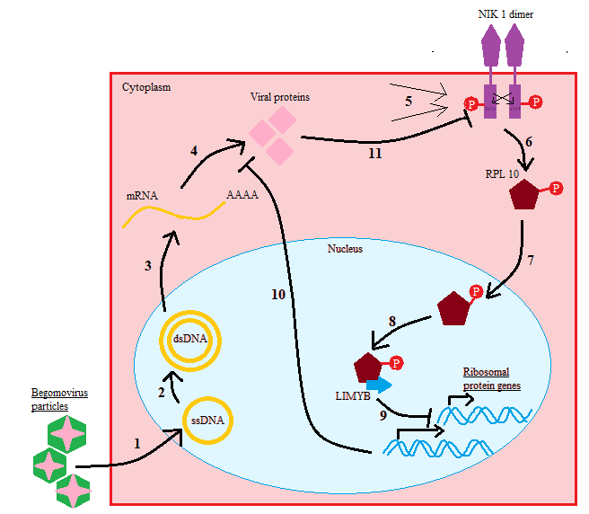

**Fig. 4** NIK1 as an antiviral immune receptor

**Mechanisms of NIK1 activation**

As a single-pass transmembrane receptor kinase, NIK is anticipated to undergo dimerization or multimerization with itself or co-receptors, facilitating transphosphorylation and subsequent kinase activation. The critical early event triggering NIK1 signaling, leading to the suppression of host global translation as an antiviral response, remains elusive. Recent insights indicate that begomovirus infection acts as the activating stimulus for NIK1-mediated defense, yet the molecular basis of this elicitation remains unknown.

Comparing the mechanism of mammalian antiviral immune receptor activation provides a basis for predicting potential ligands triggering or stabilizing NIK dimerization or multimerization with a co-receptor. Begomoviruses, as single-stranded DNA viruses replicating via double-stranded DNA intermediates in cell nuclei, produce single-stranded transcripts and double-stranded overlapping RNAs. These viral genome features may serve as specific nucleic acid ligands. In mammals, the cytoplasmic receptor PKR, activated by dsRNA molecules (>40 bp), mediates global translation suppression through eIF2a phosphorylation as an antiviral response.

Alternatively, NIK1 activation might depend on host molecular signatures (DAMPs) released in the apoplast in response to viral infection. The activation of many kinases, including NIK1, often involves phosphorylation of the activation segment (A-loop) delimited by conserved tripeptide motifs (DFG and APE). This region, conserved among LRR-RLK II subfamily members, dictates NIK1 kinase activity. NIK1 undergoes phosphorylation at conserved positions Thr474 and Thr469 in vitro, and mutations compromising autophosphorylation capacity occur in the A-loop. Substituting Thr474 with alanine inhibits autophosphorylation and NIK1's defense response. In contrast, replacing Thr474 with a phosphomimetic aspartate residue increases autophosphorylation, resulting in constitutive activation of a NIK1 mutant receptor no longer inhibited by begomovirus NSP. These findings highlight phosphorylation at Thr474 in the A-loop as a crucial regulatory mechanism for NIK activation (Carvalho et al., 2008; Fontes et al., 2004; Santos et al., 2009). These insights expand our understanding of NIK1-mediated defense activation against begomovirus infections.

**Downstream components of the NIK-mediated antiviral response**

A critical advancement in understanding plant antiviral immunity involves the identification of the ribosomal protein RPL10 as a binding partner for Nuclear Shuttle Protein-Interacting Kinases (NIKs). This discovery has shed light on the downstream effectors of the NIK-mediated antiviral response. Notably, Arabidopsis rpl10 mutants exhibited increased susceptibility to geminivirus infection, mirroring the phenotype observed in nik1 mutants (Rocha et al., 2008).

Further exploration of this molecular interaction revealed that ectopic expression of NIK1 or a hyperactive NIK1 mutant led to the relocation of phosphorylated RPL10A from the cytosol to the nuclei (Carvalho et al., 2008). Intriguingly, an inactive NIK1 mutant failed to redirect the protein to the nuclei of co-transfected cells. Simultaneously, a mutant RPL10A, which is defective for NIK1 phosphorylation, did not undergo nuclear relocation and lacked the capacity to mount a defense response against begomovirus. These findings strongly suggest that the nucleocytoplasmic shuttling of RPL10 is intricately regulated by phosphorylation and is contingent on the kinase activity of NIK1, positioning RPL10 as a vital downstream effector in the NIK1-mediated signaling cascade.

To delve deeper into the molecular intricacies of NIK1 in antiviral immunity, Arabidopsis transgenic lines carrying the gain-of-function mutant T474D on a nik1 knockout background were scrutinized for gene expression (Zorzatto et al., 2015). The constitutive activation of NIK-mediated signaling in these lines resulted in the down-regulation of translation-related genes and a consequential suppression of global translation. This led to a reduction in the loading of host mRNAs in actively translating polysomes. In begomovirus-infected lines, the association of viral mRNA with actively translating polysomes was lower in T474D lines compared to the wild type. This suggests that begomovirus struggles to sustain high levels of viral mRNA translation when global host translation is impaired. Significantly, transgenic lines ectopically expressing T474D exhibited enhanced resistance to begomovirus, underscoring the effectiveness of suppressing global protein synthesis as a protective mechanism against DNA viruses. This multifaceted interaction between NIK1, RPL10, and their impact on viral infection illuminates new avenues for developing strategies to bolster plant antiviral defenses.

**Mechanistic model for the NIK1-mediated antiviral signalling pathway.**

Since the initial identification of NIKs, significant strides have been made in understanding the intricacies of NIK1-mediated antiviral signaling, particularly its interaction with the begomovirus NSP (Fig. 1). Current knowledge reveals key aspects: The transmembrane receptor NIK1, classified as a serine/threonine kinase transducer, undergoes activation in response to viral infection, initiating a robust defense response against the virus. However, the precise molecular mechanism behind this activation remains a subject of ongoing exploration. Drawing parallels with common characteristics observed in the LRR-RLKII family, it is suggested that the extracellular domain of NIK1 may undergo oligomerization either with itself or with an unidentified ligand-dependent LRR-RLK receptor upon viral infection. This ligand could potentially be Damage-Associated Molecular Patterns (DAMPs) delivered into the apoplast through the secretory apparatus upon detecting viral infection. Alternatively, NIK1 might recognize virus-derived nucleic acids as Pathogen-Associated Molecular Patterns (PAMPs), promoting the oligomerization of this antiviral immune receptor.

The regulation of NIK kinase activity is contingent on a conformational change in the A-loop induced by phosphorylation of Thr474. Upon activation, NIK plays a pivotal role in orchestrating the nucleocytoplasmic trafficking of RPL10. Subsequently, RPL10 interacts with the transcriptional repressor LIMYB, culminating in the downregulation of Ribosomal Protein (RP) genes. This, in turn, results in the suppression of both host and viral mRNA translation, thereby establishing a direct link between the antiviral response and receptor activation.

It's important to note that the molecular events described here have been gleaned from current research, with ongoing studies aimed at providing more detailed insights into the intricate workings of NIK1-mediated antiviral signaling.

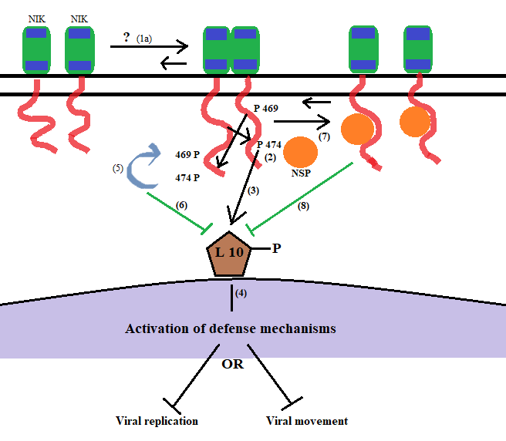

**Fig. 5** NIK1-mediated antiviral signaling pathway.

The Nuclear Shuttle Protein (NSP) plays a critical role in manipulating the host cellular environment during begomovirus infection. It achieves this by obstructing the activation of the pathway through its binding to the NIK kinase domain, causing steric interference with the phosphorylation of Thr474 in the A-loop. Consequently, the impairment of RPL10 phosphorylation occurs, leading to the retention of the Ribosomal Protein (RP) in the cytoplasm.

This interference with NIK1 activation has profound consequences, creating an intracellular environment that favors viral proliferation and spread. The inhibition of the NIK-mediated signaling pathway by NSP contributes to the evasion of host defenses, providing an advantageous milieu for the virus to thrive (Hanley-Bowdoin et al., 2013).

Furthermore, the begomovirus utilizes a unique mechanism for replication involving single-stranded DNA that undergoes replication via double-stranded DNA intermediates transcribed within the nucleus of plant-infected cells. Notably, NSP actively participates in this process by binding to the nascent viral DNA. In a coordinated effort with the classical movement protein (MP), NSP facilitates the movement of viral DNA to the cytoplasm. This collaboration aids in the efficient transportation of viral genetic material, ensuring its access to adjacent uninfected cells and contributing to the overall success of the viral infection (Hanley-Bowdoin et al., 2013).

The intricate interplay between NSP and the NIK-mediated signaling pathway, coupled with its involvement in viral DNA transport, showcases the multifaceted strategies employed by begomoviruses to manipulate host cellular processes for their own benefit. Understanding these molecular interactions is crucial for devising targeted approaches to disrupt viral strategies and enhance plant defense mechanisms against such infections.

**NIK1 may be a general negative co-receptor in signaling pathways**

A property that could potentially have a detrimental impact on defense against other pathogens is observed in the context of NIK1-mediated antiviral defense. Despite structural similarities to BAK1, the mechanism employed by NIK1 in antiviral defense differs significantly from BAK1-mediated PAMP-triggered immunity (PTI). Specifically, the expression of the constitutively activated NIK1 mutant T474D does not induce PAMP immune response-associated marker genes. Instead, it down-regulates translation-related genes, revealing a unique facet of NIK1's functional role.

To comprehensively understand the impact of NIK1 inactivation on gene expression, nik1 null alleles were utilized to examine global gene expression variation. Differential gene expression analysis was conducted using the Deseq2 method, and the resulting differentially expressed (DE) genes were stored in a PostgreSQL relational database. Subsequent analysis employing the eigenvector centrality method identified up-regulated genes in nik1, serving as significant protein hubs in the plant-pathogens interactome network, considering both protein-protein and genetic interactions (Bonacich P. 1987).

The examination of DE genes revealed a predominance of biotic stimuli responsive genes and negative regulators of development among the up-regulated list. The latter were further categorized into hubs controlling stem cell differentiation, maintenance, and development, as well as flower development, cell differentiation, and post-embryonic development. This suggests a potential involvement of NIK1 in developmental control, particularly influencing stem cell development and floral induction. Notably, the upregulation of major hubs from the BR signaling pathway in the nik1 mutant line implies a role for NIK1 as a negative regulator of brassinosteroid (BR) responses, contrasting with the positive role of BAK1 in the BRI1 pathway.

The antagonistic roles of BAK1 and NIK1 may extend to the plant immune response. In the nik1 mutant line, differentially expressed genes encoding crucial hubs in biotic stress response pathways, particularly salicylic acid (SA) signaling and bacterial response, were identified. The upregulation of relevant marker genes, including PR1, PR5, and NIM1-INTERACTING 1, suggests an activation of SA-mediated defenses. Additionally, up-regulated hubs in the bacterial response category point to a strengthened antibacterial immune response. This collective evidence supports the hypothesis that the inactivation of NIK1 may alleviate repression in certain layers of the immune response, shedding light on its multifaceted role in plant defense.

**Fig. 6** Negative control of NIK-1 in signaling pathways

**Rna silencing machinery**

The RNA silencing pathway, also known as RNA interference (RNAi), stands as a cornerstone in plant antiviral defense mechanisms, with viruses acting as both inducers and targets of this regulatory process (Wang et al., 2010; Szittya et al., 2013). The intricate interplay between plants and viruses has led to the evolution of adaptive strategies, where well-adapted plant viruses encode silencing-suppressor proteins to counteract the host's RNA silencing-based antiviral responses (Wieczorek and Obrepalska-Steplowska, 2015). Silencing-suppressor proteins play a crucial role in inhibiting RNA silencing, allowing viruses to evade the host's antiviral defenses. These proteins are multifunctional, disrupting different steps of the RNA silencing pathway, thereby ensuring successful viral replication and spread within the host organism. Understanding the molecular intricacies of these suppressor proteins provides valuable insights into the arms race between plants and viruses. Conceptual advances in the antiviral RNAi mechanism have been a focal point of research, shedding light on the dynamic nature of this defense strategy. As plant viruses continually adapt, the review aims to encapsulate the evolving virulence strategies employed by viruses to overcome the plant's adaptive RNA silencing defense. The arms race between host plants and viruses showcases the dynamic nature of plant-virus interactions, influencing the course of infection and the success of antiviral defense mechanisms. For a more in-depth exploration of antiviral RNA silencing mechanisms and suppressors, interested readers can refer to a collection of excellent, updated reviews by reputable sources (Carbonell and Carrington, 2015; Csorba et al., 2015; Zhang et al., 2015). These reviews provide comprehensive insights into the molecular mechanisms underpinning RNA silencing and the diverse strategies viruses employ to subvert this critical plant defense mechanism.

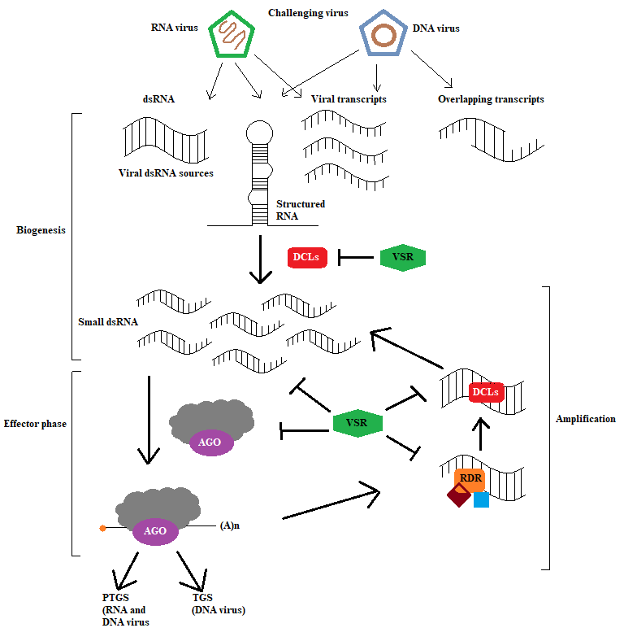**Fig. 7** The RNA silencing pathway: An Adaptive Antiviral Immunity Mechanism

**Hormone-mediated antiviral defenses**

Plant hormones serve pivotal roles in intercellular and systemic signaling systems, orchestrating developmental processes and responses to various biotic and abiotic stresses (Bari and Jones, 2009). The intricate interplay between plant viruses and their hosts often involves the manipulation of biochemical events and molecular interactions necessary for viral replication and movement, resulting in the misregulation and disruption of hormone signaling (Alazem and Lin, 2015). One crucial plant hormone in the context of viral defense is salicylic acid (SA). SA is a key player in the plant's response to pathogens, contributing to the establishment of both local and systemic resistance (Vlot et al., 2009; Pieterse et al., 2012). The involvement of SA in viral defense was first demonstrated in the interaction between Tobacco Mosaic Virus (TMV) and the tobacco N resistance gene (Gaffney et al., 1993; Jovel et al., 2011). Transgenic tobacco lines with reduced SA accumulation exhibited defects in inducing Systemic Acquired Resistance (SAR) against TMV, leading to inefficient restriction of virus movement (Gaffney et al., 1993). The SA pathway is known to be activated by a spectrum of viruses, including both DNA and RNA viruses (Whitham et al., 2006; Ascencio-Ibanez et al., 2008). In the case of Arabidopsis cpr1 mutants, characterized by the constitutive activation of SA-mediated SAR, heightened resistance against Cauliflower Mosaic Virus (CaL CuV) infection was observed (Bowling et al., 1994). This indicates the broad involvement of the SA pathway in defending against different viral pathogens. Furthermore, the intricate relationship between plant viruses and hormonal pathways extends beyond SA. Exploring how other plant hormones, such as jasmonic acid (JA) and ethylene (ET), contribute to antiviral defenses can provide a comprehensive understanding of the sophisticated mechanisms plants employ in response to viral infections (Pieterse et al., 2012). The modulation of these hormonal pathways by viruses underscores the dynamic nature of plant-virus interactions and the complex strategies plants employ to fend off viral threats.

**Conclusion:**

The intricate interplay between plants and viruses is a dynamic battleground where pathogens employ sophisticated strategies to exploit host cellular machinery, causing detrimental effects on plant growth and global crop yield. Viruses, characterized as obligate parasites, heavily rely on the host intracellular machinery for various stages of their life cycle. To counteract viral infections, plants have evolved a complex immune system employing multiple defense mechanisms, including gene silencing, immune receptor signaling, hormone-mediated defense, protein degradation, and metabolic regulation. This review has highlighted the critical role of the plant innate immune system, focusing on Pattern-Triggered Immunity (PTI) and Effector-Triggered Immunity (ETI). The identification of recessive resistance genes, such as those encoding translation initiation factors, has provided additional layers of understanding, contributing to the ongoing exploration of plant-virus interactions. Furthermore, the review delves into the RNA silencing pathway, a cornerstone in plant antiviral defense mechanisms. Viruses, in turn, have evolved silencing-suppressor proteins to counteract this defense, showcasing the ongoing coevolutionary struggle between plants and viruses. The role of plant hormones, especially salicylic acid (SA), in viral defense has been emphasized. SA is involved in establishing local and systemic resistance, and its activation is broad, encompassing both DNA and RNA viruses. Beyond SA, the review suggests exploring other hormones like jasmonic acid (JA) and ethylene (ET) to unravel the comprehensive mechanisms plants deploy against viral infections.

**Future Prospects:**

The ongoing research in the field of plant-virus interactions opens up exciting avenues for future exploration and innovation. Here are some potential directions for future research. There is a need to identify and characterize more immune receptors involved in antiviral defense. Understanding the complete landscape of receptors can offer insights into the diversity of plant-virus interactions. Investigating the crosstalk between different hormonal pathways during viral infections can provide a holistic understanding of how plants integrate multiple signals to mount an effective defense. Continuous exploration of the diverse strategies employed by viruses to counteract RNA silencing can reveal new targets for developing antiviral strategies in plants. Insights gained from understanding plant-virus interactions can contribute to the development of targeted approaches for crop improvement, with an emphasis on enhancing resistance against a broad spectrum of viral pathogens. Bridging the gap between research findings and practical applications in agriculture is essential. Strategies developed based on a deep understanding of plant-virus interactions need to be translated into effective tools for farmers to mitigate viral threats. the continuous coevolutionary race between plants and viruses provides a rich landscape for exploration. Future research holds the promise of uncovering more intricate details of these interactions, ultimately leading to innovative solutions for ensuring global food security in the face of viral threats.

Disclaimer (Artificial intelligence)

Option 1:

Author(s) hereby declare that NO generative AI technologies such as Large Language Models (ChatGPT, COPILOT, etc.) and text-to-image generators have been used during the writing or editing of this manuscript.

**References:**

1. Alazem, M, Lin, N. S. 2015. Roles of plant hormones in the regulation of host– virus interactions. *Molecular Plant Pathology*, *16*: 529–540.
2. Alcaide-Loridan, C., Jupin, I. 2012. Ubiquitin and plant viruses, let’s play together! *Plant Physiology, 160*: 72–82.
3. Andika I. B., Maruyama K., Sun L., Kondo H., Tamada, T., Suzuki, N. 2015. Different Dicer-like protein components required for intracellular and systemic antiviral silencing in Arabidopsis thaliana*. Plant Signaling and Behavior, 10*: e1039214.
4. Ascencio-Ibanez, J. T., Sozzani, R., Lee, T. J., et al. 2008. Global analysis of Arabidopsis gene expression uncovers a complex array of changes impacting pathogen response and cell cycle during geminivirus infection. *Plant Physiology, 148*: 436–254.
5. Bari, R, Jones, J. D. G. 2009. Role of plant hormones in plant defence responses. *Plant Molecular Biology, 69*: 473–488.
6. Bo¨hmH, Albert I, Fan, L, Reinhard, A, Nu¨rnberger T. 2014. Immune receptor complexes at the plant cell surface. *Current Opinion in Plant Biology, 20*: 7–54.
7. Bonacich, P. 1987. Power and centrality: a family of measures. *Am J Sociol, 2*: 1170–82.
8. Bowling, S. A., Guo, A., Cao, H., Gordon, A. S., Klessig, D. F., Dong, X. 1994. Amutation in Arabidopsis that leads to constitutive expression of systemic acquired resistance. *The Plant Cell, 6*: 1845–1857
9. Carbonell, A, Carrington, J. C. 2015. Antiviral roles of plant ARGONAUTES. *Current Opinion in Plant Biology, 27:* 111–117.
10. Carvalho, C. M., Santos, A. A., Pires, S. R., et al. 2008. Regulated nuclear trafficking of rpL10A mediated by NIK1 represents a defense strategy of plant cells against virus. *PLoS Pathogens, 4:* e1000247.
11. Csorba, T, Kontra, L, Burgyan, J. 2015. Viral silencing suppressors: tools forged to fine- tune host–pathogen coexistence. *Virology, 470*: 85–103.
12. Deleris, A, Gallego-Bartolome, J, Bao J, Kasschau, K. D., Carrington, J. C., Voinnet, O. 2006. Hierarchical action and inhibition of plant Dicer-like proteins in antiviral defense. *Science, 313*: 68–71.
13. Dodds, P. N., Rathjen, J. P. 2010. Plant immunity: towards an integrated view of plant– pathogen interactions. *Nature Review Genetics, 11*: 539–548.
14. Fontes, E. P., Santos, A. A., Luz, D. F., Waclawovsky, A. J., Chory, J. 2004. The geminivirus nuclear shuttle protein is a virulence factor that suppresses transmembrane receptor kinase activity. *Genes and Development, 18*: 2545–2556.
15. Gaffney, T, Friedrich, L, Vernooij, B, et al. 1993. Requirement of salicylic acid for the induction of systemic acquired resistance. *Science, 261*: 754–756.
16. Garcia-Ruiz, H, Takeda, A, Chapman, E. J., et al. 2010. Arabidopsis RNA dependent RNA polymerases and dicer- like proteins in antiviral defense and small interfering RNA biogenesis during turnip mosaic virus infection. *The Plant Cell, 22*: 481–496.
17. Hanley-Bowdoin, L, Bejarano, E. R., Robertson, D., Mansoor, S. 2013. Geminiviruses: masters at redirecting and reprogramming plant processes*. Nature Reviews Microbiology, 11*: 777–788.
18. Incarbone, M., Dunoyer, P. 2013. RNA silencing and its suppression: novel insights from in planta analyses. *Trends in Plant Science, 18*: 382–392.
19. Jackson, R. J., Hellen, C. U., Pestova, T. V. 2010. The mechanism of eukaryotic translation initiation and principles of its regulation. *Nature Reviews Molecular Cell Biology, 11*: 113–127.
20. Jones, J. D. and Dang, J. L. (2006) The plant immune system. *Nature, 444*, 323–329.
21. Jovel J, Walker M, Sanfac¸O. H. 2011. Salicylic acid-dependent restriction of tomato ringspot virus spread in tobacco is accompanied by a hypersensitive response, local RNA silencing, and moderate systemic resistance. *Molecular Plant-Microbe Interactions, 24*: 706–718.
22. Kang, B. C., Yeam, I., Jahn, M. M. 2005. Genetics of plant virus resistance. *Annual Review of Phytopathology, 43:* 581–562.
23. Khalid, B., Javed, M. U., Ashraf, M. A., Saeed, H. Z., Shaheen, M., Riaz, T., Riaz, R., & Nawaz, S. (2025). Microbial bio stimulants as sustainable strategies for enhancing plant resistance to viral diseases: Mechanisms and applications. *Hosts and Viruses, 12, 93-110*
24. Kørner, C. J., Klauser, D., Niehl, A., et al. 2013. The immunity regulator BAK1 contributes to resistance against diverse RNA viruses. *Molecular Plant- Microbe Interactions, 26*: 1271–1280.
25. Love, M. I., Huber, W., Anders, S. 2014. Moderated estimation of fold change and dispersion for RNA-Seq data with DESeq2. *Genome Biol, 15*: 550.
26. Machado, J. P. B., Brustolini, O. J. B., Mendes, G. C., Santos, A. A., Fontes, E. P. B. 2015. NIK1, a host factor specialized in antiviral defense or a novel general regulator of plant immunity? *Bioessays, 37:* 1236–1242.
27. Mandadi, K. K., Scholthof, K. B. G. 2013. Plant immune responses against viruses: how does a virus cause disease? *The Plant Cell, 25*: 1489–505.
28. Mariano, A. C., Andrade, M. O., Santos, A. A., et al. 2004. Identification of a novel receptor-like protein kinase that interacts with a geminivirus nuclear shuttle protein. *Virology, 318*: 24–31.
29. Nolen, B., Taylor, S., Ghosh, G. 2004. Regulation of protein kinases: controlling activity through activation segment conformation. *Molecular Cell, 15*: 661–675.
30. Parent, J. S., Bouteiller, N., Elmayan, T., Vaucheret, H. 2015. Respective contributions of Arabidopsis DCL2 and DCL4 to RNA silencing. *The Plant Journal, 81*: 223–232.
31. Pieterse, C. M. J., van der Does, D., Zamioudis, C., Leon-Reyes, A., van Wees, S. C. M. 2012. Hormonal modulation of plant immunity. *Annual Reviews of Cell and Developmental Biology, 28*: 489–521.
32. Qu, F., Ye, X., Morris, T. J. 2008. Arabidopsis DRB4, AGO1, AGO7, and RDR6 participate in a DCL4-initiated antiviral RNA silencing pathway negatively regulated by DCL1. *Proceedings of the National Academy of Sciences, USA 105*: 14732–14737.
33. Raza, M., Hussain, Z., Abbas, F., Ashraf, M. A., Imene, H. H., & Riaz, T. (2025). Advanced strategies for detection and diagnosis of potato viruses: Harnessing molecular innovations and digital tools for precision agriculture. Hosts and Viruses, 12, 39-46.
34. Revers, F., Nicaise, V. 2014. Plant resistance to infection by viruses.
35. Rocha, C. S., Santos, A. A., Machado, J. P. B., Fontes, E. P. B. 2008. The ribosomal protein L10/QM-like protein is a component of the NIK mediated antiviral signaling. *Virology, 380:* 165–169.
36. Sakamoto, T., Deguchi, M., Brustolini, O. J. B., et al. 2012. The tomato RLK superfamily: phylogeny and functional predictions about the role of the LRRIIRLK subfamily in antiviral defense. *BMC Plant Biology, 12*: 229.
37. Santos, A. A., Lopes. K. V. G., Apfata, J. A. C., Fontes, E. P. B. 2010. NSP interacting kinase, NIK: a transducer of plant defence signalling. *Journal of Experimental Botany, 61*: 3839–3845.
38. Szittya, G., Burgyan, J. 2013. RNA interference-mediated intrinsic antiviral immunity in plants. *Current Topics in Microbiology and Immunology, 371*: 153–181.
39. Vlot, A. C., Dempsey, D. A., Klessig, D. F. 2009. Salicylic acid, a multifaceted hormone to combat disease. *Annual Review Phytopathology, 47*: 177–206.
40. Wang, X. B., Wu, Q., Ito, T., et al. 2010. RNAi-mediated viral immunity requires amplification of virus-derived siRNAs in Arabidopsis thaliana. *Proceedings of the Nationtal Academy of Sciences, USA 107*: 484–489.
41. Whitham, S. A., Yang, C., Goodin, M. M. 2006. Global impact: elucidating plant responses to viral infection. *Molecular Plant-Microbe Interaction, 19:* 1207–1215.
42. Wieczorek, P., Obrepalska-Steplowska, A. 2015. Suppress to survive – implication of plant viruses in PTGS. *Plant Molecular Biology Report, 33*: 335–346.
43. Zhang, X., Zhang, X., Singh, J., Li, D., Qu, F. 2012. Temperature-dependent survival of turnip crinkle virus-infected Arabidopsis plants relies on an RNA silencing-based defense that requires dcl2, AGO2, and HEN1. *Journal of Virology, 86*: 6847–6854.
44. Zipfel, C. 2014. Plant pattern-recognition receptors. *Trends in Immunology, 35*: 345–351.
45. Zorzatto, C., Keˆnia, V. G., Kelly, J. T Welison, A., Ota´vio, J. B., Pedro, A. B. (2015). NIK1-mediated translation suppression functions as a plant antiviral immunity mechanism*. Nature, 16*(16).