**A Digital Platform for Disseminating Horticultural Technologies to Farmers and Stakeholders**

**Original Research Article**

**ABSTRACT**

Horticultural crops, including fruits, vegetables, ornamentals, medicinal crops and mushrooms play a significant role in improving the food security, nutrition, health and livelihood security for millions of people. Advancements in crop cultivation and processing methods have significantly enhanced crop yields and extended the shelf life of horticultural products. ICAR-Indian Institute of Horticultural Research (IIHR), a premier research institute in horticulture, dedicated to advancing horticultural science has developed numerous technologies that provide information on various management aspects and bringing awareness benefitting farmers and other stakeholders. From protected cultivation to post-harvest technologies and integrated pest management, these technologies are instrumental in transforming the horticulture sector. To maximize the impact of these innovations and to ensure these advancements reach a broader audience of farmers and stakeholders involved in horticulture, effective dissemination and large-scale adoption are essential. Digital technologies can bridge the information gap and empower farmers with valuable insights for sustainable agricultural development and livelihood enhancement. In this regard, efforts have been made to digitize the horticulture technologies developed at the institute and disseminate the same through web applications which is a cost effective way of communication channel reaching lakhs of farmers. The present study was aimed to design and develop a user-friendly, informative web interface to introduce and showcase these innovative technologies from crop production to value addition for horticultural crop producers and other stakeholders thus making them more accessible. This informative approach helps users understand the benefits and feasibility in identifying and adopting these technologies in their own operations. The web interface is structured to facilitate quick navigation through various horticulture technologies, enabling users to easily identify and explore the technology categories most relevant to their needs. This web interface platform can serve as an effective tool for boarder reach in the horticulture technology transfer process to enhance crop productivity and promote sustainable farming for better remuneration.

***Keywords****: horticulture, application, information, dissemination, technologies, web interface*

**1. INTRODUCTION**

Information and knowledge are very vital in agricultural development and access to need based information (Singh et al., 2019) help to improve crop production and quality. Horticulture is an important sector of agriculture significantly contributing to food security, nutrition, health and improved livelihoods (Chadha et al., 2010). Horticulture encompasses a diverse range of crops, including fruits, vegetables, ornamentals, medicinal plants (Prakash, 2023), and mushrooms. The premier institute, ICAR-Indian Institute of Horticultural Research (IIHR), Bangalore, has been at the forefront of horticultural research and innovation, developing technologies (Dhanajaya et al., 2022) that enhance productivity and profitability for farmers. It plays a crucial role in developing and promoting innovative horticultural technologies (Pekkeriet et al., 2015), contributing towards increased food, nutritional and socio-economic security (Singh et al., 2021), quality and higher productivity of horticultural crops. Horticultural crops are most prominent source in ensuring nutritional security (Siddiqui et al., 2014). Significant innovations in horticulture (Janbandhu, 2024) have taken place through plant breeding, biotechnological interventions, fertilizer and irrigation management, protected cultivation, plant health management, postharvest technology, etc. Through its research and extension services, ICAR-IIHR plays a pivotal role in shaping the future of horticultural practices (Reddy, 2024) in the country. Institute has developed a range of improved varieties and hybrids with multiple disease resistance (Sharma et al., 2021) and high yield potential in vegetables, fruits, medicinal and ornamental crops. It has been a key player in contributing to sustainable plant health management in the horticultural sector focusing on safety, cost-effectiveness, and eco-friendliness. Horticulture crop offers higher scope for value addition (Kumar et al., 2019). Institute has developed a vast range of processed and value added products with extended shelf life by adopting suitable handling, packaging and storage methods. Horticulture crops are very rich in vitamins and nutrients (Davies and Bowman, 2014). IIHR utilizes advanced research technologies in molecular biology, genetics and biotechnology to improve understanding underlying plant growth. Crop cultivation is labour intensive (Satishkumar and Umesh, 2018) and timely operations are essential for maximizing output. The institute has developed various machineries and implements to facilitate farm mechanization. These improved technologies (Joshi and Varshney, 2022) enable more efficient and sustainable farming practices (Gamage et al., 2024), particularly in how water and nutrients are managed (Kumar et al., 2024) which can lead to new business ventures and help address critical challenges such as food security, rural development and improvements in nutrition and health. As farmers become more efficient with their use of resources, their overall productivity improves. Technologies developed are commercialized to encourage entrepreneurship (Lather et al., 2021), creating employment opportunities in both rural and urban areas, and driving economic growth. ARKA is the trade mark of the technologies developed by ICAR-IIHR. These technologies are instrumental in transforming the horticulture sector, improving food security, and contributing to the economic development of India. Agricultural information and knowledge delivery systems are expected to disseminate highly accurate, specific, and crop management information ensuring that farmers have access to the right information at the right time. Popularization of agricultural technologies is one way of addressing the information needs of farmers (Sebastian and Jeyalakshmi, 2020). Information and knowledge are very vital in agricultural development. Having a centralized, accessible resource can help farmers stay up to date with the latest technologies and best practices. It could potentially bridge the information gap between research institutions and rural areas, enabling more widespread adoption of effective methods. The adoption of digital technology in agriculture helps improve the livelihood of the people (Deichmann et al., 2016) presenting significant potential for the future of farming. Digital technology can deliver right information (Ingram and Maye, 2020) and access to relevant, need based information (Singh et al., 2019) which helps to enhance crop production and quality. The paper aims to highlight the potential of developing web application to showcase the horticulture technologies from crop production to value addition and post-harvest management. A user-friendly web interface serves as a vital bridge between farmers and the wealth of horticultural knowledge available. The design of a user interface for agricultural systems (Ibrahim and Danmaigoro, 2024) plays a crucial role in ensuring effective interaction between the system and its users to disseminate horticulture technologies for adoption, enhancement of crop productivity and sustainable farming.

**2. MATERIALS AND METHODS**

Digital technologies provide low cost access to information and timely solutions to farmers (Parmar et al., 2016). Web applications that run code directly in the browser face challenges, including performance issues, cross-browser compatibility, and security risks. Advancements in web standards, development frameworks, performance optimization, and security protocols have helped to develop more secured and user-friendly web applications. In this study, a horticulture technology web application was created using HTML, CSS and JavaScripts with different web pages to edit, debug and build code. HTML is responsible for the content and structure of a webpage organizing sections and content related to various horticulture technologies with relevant images and text to make the content informative and easy to understand for users. CSS determines its presentation and style where the layout, colors, fonts, margins, paddings are defined. Also, CSS ensures that the web application adapts well to various screen sizes ensuring usability across devices. JavaScript defines the behavior and functionality of the webpage make it interactive and responding to user actions. The design tool uses compilers, code completion functions and graphical designers to enhance the application development process. The web structure was designed using Grid Layout Module to layout the different technologies categorized under six themes. Grid-based User Interface design was used for systematic framework that helps organize and align elements within a layout. This organized approach improves the readability and usability of the interface, ensuring users can find relevant information quickly. Hover effect was embedded so that the design remains responsive. Modal components are added to create pop-up boxes for displaying detailed information on a particular horticulture technology with images without leaving the current page. Different technology images are added to make the system more informative. JavaScript handles the opening and closing the modals, ensuring they appear and disappear smoothly without reloading the page. Navigation bar was provided in the application to browse through different technology categories to improve user experience providing quick access to content. After validating and testing the functionality of the application, it was made public by deploying it to the cloud service (Sharma et al., 2024). The developed web interface on horticulture technologies was uploaded securely through firebase hosting service and cloud functions which plays a critical role in securely delivering static and dynamic web content through a global Content Delivery Network, ensuring optimal performance and reliability for users to access the web application displaying horticulture technology information through web browser.

**3. RESULTS AND DISCUSSION**

The technologies developed at ICAR-IIHR are categorized into six theme areas viz., Seed and Planting Materials, Biotechnology and Plant Propagation, Fertilization and Irrigation Management, Crop Protection and Health Management, Post-Harvest Technologies and Farm Machinery each focusing on enhancing horticultural productivity, sustainability and quality.

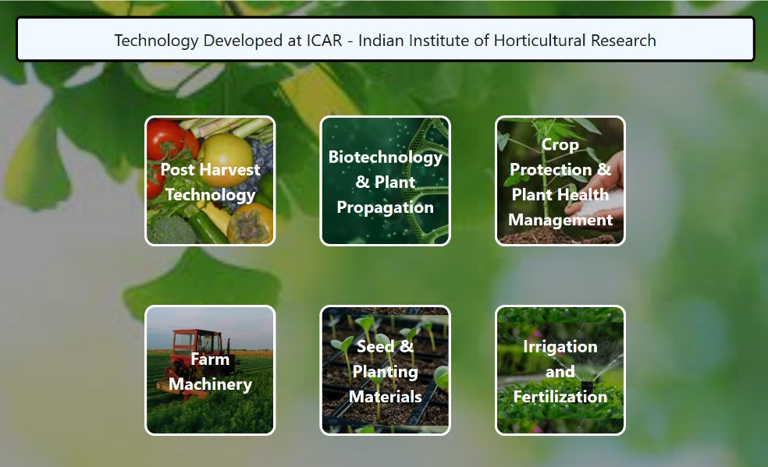

Fig. 1. Home page of web interface platform for horticulture technologies

The web application is designed using HTML5 and scripting languages with navigation structure and well organized content making it easier for users to find the horticulture technology information they need. The .tabs class styles the tab headers with background, padding, and hover effects for interactivity. At the start of the application the user is directed to the homepage where they can choose the technology category from the menu options built into the user interface. As shown in Fig. 1, the homepage is designed with tabbed navigation, allowing users to easily switch between different technology sections by clicking on the tabs.

Once the user selects a technology within a particular category, a detailed window opens with image and detailed information about the selected technology in the pop-up box. This pop-up design allows users to access relevant content without cluttering the main page with too much text, keeping the interface neat and easy to navigate. All the web pages has tabbed navigation where technology information is organized, which separate content into different sections. Active tabs are highlighted with distinct background and text color. The carousel container features tab headers with padding, which creates space around the text, making them more clickable. The background color gives the tabs a distinct and contrast look, setting them apart from other sections. Hover effects are applied to the tab headers, so when users move the cursor over a tab, the corresponding section is highlighted making it more interactive. The user can select a tab to view different technology content category. Firebase, a hosting platform designed to support app for storage and access and aimed at improving better operational performance was used to host the service (Megantoro et al., 2024) ensuring fast and uninterrupted delivery of high-quality web based content to the users.

A well-designed interface can make a huge difference in how easily users can navigate through a range of information and access information on new technologies for adoption. This user-friendly web interface allows users to access the relevant technologies needed for horticulture crop cultivation that can improve the economic condition of many farmers (Das and Singh, 2021). Security is a top priority for the web application, ensuring that all user interactions and data exchanges are protected. The platform is available in the public domain and is SSL (Secure Sockets Layer) enabled, where all communications between the user's browser and the server are encrypted. Users can access the application securely at <https://webapp-iihr.web.app>, and it is also accessible through the institute's official website. This SSL encryption reinforces trust and security for users, when browsing or engaging with the platform. The adoption of improved horticultural technologies empowers farmers to grow high-value products (Barua et al., 2023). The availability of recently developed horticulture technology information will significantly benefit farmers and other stakeholders by providing them with the knowledge needed to improve their livelihoods and contribute to the overall growth and development of the agricultural economy.

**4. CONCLUSION**

The web interface developed to showcase various horticultural technologies developed at ICAR-IIHR is the outcome of scientific research study focused on sustainable technologies useful for farmers and other stakeholders. These technologies are also commercially viable, aiming to enhance the livelihood and provide better remuneration for farmers. This digital platform enables widespread dissemination, making it possible to reach lakhs of farmers across the country and promoting the acceptance of these technologies. The essential scientific knowledge and technologies is accessible to a wide range of stakeholders from farmers to extension workers, researchers, and policymakers through this digital platform. The adoption of these innovative horticultural practices and technologies offers significant benefits to farmers, not only in terms of improving the nutritional quality of food but also in fostering sustainable farming practices offering significant benefits to farmers. The digital platform can be further improved by developing a mobile app that delivers easy access to these technologies ensuring that farmers in remote areas are also benefitted.

Disclaimer (Artificial intelligence)

Option 1:

Author(s) hereby declare that NO generative AI technologies such as Large Language Models (ChatGPT, COPILOT, etc.) and text-to-image generators have been used during the writing or editing of this manuscript.

**5. REFERENCES**

* Barua, U., Islam, M., & Medhi, S. (2023). Awareness and Adoption of Climate Resilient Horticulture Technologies by Farmers in Ri Bhoi District of Meghalaya. *International Journal of Economic Plants*, 10(4), 256-262. https://doi.org/10.23910/2/2023.4918a.
* Chadha, K.L., Singh, A.K., & Patel, V.B. (2010). Recent Initiatives in Horticulture. Westville Publishing House. ISBN 10: 9788185873541.
* Davies, F.T., & Bowman, J.E. (2014). Horticulture, food security, and the challenge of feeding the world. In XXIX International Horticultural Congress on Horticulture: Sustaining Lives, *Livelihoods and Landscapes*, 1128, 1-6.
* Das, M., & Singh, A.K. (2021). Horticulture and nutrition: Two sides of the coin. *Indian Horticulture,* 66(5), 37-40.
* Deichmann, U., Goyal, A., & Mishra, D. (2016). Will digital technologies transform agriculture in developing countries?. *Agricultural Economics*. 47, 21-33.
* Dhanajaya, M.V., Upreti K.K., & Dinesh M.R. (2022). National Horticultural Fair 2021-A Success Story. *Journal of Horticultural Sciences,* 16(2), 315-318.
* Gamage, A., R. Gangahagedara, R., Subasinghe, S., Gamage, J., Guruge, C., Senaratne, S., Randika, T., Rathnayake, C., Hameed, Z., Madhujith, T., & Merah, O. (2024). Advancing sustainability: The impact of emerging technologies in agriculture. *Current Plant Biology,* 40, 100420.
* Ibrahim, U., & Danmaigoro, A. (2024). Human-Computer Interaction in Agricultural User Interfaces. *International Journal of Applied and Scientific Research,* 2(2), 187-198.
* Ingram, J., & Maye, D. (2020). What are the implications of digitalisation for agricultural knowledge?. *Frontiers in Sustainable Food Systems,* 4, 66.
* Janbandhu, M. (2024). Advances and Emerging Trends in Horticultural Production and Management. *Journal of Experimental Agriculture International,* 46, 47-69.
* Joshi, P. K., & Varshney, D. (2022). Agricultural Technologies in India: A Review. *NABARD Research and Policy* 5.
* Kumar, D., Malik, N., & Sengar, R.S. (2019). Emerging technologies to enrich agricultural and horticultural crop quality and production. *Annals of Horticulture,* 12(1), 55-61.
* Kumar, S., Wani, Ab W., Kaushik, R., Kaur, H., Djajadi, D., Khamidah, A., Saidah, Alasbali, N., Alreshidi, M., Alam, M.W., Yadav, K., & Wani, A. (2024). Navigating the landscape of precision horticulture: Sustainable agriculture in the digital Age, *Scientia Horticulturae,* 338, 113688. 10.1016/j.scienta.2024.113688.
* Lather, R., Sridevi, V., & Singh, G. (2021). Entrepreneurship opportunities in horticulture sector. *International Journal of Agricultural Sciences,* 17(1), 311-318.
* Megantoro, P., Prastio, R.P., Kusuma, H.F.A., Abror, A., Vigneshwaran, P., Priambodo, D.F., & Alif, D.S. (2022). Instrumentation system for data acquisition and monitoring of hydroponic farming using ESP32 via Google Firebase. *Indonesian Journal of Electrical Engineering and Computer Science*, 27(1), 52.
* Parmar, R.S., Kathiriya, D.R., & Kamani, G.J. (2016). Digital-Enabled Services for agriculture development. *Gujarat Journal of Extension Education*, 27(1), 20-23.
* Pekkeriet, E., Van Henten, E.J., & Campen, J.B. (2015). Contribution of innovative technologies to new developments in horticulture. *Acta Horticulturae,* 1099, 45-54.
* Prakash, S., Singh, S., & Singh, B. (2023). Promotion of horticulture through hi-techniques. *Progressive Agriculture*, 23(1), 94-98.
* Reddy, P.P. (2024). Hi-Tech Farming for Enhancing Horticulture Productivity. First Edition. CRC Press.
* Satishkumar, M., & Umesh, K.B. (2018). Farmers Strategies to Cope Labour Shortage in Northern and Southern Dry Zones of Karnataka, India. *Current Agricultural Research Journal* 6(2), 206.
* Sebastian, A. J., & Jeyalakshmi, G. (2020). Use of Digital Tools for Horizontal Spread of Agricultural Technologies by Farmers of Kerala. *Journal of Extension Education*, 31(4), 6411-6416.
* Sharma, P., Kaur, M., Shilpa, Sharma, A., & Bhardwaj, N. (2021). Breeding vegetables for protected cultivation: A review. *Himachal Journal of Agricultural Research*, 47(1), 1-17.
* Sharma, L.K., Khanna, R., & Singh, H. (2024). Developing a Web-Based Agro-Application: SL513 SS726, *EDIS,* (2), Gainesville, FL. https://doi.org/10.32473/edis-ss726-2024.
* Siddiqui, M., Yadav, S., Dhua, R., & Ahmad, M. (2014). Ensuring Food Security through Golden Revolution: Prospects, Achievements, and Bottlenecks. *International Food Research Journal,* 21, 1271-1277.
* Singh, A.K., Sanakaran, M., & Murthy, B.N.S. (2021). Horticulture for food, nutritional and socio-economic security in India. *Indian Horticulture,* 66(5), 1-9.
* Singh, J., Kumar, P., & Singh, A. (2019). Dissemination of information to dairy farmers in Jammu and Kashmir: Developing a web module. *Information Development*, *36*(4), 546-558.