**Original Research Article**

**ISOLATION, CHARACTERIZATION, AND COMPARATIVE BIODEGRADATION EFFICIENCY OF OIL-DEGRADING BACTERIA FROM OIL-CONTAMINATED ENVIRONMENTS**

**ABSTRACT**

Soil is an important component of the ecosystem which supports life and provides an avenue for crops to grow. It harbors water bodies, holds important mineral resources, elements and supplements that help plants to grow and flourish. Pollution caused by petroleum hydrocarbons (PHs) and its derivatives significantly affect soil and its properties causing great health risks to animals and humans. Several remediation methods had been explored and were continuously used to mitigate the effects caused by different pollutants. These methods such as biostimulation and bioaugmentation merely enrich autochthonous microorganisms. However, traditional remediation methods have proven to be inadequate in completely mitigating pollution leading to growing interest in finding strategies more effective and sustainable. This study compares the efficiency of isolated species against different petroleum hydrocarbon products at successive intervals and establishes more efficient degradation specie at each time interval for each product. The present study results revealed that *Streptococcus spp* was more efficient for petrol and diesel with efficiency degradation of 96.93% and 83.10% respectively. *Pseudomonas spp* was found to be the most efficient degrader of engine oil with efficiency degradation of 83.56%. The future direction of researches should focus on identifying the functional genes and pathways enabling these bacterial species to perform degradation process coupled with using the current advancements such as nanotechnology, metagenomics, metabolomics, and genetic engineering to improve the efficiency of the degradation process, reducing the time period of the degradation and also reducing the possibility of the production of more harmful/recalcitrant byproducts by the degradation bacteria.

**Keywords**: Bioremediation, Petroleum products, Bacteria, Pollutants, Oil degradation, contaminated environment.

# 1. INTRODUCTION

Soil is a complex system of the ecosystem providing a foundation support for plant growth, food and nutritional security for both human and animals, and also serves as a dynamic reflection of the earlier ecological communities [1-3]. Soil has several important functions, including being a reactor, transformer, and integrator of other natural resources, a medium for biomass production, a storage system for heat, water, and nutrients, a buffer against stresses, a filter and detoxification system, a gene reservoir, and a conservator of natural and human heritages [4]. Soil pollution caused by oil, petroleum hydrocarbons (PHs) and its derivatives to be precise, significantly affects soil functions, properties and hydrological processes. In addition to the serious hazard to human health and environmental problems [5], it also reduces the water absorption capacity of the soil leading to reduced availability of water for plants which is indirectly increasing the risk of soil drought [6-7]. Studies on soil contamination by oil reveals increase in water repellency which affects indices and contact angles [8]. The crude oil contamination of sandy loam soil results in significant changes to the physicochemical characteristics of the soil, such as total hydrocarbon content which calls the need for adoption of remediation on crude oil contaminated soils [9].

Bioremediation approach of mitigating the effect caused by oil pollution provides a more efficient substitute of conventional remediation methods with high removal rates of saturated hydrocarbons through adsorption processes and methanogenic biodegradation [10]. Conventional methods such as biostimulation and bioaugmentation are used for mitigating crude oil spillage as they are both cost effective and environment benign [11]. These methods employ the use of living organisms such as bacteria and yeast to convert toxic contaminants like hydrocarbons found crude oil into harmless compounds by degradation mechanisms [12-13].

The conventional methods of bioremediation of contaminated environment are strongly limited by low efficiency mainly due to their long degradation time, partial oil removal, and also sometimes dependency on specific environmental conditions. There is also the problem of restricted identification of potential oil degrading species due to the utilization of traditional culturing techniques and lack of versatility of the identified species which all together reduce the efficiency of the bioremediation of contaminated environments. This problems highlight the need for more robust, effective, adaptable strategies for sustainable bioremediation of contaminated environment.

The study aims to offer more sustainable approach to environmental restoration by improving the efficacy and broadening the applicability of bioremediation and at the same time contributing to the advancement of practical knowledge of bioremediation that can inform future research and development in this field.

The current study focused on isolating, characterizing, and comparing the biodegradation efficiency of oil-degrading bacteria from oil-contaminated environments

# 2. MATERIALS AND METHODS

**2.1 Study Area**

This study was carried out in Gangrar district of Chittorgarh city in Rajasthan state. The selected places for sample collection include one (1) motor garage and two (2) petrol filling stations where three (3) samples from each location were collected from strategic locations with high oil contamination.

Gangrar district (Approximately 25°08'N latitude and 74°37'E longitude at approximately 394 meters above sea level) Chittorgarh city of Rajasthan State, India.

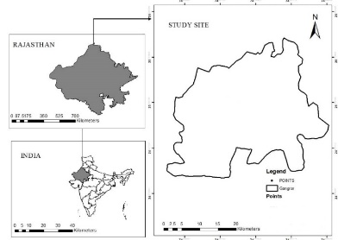

Figure 1: Map of Rajasthan State showing Gangrar District.

**2.2 Sample collection**

In total, eighteen (3) soil samples in triplicate were collected in the study areas. Of these, One (1) sample was taken from a motor garage and two (2) samples were taken from were collected from a Petrol filling station. Soil was aseptically collected from contaminated soil 10cm deep using a sterile container to a total weight of 5g for each sample. The samples were immediately transferred to the laboratory and kept in a cool dry cabinet for storage until analysis.

**2.3 Isolation and Characterization of Oil-Degrading Bacteria**

The methods soil analysis involved enrichment of microorganisms present in soil sample, screening and isolation of oil degrading bacteria, identification of bacterial isolates and gravimetric analysis to study oil degradation. Initially, enrichment of oil degrading bacteria was done using Bushnell Haas broth and engine oil as the sole carbon source. Then, screening and isolation of oil degrading bacteria was done using Bushnell Haas agar and engine oil as the sole carbon source. Identification of bacterial isolates was performed by various biochemical tests with pure cultures obtained from presumptive colonies. Finally Gravimetric analysis was done to estimate the percentage degradation of oil by bacteria [14].

**2.4 Preparation of Media**

The culture media used include Bushnell Haas Broth, Bushnell Haas Agar, Nutrient agar, Starch hydrolysis media, Tryptone broth, Carbohydrate utilization media and Methyl red broth. The media were prepared according to the manufacture specification. These media were sterilized in an autoclave at 121ºC for 15minute.

**2.5 Enrichment of microbes**

The oil degrading bacteria in the soil samples obtained were enriched using Bushnell Haas broth with engine oil as the sole carbon source placed on a shaker for a period of 5-10 days until degradation and utilization of engine oil was observed by comparing the culture flasks to uninoculated flasks

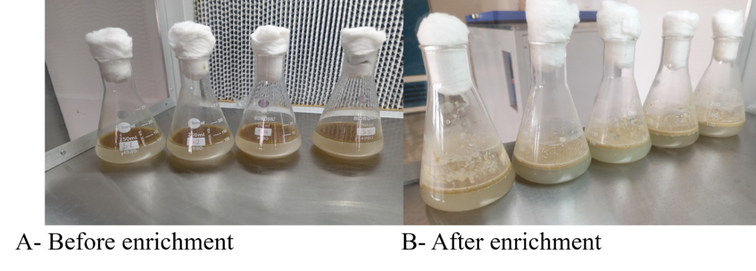

Fig. 2**:** Showing Enrichment of bacteria

**2.6 Screening of Oil Degrading Bacteria**

After the two phases of enrichment, the enriched bacteria was cultivated on Bushnell Haas Agar with engine oil as the sole carbon source. The plates were incubated at 30-35°C until visible colonies were observed.

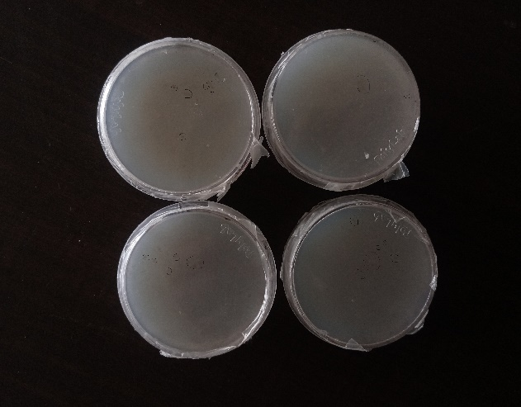

Fig.3**:**  Screened oil degrading bacteria

**2.7 Isolation of oil degrading bacteria**

From the Bushnell Haas Agar, well isolated colonies with distinct characteristics were sub-cultured onto a plate of Nutrient Agar by streaking method. Two isolates were grown and subjected to tests for identification and characterization.

Identification of the bacterial isolates was based on simple staining, gram staining, and motility test followed by biochemical analysis.

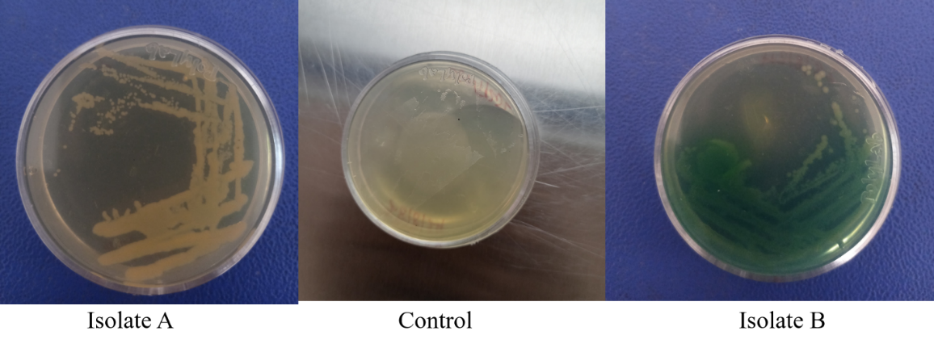

Fig. 4**:** Isolated pure culture of oil degrading bacteria

**3. RESULTS AND DISCUSSION**

**3.1 Results**

**3.1.1 Identification of bacteria**

**3.1.1.1 Simple staining**

The simple staining results showed that Isolate 1 is a spherical-shaped (cocci) bacteria while Isolate 2 is a rod-shaped (bacilli) bacteria.

**3.1.1.2 Gram staining**

Based on the results obtained from gram staining of isolates, Isolate 1 was gram positive while Isolate 2 was gram negative.

**3.1.1.3 Motility test**

Based on motility test was observed to be Isolate 1 was motile, while Isolate 2 was observed as non-motile.

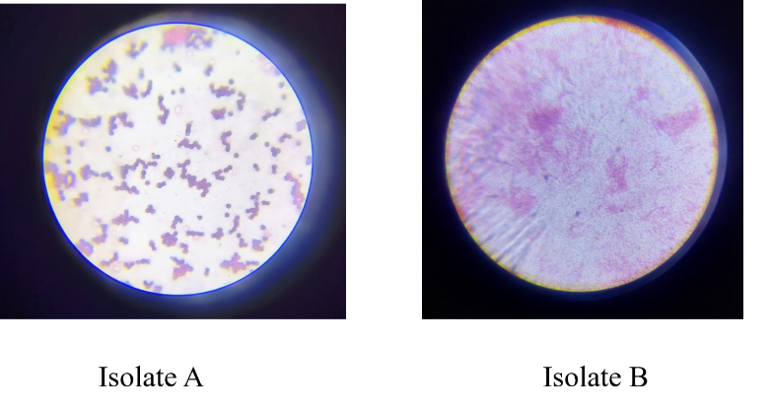

Fig. 5**:** Gram’s staining

**3.1.2 BIOCHEMICAL CHARACTERIZATION**

|  |  |  |
| --- | --- | --- |
| **Test** | **Isolate1** | **Isolate2** |
| Catalase | - | + |
| Indole | - | - |
| Methyl red | - | - |
| Starch hydrolysis | - | + |
| Glucose Utilization | + | + |
| Citrate | - | + |
| Vogues proskauer | - | - |

**3.1.3 Oil Degradation Analysis**

The isolated and identified isolates were subjected to oil degradation analysis to estimate the degradation efficiency of each isolate.

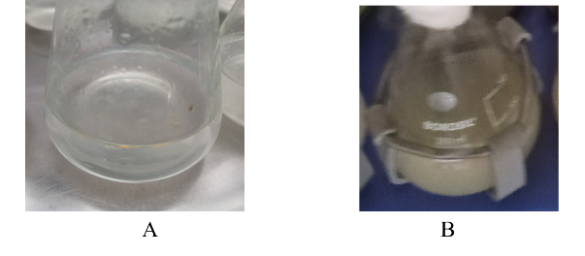

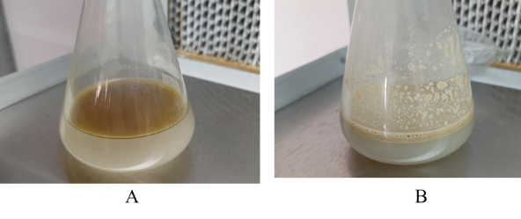

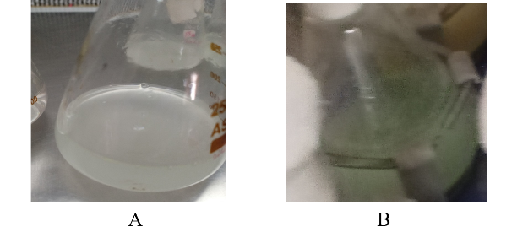

Key: (A)-Before degradation, (B)-After degradation

Fig**.** 6**:** Supplemented media during and after degradation analysis

**3.1.4 Gravimetric Analysis**

After the completion of the degradation period, Gravimetric analysis was carried out to extract and quantify the residual oil remains for the determination of the degradation efficiency among isolates.

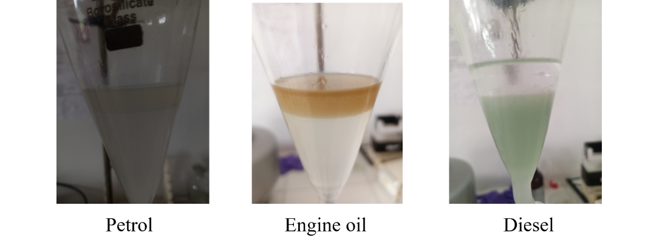

Fig.7**:** Extraction procedure during gravimetric analysis

During Gravimetric analysis three layers were formed due to separation by miscibility of the solutions: top layer contains the residual oil mixed with acetone and cyclohexane. A beaker was pre-weighed, the two lower layers were collected in a separate beaker and discarded. The upper layer was collected in the pre-weighed beaker passed through sodium anhydrous to remove moisture and placed in water bath to evaporate acetone and cyclohexane. The final residue was weighed to get the final weight of residual oil.

The isolate screened for oil degradation using gravimetric analysis against 2% petrol, diesel and engine oil over different time intervals of 5, 10 and 15 days respectively produce the following results. The degradation efficiency of each isolate is summarized in the tables below

Table 1: Showing percentage of oil degradation of petrol by the two isolates after different intervals of incubation

|  |  |  |  |  |
| --- | --- | --- | --- | --- |
| **Isolate 1** | | | | |
| Incubation time | Percentage degradation (%) | | | Average (%) |
| 5 | 25.45 | 25.60 | 25.48 | 25.51 |
| 10 | 43.20 | 43.40 | 43.51 | 43.37 |
| 15 | 96.70 | 96.99 | 97.10 | 96.93 |
| **Isolate 2** | | | | |
| 5 | 22.30 | 22.40 | 22.62 | 22.44 |
| 10 | 27.70 | 27.80 | 28.08 | 27.86 |
| 15 | 90.90 | 90.80 | 90.76 | 90.82 |

Table 2: Showing percentage of oil degradation of diesel by the two isolates after different intervals of incubation

|  |  |  |  |  |
| --- | --- | --- | --- | --- |
| **Isolate 1** | | | | |
| Incubation time | Percentage degradation (%) | | | Average (%) |
| 5 | 10.9 | 10.0 | 10.6 | 10.50 |
| 10 | 39.45 | 39.20 | 39.16 | 39.27 |
| 15 | 74.90 | 74.85 | 74.89 | 74.88 |
| **Isolate 2** | | | | |
| 5 | 18.74 | 18.70 | 18.72 | 18.72 |
| 10 | 47.50 | 47.45 | 47.49 | 47.48 |
| 15 | 83.00 | 84.18 | 83.50 | 83.56 |

Table 3: Showing percentage of oil degradation of engine oil by the two isolates after different intervals of incubation

|  |  |  |  |  |
| --- | --- | --- | --- | --- |
| **Isolate 1** | | | | |
| Incubation time | Percentage degradation (%) | | | Average (%) |
| 5 | 40.10 | 39.50 | 40.13 | 39.91 |
| 10 | 65.20 | 66.05 | 65.94 | 65.73 |
| 15 | 82.90 | 83.10 | 83.30 | 83.10 |
| **Isolate 2** | | | | |
| 5 | 9.98 | 9.70 | 9.90 | 9.86 |
| 10 | 32.20 | 32.57 | 32.40 | 32.39 |
| 15 | 76.70 | 76.40 | 76.49 | 76.53 |

**3.1.5 Efficiency of oil degrading isolates**

The efficiency of each isolate in the degradation of oil product at the end each incubation period was measured by quantifying the remaining residue of petroleum product in the medium and it is summarized below.

Table 4: Showing efficiency of oil degradation of the two isolates after 5 days intervals of incubation

|  |  |  |
| --- | --- | --- |
| **Carbon source** | ***Streptococcus spp*** | ***Pseudomonas spp*** |
| Petrol | 25.51% | 22.44% |
| Engine oil | 10.50% | 18.72% |
| Diesel | 39.91% | 9.86% |

At 5 days of incubation and shaking, *Streptococcus spp* in Diesel recorded the highest degradation with 39.91% while *Pseudomonas spp* in diesel showed the lowest degradation with 9.86%.

Figure 8: Efficiency of bacterial isolate in oil degradation at day 5

Table 5: Showing efficiency of oil degradation of the two isolates after 10 days intervals of incubation

|  |  |  |
| --- | --- | --- |
| **Carbon source** | ***Streptococcus spp*** | ***Pseudomonas spp*** |
| Petrol | 43.37% | 27.86% |
| Engine oil | 39.27% | 47.48% |
| Diesel | 65.73% | 32.39% |

At 10 days of incubation and shaking, *Streptococcus spp* in Diesel recorded the highest degradation with 65.73% while *Pseudomonas spp* in petrol showed the lowest degradation with 27.86%.

Figure 9: Efficiency of bacterial isolate in oil degradation at day 10

Table 6: Showing efficiency of oil degradation of the two isolates after 15 days intervals of incubation

|  |  |  |
| --- | --- | --- |
| **Carbon source** | ***Streptococcus spp*** | ***Pseudomonas spp*** |
| Petrol | 96.93% | 90.82% |
| Engine oil | 74.88% | 83.56% |
| Diesel | 83.10% | 76.53% |

At 15 days of incubation and shaking, *Streptococcus spp* in petrol recorded the highest degradation with 96.93%, followed by *Pseudomonas spp* in petrol with 90.82%, followed by *Pseudomonas spp* in Engine oil with 83.56%, followed by *Streptococcus spp* in diesel with 76.53%, the lowest degradation was recorded by *Streptococcus spp* in engine oil with 74.88%

Figure 10: Efficiency of bacterial isolate in oil degradation at day 15

# 3.2 DISCUSSION

In the present study, two oil degrading bacteria were isolated, namely *Streptococcus spp* and *Pseudomonas spp*. The efficiency of each isolate in its capacity to degrade oil products (petrol, diesel and engine oil) was measured. For petrol degradation, *Streptococcus spp* was found to be the most efficient degrader of petrol with efficiency degradation of 96.93%. For diesel degradation, *Streptococcus spp* was found to be the most efficient degrader of diesel with efficiency degradation of 83.10%. For engine oil degradation, *Pseudomonas spp* was found to be the most efficient degrader of engine oil with efficiency degradation of 83.56%. This result agrees with a research by which reported *Pseudomonas aeruginosa* as naturally occurring potent engine oil degraders [14]. Another on garage soil showed Pseudomonas aeruginosa as more potent degraders of engine oil due to their complex systems of degradation [15-16]

A study in Mamandur revealed *Streptococcus spp* and *Pseudomonas spp* as potential degraders of petrol, engine oil and diesel with *Streptococcus spp* as more efficient degraders of petrol and engine oil, pointing *Pseudomonas spp* as more efficient degrader of diesel [17].

# 4 CONCLUSION

**4.1 Conclusion**

In this study nine (9) soil samples were collected from three (3) different locations of Gangrar, Chittorgarh comprising two (2) filling stations and one (1) motor garage.

The present study revealed that oil degrading bacteria can be cultivated from oil contaminated soil which is the most probable growth environment for these novel microorganisms. Other microorganisms can also be found in these environments along the oil degrading bacteria, probably high resistant species that are able to resist the toxicity and limited resources of the environment.

In conclusion, *Streptococcus spp* are more efficient petrol and diesel degraders whereas *Pseudomonas spp* are more efficient engine oil degraders. The degrading efficiency of *Streptococcus spp.* was 89.6% for petrol, 74.88% for engine oil and 83.10 % for Diesel. The degrading efficiency of *Pseudomonas spp.* was 90.82% for petrol, 83.56% for engine oil and76.53% for diesel.

The future direction of researches should focus on identifying the functional genes and pathways and enabling these bacterial species to perform degradation process and using the current advancements such as nanotechnology, metagenomics, metabolomics, and genetic engineering to improve the efficiency of the degradation process, reducing the time period of the degradation and also reducing the possibility of the production of more harmful/recalcitrant byproducts by the degradation bacteria.

**Author’s Contributions**

Corresponding Author: Led the construction of the initial manuscript, conducted the laboratory analysis and rigorously monitored the editing process, ensuring consistency and clarity throughout.

Co-Author 1: Conducted a thorough analysis and detailed comparison investigations, which increased the depth and breadth of the research’s content.

Co-Author 2: Provided crucial supervision throughout the process, offering advice and expertise that greatly improved the research's quality and trustworthiness.

Co-Author 3: Played an important role in the editing process, methodically evaluating and revising the content.

**Acknowledgment**

Authors are thankful to Mewar University Managements and Staffs especially The Head of department Life science Dr. Umesh Garu, and other faculties for their immense contribution continuous support, guidance and kind advices throughout this research work.

Disclaimer (Artificial intelligence)

Option 1:

Author(s) hereby declare that NO generative AI technologies such as Large Language Models (ChatGPT, COPILOT, etc.) and text-to-image generators have been used during the writing or editing of this manuscript.

Option 2:

Author(s) hereby declare that generative AI technologies such as Large Language Models, etc. have been used during the writing or editing of manuscripts. This explanation will include the name, version, model, and source of the generative AI technology and as well as all input prompts provided to the generative AI technology

Details of the AI usage are given below:

1.

2.

3.

# V REFERENCES

1. Deb M., Sarkar S.C. (2017). Soil: An Essential but Somewhat Neglected Natural Resource. In: Minerals and Allied Natural Resources and their Sustainable Development. Springer Geology. Springer, Singapore. https://doi.org/10.1007/978-981-10-4564-6_7 Xiandang Du, Jin Zheng, Jiayu Song. (2023). Metagenomic analysis reveals specific BTEX degrading microorganisms of a bacterial consortium. AMB Express, 13(1) doi: 10.1186/s13568-023-01541-y
2. Fábio Carvalho Nunes, Lander de Jesus Alves., Claudia, Csekö, Nolasco, de, Carvalho., Eduardo, Gross., Thaís, de, Marchi, Soares., Majeti, Narasimha, Vara, Prasad. (2019). Soil as a complex ecological system for meeting food and nutritional security. 229-269. doi: 10.1016/B978-0-12-818032-7.00009-6
3. Zampedri, R., Bernier, N., Zanella, A., Giannini, R., Menta, C., Visentin, F., Mairota, P., Mei, G., Zandegiacomo, G., Carollo, S., Brandolese, A., & Ponge, J.-F. (2023). Soil, Humipedon, Forest Life and Management. *International Journal of Plant Biology*, *14*(3), 571–593. <https://doi.org/10.3390/ijpb14030045>
4. Várallyay, G. (2015). *Soil, As A Multifunctional Natural Resource*. *2*(1).
5. Yuniati, M. D. (2018). Bioremediation of petroleum-contaminated soil: A Review. *IOP Conference Series: Earth and Environmental Science*, *118*, 012063. https://doi.org/10.1088/1755-1315/118/1/012063
6. Hewelke, E., Weber, J., Gozdowski, D., & Hewelke, P. (2023). Influence of contamination with diesel oil on water sorptivity and hydrophobicity of sandy loam soil. *Land Degradation & Development*, 34(10), 2780–2790. <https://doi.org/10.1002/ldr.4646>
7. Weber, J., Hewelke, E., Gozdowski, D., & Hewelke, P. (2022). *Influence of contamination with diesel oil on sandy loam soil sorptivity*. https://doi.org/10.22541/au.165381761.13331506/v1
8. Asadi, T., Najafi, P., Chavoshi, E., & Hoodaji, M. (2022). Effect of hydrocarbonic pollutants on the stability and soil water repellency intensity: A case study in Bandar Abbas Oil Refinery, Hormozgan province, Iran. *Environmental Health Engineering and Management*, *9*(2), 105–113. https://doi.org/10.34172/EHEM.2022.12
9. Ekemube, R. A., Emeka, C., Nweke, B., Atta, A. T., & Opurum, A. N. (2022). Evaluation of Simulated Petroleum Hydrocarbon on the Physicochemical Properties of Soil. *Research Journal of Ecology and Environmental Sciences*, *2*(4), 195–210. https://doi.org/10.31586/rjees.2022.365
10. Martins, G., Campos, S., Ferreira, A., Castro, R., Duarte, M. S., & Cavaleiro, A. J. (2022). A Mathematical Model for Bioremediation of Hydrocarbon-Contaminated Soils.
11. Dana Al-Muqbel, Marwan Otifi, Rana Aly, Rasha Darra, Amani Al-Othman, Muhammad Tawalbeh, Neda Halalsheh, Chapter 15 - Bioremediation of petrochemical sludge from soils, In Developments in Applied Microbiology and Biotechnology, Metagenomics to Bioremediation, Academic Press, 2023, Pages 379-402, ISBN 9780323961134, https://doi.org/10.1016/B978-0-323-96113-4.00009-3.
12. Gayathri, V., & Krishnaprema, K. (2023). Bioremediation of Crude Oil using Hydrocarbon degrading Pseudomonas luteola by Immobilization methods. Ecology, Environment and Conservation, 29, S109–S116.
13. Gold Ezinne Agu. (2023). Bioremediation of a crude oil contaminated soil using water hyacinth (Eichhornia crassipes). World Journal of Advanced Research and Reviews, 18(3), 880–888. https://doi.org/10.30574/wjarr.2023.18.3.1124
14. Panda S. K., Kar R.N, Panda C.R (2013). Isolation and identification of petroleum hydrocarbon degrading microorganisms from oil contaminated environment*. International Journal of Environmental Sciences* 3(5), 1314-1321. https://doi:10.6088/ijes.2013030500001.
15. Nikhil, T., Verma Deepa, V., Rohan, G. and Satish, B. (2013) Isolation, Characterization and Identification of Diesel Engine Oil Degrading Bacteria from Garage Soil and Comparison of Their Bioremediation Potential. International Research Journal of Environment Sciences, 2, 48-52.
16. Nanekar RD, Kokitkar SS. Isolation, Characterization and Optimization of Indigenous Petrol Degrading Bacteria from Oil Contaminated Soil. J Pure Appl Microbiol. 2024;18(3):2014-2023. doi: 10.22207/JPAM.18.3.52
17. Vignesh, R., Arularasan, A., Gandhiraj, V., & Deepika, R. C. (2016.). *Isolation Identification And Characterization Of Potential Oil Degrading Bacteria From Oil Contaminated Sites*. *03*(04).