***Review Article***

**Hydroponics: A promising Alternative Technology for Fodder Production**

**ABSTRACT**

India's livestock sector struggles due to insufficient fodder and feed supplies, coupled with low productivity of fodder crops. India's livestock milk production lags significantly behind global averages (20-60% lower) largely due to an insufficient fodder (Begam et al, 2024). Animal husbandry is an integral component of farming systems and is a significant revenue stream for farmers. Livestock contributes 10 to 45 percent to the agricultural Gross Domestic Product (GDP) in the developing countries and it is one of the fastest growing sub-sectors in agriculture. Plants are grown for a certain period without soil by providing nutrient solutions in hydroponic systems to produce fodder. In India, Hydroponic technology has been able to produce fodder through the environmentally friendly practices such as low-cost shed net and high-cost hi-tech hydroponic is important to satisfy the demand of green fodder in the dairy industry. The feeding of highly digestible, palatable, nutritious and highly succulent hydroponics fodder to livestock increases milk yield and composition, dry matter intake, digestibility of nutrients. That enhances the health and daily weight of calves, lambs, and goats. Hydroponics has an valid opportunity to work especially in areas characterized by severe soil degradation and limited water availability. Therefore, Hydroponic technology has immense potential in producing fodder through the environmentally friendly practices which is important to satisfy the demand of green fodder in India.

**Keywords**: Green fodder, Hydroponics, Nutrient composition, productivity, Advancement and IoT.

**1.INTRODUCTION**

“Agriculture and animal husbandry are always interlinked and interrelated in many ways viz., economically, culturally and religious ways. Livestock sector plays a significant role in the welfare of India’s rural population as it employs a major section of the countries labour force and also provides a large share of  
draft power being used to cultivate crop land” (Islam et al, 2016). “The livestock sector contributes 4.11% Gross domestic product (GDP) and 25.6% of total Agriculture GDP. About 20.5 million people depend on livestock for their livelihood. Total livestock population in India increased from 512.06 million in 2012 to 536.76 million in 2019, indicating a 4.8 Percentage change over the 19th Livestock census, 2012” (20th Livestock Census-All India Report). “It is estimated that our country is facing a deficit of 11.24% in green fodder, 23.4% in dry fodder including crop reduce and 28.9% in concentrate feed ingredient availability” (IGFRI, 2022). “According to the Directorate of Economics and Statistics, DAC and FW, 2020, the area used for permanent pastures and other grazing land is 10.34 M ha. This area has been declining over time and the trend is projected to continue. The major constraints for fodder production by livestock farmers include small land holdings, uncertain rainfall, water scarcity or salinity, labor requirements, need for manure and fertilizers, longer growth periods (45-60 days), fencing against wildlife and natural calamities, lack of consistent fodder quality year-round, and the impact of climate change” (Naik *et al*., 2015a). “The dry matter (DM) content and nutritive value of fodder could be reduced due to the temperature rise and increased CO2 concentration in the atmosphere from climate changes” (Chapman, 2012). “Dairy farmers feed cows excessive concentrate to maintain milk production due to limited green forage, especially in summer. While this boosts milk output, it leads to rumen acidosis and health issues. Green fodder is crucial for cow health and long-term milk production, providing essential nutrients and improving digestion” (Hilli et al., 2023). Green fodder provides essential nutrients for growth and production, is easily digested in the rumen, and contains nutraceuticals that promote microbial activity in the rumen (Singh and Rajni, 2017).

**1.1 Constraints in Feed and Fodder Production in India**

“In India, livestock production suffers because demand and supply of fodder and feed and also productivity of fodder crops. In the absence of suitable policy on pasture and grazing lands and fodder seeds, unilateral implementation of animal husbandry policy permitting increase in the number of livestock without corresponding focus on developing fodder resources has resulted in further degradation of the pastures and fodder resources” (NAAS 2017). Kumar reported issues with forage production in India, competition with food crops, stagnant cultivation area, high-yielding food crop varieties with low crop residues, diversion of crop residues for other purposes, and lack of agricultural loans for forage cultivation.

**Fig 1. Supply and demand scenario of green and dry forages (mt)**

**Figure 2. % Deficit of demand of green and dry forages**

(Sources: IGFRI, 2013)

Figure 1 and 2 concluded that, at the current level of growth in forage resources, there will be an 18.4 % deficit in green fodder and 13.2% deficit in dry fodder in the year 2050. “Thus, the need of hour is to look for alternative methods of fodder production, especially green fodder production. Green fodder production through hydroponic technique is one of the efficient and economic methods. Hydroponics is an emerging technology widely adopted in many parts of the world and proved as the most feasible and easily adoptable one for improving the growth and reproduction in farm animals (Gebremedhin, 2015).Several fodder crops such as Cowpea, Bajra, Jowar, Maize, Sunhemp, Ragi, Horsegram can be grown hydroponically, among this maize is most preferred fodder crop in India” (Malhi et al., 2020).

**Fig 3. Advantages of Hydroponics or soil less culture:**

Source: (Elmulthum, 2023a), (Selyansky 2018)

**2. Methodology for cultivation of hydroponic fodder**

**Seed preparation and washing**

Seed cost (85–90%) is the major capital in the hydroponic fodder and soaked in a stimulant solution containing 0.1–1.5% sodium hypochlorite or 1–2% hydrogen peroxide

**Seed soaking:**

fresh aerated water for different periods like 4 h, 8 h, 12–16 h, or overnight, depending on the hardness of the seed coat.

**Germination of seed**

spread the seeds at up to 1 cm depth in plastic or lightweight metallic trays

**Seed rate**

4–7.6 kg/m2 or depending on seed used

**Environmental factors**

Temperature (19 to 22°C), Humidity (average 60%), Light intensity (2000 lux), Length (12–16 h and aeration for 3 minutes at every 2-hour interval) should be maintained.

**Loading seeds in trays and racking**

**Watering and shifting trays**

The germinated seeds are irrigated with fresh tap water or nutrient-enriched solution.

**Harvesting and feeding**:

After 7–12 days depending on crops

(Source: Reddy and Harani, 2023a)

**3. Principle of hydroponic production technology:**

“Hydroponic methods provide favorable conditions for growth through controlled environment. The grains that are used for production undergo various chemical and structural changes during growing process such as enzyme activation, which is a necessary step to hydrolyze nutrients to much simpler forms. Grain variety, quality, nutrient supply, pH, water quality, soaking time etc. are important factors that affect the quantity and quality of sprouted fodder” (Ghorbel and Koşum, 2022). “The medium provides plants with physical support, regulates the water flow, serves as reservoir of nutrients and permits gas exchange to and from the roots” (Thakur et al., 2017).

**Figure 4. Working principle of hydroponics growing system.**

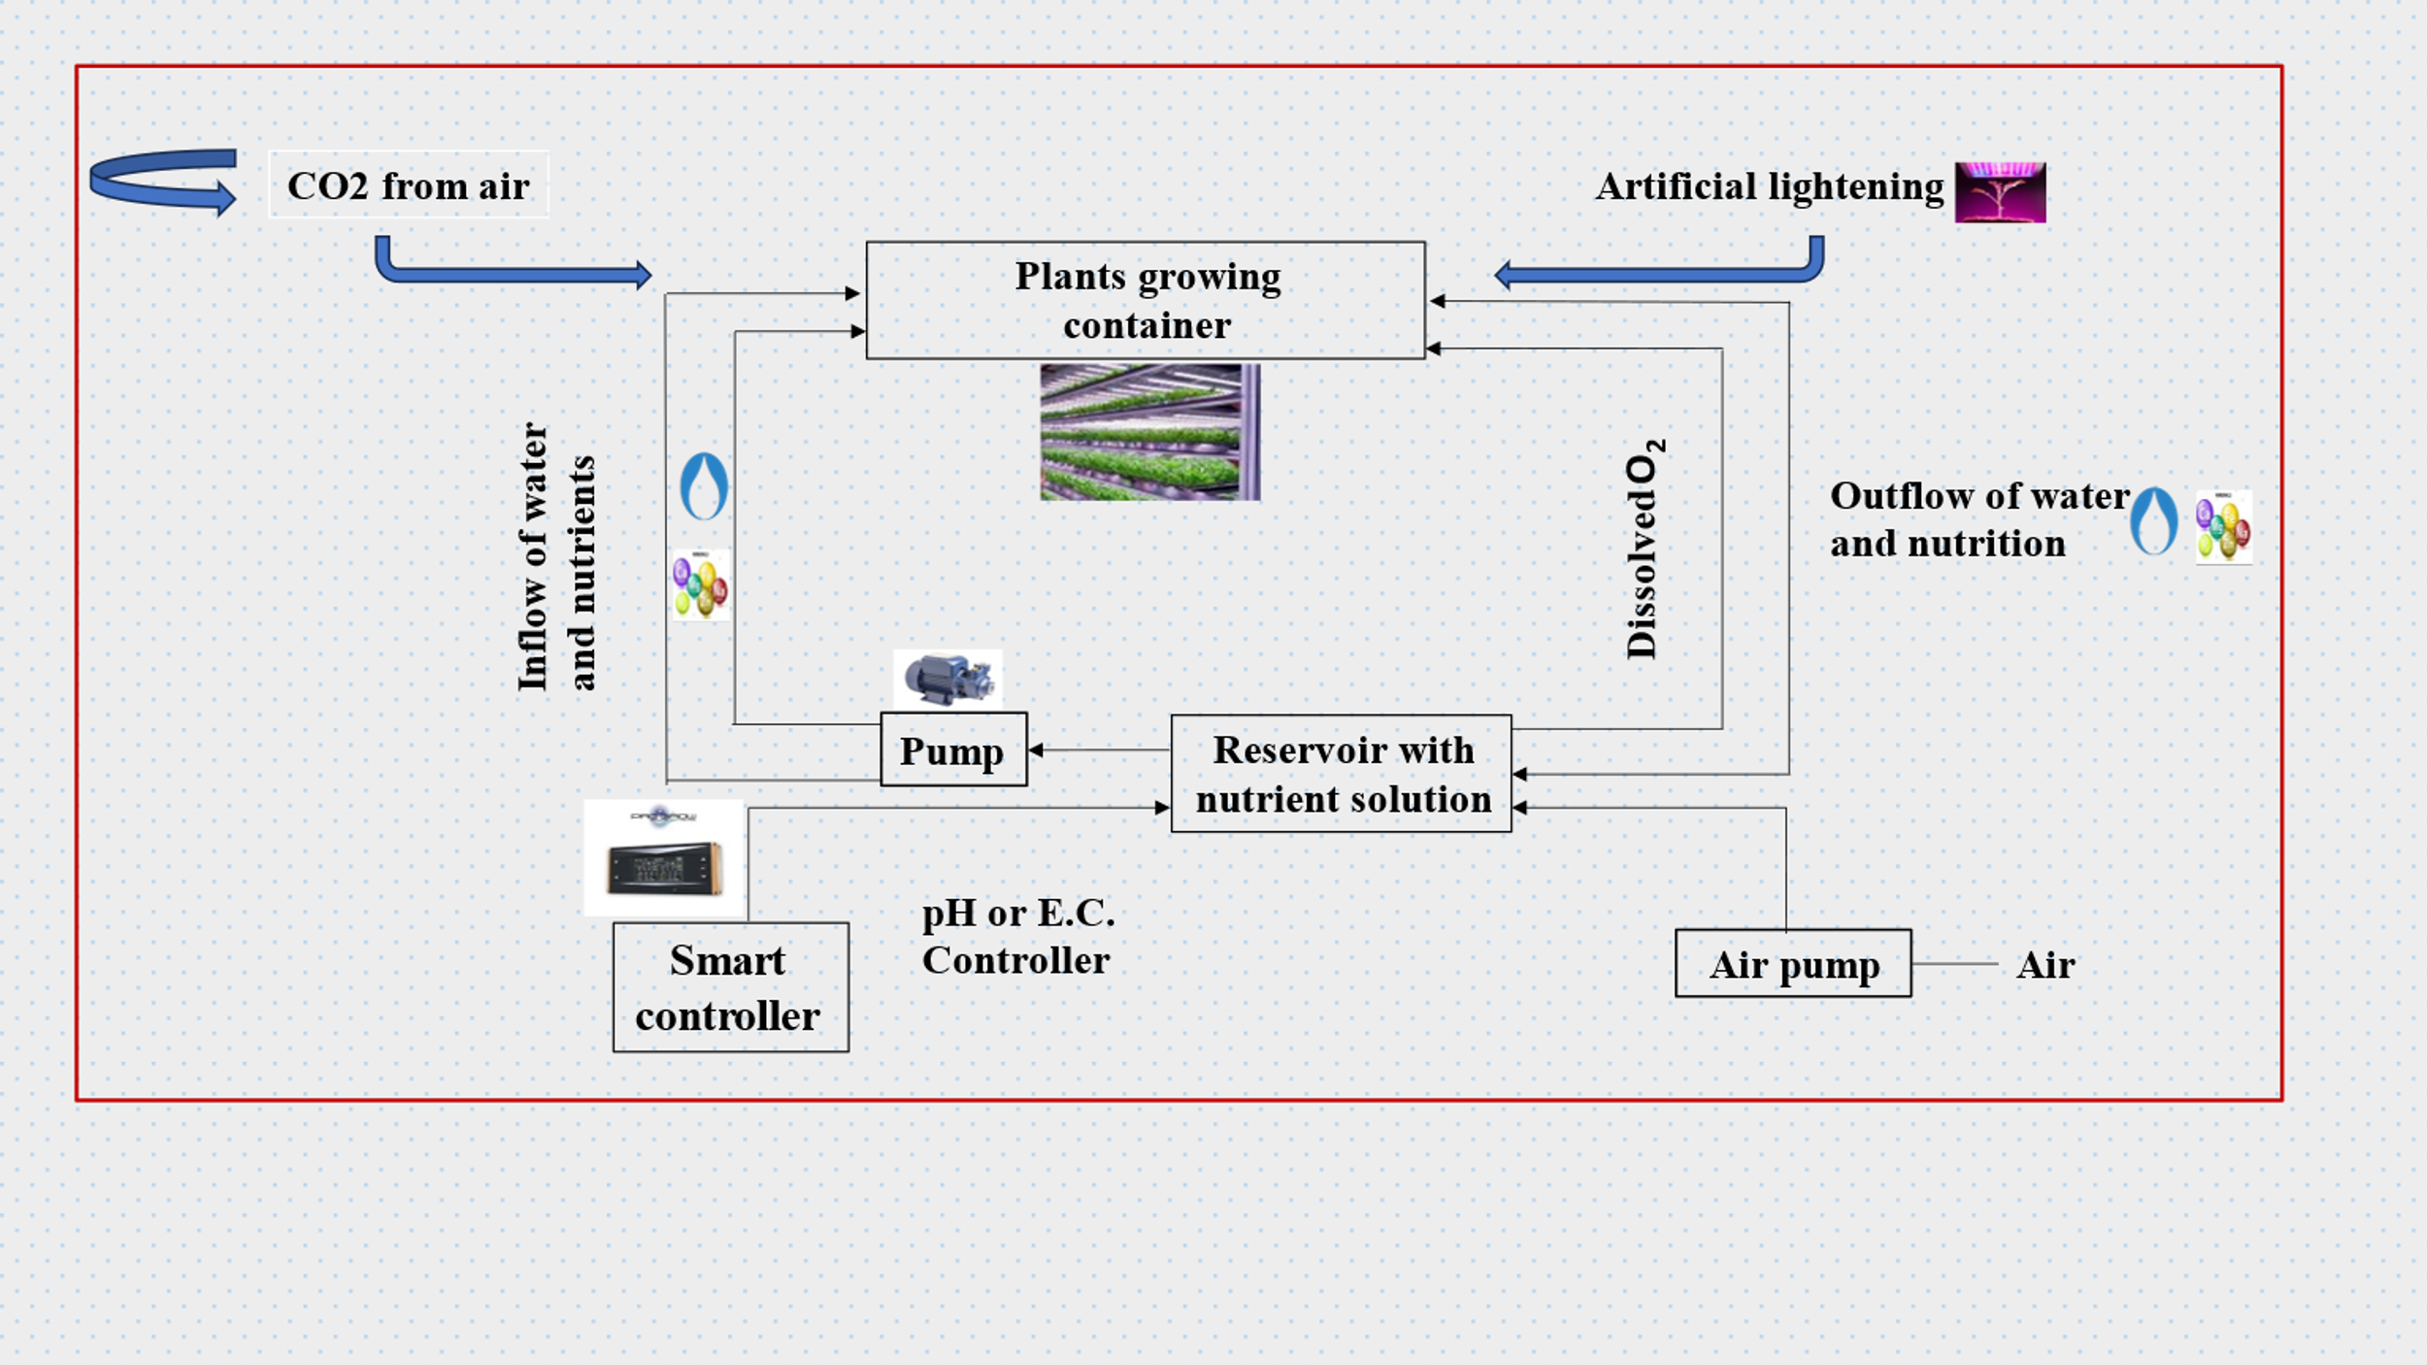

(Source: Hati and Singh, 2021)

**4. Accessibility of nutrient solution for hydroponic fodder production system**

“In hydroponic systems, the primary method of delivering plant nutrients is through nutrient solutions. Nutrient solutions are composed of inorganic and organic ions that provide specific nutrition to flourish the plants” (Thakur et al., 2023). “In hydroponics, plant nutrients are dissolved in water in inorganic and ionic forms. All essential elements for plant growth are supplied through various chemical combinations. Establishing a nutrient solution with a favorable ion ratio is crucial for successful crop cultivation in hydroponic systems” (Nguyen *et al*., 2021). Ojo *et al.*, (2024) conducted “an experiment to compare organic nutrient solutions (ONS) and commercial nutrient solutions for hydroponically growing maize fodder. It was found that maize fodder irrigated with poultry ONS recorded the highest dry matter yield (196 g) and had significantly higher crude protein (CP) content compared to other ONS and commercial solutions”.Adeoye et al., (2024) recommends “cattle nutrient solution as hydroponic organic nutrient solution for sorghum red as it enhances fresh and dry matter yields, and nutritive values”. Sharma et al., (2023) carried out experiments to “identify suitable nutrient and environmental conditions for Brahmi commercial cultivation in hydroponic system. Brahmi growth was observed to be high in NFT system followed by DFT system with cocopeat as physical support system and syngenta fertilizer as a suitable nutrient recorded higher shoot, root length, fresh and dry weight”.

**Table 1. Nutrient’s form taken up by plants and nutrients compositions as suggested by different scientists.**

|  |  |  |  |  |  |
| --- | --- | --- | --- | --- | --- |
| **Element** | **Form taken up by plants** | **Hoagland & Arnon (mg L⁻¹)** | **Hewitt (mg L⁻¹)** | **Cooper (mg L⁻¹)** | **Steiner**  **(mg L⁻¹)** |
| **Nitrogen** | NH₄⁺, NO₃⁻ | 210 | 168 | 200–236 | 168 |
| **Phosphorus** | HPO₄²⁻, H₂PO₄⁻ | 31 | 41 | 60 | 31 |
| **Potassium** | K⁺ | 234 | 156 | 300 | 273 |
| **Calcium** | Ca²⁺ | 160 | 160 | 170–185 | 180 |
| **Magnesium** | Mg²⁺ | 34 | 36 | 50 | 48 |
| **Sulfur** | SO₄²⁻ | 64 | 48 | 68 | 336 |
| **Iron** | Fe²⁺, Fe³⁺ | 2.5 | 2.8 | 12 | 2–4 |
| **Copper** | Cu²⁺ | 0.02 | 0.064 | 0.1 | 0.02 |
| **Zinc** | Zn²⁺ | 0.05 | 0.065 | 0.1 | 0.11 |
| **Manganese** | Mn²⁺, Mn⁴⁺ | 0.5 | 0.54 | 2 | 0.62 |
| **Boron** | H₃BO₃, BO₃⁻, B₄O₇²⁻ | 0.5 | 0.54 | 0.3 | 0.14 |
| **Molybdenum** | MoO₄²⁻ | 0.01 | 0.04 | 0.2 | Not considered |

Source: Salisbury and Ross (1991); Cooper (1988); Steiner(1984) ; Windsor and Schwarz (1990); Hoagland and Arnon(1938) ; Hewitt (1996)

In nutrient solutions it is very important to keep ionic balance of essential nutrients. Imbalance relationship between the essential nutrients, that is, the ratio of anions: NO3 −, H2PO4 − and SO42−, and the cations K+, Ca2+, Mg2 affected plant growth and productivity. However, for most common crop plants, critical levels for most nutrients have been determined (21). Gunasekaran et al, (2022) was conducted one study with biogas slurry as nutrient solution at 2.5%, 5.0% and 7.5% levels for hydroponic fodder maize production by foliar spraying method with six replications. The effect of graded levels on the mean biomass yield on hydroponic fodder maize growth was studied. The recorded biomass yield at the dilution of 2.5% biogas slurry as nutrient was statistically higher compared to other treatments (4.48 kg). In contrast to this study, Nugroho et al, (2015) prepare a nutrient solution from 25% bioslurry, and 75% solution of mineral fertilizers to feeding dairy cows that improve dry matter intake, energy consumption, and nitrogen consumption, also maintain nutrient digestibility and persistency of milk production during late lactation.

**Table 2. Nutritional composition differences in conventional and hydroponically grown Maize**

|  |  |  |
| --- | --- | --- |
| **Nutrients** | **Conventional green fodder** | **Hydroponic green fodder** |
| **Protein** | 10.69 | 13.59 |
| **Ether Extract** | 2.28 | 3.53 |
| **Crude Fibre** | 25.97 | 14.14 |
| **Nitrogen Free Extract** | 51.79 | 66.78 |
| **Total Ash** | 9.39 | 3.89 |
| **Acid Insoluble Ash** | 1.42 | 0.35 |

(Source: Indira et al, 2020)

The perusal data in Table 1 show that a lower percentage of CF content in hydroponic maize fodder is an increase in the size and number of cell walls for structural carbohydrate synthesis, which might be the reason for the elevated percentage of crude fibre content in commercially available fodder (Naik and Singh, 2014). Islam et al, (2024) also reported “similar results for different hydroponically cultivated crops such as maize, wheat, and sudan grass fodder has higher protein and lipid content, and conventionally grown fodder has higher levels of fiber and ash, potentially impacting digestibility and nutrient availability, and also promising methods for enhancing the nutritional quality of fodder, thereby improving livestock health and productivity”.

**5. Hydroponics technique and the sustainability of different techniques.**

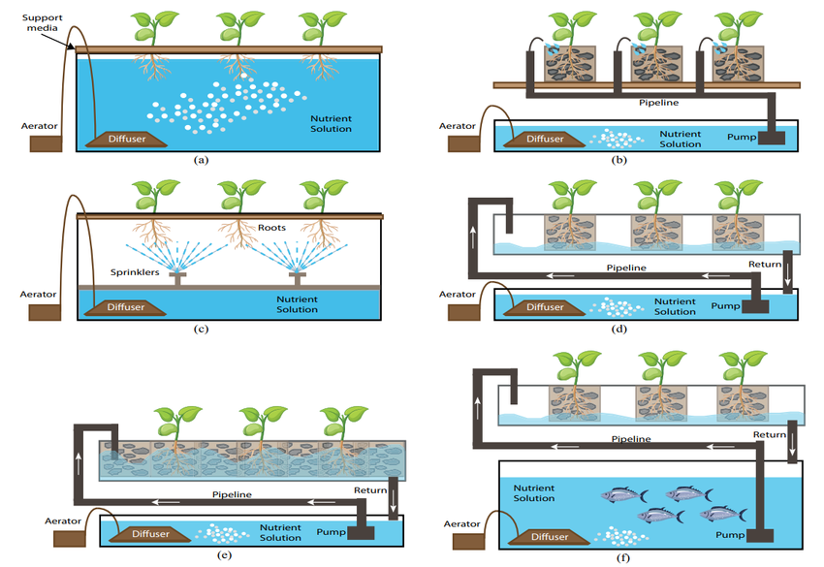In hydroponics plants cultivate without soil and uses mineral nutrient solution in water. (Dalton and Smith, 2003). “The plants grow with their roots either in nutrient solution or in an inert medium (gravel, perlite, or mineral wool). There are different types of hydroponic systems: Deep Water Culture, Drip System, Aeroponics, Nutrient Film Technique, Aquaponics and Ebb and flow. Water/moisture, nutrients, and oxygen are common factors required by plant roots. The types of hydroponic systems differ in how they offer the basic factors required for plant growth” (Kuncoro et al., 2021).

**Figure 5. Different types of hydroponic systems (a) Deep Water Culture. (b) Drip System. (c) Aeroponics. (d) Nutrient Film Technique (NFT). (e) Ebb and flow. (f) Aquaponics**

Source :(Velazquez-Gonzalez et al., 2022)

“Any technology is said to be sustainable when it is feasible in economically vaiable, ecologically safe and social equity. Through hydroponics not only sustainability achieved but sustainable intensification is posssible by without bring more additional areas into cultivation. It has been found that water reduction is possible to 90% compared to conventional soil-based farming. Additionally, this method provides the provision for recycling and also reutilization of the solutions with high nutrients. The method of vertical farming techniques promotes sustainability a waste reduction, resulting in high density crop production and innovative technologies. The AI based systems and smart home technology add relevant applications in indoor hydroponics production” (Rajaseger, et al., 2023).

**6. Comparative analysis of different fodder production through conventional and hydroponic techniques.**

“Hydroponics has multiple advantages compared to open field soil-based farming field soil-based farming. In controlled condition plants can grow faster thereby, higher yield compared to field conditions, minimize the need for pesticides, no soil-borne diseases and weed, efficient water use, able to recycle water efficient fertilizer use due to no leaching and uniformly distributed to all plant roots by nutrient solution and minimize environmental pollution due to eliminating leaching and runoff” (Fathidarehnijeha, et al., 2024). Elmulthum et al., (2023b) conducted “a study to assess water use efficiency in hydroponic and conventional production of barley green fodder. To produce one tone of barely green fodder hydroponically required 2.83 m3 compared to 117 m3 by the open field. In comparison, the water use efficiency of the barley green fodder, based on the fresh matter, under hydroponic cultivation was 48 times greater than the conventional. However, based on dry matter, under hydroponic cultivation it was three times greater than the conventional system”. Zainab et al., (2020) examined that “a higher concentration of crude protein, ether extract, nitrogen free extract, macronutrients (Ca, Na, K, Mg) and trace elements (Mn and Cu) in hydroponically grown maize fodder compare to conventional practices. This technology can ensure the provision of quality fodder for sustainable livestock production”. Chetan et al., (2021) recorded “on 10th days grain after sprouting using hydroponic technique day the maximum yield of Maize grain sprouts (average 4.5 kg per kg of maize grains with DM content 16.5% was obtained. Beyond 10 days, there was a reduction in the biomass yield. There was an increase in nutrient content (CP 13.0%, EE 4.40%, NDF 12.9%, ADF 15.5%, ash 2.99%) and decreased ME 19.76 MJ kg DM) as compared to conventionally of 60 days maize grown”.

**7. The effectiveness of hydroponically grown fodder on the growth and performance of ruminants.**

“Several studies have shown that feeding cattle with hydroponic fodder enhanced the uptake and digestibility of fodder, which in turn increased the milk production in the cattle. Therefore, hydroponics is an alternative efficient technology for producing quality fodder and year-round supply to the cattle” (Akkenapally and Lekkala*,* 2021). Joshiet al., (2024) investigated the effects of hydroponically grown maize fodder, both with and without probiotic supplementation in male Gir calves. The study revealed improvements in the concentrations of total protozoal count, total volatile fatty acids (TVFA), rumen ammonia nitrogen (NH3-N), total rumen nitrogen, TCA precipitable nitrogen (TCA-PN), and non-protein nitrogen (NPN). A similar study conducted by Jediya et al, (2021) concluded “hydroponics maize fodder has beneficial effect on growth performance and intake of digestible nutrients in Gir calves and it can replace up to 75% of crude protein of concentrate mixture”. “The concentrate can be replaced with hydroponic maize fodder at 25% and 50% levels in the diets of Tellicherry buck kids, it achieved better growth and profit” (Jemimah et al., 2023). Substituting grass silage with hydroponic maize fodder enriched with fermented compost tea up to 75% of the diet improved digestibility and rumen fermentation without negatively affecting intake, digestibility, or blood metabolites in Kacang goats. (Sulistijo et al., 2024). “The combination of maize and wheat hydroponic fodder resulted in better growth and reproductive performance compared to feeding maize or wheat hydroponic fodder alone. Furthermore, this feeding strategy reduced the cost per kilogram of live weight gain, indicating its potential for enhancing the sustainability and profitability of goat farming systems in the East Champaran region of Bihar. These might be due to supplementation of hydroponic maize and wheat improve nutrient digestibility, productive performance, and profitability in Tellicherry buck kids and optimal nutrient content in hydroponic wheat fodder could enhance fertility by supporting follicular development, ovulation, and embryo viability” (Rajak et al., 2024). Rajkumar et al., (2017) concluded that “hydroponics maize fodder can effectively substitute up to 30 per cent of protein in calf starter without compromising the growth performance”.Dadhich et al., (2020) found that feeding Rathi calves with hydroponic maize fodder improved ruminal TVFA and nitrogen fractions. The highest values were seen when 25% of CP was met through concentrate mixture and the rest with hydroponic maize fodder. Hydroponic Fodder Maize is more nutritious than conventional fodder maize and calf starter can be replaced with HFM on dry matter basis at 75 percent level without any adverse effect on the haemato-biochemical parameters in cross bred calves (Rani et al., 2019). Bhalerao et al., (2019) concluded that hydroponic green maize is superior in respect of crude protein (CP) content, ether extract (EE) and nitrogen free extract (NFE) than the green maize and lowest crude fibre content which indicates higher palatability and inclusion of 40% hydroponic green maize in the diet of Osmanabadi goats increases the DMI, improve the growth performance in terms of body weight, body length, chest girth and wither height (the height of the animal measured at the highest point of its back, where the shoulder blades meet) and economics in term of body weight gain. “Hydroponic fodder supplementation improved reproductive performance in buck kids to some extent by an earlier onset of puberty with greater scrotal circumference and testicular volume, good semen quality, and intense sexual behavior and the supplementation of hydroponic maize fodder also enhanced nutrient digestibility. The inclusion of hydroponically grown maize fodder in the diet of broiler poultry resulted in a significant gain in growth rate and an improved feed conversion ratio. Also, the supplementation of hydroponic maize fodder in the broiler poultry diet was found to reduce the feed cost by Rs. 10.36 per bird” (Murthy et al., 2020)

**8. The influence of age and seed rate on the dry matter yield and nutritive quality of hydroponically cultivated fodder**

The optimal seed rate and age are critical parameters in agro-techniques, directly influencing the productivity, profitability, and quality of fodder production (Ningoji, et al., 2020). Alemnew and Mekuriaw, (2023) concluded that based on fresh fodder biomass yield, dry matter yield, crude protein, and economic benefits, Debark-1 was the recommended barley variety on the 12-day harvesting age, followed by HB-1307, local, and Tila barley varieties. Ashique *et al*., (2024) conducted a study on four different times of harvest (9th, 11th, 13th and 15th days of harvesting) and two fodder crops (maize and cowpea). The results revealed that the higher green fodder yield (26.64 kgm-2) and dry matter yield (3.06 kgm-2) were recorded on the 15th day of harvesting in odder crop Cowpea, whereas lower green fodder yield (18.58 kgm-2) and dry matter yield (2.28 kgm-2) were recorded on the 9th day of harvesting in Maize. In terms of economics, it can be concluded that cowpea has a higher gross return, net return and B:C ratio. Harvesting the crop at 15th day has resulted in higher returns but 13th day of harvesting time was found more economical due to higher increase in the rate of gross and net monetary return.

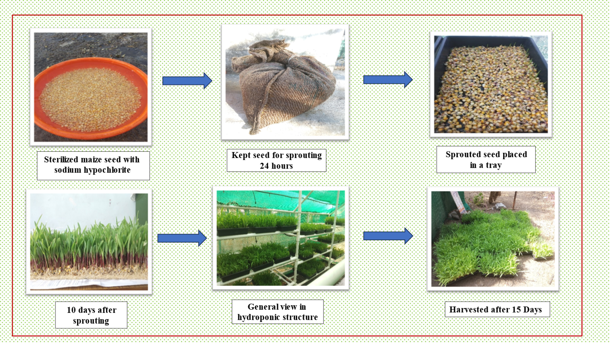

**Figure 6. Schematic view of the operation to be carried out for hydroponically grown maize at AICRP for Dryland Agriculture, Dr. Panjabrao Deshmukh Krishi Vidyapeeth, Akola (M.S.).**

Gunasekaran et al. (2018) found that the highest biomass yield (4.50 ± 0.57 kg/kg of seed) was obtained at a seed rate of 250 g/sq. ft on the 9 th  day of growth and there was no significant variation in biomass yield of hydroponic fodder maize regardless of soaking and germination times. However, numerically higher biomass yield was observed with 12 hours of soaking and 24 hours of germination. Studies on sorghum hydroponic fodder quality and quantity studies, varieties Super-1 harvested at 12 day had a good quality (CP) of fodder and it can be alternative of technology providing quality forage and land saving with a short time planting period and continuous production (Chrisdiana, 2018). Among barley green dodder, Behrokh cultivar with seed rate of 800 g/tray is recommended for fodder production in hydroponic systems in semi-arid climate condition of Iran (Afzalinia and Karimi, 2020). Three experiments were conducted to examine the effect of varieties, frequency of watering and harvesting dates on biomass yield and nutritive values of hydroponically sprouted fodder of four different maize varieties viz, s BH-661, BH-140, BH-540 and BH-545 (QPM). It was observed that BH-661 yielded the highest DM yield. The longer harvesting dates decreased fodder yield. The crude protein (CP) and cell wall contents such as neutral detergent fiber (NDF), acid detergent fiber (ADF) and acid detergent lignin (ADL) were higher for sprouted maize varieties than its grain. The in vitro dry matter digestibility (IVDMD) of the maize fodder (71.88%) for all varieties was lower than the mean values for their grain (82.65%) (Bekele et al., 2020). A solar-operated hydroponic system was set up at CTAE, Udaipur using bamboo sticks, shade net, and plastic trays with automatic irrigation managed by Arduino and solar power with three maize seed rates (600 g, 750 g, 900 g per tray) were tested. The highest crude protein (14.81%) and ether extract (3.01%) were observed in the 900g/tray hydroponic fodder after 10 days. Babu and Babu (2024) found that fodder grown under LED lights yielded 3.5 kg per tray with a water use efficiency of 825.9 kg/m³, significantly outperforming non-LED grown fodder. Crude protein and crude fiber content were 12.44% and 9.49%, respectively, under LED lights.

**9. A comparative evaluation of various hydroponic fodders is essential to determine their accessibility and suitability for farmers.**

Selecting the appropriate fodder crops and implementing cost-saving measures, hydroponic fodder production can be optimized to achieve maximum yield with minimal expenditure**.** Upreti et al., (2022) conducted an experiment to examine hydroponic fodder yields from each kg grain of several crops and it found that fodder oat recorded higher (7.96 kg) yield compared to wheat (6.76 kg) and maize (5.32 kg). Similarly, the crude protein (CP) content of the fodder was higher in wheat (16.16%) compared to oat (13.96%) and maize (12.51%). The cost of hydroponic maize, oat and wheat fodder production were obtained as recorded NPR 20.64, 24.67 and 18.76 per kg, respectively. Murthy (2017) conducted an experiment to evaluate four varieties of cereals grains and four verities of Pulses. The high biomass yield after 5 days in cereals was recorded in Bajra (6.37 kg) followed by sorghum (6.1 kg), Barley (5.06 kg) and Maize (4.82 kg). Among pulses Pillipesara (7.58 kg) yielded highest weight followed by Cowpea (7.2 kg), Lucerne (7.09 kg) and Horse gram (5.85 kg). Corn is better used as fodder compared to sorghum, because corn fodder has a greater number of leaves, the growth speed is faster, the production of fresh and dry matter is also higher compared to sorghum fodder. (Wulandari *et al*., 2024). Khanna (2015) summarized that chemical composition (% DMB) indicated CP and EE contents were higher in hydroponic maize fodder as compared to either conventional maize fodder or maize grain while the NFE content was higher compared to conventional maize fodder but lower when compared to the maize grain. Naik et al, (2015b) suggested Maize to be the choice for production of hydroponic fodder due to its easy availability, lower cost, good biomass production and quick growing habit. In another study, Naik et al. (2014) Hydroponics maize fodder of 7 days growth was studied and such hydroponics maize fodder (HMF) had higher CP (13.30 vs11.14, %), EE (3.27 vs 2.20, %), NFE (75.32 vs 53.54, %) and lower CF (6.37 vs 22.25, %), TA (1.75 vs 9.84, %) and AIA (0.57 vs 1.03, %) than Napier bajra hybrid. Garcia-Latorre and Poblaciones, (2024) studied the impact of fungal inoculation on hydroponic wheat and barley under saline conditions. The results showed that fungal treatments improved plant growth and NaCl resistance, with variations in efficacy among different fungi, L15 showed broader bioactivity, L16 was more effective in barley, and L11 was beneficial in wheat but detrimental in barley.

**10. Effect of hydroponic system on fodder Yield and milk productivity of livestock**

The primary goal of any agricultural production technology is to enhance yield, thereby contributing to increased milk production, as agriculture and livestock systems are inherently interdependent. Under such conditions, hydroponic fodder production is particularly appropriate due to its ability to optimize productivity and resource efficiency. Naik *et al*, (2015c) reported fresh yield of 8-10 kg from one kg locally grown maize in 7-10 days under low-cost devises. Assefa et al, (2020) examined that the BH661 exhibited significantly higher dry fodder yield (6.63 kg) per square meter and per kg seed than the other varieties. The 6.0 kg HMF was obtained from one kilogram of maize seed within 7 days without using any nutrients in the irrigated water (Murthy *et al*, 2020). Egamberdieva et al, (2024) analyzes “the effect of concentrated forages were replaced by Hydroponic Green Fodder 25, 35, and 45% by nutrient content, respectively and in the control group, a balanced feeding ration was prepared, considering live weight and milk productivity. The results revealed that milk yield of cows increased by 5.6–13.2 percent, and milk fat yield increased by 5.9–12.9% in comparison with the control group. It has been established that the introduction of HGF into the diet of cows improves the qualitative composition of milk and contributes to the increase of milk solids without reducing their physical properties. Feeding hydroponic green fodder to cows had no significant effect on titratable acidity and density, which contributes to incrsed of milk soilid without reducing physical properties”. Arivukodi et al., (2020) reported that “1kg of seed has potential to raise the green fodder about 15-20 kg through hydroponic system with a low-cost technique. All the nutrients like crude protein, fiber, vitamins and minerals get increased in hydroponic fodder that resulted into increase the milk production. It could be concluded from study that feeding hydroponics maize fodder to replace concentrate mixture up to 75 per cent level on CP basis increase the milk yield in Gir cows with decrease in the fat percentage and increase in milk total solids. In hydroponic fodder production, 5-10 kg of green fodder can be grown from 1kg of seeds”. This fodder shows an increase in nutritional content, including crude protein, fiber, ether extract, vitamins, and minerals. However, there is a 10-25% loss in dry matter content, varying by grain type and growth duration. Feeding hydroponic fodder to dairy cows enhances milk yield and composition due to improved nutrient intake and digestibility. (Salo, 2019). Jamimah et al, (2018) conducted a study to evaluate the effect of hydroponic maize fodder on milk production in crossbred dairy cattle by replacing CO4 grass. The study had three groups: Treatment 1 (control with no replacement), Treatment 2 (50% replacement of CO 4 grass with hydroponic maize fodder), and Treatment 3 (100% replacement of CO 4 grass with hydroponic maize fodder). Results showed that there were no significant differences in milk yield among the three groups, both before and during the trial. In a study, cows in the experimental group had a 6% higher milk yield (549.5 kg) over 305 days of lactation compared to the control group. The average daily milk yield was 1.8 kg (6%) higher. Additionally, the mass fraction of fat in milk increased by 0.4%, protein by 0.35%, resulting in a 17.5% (118 kg) increase in milk fat and a 19% (98.9 kg) increase in milk protein in the experimental group. Limba et al., (2019) assessed the utilization of hydroponic maize fodder to improve feed efficiency and milk production in Rathi cows. The study revealed a significant effect on milk yield, 4% fat-corrected milk yield, fat percentage, and total solids. However, the treatment did not significantly affect SNF%, protein%, and lactose%. Supplementation of 5-10 kg hydroponic fodders per cow per day increased milk production by 8-13%, and meat quality based on the digestibility of the nutrients (Shit, 2019). In the Satara district of Maharashtra, dairy farmers noticed the reduced cost of milk production by 2–3.5/kg feed and improved milk yield by 0.5–2.5 litre/animal/day on feeding hydroponic fodder (Reddy and Harani, 2023b).

**11. Advancements in hydroponic fodder production technologies to enhance efficiency and sustainability in meeting fodder demand**

Advancements in hydroponic fodder production technology offer a promising solution to address growing fodder demands while promoting sustainable livestock farming practices by optimizing resource utilization and maximizing yield in challenging environments. Jabbar and Ali, (2023) carried out experiments to enhance Fodder for these cultivation method (A1: Hydroponics, A2: Cultivation in the field as a comparative treatment) and the second included three concentrations of gibberellin (C0: 0 ppm, C1: 50 ppm, C2: 100 ppm), were taken. The hydroponic treatment was superior in leaf area, chlorophyll content, green fodder yield, dry fodder yield and protein content, the 100 ppm concentration of GA was superior in leaf area, green fodder yield, dry fodder yield and protein content, the interaction between the hydroponic system and 100 ppm concentration of GA was given higher leaf area, green fodder yield, dry fodder yield and protein content. Masucci et al., (2024) conducted research on a water buffalo dairy farm equipped with a fully automated hydroponic system producing approximately 6,000 kg/d of hydroponic barley fodder as fed (up 1,000 kg/d on DM basis)**.** Based on the data obtained from the in vivo study, the water and energy footprints to produce maize silage ands hydroponic barley fodder and buffalo milk, as well as income over feed cost, were evaluated. The resource footprint analysis showed potential benefits associated with HBF in terms of water consumption. However, the energy footprint assessment showed that the energy ratio of HBF was less than 1 (0.88) compared with 11.89 for maize silage. Gosavi (2017) designed an IoT-based hydroponic system that uses sensors to capture the pH level of the water solution, electrical conductivity, and luminosity. After data collection, the ARM 7 microcontroller automatically evaluates whether the values exceed the thresholds and makes the necessary adjustments. An LCD display is utilized to visualize the output and debug the system module. In this study, maize treated with nano silica (20–40 nm) is screened for resistance against phytopathogens such as *Fusarium oxysporum* and *Aspergillus niger* and compared with that of bulk silica and shows that silica nanoparticles can be used as an alternative potent antifungal agent against phytopathogens. Ronay and Dumitru, (2015) examined solar-powered hydroponic greenhouses, conducting a financial analysis to assess the economic viability of using renewable energy versus conventional power sources. The results indicated that the investment is economically viable, with a payback period of about 6 years.

**Fig 7. Challenges in Hydroponics production technology**

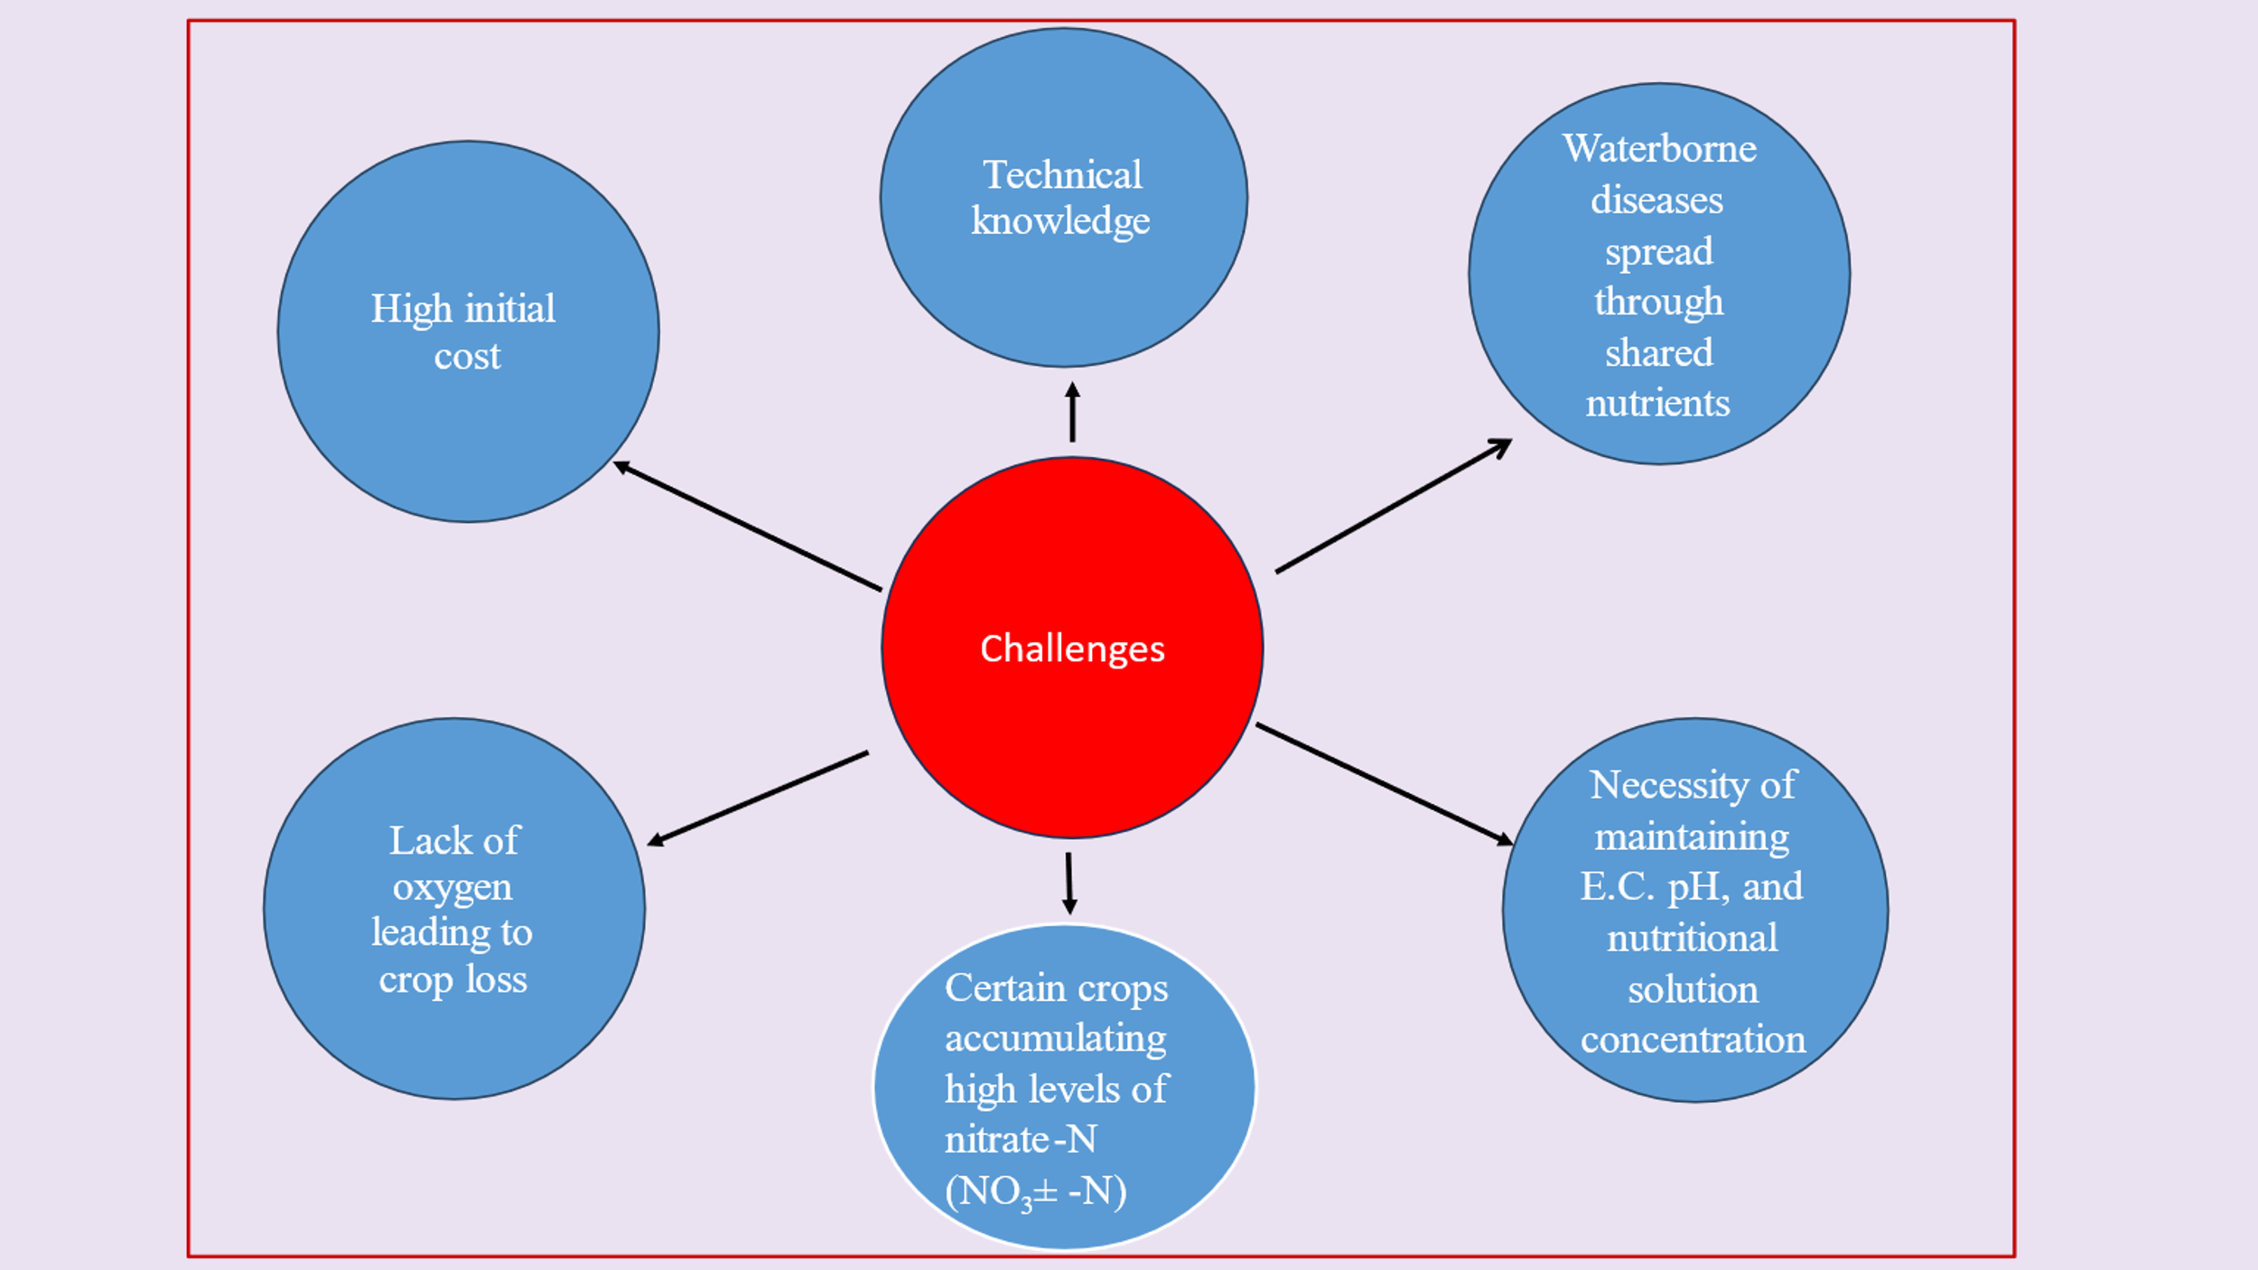

Source: (Sharma et al., 2018), (Guo et al, 2019)

**12. Future scope of hydroponics**

hydroponics, a soilless production method, promises to deliver high quality, nutritious, fresh, residue-free crops, overcoming the problems of climate change, freshwater shortage, necessity of fertile land, and the overwhelming requirement of the expanding food demand. Hydroponics production is now garnering prominence across the world because of its effective resource management and cultivation of high value crops (Kumar and Singh, 2023). Reusing partially treated (Secondary-treated domestic wastewater was fed to the hydroponic medium through batches by using an aerobic process, and the hydraulic retention time was maintained for 10 days. In addition to wastewater, a commercial hydroponic solution was added verifying the reduction in organic loading in wastewater and the growth of plants is compare with commercial hydroponic solutions.) water for hydroponic plants reduces costs, conserves water, and supports sustainable development goals like zero hunger, no poverty, clean water, and sanitation (Aishwarya and Vidhya, 2023). Hydroponics allows year-round cultivation anywhere, enhancing urban agriculture. This can improve the food supply chain's efficiency and cleanliness, boosting food security amid climate change (Wheeler and Von Braun, 2013). The establishment of the new market for hydroponics crops and vegetables in India is a great challenge as the market demand is driven by traditional or terrestrial farming. Therefore, it is a need of hours to create awareness about hydroponics in our country.

**13. Conclusions**

In the era of burgeoning global population, declining per capita availability, and the shrinking cultivated area of fodder production, hydroponics fodder production are better options especially in vertical farming. This technique intensifies fodder production by offering controlled conditions and minimizing external complexities. The efficacy of hydroponic fodder production is not solely decided by crop selection, age, and seed rate but is also significantly influenced by advancements in technology. Presently, hydroponic systems are extensively utilized to examine plant responses to various stress conditions and to identify suitable genotypes. This method also facilitates biofortification through the provision of optimized nutrient solutions, enhancing the nutritional profile of the produce. Moreover, hydroponics is a new avenue for organic food production methods. By exploiting these advancements, hydroponic systems can substantially contribute to meeting the increasing demand for high-quality fodder supporting sustainable agricultural practices.

**14. DISCLAIMER (ARTIFICIAL INTELLIGENCE)**

Author(s) hereby declares that NO generative AI technologies such as Large Language Models (ChatGPT, COPILOT, etc) and text-to-image generators have been used during writing or editing of this manuscript.

**15. CONFLICT OF INTEREST**

All authors declare that they have no conflict of interest.

**16. REFERENCES**

Adeoye, S., Ojo, V., Ogunbote, O., Ogunbote, O., Adeyemi, T. and Ahmed, A. (2024). Effect of different organic nutrient solutions and day of harvest on growth, biomass yield and chemical composition of hydroponically grown sorghum. Trends in Horticulture. 7(2):40-47.

Afzalinia, S. and Karimi, A. (2020). Barley cultivars and seed rates effects on energy and water productivity of green fodder production under hydroponic conditions. Indian Journal of Agricultural Research. 54(6):792-796.

Aishwarya, J.M. and Vidhya, R. (2023). Study on the efficiency of a hydroponic treatment for removing organic loading from wastewater and its application as a nutrient for the “Amaranthus campestris” plant for sustainability. Sustainability.15:7814.

Akkenapally, J.S. and Lekkala, S. (2021). Hydroponic fodder production: A review, The Pharma Innovation Journal, 10(11): 2435-2439.

Alemnew, Y. and Mekuriaw, Y. (2023). Effects of harvesting age and barley varieties on morphological characteristics, biomass yield, chemical composition, and economic benefits under hydroponic conditions in fogera district, Ethiopia. Advances in Agriculture, Article ID 9315556, pp-10.

Annual Report. (2019). 20th Livestock Census-All India Report, Ministry of Fisheries, Animal Husbandry and Dairying, Government of India, New Delhi.

Arivukodi, J., Poomani, G., Praveena, M. and Gnanavel, G. (2020). A review on using different types of cultivars to produce green fodder under hydroponic system and to increase the efficiency of milk. Journal of Emerging Technologies and Innovative Research. 7(2):930-932.

Ashique, A., Chorey, A.B., Ganvir, M.M. and Chaitanya, V. (2024). Productivity and economics of hydroponic fodders as influenced by harvesting time. Journal of Scientific Research and Reports.30(6):263-267.

Assefa, G., Urge, M., Animut, G. and Assefa, G. (2020). Effect of variety and seed rate on hydroponic maize fodder biomass yield, chemical composition, and water use efficiency. Biotechnology in Animal Husbandry. 36(1):87-100.

Babu, D.A. and Babu, B.C. (2024). Development and evaluation of low cost indoor hydroponic green fodder production system. Journal of Scientific Research and Reports. 30(12):871-880.

Bekele, M., Diba, D. and Yusuf, H. (2020). Watering intervals and harvesting dates affected fodder syield and nutritional values of maize varieties under hydroponic system in Wollega university. American-Eurasian J. Agric. And Environ. Sci. 20(2):89-98.

Bhalerao, S.B., Zinjarde, R.M., Atkare, V.G. and Kadam, N.P. (2019). Effect of feeding of hydroponic maize on growth performance Osmanabadi goats. Journal of Pharmacognosy and Phytochemistry. 8(5):508-511.

Chapman, S.C., Chakraborty, S., Dreccer, M.F., Howden, S.M. (2012). Plant adaptation to climate change opportunities and priorities in breeding. Crop Pasture Sci. 63:251–268.

Chethan, K.P., Gowda, N.P.S., Prabhu, T.M., Giridhar, K., Anandan, S., Dey, D.K., Soren, N.M. and Shivakumar, M.C. (2021). Biomass Yield and Nutritive Value of Maize Grain Sprouts Produced with Hydroponic Technique Compared with Maize Grain and Conventional Green Fodder. Animal Nutrition and Feed Technology 21: 121-130.

Chrisdiana, R. (2018). Quality and quantity of sorghum hydroponic fodder from different varieties and harvest time. IOP Conf. Series: Earth and Environmental Science. 119:012014

Cooper, A. (19881) The system. 2. Operation of the system. In: Books G, editor. The ABC of NFT. Nutrient Film Technique. London. pp. 3-123.

DAC and FW, GOI, (2020). Agricultural Statistics at a Glance.

Dadhich, R., Dhuria, R.K., Nehra, R., Jain, D. and Sharma, T. (2020). Effect of feeding of hydroponics maize fodder on rumen parameters in Rathi calves. Veterinary Practitioner. 21(1):142-144.

Dalton L and Smith R (2003) hydroponic developments ltd hydroponic gardening: a practical guide to growing plants without soil; hydroponic developments ltd.: Tauranga pp. 20-28.

Egamberdieva, Z., Kurbanova, S., Sadikova, C., Akhtamova, M. and Davron. (2024). The use of hydroponic green forages in increasing milk productivity and improving reproductive ability of Holstein cows. BIO Web of Conferences, Genetic Resources 01016:15.

Elmulthum, N.A., Zeineldin, F.I., Al-Khateeb, S.A., Al-Barrak, K.M., Mohammed, T.A., Sattar, M.N., Mohmand, A.S. (2023). Water use efficiency and economic evaluation of the hydroponic versus conventional cultivation systems for green fodder production in Saudi Arabia. Sustainability. 15:822.

Fathidarehnijeha, E., Nadeema, M., Cheemaa, M., Thomasb, R., Krishnapillaia, M. and Galagedara, L. (2024). Current perspective on nutrient solution management strategies to improve the nutrient and water use efficiency in hydroponic systems. Can. J. Plant Sci.104: 88–102.

Garcia-Latorre, C. and Poblaciones, M.J. (2024). Isolation, identification, and application of endophytic fungi from lavandula stoechas l.: mitigating salinity stress in hydroponic winter cereal fodder. Agronomy. 14 :2501.

Gebremedhin, W. K. (2015). Nutritional benefit and economic value of feeding hydroponically grown maize and barley fodder for Konkan Kanyal goats. Journal of Agriculture and Veterinary Science. 8(7):24–30.

Ghorbel, R. and Koşum, N. (2022). Hydroponic fodder production: an alternative solution for feed scarcity. 6th International Students Science Congress. pp:1-8.

Gosavi, J. V. (2017). Water monitoring system for hydroponics agriculture. vol 5(7):12-17.

Gunasekaran, S., Valli, C., Karunakaran, R., Gopi, H. and Gananaraj, P. T. (2022). Evaluation of growth period and water and light requirement for optimum production of hydroponic maize and horse gram fodder. Org. Agr. 12:75–80.

Gunasekaran, S., Valli, C., Karunakaran, R., Gopi, H., Gnanaraj, P. and Sankaran, V. (2018). Studies on influence of soaking, germination time and seed rate on biomass yield of fodder Maize (*Zea mays* L.) cultivated through fabricated hydroponic fodder production unit. International Journal of Livestock Research. 8(1):190-194.

Guo, J., Yan, Y., Dong, L., Jiao, Y., Xiong, H. and Shi, L. (2019). Quality control techniques and related factors for hydroponic leafy vegetables. Hort Science. 54(8):1330-1337.

Hati, A.J. and Singh, R.R. (2021). Smart Indoor Farms: Leveraging Technological Advancements to Power a Sustainable Agricultural Revolution. AgriEngineering.3:728–767.

Hewitt, E.J. (1996). Sand and water culture methods used in the study of plant nutrition. In: Technical communication No. 22. East Malling, Maidstone, Kent, England: Commonwealth Bureau of Horticulture and Plantation Crops.

Hilli, H., Kapoor, K. and Amandeep. (2023). Forage production in India: bottlenecks and opportunities by opening up new way with an increase in fodder Oats demand: A Review. Asian Journal of Dairy and Food Research. 42(3):275-285.

Hoagland, D.R. and Arnon. (1938). The Water Culture Method for Growing Plants Without Soil (Circular (California Agricultural Experiment Station), 347. ed.). Berkeley, CA: University of California, College of Agriculture, Agricultural Experiment Station.

Indian Grassland and Fodder Research Institute (Indian Council of Agricultural Research) (2013). www.igfri.res.in Vision 2050. <https://igfri.icar.gov.in/>, pp 1-40.

Indian Grassland and Fodder Research Institute Newsletter (2022). 28(1):1-12.

Indira, D., Aruna, P., Kanthi, S.S. and Kumar, K. (2020). Hydroponics as an alternative fodder for sustainable livestock production. World Journal of Advanced Research and Reviews. 05(02):087–092.

Islam, B.M., Ahmed, G.U., Islam, A., Khan, S.M, and Akter, F. (2024). Assessment of nutrient content in grain, hydroponic and conventional fodder with focus on maize, wheat and Sudan grass. International Journal of Biosciences. 24(3):187-194.

Islam, M.M., Anjum, S., Modi, R.J. and Wadhwani, K.N. (2016). Scenario of livestock and poultry in India and their contribution to national economy. International Journal of Science, Environment and Technology, 5(3):956 – 965.

Jabbar, M.K. and Ali, F.A. (2023). Providing fast fodder technology from barley crop by using a hydroponic system with different gibberellin concentrations. Trends Agric. Sci. 2(2):131-138.

Jediya, H. K., Shende, K.A., Dhuria, R.K., Vaishnava, R.S. and Barolia, Y.K. (2021). Effect of hydroponic maize fodder supplementation on growth performance, nutritive ratio and intake of digestible nutrient in Gir calves. International Journal of Bio-resource and Stress Management. 12(5):450-454.

Jemimah, R., Gnanaraj, T.P., Muthuramalingam, T., Devi, T. and Bharathidasan, A. (2018). Effect of hydroponic maize fodder with replacement of CO4 grass on milk production in crossbred dairy cattle. International Journal of Agricultural Sciences and Veterinary Medicine. 6(1):105-111.

Jemimah, R.E. Gnanaraj, T.P., Sivakumar, T., Gopinathan, A. and Meenakshi, S.S. (2023). Productive performance and economics of Tellicherry buck kids fed varying levels of hydroponic maize fodder. Indian Journal of Animal Sciences. 92(2): 250–253.

Joshi, M., Sharma, S. K. and Vaishnava, C.S. (2024). Effects of hydroponic maize fodder with and without supplementation of probiotics (*Saccharomysis cerevisiae*) on rumen parameters in calves. International Journal of Bio-resource and Stress Management. 15(5):01-06.

Khanna, C.H. (2015). Effect of feeding rations supplemented with hydroponic maize fodder on nutrient utilization and milk production in lactating graded Murrah buffaloes. Thesis submitted to the Srivenkateswara Veterinary University in partial fulfillment of the requirements for the degree of Master of Veterinary Science. pp:4-5.

Kumar, A. and Singh, J. (2023). Trends in Hydroponics Practice/Technology in Horticultural Crops: A Review. Journal of Plant & Soil Science. 35(2):57-65.

Kuncoro, C., Asyikin, M. and Amaris A (2021) Development of an automation system for nutrient film technique hydroponic environment proceedings of the 2nd International Seminar of Science and Applied Technology. Advances in Engineering Research, volume 207.

Limba, A.K., Dhuria, R.K., Sharma, T and Nehra, R. (2019). Effect of Feeding of Hydroponic Maize Fodder on Milk Production in Rathi Cows. Animal Nutrition and Feed Technology. 19(3):517

Malhi, G.S., Kaur, M., Sharma, K. and Gupta, G. (2020). Hydroponics technology for green fodder production under resource deficit conditions. Vigyan Varta. 1(5):65-68.

Masucci, F., Serrapica, F., Cutrignelli, M.I., Sabia, E., Balivo, A. and Francia, A.D. (2024). Replacing maize silage with hydroponic barley forage in lactating water buffalo diet: Impact on milk yield and composition, water and energy footprint, and economics. J. Dairy Sci. 107:9426–9441.

Murthy, A. K., Dhanalakshmi, G., Chakravarthy, K. (2017). Study on performance of different fodder crops under low-cost greenhouse hydroponic fodder production system. International Journal of Environment, Agriculture and Biotechnology. 2(2):951-953.

Murthy, K.A., Chakravarthy, K M., and Guduru, D. (2020). Effect of hydroponic maize fodder supplementation on production performance in broilers. Forage Res. 46 (1):98-100.

NAAS (2017). Policy Paper No. 85 Hydroponic Fodder Production in India. National New Delhi: 27p.

Naik PK, Singh NP, 2014. Production and feeding of hydroponics green fodder. Indian Farming 64:4244.

Naik, P.K., Dhuri, R.B., Karunakaran, M., Swain, B.K. and Singh, N.P. (2014). Effect of feeding hydroponics maize fodder on digestibility of nutrients and milk production in lactating cows. Indian Journal of Animal Sciences. 84(8):880-883.

Naik, P.K., Swain, B.K. and Singh, N.P. (2015). Production and utilization of hydroponics fodder. Indian Journal of Animal Nutrition.32(1):1-9.

Nguyen, V.Q., Van, H.T., Le S. H., Nguyen, T.H. and Lan N. T. (2021). Production of hydroponic solution from human urine using adsorption–desorption method with coconut shell-derived activated carbon. Environmental Technology and Innovation. 23:101708.

Ningoji, S. N., Thimmegowda, M. N., Boraiah, B., Anand, M. R., Murthy, K.R. and Asha, N.N. (2020). Influence of seed rate on growth, yield and economics of hydroponic fodder maize production. Range Management and Agroforestry. 41(1):108-115.

Nugroho, H. D., Permana, I. G. and Pal, D. (2015). *Media Peternakan*, 38(1): 70–76.

Ojo, V., Adeoye, S., Adeyemi, T., Oyaniran, D., Edward, T., Hassan, V., Okunlola, M. and Arigbede, O. (2024). Agronomic characteristics and chemical composition of hydroponic maize fodder as influenced by animal waste solutions. Trends in Horticulture. 7(1): 4062.

Rajak, S. K., Singh, A.K., Singh, A.K., Rai, A. and Gangwar, A. (2024). Assessment of feeding hydroponic fodder on growth and reproduction performance in Black Bengal goat. Tropical Animal Health and Production 56:388.

Rajaseger G, Chan KL, Tan KY, Ramasamy S, Khin MC, Amaladoss A, Patel KH (2023) Hydroponics: current trends in sustainable crop production. Bioinformation 19(9): 925-938.

Rajkumar, G., Dipu, M.T., Lalu, K., Shyama, K. and Banakar, P.S. (2017). Evaluation of hydroponics fodder as a partial feed substitute in the ration of crossbred calves G. Indian J. Anim. Res. 52:   
1-5.

Rani, J.K., Ally, K., Shyama, K. and Purushothaman, S. (2019). Nutritional evaluation and effect of feeding hydroponic fodder maize on the haemato-biochemical parameters in cross bred calves. J. Vet. Anim. Sci, 50(1), 57 – 62.

Reddy, P. B. and Harani, M. (2023). Hydroponics: A sustainable way of green fodder production. Indian Farming. 73(02):02-05.

Ronay, K., and Dumitru, C.D. (2015). Hydroponic greenhouse energy supply based on renewable energy Sources. Procedia Technology. 19:703-707.

Roy, A. K., Agrawal, R. K., Bhardwaj, N. R., Mishra, A. K. and Mahanta, S. K. (2019). Indian fodder scenario: redefining state wise status. ICAR- AICRP on Forage Crops and Utilization, Jhansi, India. pp:1-21.

Salisbury, F.B. and Ross, C.W. (1991). Plant Physiology. 4th ed. Beverly: Wadsworth Publishing Company; p. 481.

Salo, S. (2019). Effects of hydroponic fodder feeding on milk yield and composition of dairy cow: Review. Journal of Natural Sciences. 9(8):1-8.

Selyansky, A.I. (2018). Such greenhouses are the future. Journal Potatoes and vegetables. 7:24-26.

Sharma, M., Raghuvanshi, A.C., Singh, P. and Tejovathi. G. (2023). Analysis of viability of using hydroponics in cultivation of medicinal herb Brahmi (*Bacopa Monnieri* L. west). International Journal of Agricultural Sciences. 19:82-90.

Sharma, N., Acharya, S., Kumar, K., Singh, N., and Chaurasia, O.P. (2018). Hydroponics as an advanced technique for vegetable production: An overview. Journal of Soil and Water Conservation. 17(4):364-371.

Shit, N. (2019). Hydroponic fodder production: an alternative technology for sustainable livestock production in India. Explor Anim Med Res. 9(2):108-119.

Singh, S. and Rajni. (2017). Importance of quality fodder for higher milk production in dairy animals. Indian Farming. 67(11):36–39.

Steiner, A. A. (1984). The universal nutrient solution. In: Proceedings of IWOSC 6th International Congress on Soilless Culture; Wageningen, The Netherlands;. pp. 633-650.

Sulistijo, E. D., Benu, I., Oematan, G., Rosnah, U.S., Hilakore, M.A. and Jelantik. I. G. N. (2024). Enhancing nutrient intake, digestibility, rumen fermentation, and blood metabolites in kacang goats using compost-enriched hydroponic maize fodder. Tropical Animal Science Journal. 47(4): 475-482.

Thakur, O., Patel, S. and Dhruw, A. (2017). Hydroponics: an alternative tool for growing crops. Innovative Farming. 2(1):49-51.

Thakur, P., Wadhwa, W., Kaushal, S. and Shubham. (2023). Nutrient Dynamics for Hydroponic Production System. International Journal of Plant & Soil Science. 35(21): 982-993.

Upreti, S., Ghimire, R.P., and Banskota, N. (2022). Comparison of different cereals for hydroponic fodder production in locally constructed polyhouse at Khumaltar, Lalitpur, Nepal. Journal of Agriculture and Natural Resources. 15(1):27-33.

Velazquez-Gonzalez, R.S., Garcia-Garcia, A. L., Ventura-Zapata, E., BarceinasSanchez, J. D. O., & Sosa-Savedra, J. C. (2022). A Review on Hydroponics and the Technologies Associated for Medium-and Small-Scale Operations. Agriculture (Switzerland), 12(5).

Wheeler T, Von, B.J. (2013). Climate change impacts on global food security. Science. 341: 508-513.

Windsor, G. and Schwarz, M. Soilless Culture for Horticultural Crop Production. FAO, Plant Production and Protection. Roma, Italia; 1990. Unipub, ISBN: 0987650XXX.

Wulandari, S., Kusuma, S.B., Utomo, B. and Respati. A.N. (2024). Characterization and production hydroponic fodder for corn (*Zea mays*) and sorgum (*Sorghum bicolor*) at different harvest times. 6th International Conference on Food and Agriculture). IOP Conf. Series: Earth and Environmental Science. 1338:012017.

Zainab, S.M., Iram, S., Ahmad, K.S. and Gul, M.M. (2020). Nutritional composition and yield comparison between hydroponically grown and commercially available Zea mays L. fodder for a sustainable livestock production. Maydica, 64(3):1-9.