Trap Nest preference of Solitary bees (Hymenoptera: Apoidea) in Tamil Nadu, India
Abstract
Solitary bees play crucial role in pollination of Agricultural and horticultural crops. Construct their nests in soil, hallow reeds, wood, and preexisting cavities like man made holes. Artificial trap nests were used to study the occupancy rate. The results showed that small carpenter bee, Ceratina binghami C. preferred Peltophorum pterocarpum as nesting site with an average of 26% in a period of 21.2±9.1 days. Megachile sp., preferred papaya petioles with an average 8% of occupancy in 18±11.74 days. On an average of 3% trap occupancy was recorded in Ipomea reeds by Lithurgus sp. and Coelioxyx capitata S. in a period of 36.5±2.5 days, respectively. Vertically tied bundles of P. pterocarpum preferred by C.binghami taken less duration to occupy the nest compared to the horizontally tied bundles. In contrast, leaf cutter bees like Megachile sp., and Lithurgus sp. was preferred more in horizontally tied bundles viz., Carica papaya L. and Ipomoea carnea L. comparative to P.pterocarpum bundles which is erected vertically less preferred by the leaf cutter bees. Many nests were recorded, where the rich source of vegetation is available Clepto-parasitic bee, Coelioxys capitata S. nesting biology and different life stages were studied. The life cycle of cleptoparasite was completed in 22.2±3.64 days.
Keywords: Solitary bees, Conservation, Peltophorum pterocarpum, Ceratina binghami, Meghachile sp., Lythurgus sp., Papaya petiole and Ipomea reeds.
Introduction
Solitary bees play an important role in pollination in cultivated, uncultivated and wild plants (Kumar and Kumaranag, 2018). Solitary bees construct the nest unlike social bees. Each nest is constructed by the single female. Nest infrastructure varies among the solitary bees, which use varieties of materials like leaves, resin, mud, substrates like pruned branches, and wood (Batra, 1984). Small carpenter bee, Ceratina binghami construct simple linear nest in hollow and pruned pithy stems like Sesbania bispinos, Cashew (Yogi and Khan, 2014, Kaliaperumal, 2019). Large carpenter bee nests in wooden structures, hollow stems, pithy stems of Calotropis procera bamboo culms (Hannan et al., 2012; Hongjamrassilp and warrit, 2014). Leaf cutter bee, Megachile sp., built their nest in preexisting cavities, dead empty snail shells, holes in concrete walls, old trunks of trees (Michener, 2007). However, Parasites like chalcid wasp, Pteromalus apum parasitizes Alfalfa leaf cutter bees, Megachile rotundata drastically reduces the bee population eventually effect on the bee population and pollination (Sheffield, 2017). Furthermore, In Southern part of India, leaf cutter bees heavily parasitized by parasitoid, Melittobia sp., highly preferred in artificial trap. Trap nests, being excellent nesting site for the bees and also may attract to the parasites (Veeresh Kumar et al., 2015).
Pollinators decline is a global crisis attribute to various anthropogenic activities like agricultural intensification, pesticides usage, deforestation and habitat fragmentation. In the absence of pollinators, the flowers remain unfertilized (Raju and Rao, 2006) resulting in reduction in the reproductive success of flowering plants. Hence, there is an overwhelming need for protection and conservation of natural habitats.
Materials and Methods:
Petioles of papaya, Carica papaya L., Copper pod tree, Peltophorum pterocarpum DC., bamboo sticks, Bambusa vulgaris L.and Ipomea carnea J. were collected from the local sites and the leaves were removed, allowed to dry for two days, cut with secateurs up to 15 cm in length and tied into bundles using a thread, each bundle with ten sticks replicated with ten times. The trap nests were installed at the Agricultural College and Research Institute, Madurai in the college orchard, hostel premises, college garden area, central farm area and indoor stadium during 2018-2020. The P. pterocarpum stick bundles were tied vertically, papaya petioles, Bambusa vulgaris L. sticks and Ipomea reeds were tied horizontally. The installed traps were monitored at weekly intervals to record the occupancy of bee species viz., Ceratina binghami and Megachile sp. the number of days taken to accept the nest and number of nests occupied were also recorded. The trap nest occupancy rate was worked out by taking the ratio of number of nests occupied by the total number of supplied nests.
Results and Discussion
The installed nesting substrates were occupied by the small carpenter bees like Ceratina binghami and leaf cutter bees like Megachile sp., Lithurgus sp., Coelioxys sp., and wasps. P.pterocarpum sticks were highly preferred by C. binghami for nest construction (Fig 1.A-B) with the highest average percentage of occupancy of 26% in a period of 21.2±9.1 days. Megachile sp., preferred papaya petioles (Fig 1.E) with an average 8% of occupancy in 18±11.74 days. However, The present findings are in agreement with the findings of Amala et al. (2019) M. laticeps S. with 64.70% of nest occupancy to the papaya petioles an average 10.5± 3.50 days was required to occupy the nest. The addition of more artificial trap nests in crops such as apples, almonds, and alfalfa increased the density of solitary bee populations from the Megachilidae family (Bosch and kemp, 2002). On an average of 3% trap occupancy was recorded in Ipomea reeds by Lithurgus sp. (Fig 1.D) and Coelioxyx capitata S. in a period of 36.5±2.5 days, respectively.
The mud wasp preference was also observed in C. papaya petioles with 1.4% occupancy rate and duration taken to occupy the nest was 58.33± 7.63 days. However, the present findings are similar with findings of Loyola and Martins, (2014) they were also found that wooden trap sticks occupied with 75% of wasp nests.
Vertically tied bundles of P. pterocarpum preferred by C.binghami taken less duration to occupy the nest compared to the horizontally tied bundles. In contrast, leaf cutter bees like Megachile sp., and Lithurgus sp. was preferred more in horizontally tied bundles viz., C.papaya and I. carnea (Fig 1.C) comparative to P.pterocarpum bundles which is erected vertically less preferred by the leaf cutter bees (Fig 1.F).
Many nests were recorded, where the rich source of vegetation is available and which is very nearer to the nesting site. No nests occupancy was observed in fewer sources of floral available and far away to the nesting location. Non insects like lizards, spiders were also observed in installed traps. Furthermore, The present findings are similar with Amala and Shivalingaswamy, (2022) they also observed wasp, spiders and Coelioxys sp., in the artificial trap nests.
Clepto-parasitic bee, Coelioxys capitata S. nesting biology and different life stages (Fig 2) were studied. Egg was laid on the top of the pollen mass and the egg stage was completed in a time period of 5.20±0.84 days. The hatched curved larva fed voraciously on the pollen and completed the larval stage in a time period of 4.5±0.7 days. The mature larva transformed into pupa 5±1.4 days. The adult bee emerged from the pupa in a time span of 7.5± 0.7 days (Table 1) with a marked melanisation progressing from the head towards the thoracic region. The adults on emergence tear apart the brood cells with its powerful mandibles. Chaudhary and Jain (1978) observed the Megachile lanata F. showing preference to the artificially installed castor leaf stalks, drilled wooden blocks and castor stems. Clepto parasitic bee, Coelioxys capitata S. preference was observed more towards Ipomea carnea (Jacq) reeds. Other non megachilid bees preferred artificial trap nests with 1.4%. However, Amala and Shivalingaswamy, 2018 also observed that the Coelioxys sp. preference to the artificially installed bamboo sticks. Kumar and Belavadi (2015) supports the present investigation, they have also observed the parasites infestation with 85.5% in the artificially installed Ipomea reeds may be the reason parasites more preferred to bundles with as many as sticks. Parasites are more attracted to the artificially installed bee hotels (MacIvor et al., 2014). Sabina and Antonini, (2017) observed that 15% of the brood cells of the leaf cutter bee, Megachili maculata, in the trap nests were parasitized by the cuckoo bee, Coelioxys sp., However, Sachin (2016) who also recorded that Ipomea carnea sticks had the highest preference percentage by Megachile sp. with 30.89% for nest making. Whereas, Megachile lanata F. mortlity was also recorded with 30.37% due to natural enemies like parasites Melittobia sp. and Psocids infestation in the artificial trap nest made of Ipomea carnea J. Both sides open ended sticks allows the more preference of the predators and parasites (Dar et al., 2017).

Table: 1. Nesting biology of leaf cutter cuckoo bee, Coelioxys capitata S. in Ipomea reeds (Temperature 28±2⁰C and RH 75±5%).
Life stage | Mean± SD (Days)
Egg | 5.20±0.84
Larvae | 4.5±0.7
Pupae | 5±1.4
Adult | 7.5±0.7
Total duration | 22.2±3.64
No. of bees emerged | 3
No. of males emerged | 3

Table: 2. Preference of solitary bees towards artificial nests.
Material used | Preference of solitary bees/ other insects | Average percentage of occupancy  (%) | Average duration taken to occupy the nest per bundle (days)
Ipomea reeds | Lithurgus sp. & Coelioxys capitata | 3 | 36.5±2.5
Papaya petioles | Megachile sp. | 8 | 18±11.74
 | Wasps | 1.4 | 58.33±7.63
Peltophorum  Pterocarpum | C. binghami | 26* | 21.2±9.1
*Highest % of artificial nest occupancy
CONCLUSION
Present investigation concluded that the small carpenter bee, Ceratina binghami flexible behavior when it comes to nesting, it performs well in trap nests, which qualifies it for consideration in programs of agricultural pollination. The installation of trap nests helped to increase their population and nesting activity. The trap nest installation in cultivated lands is an easiest way and also helps in the in situ conservation of the small carpenter bees. The preference for Peltophorum pterocarpum by Ceratina binghami bee species for the construction of their nests evidences the importance of the use of vertically tied bundled trap-nests like Peltophorum pterocarpum in trap nests projects to allow a more representative capture and supply of nesting sites in areas lacking these resources to maintain or increase the population of bees that nests in preexisting cavities. Finally, our study indicated that all the native habitats may be helpful for the maintenance of bee population, Ceratina binghami.
SIGNIFICANCE OF THE STUDY
Solitary bees can be raised and multiplied in trap nests, which increases their usefulness in agricultural pollination initiatives. In crop environment, protecting solitary bees with different artificial traps promotes population expansion and increases pollination efficiency.

Disclaimer (Artificial intelligence)
Option 1:
Author(s) hereby declare that NO generative AI technologies such as Large Language Models (ChatGPT, COPILOT, etc.) and text-to-image generators have been used during the writing or editing of this manuscript.
Option 2:
Author(s) hereby declare that generative AI technologies such as Large Language Models, etc. have been used during the writing or editing of manuscripts. This explanation will include the name, version, model, and source of the generative AI technology and as well as all input prompts provided to the generative AI technology
Details of the AI usage are given below:
1.
2.
3.

REFERENCES
Amala, U, and TM Shivalingaswamy. (2018). "Trap-nest diameter preference of Megachile lanata (Hymenoptera: Megachilidae)." Journal of Entomological Science 53 (1):96-98.
Amala, U, T M Shivalingaswamy, V Kumar, and M Pratheepa. (2019). "Pruned petioles of papaya as nesting sites of the leafcutting bee, Megachile laticeps Smith and its pollen fidelity." Journal of Apicultural Research 58 (5):660-664.
Amala, U, T M Shivalingaswamy. 2022. “Leaf cutter bees (Hymenoptera: Megachilidae) as pollinators of pigeon pea(Cajanus cajan) (L.) Millsp., Fabaceae): Artificial Trap nests as a strategy for their conservation”. Sociobiology. 69(1): e7202.
Batra, S.W. (1984). "Solitary bees." Scientific American 250 (2):120-127.
Bosch, J. & Kemp, W.P.(2002) Developing and establishing bee species as crop pollinators: the example of Osmia sp., (Hymenoptera: Megachilidae) and fruit trees. Bulletin of entomological research. 92: 3-16.
Chaudhary, J., and J. Jain. (1978). "Nesting and foraging behaviour of a mason bee Megachile lanata Lepel (Megachilidae: Hymenoptera)." Indian Journal of Entomology 40 (4):405-411.
Dar, SA, GM Lone, SH Parey, I Hassan, and Bashir AR .(2017). Insect pollinators and their conservation. Journal of Entomology and Zoology Studies. 5(3): 1121-1131.
Hannan, M A, A S Alqarni, A A Owayss, and M S Engel. (2012). "The large carpenter bees of central Saudi Arabia, with notes on the biology of Xylocopa sulcatipes Maa (Hymenoptera, Apidae, Xylocopinae)." ZooKeys (201):1-14.
Hongjamrassilp, W, and N Warrit. (2014). "Nesting biology of an oriental carpenter bee, Xylocopa (Biluna) nasalis Westwood, 1838, in Thailand (Hymenoptera, Apidae, Xylocopinae)." Journal of Hymenoptera Research 41:75-94.
Kaliaperumal, V. (2019). "Nest Structure, Development and Natural Enemies of Ceratina hieroglyphica Smith, A Stem Nesting Bee Colonizing Cashew Trees in Hilly Terrains." Journal of Apicultural Science 63 (2):223-231.
Kumar, V, and KM Kumaranag. (2018). "Diversity and conservation of leaf cutter bees (Hymenoptera: megachilidae)." Plants & Agriculture Research 8 (1):53-54.
Kumar, V, and VV Belavadi. (2015). "Taxonomic studies on leaf cutter bees (Hymenoptera: Megachilidae) of karnataka." Ph.D, Department of Entomology, University Of Agricultural Sciences GKVK, Bengaluru.
Loyola, R and R PMartins, (2014). “ Trap nest occupation by solitary wasps and bees (Hymenoptera: Aculeata) in a forest urban remanent.”Revista Brasileira de Entomogia”. 55(1): 69-74.
MacIvor, JS, JM Cabral, and L Packer. (2014). "Pollen specialization by solitary bees in an urban landscape." Urban Ecosystems 17 (1):139-147.
Michener, CD. (2007). “The bees of the World” 2nd edition. The Johns Hopkins University Press, Baltimore, Maryland, 1-953.
Raju, AJ S, and S P Rao. (2006). "Nesting habits, floral resources and foraging ecology of large carpenter bees (Xylocopa latipes and Xylocopa pubescens) in India." Current Science 90 (9):1210-1217.
Sabino, W.D.O., Antonini, Y. (2017). Nest architecture, life cycle, and natural enemies of neotropical leaf cutting bees, Megachile(Moureapis)maculata (Hymenoptera: Megachilidae) in a montane forest. Apidologie. 48: 450-460.
Sachin, H. (2016). "Nesting Sites, Nesting Biology and Trap Nesting of Leaf Cutter Bees (Hymenoptera: Megachilidae)." Ph.D, Department of Entomology, University Of Agricultural Sciences GKVK, Bengaluru.
Sheffield, CS.(2017). Unusual nesting behavior in Megachile (Eutricharaea) rotundata (Hymenoptera: Megachilidae). Journal of Melittology.69:1–61.
Yogi, M K, and MS Khan. (2014). "Nesting biology of the small carpenter bees Ceratina propinqua and Ceratina simillima (Hymenoptera: Apidae)." Animal Biology 64 (2):207-216.

Figure.1 Artificial nest preferences by Solitary bees
Caesalpinia pulcherrima and Ipomea carnea preferred by Ceratina binghami and Leafcutter bee’s.
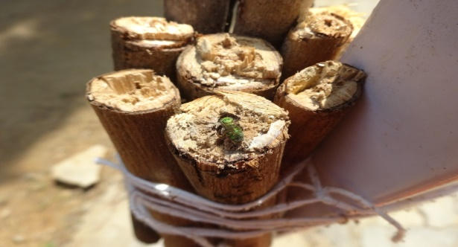 | 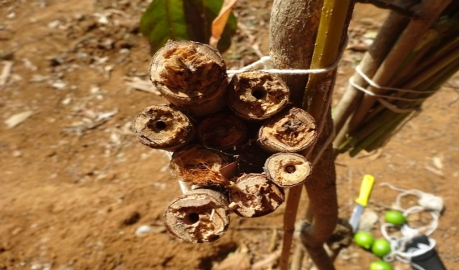
A. Preference of Ceratina binghami C. to Peltophorum pterocarpum D. | B. Preference of Ceratina binghami C. to numerous sticks of Peltophorum pterocarpum D
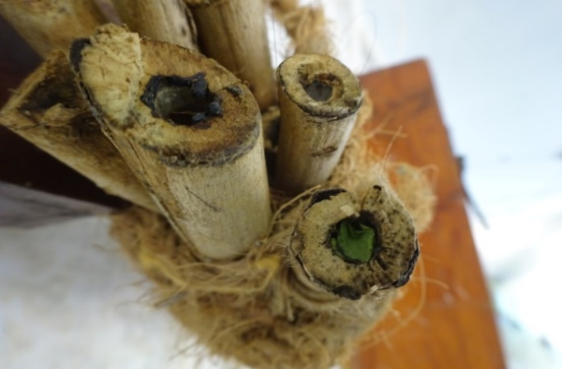 | 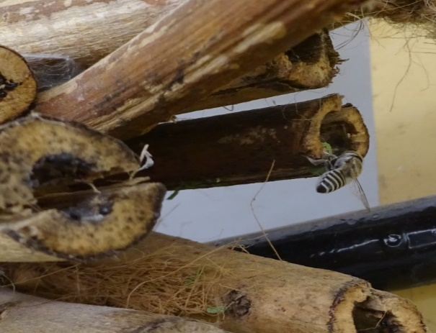
C. Ipomea carnea reeds as nesting site by Megachiliid sp. | D. Lithurgus sp. preference to Ipomea reeds
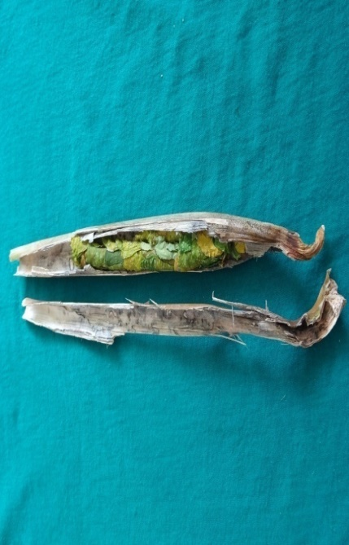 | 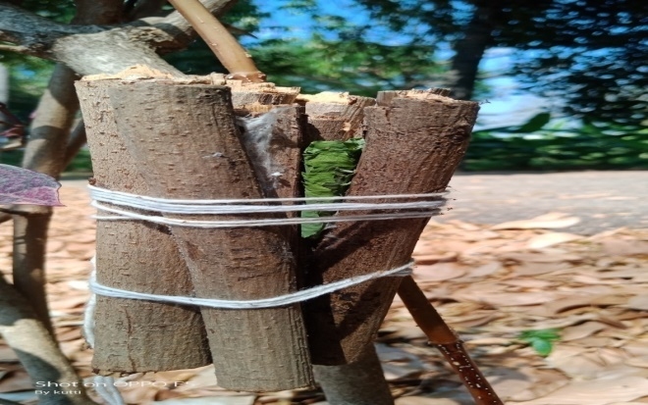
E. Papaya petiole C. papaya L. as nesting site by Megachiliid sp. | F. Nesting site of Megachile sp., to Peltophorum
Figure. 2 Nesting biology of leaf cutter bee (Clepto-parasite), Coelioxys capitata S.
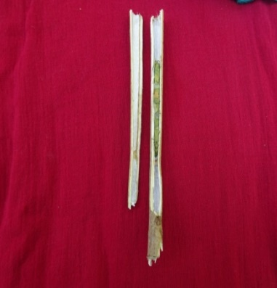  - Ipomea carnea reeds | 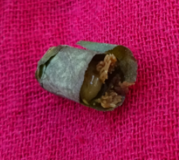  - Larva | 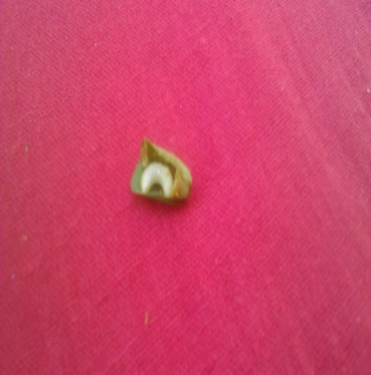  - Grub
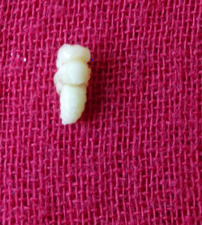  - Pupa | 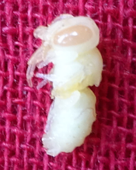  - White eyed pupa | 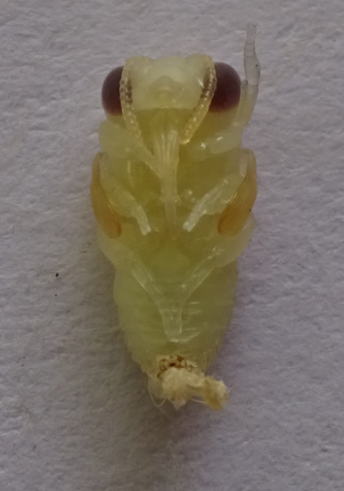  - Brown eyed Pupae
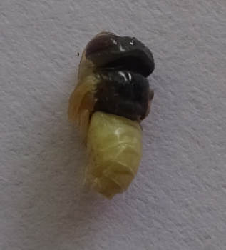  G. Head and Thorax region  with black | 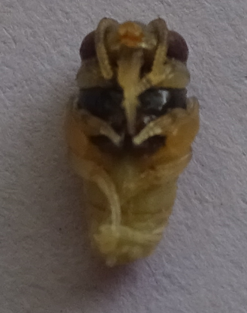  H. Ventral view | 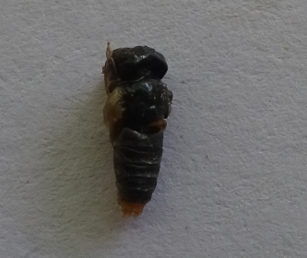  - Complete body black
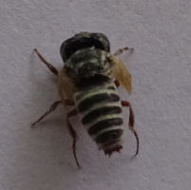  - adult with wing buds | 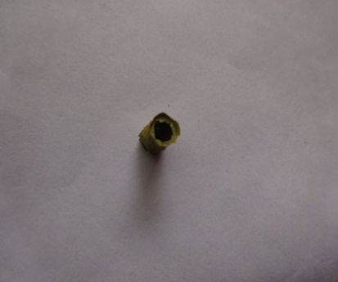  - Brood cell exit hole | 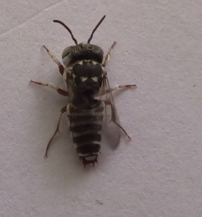  - Fully developed adult

