**Impact of Green Energy Transition on Healthcare Infrastructure: A case study of MRI systems**

.

**ABSTRACT**

|  |
| --- |
| **Aim:** To discuss green energy transition impact on healthcare infrastructure using MRI systems as a case study.  **Problem Statement:** The emissions generated in the course of health care provision have greatly contributed to climate change, air pollution and environmental degradation. A major section is the magnetic resonance imaging which is one of the largest contributors of GHG emissions as a result of its huge energy consumption. About 5% global climate change has been linked to healthcare sector responsible for approximately 8.5% of GHG emissions.  **Significance of Study:** The discussion of procedures to adopt in tackling the GHG emissions from the MRI image alongside its high energy consumption is essential. A prominent technique is transitioning into green energy in the healthcare sector.  **Methodology:** Previous literatures, chapters in book and relevant journals that present information on the influence of green energy transition on healthcare infrastructure with reference to MRI systems were consulted to compile this article. An up-to-date systematic review was conducted using published articles between 2018 to 2024.  **Discussion:** The significance of environmental sustainability in radiology departments using MRI as a case study is becoming alarming due to its potential for optimization of cost, reduction of carbon footprint and substantial energy savings. These can be achieved in MRI operations through implementation of power management informatics systems that turn off automatically and lower the energy consumption when the equipment is idle. The newest type of MRI is the power save mode which is designed to further minimize the energy consumption during non-productive period. With this, about 35–47 MWh consumed on yearly basis can be reduced and the previous electricity cost ($8050–10,800) can be lowered thereby, reducing the GHG emissions.  **Conclusion:** This review article is insightful for policymakers, healthcare providers and researchers in developing initiatives and strategies targeted at environmental sustainability promotion. Information on green energy transition impact on healthcare infrastructure using MRI as a case study is presented. The adaption plans development techniques are recommended to prepare for climate change impact and GHG emissions reduction because of their cost savings and GHG emissions reduction attributes. |

*Keywords: Healthcare Infrastructure, Green Energy Transition, Magnetic Resonance Imaging, Green House Gas Emissions, Radiology Departments*

**1. INTRODUCTION**

One of the most vital services needed by modern societies is the healthcare system due to the necessity to advance and maintain public health. Despite this huge contribution, the sector has been tagged as being energy intensive, large waste volume producer and also possesses resource-intensive supply chains [1]. This makes healthcare sector to be one of the major climate crisis contributors and thus, this is calling for serious address and attention. About 5% of both indirect and direct global climate change is caused by healthcare sector. This sector would have been the largest GHG emissions contributor on the earth, responsible for almost 8.5% of GHG emissions, if it were to be considered as a country. The adverse health challenges emanating from climate change, environmental degradation and air pollution as a result of emissions generated during health care provision are now being faced again by global health care systems calling for further rise in the health care provision demand [2]. It is imperative that there is high compliance of the solutions with the basic healthcare requirements (such as hygiene, safety and care). This makes tackling the environmental problems to be more challenging. On the other side, chance for a low-carbon and considerable health co-benefits are provided via mitigating and addressing climate change. With this, an advanced global health, human well-being and resilient future are equally ascertained [3].

The healthcare sector has remarkable capacity to change public and social policy in order to substantiate decarbonization in communities and workplaces purposely to structure global climate policy. On the other side, reduction in costs and improvement of public health are attainable via minimizing environmental harm. These achievements are serious determinants for environmental sustainability. Global warming phenomenon as a result of rise in greenhouse gases emission has necessitated the need to improve public awareness regarding the significance of advancing sustainable practices. The huge volume of energy consumed; and the need to utilize many resources for equipment operation and images generation has placed radiology field as being exceptional among other healthcare departments [4]. It has been revealed that about 1% of the cumulative global GHG emissions is coming from radiology and medical imaging departments being resource and energy intensive. Modern diagnostics depends greatly on magnetic resonance imaging (MRI), and the subordinate devices are one of the most expensive and critical ones in the hospital. The medical imaging’s influence has materialized and become a major focus as a result of the large electricity demand determining the contribution to the global climate change. A transition to green energy radiology in MRI is vital to lower its contribution to GHG emissions and global climate change [5].

Radiology practice focusing majorly on environmental sustainability and addressing waste reduction usually generated from daily activities is referred to as green radiology. A huge volume of resources and energy are required for equipment operation and images production in radiology. Additionally, the drugs and chemicals used with the equipment in radiological studies production are dangerous to the environment and require serious management for environmental safety purpose and pollution minimization. Green radiology is not only essential in costs reduction but also applicable in environmental preservation in healthcare sectors [6]. Green radiology is an innovative, sustainable and responsible technique in radiology practice that addresses minimization of harmful environmental influences of the procedures and technologies applied in radiology. Its main target is to lower the water, carbon and ecological footprint in healthcare services with reference to four strategic purposes which are (1) adequate residues and wastes disposal and recycling, (2) minimizing helium, water and energy utilization, (3) eco-friendly radiology measures promotion and (4) reduction of ionizing radiation environmental influence [2].

MRI is a strong and powerful imaging technique amidst numerous diagnostic circumstances due to its substantial electricity demand. In the 21st century, the most prominent global threat to human health is the climate change which is resulting from the global impacts of GHG emissions emanating from anthropogenic activities like electricity generation, transportation, manufacturing, agriculture, and heating and cooling. It results into quantifiable consequences such as hindered ecosystems, flooding, global increase in temperature, landslides, wildfires and more usual and harsh storms [7]. One of the largest contributors to GHG emissions within the medical imaging is MRI as a result of the huge energy consumption of attached scanners. The calculated electricity consumption of a single unit MRI machine on a yearly basis is corresponding to 26 four-person households and the energy expenditure is significantly greater compared to other imaging methods. For instance, the annual energy consumption for MRI for every 1000citizens was evaluated to be 1648 kWh in the United States in comparison with 298 kWh estimated for computed tomography (CT) [3].

The health dangers of climate alteration are harsh and will negatively affect all humans. However, the negative effects will excessively affect susceptible populations who have basically contributed the minimum to global GHG emissions. Thus, collective responsibility is needed to tackle these health inequities in order to ascertain a sustainable environment for coming generations. MRI is a non-invasive imaging technique that employs powerful radio waves and magnetic field to generate comprehensive three-dimensional anatomical images of the inner body part [8]. MRI devices have been examined and extensively investigated from different perspectives such as cost-benefit aspects, safety, technological advancements, diagnostic capabilities and accessibility. The most prominent MRI technology is the superconducting MRI magnet technique having the gradient coils, bore, superconducting magnet, radiofrequency coils and a computer system as the main components as shown in Figure 1. High-resolution images are generated by the superconducting magnet but a major disadvantage is the need for extremely low temperature (-269 oC) to cool it down in order to allow the superconducting state to create a strong magnetic field. Thus, many of the energy consumed by the device are accorded with cryocoolers and magnets for constant condensation and cooling of helium gas to liquid. [9]

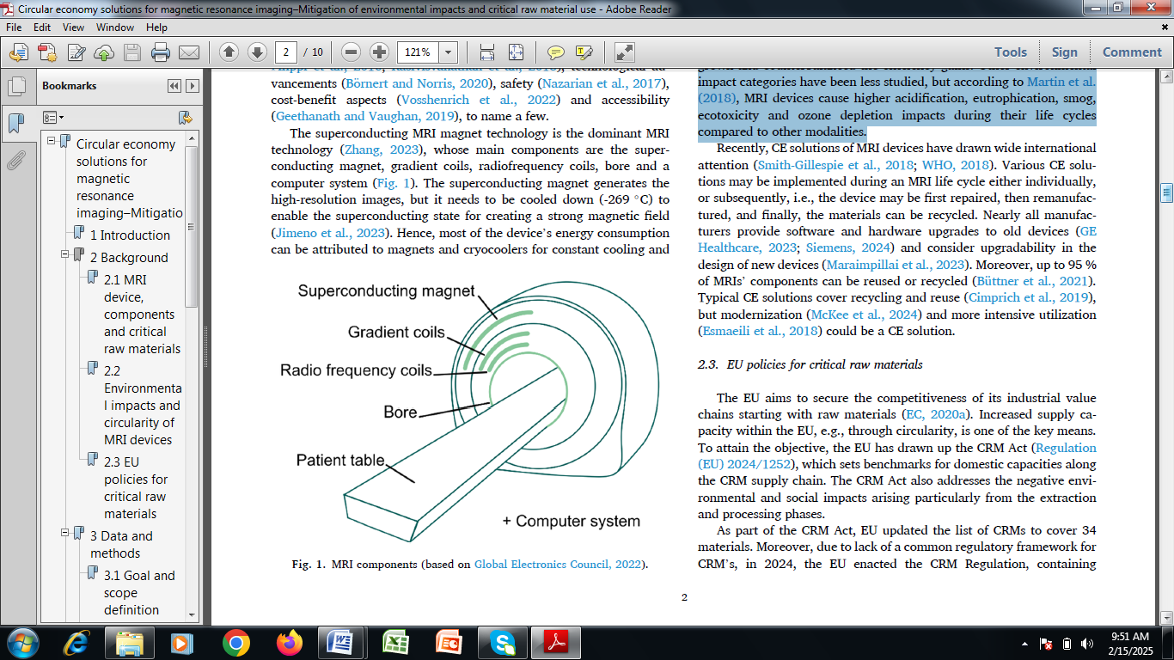

**Figure 1: Components of MRI**

Studies have shown and proved MRI devices to be the most energy-intensive equipment in comparison to other imaging techniques like X-ray, computer tomography and ultrasound. The most often examined environmental impacts are fossil resource exhaustion and climate change. The energy consumption of MRI in the production and use phases are respectively 12,248,000 MJ/device and 216 MJ/examination [6]. The use phase originates from the standby mode and superconducting magnets constant cooling. The electricity required for image production in the active mode is extremely small when compared with the total electricity consumption. The number of devices has risen and balanced up with the efficiency gains in the last couple of years despite the fact that the devices’ energy consumption has reduced. However, studies on other environmental influence divisions are still limited but MRI devices have been proved to cause higher ecotoxicity, eutrophication, acidification, smog and ozone depletion effects during their life cycles in comparison to other techniques [5]. The lifecycle of MRI device is presented as Figure 2. It encompasses production, first use, device update, transportation, second use and recycling.

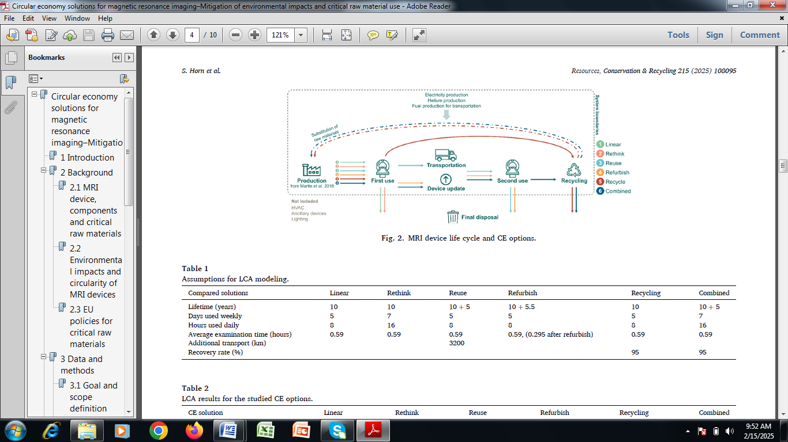

**Figure 2: Lifecycle of MRI device**

With reference to MRI life-cycle emission assessments, 2.73 million MJ equivalent to 753,000 kWh of fossil fuels is often consumed in the production phase from raw materials to delivery which is the same as yearly GHG emissions from driving73 gasoline-powered passenger vehicles. An average of 20 kg of CO2 equivalents per exam (14 kg of CO2 equivalents for use and 6 kg of CO2 equivalents production phases) is emitted by MRI when compared with driving a distance of 83 km with a gasoline-powered passenger vehicle. There is high expectation of increase in the environmental impacts as time progresses based on the records of GHG emissions from MRI if actions are not taken to address this [10]. Existing opportunities to address MRI environmental sustainability are categorized thus: (1) there is need to develop adaption plans in preparation for the climate change impact in MRI departments and health systems, (2) design techniques for GHG emissions reduction from MRI during use and production stages, and (3) finite resources preservation and water body pollution mitigation [11].

This review article discusses the environmental impacts of MRI on the climate change with reference to the energy consumption. It covers green energy transition impact on healthcare infrastructure using MRI systems as a case study. Chapter one discusses the environmental pollution emanating from the use of fossil fuels in powering the MRI scanners leading to GHG emissions. The fundamental principles of MRI operations in radiology departments are also discussed. Chapter two discusses the need for green energy transition in radiology using MRI as a case study and MRI energy management techniques in various use phases. Chapter three presents energy requirements during active MRI scanning focusing on the scanner, sequence and protocol length. Information on the current challenges and future prospects is also presented here. Chapter four addresses the conclusion of the review article.

**2.0 The Need for Green ENergy transition in Radiology: MRI As A case study**

Though medical imaging is very vital for accurate treatment and diagnosis, it is classified as being a resource-intensive field. The contribution of radiology to healthcare’s substantial carbon footprint is enormous asides the large waste from one time-use materials and the radiopharmaceuticals disposal [12]. This is also supported with extreme energy requests for equipment such as CT machines and MRI scanners. These challenges can be easily addressed through adopting green radiology. This is a sustainable imaging technique which can be achieved via the implementation of environmentally alert practices. This movement is in line with the global target for sustainability across various industries in order to ensure that healthcare essential services are effectively rendered [7]. Figure 3 shows the summary of strategies to address the environmental sustainability in MRI. Suggested strategies to reduce GHG emissions include power management strategies; AI applications; low field MRI; appropriate use and decision support tools; power and energy savings for other equipment; production and refurbishment of MRI equipment; reducing waste and travel related emissions.

The major strategies that can be adopted for energy reduction in MRI have been identified. The first one is the advancement of the MRI equipment design. Currently, energy-efficient imaging systems whose power and energy consumption are drastically reduced without hindering their output performances are being developed by manufacturers [13]. They are incorporated with features such as intelligent power-saving modes to minimize their standby energy consumption. Also, the implementation of facility optimization has been executed. MRI in radiology departments are now being upgraded with automated controls which are designed to notably cut the energy use when not in operation; LED lighting; and energy-efficient heating, ventilation and air conditioning systems. Additionally, operational adjustments measures have been implemented in MRI operations which involve strategically scheduling procedures of imaging during hours of off-peak energy and lowering the idle machine times can also reduce the energy consumptions [14]. Lastly, the incorporation of renewable energy into MRI is a major green technique of reducing energy consumption and consequently GHG emissions that may emanate from it. Renewable energy solutions such as green energy purchase from suppliers and solar panels are now becoming more prevailing. Imaging centres and hospitals are progressively investing in renewable energy solutions. This transition to green energy is in line with sustainability targets with high expectations of GHG emissions reduction due to non-reliance on fossil fuels [7].

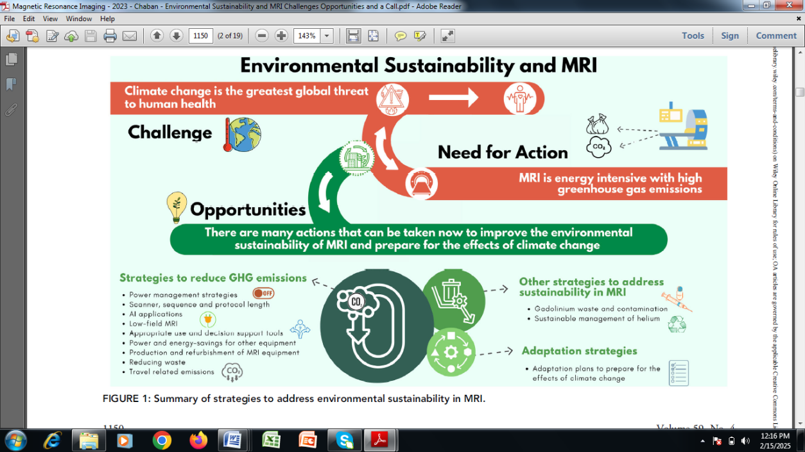

**Figure 3: Summary of strategies to address environmental sustainability in MRI**

**2.1 MRI energy Management techniques in various Use Phases**

Consistent and constant energy is needed by MRI scanners as a result of the uninterrupted cooling system operation and thus, they are never completely powered off. However, the mode and state of the MRI scanner are influencing factors for the energy draw. The energy requirements and power consumption for different MRI states are already defined. The time at which the MRI scanner is energetically acquiring data is called the scan time. During this period, image acquisition is executed and the maximum amount of energy is required. The scanner state between the examinations of individual patient is called the idle mode. This is automatically implemented without the interaction of the operator [8]. The lowest power-mode is referred to as the system off and this is initiated by the MRI operator. The power save mode type of the MRI is the newest kind being supplied by vendors and it is designed to further minimize the energy consumption during non-productive period. On annual basis, about 35–47 MWh of energy is consumed by MRI scanners during the off state of the system. This represents about 31%–38% of their cumulative energy consumption in a year. With reference to an average cost of electricity being $0.23/kWh, about $8050–10,800 is incurred as electricity costs [6].

Despite the information regarding the mode of operational mechanism of MRI scanners on global basis is still very limited, records revealed that more than half of MRI scanners in the world are not switched off during the hours of non-productiveness. This is an automatic reflection that there is need to address the cost savings and energy consumption potentials of green energy transition on healthcare infrastructure using MRI as a case study. The possibility of corresponding GHG emissions reductions is ascertained via the reduction of energy waste during non-productive periods [15]. The energy consumption of scanners is reduced by 25% – 33% when they are switched from idle to off mode when they are not in operational usage. Also, the implementation of a power save option additionally lowered the energy usage by approximately 22% – 28% when compared with the off mode. On an annual scale, the adoption and implementation of a power save mode in MRI scanners could result in reducing the total potential energy cost and consumption by $8.2–$10.7 USD million and 58,863–76,288 MWh respectively during 12 hours overnight of non-productive usage throughout the entire ambulatory MRI units. If this is adequately conserved and preserved, it is the same as the yearly energy consumption of a town having about 5519–7175 residential homes [16].

The implementation of departmental policies supporting switching off of MRI scanners when they are not in use and lower-energy modes development on all scanners is very crucial. These have the potential to drastically reduce the energy consumption and increase the energy cost savings. In order to ensure the availability of low power modes with negligible time to power cycle to off and back to being ready to scan in all scanners, collaboration with partners in the industry is essential [11]. The minimization of patient no-shows and improvement of MRI scheduling are further techniques via which energy waste can be reduced during idle time. There is need to implement assisted technologist workflow technique or multi-technologist method in cases where more than one technologists are responsible for patient preparation n order to reduce the non-productive period between patients.

**3.0 Energy During Active MRI Scanning: Scanner, Sequence, and Protocol Length**

The volume of energy consumed during active MRI scanning differs between scanners, gradient systems and pulse sequences. For instance, diffusion weighted imaging and echo-planar imaging considerably require more power consumption than most other pulse sequences. Field strength is another factor that accounts for the variability in energy consumption of MRI scanners and is basically more at 3T when compared to 1.5T, which in return more than 0.55T based on output comparison. The energy consumed is not only a function of the gradient system but also depends on the field strength, duration and specific pulse sequence [14]. However, more energy is required for more powerful gradient systems. At higher field strengths, gradient systems are generally more powerful. They can usually be operated in various kinds of modes and further investigation is essential on the way a low power mode selected could enhance cost and energy savings along with the influence on image quality and scan time. There is also need to engage in consistent technical development in order to measure sequences after designing with reduced energy requirements while the image quality is being maintained [10].

The general MRI scanners energy consumption is a function of many factors such as the durations of complete protocol and each sequence. Basically, there is a direct proportionality between the total scan length and energy consumed during active scanning. Studies have shown that abbreviated protocols that are personalized towards exam indication having some specific needs can appreciably lower the scan length thereby lowering the overall GHG emissions and energy use [13]. For instance, scan times can be reduced by 30%–50% in abbreviated breast MRI protocols in which unnecessary sequences are omitted while still assuring that high diagnostic accuracy is maintained. A shortened breast MRI exam in which sequences like post-contrast T1-weighted imaging, T2-weighted imaging and DWI reduced scan time from 30 to 15 minutes are removed has been demonstrated. A twenty minute scan time reduction in a musculoskeletal MRI for an abbreviated protocol to examine pelvis and occulthip fractures has been demonstrated in an elderly patient and compared with complete standard MRI exam having specificity and high sensitivity of 97%–98% and 92%–100% [8].

Further advantages of utilizing abbreviated MRI protocols asides energy and time savings are improvement in patient satisfaction, shorter wait times (in cases where shorter MRI booking slots accompanied the shorter protocols) and improvement in accessibility. There is high possibility of patients not canceling his/her appointments or showing up for MRI follow-up if the scan time is very short [15]. Also, it is feasible to have improved image quality for patients who struggle to finish longer exams as a result of less patient movement with a very short protocol. This may typically be helpful to patients subjected to cardiac MRI who are lacking breath because repeated breath-holds are needed. Additionally, new techniques focusing on free running multitasking and multi-contrast approaches featured with incorporated finger printing has offered new opportunities for shorter and simplified MRI measures. Interestingly, sufficient imaging systems that answer the clinical question remain dominant. Accelerated imaging and abbreviated protocols should be incorporated only into clinical workflows when there is negligible negative influence on clinical outcomes or patient care [11].

**3.1 Overcoming Challenges in Green Radiology**

The major challenges of using green radiology in healthcare sectors are identified. The initial costs are usually high making investing in green building designs, renewable energy systems and energy-efficient equipment to be challenging. However, the initial expenses are usually out-weighed by the operational costs and long-term energy cost savings. Also, ensuring a balance between clinical needs and sustainability is often tasking [17]. It is usually critical to ensure that patient care does not compromise sustainable practices. Initiatives from green radiology must set environmental targets to be at equilibrium with the clinical priorities of efficiency, safety and accuracy. The implementation and green practices adoption may be hindered by the strict regulations that govern upgrading equipment and disposal of radiopharmaceutical [18]. Propagation of updated policies that enhance sustainability is imperative. Additionally, there is need to construct energy-efficient green MRI. Green building measures and principles can be incorporated in newly designed radiology amenities. These should feature renewable energy systems, natural lighting and energy-efficient insulation. Also, eco-friendly construction can be validated and guided with help of certifications such as Building Research Establishment Environmental Assessment Method (BREEAM) [19]. Lastly, sustainable interiors must be encouraged and maintained. The use of recycled and non-toxic materials for furniture, walls and flooring lowers consumption of resources and supports indoor air quality. Eco-friendly adhesives and paints further reduce the carbon footprint of buildings.

**3.2 Future Trends in Sustainable green MRI systems**

In order to make green MRI systems to be sustainable, there is need to establish centres handling carbon-neutral imaging. The principal target of green radiology is to achieve carbon neutrality. Imaging centres can be operated while minimum environmental impact is exhibited via the combination of waste reduction techniques, efficient technologies and renewable energy sources. Also, the principles of circular economy in radiology especially MRI should be adopted [20]. This should incorporate waste minimization via recycling; and reusing and repurposing of materials in order to gain more attentions in the imaging sector. For instance, decommissioned imaging equipment being repurposed for research and training benefits will have its lifecycle extended. Nonetheless, global collaboration between industries, vendors, manufacturers and health workers should be encouraged. Radiology departments around the globe now share best innovations and practices as sustainability is becoming a global priority. Research collaborations, symposia and international forums enhance advancements towards a greener future. Also, awareness and staff training should be encouraged. Enlightening radiology staff regarding sustainability enhances eco-friendly practices implementation and adoption. Sustainable procurement techniques, waste segregation protocols and energy-saving methods can be covered by the training sessions. Collaboration with leaders in the industry is essential as part of the future trends in sustainable green MRI systems [21]. Innovation in sustainable imaging is driven through partnerships with environmental organizations, policymakers and manufacturers. Joint efforts to improve advocate for green policies and development of eco-friendly equipment should be encouraged to strengthen the effect and influence of these initiatives. Lastly, the involvement of patients should not be jeopardized. The roles of patients in green radiology are very crucial via supporting facilities that rank sustainability higher. Patients’ encouragement in recycling programmes participation and provision of feedback on eco-friendly practices promotes and enhances a culture of collective responsibility [22].

**4. conclusion**

In recent time, MRI environmental impact has become subject of discussion. Its high volume of electricity demand when compared with other imaging techniques alongside water bodies’ contamination during and after its operation has called for serious attention. With reference to the pressing climate change threat issues, there is need to address the challenges in order to improve the environmental sustainability of MRI. A major recommendation is the green energy transition of radiology especially the MRI. It is an energy-intensive imaging technique and it has been identified to be responsible for many potential adverse environmental effects. However, numerous steps that can be followed in improving MRI environmental sustainability are in existence. These include techniques for adaption plans development in order to prepare for climate change impact and GHG emissions reduction in use and production phases. In conclusion, many of these techniques possess important co-benefits which include cost savings and reduction of GHG emissions alongside health equity, advanced health and patient satisfaction.

Disclaimer (Artificial intelligence)

Option 1:

Yvanne Komenan hereby declare that NO generative AI technologies such as Large Language Models (ChatGPT, COPILOT, etc.) and text-to-image generators have been used during the writing or editing of this manuscript.

**References**

1. Mariampillai, J., Rockall, A., Manuellian, C., Cartwright, S., Taylor, S., Deng, M., Sheard, S., 2023. The green and sustainable radiology department. Die Radiologie 63, 21–23.

2. Esmaeili, A., McGuire, C., Overcash, M., Ali, K., Soltani, S., Twomey, J., 2018. Environmental impact reduction as a new dimension for quality measurement of health care services – The case of magnetic resonance imaging. Int. J. Health Care Qual. Assur. 31 (8), 910–922.

3. Geethanath, S., Vaughan, J.T., 2019. Accessible magnetic resonance imaging: a review. J. Magn. Reson. Imaging 49 (7), e65–e77.

4. Bergfald, M., Kristensen, K., Lystad, H., 2024. Recycling of critical raw materials in the nordics. TemaNord 2024: 513. Nordic Council of Ministers, Oslo.

5. Chaban, Y.V., Vosshenrich, J., McKee, H., et al., 2024. Environmental sustainability and MRI: challenges, opportunities, and call for action. J. MRI 59 (4), 1149–1167.

6. Cimprich, A., Santill´an-Saldivar, J., Thiel, C., Sonnemann, G., Young, S., 2019. Potential for industrial ecology to support healthcare sustainability: scoping review of a fragmented literature and conceptual framework for future research. J. Ind. Ecol. 23 (6), 1344–1352.

7. Büttner, L., Posch, H., Auer, T., Jonczyk, M., Fehrenbach, U., Hamm, B., Bauknecht, H.C., B¨oning, G., 2021. Switching off for future – Cost estimate and a simple approach to improving the ecological footprint of radiological departments. Eur. J. Radiol. 8, 100320.

8. Turunen, T., Suikkanen, J., 2024. EU and recycling of critical raw materials: stuck in legal limbo? Eur. Energy Environ. Law Rev. 33 (3), 139–149.

9. Brown, M., Schoen, J.H., Gross, J., Omary, R.A., Hanneman, K., 2023. Climate change and radiology: impetus for change and a toolkit for action. Radiol 307, e230229.

10. van Beek, E.J.R., Kuhl, C., Anzai, Y., et al., 2018. Value of MRI in medicine: more than just another test? J. Magn. Reson. Imaging 49, e14–e25.

11. Nyl´en, E.-J., Johanson, J.-E., Vakkuri, J., 2023. The loop from idealised to messy-untangling ideational features of the circular economy and hybridity in its making. Environ. Sci. Policy 140, 146–151.

12. Cimprich, A., Young, S.B., Schrijvers, D., 2023. The role of industrial actors in the circular economy for critical raw materials: a framework with case studies across a range of industries. Miner Econ 36, 301–319.

13. Ora, U., 2023. Radiologienk¨adeteiv¨atriit¨a [There are not enough ragiologists]. Finnish Med. J. 15 August 2023.

14. Vosshenrich, J., Breit, H.C., Bach, M., Merkle, E.M., 2022. Economic aspects of low-field magnetic resonance imaging: acquisition, installation, and maintenance costs of 0.55 T systems. Radiologe 62 (5), 400–404.

15. Lazarevic, D., Salo, H., Kautto, P., 2022. Circular economy policies and their transformative outcomes: the transformative intent of Finland’s strategic policy programme. J. Clean. Prod. 379 (2), 134892.

16. Mancini, L., Benini, L., Sala, S., 2018. Characterization of raw materials based on supply risk indicators for Europe. Int J Life Cycle Assess 23, 726–738.

17. Mariampillai, J., Rockall, A., Manuellian, C., Cartwright, S., Taylor, S., Deng, M., Sheard, S., 2023. The green and sustainable radiology department. Die Radiologie 63, 21–23.

18. EC (European Commission). 2023. Proposal for a Regulation of the European Parliament and of the Council establishing a framework for ensuring a secure and sustainable supply of critical raw materials and amending Regulations (EU) 168/ 2013, (EU) 2018/858, 2018/1724 and (EU) 2019/1020. COM/2023/160 final.

19. Langstaff, K., Brzozowski, V., 2024. Managing environmental sustainability in a healthcare setting. Healthc. Manage. Forum 30 (2), 84–88.

20. Kautto, P., Lazarevic, D., 2020. Between a policy mix and a policy mess: policy instruments and instrumentation for the circular economy. In: Brand˜ao, M., Lazarevic, D., Finnveden, G. (Eds.), Handbook of the Circular Economy.

21. EC (European Commission). 2023. Study on the critical raw materials for the EU 2023 – Final Report. Publications Office of the European Union.

22. Brown, M., Schoen, J.H., Gross, J., Omary, R.A., Hanneman, K., 2023. Climate change and radiology: impetus for change and a toolkit for action. Radiol 307, e230229.