***Review article***

**Bridging Knowledge Gaps: The Extension Services in Advancing Organic Farming- A Global Perspective**

**ABSTRACT**

Agricultural extension plays a pivotal role in facilitating the adoption of sustainable organic farming practices by bridging the knowledge gap between research institutions and farmers. Organic farming is a viable alternative to conventional agriculture, promoting soil health, biodiversity conservation, and reduced chemical dependency while ensuring long-term productivity. This review explores the significance of agricultural extension in enhancing organic farming through participatory learning, digital interventions, market-led approaches, and policy support. Key strategies include farmer field schools, demonstration plots, ICT-based advisories, and the development of organic value chains. However, challenges such as knowledge gaps, complex certification processes, inadequate market access, and weak policy support hinder widespread adoption. Addressing these challenges requires a multi-stakeholder approach, integrating research, government initiatives, and farmer-led networks. Strengthening research-extension-farmer linkages, simplifying certification, and fostering climate-smart organic practices can further enhance the impact of extension services. The paper highlights the need for capacity building among extension personnel and the promotion of farmer-centric organic farming models to ensure sustainability. Future efforts should focus on digital extension tools, participatory research, and institutional reforms to create an enabling environment for organic farming. By reinforcing agricultural extension systems, the transition toward a resilient, sustainable, and profitable organic farming ecosystem can be accelerated.

**Keywords:** *Agricultural extension, Organic farming, Sustainable agriculture, Knowledge transfer, Certification process*

1. **Introduction**

Agricultural extension plays a crucial role in transforming traditional farming practices into sustainable, resource-efficient, and climate-resilient systems. Organic farming, a key component of sustainable agriculture, has gained prominence as an alternative to conventional farming, emphasizing ecological balance, biodiversity conservation, and reduced chemical inputs (Lorenz & Lal, 2022). The transition to organic agriculture requires scientific knowledge, technological interventions, and policy support, all of which are facilitated by an effective agricultural extension system. Extension services act as a bridge between research institutions and farmers, ensuring the transfer of innovative techniques, market intelligence, and regulatory compliance for organic certification (Arowosegbe et al., 2024). This review explores the role of agricultural extension in empowering farmers to adopt organic farming practices, thereby enhancing livelihood security and environmental sustainability.

Organic farming is based on ecological principles such as maintaining soil fertility, promoting biological pest control, and reducing synthetic inputs (Kumari et al., 2023). However, despite its benefits, its adoption remains limited due to several challenges, including lack of awareness, insufficient technical knowledge, market uncertainties, and certification complexities. Agricultural extension serves as a crucial mechanism to address these challenges by providing farmers with the necessary information, training, and resources to successfully transition to organic systems (Rickards et al., 2025). Extension services facilitate knowledge dissemination through various approaches, including farmer field schools, participatory rural appraisals, on-farm demonstrations, and digital advisory platforms (Osumba et al., 2021). These initiatives enhance farmers’ capacity to manage organic production systems effectively while complying with certification and market standards.

One of the primary challenges in organic farming adoption is the limited technical knowledge among farmers regarding organic soil management, composting techniques, crop diversification, and integrated pest management. Agricultural extension programs focus on building farmers’ competencies through hands-on training, workshops, and collaborative research initiatives (Chowdhury et al., 2014). Additionally, the complexity of organic certification often discourages smallholder farmers from transitioning to organic agriculture. Extension services play a vital role in simplifying certification processes by guiding farmers on compliance with Participatory Guarantee Systems (PGS) and third-party certification standards (Kaufmann et al., 2023). The promotion of sustainable agricultural practices through extension education is multifaceted, involving information dissemination, training programs, advisory services, technical assistance, and the encouragement of technology adoption. Additionally, extension services contribute to building the capacity of farmers and other stakeholders to address the challenges and opportunities associated with sustainable agriculture.

Market accessibility is another critical concern for organic farmers. Without well-established market linkages, organic produce may not fetch premium prices, affecting farmers' profitability. Extension services assist in developing direct farmer-consumer networks, cooperatives, and organic value chains, ensuring better price realization (Bisht et al., 2021). Furthermore, policy support and institutional frameworks significantly influence the expansion of organic farming. Extension professionals act as facilitators, advocating for farmer-friendly policies, subsidies, and financial incentives that encourage organic adoption (Moojen et al., 2024). The term "Extension" is derived from the Latin words ‘tensio,’ meaning stretching, and ‘ex,’ meaning out. It is a process of enabling rural communities to improve their agricultural productivity, enhance their livelihoods, and raise their overall standard of living. Extension education is an educational process that provides knowledge to rural populations about improved farming practices in a way that helps them make informed decisions based on their specific local conditions. Extension education plays an essential role in promoting sustainable agricultural development through the dissemination of knowledge, skills, and techniques to farmers, aiming to conserve the environment, improve agricultural productivity, and enhance sustainable livelihoods (Sithole et al., 2024).

A comprehensive extension model for organic farming should integrate multiple stakeholders, including researchers, policymakers, agribusinesses, and farmers, to create an ecosystem that supports organic transition. The use of Information and Communication Technologies (ICTs), such as mobile apps, online advisory services, and remote sensing tools, can further enhance the outreach and effectiveness of extension services (Sindhu & Sindhu, 2017). Incorporating climate-smart organic practices, such as agroforestry, crop rotation, and vermicomposting, into extension programs can improve resilience against climate change. Strengthening agricultural extension services is vital for accelerating the adoption of organic farming. A farmer-centric extension approach that combines knowledge dissemination, market facilitation, policy advocacy, and digital interventions can create a sustainable and profitable organic farming system (Chiwaridzo et al., 2024). Future strategies should focus on participatory extension models, capacity-building programs, and institutional reforms to enhance the effectiveness of organic farming initiatives.

1. **Concept of Sustainable Agriculture**

As global populations continue to grow, the demand for food and other agricultural resources also increases. Sustainable agriculture has emerged as a critical approach to addressing challenges such as biodiversity loss, land degradation, soil erosion, salinization, climate change, water scarcity, and the economic struggles of smallholder farmers (Hossain et al., 2020). The concept of sustainable agriculture gained prominence following the Brundtland Report in 1987, which introduced the broader idea of sustainable development.

Sustainable agriculture is defined as an integrated system of plant and animal production practices that, over the long term, satisfy human food and fiber needs, enhance environmental quality, efficiently use non-renewable and on-farm resources, sustain the economic viability of farm operations, and enhance the quality of life for farmers and society. Sustainable agriculture prioritizes practices that maintain soil health, conserve water resources, reduce greenhouse gas emissions, and protect biodiversity. Key practices include conservation tillage, crop rotation, agroforestry, organic farming, integrated pest management, and the use of renewable energy sources.

1. **Significance of Sustainable Agriculture**

Sustainable agriculture is crucial for balancing environmental conservation with the need for safe and healthy food production. Key objectives of sustainable agriculture include: Producing sufficient food, feed, fibres, and energy to meet the needs of a growing global population. Protecting the environment and enhancing natural resources. Sustaining the economic viability of farming systems. Maximizing the efficient use of non-renewable and on-farm resources while integrating natural biological cycles. Enhancing the quality of life for farmers and society.

1. **The Role of Extension Services in Sustainable Agriculture Development**

Extension education plays a fundamental role in promoting sustainable agriculture by fostering knowledge dissemination, capacity building, and technology adoption. Its significance can be highlighted in the following areas:

**4.1 Dissemination of Knowledge**

Extension services help disseminate knowledge about sustainable farming techniques, enabling farmers to adopt innovative and environmentally friendly agricultural practices. This knowledge includes information on soil health management, crop diversification, water conservation, and organic farming techniques.

**4.2 Capacity Building and Skill Development**

Through training programs, extension services enhance farmers’ skills in sustainable farming practices such as organic pest management, composting, and conservation agriculture. Farmers are provided with practical knowledge that allows them to improve their agricultural productivity and resilience to climate change.

**4.3 Promoting Adoption of Organic Farming**

Organic farming is an essential component of sustainable agriculture, emphasizing ecological balance, biodiversity conservation, and the reduction of synthetic inputs. Extension services play a key role in encouraging the transition to organic farming by providing farmers with the necessary training, resources, and policy support to adopt organic practices effectively.

**4.4 Conservation of the Environment**

Extension education helps farmers understand the importance of environmental conservation. Sustainable agriculture minimizes soil degradation, pollution, and excessive use of chemical fertilizers and pesticides, thereby maintaining ecosystem health.

**4.5 Adaptation to Climate Change**

Climate change poses a significant challenge to global agriculture. Extension services provide farmers with knowledge and mitigation strategies to adapt to changing climatic conditions, such as drought-resistant crops, improved irrigation methods, and agroforestry techniques.

1. **The Role of Agricultural Extension in Organic Farming**

Agricultural extension plays a critical role in promoting **sustainable organic farming** by bridging the gap between research and farmers. As global agricultural systems face growing environmental and economic challenges, organic farming emerges as a **viable alternative** that ensures **soil health, biodiversity conservation, reduced chemicaldependency, and improved farm productivity (**Gamage et al., 2023**).** However, the successful adoption of organic farming practices largely depends on the **effectiveness of extension services** in educating and supporting farmers. This review explores the significance of agricultural extension in organic farming, its strategies, challenges, and potential opportunities for strengthening organic agriculture. Agricultural extension services function as a **knowledge dissemination system** that equips farmers with relevant information, skills, and resources to implement organic farming practices successfully. The key functions of extension services in organic farming illustrated in Fig. 1 include:

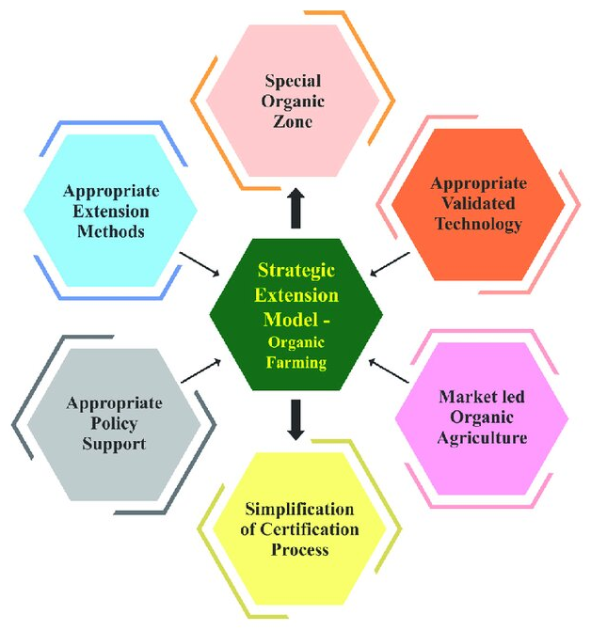

**Fig. 1:** Strategic extension model for empowering the farmers by enhancing livelihood security through organic farming practices (Paramasivam *et al.,* 2022)

**5.1 Farmer Awareness and Training:**

* Conducting capacity-building programs on organic inputs, soil fertility management, and pest control.
* Educating farmers on the long-term benefits of organic agriculture.

**5.2 Technology Transfer and Adoption:**

* Introducing validated organic farming technologies such as **vermicomposting, crop rotation, biofertilizers, and green manures.**
* Promoting **integrated organic farming systems** to maximize resource efficiency.

**5.3 Organic Certification and Compliance Support:**

* Assisting farmers in navigating the complex organic certification process.
* Encouraging **Participatory Guarantee Systems (PGS)** as a cost-effective certification alternative.

**5.4 Market Linkages and Value Addition:**

* Enhancing farmer access to **organic markets, retail stores, and export opportunities.**
* Promoting branding, labelling, and value-added processing of organic products.

**5.5 Policy Advocacy and Institutional Support:**

* Engaging with policymakers to formulate **organic-friendly agricultural policies.**
* Facilitating access to government incentives, financial aid, and subsidies for organic farmers.

1. **Extension Strategies for Organic Farming Promotion**

To ensure widespread adoption of organic farming, extension services must employ **innovative and farmer-centric strategies,** including:

**6.1 Participatory Extension Approaches:** A **farmer-led** approach where extension agents work closely with organic farmers, cooperatives, and local communities. This involves:

* **Farmer Field Schools (FFS):** Hands-on training programs where farmers learn by doing.
* **Demonstration Plots:** Showcasing organic practices on experimental farms.
* **Knowledge Sharing Networks:** Encouraging **peer-to-peer learning** through farmer groups.

**6.2 Digital and ICT-Based Extension:** Modern extension services leverage **Information and Communication Technologies (ICTs)** to reach a larger audience. Some key approaches include:

* **Mobile Applications and SMS Services:** Providing real-time organic farming advisories.
* **Online Training Modules and Webinars:** Educating farmers through digital platforms.
* **AI and Remote Sensing in Organic Farming:** Using precision agriculture tools for soil health monitoring and organic crop management.

**6.3 Market-Led Extension Approaches**

* Developing **organic value chains** by linking farmers with national and international organic markets.
* Promoting **contract farming and organic cooperatives** for bulk sales and fair pricing.
* Enhancing organic farmers' negotiation power by **eliminating middlemen** and ensuring direct farm-to-market linkages.

**6.4 Capacity Building for Extension Personnel**

* Training extension workers in **organic farming principles, certification standards, and innovative extension methodologies** is crucial for effective knowledge transfer. This can be achieved through:
* **Regular training programs** on organic farm management.
* **Cross-learning with organic farming experts and research institutions**.

1. **Role of Agricultural Extension in Promoting Organic Farming for Sustainable Agriculture**

Organic farming has gained significant importance in the context of sustainable agriculture, offering an environmentally friendly alternative to conventional farming methods. Agricultural extension plays a crucial role in facilitating the widespread adoption of organic farming by equipping farmers with knowledge, resources, and skills necessary for transitioning to sustainable practices (Arowosegbe et al., 2024). The integration of extension services into organic farming ensures that farmers receive continuous technical support, market linkages, and access to research-driven innovations that enhance productivity while maintaining ecological balance illustrated in Fig. 2.

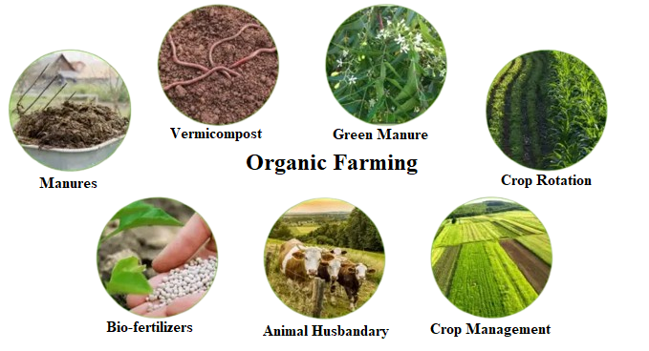

**Fig 2:** Benefits of organic farming

**7.1 Enhancing Soil Fertility and Nutrient Management through Extension Services**

One of the primary challenges in organic farming is maintaining soil fertility without relying on synthetic fertilizers. Agricultural extension programs help farmers adopt natural soil enrichment techniques such as the application of **manures, vermicompost, green manure, and bio-fertilizers (**Khan & Kwot, 2024**).** These organic inputs improve soil structure, increase microbial activity, and enhance nutrient availability, ensuring long-term soil health and sustainable crop production. Extension educators conduct field demonstrations and workshops to showcase the benefits of organic soil amendments, empowering farmers to transition from chemical-based agriculture to organic alternatives.

**7.2 Sustainable Crop Management Strategies through Extension Education**

Effective **crop management** is essential for maintaining high yields in organic farming. Extension services provide farmers with scientifically backed knowledge on **crop rotation, intercropping, and mixed cropping systems (Chouhan et al., 2023).** These practices help in pest and disease management, reduce soil depletion, and improve overall farm biodiversity. Agricultural extension agents work closely with farmers to design rotational cropping plans suited to local agro-climatic conditions, ensuring balanced nutrient cycling and resilience to pests and diseases without the use of chemical pesticides.

**7.3Integrating Animal Husbandry into Organic Farming Systems**

Livestock plays a critical role in organic farming by providing natural fertilizers and supporting nutrient recycling. **Animal husbandry** in organic systems contributes to soil fertility through manure application while offering additional economic benefits such as milk, meat, and wool production (Nardone et al., 2004). Extension services train farmers in sustainable livestock management practices, including organic feed production, disease prevention, and ethical animal rearing. This integrated approach ensures that organic farming remains both ecologically and economically viable.

**7.4 Market Linkages and Certification Support through Agricultural Extension**

One of the significant barriers to the widespread adoption of organic farming is access to profitable markets and certification. Agricultural extension programs assist farmers in navigating **Participatory Guarantee System (PGS) certification** and organic labelling processes, which help them secure better prices for their produce (Niederle et al., 2020). Extension officers connect organic farmers with **retailers, bulk buyers, and export markets,** ensuring that organic products reach a wider consumer base. This market-oriented approach enhances the economic sustainability of organic farming.

**7.5 Training, Capacity Building, and Policy Support**

For organic farming to thrive, continuous **training and capacity-building programs** are necessary. Extension services play a pivotal role in organizing workshops, field demonstrations, and farmer field schools that enhance practical knowledge of organic techniques. Additionally, agricultural extension contributes to policy formulation by advocating for incentives, subsidies, and financial support for organic farmers. Government initiatives, research institutions, and non-governmental organizations (NGOs) collaborate with extension agencies to develop region-specific organic farming models tailored to the needs of small and marginal farmers.

**7.6 Strengthening Organic Farming through Extension Services**

The success of organic farming depends on the active involvement of agricultural extension services in knowledge dissemination, technology transfer, and market facilitation. By bridging the gap between research and field application, extension educators empower farmers to adopt sustainable practices that improve soil health, enhance productivity, and contribute to environmental conservation (Adnan et al., 2018). As global demand for organic produce continues to rise, strengthening extension services will be crucial in transforming traditional farming systems into resilient and profitable organic enterprises, ensuring long-term agricultural sustainability.

1. **Integration of Organic Farming with Agricultural Extension Services**

The Fig. 3 illustrates the interconnected components essential for promoting organic agriculture through extension services. Organic farming requires a multi-faceted approach that includes training, diagnostics, certification, and market linkages to ensure sustainable production and farmer empowerment (Addai et al., 2024). Agricultural extension services play a critical role in guiding farmers through these stages, helping them adopt organic practices while ensuring economic viability.

Key aspects of the organic farming framework in the image align with the principles discussed in Insights into Agricultural Extension. These include training and advisory services to equip farmers with knowledge on sustainable practices, diagnostics for soil and pesticide residue testing to ensure organic integrity, and certification processes to facilitate market access. Additionally, extension programs enhance value chain development by promoting bio-enterprises, food processing, and retail linkages, thereby strengthening the adoption of sustainable agriculture. This integrated approach ensures that farmers transition smoothly into organic farming, benefiting from both environmental conservation and economic opportunities.

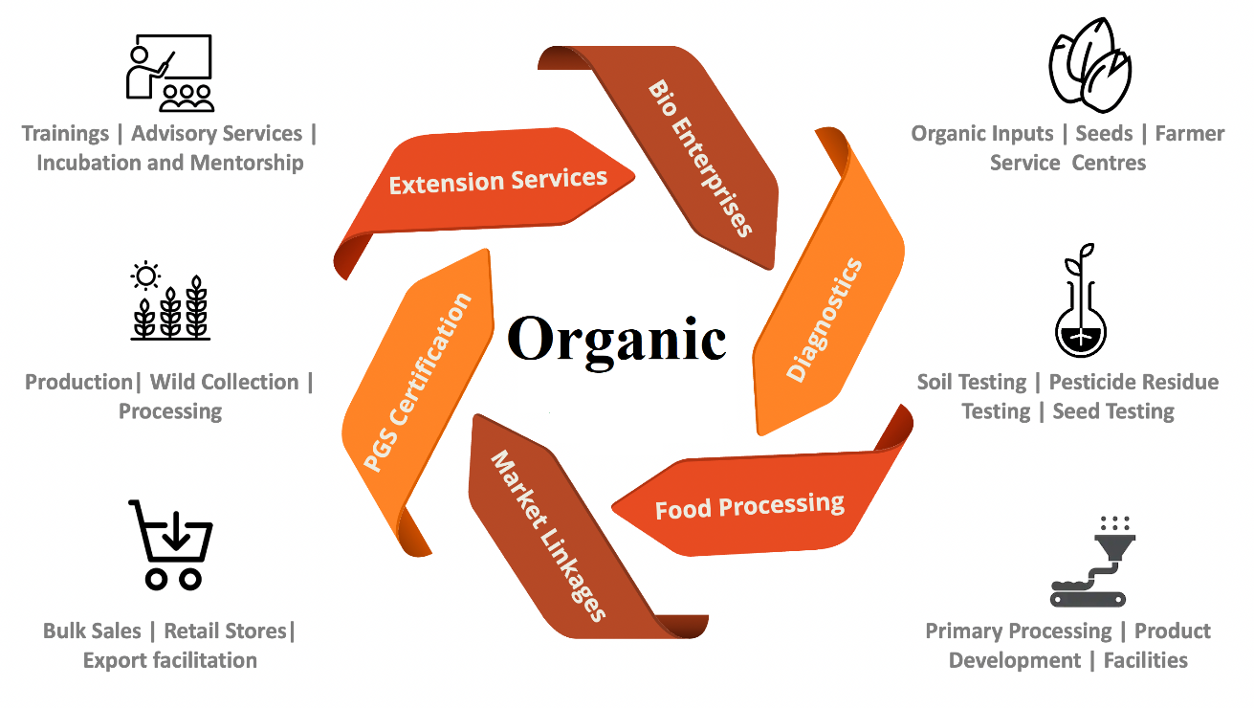

**Fig. 3:** Integrated Extension Framework for Promoting Organic Agriculture

1. **Challenges in Promoting Sustainable Agriculture Through Extension Services**

Despite the benefits of extension services in promoting sustainable agriculture, several challenges exist:

**Limited resources and funding:** Many extension programs lack adequate funding, limiting their ability to reach a broader audience.

**Lack of trained personnel:** The effectiveness of extension services depends on the expertise of extension agents, but many regions face shortages of skilled personnel.

**Resistance to change:** Farmers accustomed to conventional farming methods may be reluctant to adopt sustainable practices due to cultural and economic reasons.

**Inadequate infrastructure:** Poor infrastructure in rural areas hampers the effective delivery of extension services.

1. **Strategies for Enhancing Extension Services in Sustainable Agriculture**

To maximize the effectiveness of extension services in promoting sustainable agriculture, several strategies can be implemented:

**Investing in extension education:** Increased funding and resources can enhance the capacity of extension programs to support farmers effectively.

**Localized approaches:** Tailoring extension programs to suit local contexts ensures that farmers receive relevant and practical information.

**Public-private partnerships:** Collaboration between government agencies, non-governmental organizations, and private sector players can enhance the reach and impact of extension services.

**Utilization of digital technologies:** Mobile applications, online training platforms, and digital advisory services can help disseminate knowledge more efficiently.

**Incorporation of participatory approaches:** Engaging farmers in decision-making processes ensures that extension services address their specific needs and concerns.

1. **Future Aspects of Agricultural Extension in Organic Farming**

The future of agricultural extension in organic farming lies in the integration of innovative technologies, farmer-centric policies, and sustainable practices to promote widespread adoption. As the global demand for organic products continues to rise, extension services must evolve to address emerging challenges and opportunities in the organic agriculture sector. The following key areas highlight the future directions for enhancing agricultural extension in organic farming (Table 1):

**11.1 Digitalization and ICT Integration**

The use of Information and Communication Technologies (ICTs) will revolutionize agricultural extension by providing real-time, data-driven advisory services to farmers. Mobile applications, artificial intelligence (AI)-based decision support systems, and remote sensing tools can offer precise recommendations on organic farming practices, pest and disease management, and soil health improvement (Sharma & Shivandu, 2024). Online platforms and social media networks will also play a crucial role in knowledge sharing, connecting farmers with experts and organic market opportunities.

**11.2 Climate-Smart Organic Farming**

With climate change posing significant threats to agriculture, future extension programs must focus on climate-smart organic practices. Strategies such as agroecology, integrated pest management, crop diversification, and water conservation will be essential in enhancing resilience against erratic weather patterns (Altieri et al., 2015). Extension workers must be trained in climate adaptation strategies and sustainable resource management to guide farmers in mitigating climate risks effectively.

**11.3 Strengthening Participatory Extension Approaches**

Farmer-led extension models, such as Farmer Field Schools (FFS) and participatory research initiatives, will become more prominent in organic farming extension. These approaches empower farmers by involving them in decision-making, technology development, and policy formulation. Strengthening farmer cooperatives and self-help groups will further enhance knowledge exchange and collective bargaining power in organic markets.

**11.4 Simplification of Organic Certification and Market Linkages**

A major bottleneck in organic farming adoption is the complexity of certification processes and limited access to premium markets. Future extension services should focus on promoting Participatory Guarantee Systems (PGS), which simplify certification for smallholder farmers (Taranov & Kawabata, 2024). Additionally, organic value chains must be strengthened by linking farmers directly with domestic and international markets through e-commerce platforms, organic fairs, and contract farming models.

**11.5 Policy Support and Institutional Frameworks**

Governments and extension agencies must work collaboratively to formulate supportive policies that incentivize organic farming. Financial assistance, subsidies, and technical support will be crucial in encouraging more farmers to transition to organic agriculture. Institutional reforms, including capacity-building programs for extension personnel and investment in organic research, will further enhance the impact of extension services.

**Table 1: Key Aspects of Agricultural Extension in Organic Farming**

| ***Aspect*** | ***Role in Organic Farming*** | ***Challenges*** | ***Future Prospects*** |
| --- | --- | --- | --- |
| ***Knowledge Dissemination*** | Educates farmers on organic practices, soil health, and sustainability. | Low awareness and limited access to reliable information. | Digital learning platforms, AI-driven advisory services. |
| ***Technology Adoption*** | Promotes climate-smart and eco-friendly techniques like IPM, biofertilizers. | Resistance to new techniques due to lack of training. | Integration of precision farming, IoT, and automation. |
| ***Capacity Building*** | Provides training programs, field demonstrations, and workshops. | Insufficient extension personnel and funding. | Public-private partnerships for extensive farmer training. |
| ***Policy Support*** | Advocates for organic farming incentives and certification simplifications. | Bureaucratic hurdles and high certification costs. | Streamlined certification processes, subsidies for organic inputs. |
| ***Market Linkages*** | Connects farmers with organic markets, cooperatives, and consumers. | Limited access to premium organic markets. | E-commerce platforms, blockchain for supply chain transparency. |
| ***ICT in Extension*** | Uses mobile apps, AI chatbots, and digital advisory services for real-time support. | Digital illiteracy and lack of internet infrastructure. | Expansion of mobile-based and cloud computing services. |
| ***Sustainability Practices*** | Encourages agroforestry, crop rotation, and natural pest control. | Climate variability affecting productivity. | Climate-resilient crop varieties and integrated organic systems. |
| ***Farmer Empowerment*** | Enhances decision-making, self-reliance, and cooperative development. | Dependency on subsidies and lack of institutional support. | Strengthened farmer-led participatory models and rural entrepreneurship. |

1. **Conclusion**

As organic agriculture continues to gain global recognition due to its environmental, economic, and health benefits, the need for an efficient and farmer-centric extension system becomes more vital. The book "Insights into Agricultural Extension" effectively highlights the importance of knowledge dissemination, technology adoption, and capacity building in fostering sustainable agricultural practices. One of the key aspects of organic farming discussed is the role of climate-smart practices, such as crop diversification, agroforestry, integrated pest management, and sustainable soil and water management. These methods ensure resilience to climate change while improving soil fertility and long-term productivity. Extension services must focus on equipping farmers with the necessary skills to adopt these practices through participatory learning, training programs, and field demonstrations. Furthermore, the adoption of ICT-based extension services, including mobile applications, digital advisory platforms, and e-learning tools, will enhance knowledge accessibility for farmers. The integration of organic farming into national agricultural policies, along with financial incentives and simplified certification processes, will encourage more farmers to transition to organic production. Strengthening farmer cooperatives and market linkages will further ensure the economic viability of organic farming. To achieve long-term sustainability, future agricultural extension systems should focus on farmer-led participatory approaches, climate-resilient techniques, and innovative technology-driven solutions. A collaborative effort between policymakers, researchers, extension agents, and farmers is essential in overcoming challenges such as certification barriers, market access limitations, and knowledge gaps.

**DISCLAIMER (ARTIFICIAL INTELLIGENCE)**

Author(s) hereby declare that NO generative AI technologies such as Large Language Models (ChatGPT, COPILOT, etc.) and text-to-image generators have been used during the writing or editing of this manuscript.

**REFERENCES**

Addai, G., Suh, J., Bardsley, D., Robinson, G., & Guodaar, L. (2024). Exploring sustainable development within rural regions in Ghana: A rural web approach. *Sustainable Development*, *32*(4), 3890-3907.

Adnan, N., Nordin, S. M., Rahman, I., & Noor, A. (2018). The effects of knowledge transfer on farmers decision making toward sustainable agriculture practices: In view of green fertilizer technology. *World Journal of Science, Technology and Sustainable Development*, *15*(1), 98-115.

Altieri, M. A., Nicholls, C. I., Henao, A., & Lana, M. A. (2015). Agroecology and the design of climate change-resilient farming systems. *Agronomy for sustainable development*, *35*(3), 869-890.

Arowosegbe, O. B., Alomaja, O. A., & Tiamiyu, B. B. (2024). The role of agricultural extension workers in transforming agricultural supply chains: enhancing innovation, technology adoption, and ethical practices in Nigeria. *World Journal of Advanced Research and Reviews*, *23*(3), 2585-2602.

Arowosegbe, O. B., Alomaja, O. A., & Tiamiyu, B. B. (2024). The role of agricultural extension workers in transforming agricultural supply chains: enhancing innovation, technology adoption, and ethical practices in Nigeria. *World Journal of Advanced Research and Reviews*, *23*(3), 2585-2602.

Bisht, I. S., Rana, J. C., & Pal Ahlawat, S. (2020). The future of smallholder farming in India: Some sustainability considerations. *Sustainability*, *12*(9), 3751.

Chiwaridzo, O. T., Musiiwa, R., & Hlasi, T. (2024). Digitizing Marketing in Agriculture: Leveraging Information Communication Technologies for Success in Zimbabwe. In *Sustainable Practices for Agriculture and Marketing Convergence* (pp. 151-176). IGI Global.

Chouhan, S., Kumari, S., Kumar, R., & Chaudhary, P. L. (2023). Climate resilient water management for sustainable agriculture. *International Journal of Environment and Climate Change*, *13*(7), 411-426.

Chowdhury, A. H., Hambly Odame, H., & Leeuwis, C. (2014). Transforming the roles of a public extension agency to strengthen innovation: Lessons from the National Agricultural Extension Project in Bangladesh. *The journal of agricultural education and extension*, *20*(1), 7-25.

Gamage, A., Gangahagedara, R., Gamage, J., Jayasinghe, N., Kodikara, N., Suraweera, P., & Merah, O. (2023). Role of organic farming for achieving sustainability in agriculture. *Farming System*, *1*(1), 100005.

Hossain, A., Krupnik, T. J., Timsina, J., Mahboob, M. G., Chaki, A. K., Farooq, M., ... & Hasanuzzaman, M. (2020). Agricultural land degradation: processes and problems undermining future food security. In *Environment, climate, plant and vegetation growth* (pp. 17-61). Cham: Springer International Publishing.

Kaufmann, S., Hruschka, N., & Vogl, C. R. (2023). Participatory Guarantee Systems, a more inclusive organic certification alternative? Unboxing certification costs and farm inspections in PGS based on a case study approach. *Frontiers in Sustainable Food Systems*, *7*, 1176057.

Khan, J. A., & Kwot, O. (2024). The Role of Natural Organic Fertilizers on Soil Fertility Management and Crop Production in Ethiopia. *Agriculture Practices in Ethiopia: Present Scenario, Problems, Causes, and Solutions*, 1.

Kumari, S., Kumar, R., Chouhan, S., & Chaudhary, P. L. (2023). Influence of various organic amendments on growth and yield attributes of mung bean (*Vigna radiata* L.). *International Journal of Plant & Soil Science*, *35*(12), 124-30.

Lorenz, K., & Lal, R. (2022). Combining conventional and organic practices to reduce climate impacts of agriculture. In *Organic Agriculture and Climate Change* (pp. 201-218). Cham: Springer International Publishing.

Moojen, F. G., Grillot, M., de Faccio Carvalho, P. C., & Ryschawy, J. (2024). Farm advisors play a key role in integrating crop-livestock at the farm level: perceptions and experiences in Brazil and France. *The Journal of Agricultural Education and Extension*, *30*(5), 683-707.

Nardone, A., Zervas, G., & Ronchi, B. (2004). Sustainability of small ruminant organic systems of production. *Livestock Production Science*, *90*(1), 27-39.

Niederle, P., Loconto, A., Lemeilleur, S., & Dorville, C. (2020). Social movements and institutional change in organic food markets: Evidence from participatory guarantee systems in Brazil and France. *Journal of Rural Studies*, *78*, 282-291.

Osumba, J. J., Recha, J. W., & Oroma, G. W. (2021). Transforming agricultural extension service delivery through innovative bottom–up climate-resilient agribusiness farmer field schools. *Sustainability*, *13*(7), 3938.

Paramasivam, S., Henry, P., Seethapathy, P., & Rajamohan, T. (2022). A strategic model for empowering farmers by improving livelihood security through organic farming practices in Tamil Nadu, India. *Journal of Agricultural Sciences–Sri Lanka*, *17*(3).

Prajapati, C. S., Priya, N. K., Bishnoi, S., Vishwakarma, S. K., Buvaneswari, K., Shastri, S., ... & Jadhav, A. The Role of Participatory Approaches in Modern Agricultural Extension: Bridging Knowledge Gaps for Sustainable Farming Practices. J. Exp. Agric. Int., 47(2), 204-22.

Rickards, C., Marenya, P., Chiduwa, M., Eitzinger, A., Fisher, M., & Snapp, S. (2025). Enhancing farmers' agency is a more effective extension paradigm: The case of soil health management in Africa. *Agricultural Systems*, *225*, 104267.

Sharma, K., & Shivandu, S. K. (2024). Integrating artificial intelligence and internet of things (IoT) for enhanced crop monitoring and management in precision agriculture. *Sensors International*, 100292.

Sindhu, S., & Sindhu, D. (2017). Information dissemination using computer and communication technologies for improving agriculture productivity. *Development*, *6*(6).

Sithole, M., Agholor, I., Morepje, M., Msweli, N., Ndlovu, S., & Mgwenya, L. (2024). Smallholder transition to Agripreneurship: the role of agricultural extension education. *International Journal*, *80*(10/1).

Taranov, I., & Kawabata, Y. (2024). Organic agriculture in Kyrgyzstan: Experiences with implementing participatory guarantee systems. *Frontiers in Sustainable Food Systems*, *8*, 1453850.