***Original Research Article***

**Study of Structure and Optical Properties of TiO2 Doped with Metal**

# Abstract

TiO2 dopped with CuO nanocomposites are one of the most capable materials for cost-effective, reliable, and solar energy saving in addition to the development of substitute commercial in solar production and energy storage while increasing their efficiency in desired applications. This present research aims to investigate the effect of the addition on the optical and structural properties of the TiO2 using the Sol-gel method at different (CuO) concentrations ranging between 5% and 15%. The crystal structure and optical properties of synthesized samples were examined using X-Ray Diffraction (XRD), and Ultraviolet–Visible spectroscopy (UV) respectively. All samples showed Anatase crystal structure with an observed increase in the crystal size as the CuO concertation increased from 100.9 nm to 207.3 nm. In addition, this increase in percentages has affected the optical parameters by enhancing the optical proficiency for the prepared samples with a noticed slight shift to the visible region to improve its efficiency to be used as photocatalytic and energy-saving applications in more reliable and effective methods. This study has yielded significant insights that may aid in the advancement of optoelectronic applications in industries by reducing costs. These results could be instrumental in enhancing production processes and making the use of more viable and cost-effective options for industrial operations.

# Key Words:

TiO2/CuO/ Optical Properties/ Structural Properties/ Optical Energy Gap

# Introduction

One of the most significant renewable energy sources on the earth is Solar power, which can potentially improve energy globally [1]. The metal-semiconductor devices industry is growing at a rapid speed universally [2]. Producing solar cells with high efficiency and exceptional cost-operational techniques is critical to implementing the ever-increasing energy requests [3,4]. In a solar cell, the semiconductor materials are mainly selected based on their band gap, optical properties, and charge carrier diffusion length [5,6]. On the other hand, metal oxide (MO) semiconductors are costly reasonable, chemically stable, and environmentally suitable for photoelectric devices with their benefit of effects of different ambient conditions [7,8]. A highly efficient solar cell requires a high band gap semiconductor material to be used as a window layer to permit the optimum possible amount of light and a narrow band gap semiconductor material for the optically active photovoltaic layer to perform nearly complete light absorption [9]. Granting absorption of the visible solar spectrum can be increased by growing a thicker layer or increasing the concentration, however, this can cause an exceeding electron diffusion length through the network of the nanoparticles leading to a damaging effect on the device [10]. Hence, it is favorably considerable to determine the best possible layer thickness and material concentrations in the device structure to absorb the maximum visible light range and convert it into the highest electrical energy.

Titanium dioxide (TiO2) has gained a lot of attention in the past few years due to its application in solar energy, photovoltaic devices, integrated waveguides, photocatalysts, hydrogen production, CO2 reduction, pollutant degradation, microorganism inactivation, and medicine [11]. There are several shapes of TiO2 like powder, bulks, and thin films, the last one is suitable for optical applications because it is transparent in the visible and infrared spectra with a white solid inorganic metal oxide substance that is stable thermally, also non-expensive, non-flammable, non-soluble, non-hazardous, and naturally found in rocks and mineral sands [12,13].

Copper oxide (CuO) is considered a narrow-band gap semiconductor metal oxide that is widely studied and has numerous literature reports on a photovoltaic heterostructure which is often arranged by employing low-cost techniques [14-15]. CuO is environmentally friendly, has a great frequency, a relatively easy preparation technique, and individual square planar coordination of copper and oxygen are only a few of the advantages of copper oxide [16,17].

To date, various techniques have been reported to synthesize titanium dioxide doped with copper oxide thin films such as Sol-gel, thermal evaporation, coating, chemical vapor deposition, sputtering, anode oxidation, and pulsed laser deposition, however, the properties of the prepared thin film can be simply improved through altering the operating parameters [18,19]. There are three crystallographic structures of titanium oxide, which are Rutile (tetragonal), anatase (tetragonal), and brookite (orthorhombic) while rutile is the most stable phase of titanium dioxide [20]. The rutile phase is easier to synthesize titanium dioxide than the anatase phase because of its more thermodynamic stability [21]. This research involves the preparation and fabrication of TiO2/CuO by Sol-gel technique in an attempt to obtain cast films with good physical properties. Furthermore, the effect of adding the CuO was studied with varying concentrations. Also, the study investigated the changes in the crystal structure and morphology of TiO2/CuO nanocomposite.

The analysis revealed that changes in crystallinity are related to structural changes, as observed using X-ray diffraction. Additionally, the optical properties of the nanocomposite were examined to understand better how CuO interactions affect important properties of TiO2. The results of this study provide valuable insights that can help advance the industrial application of these composites as materials with reduced cost.

# Experimental

# 2.1 Materials

Copper (II) Chloride and Titanium (IV) Chloride were purchased from Sigma Aldrich. Sodium hydroxide (NaOH), ethanol, and hexadecyltrimethylammonium bromide were purchased from Sigma Aldrich. All chemical reagents were of analytical grade and used without further purification. Double distilled water was used throughout the experiments.

# 2.2 Preparation of pure TiO2 and CuO

First, pure TiO2 and CuO were synthesized then the CuO was incorporated into the TiO2 to form the final nanocomposite. To synthesize pristine TiO2, 7.5 mL of titanium (IV) Chloride was used as the precursor, which was dissolved in 25 mL of distilled water, and 1.5 g of sodium Chloride was dissolved in 80 mL of distilled water. The prepared NaOH solution was added dropwise to titanium (IV) Chloride, and the system was left for homogenization under constant stirring for 30 min. The yellowish gel formed after the reaction was dried at 100 oC for 1 day until it turned into a yellow block crystal. Calcination of the synthesized materials was carried out in air at 450 oC for 2 hours, resulting in white-colored TiO2. For the synthesis of pristine CuO, 2 g of copper (II) Chloride was used as the precursor, which was dissolved in 25 mL of distilled water, and 1.5 g of NaOH was dissolved in 80 mL of distilled water. The prepared NaOH solution was added dropwise to copper (II) Chloride, and the system was left for homogenization under constant stirring for 30 min. As the reaction occurred, the color turned from dark blue to black. A filter paper was used to centrifuge the formed gel, which was then washed with water. The sample was allowed to dry at 100 oC for 1 day, then annealed at 450 oC for 2 hours, resulting in black-colored CuO.

# 4.3 Preparation of TiO2/CuO nanocomposites

For the Synthesis of TiO2/CuO nanocomposites, the CuO was incorporated into the TiO2 which was prepared by following a similar procedure to the pure TiO2 and CuO, however, after calcination, different concentrations (0.05, 0.10, and 0.15 wt%) of copper (II) Chloride were mixed with a fixed volume of titanium Chloride (7.5 mL).

To remove any residual solvents, the composite films are placed on a hot plate at 35°C for three hours. Finally, the composite was capsulated into circle pieces measuring 6 mm with a thickness of 0.5 mm for characterization and testing.

Table 1 Prepared nanocomposites at different ratios of (CuO) concentrations

|  |  |  |
| --- | --- | --- |
| Samples | (CuO) concentrations | (TiO2) concentrations |
| TiO2 | 0% | 100 % |
| TiO2/CuO | 5 wt.% CuO | 95 wt.% TiO2 |
| TiO2/CuO | 10 wt.% CuO | 90 wt.% TiO2 |
| TiO2/CuO | 15 wt.% CuO | 85 wt.% TiO2 |

# Characterization techniques

X-ray diffraction measurements were conducted using a Shimadzu 6000 X-ray diffractometer with Cu-kα radiation of wavelength at λ = 1.5406 Å. Optical absorption spectra were recorded at room temperature using a UV–VIS–NIR spectrophotometer type JASCO V670 double beam spectrophotometer, which covered a wavelength range of 190–2700 nm. The reflectance spectrum was measured at a 6-degree angle from the normal direction of the sample surface. Characterization techniques Fourier transform infrared (FTIR) spectra measurements of these films were recorded using (Shimadzu UV-2600) IR spectrometer with a resolution of 4 cm-1. The measurements were taken over the wave number range 500–4000 cm-1. From these data, the optical constants such as band edge, optical band gap (both direct and indirect), and refractive index were determined.

# Results and Discussions

# X-Ray Diffraction

Each X-ray diffraction line obtained is broadened due to instrumental and physical factors (crystallite size and micro strains). Therefore, the first step is the calculation of crystallite size, and lattice strain from the Pattern of XRD. In the present work, the instrumental broadening-corrected by comparing the experimental data with reference to the parabolic approximation correction:

$β2=(1-\frac{b^{2}}{B^{2}})$ (1)

Where $β$ is the observed full-width half maximum obtained from the instrument after the calibration, the B and b are the breadths (in radians) of the same Brag-peak from the XRD scans of the experimental and reference powder, respectively.

Figure 1 shows the X-ray diffraction patterns for the pure TiO2, and TiO2/CuO composites at different CuO concentrations (5wt%, 10 wt%, 15 wt%) correspondingly. The variation of the CuO content in composites samples results in changing the optical behavior, which may be associated with the induced structural changes. All samples showed a very defined, sharp, and narrow peak, indicating the production of a highly crystalline sample.

It can be observed from the X-ray diffraction pattern in Figure 1(a) for the pure TiO2 that diffraction lines have anatase phase corresponding to crystal planes of (101) ,(004), (200), (211), (220), (204), (220) at 2𝜃 values 25.1, 40.0,49.0, 54.996, 57.006, 62.31, 72 and match index data of (JCPDS# 01- 0562). In pure TiO2, we notice the appearance of anatase and rutile, with the absence of brookite that requires special conditions, as Anatase is the metastable phase of TiO2 and usually formed at low temperature, TiO2 Rutile phase (JCPDS# 21-1276) is found at 2𝜃 values of 27.72⁰,38.2⁰, and these is corresponded to crystal planes of (110) and (004). The highest intensity (950.5576 a.u) was at 62.32⁰. Peaks of CuO (110), (002), and (101) are observed at 32.482°, 34.5°and 38.5°, respectively (JCPDS# 05-0661). From the XRD pattern, we can see that the ratios of CuO affects the intensity of prepared composite TiO₂/CuO i.e., the peaks intensity of CuO increases with increasing the ratios of CuO.

By comparing the pattern of 5wt% CuO ratio indicated in Figure 1(b) for the CuO with pure TiO2 we observed the disappearance of the peaks of anatase at 55 and 720 and slight decrease of intensity of anatase TiO2 which locate at 25.10. In addition, two peaks with low intensity assigned to monoclinic CuO at 2𝜃 values 32.42⁰, 34.36⁰, with planes (110), (002) in addition we show slight peak shift of rutile phase from 38.2 to 38.48 due to the interaction and fusion between titanium dioxide and copper oxide. from above its concluded that the addition of CuO with 5wt% weight ratio could not change the crystal structure of the sample. In addition, no strength peaks belong to CuO had appeared because small amount of CuO used in this sample. However, we did not clearly observe the XRD peaks corresponding to the CuO monoclinic phase. This isunderstandable because (i) the lattice constants of tetragonal anatase TiO2 are similar to those of CuO.

Figure 1(b) shows the CuO 10 wt.% nanocomposite photocatalyst sample which exhibit same behavior of the TiO2/CuO with ratio of 5wt%, where only one peak belongs to anatase TiO2 (211) had disappeared, and we notice increased all the intensity of the peaks which belongs to the monoclinic CuO due to increase its ratio. in addition, we noticed the intensity decrease of anatase TiO2 with plane (111) which observed at 2 theta at 400**.** Following a thorough analysis observed in Figure 1 (c), and (d), it has been found that the CuO 10 wt.% and 15 wt.% nanocomposite photocatalyst sample shows only the disappearance of anatase TiO2 with plane (111) which observed at 2 theta 400 and over all we show the increase of all peaks that related to monoclinic CuO**.**

Moreover, it is obvious that the CuO/TiO2 nanocomposite photocatalyst with different ratio of CuO exhibited a slitght different XRD patterns.No formation of new compound either secondary or tertiary compounds, even after the addition of CuO into TiO2 up to 15 wt.% ratio. The diffraction peaks belonging to monoclinic CuO was observed for the TiO2/ CuO (85:15) nanocomposite photocatalyst samples due higher concentration of CuO was assigned to monoclinic CuO were at 35.48˚ and 38.73˚ could be indexed to (002) and (111) plane, respectively used in these samples. While all the intensity of peak assigned to anatase TiO2 was decreased demonstrating that TiO2 and CuO coexist in the TiO2/CuO heterojunction**.** The presence of a combination of anatase and rutile TiO2 phase in the sample with high concentration of CuO promoted the transformation of anatase into rutile phase, consistent with prior reports [20]. Therefore, at high concentration of CuO 15% loading, rutile TiO2 can be observed because it’s more stable than anatase TiO2 As shown in Figure 1(d), for TiO2/CuO 15 wt.% nanocomposite photocatalyst sample the rutile TiO2 phase was formed as a peak appeared at 2θ of 27.40°, and 57.07° that could be assigned to (110), (220) plane of rutile TiO2 phase While the peaks at 2θ 49. 0° and 55.05° could be indexed to (200) and (105) anatase TiO2 disappeared. The intensity of the XRD peak increases and the FWHM reduces with the increase of the Concentration of CuO, which indicates that the crystal quality of the system TiO₂/CuO nanocomposite is improved without phase change.

The Debye Scherer equation is used to calculate the average crystalline size of all samples using the reflection of the 2θ value of the XRD data.

$D=\frac{Kλ}{β COSθ}$ (2)

where D is the average crystallite size, the value of Scherer constant ‘k’ is 0.9, λ = 0.15406 nm is the wavelength of the X-ray beam, and 𝛽 is the full-width half maximum, and $θ$ is the position of the XRD line diffraction [22]. The crystallite size depended on the lattice micro-strain and the intensity of the peak. It has been observed that generally, the average crystallite size increases with the increasing Concentration of the CuO.

Figure 2 demonstrates that the integrated intensity decreases gradually as the CuO ratio increases. The observed decrease in integrated intensity provides evidence of the ordering character of the nanocomposite samples. This enhanced orderliness is attributed to the atom arrangement caused by CuO doping, which results in a reduction of entanglements per atom and a consequential increase in atom mobility. Conversely, the decrease in integral intensity signals an enhancement in the number of ordered phases present within the samples. This decrease is indicative of improved crystallinity. On the other hand, the data also indicates that an increase in CuO ratios leads to a reduction in the full width at half maximum (FWHM), which suggests an increase in crystal size, as depicted in Figure 2. The Debye-Scherer equation calculates the average crystalline size of all samples using the reflection of the 2θ value of the XRD data. The average grain size increases from 100.9 nm to 207.3 nm with increasing the CuO concentrations.

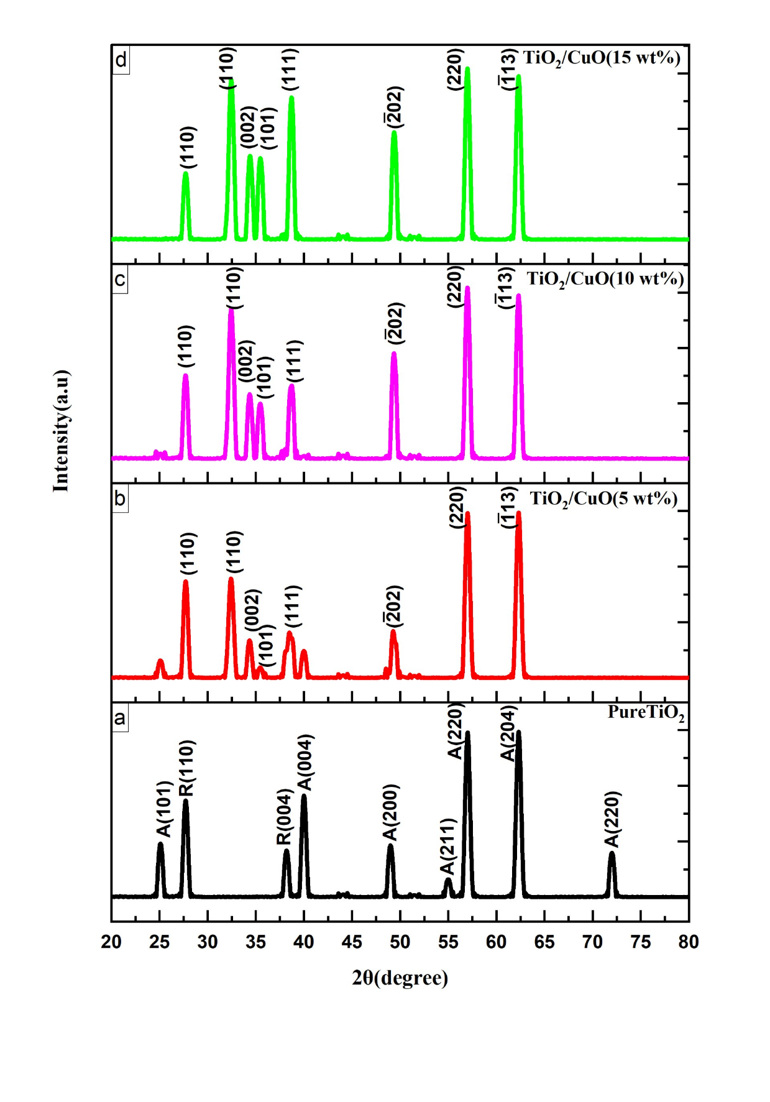

Figure. 1 XRD pattern of TiO₂/CuO nanocomposite with a Concentration as: a) pure TiO₂, b) TiO₂/CuO(5%), c) TiO₂/CuO(10%),d) TiO₂/CuO(15%).

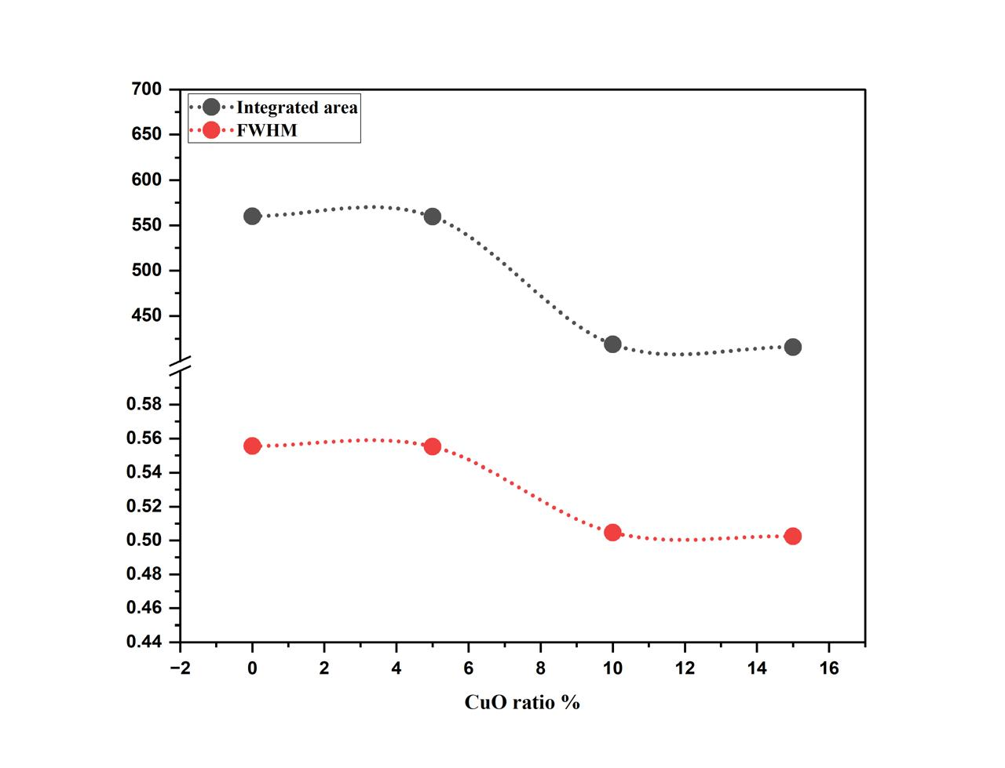

Figure. 2 The effect of CuO ratio on the a) FWHM and b) the Integrated intensity.

Tauc's relation was utilized to determine the optical energy gap of both TiO2 and the nanocomposite TiO2/CuO samples, which can be expressed as follows:

𝛼 = 𝛽 ℎ𝜈 (ℎ𝜈 − 𝐸𝑔𝑥) (3)

Where 𝛼 is the absorption coefficient, *β* is the constant associated with electronic transition probabilities, *hυ* is the photon energy, *Eg* is the optical forbidden gap, and *x* is an exponent factor where the exponent values determine the type of electronic transitions that could occur during the process of photon absorption. For forbidden and allowed direct transition, x = 3/2 and **½**, while for indirect *x* = 2 and 3, respectively. According to Tauc's equation, the optical energy gap is determined by plotting (αhν)1/2 as a function of hν, taking into account the linear portion of the fundamental absorption edge of the UV–visible absorption spectra as shown in Figure 5. Extrapolating the linear portion to the hν axis yields the corresponding indirect band gap. The obtained values are plotted as a function of CuO concentration in Figure 5. A decrease in the values of the optical energy gap with increasing CuO concentration has been observed from 3.2 eV for the control sample to 2.95 eV for samples with CuO concentration of 15wt% as presented in Table 2. The observed reduction in the optical band gap indicates that the CuO increases induced slight disorder in the TiO2/CuO composite samples. The present study reports on the values of the absorption coefficient of pure TiO2 and TiO2/CuO composites. The obtained results reveal that the value for the absorption coefficients is less than 104 cm−1, which implies an indirect electronic transition. These finding sheds light on the electronic properties of PVA/PEG and TiO2/CuO S composites and have potential implications for their use in various applications. Further research exploring these properties is warranted to fully elucidate the underlying mechanisms and optimize their utility.

# FTIR Analysis

FTIR spectral analysis was conducted to investigate the structural modifications in the composite TiO₂/CuO with different ratios of CuO (5 %,10%, and 15 wt %.) The extent of these changes was estimated from the relative increase or decrease in the intensity of the peaks associated with the functional groups present in the composite TiO₂/CuO. Figure 3 shows the infrared spectra of the control pure TiO2 and nanocomposite at different ratios of CuO (0.5, 10, and 15 wt.%). The variation of the absorbance measured at these characteristic wavenumbers with the varying CuO ratio showed that the TiO2/CuO sample characteristic transmittance peaks were observed. In the spectra of pure TiO2 the characteristic bands appeared at 443.63,879.54 cm-1 and 1433 cm-1 are attributed to the Ti-O-Ti vibration. The broad absorption peak around 3400cm-1 is generated by OH bending vibrations in combination with Ti atoms. In the spectrums of nanocomposite TiO2/CuO with different ratios of CuO, it accumulates between the TiO2 and CuO bands. The bands 536.21,487.99 and 453.27 cm-1 were assigned to the vibrations of CuO.

From figures we show the characteristic bands of CuO increased with increasing the ratios of CuO, these results agree with XRD results.

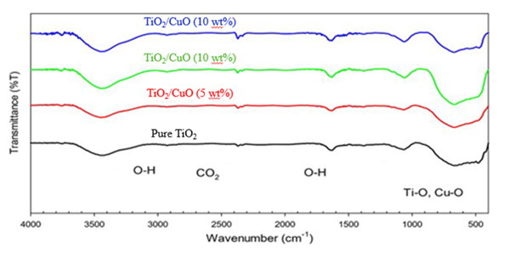

Figure. 3 FTIR spectra (Transmittance vs. wavenumbers) of the TiO2/CuO nanocomposite with a Concentration as: a) pure TiO₂, b) TiO₂/CuO (5wt %), c) TiO₂/CuO(10 wt%),d) TiO₂/CuO(15wt %).

# Optical Properties

The optical properties of the prepared nanocomposites were explored in the range of 300–800 nm. Figure 4 depicts the absorption spectra of the nanocomposites TiO2/CuO. The analysis of optical absorption spectra offers valuable insights into the composition and energy gap of nanocomposite materials. To investigate the impact of different CuO ratios in TiO2/CuO nanocomposites, optical absorption measurements were conducted. Figure 3 displays the absorption spectra of all prepared samples in the UV-vis range (190-900 nm). The recorded spectra exhibit a maximum absorption band (shoulder) at approximately 380 nm for TiO2/CuO, originating from the anatase TiO2. The position of this band is slightly blue-shifted as the CuO ratio increased in the nanocomposite reaching 375 nm for TiO2/CuO (15 wt%). These observed shoulders are caused by the formation of impurity levels just below the conduction band of TiO2 due to the addition of CuO.

This synergistic effect enables the TiO2 valence electrons to jump over the conduction band effortlessly. Therefore, it could suppress the charge carrier recombination and improve the charge transport efficiency.

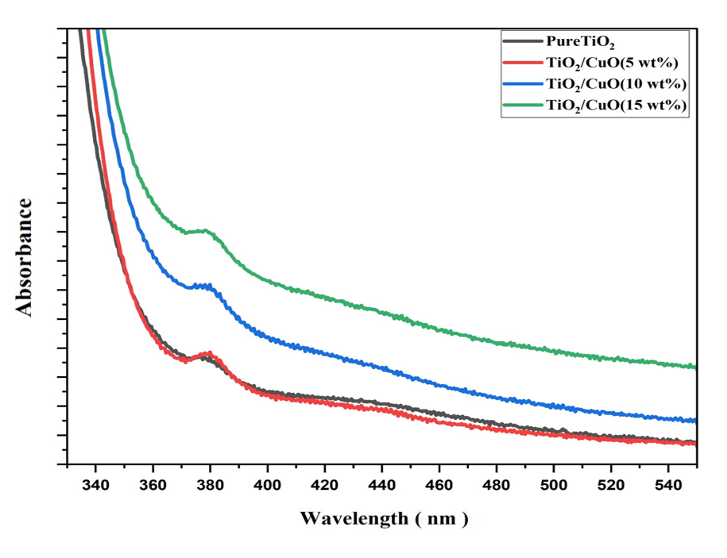

Figure. 4 UV–VIS absorption spectra of the nanocomposite TiO2/CuO nanocomposite with a Concentration as: a) pure TiO₂, b) TiO₂/CuO (5wt %), c) TiO₂/CuO (10 wt%),d) TiO₂/CuO(15wt %).

Table 2 The values of the energy gap for indirect (Eg eV) for the prepared samples at different ratios of (CuO) concentrations.

|  |  |
| --- | --- |
| Samples | Eg (eV) |
| (control)TiO2 | 3.2 eV |
| TiO2/CuO 5wt.% | 3.177 eV |
| TiO2/CuO10wt.% | 3.09 eV |
| TiO2/CuO 15 wt.% | 2.98 eV |

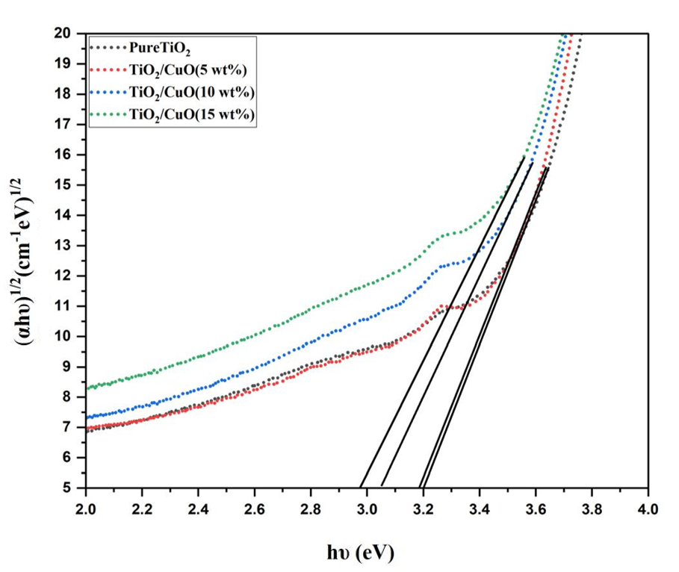

Figure. 5 The variation of (αhv)1/2 against the energy of the photon (hv) of the pure TiO2 and TiO2/CuO

# Conclusion

There is significant attention on the development of optoelectronic and solar cells with novel structures as substitute commercial applications in production. nanocomposite of TiO2/CuO is considered one of the promising choices for cost-effective development and reliable solar energy along with increasing their efficiency. The TiO2/CuO was prepared using the Sol-gel technique. It was found that the concentration ratio of the CuO has a significant effect on the structure and optical properties.In XRD results we find anatase and rutile phase for the TiO2 and a monoclinic was observed for the CuO, the average crystallite size increases with the increasing ratio of the CuO (5, 10, 15 wt%).UV-visible spectrum indicated that increasing CuO concentration in the TiO2/CuO had redshift is indicated to the ratio has a strong effect on the optical parameters. the increase in the maximum intensity of the absorbance percentage with a clear shift from lower wavelength to higher wavelength with energy value (3.2 – 2. 98) eV of the absorption edge as the ratio increases from 5 wt% up to 15 wt%. The higher wavelength means lower energy transmittance from nanocomposites which indicates higher energy absorbed and consequently lowering in the optical energy gap due to the formation of a light state during the preparation of the samples. From the study effect of the concentration on the optical parameters, we find that increasing the CuO ratio enhances its optical activity and shifts it to the visible region which makes it useful in photocatalytic and energy-saving applications.

Disclaimer (Artificial intelligence)

Option 1:

Author(s) hereby declare that NO generative AI technologies such as Large Language Models (ChatGPT, COPILOT, etc.) and text-to-image generators have been used during the writing or editing of this manuscript.

Option 2:

Author(s) hereby declare that generative AI technologies such as Large Language Models, etc. have been used during the writing or editing of manuscripts. This explanation will include the name, version, model, and source of the generative AI technology and as well as all input prompts provided to the generative AI technology

Details of the AI usage are given below:

1.

2.

3.

# References

[1] Z. Dilli, A. Akturk, N. Goldsman, M. A. Holloway, and J. C. Rodgers, “Nonlinear behavior of electrostatic discharge protection structures under high-power microwave excitation: Modeling and simulation,” in 2011 IEEE International Symposium of Circuits and Systems (ISCAS), IEEE, 2011, pp. 1840–1843.

[2] M. C. MORARO, “OPTICAL AND ELECTRICAL CHARACTERIZATION OF Cd x Se 1-x S AND Cu 2 STHIN FILMS FOR SOLAR CELL APPLICATION MOGUNDE CHARLES MORARO (B. EdSc),” 2016.

[3] A. L. Linsebigler, G. Lu, and J. T. Yates Jr, “Photocatalysis on TiO2 surfaces: principles, mechanisms, and selected results,” Chem Rev, vol. 95, no. 3, pp. 735–758, 1995.

[4] A. Pradel and M. Ribes, “Ionic conductivity of chalcogenide glasses,” in Chalcogenide Glasses, Elsevier, 2014, pp. 169–208.

[5] M. Dey et al., “Deposition of CdS thin film by thermal evaporation,” in 2019 International Conference on Electrical, Computer and Communication Engineering (ECCE), IEEE, 2019, pp. 1–5.

[6] I. F. Chetverikova, M. v Chukichev, and L. N. Rastorguev, “X-ray phase analysis and elastic properties of gallium nitride,” Izvestiya Akademii Nauk SSSR, Neorganicheskie Materialy, vol. 22, no. 1, pp. 63–66, 1986.

[7] B. K. Meyer et al., “Binary copper oxide semiconductors: From materials towards devices,” physica status solidi (b), vol. 249, no. 8, pp. 1487–1509, 2012.

[8] A. L. Linsebigler, G. Lu, and J. T. Yates Jr, “Photocatalysis on TiO2 surfaces: principles, mechanisms, and selected results,” Chem Rev, vol. 95, no. 3, pp. 735–758, 1995.

[9] S. C. Abrahams and J. L. Bernstein, “Rutile: normal probability plot analysis and accurate measurement of crystal structure,” J Chem Phys, vol. 55, no. 7, pp. 3206–3211, 1971.

[10] M. Horn, C. F. Schwebdtfeger, and E. P. Meagher, “Refinement of the structure of anatase at several temperatures,” Zeitschrift für Kristallographie-Crystalline Materials, vol. 136, no. 1–6, pp. 273–281, 1972.

[11] P. Sawicka-Chudy et al., “TiO2 Grown by Pulsed Laser Deposition and Reactive DC Direct Current Sputtering as an Intermediate Buffer Layer in Photovoltaic Structures,” Journal of Nanoelectronics and Optoelectronics, vol. 13, no. 7, pp. 995–1000, Jun. 2018, doi: 10.1166/jno.2018.2348.

[12] M. A. Green, Y. Hishikawa, E. D. Dunlop, D. H. Levi, J. Hohl‐Ebinger, and A. W. Y. Ho‐Baillie, “Solar cell efficiency tables (version 52),” Progress in Photovoltaics: Research and Applications, vol. 26, no. 7, pp. 427–436, 2018.

[13] R. Jose, V. Thavasi, and S. Ramakrishna, “Metal oxides for dye‐sensitized solar cells,” Journal of the American Ceramic Society, vol. 92, no. 2, pp. 289–301, 2009.

[14] S. Ruhle et al., “All-oxide photovoltaics,” J Phys Chem Lett, vol. 3, no. 24, pp. 3755–3764, 2012.

[15] S. Goto, Y. Adachi, K. Matsuda, and M. Nose, “Crystal structure and optical properties of TiO2 thin films prepared by reactive RF magnetron sputtering,” Archives of Metallurgy and Materials, vol. 60, no. 2A, pp. 965–967, 2015, doi: 10.1515/amm-2015-0240.

[16] J. Zheng, S. Bao, and P. Jin, “TiO2 (R)/VO2 (M)/TiO2 (A) multilayer film as smart window: Combination of energy-saving, antifogging and self-cleaning functions,” Nano Energy, vol. 11, pp. 136–145, 2015.

[17] M. J. Powell et al., “Intelligent multifunctional VO2/SiO2/TiO2 coatings for self-cleaning, energy-saving window panels,” Chemistry of Materials, vol. 28, no. 5, pp. 1369–1376, 2016.

[18] M. C. Rao, K. Ravindranadh, and M. S. Shekhawat, “Structural and electrical properties of TiO2 thin films,” in AIP Conference Proceedings, AIP Publishing LLC, 2016, p. 020077.

[19] G. K. Dalapati et al., “Color tunable low-cost transparent heat reflector using copper and titanium oxide for energy saving application,” Sci Rep, vol. 6, no. 1, pp. 1–14, 2016.

[20] M. I. Khan, K. A. Bhatti, R. Qindeel, H. S. Althobaiti, and N. Alonizan, “Structural, electrical and optical properties of multilayer TiO2 thin films deposited by sol–gel spin coating,” Results Phys, vol. 7, pp. 1437–1439, 2017.

[21] M. Kang, S. W. Kim, and H. Y. Park, “Optical properties of TiO2 thin films with crystal structure,” Journal of Physics and Chemistry of Solids, vol. 123, pp. 266–270, 2018.

[22] D. S. C. Halin, M. M. A. Abdullah, M. A. A. Mohd Salleh, N. Mahmed, A. N. Mohd Sakeri, and K. Abdul Razak, “Synthesis and characterization of Ag/Tio2 thin film via sol-gel method,” in Solid State Phenomena, Trans Tech Publications Ltd, 2018, pp. 140–145. doi: 10.4028/www.scientific.net/SSP.273.140.