Original Research Article
Biological Insights into Dagger-Tooth Pike Conger Eel, Muraenesox Cinereus (Forsskål, 1775): Length- Weight Relationship and Condition Factor Analysis Along the Mangalore Coast, Karnataka, India

ABSTARCT
This study examined the length-weight relationship (LWR) and relative condition factor (Kn) of Muraenesox cinereus along the Mangaluru coast of Karnataka, India, during the period from August 2023 to March 2024. A total of 492 specimens were collected and analyzed, with lengths ranging from 15.7 to 57.6 am and weights from 8 to 183 g. The LWR equation s for males, females and combined data were determined as W = 0.0188 L^{2.3089}, W = 0.0224 L^{2.2944}, and W = 0.0186 L ^{2.3309,} respectively, with coefficients of determination (r²) of 0.8269, 0.7791, and 0.7996. Both sexes exhibited negative allometric growth, as indicated by them growth coefficient (b<3). An analysis of covariance (ANCOVA) performed on log-transformed length- weight data revealed no significant differences (p>0.05) in mean weight between male and females or in the regression slopes of the LWR. Similarly, the relative condition factor (Kn) showed no significant variation across months or size groups. The study highlights consistent negative allometric growth in Muraenesox cinereus along the Mangalore coast, with no significant sex-based differences in growth patterns or condition factor. These findings provide valuable insights into the species growth dynamics and contribute to its effective management and conservation in the region.
Keywords: Muraenesox cinereus, Condition factor, Length-Weight relationship, Analysis of Covariance

- INTRODUCTION
Fishes that are known as daggertooth pike conger eel (Muraenesocidae: Anguilliformes) are distributed in the south-central Japan waters, the Yellow Sea, the East China Sea, and the Indo-West Pacific (Yamada et al., 2007). Highly compressed vomerine teeth characterize the genus Muraenesox, each exhibiting two prominent basal cusps, setting it apart from other genera (Castle and Williamson, 1975). The species, M. cinereus (Forsskål, 1775), commonly referred to as the Daggertooth Pike Conger eel, is a demersal fish species that is subject to commercial exploitation and frequently caught as by-catch in various demersal fisheries within its range (Najmudeen and Zacharia, 2017). Global landings of this species have markedly increased in recent years. In 2022, India reported a total eel production of 15,184 tonnes (CMFRI, 2023), with the East and West coasts contributing approximately 14,000 and 16,000 tonnes, respectively (Department of Fisheries, 2022). This species is regularly harvested by mechanized trawlers operating along the southwest coast of India throughout the year (Najmudeen,2015).
Studying the length-weight relationships (LWRs) in fish provides crucial information about their biological, ecological, physiological, and population characteristics, as well as the overall health of the examined fish populations. From a mathematical perspective, LWR demonstrates the relationship between a fish's length and its body weight, allowing for the estimation of weight based on length measurements, which is useful in determining biomass (Froese, 2006). The relative condition factor (CF) reflects deviations in an organism’s body weight from the expected standards, providing valuable information about its growth performance and overall health (Jisr et al., 2018).
The aim of this study on the length-weight relationship and relative condition factor of M. cinereus is to establish growth patterns and assess the health of the species. Specifically, it seeks to determine how length correlates with weight, calculate the relative condition factor to evaluate overall well-being, and explore the influence of environmental factors on growth. The findings will provide essential baseline data to inform this species effective management and conservation strategies.
- MATERIAL AND METHODS
  - Study Area
Over an eight-month period (August 2023 to March 2024), 492 M. cinereus specimens were collected biweekly from trawl boat landings at Mangaluru fishing harbors (1250'54" N; 7450'11" E), as shown in Fig. 1. The gathered specimens were preserved on ice, packaged, and transported to the laboratory for additional examination. In the laboratory, the total length (TL) of each specimen were measured with an accuracy of 0.1 cm, and the body weight (W) was recorded to the nearest 0.1g.
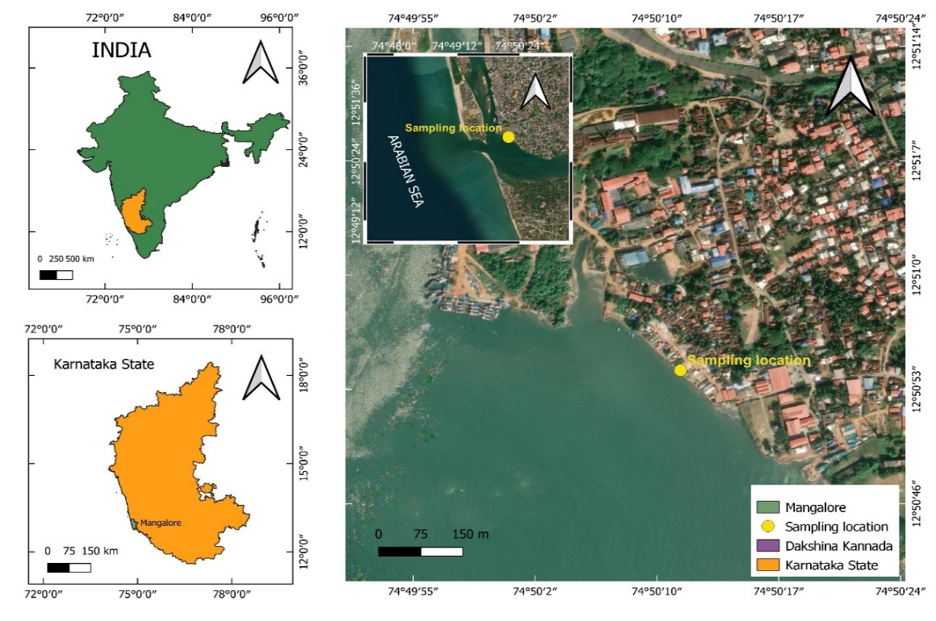
Fig. 1. Geographical representation of sampling station along Mangaluru, Karnataka

  - Length-weight relationship
Measurements of the fish included their total length (TL) and body weight. The specimens exhibited lengths ranging from 15.7 to 57.6 cm and weights varying between 8 and 183 g. The length-weight relationship was determined using the equation W = a(TL)^{b}, where W represents the total body weight in grams, TL denotes the total length in centimeters, a is the coefficient related to body weight and b is the exponent reflecting allometric growth (Le cren,1951). To assess differences in the length-weight relationships between male and female specimens, an analysis of covariance (ANCOVA) was performed (Snedecor and Cochran, 1967).
  - : Relative Condition Factor
The relative condition factor (CF) for each fish was calculated following the methodology outlined by Le Cren (1951) using the formula
$$Kn=\frac{Wo}{Wc}$$
Where, W_{O} = observed weight; W_{C} = calculated weight
  - Statistical Analysis
The statistical analysis was performed using two software packages: Microsoft Excel 2016 and IBM SPSS Statistics 21.0.
- RESULTS

  - Length-weight relationships (LWRs)
No significant gender based differences were found in the length-weight relationship (ANCOVA, p>0.05). Muraenesox cinereus exhibited negative allometric growth, with growth coefficient of less than three (b<3) for males (2.3089), females (2.2944), and the Combined data for both sexes (2.3309). Figures 2a, 2b and 2c present scatter plots illustrating the length-weight relationship for males, females and pooled samples, respectively. The equations were derived from the analysis of length-weight variations within the size range of 15.7 to 57.6 cm and 8 to 183 g.
Male: Log W = 3.6474 + 2.3089 Log TL (r² = 0.8269)
Female: Log W = 4.4385 + 2.2944 Log TL (r² = 0.7791)
Sexes combined (Males and Females): Log W = 4.1165 + 2.3309 Log L (r² =0.7996)
Fig. 2. Length-weight relationship of M. cinereus a) Male, b) Female c) Sex-pooled

  - Relative Condition Factor (Kn)
The relative condition factor (CF) exhibited monthly variations for both sexes. Males showed the highest Kn in October (1.03192) and the lowest in February (0.91117). For females, the peak Kn was observed in November (1.07333), while the minimum occurred in September (1.00703) (Table 1). Female specimens in the 54-57 cm and 57-60 cm size categories displayed reduced Kn values, with intermediate levels found in the 30-33 cm, 24-27 cm, and 27-30 cm ranges. Both males and females demonstrated the highest Kn in the 39-42 cm size group. Male specimens had the lowest Kn in the 30-33 cm range, with moderate values observed in the 15-18 cm, 24-27 cm, and 36-39 cm size categories (Table 2).
Table 1: Monthly fluctuation in the Mean Relative Condition Factor (Kn) of Males and Females, Muraenesox cinereus
Month | Male |  | Female
 | No. of Fishes | Kn | No. of Fishes | Kn
Aug. | 48 | 1.01435 | 17 | 1.01424
Sep. | 21 | 1.01849 | 40 | 1.00703
Oct. | 41 | 1.03192 | 21 | 1.01450
Nov. | 38 | 1.00583 | 22 | 1.07333
Dec. | 38 | 1.01377 | 23 | 1.02308
Jan. | 26 | 1.02287 | 35 | 1.01821
Feb. | 11 | 0.91117 | 51 | 1.01458
Mar. | 26 | 1.03009 | 34 | 1.02753
Weighted average | 249 | 1.0061 | 243 | 1.0241

Table 2: size- based variation in the Mean Relative Condition Factor (Kn) of Males and Females, Muraenesox cinereus
Size group (cm) | Males |  | Females
 | No. of Fishes | Kn | No. of Fishes | Kn
15-18 | 11 | 1.18295 | 0 | 0.0000
18-21 | 30 | 1.0097 | 9 | 1.1339
21-24 | 32 | 1.0720 | 33 | 0.8916
24-27 | 28 | 1.0890 | 71 | 1.0457
27-30 | 55 | 1.0063 | 62 | 0.9810
30-33 | 62 | 0.9625 | 20 | 1.2077
33-36 | 15 | 1.0154 | 16 | 0.9692
36-39 | 7 | 1.0607 | 11 | 0.9752
39-42 | 6 | 1.2945 | 13 | 1.3493
42-45 | 2 | 1.0308 | 5 | 0.9274
45-48 | 1 | 1.0321 | 0 | 0.0000
48-51 | 0 | 0.0000 | 0 | 0.0000
51-54 | 0 | 0.0000 | 0 | 0.0000
54-57 | 0 | 0.0000 | 2 | 0.5576
57-60 | 0 | 0.0000 | 1 | 0.3916

- Discussion
As outlined in Le Cren (1951) concept of the ‘Cube law’, an ideal fish should have a growth coefficient (b) of 3.0; however, this value can vary significantly among different species. In the current study, both adult males and females of M. cinereus displayed a negative allometric growth pattern (b < 3), indicating that the species experiences a more significant increase in length relative to weight as it develops (Le Cren, 1951; Froese, 2006). These results align with the findings of Piria et al. (2014) regarding Anguilla anguilla from karstic rivers in Croatia. The LWR in fish is affected by various factors, including habitat, geographic location, seasonal changes, reproductive maturity, sex, dietary habits, stomach contents, health status, and preservation techniques (Tesch, 1971). Variations in the ‘b’ value of length-weight relationship (LWR) can be influenced by multiple factors including sample size, the range of lengths analyzed, geographical location, physiological characteristics, ontogenic stages, seasonal influences, population structure, sex, reproductive maturity, and stomach content (Mommsen, 1998; Rajesh et al., 2020).
The relative condition factor (CF) serves as a crucial measure for assessing fish health, including proper growth, feeding intensity, spawning, and maturation (Jisr et al., 2018; Nair et al., 1983). This parameter serves as an important indicator of the general health and fitness of fish population. The condition factor (Kn) for both male and female Muraenesox cinereus exhibited consistent fluctuations across months, with values near 1, suggesting comparable health status between the sexes. According to Jisr et al. (2018), a Kn value exceeding 1 indicates optimal growth conditions, whereas a value under 1 suggests poor health. Various elements can impact the condition factors in fish, including environmental circumstances, ecological variables, changes across seasons, the availability of food, development of gonads, pressure from fishing activities, and stress-inducing factors (Zargar et al., 2012; Ahmad, 2013; Ali et al., 2014; Komsari et al., 2015).
- CONCLUSION
The research provides a thorough examination of results indicating a negative allometric growth trend in both male and female specimens, emphasizing that length increases more rapidly than weight during their development. Consistently, the relative condition factor showed values close to 1, indicating similar health status across both sexes. The investigation also revealed various environmental and biological elements affecting growth and condition, such as habitat, food accessibility, and seasonal changes. These findings are crucial for comprehending the life history characteristics of M. cinereus and emphasize the importance of implementing effective management approaches to maintain the species' sustainability in its natural environment. Ongoing research in this field will be vital for assessing population health and guiding conservation initiatives.

REFERENCES
Ahmad, F. M. Y. (2013). Length-weigh relationships, relative condition factor, and relative weight of Characidae fish in Jebel Aulia Dam, Sudan. International Journal of Marine, Atmospheric and Earth Sciences, 1-7.
Ali, S., Barat, A., Kumar, P., Sati, J., Kumar, R., & Haldar, R. S. (2014). Study of length-weight relationship and condition factor for the golden mahseer, Tor puttiora from Himalayan rivers from India. Journal of Environmental Biology, 35(1), 225-228.
Castle, P. H. J., & Williamson, G. A. (1975). Systematics and Distribution of Eels of the Muraenesox Group (Anguilliformes, Muraenesocidae): A Prelimerary Report and Key. Rhodes University.
Department of Fisheries. (2022). Handbook On Fisheries Statistics. Ministry of Fisheries, Animal Husbandry and Dairy, Government of India, New Delhi.
Froese, R. (2006). Cube law, condition factor and weight–length relationships: history, meta‐analysis and recommendations. Journal of applied ichthyology, 22(4), 241-253.
Froese, R., Pauly, D. (2020). FishBase: concepts, design and data sources ICLARM, Philippines.
Jisr, N., Younes, G., Sukhn, C., & El-Dakdouki, M. H. (2018). Length-weight relationships and relative condition factor of fish inhabiting the marine area of the Eastern Mediterranean city, Tripoli-Lebanon. The Egyptian Journal of Aquatic Research, 44(4), 299-305.
Le Cren, E. D. (1951). The length-weight relationship and seasonal cycle in gonad weight and condition in the perch (Perca fluviatilis). The Journal of Animal Ecology, 201-219.
Mommsen, T. P. (1998). Growth and metabolism. The physiology of fishes, 2, 65-97.
Morey, G., Moranta, J., Massutı, E., Grau, A., Linde, M., Riera, F., & Morales-Nin, B. (2003). Weight–length relationships of littoral to lower slope fishes from the western Mediterranean. Fisheries Research, 62(1), 89-96.
Nair, J. R., Nair, N. B., & Balasubramanian, N. K. (1983). Condition and relative condition cycles in the tropical glassy perchlet Chanda (= Ambassis) commersonii (Cuv. and Val.) (Pisces: Centropomidae). Proceedings: Animal Sciences, 92, 415-422.
Najmudeen, T. M. (2015). Classification of Exploited Demersal Finfishes of India: Pigface breams, lizardfishes and eels.
Najmudeen, T. M., & Zacharia, P. U. (2017). Taxonomy of exploited demersal finfishes of India: lizardfishes, pigface breams, eels, guitar fishes and pomfrets.
Rajesh, K. M., Rohit, P., & Roul, S. K. (2020). Length-weight relationships (LWRs) of fourteen marine pelagic fish species in the southeastern Arabian Sea. Thalassas: An International Journal of Marine Sciences, 36(2), 371-374.
Saemi Komsari, M., Bani, A., & Khara, H. (2015). Growth and population structure of the European perch, Perca fluviatilis Linnaeus, 1758 (Osteichthyes: Percidae) in the Anzali Wetland south-west Caspian Sea.
Snedecor, G.W., Cochran, W.G. (1967). Statistical Methods, sixth ed. Oxford and IBH Publishing Co, New Delhi, India.
Tesch, F. W. (1971). Age and growth. Methods for assessment of fish production in fresh waters.
Yamada, U., Tokimura, M., Horikawa, H., & Nakabo, T. (2007). Fishes and fisheries of the East China and Yellow Seas. Tokai University: Hadano, Japan.
Zargar, U. R., Yousuf, A. R., Mushtaq, B., & Jan, D. (2012). Length-weight relationship of the crucian carp, Carassius carassius in relation to water quality, sex and season in some lentic water bodies of Kashmir Himalayas. Turkish Journal of Fisheries and Aquatic Sciences, 12(3).

