Synthesis, Characterization and Anti-bacterial activity of Phenyl-D-Glucosazone

Abstract:
This study aims to describe the synthesis and determination of antibacterial activity of Phenyl-D-Glucosazone. Melting point and IR spectral data was confirm the structure of compound and antibacterial activity was characterized by the nature of biological activities. The antibacterial activity of the prepared compound was employed by using the agar well diffusion method and tested against Gram positive (S. aureus,) and Gram negative (Klebsiella pneumonia,) bacterial strain.

KEYWORDS: -

Phenyl-D-Glucosazone, Microbial study, Agar well diffusion method, Bacteria,

Introduction:
“Glucosazone is a yellow crystalline substance that is often used to identify the presence of glucose. It's chemically very similar to fructosazone and mannosazone. Glucosazone is an example of osazone. Osazones are a class of carbohydrates formed by the reaction of reducing sugars with phenylhydrazine. Osazone is a derivative of the sugar glucose. It is used in the Osazone test which is a method for identifying specific types of sugars. Osazone is a modified form of water that is used in Organic Chemistry to identify specific types of acids. Phenyl glucosazone is formed when reacting glucose with an excess of phenyl hydrazine in the presence of acid at elevated temperature” [1,2].
“Maria Molnar et al¹ reported “a continuous flow approach for the generation of phenyl glucosazone from glucose and phenyl hydrazine is reported giving the pure target in 53% isolated yield. This thermal process generates the target product as an insoluble material that causes reactor fouling via adhering to the reactor walls. To overcome this issue a segmented flow approach was realised where by streams of air and the reaction solution were combined in a T-piece and directed through the heated reactor coil. The resulting micro-mixing prevented reactor fouling and blocking and allowed for multi-hour reactions to generate the desired target in high yield. The value of the phenyl glucosazone product was demonstrated via its oxidative cyclisation into 2H-phenyl-1,2,3- triazoles which represent important heterocyclic scaffolds”. Phenyl D-Glucosazone is a chemical widely used in the medicinal field. It is used for the treatment of osteoarthritis, it also used as a pain killer and more. It is a derivative of glucose and phenyl group.

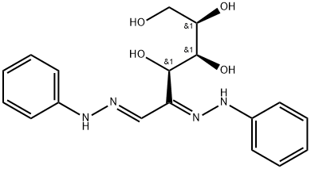
Structure of Phenyl D-Glucosazone:

FIG 1 : Structure of Phenyl D-Glucosazone
Experimental Methods:
Materials and Methods:

All the chemicals used were analytical grade. Double distilled water was used for all purposes

AnalaR grade of reagents used for the preparation of Phenyl D-Glucosazone

Preparation of Phenyl-D-Glucosazone
“2 ml of glacial acetic acid is mixed with 5 ml of water and 2 ml of phenylhydrazine and solution is shaken until a phenylhydrazine acetate is obtained. To this solution 1 g of glucose dissolved in 5 ml of water is added. The the reaction mixture is gently heated in a boiling water-bath. The yellow glucosazone usually begins to crystallize out after about 15 minutes heating. The heating is continued with occasional stirring for 45 minutes, and obtained solutions is filtered, wash with water and then with a few milliliters of methanol. Yield of glucosazone is about 1.5 g. The purification is performed by recrystallization from large amount of methanol or ethanol yielding bright yellow crystals, which melt at 204° C with decomposition” [4].
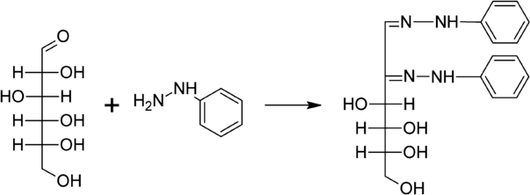
FIG 2: Preparation of Phenyl-D-Glucosazone
Characterization of Prepared compound:

The structure of Phenyl D-Glucosazone was confirmed by its elemental analysis. Further, this compound was confirmed by melting point and characterized by vibrational spectroscopy (perkin Elmer, Model Spectrum Two, Range: 4000 nm -400 cm in the IR range.²⁻⁸
Antibacterial Screening:

The prepared compound was characterized with anti bacterial screening by using the agar well diffusion method.^{9,10} “Bacterial cultures such as gram positive (S. aureus,) and gram negative (Klebsiella pneumonia,) bacterial strain were obtained from Kirnd Institute of Research and Development Pvt.Ltd, Tiruchirappalli. 100 ml of a fresh culture containing 1×10⁸ CFU/ml of bacteria was spread onto the Mueller Hinton Agar (MHA) plates using the sterile swab. The perti-plate was tested at a 10 mg/ml, 20 mg/ml, 30 mg/ml concentration of the compounds were dispersed in dimethyl sulphoxide (DMSO). Zone of inhibition levels (mm) was measured subsequently for 24 h at 37 °C. For positive control, standard antibiotic Streptomycin (10 µg disc) was used” [5].

Results And Discussion

Vibrational Spectroscopy of Phenyl D-Glucosazone:
The FT-IR spectra of Phenyl D-Glucosazone shown below:

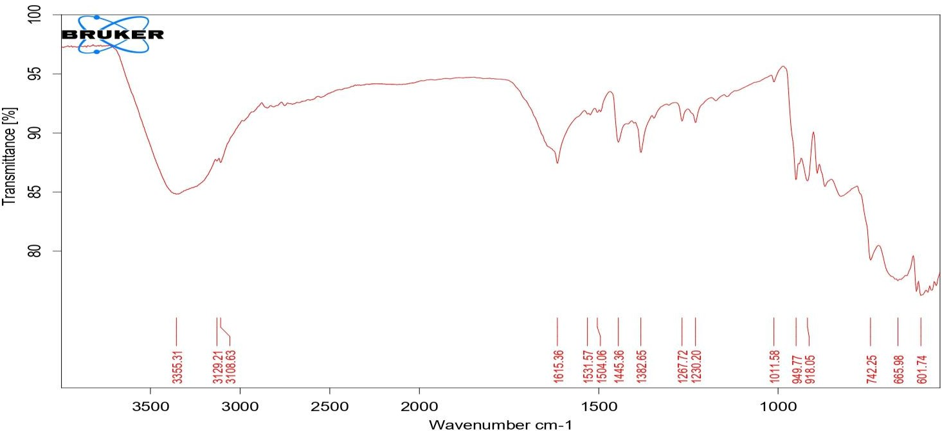
Figure: 3 FT - IR Spectrum OF Phenyl D-Glucosazone

Table : 1 FT-IR Spectral Data of Phenyl D-Glucosazone

FUNCTIONAL GROUP | IR FREQUENCY CM⁻¹
O-H | 3355.31
N-H | 3129.21
C=C | 1531.57
C-O | 1382.65
C-N | 1230.20

Based on infrared (IR) spectrum shown in Figure - 3, the compound contains several functional groups. Firstly there consist of alcohol group (O-H) at 3355.31 cm⁻¹ and Carbon oxygen bond at 1382.65 cm⁻¹.Nitrogen Hydrogen bond (N-H) at 3129.21 cm⁻¹ It contains Carbon Nitrogen bond at (C-N) at 1230.20 cm⁻¹ and Arene bond (C=C) at 1531.57 cm⁻¹

Antibacterial Activity of Phenyl D-Glucosazone:
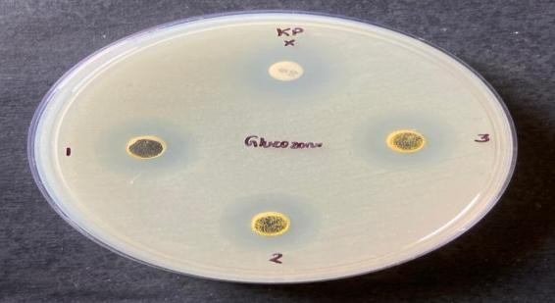
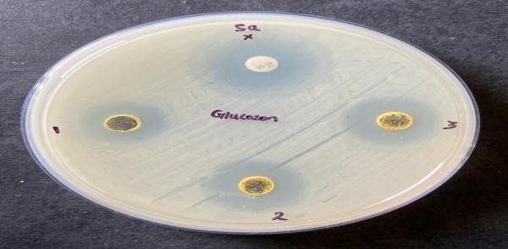
The antibacterial activity of the prepared Phenyl D-Glucosazone was employed by using the agar well diffusion method and tested against gram positive (S. aureus,) and gram negative (Klebsiella pneumonia,) bacterial strain. 100 mL of a fresh culture containing 1×10⁸ CFU/mL of bacteria was spread onto the Mueller Hinton Agar (MHA) plates using the sterile swab. The perti-plate was tested at a 10 mg/ml, 20 mg/ml, 30 mg/ml concentration of the Phenyl D-Glucosazone dispersed in dimethyl sulphoxide (DMSO). Zone of inhibition levels (mm) was measured subsequently for 24 h at 37 °C. For positive control, standard antibiotic Streptomycin (10 µg disc) was used.

Figure: 4 Antibacterial activity of Phenyl D-Glucosazone
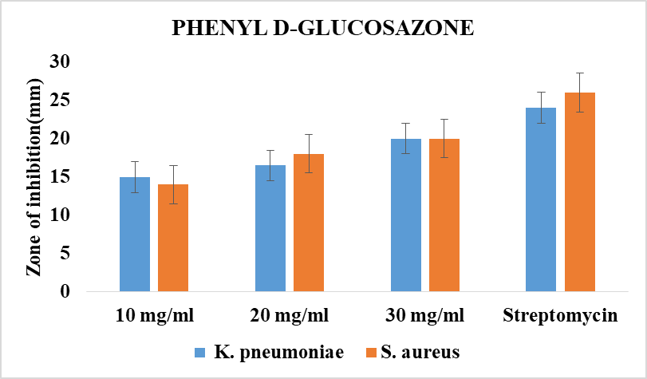

Figure: 5 Bar Graph activity of Phenyl D-Glucosazone
Table 2: Antibacterial activity of Phenyl D-Glucosazone

Organisms | DMSO Extract added in the Zone Inhibition(mg/ml)
Organisms | 10 mg/ml | 20 mg/ml | 30 mg/ml | Streptomycin
K. pneumoniae | 15 | 16.5 | 20 | 24
S. aureus | 14 | 18 | 20 | 26

The antibacterial activity result of the Phenyl D-Glucosazone(Figure – 4 and 5) showed a varying degree of inhibition zone in tested microbes.The antibacterial activity of the test samples rises with rises in the Concentration(Table -2). In this study Streptomycin was used as a standard antibiotic. Gram positive bacteria S. aureus shows a higher activity in 30 mg/ml and also Gram-negative bacteria (Klebsiella pneumonia,) a higher activity in 30

CONCLUSION

The present study synthesized and characterized Phenyl D-Glucosazone using IR spectroscopic analysis. This compound was screened against two gram-positive and gram-negative bacteria. The concentration of the Phenyl D-Glucosazone compound increases with an increase in activity. The gram-positive bacteria S. aureus showed only nearly higher activity in 30 mg/ml. But, the gram-negative bacteria K. pneumonia has a nearly higher activity in 30 mg/ml for Phenyl D-Glucosazone as compared to Streptomycin.

Disclaimer (Artificial intelligence)
Option 1:
Author(s) hereby declare that NO generative AI technologies such as Large Language Models (ChatGPT, COPILOT, etc.) and text-to-image generators have been used during the writing or editing of this manuscript.
Option 2:
Author(s) hereby declare that generative AI technologies such as Large Language Models, etc. have been used during the writing or editing of manuscripts. This explanation will include the name, version, model, and source of the generative AI technology and as well as all input prompts provided to the generative AI technology
Details of the AI usage are given below:
1.
2.
3.

References:

Maria Molnar Marcus Baumann, Continuous flow synthesis of phenyl glucosazone and its conversion to 2H-1,2,3-Triazole building blocksJournal of Flow Chemistry 13:211–215(2023),file:///C:/Users/DELL/Downloads/Continuous_flow_synthesis_of_phenyl_glucosazone_an.pdf.

P.S.Kalsi Spectroscopy of Organic Compounds 6th Edition New Age international Publishers, 2004,https://books.google.com.et/books?id=QWq47QClOM0C&printsec=frontcover#v=onepage&q&f=false

Robert M. Silverstein, Francis X. Webster , Spectrometric identification of Organic compounds, 6th Edition John Wiley & Sons, India, 2009,https://quimicafundamental.wordpress.com/wp-content/uploads/2014/05/spectrometric-identification-of-organic-compounds-silverstein.pdf

- Willam Kemp Organic Spectroscopy 3rd Edition Macmillan, New York 1991, https://tech.chemistrydocs.com/Books/Spectroscopy/Organic-Spectroscopy-By-William-Kemp-3rd-Edition.pdf

- J.R. Dyer , Application of Absorption spectroscopy of organic compounds , 1st Edition, Prentice Hall, US1965. https://archive.org/details/applicationsofab00dyer

- Pa Pa San, Investigation of Phenyl Glucosazone Compound Using Jaggery by Enzyme, file:///C:/Users/DELL/Downloads/Investigation%20of%20Phenyl%20Glucosazone%20Compound%20Using%20Jaggery%20by%20Enzyme-2.pdf

- Volc J, Sedmera P, Musilek V. Glucose-2-oxidase activity and accumulation of d-arabino-2-hexosulose in cultures of the basidiomycete Oudemansiella mucida. Folia microbiologica. 1978 Jul;23:292-8. doi: 10.1007/BF02922207.

- Mark Lautens, Jonathan BajohSegmented Continuous Flow Allows for Convenient Synthesis of Phenyl Glucosazone, Synfacts 2023; 19(04): 0425,DOI: 10.1055/s-0042-1753417, https://www.thieme-connect.com/products/ejournals/abstract/10.1055/s-0042-1753417

- Dr. S. K. Periyasamy ,Dr.M.Venkatesan & Dr.C.Karikal Chozhan, Structural Reactivity and Oxidation Kinetics of Cyclic Alcohols by Imidazolium Fluorochromate, Eur. Chem. Bull. 2025, 14( 01), 27-34. https://www.eurchembull.com/archives/volume-14/issue-1/17832

- S. Sundari, Dr. S. K. Periyasamy, Dr. M. Iyanar, Synthesis, Characterization and Anti bacterial activity of Benzimidazolium Chlorochromate, Eur. Chem. Bull. 2025, 14(1), 56-60. https://www.eurchembull.com/archives/volume-14/issue-1/17855.

