***Short communication***

**Hands-on Guide to Sample Size Calculation in Medical Research Using EZR**

**ABSTRACT**

Sample size calculation is an important part of any medical research. The statistical analysis will provide valid inference only when the sample size is adequate enough to answer the research question. A small sample size may produce inconclusive results and too large sample size will waste the resources and could expose more participants than necessary. Hence the proper estimation of minimum required sample size for research is an important step in the design of any study. The present article gives an introduction to the various aspects of sample size estimation with hypothetical examples along with step-by-step illustration using EZR software.

Key words: Power analysis, Sample size, EZR software, Medical Research

**INTRODUCTION**

The purpose of research is to get to the bottom of a problem to find solution(s). This process of problem solving requires statistics to a great extent. Ideally, answering an epidemiological research question requires data from the entire population of interest, which is not feasible in reality. [1]

Except census, a complete enumeration survey which involves data collection from all persons belonging to a particular region, all the other forms of studies are conducted on a sub-group of the population known as “sample” who are drawn from the concerned population. The data retrieved from the sample is analyzed using appropriate statistical methods to draw conclusions and make inference about the population under study.

Determining the size of sample is crucial in any research since a small sample will produce a result which may not have sufficient power to detect a difference between the study groups, which in turn might lead to an inflation of type II error. For obvious reasons, a small sample size is quite alluring, but will lead to wastage of resources and the results will be questionable. A sample size very large is also not recommended as it leads to squandering of resources when an accurate answer can be obtained from a smaller sample. Also, if the study is intervention-based, many participants will be deprived of a better treatment or may be exposed to unnecessary risk if the treatment has side-effects. Due to these reasons, it is very important to calculate an optimum sample size before the start of any research.[2] Hence this paper intends to provide the theory and a step-by-step guide to calculation of sample size using EZR (Easy R), which is the menu-driven package of R software.

The main factors which must be considered while estimating sample size are[4–6],

* Primary objective, outcome variable and study design: Sample size is calculated on the basis of primary objective, nature of the outcome variable (binary or continuous) and design of the study.
* Type I error or α-error: Rejecting a null hypothesis when the null hypothesis is true is known as Type I error. The probability of committing this error is known as the level of significance (α), which is usually set at 5%. The sample size has to be increased to reduce the type I error.
* Type II error or β-error: Not rejecting a null hypothesis when the null hypothesis is not true is known as Type II error. By convention, it can be set at 20%, 10% or 5%. The probability of not committing this error is known as the power of the study, which should be at least 80%. The sample size has to be increased to increase the power of study.
* Margin of error is an acceptable error percentage, which determines how far the estimate of the study is from the true value. This represents the precision of the estimate.
* Clinically significant difference is the minimum clinically acceptable difference in the outcome variable between the groups under comparison. The value of clinically significant difference is an input from researcher/clinician based on clinical judgment.[7]
* Number of study groups: The total number of study groups is an essential factor in determining the sample size.
* Number of repeated measurements: When repeated measurements are taken, such as in longitudinal studies or when multiple measurements are collected from the same subjects, the number of these measurements needs to be accounted for.
* Other factors which need to be considered are standard deviation for quantitative measurements, proportion in qualitative measurements and attrition rate. These values are either known from literature or can be determined through a pilot study or based on expert opinion and domain knowledge.[8]
* Study constraints such as the study period, available funding, ethical considerations, and logistical resources should be considered, as these factors may restrict the number of participants that can be feasibly included in the study.

The sample size estimated after the calculations is not an exact but a ballpark figure. Certain times, the estimated sample size will have to be adjusted due to limited funds, duration and participants.[9,10] However, the researcher must ensure that a major shift in the calculated size of the sample does not occur due to the aforementioned reasons.[11] This article primarily focuses on sample size calculation for common estimation and comparison procedures in medical research, including determining sample size for estimating means and proportions; and comparing means and proportions between groups.

1. **SAMPLE SIZE FOR ESTIMATION PROCEDURES**

### Sample size based on estimation of mean

Sample size is determined by the way the outcome is measured. When the outcome is a continuous variable, it can take any value in a given range (example: body mass index (BMI), cholesterol level etc.). The appropriate measure to summarize such variables is using the mean. Sample size based on estimation of mean is used when the aim of the study is to find the average value of a quantitative outcome variable (example: Estimation of mean BMI).

The assumptions for sample size calculation for estimation of mean are

* The outcome variable is continuous in nature.
* The sampling distribution of the sample mean is approximately normal.
* The observations are independent.

$$n=\frac{z_{(1-\frac{α}{2})}^{2}{}^{2}}{d^{2}}$$

where,

σ=standard deviation

d=margin of error

$z_{(1-\frac{α}{2})}$ =Normal distribution table value for the desired confidence level (α)

Problem 1: A researcher wishes to estimate the average weight of full-term newborns in a hospital. How large a sample of birth records should be taken at 5% level of significance? Researcher will be satisfied to let the precision to be 0.5 kg, and from the previous studies it is found that the population standard deviation is about 2 kg.

Solution:

Step 1: Extract information regarding

* Standard deviation of birth weight = 2 kg (i.e. 𝜎 = 2)
* Margin of error = 0.5 kg (i.e. d = 0.5)
* Level of significance = 5%

Step 2: Open EZR and go to Statistical analysis $->$ Calculate sample size $->$ Calculate sample size from standard deviation and confidence interval.

Step 3: Enter the value *2* for ‘Standard deviation (expected)’ and *1 i.e. (0.5×2)* for ‘Confidence interval width’, a value of *95* for ‘Confidence level’ and click ‘OK’.

*Note:*

* *Confidence interval width is twice the value of precision fixed for the study. (Confidence interval width = 2 × precision).*
* *If the level of significance is 5%, confidence level is 95%.*

Step 4: The output window displays the estimated minimum required sample size as 62.

### Sample size based on estimation of proportion

When the outcome of interest is to determine a characteristic which can be counted, the appropriate measure to summarize such variables is using the proportion.

Sample size based on estimation of proportion is used when aim of the study is to find the number of individuals (proportion) of an outcome variable which is categorical in nature (example: Estimation of proportion of type II diabetes among adolescents).

The assumptions for sample size calculation for estimation of proportion are

* The outcome variable measure should be categorical.
* The sampling distribution of the sample proportion (p) is approximated to normal.

$$n=\frac{z_{(1-\frac{α}{2})}^{2}pq}{d^{2}}$$

where,

p=expected proportion of event of interest

q= $1-p$

d=margin of error

$z_{(1-\frac{α}{2})}$ =Normal distribution table value for the desired confidence level (α)

Problem 2: A researcher aims to estimate the proportion of hypertension among graduate students in a college. How many individuals should be included in the study so that the proportion may be estimated within 5% points of the true value at 5% level of significance? Researcher anticipates that the proportion of hypertension is 15%.

Solution:

Step 1: Extract information regarding

* Expected proportion = 15% (i.e. p = 0.15)
* Margin of error = 5% (i.e. d = 0.05)
* Level of significance = 5%

Step 2: Open EZR and go to Statistical analysis $->$ Calculate sample size $->$ Calculate sample size from proportion and confidence interval.

Step 3: Enter the value *0.15* for ‘Proportion’ and *0.1 (0.05×2)* for *‘*Confidence interval width*’*, a value of *95* for ‘Confidence level’ and click ‘OK’.

Step 4: The output window displays the estimated minimum required sample size as 196.

Additional information: When one wants to estimate the proportion within a defined percentage of expected proportion itself, then relative precision is used instead of absolute.

In that case, the formula for sample size calculation for estimation of proportion is

$$n=\frac{z_{(1-\frac{α}{2})}^{2}pq}{{(pd)}^{2}}$$

1. **SAMPLE SIZE FOR COMPARISON PROCEDURES**

### Sample size based on comparison of two means

Sample size based on comparison of means is determined for studies when the outcome is a continuous variable, and the study aims to compare the average of this outcome across two independent groups (example: comparison of systolic blood pressure between groups such as diabetic and non-diabetic).[12]

The assumptions for sample size calculation for comparison of means are

* The outcome variable should be continuous.
* The sampling distribution of the sample mean is approximately normal.
* The observations are independent.
* The variances in the two groups are similar.

$$n=\frac{2{}^{2}{(z_{\left(1-\frac{α}{2}\right)}+z_{(1-β)})}^{2}}{{μ_{d}}^{2}}$$

where,

σ=pooled (average) standard deviation of two groups,

where, ${}_{1}$ = standard deviation of first group

${}_{2}$ = standard deviation of second group

$μ_{d}$ =clinically significant difference

$z_{(1-\frac{α}{2})}$ =Normal distribution table value for the desired confidence level $(α)$

$z_{(1-β)}$ =Normal distribution table value for the desired power $(1-β)$

*Note: The above formula determines sample size for one group. Hence the total sample size is n*=2n.*

Problem 3: A study is planned by the nutrition department to see whether a dietary supplement given to pregnant women will reduce the systolic blood pressure (SBP) level during the time of delivery. One group will receive the new supplement whereas the other group will receive the normal diet. From a pilot study, the standard deviation of SBP was 40 mm/hg and it is expected to be the same for both the groups. What is the required sample size if we expect a difference of 20 mm/hg SBP between groups at 5% level of significance with 80% power?

Solution:

Step 1: Extract information regarding

* Standard deviation = 40 (i.e. 𝜎 = 40)
* Clinically significant difference = 20 (i.e. µd=20)
* Level of significance = 5%
* Power of the study = 80%

Step 2: Open EZR and go to Statistical analysis $->$ Calculate sample sizeCalculate sample size for comparison between two means.

Step 3: Enter the value *20* for ‘Difference in means’ and *40* for ‘Standard deviation in each group’ and click ‘OK’.

Step 4: The output window displays the estimated minimum required sample size as 63 in each group (total sample size required is 126).

***Additional information:*** Comparison of means across more than two groups: When the outcome variable is being compared between more than two groups, the sample size is calculated using the same formula given above, but with adjustment for number of comparisons. This adjustment is done using the level of significance after dividing it by number of comparisons and obtaining a new z table value.

Example: In Problem 3, if there was another group in addition to the new supplement and normal diet group, then the z table value would be 2.32, i.e., (1-alpha)/(2×number of comparisons). Here for 3 groups, the number of comparisons is 3. The sample size for each group would be 80 and the total sample size of 240. The value of z table can be obtained using *NORMSINV* function of MS Excel.

### Sample size based on comparison of two paired means

Sample size based on comparison of means is determined for studies when the outcome is a continuous variable, and the study aims to compare the average of this outcome across two-time points13 (example: comparison of systolic blood pressure of patients measured before and after treatment).

The assumptions for sample size calculation for comparison of paired means are

* The outcome variable should be continuous.
* The differences between paired measurements should be normally distributed
* The observations are independent.

$$n=\frac{{}^{2}{(z_{\left(1-\frac{α}{2}\right)}+z_{(1-β)})}^{2}}{{μ_{d}}^{2}}$$

where,

σ=pooled (average) standard deviation of two time points,

where, ${}_{1}$ = standard deviation of first time point

${}_{2}$ = standard deviation of second time pint

$μ_{d}$ =clinically significant difference

$z_{(1-\frac{α}{2})}$ =Normal distribution table value for the desired confidence level $(α)$

$z_{(1-β)}$ =Normal distribution table value for the desired power $(1-β)$

Problem 4: A study is being designed to assess whether a dietary supplement administered to pregnant women can reduce systolic blood pressure (SBP). Based on a pilot study, the standard deviation of SBP was 40 mmHg before the intervention and 30 mmHg after. To detect a 20 mmHg reduction in SBP with a 5% significance level and 80% power, what is the required sample size?

Solution:

Step 1: Extract information regarding

* Standard deviation = 35 (i.e. 𝜎 = 35)
* Clinically significant difference = 20 (i.e. µd=20)
* Level of significance = 5%
* Power of the study = 80%

Step 2: Open EZR and go to Statistical analysis $->$ Calculate sample size $->$ Calculate sample size for comparison between two paired means.

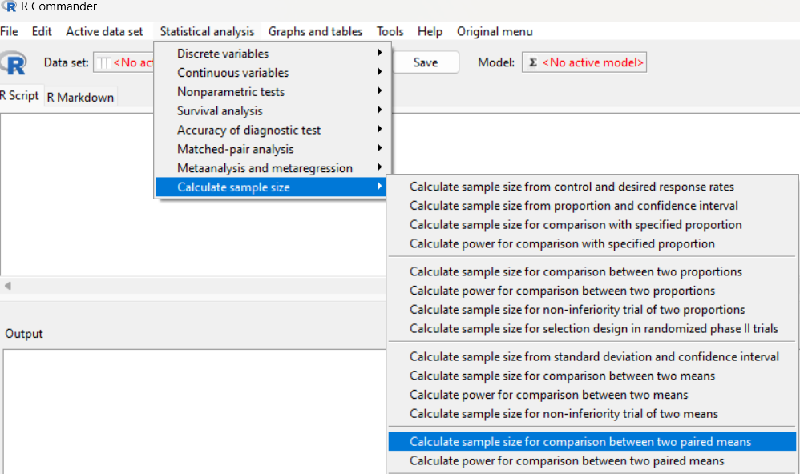

Step 3: Enter the value *20* for ‘Difference in means’ and *35* for ‘Standard deviation in each group’ and click ‘OK’.

Step 4: The output window displays the estimated minimum required sample size is 27

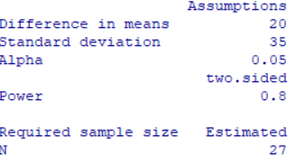

**Additional information:**

If there is a single group with more than two time points, the sample size should be adjusted for the design effect as outlined below[13].

× DE

If there are two independent groups with two or more time points, the sample size should be adjusted for the design effect as outlined below.

$$n= \frac{{2\left(z_{1-α/2}+ z_{1-β}\right)}^{2}σ^{2} }{{μ_{d}}^{2}} ×DE$$

In both cases the design effect, DE= $\left[1+(m-1)ρ\right]$, where m is the number of time points, ρ is intra-cluster correlation coefficient.

### Sample size based on comparison of two proportions

Sample size based on comparison of proportions is determined for studies when the outcome is categorical in nature and the study aims to compare the proportion of this outcome across two independent groups (example: comparison of proportion of type II diabetes (present/absent) among males and females).

The assumptions for sample size calculation for comparison of proportions are

* The outcome variable should be categorical.
* The sampling distribution of the sample proportion is approximated to normal.

$$n=\frac{2PQ{(z_{\left(1-\frac{α}{2}\right)}+z_{(1-β)})}^{2}}{{(p_{1}-p_{2})}^{2}}$$

where,

P=pooled proportion of two groups,

where, $p_{1}$ = proportion in first group

$p_{2}$ = proportion in second group

Q= $1-P$

$z_{(1-\frac{α}{2})}$ =Normal distribution table value for the desired confidence level $(α)$

$z_{(1-β)}$ =Normal distribution table value for the desired power $(1-β)$

*Note: The above formula determines sample size for one group. Hence the total sample size is n*=2n.*

Problem 5: A study is planned to compare the proportion of occurrence of myocardial infarction between two groups such estrogen plus progesterone group and only estrogen group. From the previous study, proportion of myocardial infarction is found to be 25% among estrogen plus progesterone group and 15% among only estrogen group. What should be the number of subjects recruited in each group with a power of 80% at a level of significance of 5%?

Solution:

Step 1: Extract information regarding

* Proportion of myocardial infarction in estrogen plus progesterone group=25% ($p_{1}=0.25$)
* Proportion of myocardial infarction in only estrogen group=15% ($p_{2}=0.15$)
* Level of significance = 5%
* Power of the study = 80%

Step 2: Open EZR and go to Statistical analysis $->$ Calculate sample size $->$ Calculate sample size for comparison between two proportions.

Step 3: Enter the value *0.25* for ‘Proportion in group 1’, *0.15* for ‘Proportion in group 2’, click ‘No correction’ under ‘Continuity correction of chi-square test’ and click ‘OK’.

Step 4: The output window displays the estimated minimum required sample size as 250 in each group (total sample size required is 500).

When the outcome variable is being compared between more than two groups, the sample size is calculated by obtaining a new z value after adjusting for the number of comparisons, similar to the sample size calculation for comparison of mean for more than two groups.

**CONCLUSION**

Calculating the sample size is a fundamental and crucial step in the design of any study. The sample size must be carefully determined at the planning stage, based on the study's primary objective and design to ensure the validity and reliability of the results. Seeking the expertise of a statistician during this stage is highly recommended, as their input can help in selecting the appropriate method for calculation and addressing potential challenges. Furthermore, when publishing research findings, it is imperative to provide comprehensive details about the sample size, including the rationale behind the chosen size and the method used for its calculation. This transparency not only strengthens the credibility of the study but also allows for the accurate interpretation and replication of the research. Therefore, proper attention to sample size calculation is essential for the overall success of the research.

**CONFLICTS OF INTEREST**

The authors declare that there is no conflict of interest.

**COMPETING INTERESTS DISCLAIMER**

Authors have declared that they have no known competing financial interests OR non-financial interests OR personal relationships that could have appeared to influence the work reported in this paper.

**GLOSSARY OF TERMS**

* **Standard deviation:** A measure that quantifies the amount of variation or dispersion in a dataset.
* **Margin of error: The maximum expected difference between the true population parameter and a sample estimate.** A smaller margin of error indicates higher precision of estimate.
* **Confidence interval:** A range of values that is likely to contain the true population parameter with a specified probability (confidence level).
* **Confidence level: The probability that the confidence interval contains the true population parameter.**
* **Normal distribution: A symmetrical, bell-shaped probability distribution where most observations cluster around the central peak.**
* **Clinically significant difference: The smallest change in outcome that clinicians would identify as important.**
* Intra-class correlation coefficient (ICC) quantifies the consistency or homogeneity of the measurements assessed at different time-points, on the same subject.

**Ethical Approval:**

As per international standards or university standards written ethical approval has been collected and preserved by the author(s).

Disclaimer (Artificial intelligence)

Option 1:

Author(s) hereby declare that NO generative AI technologies such as Large Language Models (ChatGPT, COPILOT, etc.) and text-to-image generators have been used during the writing or editing of this manuscript.

Option 2:

Author(s) hereby declare that generative AI technologies such as Large Language Models, etc. have been used during the writing or editing of manuscripts. This explanation will include the name, version, model, and source of the generative AI technology and as well as all input prompts provided to the generative AI technology

Details of the AI usage are given below:

1.

2.

3.

**REFERENCES**

1. Krejcie RV, Morgan DW. Determining Sample Size for Research Activities. Educ Psychol Meas 1970;30(3):607–10.

2. Binu V, Mayya S, Dhar M. Some basic aspects of statistical methods and sample size determination in health science research. AYU Int Q J Res Ayurveda 2014;35(2):119.

3. Karun MK, Puranik A.

4. Bolarinwa O. Sample size estimation for health and social science researchers: The principles and considerations for different study designs. Niger Postgrad Med J 2020;27(2):67.

5. Sadiq IZ, Usman A, Muhammad A, Ahmad KH. Sample size calculation in biomedical, clinical and biological sciences research. J Umm Al-Qura Univ Appl Sci 2025;11:133-141

6. Noordzij M, Tripepi G, Dekker FW, Zoccali C, Tanck MW, Jager KJ. Sample size calculations: basic principles and common pitfalls. Nephrol Dial Transplant 2010;25(5):1388–93.

7. Lenth RV. Some Practical Guidelines for Effective Sample Size Determination. Am Stat 2001;55(3):187–93.

8. Hertzog MA. Considerations in determining sample size for pilot studies. Res Nurs Health 2008;31(2):180–91.

9. Althubaiti A. Sample size determination: A practical guide for health researchers. J Gen Fam Med 2023;24(2):72–8.

10. Bacchetti P. Ethics and Sample Size. Am J Epidemiol 2005;161(2):105–10.

11. Chan AW, Hrobjartsson A, Jorgensen KJ, Gotzsche PC, Altman DG. Discrepancies in sample size calculations and data analyses reported in randomised trials: comparison of publications with protocols. BMJ 2008;337(dec04 1):a2299–a2299.

12. Zhong B. How to Calculate Sample Size in Randomized Controlled Trial? J Thorac Dis 2009;1:51–4.

13. Machin D, Campbell MJ, Tan SB, Tan SH. Sample size tables for clinical studies. John Wiley & Sons; 2011 Aug 26.